**PRODUCTION OF HYBRID COMPOSITE USING SISAL FIBER AND FALSE BANANA FIBER FOR DASHBOARD APPLICATION**

Dawit Wami Negera 1, Dr. Ramesh Babu Nallamothu 2

*1Lecturure at Mechanical Engineering Department, College of Engineering, Assosa University, Assosa, Ethiopia, and Email:* [*D.wami@yahoo.com*](mailto:D.wami@yahoo.com) *Mobile Phone: 0920841111, P.O. Box:18*

*2Lecturer at Mechanical Systems and Vehicle Engineering Department, Adama Science and Technology University, Adama, Ethiopia, Email:* [rbnallamothu@gmail.com](mailto:rbnallamothu@gmail.com) , *Mobile Phone: 0912234395, P.O. Box:18*

**ABSTRACT**

The necessity to discover a workable substitute for heavy metals to replace them in alternative natural fiber reinforced polymer composites is driven by the growing concern over environmental issues, attention to green and clean composite materials. Light materials are receiving a lot of attention in order to decrease vehicle weight, fuel consumption, and improve physical and mechanical qualities due to stricter environmental and passive safety rules. The purpose of this thesis work is to fabricate, describe the methods used to prepare specimens and models, carry out an experiment to gather data on, and analyze mechanical properties. False bananafiber (FBF) and sisal fiber (SF) were used to create the composite, which was then compressed using a general purpose (GP) resin with hardener mixture and a straight forward hand lay-up method. Then, tests for density, water absorption, tensile strength, compression strength, and flexural strength were performed in accordance with ISO and ASTM standards. The findings indicate that the 1:3 ratio has a higher overall tensile strength than both the 1:1 ratio and the 3:1 ratio, at 69 MPa. 3:1 ratio 380 MPa. In a compression strength test, a 3:1 ratio likewise produced a higher value of 12.30 MPa. Test results for the bending strength and water absorption (regular tap water and rainwater) were and (2.64% and 3.07%), respectively, which are substantially lower than from 1:1 ratio and 3:1 ratio. The preparation of hybrid composite, characterization of the mechanical and physical properties, modeling of the dashboard using Solid Work 2017, compare and contrast the cost, weight and percentage fuel reduction with the convectional one. Finally, fabrication of a prototype for the dashboard of a PEUGEOT model car with improved mechanical and physical properties for demonstration purposes.

***Keywords:*** Dashboard, Flexural, Fuel consumption, Light material

**INTRODUCTION**

The increase in environmental consciousness and community interest, the new environmental regulations and unsustainable consumption of petroleum led to thinking of the use of environmentally friendly materials(Goud & Rao, 2011). The natural fiber is considered one of the environmentally friendly materials which have good properties compared to synthetic fiber. Increasing attention towards sustainable development and environmental awareness forces researchers to explore more on the green biodegradable materials based on agricultural wastes(Goud & Rao, 2011). Fiber hybridization is a promising strategy to toughen composite materials(Karthick & Aruna, 2017). By combining two or more fiber types, these hybrid composites offer a better balance in mechanical properties than non-hybrid composites. The basic aim of developing a new material for automotive application is to enhance vehicle efficiency and fuel economy by reducing the dead weight of the vehicle. Through weight reduction the fuel consumption may also be decreasing. By the 10 % weight decreasing, the fuel consumption of a vehicle decreases by 7 %, what also means that reducing the weight by about 1 kg will measurable reduce the CO2 emissions(Venkateshwaran et al., 2011). In developing Country most of the situation the body and spare part of Automotive was purchased/imported from abroad like dashboard, pumper, right and left doors etc. These imported materials are heavy in weight, expensive and have a great impact on the environment(Venkateshwaran et al., 2011). The problems mostly shown on the vehicle’s dashboard are, The PEUGEOT vehicle model is old model vehicle so it’s difficult to get accessory of this model. The PEUGEOT automobile model vehicles dashboard simply scratched proof(Boopalan et al., 2013). Day time veiling glare in automobiles caused by dashboard reflectance and when the dashboard assembly is installed a vehicle; the heating and cooling cycles produce a different thermal expansion of the port of plastic material and of the metal part of hybrid supporting structure(Sinha et al., 2017).

To eliminate or minimize those problems listed above by changing the materials to hybrid composite of FBF and SF reinforced with GP resin with hardener is appropriate, and also coated with black paint to reduce glare reflection to the driver and tilt the dashboard in some angle to change the direction of reflection out ward from the driver (Singh & Kumar Gupta, 2022). The general objective of this thesis work is to fabricate and characterize the hybrid composite for construction of dashboard in automobile application and specific objectives are produce a hybrid composite of FBF and SF fibers reinforced composite material, measure the tensile, compression, flexural(bending), density and water absorption properties of composite material, fabricate the PEUGEOT model automobile vehicle dashboard using the composites and compare the performance of vehicle dashboard made up of composite with the conventional materials(Badrinath & Senthilvelan, 2014).

**MATERIALS AND METHOD**

The manufacturing process of the hybridization of FBF and SF reinforced GP resin composite material has been presented starting from the extraction of each fiber, their material property, preparation of PEUGEOT model vehicle dashboard and comparison of mechanical and physical properties with the existing materials.

The samples were fabricated based on weight fraction. The procedure to fabricate hybrid composite was described clearly in Figure 1.

* FBF and SF were collected and extracted manually from Dire Hincinni and Ambo town respectively and treated by using 8 grams of NaOH with 10 liters of distilled water in the plastic container. The FBF and SF are then soaked in the solution for 24 hours. Then, treated fibers were washed many times till it becomes neutral by means of down runner water. Finally, it dried in air for one day in sunlight.
* Arrange the FBF and SF according to the desired Wight ratio by weighing individually and hybridize by intra yarn or fiber-by-fiber hybridization mechanism. After that, by using local weaving equipment produce a fiber orientation of (0, 90)0 plane type.
* GP resin and hardener (catalyst) were bought from world fiberglass and waterproofing Engineering Company, Addis Ababa, Ethiopia and Brush, gloves, roller wax (mold releaser), steering wood and scissors were purchased from the local pharmacy and market centers. The Mold was prepared from timber wood to fabricate samples.
* Simple hand lay-up composite production method was used that followed by compression molding for 48 hours to remove excess resin and air bubbles and curing for 48 hours.
* The fabricated sample was cut into specimens based on the ASTM standard to obtain there mechanical and physical properties by using conventional testing machines.
* The result was analyzed and optimal hybrid composite fabrication Wight ratio was identified.
* Finally, preparing the model of a dashboard for PEUGEOT model vehicle by the composite with better mechanical and physical properties.

Generally, methodology flow chart for preparation of hybrid composite shown in Figure 1.

FBF & SF steam/blast collection

Fiber extraction

Fiber Drying

Fibers treatment in 8 g NaOH & 10 L distilled water

Washing fibers by running water repeatedly &drying in air

Hybrid fibers & weaving ply orientation of (0,90)0

Mold preparation

Purchasing resin and hardener

Mixing resin& hardener based on Wight ratio

Composite fabrication based on Wight fraction of FBF, SF, resin and hardener

Applying load

Curing

Specimen preparation

Conducting test

Analysis tests

Preparing the Model of dashboard for PEUGEOT vehicle by the better mechanical & physical properties

Figure 1: Methodology chart for preparation of hybrid composite of FBF and SF.

**Extraction process of False Banana /Ensete / fiber**

The extraction of the fiber was not taken part as the main objective. Rather the fiber as a byproduct. The main reason for extraction process is searching food. The process is discussed as follows according to the observation made(Boopalan et al., 2013).

* Cut the Enset plant which is ripe and ready for the process, from the ground level.
* Cut the outer two layers of the plant into smaller pieces.
* Attach the smaller piece on an inclined plane wood and hold it with right leg.
* Between the right leg and the inclined plane wood scrap it with a tool made from wood to squeeze the size.

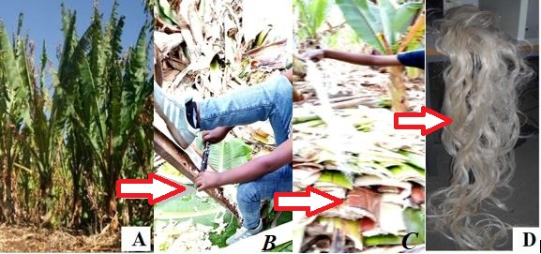

Figure 2: Manual extraction process of FBF. A) FB (Ensate) plant. B) During extraction process. C) Extracted FBF before washing. D) Dried FBF.

**Sisal fiber**

**Extraction process of sisal fiber**

In general, the extraction process of the sisal fiber from sisal plants was concisely summarized as below:

* All lower leaves, standing at an angle of more than 45 degrees to the vertical, are cut away from the bole of the plants with a sharp flexible knife.
* After that gently or carefully remove the thorn from the leaves of sisal in both sides of its edge and tip.
* Then the leaves are trimmed in a longitudinal direction in to different strips for ease of fiber extraction.
* The peeling part is clamped between the wood table and knife.
* Then it’s hand-pilled gently through in longitudinal direction in order to remove the resinous materials as shown in Figure 3.
* Then the extracted fiber washed gently with pure water in order to loosen, and separate the fiber until individual fibers are obtained.
* Then the extracted fibers are then dried over the sun for three days.

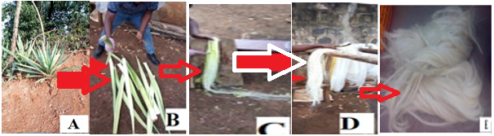

Figure 3: Manual extraction process of sisal fiber.

1. Sisal plants B. Longitudinally trimmed sisal plant C. Peeling of sisal plant for sisal fiber extraction D. Extracted sisal fiber before washing with water and drying E. Extracted sisal fiber in drying process after washing

**Sodium hydroxide (NaOH)**

Sodium hydroxide, also known as lye or caustic soda, has the molecular formula NaOH and is a highly caustic metallic base and alkali salt. Pure sodium hydroxide is a whitish solid, which is available in pellets, flakes, granules, and as a 50 % saturated solution(Mizera et al., 2015).

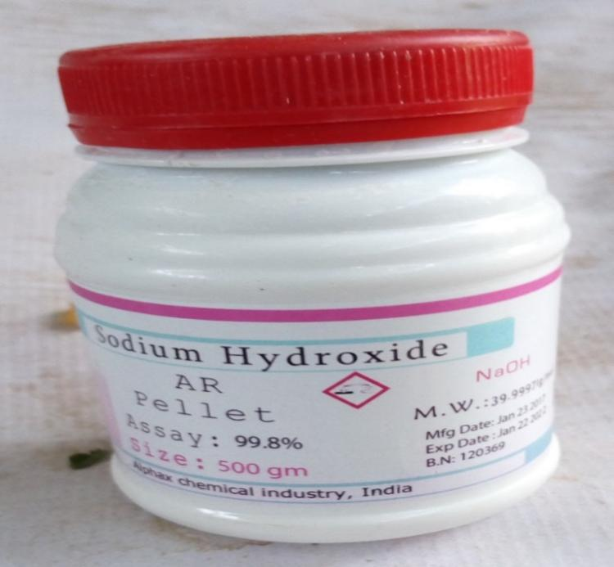

Figure 4: Sodium hydroxide (NaOH).

**Alkali treatment of FBF and SF**

When the percentage of NaOH is increased it affects the properties of the fiber by reducing the bonding capacity during the preparation of the composites(Holbery & Houston, 2006).

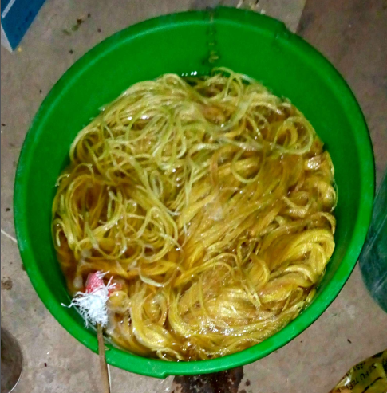

Figure 5: FBF and SF after socked by NaOH.

**Determination of fibers and GP resin weight fractions of the hybrid composite**

According to (Singh & Kumar Gupta, 2022)Fiber, matrix mass fraction and volume fraction content of the composite material were calculated by the equation:

$\frac{M_{fiber}}{M_{matrix}}=\frac{ρ_{fiber }×V_{fiber}}{ρ_{matrix}×V_{matrix}}…………………………………………………………….$ ( 1)

Measure the weight of fibers using digital weight measuring device high precision instruments.

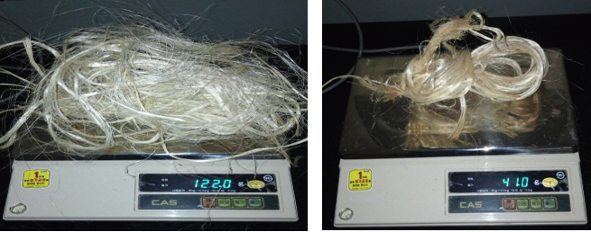

Figure 6: Digital weight measurement device.

### Hybridization Mechanism of false banana fiber and sisal fiber

The term ‘hybrid composite’ is generally used to describe a matrix containing at least two types of reinforcements, but this paper is restricted to hybrid composites containing two types of reinforcing fibers(false banana fiber and sisal fiber)(Swolfs et al., 2014).

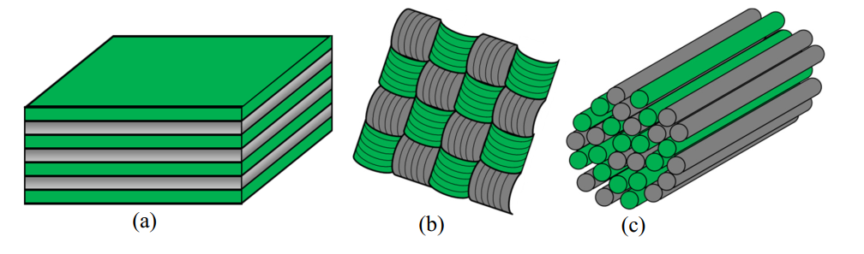

Figure 7: The three main hybrid configurations (Gan, 2009).

1. Interlayer or layer-by-layer (B).Intralayer or yarn by-yarn, (C).Intra yarn or fiber-by-fiber

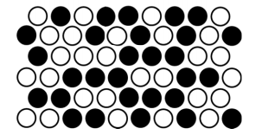

Figure 8: Completely random dispersion (Gan, 2009).

After that, by preparing local weaving (loom) equipment using 1m2 wood plate and nail to produce different hybrid composition of FBF and SF ratios. For fiber orientation of (0,90)0 .

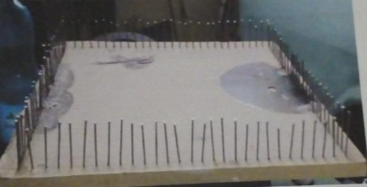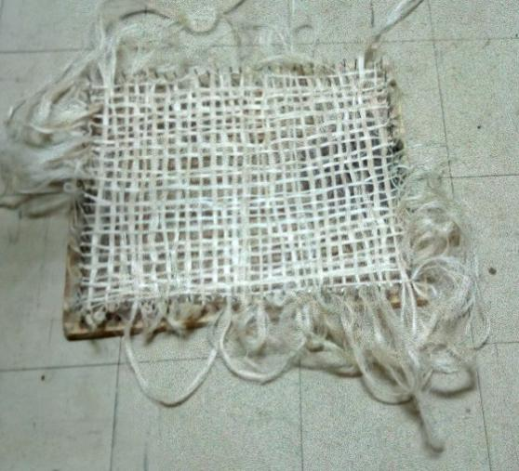

Figure 9: Weaving (loom) equipment. Figure 10: Weaving (loom) orientation of (0, 90)0

**GP resin with hardener**

Ratio of 10:1 for GP and hardener respectively as recommended.

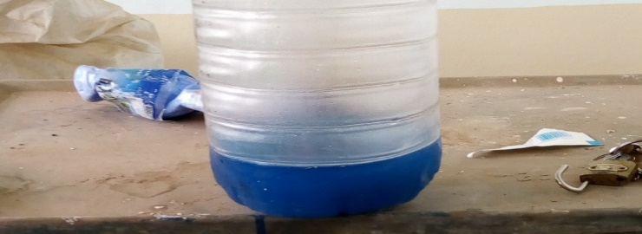

Figure 11: GP resin.

**Hand lay-up technique**

Hand lay-up technique is the simplest method of composite processing. The infrastructural  
requirement for this method is also minimal.

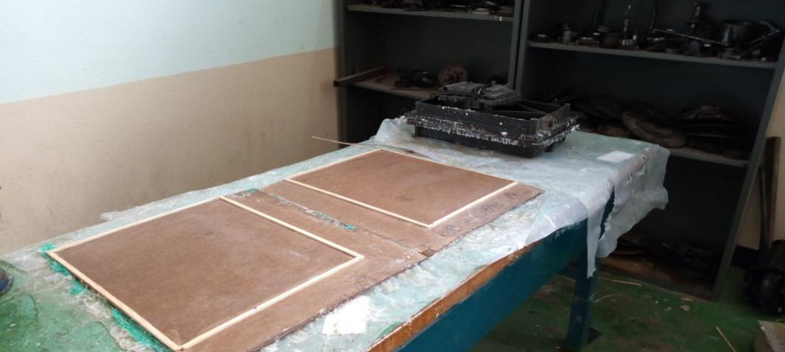

Figure 12: Mold.

**Mold Release wax (Cream)**

Mold release wax is a cream or semi fluid smoothers the paint surface or bare metal surface and will reduce the friction between debris and make meaning that tiny debris is more likely to slide off composite rather than damage it(Singh & Kumar Gupta, 2022).

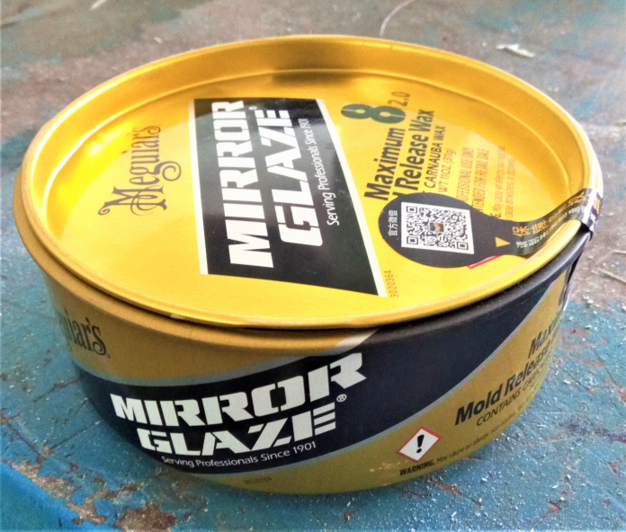

Figure 13: Mold releaser (wax).

**Hand lay-up procedure**

First, a release gel is sprayed on the mold surface to avoid the sticking of polymer to the surface.  
Thin plastic sheets are used at the top and bottom of the mold plate to get good surface finish  
of the product.

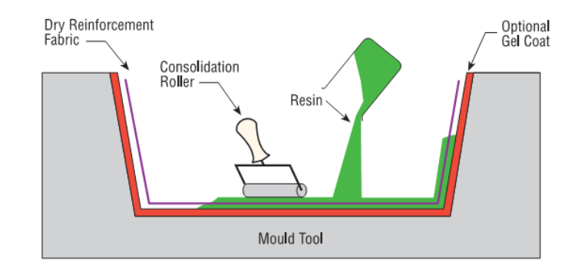

Figure 14: Hand lay-up techniques (Adem et al., 2015)**.**

**Compression and Curing**

High load materials are loaded on the mold to remove excess GP resin and curing for 24 hours for at room temperature. After curing period, the hybrid FBF and SF GP matrix were removed from the mold.

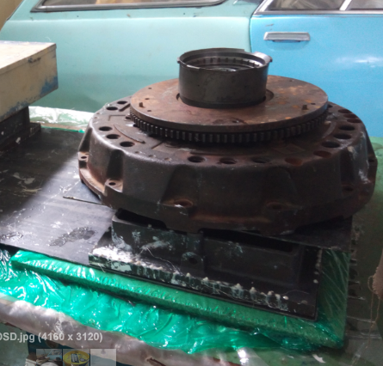

Figure 15: Compression and curing process.

**Fabrication of composite specimens**

FBF and SF were washed and properly dried. Fibers were depending on desired weight ratio settled. The MDF wood mold of size 300 mm x 250 mm x 4 mm were cleaned properly and uniform thickness was ascertained using thickness gauge.

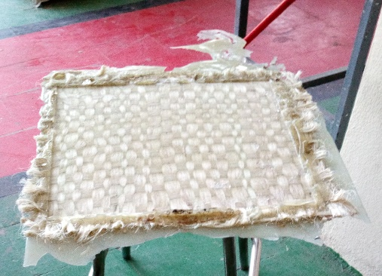

Figure 16: Fabricated hybrid composite from FBF and SF.

General schematic flows for the production of hybrid composite from FBF and SF preparation process are shown in Figure 17.

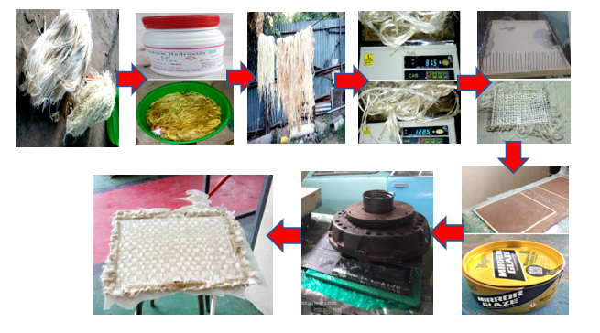

Figure 17: Hybrid composite of false banana fiber and Sisal fiber fabrication procedures.

**Measurements for test specimens**

The specimens for the hybrid composite of FBF and SF for the tensile test were prepared in accordance with the necessary Ethiopian Conformity Assessment Enterprise (ECAE) Testing material (ISO 6892-1) standards.

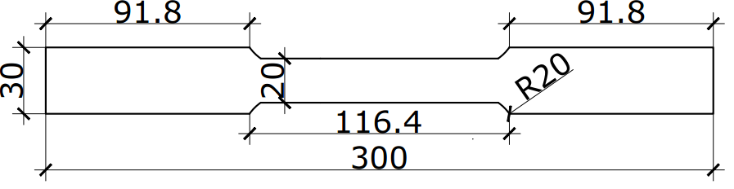

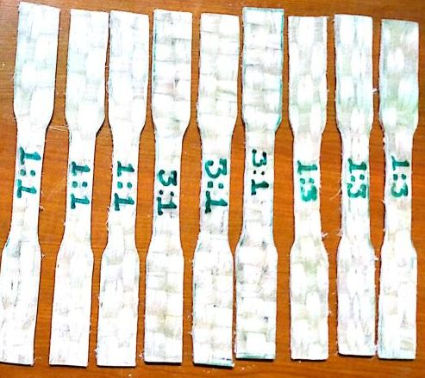

(a) Tensile Test Specimen

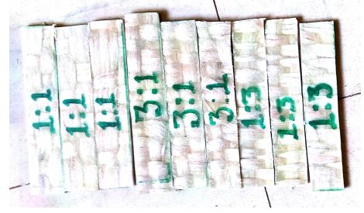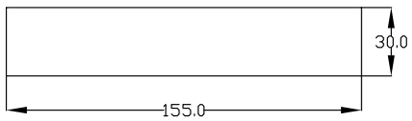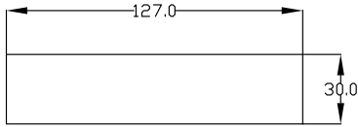



(b) Compression Test Specimen (c) Bending Test Specimen

Figure 18: Test specimen dimensions.

**Test of tensile strength**

Figure 21, depicts the results of a tensile strength test on UTM 2000 KN performed by Ethiopian Conformity Assessment Enterprise.

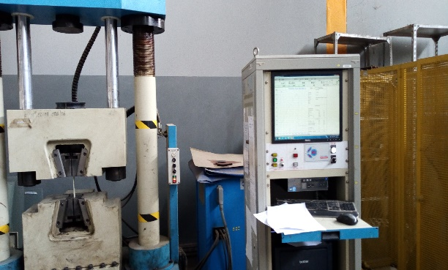

Figure 19: Tensile strength test.

**Test of compression strength**

For the hybrid composite of FBF and SF, compression strength test specimens in accordance with ASTM D -3410 were developed. There were three different ratios used: 1:1, 3:1, and 1:3.

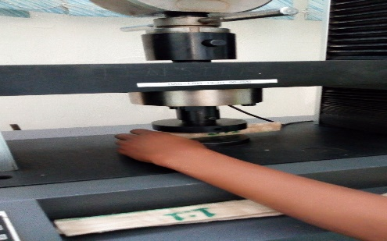

Figure 20: Compression strength test.

**Test for flexural strength**

The ability of a material to resist deformation under load is known as flexural strength.

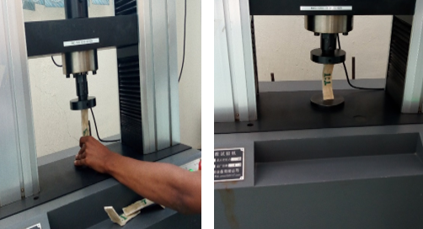

Figure 21: Flexural (Bending) strength test.

**Density measurement**

Experimentally, the actual density (ρce) of the composite is determined using a 30 mm $×$ 30 mm sample using a straightforward water immersion approach.

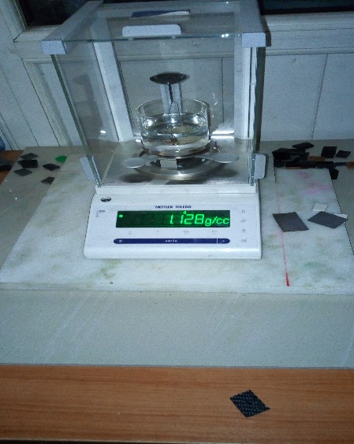

Figure 22: Constructed hybrid composite of FBF and SF density measurement technique.

**Absorption of water**

Source moisture absorption was carried out in line with ASTM D - 570-98, according to the literature the specimen was 30mm by 30mm in size. (Haldar et al., 2017) provided the information for the equation below.

$\% Water Absorption = \frac{W_{t - }W_{o}}{W_{o}}×100 OR \frac{M_{W - }M_{a}}{M_{a}} ×100$………………………. (1)

$Where : W_{t}=Weight of Wet sample$ $,{ W}_{o}=Weight of dry sample$

$M_{W} =Mass of Wet sample$ ${, M}_{a }=Mass of dry sample$

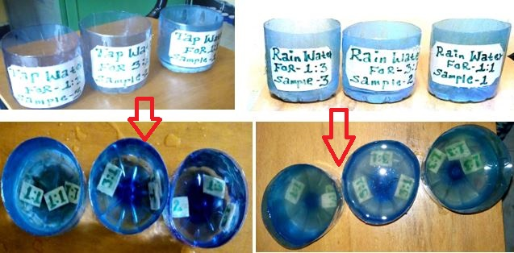

Figure 23: Water absorption test.

**Computation of mass**

The SOLID WORK 2017 software uses the density relationship to compute the mass of the dashboard for both the standard dashboard and the modified dashboard, which are constructed of metal sheet and composite material, respectively.

Now, calculate the mass saved for the dashboard

$Mass Saved=Mass of convectional dashboard – Mass of composite material$

$$\% Mass Saved=\frac{Mass Saved}{Mass of convectional dashboard}×100……………………………( 8)$$

**RESULTS AND DISCUSSION**

The results of mechanical properties and physical properties are provided based on the study's objectives and methods. MS Excel and the Minitab 18 program were used for the interpretation and analysis. On the basis of the results from the experiment, the ideal sample composition was discussed.

**Analysis of Tensile strength**

The tensile strength test results are tabulated and shown in Table 1 based on a hybrid composition of FBF and SF ratios with three trial specimens for each (FBF: SF) of 1:1 ratio, 3:1 ratio, and 1:3 ratio and an average value for those specimens.

Table 1. Tensile strength test results for various hybrid composites with different weight fractions.

|  |  |  |  |  |
| --- | --- | --- | --- | --- |
| Hybrid composite material  (Ratio) | Samples | Max. load  (kN) | Max. Elongation  (%) | Tensile strength  (MPa) |
| **1:1** | Trial-1 | 4.22 | 7.9 | 44 |
| Trial-2 | 4.39 | 14.4 | 46 |
| Trial-3 | 5.18 | 5.6 | 51 |
| **Average** | **4.59** | **9.3** | **47** |
| **3:1** | Trial-1 | 6.72 | 7.2 | 48 |
| Trial-2 | 7.81 | 7.2 | 52 |
| Trial-3 | 6.00 | 7.9 | 41 |
| **Average** | **6.84** | **7.43** | **47** |
| **1:3** | Trial-1 | 9.85 | 8.7 | 76 |
| Trial-2 | 6.39 | 6.5 | 70 |
| Trial-3 | 6.45 | 5.6 | 62 |
| **Average** | **7.56** | **6.94** | **69** |

Individual results for each sample and the average result for each hybrid composite ratio are listed in Table 1. The average value from each test was used to analyze the results. Figure 24 from UTM displays the specific results of each specimen graphically.

Figure 24: Tensile strength comparison for various weight fractions.

The hybrid composite of FBF and SF with a 1:3 ratio has a greater tensile strength based on the average tensile stress value of the produced composite. Equal tensile strength exists in FBF and SF hybrid composites with 1:1 and 3:1 ratios. In brief, the hybrid composite of FBF and SF with a 1:1 ratio and a 3:1 ratio show reduced tensile strength.

**Investigation of compression strength**

According to the findings of compression tests, the 3:1 ratio hybrid composite made of FBF and SF has a better compression strength. The compression strength of the FBF and SF hybrid composite with a 1:1 ratio is noticeably very low. A hybrid composite of FBF and SF with a 1:3 ratio demonstrates approximate approximation to one with a 3:1 ratio. According to the research, composite materials that have been manufactured with false banana fiber (FBF) have a higher compression strength than others. Maximum applied load and maximum deflection were measured for three hybrid composites of FBF and SF with ratios of 1:1, 1:3, and 3:1, and three trial sample specimens for each ratio.

Table 2. Compression strength test results for various hybrid composites of weight fraction.

|  |  |  |  |  |
| --- | --- | --- | --- | --- |
| Hybrid composite material | Samples | Max. load  (N) | Max. deformation  (mm) | Compression strength  (MPa) |
| **1:1** | Trial-1 | 2510 | 1.24 | 0.80 |
| Trial-2 | 11630 | 2.80 | 3.83 |
| Trial-3 | 12410 | 2.91 | 4.10 |
| **Average** | **8850** | **2.31** | **2.92** |
| **3:1** | Trial-1 | 38810 | 3.11 | 12.90 |
| Trial-2 | 33480 | 2.80 | 11.10 |
| Trial-3 | 38810 | 3.11 | 12.90 |
| **Average** | **37033.33** | **3.007** | **12.30** |
| **1:3** | Trial-1 | 29390 | 3.21 | 9.70 |
| Trial-2 | 22260 | 2.27 | 7.40 |
| Trial-3 | 30510 | 3.43 | 10.10 |
| **Average** | **27,386.66** | **2.97** | **9.07** |

Individual results for each sample and the average result for each hybrid composite ratio are given in Table 2 for compression strength. The average value from each test was used to analyze the results. Each hybrid composite's individual average results are displayed.

Figure 25: Analysis of compression strength for various weight fractions.

**Investigation of flexural (bending) strength**

The tabulated results of the flexural test are shown in table 3, based on the highest values of the three-hybrid composite of FBF and SF for each of the three trial specimens. Graphs are used to display the average flexural test results.

Table 3. Flexural strength test results for various hybrid composite mass fractions.

|  |  |  |  |  |  |
| --- | --- | --- | --- | --- | --- |
| Hybrid composite | Samples | Max. load  (kN) | Max. deflection  (mm) | Max. bending elastic modulus (MPa) | Flexural strength  (MPa) |
| **1:1** | Trial-1 | 0.38 | 5.30 | 150.81 | 36.80 |
| Trial-2 | 2.31 | 5.29 | 916.78 | 167.18 |
| Trial-3 | 1.68 | 3.64 | 666.75 | 93.35 |
| **Average** | **1.46** | **4.74** | **578.11** | **99.11** |
| **3:1** | Trial-1 | 2.68 | 5.31 | 1063.62 | 88.01 |
| Trial-2 | 2.16 | 5.31 | 857.25 | 161.98 |
| Trial-3 | 6.48 | 8.85 | 2571.75 | 198.70 |
| **Average** | **3.77** | **6.49** | **1497.54** | **149.56** |
| **1:3** | Trial-1 | 3.00 | 2.90 | 1190.62 | 333.39 |
| Trial-2 | 4.83 | 2.90 | 1916.90 | 537.43 |
| Trial-3 | 4.00 | 2.68 | 1587.50 | 272.05 |
| **Average** | **3.94** | **2.82** | **4695.02** | **380.95** |

Figure 26: Flexural (Bending) strength evaluation in relation to different weight fractions.

Based on fabricated composite material, the hybrid composite of FBF and SF with a 1:3 ratio has a higher average flexural (bending) strength value. It was evident that as the proportion of sisal fiber increased, so did the flexural (bending) strength value of the composite material. In summary, from the perspective of this investigation, hybrid composites of FBF and SF with a 1:1 ratio demonstrate substantially lower average values for flexural (bending) strength, whereas hybrid composites of FBF and SF with a 3:1 ratio show rather moderate average values. The average value of the FBF:SF hybrid composite with a 1:3 ratio exhibits twice as much as a 3:1 ratio.

**% water absorption**

Based on the hybrid composition of FBF and SF ratios with three trial specimens for each ratio and the average value for those specimens, the water absorption findings for regular tap water and rainwater are calculated and provided in Table 4.

Table 4. Hybrid synthesis of FBF and SF findings of water absorption percentage for regular tap water and rainwater for five days (120 hours).

|  |  |  |  |  |  |  |  |
| --- | --- | --- | --- | --- | --- | --- | --- |
| **% Water Absorption for ordinary tap water** | | | | | | | |
| Fibers Ratio | | | | Mass of dry sample(g) | Mass of Wet sample(g) | % Water Absorption | Average % Water  Absorption |
| **1:1** | | Trial – 1 | | 2.93 | 3.00 | 2.39 | **2.68** |
| Trial – 2 | | 2.69 | 2.77 | 2.97 |
| Trial – 3 | | 2.99 | 3.07 | 2.67 |
| **3:1** | | Trial – 1 | | 4.78 | 5.00 | 4.60 | **4.21** |
| Trial – 2 | | 4.10 | 4.30 | 4.87 |
| Trial – 3 | | 6.01 | 6.20 | 3.16 |
| **1:3** | | Trial – 1 | | 3.91 | 4.01 | 2.55 | **2.64** |
| Trial – 2 | | 4.26 | 4.39 | 3.05 |
| Trial – 3 | | 3.87 | 3.96 | 2.32 |
| **% Water Absorption for Rain water** | | | | | | | |
| **1:1** | Trial – 1 | | 3.23 | | 3.32 | 2.78 | **3.21** |
| Trial – 2 | | 3.43 | | 3.53 | 2.91 |
| Trial – 3 | | 2.28 | | 2.37 | 3.94 |
| **3:1** | Trial – 1 | | 4.76 | | 4.93 | 3.57 | **3.80** |
| Trial – 2 | | 5.00 | | 5.20 | 4.00 |
| Trial – 3 | | 4.68 | | 4.86 | 3.84 |
| **1:3** | Trial – 1 | | 4.00 | | 4.13 | 3.25 | **3.07** |
| Trial – 2 | | 4.16 | | 4.28 | 2.88 |
| Trial – 3 | | 4.19 | | 4.32 | 3.10 |

In 5 days, all hybrid composite FBF and SF average values for regular tap water and rainwater were tallied and individually examined for their water absorption percentages (120 hours). The average value of each sample is used in the comparison.



Figure 27: % water absorption in comparison to various weight fractions.

From a results perspective, a hybrid composite of FBF and SF with a 3:1 ratio offers very high water absorption for regular tap water. A hybrid composite of FBF and SF with a 1:3 ratio absorbs less water than a hybrid composite of the same materials with a 1:1 ratio, which is reasonably close to the same value.

Hybrid composite of FBF and SF with a 3:1 ratio provides very strong water absorption for rainwater. Less water is absorbed by hybrid composites of FBF and SF with a 1:3 ratio, whereas moderate value is exhibited by hybrid composites of FBF and SF with a 1:1 ratio.

It was evident that rainwater exhibits greater water absorption than regular tap water. This shows that if the water is hard water, composite material absorbs more water (rain water). On both types of water, the 3:1 ratio of the FBF/SF hybrid composite absorbs more water than 1:1 ratio, while 1:3 ratio absorbs the least amount of water.

It was evident that rainwater exhibits greater water absorption than regular tap water. This shows that if the water is hard water, composite material absorbs more water (rain water). On both types of water, the 3:1 ratio of the FBF/SF hybrid composite absorbs more water than 1:1 ratio, while 1:3 ratio absorbs the least amount of water.

Greater water absorption rates are not advised for automotive body applications or other industrial uses.

**Density evaluation**

Based on the hybrid composition of the FBF and SF ratios with an average value for those specimens, the density analysis test results are tallied and shown in Table 5.

Table 5. Results of density tests.

|  |  |
| --- | --- |
| Hybrid composite material | Density (g/cm3) |
| **1:1** | **1.270** |
| **3:1** | **1.530** |
| **1:3** | **1.128** |

In Figure 28. Each hybrid composite of FBF and SF has its density graphically calculated.

Figure 28: Density comparisons for various weight fractions

In terms of density, hybrid composites of FBF and SF with a 3:1 ratio have a higher density than those with a 1:3 ratio, while those with a 1:1 ratio have a moderate density in comparison to those with other ratios. Reducing weight is the primary goal of the study of density, therefore as density decreases, mass likewise decreases. False banana fiber ratio rises with increasing car body component density. Thus, it is not advised to use false banana fiber instead of sisal fiber in composite materials for vehicle body applications (such as the dashboard). Density of automotive body component, increasing false banana fiber ratio increases. So, using false banana fiber relative to sisal fiber in composite material for vehicle body applications (vehicle dashboard) is not recommended.

**Mass reduction in percentage**

The mass of both conventional (steel metal sheet laminated by rubber) vehicle dashboard and hybrid composite material of FBF and SF vehicle dashboard results from Solid Work 2017 are tabulated in Table 6.

Table 6. Density, mass, mass saved in gram and percentage.

|  |  |  |  |  |  |
| --- | --- | --- | --- | --- | --- |
| Materials | Density  (g/cm3) | Mass  (g) | Volume  (cm3) | Mass saved  (g) | Mass saved  (%) |
| Steel Sheet Metal | 7.800 | 26890587.84 | 3447.511 | _ | _ |
| Composite Material  (1:1 ratio) | 1.270 | 4378339.302 | 3447.511 | 22,512,248.538 | **83.718** |
| Composite Material  (3:1 ratio) | 1.530 | 5274692.230 | 3447.511 | 21,615,895.610 | **80.385** |
| Composite Material  (1:3 ratio) | 1.128 | 3888792.703 | 3447.511 | 23001795.137 | **85.538** |

In Figure 29 shows percentage mass reduction for hybrid composite material of FBF and SF vehicle dashboard are computed graphically.

Figure 29: Comparison of mass reduction with different weight fraction.

Hybrid composites of FBF and SF with a 1:3 ratio have a higher percentage mass reduction than those with a 3:1 ratio and a 1:1 ratio have a modest percentage mass reduction compared to those with other ratios. This indicates that hybrid composite of FBF and SF 1:3 ratio can save more mass than others next to hybrid composite of FBF and SF 1:3 ratio, with composite of FBF and SF 1:1 ratio showing the best mass reduction and hybrid composite of FBF and SF 3:1 ratio showing the least amount of mass savings compared to other composites.

Reducing the mass of automobile body components is the primary objective of the study of percentage mass reduction (vehicle dashboard). As is evident from Table 4.6, the hybrid composite of FBF and SF has a reduced mass by a percentage, and vice versa. It is not advised to reduce the bulk of an automotive body component (such as the dashboard) using a hybrid composite made of FBF and SF by more than a certain percentage.

**FABRICATION OF PEUGEOT MODEL VEHICLE DASHBOARD FROM HYBRID COMPOSITE OF FBF AND SF**

Based on the results obtained from the mechanical and physical properties laboratory tests of tensile, compression, bending, water absorption and density concluding that the best to manufacture vehicle dashboard using (0,900) degree with Hybrid composite of FBF and SF with 1:3 ratio are selected.

Generally, to manufacture the PEUGEOT model vehicle dashboard in this thesis work follow manufacturing procedure listed below:

* Preparing the cope and drag parts from the original dashboard by using E-glass fiber because synthetic fibers have good surface finish relative to natural fibers

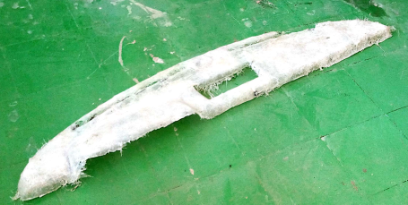

Figure 30: Cope molds for manufacturing of PEUGEOT model vehicle dashboard.

* By arranging the FBF and SF according to the desired weight ratio then co-mingle together randomly by fiber - fiber and woven by (0,90)0 for relative to the area dashboard.
* Mix the GP resin with hardener (catalyst) with appropriate ratio and stir to gather for 15 minutes.
* Clean and add mold releaser on the internal surface of cope and drag parts then accession (add) the mixed GP resin with hardener (catalyst) slightly on the mold then macadamize the plane woven on the mixed GP resin after that again accession (add) the mixed GP raisin at the top surface of the woven and then place cope on and up load a heavy materials for compression and wait for 24 hours for curing time.

Finally, release the up loaded heavy materials and the replaced PEUGEOT model vehicle dashboard is manufactured then to get good surface finish rubbing the surfaces by sand paper after that clean and paint by Spray the replaced dashboard by black color paint because of to reduce glare reflection to the driver and tilt the dashboard in some angle to change the direction of reflection out ward from the driver.

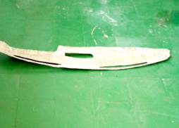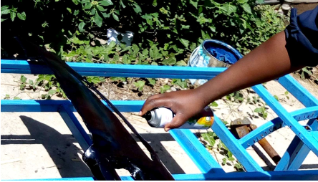

1. Dashboard before paint B. Dashboard during painting

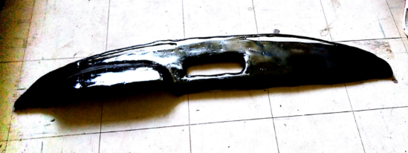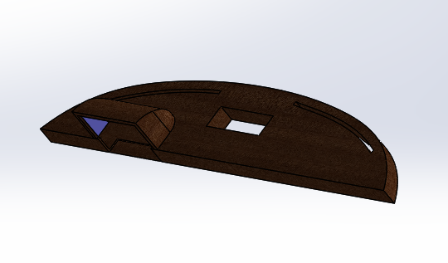

1. Dashboard after painting.

D. Dashboard modeled by Solid Work 2017.

Figure 31: Prototype of PEUGEOT model vehicle dashboard fabrication procedure.

Figure 4.9 Prototype of PEUGEOT model vehicle dashboard fabrication procedure.

**CONCLUSIONS**

The following inferences are made in light of the data from the tensile, compression, bending, density, and water absorption characteristics experiments included in this thesis:

* A hybrid composite made of FBF and SF in a 1:3 ratio has a strong tensile property. The hybrid composite used in this study, which was filled with more sisal fiber by the Force of three hands, exhibits the highest level of tensile strength. Yet, when sisal fiber is packed by hand, the composite's tensile strength test results are equal. The maximum tensile strength that could be measured was at a 1:3 ratio, which had an average value of 69 MPa. Yet, a composite with an equal ratio of FBF and SF and one to three ratios of FBF and SF has identical values of tensile strength, both of which recorded average values of 47 MPa. Typically, a composite filled with greater ratios of sisal fibers has better tensile strength.
* According to the results of the compressive strength test, the hybrid composite of FBF and SF 3:1 ratio has the highest value of all hybrid composites of FBF and SF ratios, with an average harness value of 12.30 MPa.
* Findings indicate that the hybrid composite of FBF and SF with a 1:3 ratio has the highest flexural (bending strength) value compared to other hybrid composites of FBF and SF ratios, with an average value of 380.9 MPa, which is twice as much as the hybrid composite of FBF and SF with a 3:1 ratio and three times as much as the hybrid composite of FBF and SF 1:1 ratio. This suggests that adding more sisal fiber to the hybrid FBF and SF composite will result in a material that cannot be easily flexed.
* In two different types of water, there is also a water absorption %. The first method uses regular tap water. A hybrid composite made of FBF and SF in a 3:1 ratio absorbs 4.21% more water in this sort of water than it does in other ratios. In terms of water absorption, hybrid composites of FBF and SF with ratios of 1:1 and 1:3 absorb almost the same amount of water, 2.68% and 2.64%, respectively.
* For the second type of water—rainwater—again, the hybrid composite of FBF and SF with a 3:1 ratio reported more water absorption up to 3.80%, and the hybrid composite of FBF and SF with a 1:1 ratio trailed the 3:1 ratio by 3.21%. Hybrid composites with a 1:3 ratio exhibit the lowest rainwater absorption.
* More water absorption is observed for both types of water on a hybrid composite of FBF and SF with a 3:1 ratio, followed by a 1:1 ratio with the least water absorption being observed on a 1:3 result. It is more ideal in this situation to use the list number for the water absorption percentage. As a result, a hybrid composite of FBF and SF with a 1:3 ratio is preferred. According to the test results, a hybrid composite of FBF and SF with a 3:1 ratio has a higher water absorption rate for both types of water, meaning that a composite material with a higher false banana fiber content will hold onto more liquid.
* Using a lot of faux banana fiber as a reinforcing material for composite materials is not advised for car body areas that are frequently exposed to rain.
* It is not advised to use a lot of faux banana fiber as a reinforcing material for composite materials in car body components that are frequently exposed to rain.
* According to the results of the density analysis, the hybrid composite of FBF and SF with a 3:1 ratio has a relatively higher density with a value of 1.530 g/cm3, while the hybrid composite of FBF and SF with a 1:1 ratio comes in second with a value of 1.27 g/cm3. The hybrid composite of FBF and SF with a 1:3 ratio has the lowest density.
* Because density and mass have a direct relationship, it is preferable in this instance to utilize the list number as the outcome of the density analysis because as density decreases, so does mass and vice versa. So, one of the goals of this research is to reduce the bulk of the vehicle dashboard. In this situation, a hybrid composite with a low density that combines FBF and SF in a 1:3 ratio is preferred.

Briefly, hybrid composite of FBF and SF with a 1:3 ratio provides the optimum mechanical and physical qualities from the perspective of car dashboard use. In comparison to other hybrid composites made of FBF and SF, the 1:3 ratio has higher tensile strength, moderate compression strength, higher flexural (bending) strength, the least amount of water absorption for both types of water, and the least amount of density, which translates to higher percentages of mass reduction. Generally speaking, all samples are suitable for use in car dashboard applications based on their mechanical and physical features. The mechanical and physical characteristics value achieved in this study has the best strength, water absorption, and density when compared to the findings of other researchers.

**REFERENCES**

Adem, E., Reddy, G. M., Koricho, E. G., Science, A., Science, A., Science, A., Vehicle, C., & Introduction, I. (2015). *Experimental Analysis of E-Glass / Epoxy & E-Glass / polyester Composites for Auto Body Panel*. *May*, 377–383.

Badrinath, R., & Senthilvelan, T. (2014). Comparative Investigation on Mechanical Properties of Banana and Sisal Reinforced Polymer based Composites. *Procedia Materials Science*, *5*, 2263–2272. https://doi.org/10.1016/j.mspro.2014.07.444

Boopalan, M., Niranjanaa, M., & Umapathy, M. J. (2013). Study on the mechanical properties and thermal properties of jute and banana fiber reinforced epoxy hybrid composites. *Composites Part B: Engineering*, *51*, 54–57. https://doi.org/10.1016/j.compositesb.2013.02.033

Gan, Y. X. (2009). Effect of interface structure on mechanical properties of advanced composite materials. *International Journal of Molecular Sciences*, *10*(12), 5115–5134. https://doi.org/10.3390/ijms10125115

Goud, G., & Rao, R. N. (2011). Effect of fibre content and alkali treatment on mechanical properties of Roystonea regia-reinforced epoxy partially biodegradable composites. *Bulletin of Materials Science*, *34*(7), 1575–1581. https://doi.org/10.1007/s12034-011-0361-4

Haldar, P., Modak, N., & Sutradhar, G. (2017). Comparative Evaluation of Mechanical Properties of Sisal-Epoxy Composites with and Without Addition of Aluminium Powder. *Materials Today: Proceedings*, *4*(2), 3397–3406. https://doi.org/10.1016/j.matpr.2017.02.228

Holbery, J., & Houston, D. (2006). Natural-fiber-reinforced polymer composites in automotive applications. *Jom*, *58*(11), 80–86. https://doi.org/10.1007/s11837-006-0234-2

Karthick, R., & Aruna, M. (2017). A Review on Mechanical Behaviour of Sisal Fibre Reinforced Composites. *International Journal of Scientific Development and Research (IJSDR)*, *3*(8), 1071–1073.

Mizera, Herák, D., Müller, M., & Hrabě, P. (2015). Mechanical behaviour of polymeric composite with fibres of false banana (Ensete ventricosum). *Agronomy Research*, *13*(3), 680–689.

Singh, S., & Kumar Gupta, P. (2022). Effect of fiber orientation on mechanical properties of jute/carbon/glass hybrid composite. *Materials Today: Proceedings*, *68*(December), 2574–2580. https://doi.org/10.1016/j.matpr.2022.09.419

Sinha, A. K., Narang, H. K., & Bhattacharya, S. (2017). Mechanical properties of natural fibre polymer composites. *Journal of Polymer Engineering*, *37*(9), 879–895. https://doi.org/10.1515/polyeng-2016-0362

Swolfs, Y., Gorbatikh, L., & Verpoest, I. (2014). Fibre hybridisation in polymer composites: A review. *Composites Part A: Applied Science and Manufacturing*, *67*, 181–200. https://doi.org/10.1016/j.compositesa.2014.08.027

Venkateshwaran, N., ElayaPerumal, A., Alavudeen, A., & Thiruchitrambalam, M. (2011). Mechanical and water absorption behaviour of banana/sisal reinforced hybrid composites. *Materials and Design*, *32*(7), 4017–4021. https://doi.org/10.1016/j.matdes.2011.03.002