Day-ahead optimal scheduling of micro gas turbine-based microgrid considering electricity and heating energy

Qian Zhang1, *, Mohsen Assadi1

1 Department of Energy and Petroleum Engineering, University of Stavanger, Stavanger, Norway

* q.zhang@uis.no

**Abstract**. Microgrids are considered as the crucial element in the integration of various distributed energy resources in buildings. They are capable of operating in both grid-connected and islanded mode and have shown immense potential in absorbing renewable energy. However, the widespread implementation of intermittent renewable energy sources, coupled with variable electricity pricing, has significantly increased the operation uncertainty of microgrids. This paper presents an analysis of the operation strategies of an integrated energy system that includes a micro gas turbine, a ground source heat pump, PV panels with the aim of meeting the heating and electricity demands of a commercial building. To facilitate this endeavor, a neural network model for micro gas turbines was developed with a focus on fast computation time and high accuracy in capturing off-design performance. Furthermore, mathematical models for ground source heat pump, PV panel were developed and validated using the Modelica language. Dymola optimization package was utilized to derive the day-ahead scheduling followed by one-hour intervals for the system, with the purpose of minimizing the electricity and heating costs associated with the system. The results demonstrate that the total costs could be reduced by approximately 51% during the analyzed period, indicating a promising avenue for cost savings in the system's operation.

1. Introduction

To address climate change, there is a growing global shift towards renewable energy sources as a sustainable and eco-friendly alternative to fossil fuels. However, the intermittent nature of renewable energy poses a significant obstacle to its consistent and reliable generation. One potential solution to tackle this challenge is the implementation of microgrid. A microgrid is a decentralized energy system that integrates a variety of distributed energy resources and energy storage techniques to meet users’ demands, such as heating, cooling, and electricity [1]. It offers the flexibility to operate in both grid-connected and islanded configurations.

The MGT has captured considerable attention worldwide due to its compact size, high power-to-weight ratio, and fuel flexibility. As a dispatchable generation source, MGT can integrate with renewable energy sources, ensuring a reliable energy supply when renewable energy is not available. Extensive investigations have been conducted on MGT-based microgrids. Das et al. [2] examined the techno-economic aspects of an off-grid community's microgrid that consisting of PV, wind turbine, battery, and MGT, aimed to meet the electricity and heating demand. The findings revealed a significant reduction in the initial investment by utilizing waste heat from MGT. Furthermore, the proposed system, capable of meeting both electricity and heating demand, achieved a 40% reduction in CO2 emissions compared to a system focused solely on electricity. Kumar et al. [3] proposed a microgrid that encompasses PV, battery, MGT, a desalination unit, and a gasifier. This hybrid energy system aims to meet the community's demand for electricity, clean water, and gas. Through techno-economic optimization, the researchers determined that the optimized system could generate 80,423 kWh of electricity and 34,778 MJ of heat annually. Moreover, the recovery of waste heat from MGT allowed the desalination unit to produce 9,516 liters of clean water per day.

Considering the intermittency of renewable energy and the continuously shifting user demands, implementing day-ahead scheduling in microgrids is paramount to efficiently manage energy supply and storage. Pallante et al. [4] conducted a study on day-ahead scheduling for a real office building equipped with a heating system, fan coil power supply network, and lighting network. MATLAB/Simulink was employed to create a physical model of the building. Taking into account weather conditions and hourly energy prices, the study determined optimal schedules for room temperature set points and flow water temperature set points. The results demonstrated significant potential cost savings, ranging from 10% to 28% across diverse scenarios. Reynolds et.al [5] developed a data-driven model for a small office building located in Cardiff, UK, using artificial neural networks. Genetic algorithm was employed to derive the day-ahead scheduling for the room temperature set-point. The study highlighted a significant 25% reduction in energy consumption achieved through optimized scheduling compared to a baseline heating strategy.

This paper examines a day-ahead scheduling strategy for a microgrid that integrates a MGT, PV system, and GSHP. Dynamic simulation models for the primary components have been developed and validated. The genetic algorithm has been employed for the dynamic scheduling. A comparison to a rule-based operation strategy emphasizes the advantages of the proposed approach.

1. System description

Within this study, we investigated a microgrid integrating a MGT, PV system, and GSHP to satisfy both the heating and electricity needs of an office building. The MGT, PV system, and grid power are utilized to address the electricity demand. Additionally, GSHP and the waste heat from the MGT was utilized to meet the heating demand. The schematic of the microgrid is shown in the Figure 1.

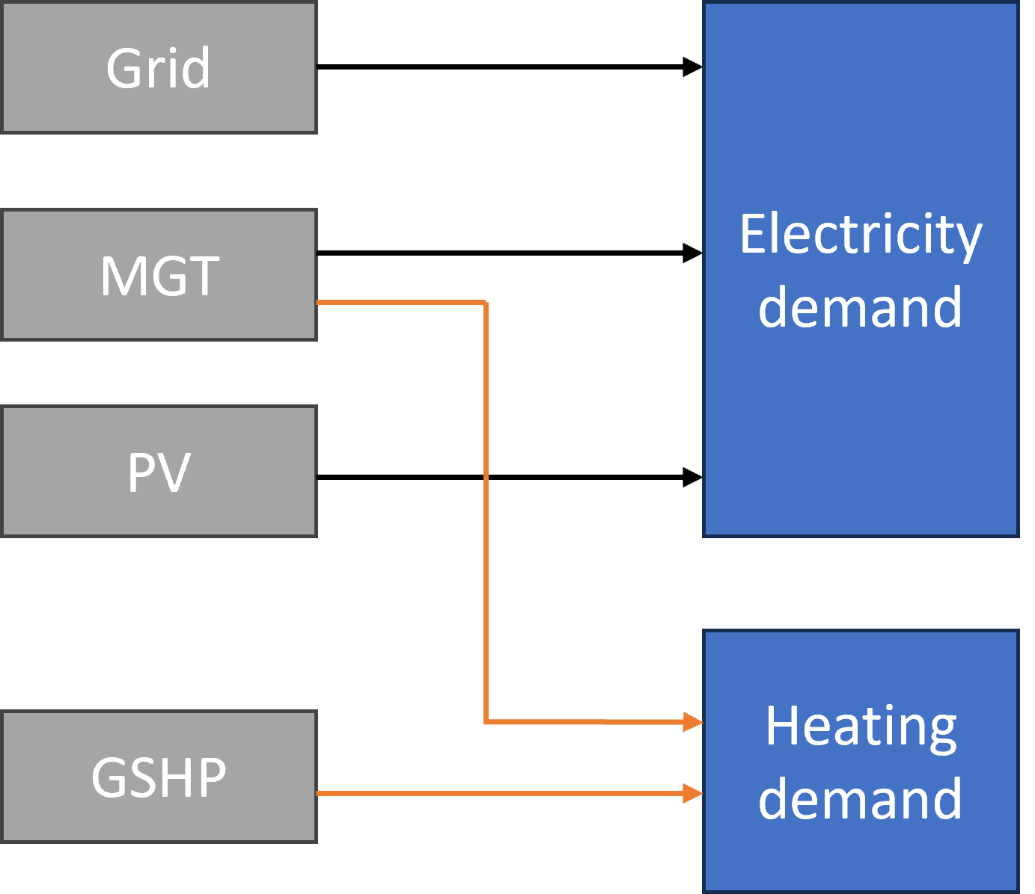

**Figure 1**. Schematic of the microgrid

The electricity and heating demand profiles for the office building is shown in the Figure 2.

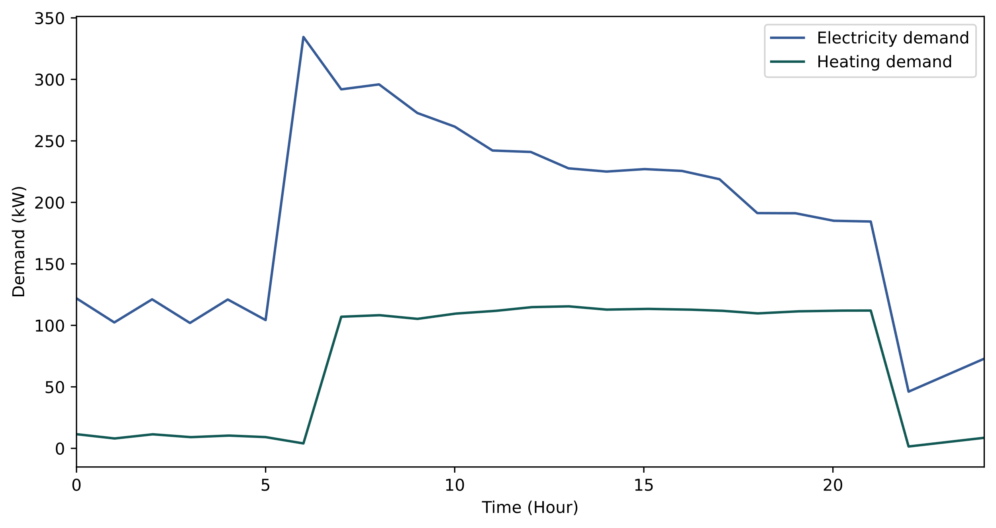

**Figure 2**. Electricity and heating demand for the office building (24 hours)

1. Modeling and validation

This study employs Modelica, an equation-based object-oriented language, to analyze the dynamic performance of the microgrid. The global Modelica community has made significant contributions by developing well-established open-source packages tailored for modeling and simulating microgrids and building energy systems. Some notable packages include IDEAS [6], Buildings [7], AixLib [8], and BuildingSystems [9].

## Micro gas turbine

Assessing the off-design performance of MGT involves the use of detailed thermodynamic models, which have been extensively developed to analyze the influence of changing operational and environmental conditions. However, these detailed models come with a high computational load, making them impractical for operational optimization. Hence, this study introduces a data-driven model for MGT based on the real-world operation data, which can provide fast computational speed and accurate prediction. Inspired by the brain, an ANN models complex data relationships through weight and bias adjustments. The FFNN, one of the most common types of ANN, processes data unidirectionally from input to output layers. In this study, FFNN is utilized for modeling a MGT incorporating 4 inputs (ambient temperature, ambient pressure, air humidity, and power demand) and 2 outputs (fuel consumption and waste gas temperature). Optimizing internal model parameters, often referred to as hyperparameters, is a crucial aspect of developing effective ANN model. This encompasses parameters like the learning rate, the architectural aspects such as the hidden layer count, neuron number within each layer, as well as the activation functions and optimizer. These hyperparameters are of paramount importance in shaping the model's capacity to acquire knowledge from training data effectively and generalize this knowledge for accurate predictive outcomes. In this study, Table 1 presents an overview of the hyperparameters and their respective ranges.

**Table 1:** Hyperparameter and range

|  |  |
| --- | --- |
| Hyperparameter | Range |
| Neurons in the hidden layers | [8 – 128] |
| Number of hidden layers | [1 – 4] |
| Activation function | [Relu, Elu] |
| Optimizer | [AdaGrad, RMSprop, SGD] |
| Learning rate | [1e-4, 1e-3, 0.01, 0.1] |

The search for optimal hyperparameters is conducted via Bayesian optimization, with the results presented in Table 2.

**Table 2**. Parameter of ANN model for MGT

|  |  |
| --- | --- |
| Parameter | Description |
| Number of hidden layers | 3 |
| Number of neurons of hidden layer 1 | 33 |
| Activation Function of hidden layer 1 | Elu |
| Number of neurons of hidden layer 2 | 95 |
| Activation Function of hidden layer 2 | Relu |
| Number of neurons of hidden layer 3 | 21 |
| Activation Function of hidden layer 3 | Relu |
| Cost function | Mean squared error |
| Optimizer | AdaGrad |

Operation data obtained from Turbec T100, encompassing a variety of ambient conditions and power outputs, were harnessed in developing a data-driven model. The dataset was divided into training (70%), validation (10%), and testing (20%). Figure 3 displays a comparison between the predictions of the data-driven model and testing data that not utilized in the training process. The resulting MAPEs for fuel consumption and waste gas temperature were found to be 0.25% and 0.19%, respectively. More detailed information about modeling and validation of MGT can be found in our previous publication [10].

**Figure 3.** Validation of micro gas turbine

## Ground source heat pump

In the ground source heat pump system, there are two essential components: the borehole heat exchanger and the brine to water heat pump. The borehole heat exchanger utilizes a series of vertical boreholes in the ground to aid in heat transfer. These boreholes are filled with a circulating fluid, commonly a mixture of water and antifreeze, that absorbs heat from the surrounding ground in winter and releases excess heat during summer. The brine to water heat pump is responsible for extracting or injecting heat by the circulating fluid, ensuring effective heating or cooling for the building or system.

The modeling of the borehole heat exchanger involves utilizing MoBTES [11], an open-source package developed using the Modelica language. The TRCM is employed to accurately model heat transfer within the borehole, emphasizing short-term accuracy. Additionally, the finite difference method is adopted to model heat exchange between the borehole and the ground. The accuracy of the borehole heat exchanger model is validated using real-world operation data from UPV, Spain [12]. The borehole heat exchanger consists of six single U-tube boreholes interconnected in a balanced parallel arrangement. Each borehole has a depth of 50 meters, and there is a 3-meter spacing between them. These six boreholes are organized in a rectangular grid layout of 2 by 3, covering a total area of 18 m2. For additional details, refer to Table 3.

**Table 3**. Parameter of borehole heat exchanger model

|  |  |
| --- | --- |
| Parameter | Description |
| Working fluid | Water |
| Tube outer diameter | 0.016 m |
| Tube inner diameter | 0.0127 m |
| Tube shank spacing | 0.07 m |
| Borehole depth | 50 m |
| Borehole diameter | 0.150 m |
| Borehole number | 6 |
| Borehole distance | 3 m |
| Pipe thermal capacity | 1.81106 J/(m3.K) |
| Pipe thermal conductivity | 0.4 W/(m.K) |
| Grout thermal capacity | 3.2e6 J/(m3.K) |
| Grout thermal conductivity | 2.09 W/(m.K) |
| Ground thermal capacity | 32e6 J/(m3.K) |
| Ground thermal conductivity | 2.09 W/(m.K) |

A 4-day measurement data period (from September 13th to 16th, 2005) during the GSHP system's cooling mode operation has been selected for validation. The Figure 4 illustrates two boundary conditions for validation: the borehole heat exchanger 's inlet temperature and flow rate. The continuous stop-start intervals of the GSHP operation can also be observed through the flow rate of the borehole heat exchanger. The accuracy of developed model is established by comparing the predicted borehole heat exchanger outlet temperature with the measured data. The comparison result is represented in the Figure 4, indicating a good agreement between the model's predictions and the actual measurements. During the off periods of the GSHP system, some deviations are observed, however, these have no impact on the calculation of the GSHP system's heating capacity and energy consumption. Excluding these off periods, a statistical analysis yields a low MAPE of 2.81% when comparing the measured and simulated outlet temperatures.

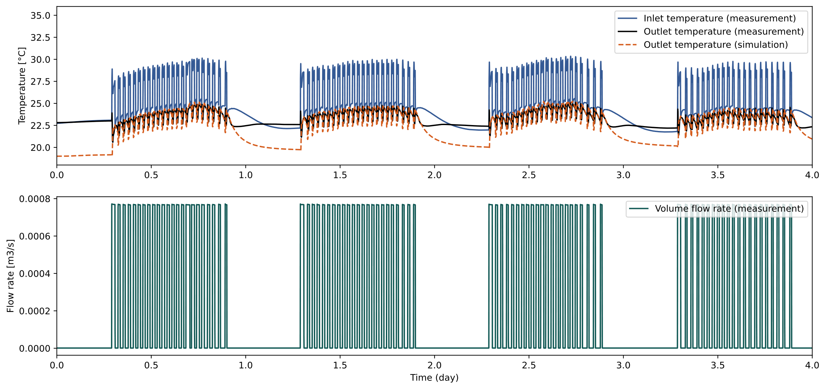

**Figure 4**. Validation of borehole heat exchanger model

For modeling the brine to water heat pump, a regression model based on performance data obtained from manufacturers is employed. This regression model considers key input parameters: source side brine inlet temperature, brine flow rate, load side water inlet temperature, and water flow rate. With this model, power consumption and heat capacity can be predicted. To demonstrate the model's accuracy, a validation study has been conducted using a 130 kW heat pump. In Figure 5 and Figure 6, we present a comparative analysis of the simulation results and the catalog data concerning the heating capacity and power consumption of heat pump. The visual representation clearly indicates a close match between the simulation results obtained from the regression model and the catalog data, with a relative error of less than 5% for both heating capacity and power consumption. Detailed information can be found in our previous publication [10].

**Figure 5.** Validation of heating capacity of heat pump

**Figure 6.** Validation of power consumption of heat pump

## PV panel

AixLib, an open-source package developed in the Modelica language, is employed to model PV systems. This model enables accurate prediction of the nonlinear electrical behavior of PV systems, which are affected by variations in cell temperature and solar irradiance. The Single-Diode method [13] is employed to model the physical behavior of the PV cell, while an empirical approach is utilized to model the cell temperature based on the specific mounting types of PV.

To validate the model's accuracy, operation data collected from a PV system installed on the rooftop of the NIST Campus building is employed. The PV array is comprised of 312 Sharp NU-U235F2 modules, with a rated power output of 73.3 kW. Each panel is oriented southwards and fixed at a 10-degree tilt angle. One week of operation data, ranging from June 6, 2016, to June 13, 2016, is utilized to illustrate the model's accuracy. By utilizing solar irradiance, wind speed, and ambient temperature, the model can predict power generation from the PV system. Figure 7 demonstrates a good agreement between the predicted and measured power generation. The resulting MAPE is 6%.

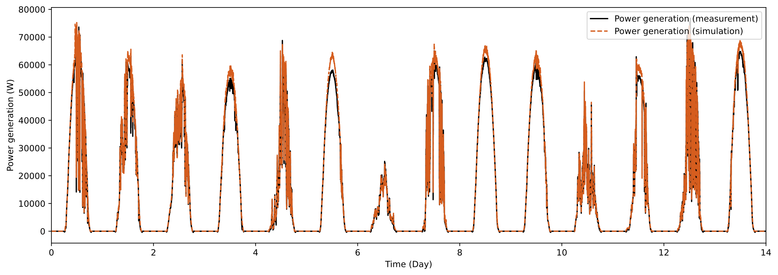

**Figure 7**. Validation of PV system model

1. Optimization

Day-ahead scheduling is a critical aspect of microgrid operations, enabling efficient energy resource management by planning generation and storage, considering variable load and energy prices. Day-ahead scheduling allows microgrids to harness the benefits of price fluctuations, redistributing user load to low-price periods. Furthermore, day-ahead scheduling promotes the integration of renewables like solar and wind, aligning with sustainability targets.

In this study, the optimization objective is to minimize operation costs, including both the cost of natural gas for the MGT and the cost of purchasing electricity. Calculating the operation cost involves utilizing the prices of electricity and natural gas. Figure 8 displays the hourly electricity prices. In this study, the cost of natural gas is set at 0.75 NOK/kWh.

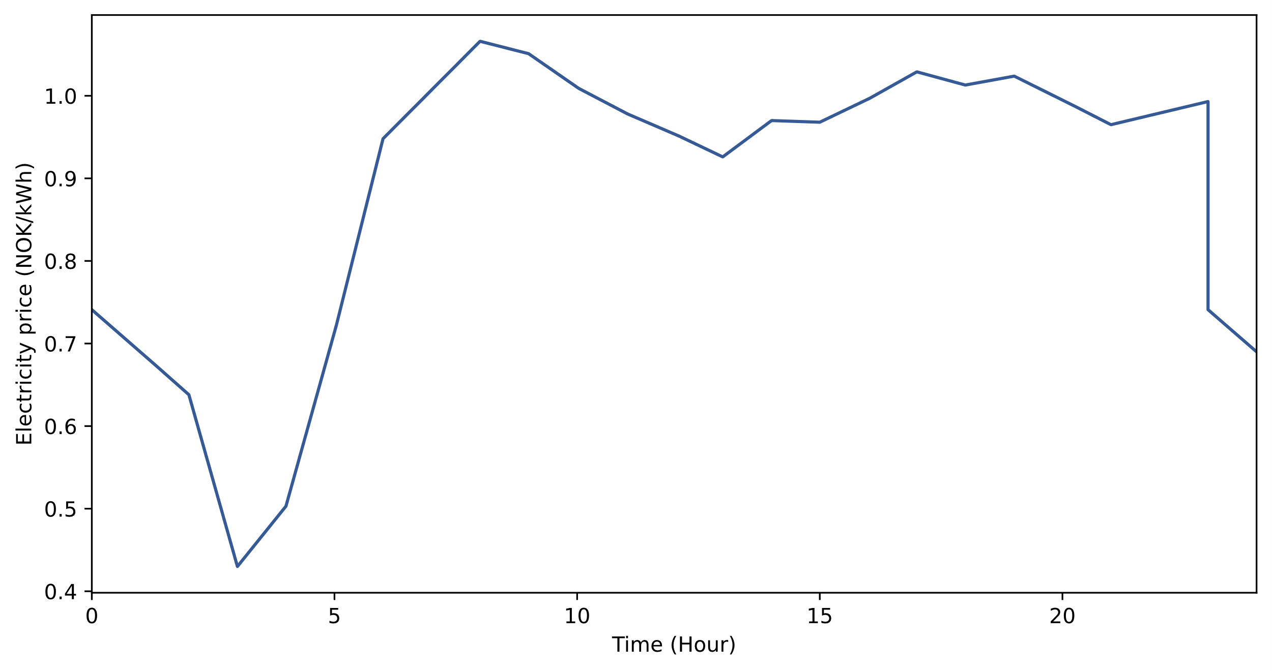

**Figure 8**. Electricity price for 24 hours

The operation cost can be represented as follows:

$$Cost=\int_{t=0}^{t=24}{E_{grid}∙P_{e}dt}+\int_{t=0}^{t=24}{{Fuel}_{MGT}∙P_{g}dt}$$

Where:

$Cost$– operation cost of the microgrid (NOK)

$E_{grid}$– Electricity purchased from grid (kWh)

$P_{e}$– Price of electricity (NOK/kWh)

${Fuel}_{MGT}$– Fuel consumption of MGT (kWh)

The optimization variable in this study is the capacity and on-off status of the MGT. The optimization is carried out at one-hour intervals, which results in a 24-hour capacity time profile. This time profile is essential for effectively managing the energy generation and consumption patterns over the course of a day, considering varying demands and available resources. To achieve this, we employ the Dymola optimization package, a powerful tool that supports multiple optimization algorithms. In this case, the genetic algorithm is chosen as the optimization algorithm due to its capability to navigate and search through an extensive and complex solution space effectively. Genetic algorithms mimic the process of natural selection and evolution, making them adept at finding nearly optimal solutions in a computationally efficient manner.

1. Results and discussions

Day-ahead scheduling for the microgrid involved computing the capacity for the MGT, PV system, and purchased grid electricity for every hour. A comparison of performance was made by evaluating a baseline case utilizing rule-based operation.

## Day-ahead scheduling of the microgrid

The genetic algorithm was utilized to determine the optimization variables—specifically, the MGT's capacity and its on-off status for each hour, illustrated in Figure 9. At the start of the day, MGT is switched on at 7 am, with a capacity of 108 kW. Shortly thereafter, MGT undergoes shutdown. In the afternoon, MGT operates for several hours. During the night, specifically at 8 pm, MGT is turned on.

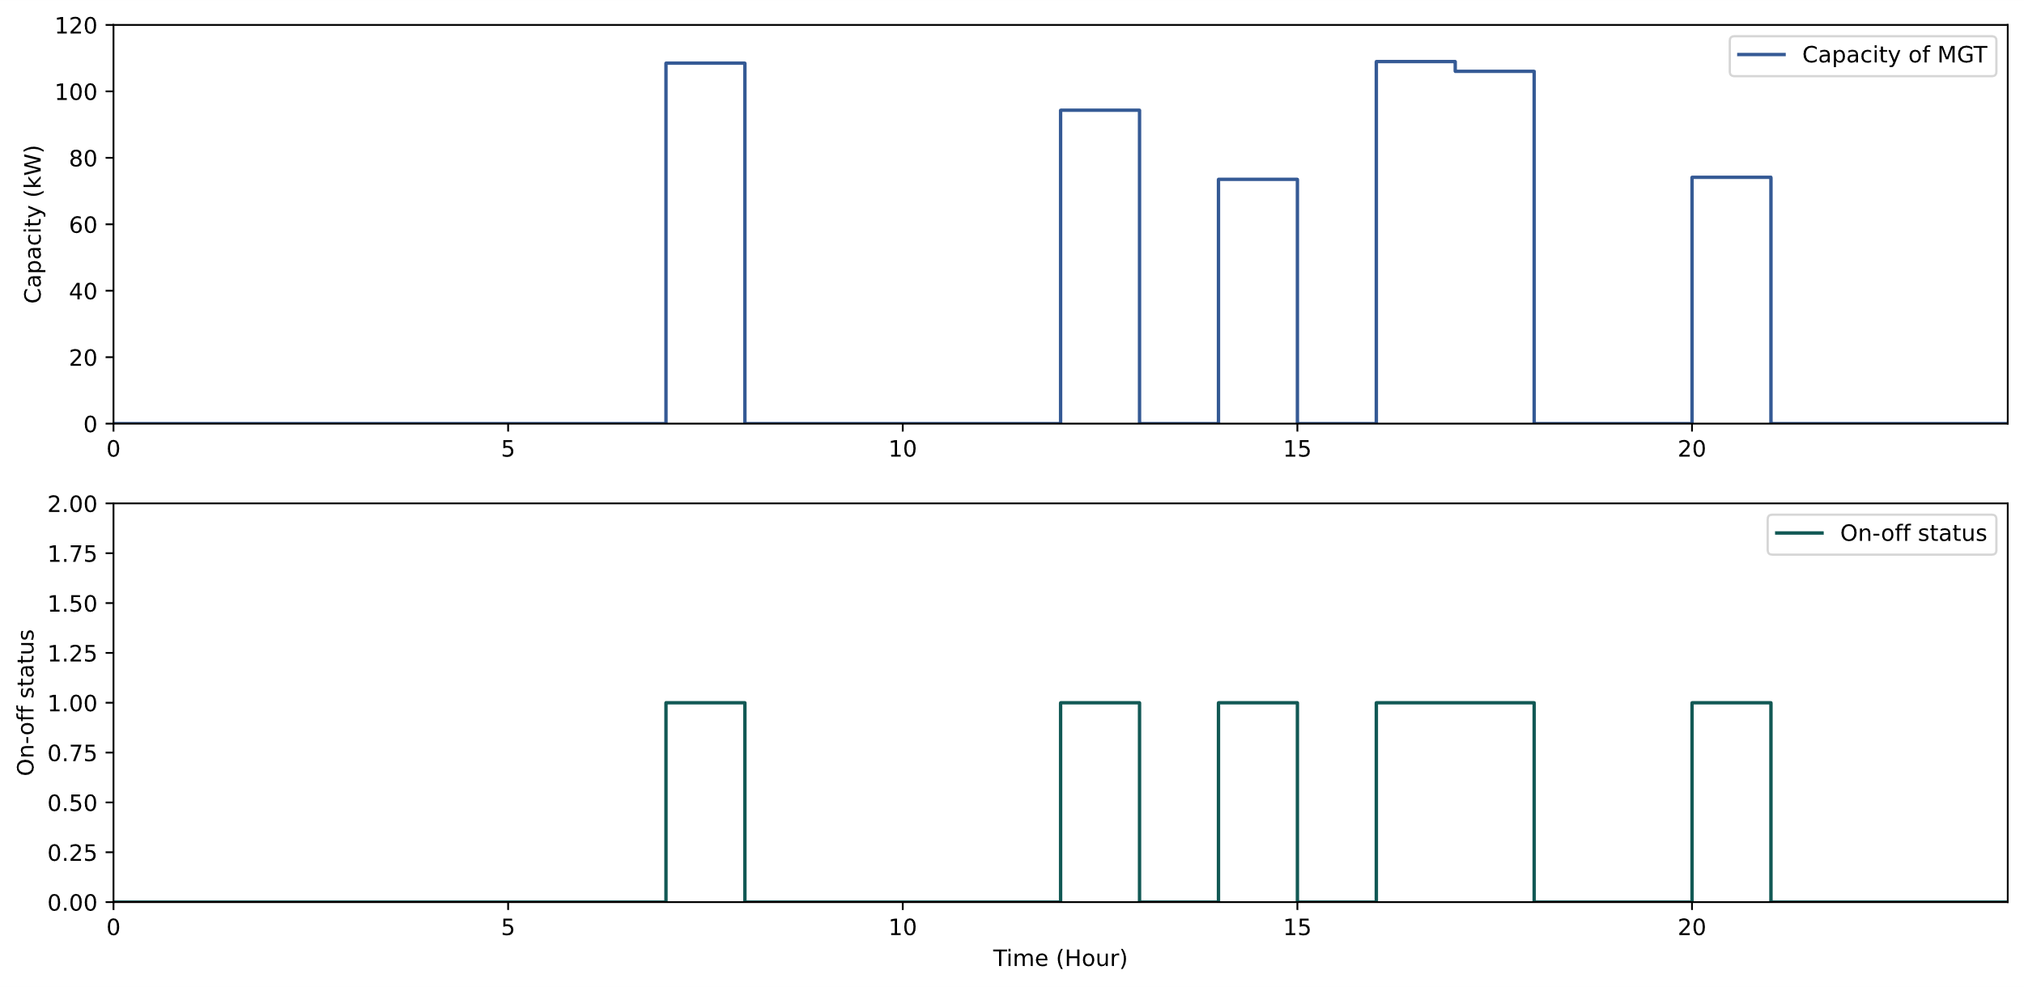

**Figure 9**. Optimization results for capacity and on-off status of MGT

The day-ahead scheduling results for the microgrid are depicted in Figure 10. The PV system contributes to electricity generation during the day's peak when solar irradiance is at its highest. MGT operations at 7 am, in the afternoon, and at 8 pm. Any additional demand is supplied through purchased electricity from the grid. Utilizing day-ahead scheduling, an operational cost of 3965 NOK is achieved.

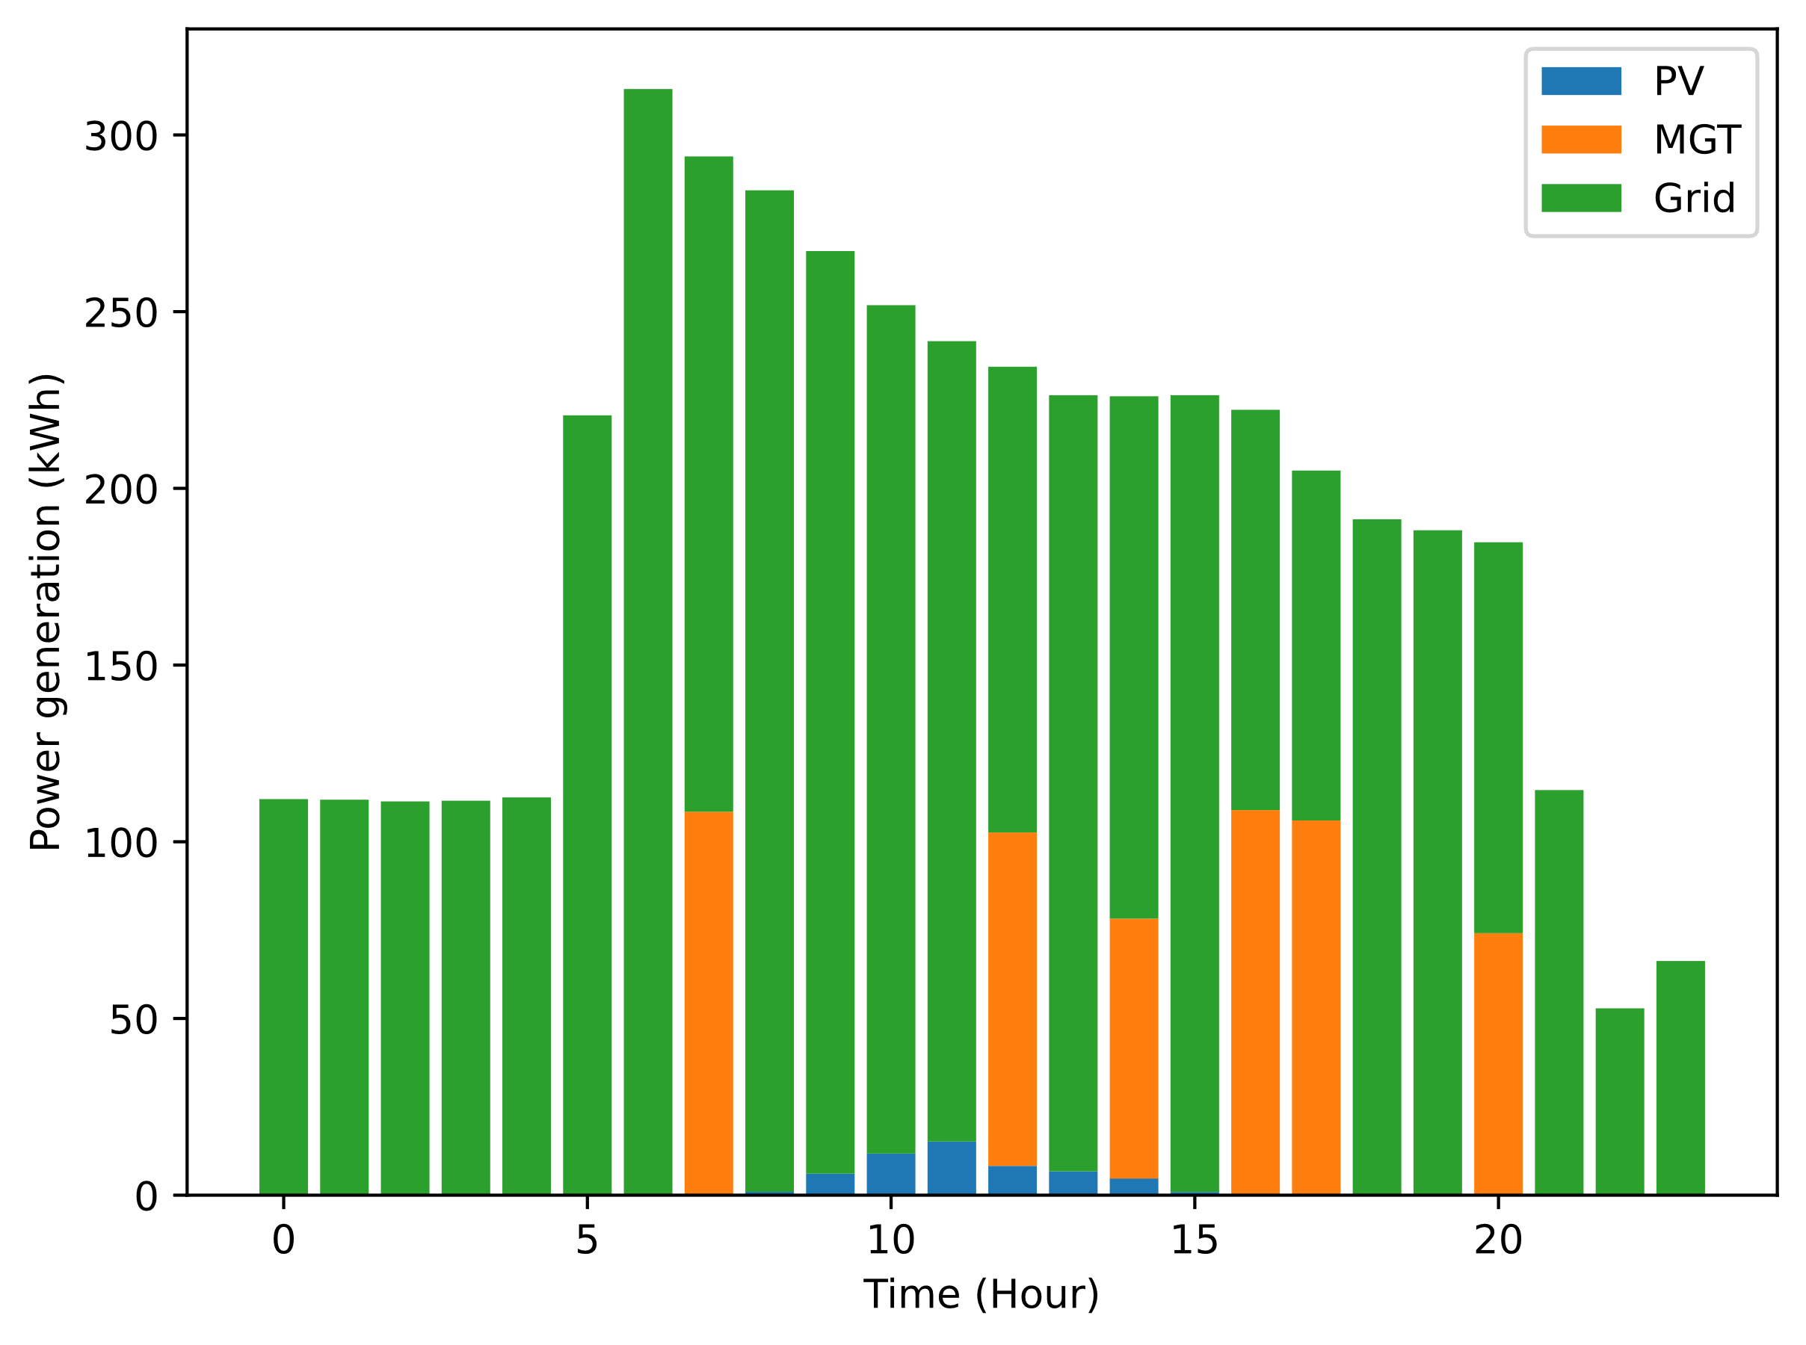

**Figure 10**. Day-ahead scheduling of the microgrid

## Comparison with rule-based operation

A comparison was made between the day-ahead scheduling strategy and a rule-based operation approach for the microgrid. Under this rule-based strategy, the priority is to optimize electricity generation through the PV system. When the PV capacity proves insufficient, the MGT steps in to generate electricity and satisfy demand. If the MGT operates at its peak capacity and demand persists, grid electricity is acquired to meet the energy needs. Similarly, the waste heat produced by the MGT is utilized to meet the heating needs. If the waste heat proves inadequate, the GSHP operates to meet the remaining heating demand.

The rule-based operation strategy is applied to the microgrid, considering same electricity and heating demands. This approach results in an operational cost of 8116 NOK. Notably, the implementation of a day-ahead scheduling strategy showcases a significant 51% reduction in operational costs.

1. Conclusions

A day-ahead scheduling for the microgrid, integrating a MGT, PV system, and GSHP, is conducted to meet the heating and electricity demands of the office building. Key conclusions from this study can be outlined as follows:

* The models for the primary components within the microgrid were developed and validated. The MAPE for the borehole heat exchanger model was recorded at 2.81%, while the MAPE for the PV system model stood at 6%.
* The microgrid's operation cost was minimized by optimizing the capacity and on-off status of the MGT using a genetic algorithm, considering the provided demand profile and energy price. The optimal scheduling obtained resulted in a daily operation cost of 3965 NOK.
* A comparison was conducted between a rule-based operation strategy and a day-ahead scheduling strategy for the microgrid. The comparison revealed that the day-ahead scheduling strategy achieved a 51% reduction in operation costs compared to the rule-based operation strategy.

Abbreviation

ANN – Artificial neural network

CO2 – Carbon dioxide

FFNN – Feed-forward neural network

GSHP – Ground source heat pump

MAPE – Mean absolute percentage error

MGT – Micro gas turbine

PV – Photovoltaic

TRCM – Thermal resistance and capacity model

References

1. Gu, W., Wu, Z., Bo, R., Wei, L., Zhou, G., Chen, W., & Wu, Z. (2014). Modeling, planning and optimal energy management of combined cooling, heating and power microgrid: A review. International Journal of Electrical Power & Energy Systems, 54, 26–37. <https://doi.org/10.1016/j.ijepes.2013.06.028>
2. Das BK, Tushar MSHK, Zaman F. Techno-economic feasibility and size optimisation of an off-grid hybrid system for supplying electricity and thermal loads. Energy 2021;215:119141. <https://doi.org/10.1016/j.energy.2020.119141>.
3. Kumar N, Karmakar S. Techno-economics of a trigeneration HRES; a step towards sustainable development. Renew Energy 2022;198:833–40. <https://doi.org/10.1016/j.renene.2022.08.107>.
4. Pallante, A., Adacher, L., Botticelli, M., Pizzuti, S., Comodi, G., & Monteriù, A. (2020). Decision support methodologies and day-ahead optimization for smart building energy management in a dynamic pricing scenario. Energy and Buildings, 216, 109963. <https://doi.org/10.1016/j.enbuild.2020.109963>
5. Reynolds, J., Rezgui, Y., Kwan, A. S. K., & Piriou, S. (2018). A zone-level, building energy optimisation combining an artificial neural network, a genetic algorithm, and model predictive control. Energy, 151, 729–739. <https://doi.org/10.1016/j.energy.2018.03.113>
6. Jorissen F, Reynders G, Baetens R, Picard D, Saelens D, Helsen L. Implementation and verification of the IDEAS building energy simulation library. J Build Perform Simul 2018;11:669–88. <https://doi.org/10.1080/19401493.2018.1428361>.
7. Wetter M, Zuo W, Nouidui TS, Pang X. Modelica Buildings library. J Build Perform Simul 2014;7:253–70. <https://doi.org/10.1080/19401493.2013.765506>.
8. Müller D, Lauster M, Constantin A, Fuchs M, Remmen P. AixLib - An Open-Source Modelica Library within the IEA-EBC Annex 60 Framework.
9. Nytsch-Geusen C, Huber J, Ljubijankic M, Rädler J. Modelica BuildingSystems − eine Modellbibliothek zur Simulation komplexer energietechnischer Gebäudesysteme. Bauphysik 2013;35:21–9. <https://doi.org/10.1002/bapi.201310045>.
10. Zhang, Q., Banihabib, R., Fadnes, F., Sazon, T., Ahmed, N., & Assadi, M. (2023). Techno-economic analysis of a biogas-fueled micro gas turbine cogeneration system with seasonal thermal energy storage. Energy Conversion and Management, 293, 117407. <https://doi.org/10.1016/j.enconman.2023.117407>
11. Formhals J, Hemmatabady H, Welsch B, Schulte D, Sass I. A Modelica Toolbox for the Simulation of Borehole Thermal Energy Storage Systems. Energies 2020;13:2327. <https://doi.org/10.3390/en13092327>.
12. Ruiz Calvo, F., & Montagud, C. (2014). Reference data sets for validating GS HP system models and analyzing performance parameters based on a five year operation period. Geothermics, 51, 417 428. <https://doi.org/10.1016/j.geothermics.2014.03.010>
13. Batzelis, E., & Papathanassiou, S. A. (2016). A method for the analytical extraction of the Single-Diode PV model parameters. IEEE Transactions on Sustainable Energy, 7(2), 504–512. <https://doi.org/10.1109/tste.2015.2503435>