MATT’S PATROL: A Generalized Framework to Track Marine Litter Path, Fare, and Toll
Jazzie R. Jao^{1,*}, Edgar A. Vallar ², Marlon Era ³, Marc Jeff Lañada ³, Jezzel R. Jao⁴
¹Department of Software Technology, College of Computer Studies, De La Salle University, 2401 Taft Ave, Malate, Manila, 1004 Metro Manila, Philippines
²Department of Physics, College of Science, De La Salle University, 2401 Taft Ave, Malate, Manila, 1004 Metro Manila, Philippines
³Department of Sociology and Behavioral Sciences, De La Salle University, 2401 Taft Ave, Malate, Manila, 1004 Metro Manila, Philippines
⁴Management and Organization Department, Ramon V. del Rosario College of Business, De La Salle University, 2401 Taft Ave, Malate, Manila, 1004 Metro Manila, Philippines

* jazzie.jao@dlsu.edu.ph
Abstract. Attention is being given to the transportation and mapping of marine litter pathways due to their negative impact on the environment, society, and economy. Many models have been created to examine ocean dynamics and particle tracking systems. This study aims to contribute to these existing models by introducing a framework called "MATT'S PATROLL: MArine liTTer'S PATh, faRe, and tOLL." This system is designed to manage and control marine litters that are between 5-2.5 cm in size. It consists of three main components: computational, socio-ecological, and economic models. The Lagrangian flow field model is used to model the spatio-temporal behavior of litters on the surface of the ocean. The "faRe" component describes the direct and indirect effects of meso-particles on sea and land populations while they wait to accumulate on shorelines and other settlements. The "tOLL" component examines the long-term ecological and socio-economic costs on ecosystems in land and water, as well as the damage and loss in gross revenue from the marine sector when marine litters penetrate habitats and livelihoods. This is achieved by identifying the interaction between resource systems and units, actors involved, and governance systems, and by using the Marine Litter Valuation Model.

- Introduction and Background

The term marine litter refers to any solid waste materials that have been discarded, disposed of, or abandoned in the marine and coastal environment and this can include a variety of materials such as plastics, wood, metals, glass, rubber, clothing, paper, and more [1]. The most prevalent form of marine litter is plastic waste, which is predicted to reach 12 billion metric tons in landfills or natural environments by 2050 and could potentially populate the oceans with at least 5 trillion particles if current management and human actions continue as they are [2].

Knowing the abundance, path, and spatio-temporal distribution of marine meso-litter particles is crucial for effective waste management and protecting ecosystems on both land and in water [2]. The ocean's movements vary greatly, ranging from tiny millimeters to thousands of kilometers. Tracers such as salt, nutrients, heat, and biological debris are carried by every fluid particle that shifts in the seawater. Determining how seawater moves among different regions of the ocean is essential for practical and theoretical purposes. Identifying pathways that seawater follows, as well as the transport and associated tracers, is crucial in understanding the role of the ocean in climate and marine ecology. Therefore, modeling marine litter tracking is not straightforward and requires several measures beforehand. Long-term monitoring in the marine environment is necessary since litter can remain in the sea for years, decades, and even centuries. # Most of these plastics penetrate the ocean floor or accumulate around coastal and open-sea areas, affecting both marine and land environments. Researchers have used Lagrangian-based particle tracking models extensively to address the issue of marine litter pollution. For example, in the Central Mediterranean Sea[1], a Lagrangian model that employed simulation-derived currents and wind speeds was used to transport sea floaters. The Adriatic Sea's [3] marine pollution condition was described by using a floating litter transport model based on Lagrangian principles, with the consideration of the evolution of particle concentration over time, using the Markov chain model.

Marine litter is becoming a growing issue in the Philippines and its consequences have already been felt. According to research, the Philippines is one of the top twenty countries with the highest amount of mismanaged plastic waste and is responsible for 0.28-0.75 million metric tons of plastic waste entering the ocean [4]. Various studies have shown that plastic debris has disrupted the feeding patterns of marine animals in different parts of the country. Despite the increasing concern about marine litter pollution in the Philippines, there are still only a few studies examining this problem. The management of plastic is a crucial issue due to its slow degradation rate and increasing use. One solution is to enhance collaborations between multidisciplinary fields of study. Understanding the socio-economic impact of plastics is essential in shaping future international negotiations on its design, production, reuse, and reprocessing. This study presents the following objectives below:

- Provide a unified framework of marine litter management with computational, sociological, and economical components to track and quantify marine litter life cycle from source to sink in the long-term basis.
- Simulate the path of several marine litter particles using the Lagrangian ocean dynamics framework in PARCELS [5] library in Python.
- Apply the simulation of path tracking to a specified marine area around a specified area in the island of the Philippines.

As marine litter caters several compartments, the study at hand is focused only on inspecting the path of meso-particles with a scale of 5-2.5 cm. This is because there is a different numerical description requirement for micro and nano particles populating the marine ecosystem. Moreover, since marine litter particles encompass a wide range of types, the study is only focused on evaluating plastic debris and a static hydrodynamic data from 2020 and interpolated over a wide range of days to accommodate the tracking mechanism of the model.

- Methodology
To begin running particles with Parcels, a FieldSet object must be defined. This object is a collection of hydrodynamic fields that describe ocean dynamics and motion, necessary for modelling litters under the assumption of known flow environments. The meridional and zonal ocean data from HYCOM, commonly obtained from Ocean General Circulation Models (OCGM), are used for these fields. It should be noted that this study does not provide a reliable count of meso-litter particles as they are artificially simulated. The approximate weight of plastic litters is determined using the latest statistics report from 2014 [6], which details the average weight of different plastic products.

The data captured around a specified bounding box around the Visayas Region, Philippines is used in this study. One-hundred pieces of meso-litters along the shore of Batangas City are simulated for the ParticleSet component of the simulation. The Runge-Kutte Advection kernel, which is a function of the particle set, fieldset, and time, is used for the simulation. Along with the simulation, a generalized framework for managing and controlling marine litter is introduced in Figure 1. This framework begins with modelling the problem using OGCMs and particle tracking systems and balancing the need for credible data using remote sensing, satellite data, and citizen science methods. These methods are vital in identifying environmental mitigations, such as managing key sources of litters from different land locations and implementing more/less strict legislative measures. Considering variables like litter characteristics, ocean dynamics variables like temperature, elevation, and pressure is also insightful for a more realistic modelling approach. However, incorporating these variables is challenging as ocean dynamics play a significant role and are not entirely predictable. From the modelling process, practical data resolution and insight are expected to be derived. Economics and social science are also involved in tackling the short- and long-term cost and benefit of marine litter management and the community effect it imposes.

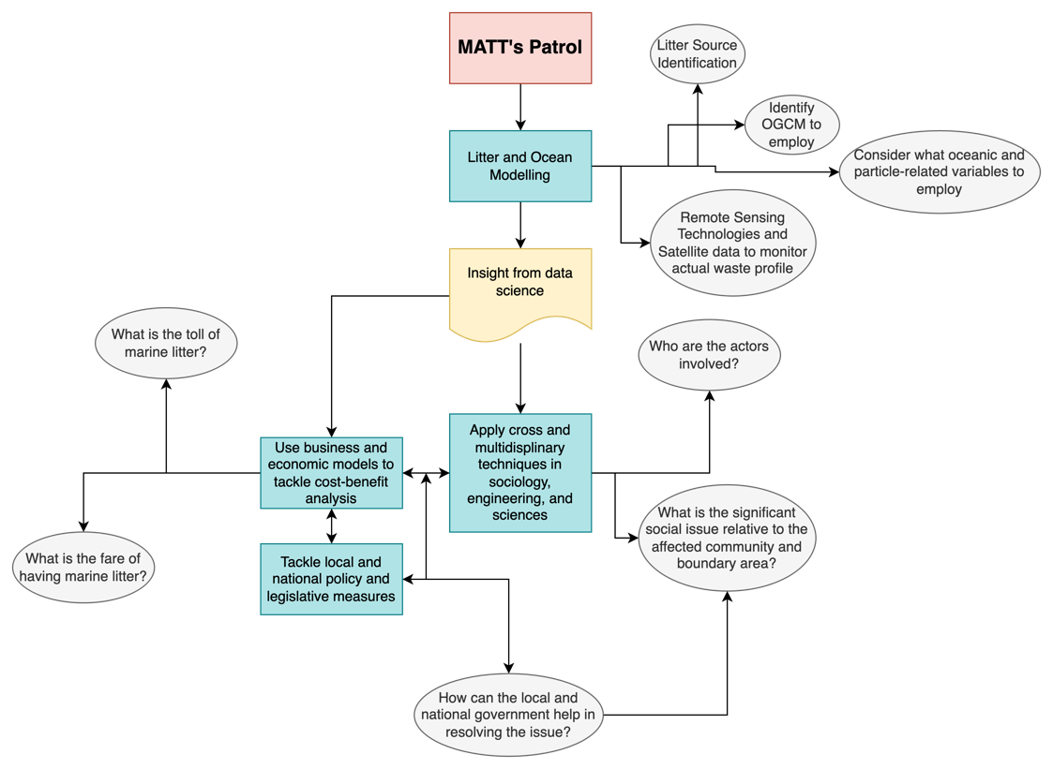
Figure 1. The MATT’s PATROL Framework

- Results and Discussions
This section aims to discuss the results of the simulation from the.

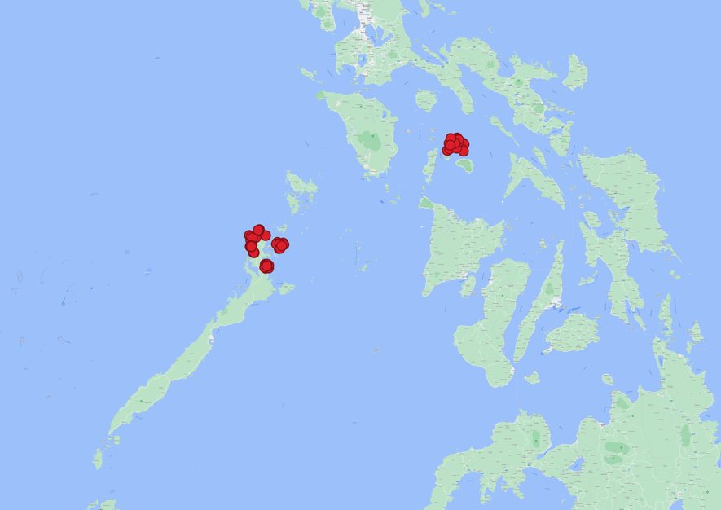
Figure 2. Distribution of Simulated Meso-litters (Plastics) around the locality of Visayas Region in the Philippines.

The simulated plastics are tracked forward in time near El Nido, Taytay, and Romblon islands, carrying the following assumptions: their weights, shape, and chemical composition are negligible in their dynamics on the field data itself. Figure 2 shows the configuration of such litters starting day 0. There is a significant displacement observed between days two and eight as the latter starts to turn in the westward direction, which is due to the high zonal velocity, $v$. For the next 20 and 30 days, the particles are seen to be going back and forth before dispersing away again, while forming clusters of litters. The results below show the Day 2, 8, 20, and 30 configurations of plastic litters situated and influenced by ocean hydrodynamic velocity fields.

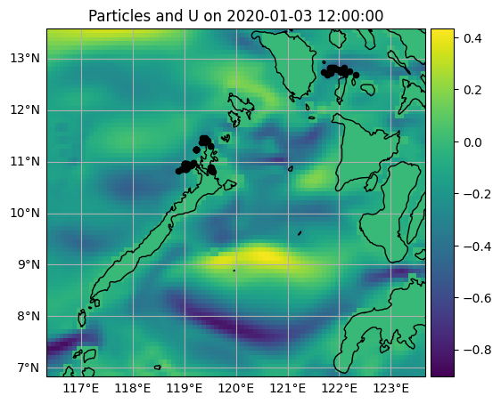 (a) | 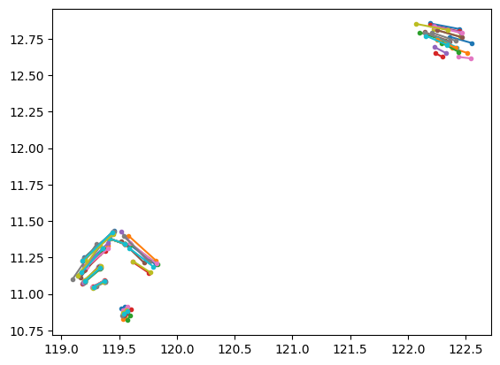  (b)
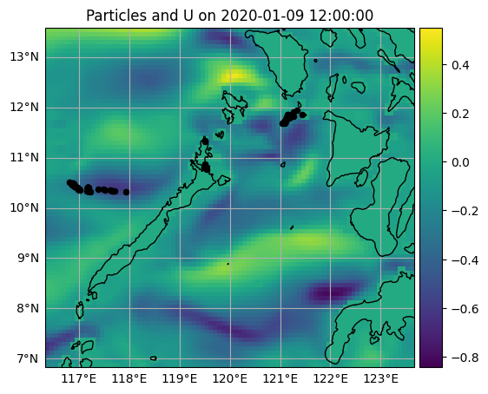 (c) | 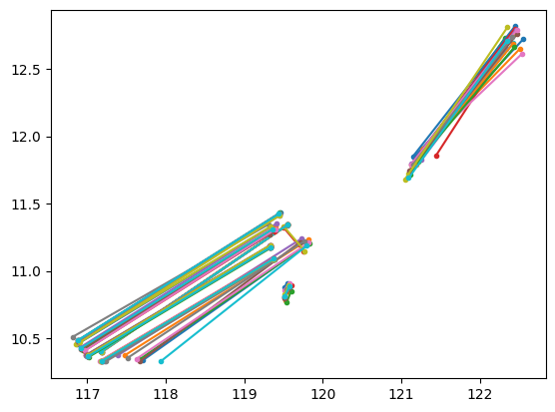 (d)
Figure 3. Plastic Litter Path (a) Day 2 Particle Configuration (b) Day 1 visualization with distance travelled, (c) Day 8 Particle Configuration, (d) Day 1 visualization with distance travelled

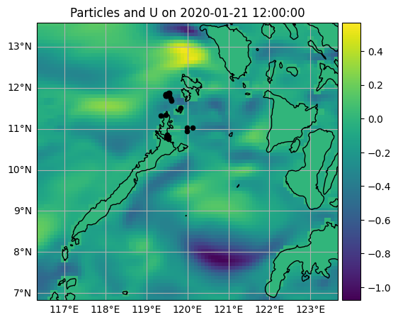 (a) | 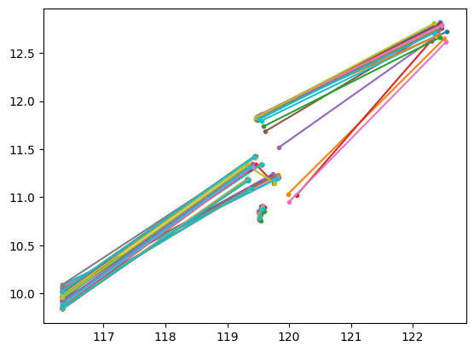 (b)
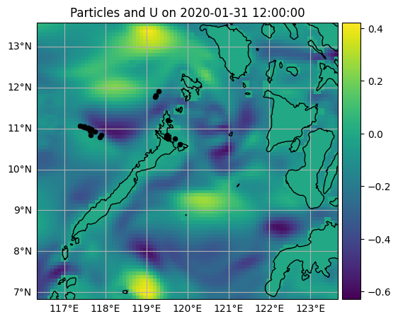 (c) | 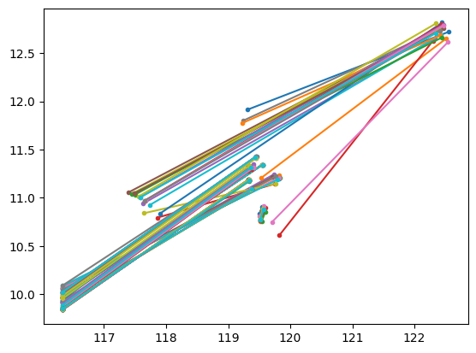 (d)
Figure 4. Plastic Litter Path (a) Day 20 Particle Configuration (b) Day 1 visualization with distance travelled, (c) Day 30 Particle Configuration, (d) Day 1 visualization with distance travelled

After 60 days, the plastic litters are almost all disposed from the boundary area of the map and 15 particles managed to remain around the source of waste, the coastal regions. Moreover, some managed to reach the locality around Batangas area, as seen in Figure 5 below. This may suggest a possible interruption in the livelihood of fisherfolks and tourism in this area and can be tackled using environmental sociological measures and marine litter valuation models.

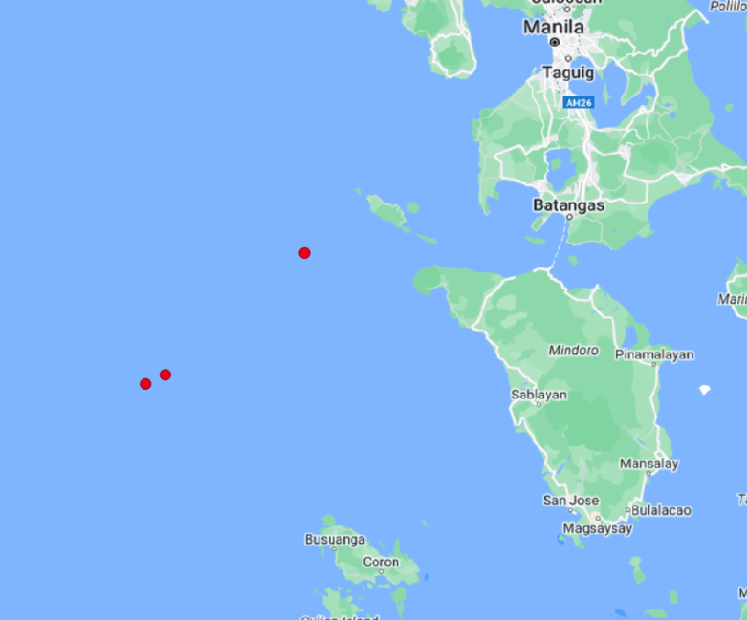
Figure 5. Day 60 of Plastic Litter On the Ocean.

Based on the results, the need to control plastic litter is necessary even for short-term time scale as they tend to oscillate and proceed to going back from their source, in this case the coastal regions. This can have negative consequences to community perception, marine ecosystem, and livelihood so socio-economic and legislative measures are a must to seal the loop of sustainable management and control of marine litter. For example, the area in Batangas from Figure 5 is a port where market and goods trade happen.

References

[1] Sivadas S K, Mishra P, Kaviarasan T, Sambandam M, Dhineka K, Murthy M V R, Nayak S, Sivyer D and Hoehn D 2022 Litter and plastic monitoring in the Indian marine environment: A review of current research, policies, waste management, and a roadmap for multidisciplinary action Mar. Pollut. Bull. 176 113424
[2] Liubartseva S, Coppini G, Lecci R and Creti S 2016 Regional approach to modeling the transport of floating plastic debris in the Adriatic Sea Mar. Pollut. Bull. 103 115–27
[3] Declerck A, Delpey M, Rubio A, Ferrer L, Basurko O C, Mader J and Louzao M 2019 Transport of floating marine litter in the coastal area of the south-eastern Bay of Biscay: A Lagrangian approach using modelling and observations J. Oper. Oceanogr. 12 S111–25
[4] EY S 2018 Modeling of Small Sea Floaters in the Central Mediterranean Sea: Seasonality of At--Sea Distributions Oceanogr. Fish. Open access J. 7
[5] Kehl C, Nooteboom P D, Kaandorp M L A and Sebille E van 2023 Efficiently simulating Lagrangian particles in large-scale ocean flows — Data structures and their impact on geophysical applications Comput. Geosci. 175 105322
[6] StatistaResearch 2014 Average weight of polyethylene terephthalate bottles as of 2014, by type (in grams)

