Optimization of the Routing Problem using the Physics-based Electromagnetism-Like Algorithm
Jazzie R. Jao^{1,*}, Edgar A. Vallar ²
¹Department of Software Technology, College of Computer Studies, De La Salle University, 2401 Taft Ave, Malate, Manila, 1004 Metro Manila, Philippines
²Department of Physics, College of Science, De La Salle University, 2401 Taft Ave, Malate, Manila, 1004 Metro Manila, Philippines
* jazzie.jao@dlsu.edu.ph
Abstract. Waste collection is considered as a first objective in planning a sustainable waste management, and provision of substantial collection coverage in urban and rural areas should be satisfied before investing in more sophisticated infrastructure. Therefore, good waste collection service is essential to upgrade further the next levels of a municipal solid waste system. One of the ways to enhance performance on waste collection is to plan effective routing of trucks. The study formulated a Waste Collection Arc Routing Problem to model the waste collection routing problem of Parang, Marikina City. The study revealed that the EM-like with local search and selection strategy mechanism displayed significant minimization abilities of distance values, and the capacity consideration of truck is important to attain better efficiency and cost savings of route.

- Introduction
Municipal Solid Waste Management (MSW) has been considered to be one of the challenging sectors to manage [1–3] due to its complex-natured behavior [4], quick growth of waste amount brought about by development, and high management costs [5] both in developing and developed countries. To be specific, developing countries are faced with greater magnitude of problems in inefficient poor segregation, collection, storage, treatment and disposal practices [6] which can be associated, in general, with lack of enabling system made up of legal, regulatory, and economic instruments, including sufficient financing, staff capacity, and stakeholder awareness [3,7]. According to [8], these waste management problems are evident in the Philippines as the country grows its population increases its household consumption with 0.03 percent from 2019 to 2020 [3] and expands its urbanization with 0.13 percent from 2010 to 2015.
The process of MSW management can be grouped into four stages of waste life cycle: generation, collection and transportation, transformation, treatment, and final disposal, where each one depends upon different factors in society and are vertically integrated, that is, changes to one part of the system impact the entire value chain. Waste collection and transportation in the Philippine-context is defined to be the act of removing waste from the source or common bin points in a given area, where waste segregation is expected to be done at source with corresponding labels before collection, and that waste trucks may be heterogenous to satisfy the storage of a given type of waste [8]. Local Government Units (LGUs) are given the responsibility to conduct this mandate. Some of them have implemented mandatory segregation at source by a "no segregation, no collection" city ordinance, like in Parang, Marikina City, in line with scheduling mechanisms. Collection can be done in the following ways: door-to-door collection, stationary collection through the Materials Recovery Facilty (MRFs), and mobile waste collection through waste collection vehicles. Approximately 2 billion people worldwide do not have access to waste collection and around 3 billion lacked controlled waste disposal facilities in developing countries. Waste collection is considered as first and basic objective in planning a sustainable waste management [3] and provision of substantial collection coverage in urban and rural areas should be satisfied before investing in more sophisticated infrastructure. Negligence of this aspect has been shown to overthrow waste treatment despite the availability of treatment facilities as waste is not properly collected and disposed. Therefore, good waste collection service is essential to upgrade further the next levels of a MSW system like waste segregation, recycling, and recovery. In fact, [9] calls for efficient and effective solid waste collection by system analysis and operations optimization. One of the ways to enhance performance on waste collection is to plan effective routing of trucks.
Significant amount of research on collection route optimization have been conducted through the years. Commonly, this problem has been formulated as a Vehicle Routing Problem in two different ways: Node Routing Problem and Arc Routing Problem. The first one is when waste is to be collected along street segments, and the latter is when waste is serviced from each house, considered as a node. A distinct instance of ARP called Capacitated Arc Routing Problem, first introduced by [10] is the one relevant to this study. It requires to find a set of routes for vehicles with limited capacities, situated at a source called the depot, such that the total demand serviced on each route does not exceed the vehicle capacity while the total cost is minimized. The study specifically uses the single-objective ARP formulation to minimize the distance taken by the waste truck. Other measures like fuel consumption and Greenhouse Gas (GHG) Emissions are also calculated using the Comprehensive Modal Emission Model (CMEM) where the load and speed of the collection vehicle are included in the predictor variables. VRP is one of the intractable problems in combinational optimization that can only be solved with exact methods of solution when the problem size is small. This motivates the use of EM-like algorithm, an approximation algorithm to solve the waste collection routing problem formulated as a single-objective optimization problem where a distance function is minimized. The waste collection is done in the road network located in the boundary of Parang, Marikina City.

- Background
Waste collection routing can be modeled as an NRP or ARP. The use of NRP is common in handling problems with large containers that are based in relatively small number of collection points, while ARP is useful when it comes to servicing a continuous collection demand like in door-to-door and household collection cases. The main objective of both problems is in general similar, that is, to minimize some cost function. However, few literatures have only dealt with general routing applications in waste collection since the use of different vehicles usually enables the separation of the two types of VRP mentioned. Many authors have based their research on increasing the efficiency of waste collection and transport processes because they were identified as being the most expensive functional elements in the entire waste management process. Some focused on shortening routing distance, minimization of collection expenses and number of collection vehicles. Lack of scientific and technological interventions in route selection can result in poor and costly planning of collection systems [11] so various studies have been employing: (1) mathematical optimization, grouped as either exact methods or approximate methods (2) GIS-based approaches using QGIS and ARCGIS, and (3) specialized softwares in solving the VRP [9]. Exact methods to solve the CARP were only proven to be accurate at few instances, like the study conducted by [12], having networks of 200 nodes and 300 edges. This has caused the area of approximate algorithms to emerge as method to generate relatively good quality solutions at a reduced computation time by sacrificing the guarantee of global optimality. The CARP was mostly solved alone by constructive heuristics in the early stages of its emergence. But lately, recent researchers have opted on using it as only a part of a more sophisticated algorithm for generating initial solutions like metaheuristics. Some of the works that employed constructive heuristics include the work of [10], [13], [14], and [15]. The Path-Scanning algorithm is the commonly used method. It was proposed by [10] and it constructs routes one by one. It starts from a node called the depot and a route is constructed through repeatedly adding a task, which is treated as an arc in this case. Note that different directions of servicing tasks lead to different solutions since the line is treated an arc. The criteria are the arc that will be added is nearest from the current end of route (i.e the head of last arc) among all the other arcs that do not go over beyond the truck capacity. In case there is more than one of this selection, tie-breaking rules are given to aid the decision.
For the metaheuristics approach in waste collection routing problem, there have been generous amount of works conducted through the years. [16] integrated an evolutionary algorithm Chaotic Particle Swarm Optimization in GIS in aiming to maximize the MSW collection at Danang City. The implementation of the algorithm obtained better total collected waste amount than the currently applied method in the said city. A multi-objective model of the waste bin collection in selected rural areas of Spain was analyzed by [17], where Tabu Search algorithm is used in minimizing cost of transport and improvements to the level of service, that is, the frequency of waste collection at each point over the planning period. The model is compared to another variant of Genetic Algorithm (GA) and showed better and denser set of solutions. [18] formulated a mathematical model in an oriented graph to minimize total costs with respect to time and capacity constraints of a waste collection arc routing problem. The total instance was 1,467 vertices and 3,529 edges. Input parameters (operation costs, vehicle capacities, waste collection demand). were obtained from demographic database and waste management expert estimates. The input data distances and times were defined prior to calculation, that is, distance of the end node of one arc to the initial node of the second arc. Using GA with local search the solution is found in the form of demand arc sequences for each route of each vehicle for all days throughout the entire planning horizon. One key component of the algorithm is the use of a fitness function which was used for checking feasible and unfeasible solutions. The study also suggested that stopping criterion of the algorithm for waste collection can depend on the preferred total number of iterations, running time of algorithm, or combinations of the previous ones. The proposed algorithm showed better performance than those already operating routes and a potential savings of around 7 % were computed.
Originally, EM-like is formulated for continuous optimization problems. An interesting approach to its usage on discrete optimization problems is done by several authors. [19] applied the algorithm to an optimization task of discrete nature called single machine scheduling problem. In order to do this, Random-Key (RK) procedure with genetic operations are done to encode the feasible solutions. By performing ANOVA and Duncan Test on the obtained function values, the study concluded that compared to the standard genetic algorithm, the attraction-repulsion mechanism has better performance. [20] also used the EM-like for the same problem except that Tabu Search instead of GA operators are used to improve the search process. It can be concluded that across different algorithms, the EM-TS garnered the lowest values. Similar positive results appeared on [21]. They considered a hybrid EM-like with scatter search and its application on Resource Constrained Project Scheduling Problem (RCPSP). Moreover, the force and charge calculation are modified such that Euclidean distance is removed and the charge values now takes [-1,1] values. The previous formulation only takes [0,1] values. The results of the comparison between other algorithm's performance in terms of solving benchmark instances on Project Scheduling Problem (PSP) show that the EM-like is superior and is effective in optimizing the given cost function, except for the results obtained from [22]. A study by [23] was conducted to hybridize the EM-like for solving the Capacitated VRP using a new local procedure iterated swap procedure. The solution yields a sequence of nodes, such that the initial is the depot, that satisfies given constraints of tour time/length limit and vehicle capacity. After testing the efficiency of the algorithm using 14 classical instances, the hybrid EM-like is found to be competitive compared PSO and ACO. In conclusion, the EM-like is shown to be flexible in terms of being applied to wide range of problems: discrete optimization, continuous optimization, simulated data using test functions, training neural networks, and vehicle routing problems. It can be hybridized with other well-established algorithms to improve its efficiency or be used on its own and perform parameter modifications.
- Methods
The study will be conducted inside the administrative boundary of Barangay Parang, Marikina City located in National Capital Region, Philippines. The road segments that need to be visited are generated randomly. Each collection point is assumed to be a residential household that is assumed to consist of three adult people of random gender. The type of waste that these people produce is assumed to be of residual waste category. There are a total of 206 intersections and 203 road segments in the network data generated. Figure 1 shows the area boundary of the study using satellite and non-satellite map. The red node represents the intersection point where the path of the outgoing street from the depot is heading towards, while the rest of the black nodes corresponds to the intersection points of the network boundary.

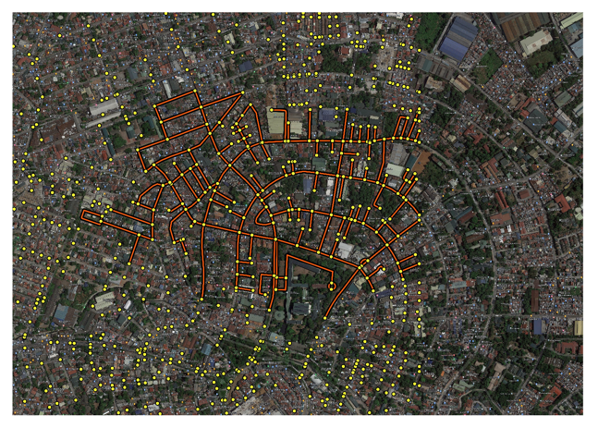 | 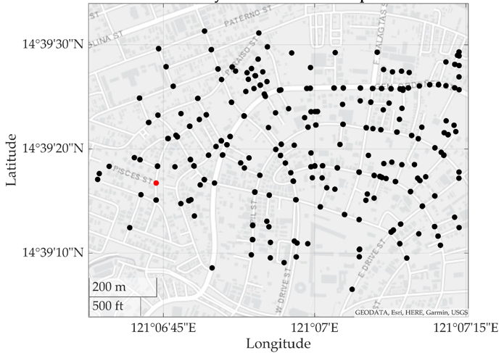
Figure 1. The Streets and Area Boundary of the Study.

The Network and Problem Design
The discussion of the network profile deserves careful design and discussion in this study as it will be the exploration medium of the EM-like algorithm. The shapefile data of the boundary area is extracted using OSM tools to render the edgelist information and its features. These features are composed of the street length, street speed limit, and the vector of coordinate points that span the street. Cleaning and the data include filling up the blank entries and adding additional column of information. The obtained CSV file is then loaded on MATLAB. The CSV file containing the edgelist will be modified, such that the two-way streets will be separated when plotted as a graph. Street network can be translated into a directed multigraph representation by first taking its undirected graph representation, as seen in Figure 2, and then duplicating the arc once when there exist in-out traffic directions. If there is only either in or out, then the arc is left as it is. The dotted ray in the same figure means that the road segment between nodes H, and I and I and J takes only one traffic direction. A strongly connected graph is created that will serve as the basis of generating random streets to service, such that every street and intersection is reachable given an arbitrary starting position.

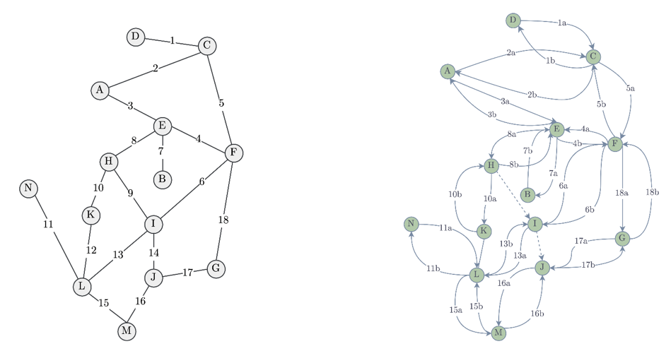
Figure 2. Undirected vs. Directed Multigraph Representation.

The problem statement of the study is later defined to be a single optimization involving the minimization of the total distance taken by the truck while covering all the elements of the set of required streets. Two problem definitions are given below:

Definition 1. (The Baseline Scenario of ARP).
The baseline scenario of the ARP is the problem of finding a permutation of the set of required streets such that the following function is minimized:

$$f\left(π\right)=\sum_{i=1}^{O}{l_{i}}$$

where $π$ is an arbitrary permutation of the required streets, $l_{i}$ is the road length of the $i^{th}$ street from the constructed path, and O is the number of elements in this path constructed at every iteration such that it contains the sequence of edges or nodes to take to execute a feasible collection service.

The calculation of fuel consumption of a waste truck traversing a street segment with length $d$, embodying a speed $v$, and carrying a load $f$, is done using CMEM [24] is used as seen in equation.

$$Fuel\left(v\right)=λ\left(FNV+wγαv+γαfv+βγv^{3}\right)d/v$$ | (1)

where:
$$γ=ξ/κψ$$
$$α=gsinθ+gC^{r}cosθ$$
$$β=0.5C^{d}ρA$$

The parameters of this equation is adapted from the study of [25] and are given in Table 1.

Table 1. Parameters of the CMEM.
Symbol | Name | Unit | Value
$$F$$ | Engine friction factor | kg/rev/liter | 0.20
$$N$$ | Engine speed | rev/s | 34
$$V$$ | Engine displacement | liters | 7
$$A$$ | Frontal surface area | $$m^{2}$$ | 7.6
$$C^{d}$$ | Aerodynamic drag coefficients | - | 0.55
$$C^{r}$$ | Rolling resistance coefficients | - | 0.009
$$r$$ | Vehicle acceleration | $$m/s^{2}$$ | 0
$$w$$ | Curb weight | kg | 5,500
$$κ$$ | Heaving value for diesel fuel | kJ/g | 45
$$ε$$ | Vehicle drive train efficiency | - | 0.4
$$ϖ$$ | Efficiency parameter for diesel engines | - | 0.9
$$ξ$$ | Fuel to air mass ratio | - | 1
$$ψ$$ | Conversion factor from grams to liters | - | 737
$$ρ$$ | Air density | $$kg/m^{3}$$ | 1.2041
$$g$$ | Gravity | $$m/s^{2}$$ | 9.81

In general, the waste collection route table will always contain street segments that are traversed more than once. This is because real-world data is inherently sparse. Moreover, due to its topology, some streets may only be accessed through a single road or detour is required due to traffic direction considerations, like if it’s one-way or two-way. To prevent double counting the objective function value and collection service (load and time), equation (2) ensures that if a street appeared more than once in the path, the first traversal will have a non-zero value, otherwise zero for succeeding traversals. To calculate for the GHG emission, a carbon emission factor of 2.6391 kgs of CO2 per liter burnt is used.

$$x_{ij}=\left\{\begin{aligned}1, &if a_{ij} first appearance \\ 0, &if a_{ij} n^{th} appearance where n=2,3,…\end{aligned}\right.$$ | (2)

EM-like Algorithm
The EM-like being a population-based algorithm requires a set of initial solutions. A possible solution of the TSP as mentioned in the previous section can be regarded as a permutation of the set of cities or locations that requires service. The aim is to permute this set and determine what sequence of streets gives the minimum cost expense of waste collection. This permutation is embedded on the search agent of the EM-like, the charged particles. Since the population affects the effectiveness and efficiency of the algorithm [26], the candidate solutions, are heuristically initialized through declaring a canonical ordering and perturbing it to produce modified versions, where the canonical ordering follows the metric city block distance. The intuition behind is to be able to generate “good enough” permutation of streets that is ordered according to its proximity from the depot. Random generation of permutation is possible, and it is also considered as an alternative parameter of the population initialization process. After initializing population of solutions, the next step is to calculate their charges according to equation (3). This equation, unlike electrical charges, always assume that the particles are positive.

$$q_{i}=\exp\left[-n\frac{f\left(x_{i}\right)-f\left(x_{best}\right)}{\sum_{j=1}^{m}{\left[f\left(x_{j}\right)-f\left(x_{best}\right)\right]}}\right],∀i=1,…,m$$ | (3)

Where $n$ is the number of dimensions, in this context, the number of streets of the path, $f\left(x_{i}\right),f\left(x_{j}\right)$ the objective function value of particles $i$ and $j$, and $m$ is the number of initialized population of solutions. Next is to implement how new solutions are produced from the previous one. The EM-like is a population-based algorithm so it uses the presence and interactions of a collection of solutions to explore the search space. The mechanism of the attraction-repulsion of charged particles in physics is utilized to recalibrate the positions of particles according to their fitness value. This fitness value is embedded to the magnitude of their charge calculated in the previous section. The implementation is done by using equation (4). Notice that this is expressed in vector form. The traditional formulation of EM-like by [27] assumes that the particle can be placed in an $n-$dimensional space. As such, it is considered that each particle's position is composed of $n-$components that can be written as in equation (5).

$$F_{ij}=\left\{\begin{aligned}(x_{j}-x_{i})\frac{q_{i}q_{j}}{{\left|x_{j}-x_{i}\right|}^{2}}, &if f\left(x_{i}\right)> f\left(x_{j}\right) \\ (x_{i}-x_{j})\frac{q_{i}q_{j}}{{\left|x_{j}-x_{i}\right|}^{2}}, & if f\left(x_{i}\right)≤ f\left(x_{j}\right)\end{aligned}\right.$$ | (4)

$$x_{i}=x_{i}^{1}{\hat{x}}^{1}+x_{i}^{2}{\hat{x}}^{2}+…+x_{i}^{n}{\hat{x}}^{n}$$ | (5)

The two conditional statements on equation (4) signifies the need to specify which particle, between $x_{j}, x_{i}$ has "better" objective function value. Note that we are dealing with a minimization problem so the definition of a better solution in this case is the one with lower cost. The first statement means that if particle $j$ has better (lower) value of $f$, it attracts the particle $i$ and the direction of the displacement is towards the particle $j$, otherwise particle $i$ gets attracted to it. Finally, the term in the denominator, is the Euclidean distance between particle $i$ and $j$ where the given result is a scalar quantity. After getting the resultant forces on each particle $i$ due to the presence of other particles, the amount of movement resulting from the action of these forces is computed on every $n$ component of each $f\left(x_{i}\right)$.

- Results and Discussions
The EM-like algorithm is tested on a set of modified variables called the parameter scenarios detailed in Table 2. Each of this setting is compared in terms of solution results.

Table 2. Overview of Parameter Settings.
Scenario | Pairwise Distance | Local Search Improvement | Particle Movement Boundary
$$αCBL-o$$ | City-block | Yes | [0,1]
$$αCBL-h$$ |  |  | rand
$$αCBNL-o$$ |  | No | [0,1]
$$αCBNL-h$$ |  |  | rand
$$αRBL-o$$ | Random | Yes | [0,1]
$$αRBL-h$$ |  |  | rand
$$αRDNL-o$$ |  | No | [0,1]
$$αRDNL-h$$ |  |  | rand

Table 3. Results of Different Parameter Settings on ARP using EM-like Algorithm .
No | Scenario | Distance [m] |  | Cost [PHP] |  | GHG [g of CO2e]
 |  | Best | Worst | Best | Worst | Best | Worst
1 | $$αCBL-o$$ | 12931 | 21129 | 335.2690 | 408.3794 | 16.0080 | 19.1097
2 | $$αCBL-h$$ | 12934 | 20447 | 333.6144 | 404.0426 | 16.0758 | 19.5955
3 | $$αCBNL-o$$ | 14979 | 20222 | 341.1939 | 392.2709 | 16.3717 | 19.9693
4 | $$αCBNL-h$$ | 14984 | 22696 | 346.5605 | 416.1693 | 16.6292 | 18.8226
5 | $$αRBL-o$$ | 22467 | 33476 | 411.4950 | 474.4036 | 19.4955 | 22.9103
6 | $$αRBL-h$$ | 20522 | 35951 | 406.2944 | 477.4615 | 19.7450 | 22.7636
7 | $$αRDNL-o$$ | 25249 | 35249 | 415.2007 | 476.7235 | 20.1936 | 23.2294
8 | $$αRDNL-h$$ | 24901 | 36572 | 420.8440 | 484.1110 | 19.9228 | 22.8749

The $αCBL-o$ obtained better distance value of 12931 compared to
$αCBL-h$ scenario's 12934. Both implemented a local search procedure. However, the corresponding cost of $αCBL-h$ is better than that of $αCBL-o$. This shows that minimizing the distance does not lead to minimization of the corresponding cost due to fuel consumption. This is because lack of capacity considerations forces the truck to be overfilled; thus, increased need to consume fuel. A total of 2000 iterations is made across all parameter scenarios as show in Figure 3-Figure 6.
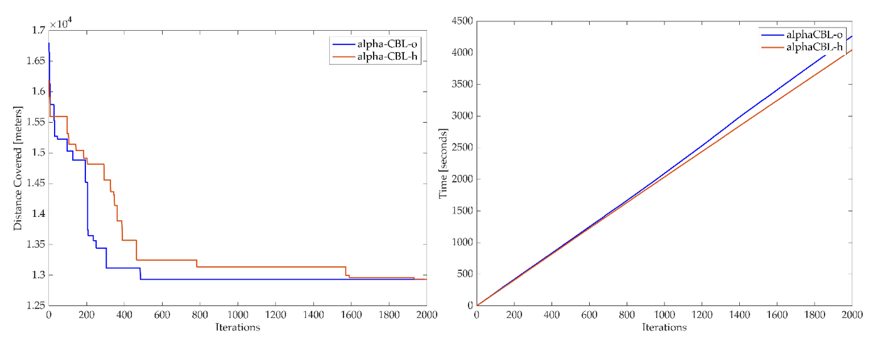
Figure 3. Distance and Time Minimization Curve of $αCBL-o$ vs. $αCBL-h$ for 2000 Iterations.

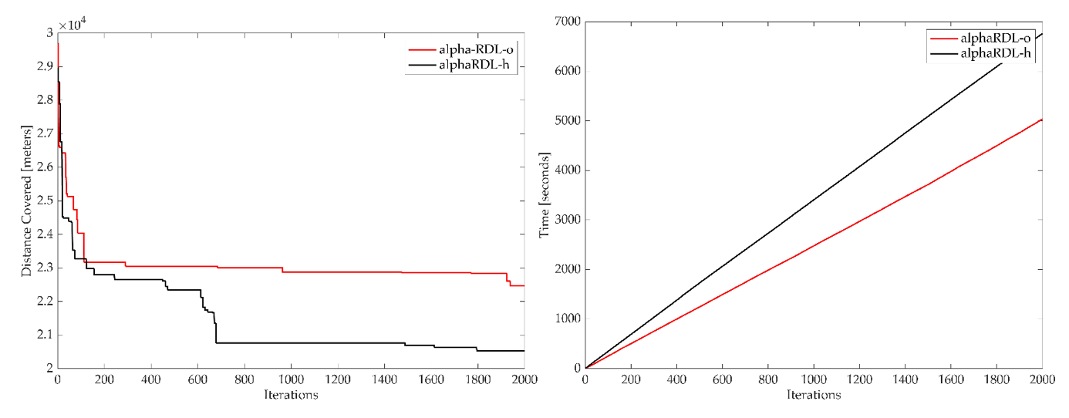
Figure 4. Distance and Time Minimization Curve of $αRDL-o$ vs. $αRDL-h$ for 2000 Iterations.

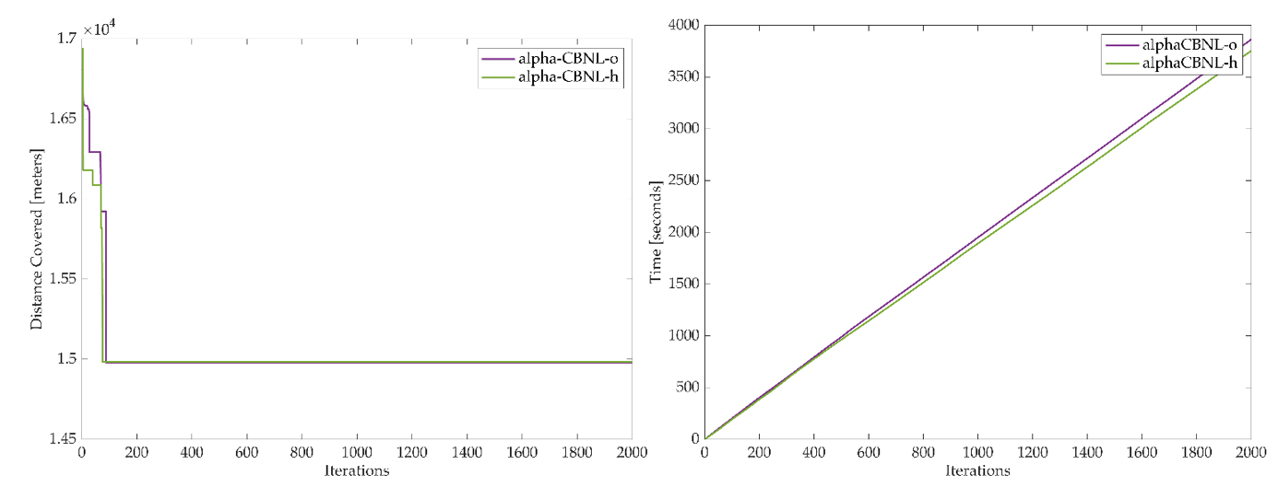
Figure 5. Distance and Time Minimization Curve of $αCBNL-o$ vs. $CBNL-h$ for 2000 Iterations.

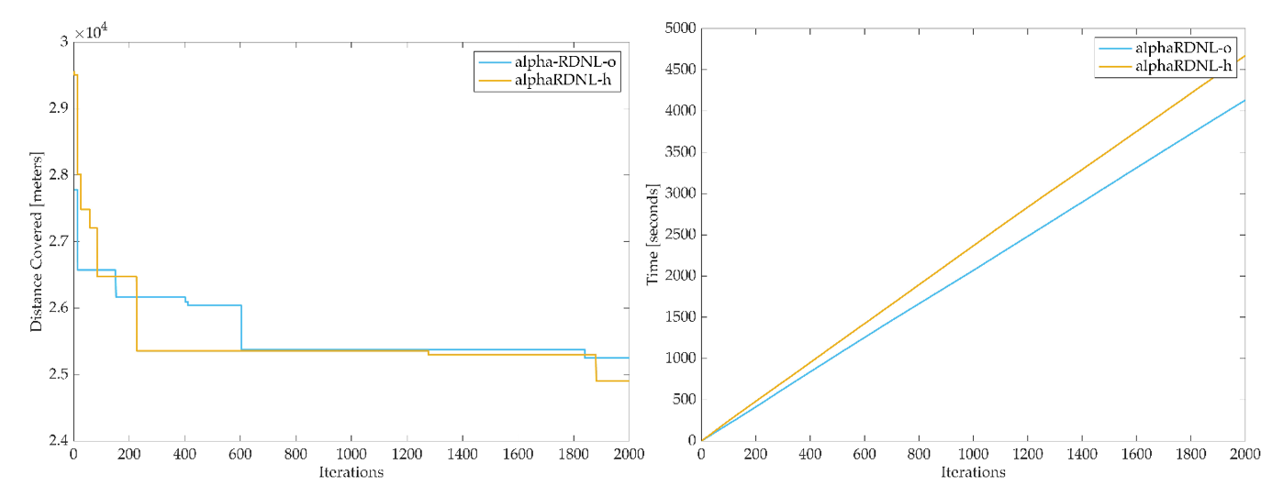
Figure 6. Distance and Time Minimization Curve of $αRDNL-o$ vs. $RDNL-h$ for 2000 Iterations.

In general, the use of diﬀerent particle boundary movement modiﬁed the search process of EM-like. The best distance value originated from the α-CBL-o scenario where the movement is restricted in [0,1]. The same scenario also displayed higher dissimilarity between the particles compared to the competing case of α-CBL-h. Dissimilarity indicates that the exploration is diverse and not redundant. This implies a good quality search as the aim of the EM-like is to explore diverse spaces and intensify the obtained good values. As shown in the comparison of the parameter scenarios in ﬁgure 5.9, the random permutation initialization scenario α-RD started from a large objective function value and although decreasing in value, its convergence to come close to the initial starting point of α-CD scenario appeared far-fetched. Therefore, it requires more iterations, leading to higher computational expense to eventually reach the range of values generated from the better initialization method implemented in the city-block based distance. This creates closer paths and spatially-informed conﬁguration of feasible solution. Therefore, there is a speed of convergence issue with regards to the use of EM-like in this problem of VRP.

  - Metaheuristics for Maritime Operations
The study may also be applied in the problem of ship optimization wherein the medium of exploration is not described by a topological object represented by a street network. The Ship Routing Problem (SRP) involves assigning a fleet of known ships of different types to transportation requests. Although like the Vehicle Routing Problem (VRP), there are some distinct differences between the two. For instance, in VRP, vehicles must return to the depot, while ships are not required to return to the starting point. Additionally, certain ships cannot transport specific cargoes or enter ports due to physical or political/cultural limitations. Other variations include round-the-clock operation, differing start times (meaning some ships may have jobs at the start of the planning horizon), mandatory and optional cargoes, among other factors. When it comes to shipping companies, selecting the best route involves weighing the options of hub-and-spoke transportation or direct shipment. Factors such as the predicted volume of goods to be transported, the frequency of trips, and the available fleet size all play a role in the decision-making process. There exist many problems formulation of maritime shipping related problems. One example is the tramp shipping problem, wherein a company that has a fleet of ships with different sizes and fuel consumptions receives orders to load a full ship-load cargo at an origin port within a given time window and to transport it to a destination port. Therefore, timely decisions regarding spot orders and fleet assignments are crucial. The EM-like algorithm may be used to optimize such operations. This problem aims to maximize the overall profit of the company by subtracting the expenses incurred during empty sailings, such as transportation and fuel costs, from the total revenue generated. Figure 7 below describes the solution representation of the tramp routing problem involving three distinct ships labelled as A, B, C and five cargoes. The simplest problem formulation involves a set of ships and cargoes that require service. The solution encoding may be represented as a 2D vector consisting of the shipping requests and ship allocations. At a port, ships either begin their journey to another port or terminate their journey if there are no further loading or unloading operations scheduled. The duration of each ship's voyage from one port to another is determined by the distance between the two ports and the speed of the ship. It is assumed that each port can accommodate only one ship for loading and unloading within a specified time. The distance lines may be generally computed using metric measures like the Euclidean distance and the vector $\vec{r}$ denotes the distance required to return.

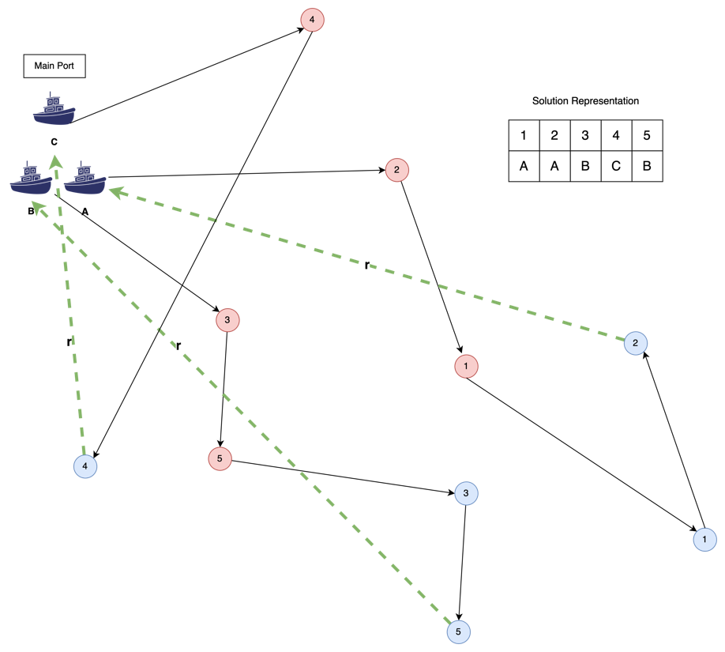
Figure 7. Problem and Solution Representation of the Tramp Routing Problem

The method of local procedure and exploration of solutions in the EM-like will involve the different allocations of ships to cargoes using the heuristic procedure of equation (4). The attraction of cargoes will depend on the randomly assigned particle magnitude and the Euclidean distance specified between them. The algorithm’s termination criteria may be based on the maximum iterations reached or a specific threshold of acceptable distance travelled given the constraints of the solution-finding process like immediate optimized route response and computational resources.
- Conclusions
Based from the result of the simulation, modifying the boundary of particle movement makes significant difference in the search process of the EM-like; however, the study does not show any mathematical proof that it is indeed the particle movement boundary that causes the improvement of the search since how the permutations are modified per iteration, which is also crucial as the \ac{VRP} at hand is formulated as a permutation problem, is not detailed. It is only the solutions that are compared. However, based on the results, if the particle is set to move within a random boundary, while keeping other parameters constant, the solution obtained are better. There is an exception, however, since the αCBNL-o and αCBL-o displayed better values if the movement is only within [0,1]. Subjecting the algorithm with a local search procedure significantly improved the obtained values per iteration, with the highest improvement of 21 percent. This trend is evident to all the parameter scenarios. The study also recommends the implementation of capacity considerations in waste collection to ensure that the cost is also being minimized. Moreover, due to the minute difference and inconsistent results from the αCBNL-o and αCBL-h where particle boundary movement is modified, it is interesting for future work to study the behaviour of permutations across iterations between the two cases of the boundary of particle movement. For example, knowing how the permutations are re-arranged due to the interactions and modified movement can provide insight how well the mechanism obtain neighbour or diverse the decision variables. Comparing these permutations may be done using metric such as Kendall-Tau and Spearman's Rho. To improve the speed convergence, it is suggested to modify parameters like random step length and particle boundary movement. It is also worth looking at the behaviour of the algorithm when the problem is formulated in multi-objective space or in terms of a penalty function to include the constraint of truck capacity. The multi-objective domain is more complex, so it is interesting to investigate how the algorithm re-formulation or modification is done to tailor the sophistication. In conclusion, the EM-like algorithm displayed significant minimization abilities of distance values. The traditional EM-like framework is used with local search and selection strategy implementation. It displayed 39 percent of solution improvement in the span of 71 minutes of computational completion time.
References
[1] Diaz L F Waste Management in Developing Countries and the Circular Economy Waste Management & Research
[2] EPA 2020 Best Practices for Solid Waste Management: A Guide for Decision-Makers in Developing Countries
[3] Group W B 2018 Municipal Solid Waste Management: A Roadmap for Reform for Policy Makers (1818 H Street NW Washington, DC 20433)
[4] Kolekar K A, Hazra T and Chakrabarty S N 2016 A Review on Prediction of Municipal Solid Waste Generation Models Procedia Environ Sci 35 238–44
[5] Fernández-Aracil P, Ortuño-Padilla A and Melgarejo-Moreno J 2018 Factors related to municipal costs of waste collection service in Spain J Clean Prod 175 553–60
[6] Agaton C B, Guno C S, Villanueva R O and Villanueva R O 2020 Economic analysis of waste-to-energy investment in the Philippines: A real options approach Appl Energ 275 115265
[7] Mmereki D, Baldwin A and Li B 2016 A comparative analysis of solid waste management in developed, developing and lesser developed countries Environ Technology Rev 5 120–41
[8] Magalang A A 2013 Municipal Solid Waste Management in Asia and the Pacific Islands, Challenges and Strategic Solutions Environ Sci Eng 281–97
[9] Sulemana A, Donkor E A, Forkuo E K and Oduro-Kwarteng S 2018 Optimal Routing of Solid Waste Collection Trucks: A Review of Methods J Eng 2018 1–12
[10] Golden B L and Wong R T 1981 Capacitated arc routing problems Networks 11 305–15
[11] Tavares G, Zsigraiova Z, Semiao V and Carvalho M G 2009 Optimisation of MSW collection routes for minimum fuel consumption using 3D GIS modelling Waste Manage 29 1176–85
[12] Martinelli R, Poggi M and Subramanian A 2013 Improved bounds for large scale capacitated arc routing problem
[13] Benavent Enrique, Campos V, Corberán A and Mota E 1990 The capacitated arc routing problem. A heuristic algorithm
[14] Pearn W L 1989 Approximate solutions for the capacitated arc routing problem
[15] Eydi A and Javazi L 2012 A novel heuristic method to solve the capacitated arc routing problem
[16] Son L H 2014 Optimizing Municipal Solid Waste collection using Chaotic Particle Swarm Optimization in GIS based environments: A case study at Danang city, Vietnam Expert Syst Appl 41 8062–74
[17] Gómez J R, Pacheco J and Gonzalo-Orden H 2013 A Tabu Search Method for a Bi-Objective Urban Waste Collection Problem
[18] Nevrlý V, Popela P and Šomplák R 2019 Heuristics for Waste Collection Arc Routing Problem
[19] Chang P-C, Chen S-H and Fan C-Y 2009 A hybrid electromagnetism-like algorithm for single machine scheduling problem Expert Syst Appl 36 1259–67
[20] Sels V and Vanhoucke M 2014 A hybrid Electromagnetism-like Mechanism/tabu search procedure for the single machine scheduling problem with a maximum lateness objective Comput Ind Eng 67 44–55
[21] Debels D, Reyck B D, Leus R and Vanhoucke M 2006 A hybrid scatter search/electromagnetism meta-heuristic for project scheduling Eur J Oper Res 169 638–53
[22] Valls V, Ballestín F and Quintanilla S 2004 A Population-Based Approach to the Resource-Constrained Project Scheduling Problem Ann Oper Res 131 305–24
[23] Yurtkuran A and Emel E 2010 A new Hybrid Electromagnetism-like Algorithm for capacitated vehicle routing problems Expert Syst Appl 37 3427–33
[24] Demir E, Bektaş T and Laporte G 2012 An adaptive large neighborhood search heuristic for the Pollution-Routing Problem Eur J Oper Res 223 346–59
[25] Lai D, Costa Y, Demir E, Florio A and Woensel T V 2021 The Pollution-Routing Problem with Speed Optimization and Uneven Topography Arxiv
[26] Talbi E 2018 Metaheuristics
[27] Birbil Ş İ and Fang S-C 2003 An Electromagnetism-like Mechanism for Global Optimization J Global Optim 25 263–82

