**Production of Hybrid Composite Using Sisal Fiber and False Banana Fiber for Dashboard Application**

**Dawit Wami Negera1,*and** **Ramesh Babu Nallamothu1**

1 Assosa University, Ethiopia

2Adama Science and Technology University, Ethiopia

* Corresponding author: [D.wami@yahoo.com](mailto:D.wami@yahoo.com)

**Abstract**. The necessity to discover a workable substitute for heavy metals to replace them in alternative natural fiber reinforced polymer composites is driven by the growing concern over environmental issues, attention to green and clean composite materials. Light materials are receiving a lot of attention in order to de-crease vehicle weight, fuel consumption, and improve physical and mechanical qualities due to stricter environmental and passive safety rules. The purpose of this thesis work is to fabricate, describe the meth-ods used to prepare specimens and models, carry out an experiment to gather data on, and analyze me-chanical properties. False banana fiber (FBF) and sisal fiber (SF) were used to create the composite, which was then compressed using a general purpose (GP) resin with hardener mixture and a straight for-ward hand lay-up method. Then, tests for density, water absorption, tensile strength, compression strength, and flexural strength were performed in accordance with ISO and ASTM standards. The find-ings indicate that the 1:3 ratio has a higher overall tensile strength than both the 1:1 ratio and the 3:1 ratio, at 69 MPa. 3:1 ratio 380 MPa. In a compression strength test, a 3:1 ratio likewise produced a higher value of 12.30 MPa. For water absorption rain water absorbs more water relative to tap water. The preparation of hybrid composite, characterization of the mechanical and physical properties, modelling of the dashboard using Solid Work 2017, compare and contrast the cost, weight and percentage fuel reduction with the convectional one. Finally, fabrication of a prototype for the dash-board of a PEUGEOT model car with improved mechanical and physical properties for demonstration purposes.

1. Introduction

The increase in environmental consciousness and community interest, the new environmental regulations and unsustainable consumption of petroleum led to thinking of the use of environmentally friendly materials [1]. The natural fiber is considered one of the environmentally friendly materials which have good properties compared to synthetic fiber [1]. One of the method to increase the strength of composite materials are fiber hybridization. This method is by mixing of two or more fibers together.

Due to their superior mechanical qualities, stronger strength, and lower weight compared to many metals and alloys, as well as the ability to customize their microstructures, composites have found widespread use in structural and civil engineering and mechanical engineering, along with the auto sector and energy applications.

The performance of wind turbines can also be enhanced using composite. Numerous research disciplines are focusing on employing light composite to increase wind turbine performance materials used to make the turbine blades, as shown in [3-4]. The wind's horizontal axis turbine blade rotates with a modest force when the weight of the blade is lowered. As a result, the blade rotates more frequently. Since Power directly relates to the number of rotations.

Reduced fuel usage may also result from weight loss. A vehicle's fuel consumption drops by 7% as a result of a 10% weight loss, which also indicates that a 1 kg weight loss will significantly lower CO2 emissions. The car industry is attempting to adopt new, lightweight materials to cut greenhouse gas emissions. The price of these materials is the only barrier to their use, which is why new production methods and technologies are being developed.

The ability of the material structure to absorb energy in a controlled manner is known as the impact strength [2].

To eliminate or minimize those problems listed above by changing the materials to hybrid composite of FBF and SF reinforced with GP resin with hardener is appropriate, and also coated with black paint to re-duce glare reflection to the driver and tilt the dashboard in some angle to change the direction of reflection out ward from the driver [3]. The general objective of this thesis work is to fabricate and characterize the hybrid composite for construction of dashboard in automobile application and specific objectives are pro-duce a hybrid composite of FBF and SF fibers reinforced composite material, measure the tensile, com-pression, flexural(bending), density and water absorption properties of composite material, fabricate the PEUGEOT model automobile vehicle dashboard using the composites and compare the performance of vehicle dashboard made up of composite with the conventional materials.

1. Materials and method

Generally, methodology flow chart for preparation of hybrid composite shown in Figure 1.

FBF & SF steam/blast collection

Fiber extraction

Fiber Drying

Fibers treatment in 8 g NaOH & 10 L distilled water

Washing fibers by running water repeatedly &drying in air

Hybrid fibers & weaving ply orientation of (0,90)0

Purchasing resin and hardener

Mixing resin& hardener based on Wight ratio

Preparing the Model of dashboard for PEUGEOT vehicle by the better mechanical & physical properties

Mold preparation

Composite fabrication based on Wight fraction of FBF, SF, resin and hardener

Applying load

Curing

Specimen preparation

Conducting test

Analysis tests

**Figure 1:** Methodology chart for preparation of hybrid composite of FBF and SF.

## Extraction Process of false banana /ensete/ fiber

The extraction of the fiber was not taken part as the main objective. Rather the fiber as a byproduct. The main reason for extraction process is searching food. The process is discussed as follows according to the observation made [2].

* Cut the Enset plant which is ripe and ready for the process, from the ground level.
* Cut the outer two layers of the plant into smaller pieces.
* Attach the smaller piece on an inclined plane wood and hold it with right leg.
* Between the right leg and the inclined plane wood scrap it with a tool made from wood to squeeze the size.

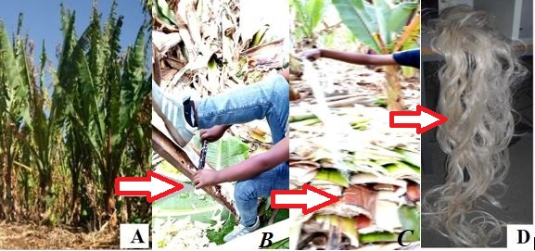

**Figure 2:** Manual extraction process of FBF. A) FB (Ensate) plant. B) During extraction process. C) Extracted FBF before washing. D) Dried FBF.

1. **Sisal fiber**
2. ***Extraction process of sisal fiber***

In general, the extraction process of the sisal fiber from sisal plants was concisely summarized as below:

* All lower leaves, standing at an angle of more than 45 degrees to the vertical, are cut away from the bole of the plants with a sharp flexible knife.
* After that gently or carefully remove the thorn from the leaves of sisal in both sides of its edge and tip.
* Then the leaves are trimmed in a longitudinal direction in to different strips for ease of fiber extraction.
* The peeling part is clamped between the wood table and knife.
* Then it’s hand-pilled gently through in longitudinal direction in order to remove the resinous materials as shown in Figure 2.
* Then the extracted fiber washed gently with pure water in order to loosen, and separate the fiber until individual fibers are obtained.
* Then the extracted fibers are then dried over the sun for three days.

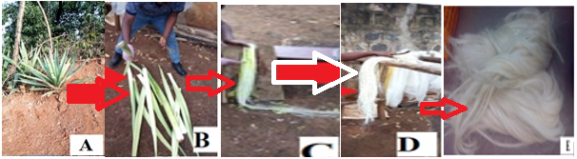

Figure 3: Manual extraction process of sisal fiber.

1. ***Hand lay-up procedure***

First, a release gel is sprayed on the mold surface to avoid the sticking of polymer to the surface. Thin plastic sheets are used at the top and bottom of the mold plate to get good surface finish of the product.

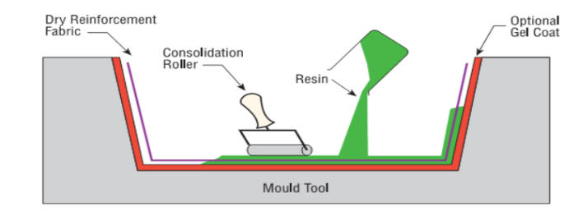

Figure 4: Hand lay-up techniques [5].

1. *Fabrication of composite specimens*

General schematic flows for the production of hybrid composite from FBF and SF preparation process are shown in Figure 5.

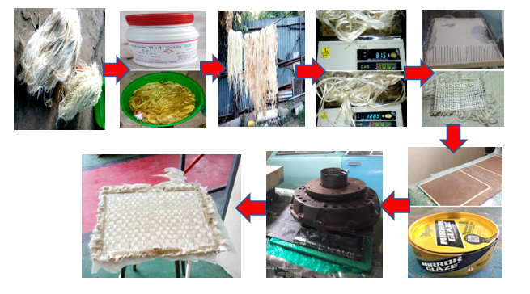

Figure 5: Hybrid composite of false banana fiber and Sisal fiber fabrication procedures.

1. *Measurements for test specimens*

The specimens for the hybrid composite of FBF and SF for the tensile test were prepared in accordance with the necessary Ethiopian Conformity Assessment Enterprise (ECAE) Testing material (ISO 6892-1) standards.

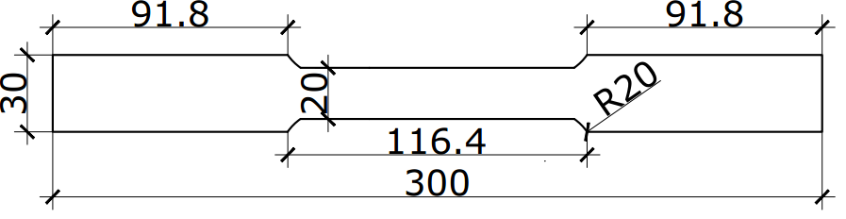

(a) Specimen for Tensile.

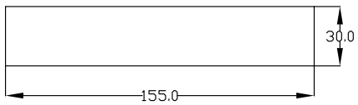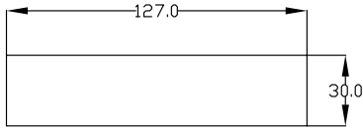

(b) Specimen for compression. (c) Specimen for Bending.

**Figure 5.** Size of test samples.

1. *Test of tensile strength*

Depicts the results of a tensile strength test on UTM 2000 KN performed by Ethiopian Conformity Assessment Enterprise.

1. *Test of compression strength*

For the hybrid composite of FBF and SF, compression strength test specimens in accordance with ASTM D -3410 were developed. There were three different ratios used: 1:1, 3:1, and 1:3.

1. ***Test for flexural strength***

The ability of a material to resist deformation under load is known as flexural strength.

1. *Density measurement*

Experimentally, the actual density (ρce) of the composite is determined using a 30 mm $×$ 30 mm sample using a straightforward water immersion approach.

1. *Absorption of water*

Source moisture absorption was carried out in line with ASTM D - 570-98, according to the literature the specimen was 30mm by 30mm in size [3]; provided the information for the equation below.

$\% Water Absorption = \frac{W_{t - }W_{o}}{W_{o}}×100 OR \frac{M_{W - }M_{a}}{M_{a}} ×100$………………………. (1)

$Where : W_{t}=Wet sample weight$ $,{ W}_{o}=Weight of dry sample$

$M_{W} =Mass of Wet sample$ ${, M}_{a }=Mass of dry sample$

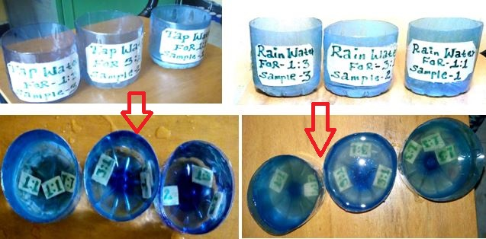

Figure 6. Checkup for water absorption.

1. ***Computation of mass***

The SOLID WORK 2017 software uses the density relationship to compute the mass of the dashboard for both the standard dashboard and the modified dashboard, which are constructed of metal sheet and composite material, respectively.

To calculate the volume savings for the panel.

$Reduction=Mass of convectional Panel – Mass of Hybrid composite \% Mass Saved=\frac{Mass Saved}{Mass of convectional dashboard}×100……………………………( 1)$

1. Results and Discussion

The results of mechanical properties and physical properties are provided based on the study's objectives and methods.

* 1. *Analysis of tensile strength*

The tensile strength test results are tabulated and shown in Table 1 based on a tasted spacemen result specimens for each (FBF: SF) of 1:1 ratio, 3:1 ratio, and 1:3 ratio and an average value for those specimens.

Table 1. Tensile strength test results for various hybrid composites with different weight fractions.

|  |  |  |  |  |
| --- | --- | --- | --- | --- |
| Hybrid composite material  (Ratio) | Samples | Max. load  (kN) | Max. Elongation  (%) | Tensile strength  (MPa) |
| **1:1** | Trial-1 | 4.22 | 7.9 | 44 |
| Trial-2 | 4.39 | 14.4 | 46 |
| Trial-3 | 5.18 | 5.6 | 51 |
| **Average** | **4.59** | **9.3** | **47** |
| **3:1** | Trial-1 | 6.72 | 7.2 | 48 |
| Trial-2 | 7.81 | 7.2 | 52 |
| Trial-3 | 6.00 | 7.9 | 41 |
| **Average** | **6.84** | **7.43** | **47** |
| **1:3** | Trial-1 | 9.85 | 8.7 | 76 |
| Trial-2 | 6.39 | 6.5 | 70 |
| Trial-3 | 6.45 | 5.6 | 62 |
| **Average** | **7.56** | **6.94** | **69** |

Individual results for each sample and the average result for each hybrid composite ratio are listed in Table 1. The average value from each test was used to analyse the results. Figure 24 from UTM displays the specific results of each specimen graphically.

**Figure 7.** Tensile strength comparison for various weight fractions.

* 1. *Investigation of compression strength*

**Table 2.** Compression strength test results for various hybrid composites of weight fraction.

|  |  |  |  |  |
| --- | --- | --- | --- | --- |
| Hybrid composite material | Samples | Max. load  (N) | Max. deformation  (mm) | Compression strength  (MPa) |
| **1:1** | Trial-1 | 2510 | 1.24 | 0.80 |
| Trial-2 | 11630 | 2.80 | 3.83 |
| Trial-3 | 12410 | 2.91 | 4.10 |
| **Average** | **8850** | **2.31** | **2.92** |
| **3:1** | Trial-1 | 38810 | 3.11 | 12.90 |
| Trial-2 | 33480 | 2.80 | 11.10 |
| Trial-3 | 38810 | 3.11 | 12.90 |
| **Average** | **37033.33** | **3.007** | **12.30** |
| **1:3** | Trial-1 | 29390 | 3.21 | 9.70 |
| Trial-2 | 22260 | 2.27 | 7.40 |
| Trial-3 | 30510 | 3.43 | 10.10 |
| **Average** | **27,386.66** | **2.97** | **9.07** |

Individual results for each sample and the average result for each hybrid composite ratio are given in Table 2 for compression strength. The average value from each test was used to analyse the results. Each hybrid composite's individual average results are displayed.

`

Figure 8. Analysis of compression strength for various weight fractions.

* 1. *Investigation of flexural (bending) strength*

Graphs are used to display the average flexural test results.

Table 3. Flexural strength test results for various hybrid composite mass fractions.

|  |  |  |  |  |  |
| --- | --- | --- | --- | --- | --- |
| Hybrid composite | Samples | Max. load  (kN) | Max. deflection  (mm) | Max. bending elastic modulus (MPa) | Flexural strength  (MPa) |
| **1:1** | Trial-1 | 0.38 | 5.30 | 150.81 | 36.80 |
| Trial-2 | 2.31 | 5.29 | 916.78 | 167.18 |
| Trial-3 | 1.68 | 3.64 | 666.75 | 93.35 |
| **Average** | **1.46** | **4.74** | **578.11** | **99.11** |
| **3:1** | Trial-1 | 2.68 | 5.31 | 1063.62 | 88.01 |
| Trial-2 | 2.16 | 5.31 | 857.25 | 161.98 |
| Trial-3 | 6.48 | 8.85 | 2571.75 | 198.70 |
| **Average** | **3.77** | **6.49** | **1497.54** | **149.56** |
| **1:3** | Trial-1 | 3.00 | 2.90 | 1190.62 | 333.39 |
| Trial-2 | 4.83 | 2.90 | 1916.90 | 537.43 |
| Trial-3 | 4.00 | 2.68 | 1587.50 | 272.05 |
| **Average** | **3.94** | **2.82** | **4695.02** | **380.95** |

Figure 9: Flexural (Bending) strength evaluation in relation to different weight fractions.

* 1. *% water absorption*

The water absorption findings for regular tap water and rainwater are calculated and provided in Table 4.

**Table 4.** Hybrid synthesis of FBF and SF findings of water absorption percentage for regular tap water and rainwater for five days (120 hours).

|  |  |  |  |  |  |  |  |
| --- | --- | --- | --- | --- | --- | --- | --- |
| **% Water Absorption for ordinary tap water** | | | | | | | |
| Fibres Ratio | | | | Mass of dry sample (g) | Mass of Wet sample (g) | % Water Absorption | Average % Water  Absorption |
| **1:1** | | Trial – 1 | | 2.93 | 3.00 | 2.39 | **2.68** |
| Trial – 2 | | 2.69 | 2.77 | 2.97 |
| Trial – 3 | | 2.99 | 3.07 | 2.67 |
| **3:1** | | Trial – 1 | | 4.78 | 5.00 | 4.60 | **4.21** |
| Trial – 2 | | 4.10 | 4.30 | 4.87 |
| Trial – 3 | | 6.01 | 6.20 | 3.16 |
| **1:3** | | Trial – 1 | | 3.91 | 4.01 | 2.55 | **2.64** |
| Trial – 2 | | 4.26 | 4.39 | 3.05 |
| Trial – 3 | | 3.87 | 3.96 | 2.32 |
| **% Water Absorption for Rain water** | | | | | | | |
| **1:1** | Trial – 1 | | 3.23 | | 3.32 | 2.78 | **3.21** |
| Trial – 2 | | 3.43 | | 3.53 | 2.91 |
| Trial – 3 | | 2.28 | | 2.37 | 3.94 |
| **3:1** | Trial – 1 | | 4.76 | | 4.93 | 3.57 | **3.80** |
| Trial – 2 | | 5.00 | | 5.20 | 4.00 |
| Trial – 3 | | 4.68 | | 4.86 | 3.84 |
| **1:3** | Trial – 1 | | 4.00 | | 4.13 | 3.25 | **3.07** |
| Trial – 2 | | 4.16 | | 4.28 | 2.88 |
| Trial – 3 | | 4.19 | | 4.32 | 3.10 |

In 5 days, FBF and SF average values for regular tap water and rainwater were tallied and individually examined for their water absorption percentages (120 hours). The average value of each sample is used in the comparison.



**Figure 10.** % water absorption in comparison to various weight fractions.

*Density Evaluation*

Based on the hybrid composition of the FBF and SF ratios with an average value for those specimens, the density analysis test results are tallied and shown in Table 5.

Table 5. Results of density tests.

|  |  |
| --- | --- |
| Hybrid composite material | Density (g/cm3) |
| **1:1** | **1.270** |
| **3:1** | **1.530** |
| **1:3** | **1.128** |

In Figure 10. Each hybrid composite of FBF and SF has its density graphically calculated.

Figure 11. Density comparisons for various weight fractions.

* 1. *Mass reduction in percentage*

Table 6 lists the mass of FBF and SF Vehicle panel results from solid work 2017 for both known (ordinary) and hybrid composite panel.

Table 6. Density, mass, and percentage of mass saved in grams.

|  |  |  |  |  |  |
| --- | --- | --- | --- | --- | --- |
| Materials | Density  (g/cm3) | Mass  (g) | Volume  (cm3) | Mass saved  (g) | Mass saved  (%) |
| Steel Sheet Metal | 7.800 | 26890587.84 | 3447.511 | _ | _ |
| Composite Material  (1:1 ratio) | 1.270 | 4378339.302 | 3447.511 | 22,512,248.538 | **83.718** |
| Composite Material  (3:1 ratio) | 1.530 | 5274692.230 | 3447.511 | 21,615,895.610 | **80.385** |
| Composite Material  (1:3 ratio) | 1.128 | 3888792.703 | 3447.511 | 23001795.137 | **85.538** |

Figure 12 displays the graphically computed percentage mass reduction for hybrid composite materials of FBF and SF vehicle dashboard.

**Figure 12.** Comparison of mass reduction with different weight fraction.

1. Fabrication Of Vehicle Dashboard from Hybrid Composite Of Fbf AND SF

Based on the results obtained from the mechanical and physical properties laboratory tests of tensile, compression, bending, water absorption and density concluding that the best to manufacture vehicle dashboard using (0,900) degree with Hybrid composite of FBF and SF with 1:3 ratio are selected.

Generally, to manufacture the PEUGEOT model vehicle dashboard in this thesis work follow manufacturing procedure listed below:

* Preparing the cope and drag parts from the original dashboard by using E-glass fiber because synthetic fibers have good surface finish relative to natural fibers

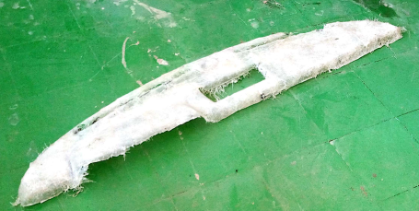

Figure 13. Cope molds for manufacturing of PEUGEOT model vehicle dashboard.

* By arranging the FBF and SF according to the desired weight ratio then co-mingle together randomly by fiber - fiber and woven by (0,90)0 for relative to the area dashboard.
* Mix the GP resin with hardener (catalyst) with appropriate ratio and stir to gather for 15 minutes.
* Clean and add mold releaser on the internal surface of cope and drag parts then accession (add) themixed GP resin with hardener (catalyst) slightly on the mold then macadamize the plane woven on the mixed GP resin after that again accession (add) the mixed GP raisin at the top surface of the woven and then place cope on and up load a heavy materials for compression and wait for 24 hours for curing time.

Finally, release the up loaded heavy materials and the replaced PEUGEOT model vehicle dashboard is manufactured then to get good surface finish rubbing the surfaces by sand paper after that clean and paint by Spray the replaced dashboard by black color paint because of to reduce glare reflection to the driver and tilt the dashboard in some angle to change the direction of reflection out ward from the driver.

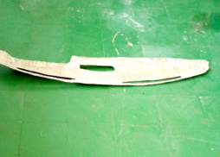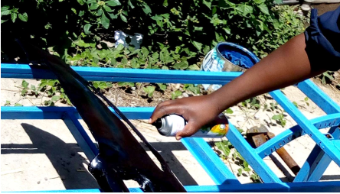

1. Dashboard before paint. B. Dashboard during painting.

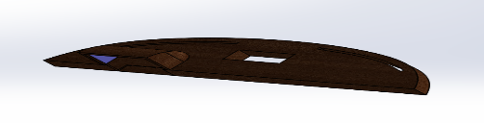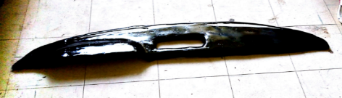

C. Dashboard after painting. D. Modeled by Solid Work.

Figure 14. Prototype of PEUGEOT model vehicle dashboard fabrication procedure.

1. CONCLUSIONS

The following inferences are made in light of the data from the tensile, compression, bending, density, and water absorption characteristics experiments included in this thesis:

* A hybrid composite made of FBF and SF in a 1:3 ratio has a strong tensile property. The hybrid composite used in this study, which was filled with more sisal fiber by the Force of three hands, exhibits the highest level of tensile strength. Yet, when sisal fiber is packed by hand, the composite's tensile strength test results are equal. The maximum tensile strength that could be measured was at a 1:3 ratio, which had an average value of 69 MPa. Typically, a composite filled with greater ratios of sisal fibers has better tensile strength.
* According to the results of the compressive strength test, the the flexural (bending strength) of the hybrid composite of FBF and SF with a 1:3 ratio has the highest value than other hybrid composites of FBF and SF ratios with an average harness value of 12.30 MPa, according to the results.
* Findings indicate that the hybrid composite of FBF and SF with a 1:3 ratio has the highest flexural (bending strength) value compared to other hybrid composites of FBF and SF ratios, with an average value of 380.9 MPa, which is twice as much as the hybrid composite of FBF and SF with a 3:1 ratio and three times as much as FBF and SF are blended in a 1:1 ratio. This suggests that adding more sisal fiber to the hybrid FBF and SF composite will result in a material that cannot be simply flexed. Two different types of water also exhibit water absorption percentage.
* In two different types of water, there is also a water absorption %. The first method uses regular tap water. A hybrid composite made of FBF and SF in a 3:1 ratio absorbs 4.21% more water in this sort of water than it does in other ratios. In terms of water absorption, hybrid composites of FBF and SF with ratios of 1:1 and 1:3 absorb almost the same amount of water, 2.68% and 2.64%, respectively.
* For the second type of water—rainwater—again, the hybrid composite of FBF and SF with a 3:1 ratio reported more water absorption up to 3.80%, and the hybrid composite of FBF and SF with a 1:1 ratio trailed the 3:1 ratio by 3.21%. Hybrid composites with a 1:3 ratio exhibit the lowest rainwater absorption.
* A hybrid composite of FBF and SF with a 3:1 ratio exhibits greater water absorption for both types of water than a 1:1 result, which is followed by a 1:3 result with the least amount of water absorption. Use of the list number for the percentage of water absorption is preferable in this circumstance. The preferred hybrid composite is a 1:3 ratio of FBF and SF. According to the test results, a hybrid composite of FBF and SF with a 3:1 ratio has a higher water absorption rate for both types of water, indicating that a composite material with a higher false banana fiber content will hold onto more liquid.
* Using a lot of faux banana fiber as a reinforcing material for composite materials is not advised for car body areas that are frequently exposed to rain.
* It is not advised to use a lot of faux banana fiber as a reinforcing material for composite materials in car body components that are frequently exposed to rain.
* According to the results of the density analysis, the hybrid composite of FBF and SF with a 3:1 ratio has a relatively higher density with a value of 1.530 g/cm3, while the hybrid composite of FBF and SF with a 1:1 ratio comes in second with a value of 1.27 g/cm3. The hybrid composite of FBF and SF with a 1:3 ratio has the lowest density.
* Because density and mass have a direct relationship, it is preferable in this instance to utilize the list number as the outcome of the density analysis because as density decreases, so does mass and vice versa. So, one of the goals of this research is to reduce the bulk of the vehicle dashboard. In this situation, a hybrid composite with a low density that combines FBF and SF in a 1:3 ratio is preferred.

**References**

[1]Goud, G., & Rao, R. N. (2011). Effect of fibre content and alkali treatment on mechanical properties of Roystonea regia-reinforced epoxy partially biodegradable composites. *Bulletin of Materials Science*, *34*(7), 1575–1581. https://doi.org/10.1007/s12034-011-0361-4

[2]Karthick, R., & Aruna, M. (2017). A Review on Mechanical Behaviour of Sisal Fibre Reinforced Composites. *International Journal of Scientific Development and Research (IJSDR)*, *3*(8), 1071–1073.

[3] Singh, S., & Kumar Gupta, P. (2022). Effect of fiber orientation on mechanical properties of jute/carbon/glass hybrid composite. *Materials Today: Proceedings*, *68*(December), 2574–2580. https://doi.org/10.1016/j.matpr.2022.09.419

[4] Boopalan, M., Niranjanaa, M., & Umapathy, M. J. (2013). Study on the mechanical properties and thermal properties of jute and banana fiber reinforced epoxy hybrid composites. *Composites Part B: Engineering*, *51*, 54–57.

[5] Adem, E., Reddy, G. M., Koricho, E. G., Science, A., Science, A., Science, A., Vehicle, C., & Introduction, I. (2015). *Experimental Analysis of E-Glass / Epoxy & E-Glass / polyester Composites for Auto Body Panel*. *May*, 377–383. B