Open material database for tensile test properties of additive manufacturing materials
A A Garcia-Granada^{1, *}, H. Rostro-González¹, J M Puigoriol-Forcada¹ and G Reyes-Pozo¹
¹ Grup d’Enginyeria en Producte Industrial (GEPI), Institut Químic de Sarrià, Universitat Ramon Llull, Via Augusta 390, 08017 Barcelona, Spain

*andres.garcia@iqs.url.edu
Abstract. In recent years, the investigation of material properties within additive manufacturing, also known as 3D printing, has gained significant research attention. The intricate interplay between numerous fabrication parameters and the resultant material properties of 3D-printed components has become crucial, particularly for enabling effective topology optimization. Considering this, we propose the establishment of an accessible open database. This repository stores a comprehensive collection of fabrication files corresponding to each distinct material and printer combination, accompanied by the outcomes of meticulous tensile testing. To support the research community, our initiative extends to the inclusion of material provider datasheets, facilitating comprehensive result comparisons. A standardized approach utilizing consistently applied strain rates is recommended, focusing on a compact dog bone specimen design. This pioneering attempt encompasses an expansive array of data derived from 25 distinct materials and 9 diverse printers, meticulously capturing the inherent variability within the samples. The database catalogues the complete spectrum of tensile test data, encompassing various essential measurements such as mass, and crucial material properties including Young's modulus, yield stress, fracture strain, and absorbed energy. These recorded metrics can be seamlessly correlated against density, manufacturing time, or cost parameters, enabling the generation of insightful plots and analysis. Through this collaborative effort, we aim to provide researchers with a robust foundation for informed decision-making and advancements in additive manufacturing.

- Introduction
Additive manufacturing has emerged as a revolutionary technique, allowing the production of individual components without the reliance on traditional tooling methods such as molds for plastic injection or matrices for metal stamping [1,2]. For these materials you can find sdatabase such as Matweb [3], Campusplastics [4] and material selection software such as Granta Design [5]. Additive manufacturing is experiencing a rapid expansion in various applications, driven by the advent of novel printers, transformative technologies, and an evolving spectrum of materials [6,7]. Nevertheless, the successful utilization of additive manufacturing demands a comprehensive understanding of material properties, which exhibit notable variations contingent upon distinct manufacturing parameters [8]. For example, in the pursuit of optimal material properties for additive manufacturing, Garcia-Granada et al. [9] encountered challenges in implementing topology optimization. Their comparative study of two high-performance 3D printing machines revealed intriguing insights. The success of optimization was evident in the case of a Fortus 400mc employing Fused Deposition Modeling (FDM) technology, utilizing ABS-M30 material. However, the same level of optimization eluded the Polyjet Objet30 Prime printer, even with the utilization of Verowhite material. FDM is a trademarked term owned by Stratasys, a 3D printing company. Fused Filament Fabrication (FFF) is a generic term that describes the same technology.
In the realm of advanced manufacturing, FDM stands as a pioneering technique that holds immense promise for the fabrication of thermoplastic polymer composites. The synergy of thermoplastic polymers with composite materials presents a compelling avenue for achieving enhanced mechanical, thermal, and functional properties [10]. Domingo-Espin et al. [11] have made significant progression in unraveling the complexities of fused deposition modeling for polycarbonate parts. Through meticulous experimentation, they have discerned that the Young's modulus can fluctuate within a range of ±10%, a phenomenon attributed to the orientation during printing. Similarly, tensile strength exhibited variations of up to ±20%, while ultimate strain displayed a significant scatter, spanning from as low as 2% to a substantial 11.8%. On the tensile testing, a review of additively manufactured polymers is given in [12]. In this paper, it becomes evident that a significant gap exists in the realm of suitable standards designed to systematically evaluate the tensile properties of polymer components. This gap is particularly conspicuous when considering the intricate landscape of Fused Filament Fabrication (FFF), where the mechanical behavior is intricately governed by a multitude of printing parameters [13]. The inadequacy of existing standards becomes apparent in their inability to encompass the diverse array of influential factors that contribute to the mechanical characteristics of FFF-produced parts [14].
There is a need to document all sort of material properties for additive manufacturing such as thermal conductivity [15], viscoelastic properties [16], conductive properties [17].
The substantial diversity in printing parameters, printer models, and material properties is the focal point of our efforts in this work. To address this multifaceted challenge, we propose the creation of a comprehensive database that incorporates many of the key factors discussed here. This database is poised to serve as a foundational resource in the field of additive manufacturing.
Our initial iteration of this additive manufacturing database, denoted as Version 01, is now accessible through AMDB [18]. This repository stands as an invaluable asset, catering to the needs of both researchers and practitioners alike. It streamlines the exploration and integration of critical insights and data within the realm of additive manufacturing, offering a robust platform for advancing knowledge and innovation in this dynamic field.

- Materials and methods

Geometry
Tensile tests are performed using a small geometry to minimise the use of material and manufacturing time. The geometric configuration is inspired by the ASTM_D638_V standard, with dimensions set at a thickness of 2 mm and width of 3.18 mm, culminating in a cross-sectional area of 6.36 mm². For precise specifications of an individual tensile specimen, refer to Figure 1a, which requires a material volume of 930 mm³. Length for strain calculation was calibrated using finite element analysis as shown in Figure 1c. For a displacement of U=1 mm and E=2000 MPa an average stress of σ=80 MPa was observed in the cross-section area. Therefore, for deformation calculations (ε=U/L) we used the length L=E*U/σ=2000*1/80=25mm.
To streamline the process, an STL file encompassing four specimens has been curated and incorporated into the material database. This strategic optimization minimizes the required printing volume to 5541.19 mm³ (32.03 x 86.50 x 2), while material consumption remains confined to 3720 mm³ (4 x 930). The intricate details of the STL geometry earmarked for printing are meticulously outlined in Figure 1b, with slim 1.14 mm separations thoughtfully incorporated between specimens.
While the adoption of such diminutive specimens offers noteworthy advantages in terms of economizing both time and material resources, it is pertinent to acknowledge a limitation. Regrettably, due to their small size, the ability to investigate the implications of infill patterns is curtailed. This restriction is attributed to the preponderance of slicing utilized for generating outer surfaces, thereby warranting a judicious consideration of the experimental scope and its corresponding constraints.

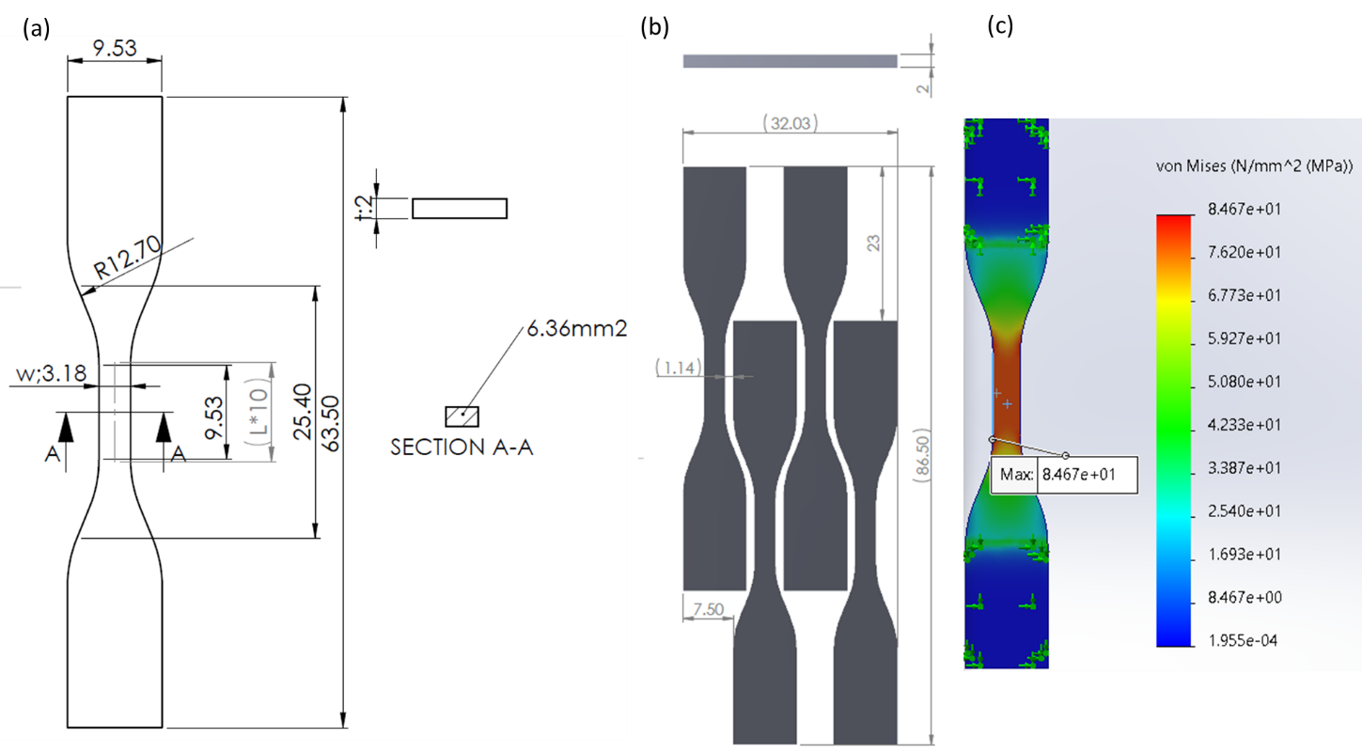
Figure 1. Geometry of (a) 1 tensile specimen and (b) downloaded STL for 4 tensile specimens and (c) length calibration.

3D printers and slicing
The material database encompasses a diverse array of printers and slicing methods, accommodating a wide spectrum of choices. A primary premise of this database is to meticulously chronicle crucial details, including the specific material, printer model, slicing technique employed, and the associated manufacturing file. This comprehensive documentation is instrumental in fostering repeatability and ensuring the veracity of the results obtained.
In alignment with the scope of this paper, a specific subset of machines, slicing software, and materials has been judiciously considered, as outlined in Table 1. Each material, within the database, warrants a meticulous record encompassing the printer model utilized, the slicer employed, a visual representation of the slicing process, the manufacturing file itself, and, upon completion of testing, a minimum of four illustrative result images. The column run in material database makes reference to the specimen test run recorded in the tensile test machine.
By adhering to this meticulous documentation framework, the material database not only amplifies the value of this research but also lays a robust foundation for future investigations, augmenting the transparency, reliability, and transferability of findings across diverse additive manufacturing scenarios.

Table 1. 3D printing machine, slicing and material
Technology | Slicing software | Machine | Materials | Run | Cost  (€/min) | Cost  (€/gr)
FFF  /  FDM | Cura 4.8.0 | Ultimaker S5 | PLA | 135-138 | 0.02 | 0.1
 |  |  | ABS | 149-152 | 0.02 | 0.1
 |  |  | TPU | 145-148 | 0.02 | 0.1
 |  |  | TPU+ABS | 141-144 | 0.02 | 0.1
 |  |  | PCL | 186-189 | 0.02 | 0.1
 |  | Prusa i3 mk3 | PLA | 115-119+121-126 | 0.01 | 0.1
 |  |  | ABS | 153-156 | 0.01 | 0.1
 |  |  | PETG | 191-194 | 0.01 | 0.1
 |  |  | PLAFe | 227-232 | 0.01 | 0.1
 |  |  | PETG+PLA | 196-199 | 0.01 | 0.1
 |  | Ender 3v2 | PHA210 | 238-240 | 0.01 | 0.1
 |  |  | PHA190 | 234-237 | 0.01 | 0.1
 | Axon 2 | BFB 3000 | PLA | 131-134 | 0.01 | 0.1
 |  |  | ABS | 131b-134b | 0.01 | 0.1
 |  |  | PP0.5 | 204-207 | 0.01 | 0.1
 |  |  | PP0.25 | 200-203 | 0.01 | 0.1
 | Insight 14.4 | Fortus 400mc | ABS-M30 | 241-244 | 0.30 | 1.0
 | Cloudprint | Makerbot M.X | Nyloncarbon | 176-179 | 0.10 | 0.25
SLA | Formlabs 3BL | Preform 3.25 | FLEX80A | 164-167+217-220 | 0.10 | 1.0
 |  |  | BIO | 180-183 | 0.10 | 1.0
 |  |  | ELASTIC50A | 168-172 | 0.10 | 1.0
 |  |  | GREY | 221-225 | 0.10 | 1.0
SLS | Sintratek Kit | Sintratec C1.2 | TPU | 233 | 0.02 | 0.1
Polyjet | Objet 30 Prime | Objet 9.2.8 | Verowhite | 127-130 | 0.10 | 0.25
 |  |  | Med610 | 157-160 | 0.10 | 0.25
 |  |  | Tangogrey | 161-162+174-175 | 0.10 | 0.25

To exemplify the thorough documentation provided within the database, we present two snapshots showcasing the slicing process. Figure 2 captures a snapshot of Cura for Prusa, while Figure 3 displays a snapshot of Preform for Formlabs. These visual representations serve as illustrative instances, showing the intricate slicing strategies employed. The underlying intent is to facilitate direct comparisons, especially when different slicing software solutions are employed. By archiving these insights, the database delights a systematic approach to deciphering the impact of varying slicing methodologies, thus fostering a deeper understanding of the interplay between software choices and additive manufacturing outcomes.
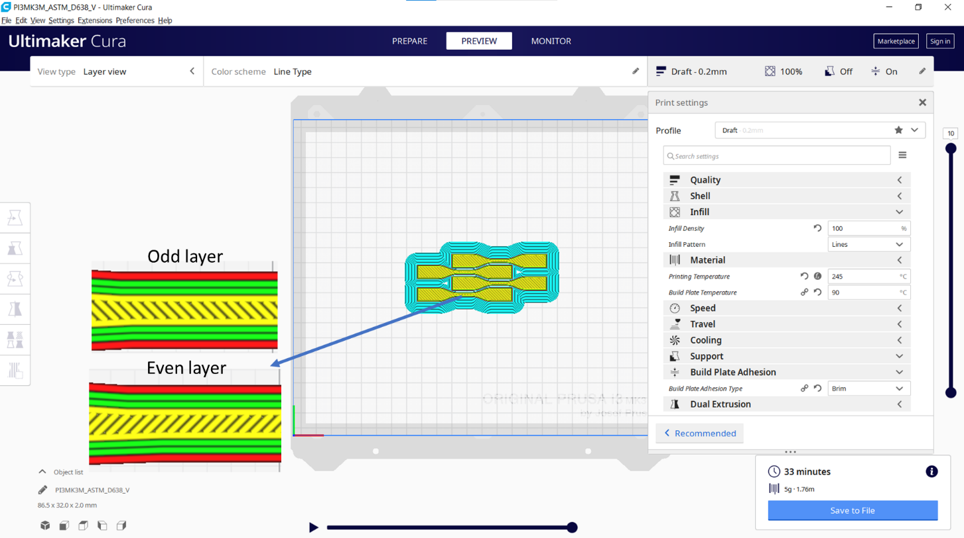
Figure 2. Slicing from Cura for Prusa with specimens manufactured in 33 minutes using 5 grams of material.

In Figure 2, the slicing process for FDM is depicted, showcasing an infill parameter configured at 100%. This deliberate choice is aimed at achieving the utmost density for the targeted layer height. Specifically, in the context of Draft mode, where layers are set at 0.2 mm thickness, the intricate composition involves the incorporation of 10 individual layers.
In Figure 3, the SLA slicing process is shown for Objet 30 Prime printer, encompassing 27 layers in total. Among these, 20 layers, each measuring 0.1 mm, constitute the part, while an additional 7 layers are dedicated to the base for secure platform attachment.
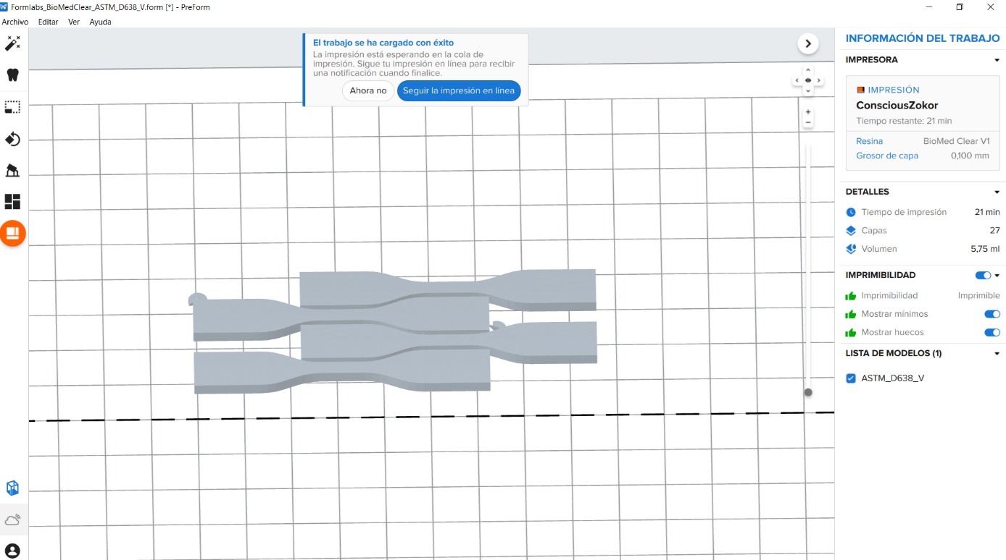
Figure 3. Slicing from Preform for Formlabs BioMed clear V1 specimens manufactured in 21 minutes using 5.75 grams of material.

Time and cost
For each individual setup involving four specimens, a multitude of adjustable parameters employs a discernible impact on manufacturing time. Delving into the realm of cost considerations, the calculations are meticulously derived from the operational experience garnered over the machine's working hours, aimed at spreading the acquisition cost across a seven-year utilization span. To illustrate, envision a machine operational for 500 hours annually. In this instance, the calculation unfolds as follows: 500 hours × 7 years = 3500 working hours. If the original machine cost is set to 7000€, this translates to a cost apportionment of 7000€ / 3500h = 2€/h = 0.033€/min. This column is shown in table 1 and can be changed in Excel file to be downloaded from the material database.
Encompassing these numbers, the equation further incorporates the inclusion of maintenance costs and energy expenditures, yielding the comprehensive cost per minute. Other overhead costs, including labour costs, are not considered because of the substantial differences among geographical regions. It is an attempt to standardize results for comparison purposes.
The essence of the database's design lies in its adaptability, offering users the latitude to configure their cost parameters in harmony with their distinct machine utilization patterns. This dynamic feature underpins the very essence of the database, placing the power to customize cost considerations squarely in the hands of individual users.
Expanding the ambit to material costs, the calculation includes the expenditure of acquiring material while considering the tangible utilization within a tank. On the realm of FDM filament, approximately 80% of material finds purpose, while a portion is forfeited to failed tests and material replacements. Similarly, for object’s material, nearly 40% is lost during washing and material replacement. These empirical experiences intricately factor into the determination of real material costs. Therefore, the true cost of each material must be calibrated to reflect these practical realities, mirroring the authenticity of the user's experience.

Tensile test
Consistency and rigor establish the testing methodology for all tensile specimens, aligning with the established protocol outlined by ASTM D638: Standard Test Method for Tensile Properties of Plastics. Employing an MTS insight equipped with a 10 kN load cell, the testing transpires at a controlled displacement rate of 10 mm/min, meticulously capturing data at a frequency of 50 Hz. This data acquisition, amounting to 300 test points over a 1 mm displacement (1/25=4%) in 60 seconds, ensures a granular understanding of the mechanical response.
Each specimen's grip displacement, load cell force, and time are meticulously documented throughout the testing process, forming a comprehensive data repository. Stress and strain calculations are rendered feasible through engineering equations that presuppose low strain and a uniform cross-section. This foundational approach allows the derivation of these crucial mechanical properties with precision, laying the groundwork for insightful analyses and robust conclusions.
To calculate stress and strain, engineering equations assuming low strain and constant section. Therefore, stress is calculated as measured force divided by initial area $σ=\frac{F}{A}$ where $σ$ is stress, $F$ is force and $A$ is cross section area. Strain is also calculated from measured displacement an initial calibrated length $ϵ=\frac{U}{L}$ where $ϵ$ is strain, $U$ is measured displacement and $L$ is calibrated length assumed to be constant during the test. Please note that changing in calculations $L$ from 10 to 20 mm would imply to obtain a doubled Young’s modulus. For all specimens the same $L$=25 mm was used even though some specimens showed early necking with deformation localised on small length. However, it was considered of interest to always compare the same force-displacement behaviour and therefore all tests used the same cross section and gage length.

- Results
The material database serves as a repository that stores an array of material tests, facilitating comprehensive comparisons across variables such as materials, printers, and costs. Essential mechanical properties like Young's Modulus, yield stress, ultimate stress, and energy can be juxtaposed for insightful analyses. Throughout all tests conducted, the highest recorded force reached 0.8 kN (approximately 125 MPa), which remained well within the range accommodated by the 10 kN load cell.
However, certain soft materials, including Formlabs Flexible 80A and Objet TangoGray, exhibited a greater degree of noise in load measurements compared to the optimal capacity of the current load cell. Despite encountering maximum loads of 0.04 kN (around 6.25 MPa) for these softer materials, the decision was made to retain the same load cell for the sake of maintaining uniformity across the comparisons.
Figure 4, shows a snapshot of the material database, illustrating the meticulous documentation of each printer and material. Each column is a material, printer and setup providing in each row material properties from literature and measured. This documentation encompasses slicing snapshots, downloadable manufacturing files, and material datasheets from providers, fostering seamless comparisons.
The material database further facilitates the generation of diverse graphs, exemplified in Figure 5, which plots yield stress against cost. With the added benefit of an available EXCEL file for the material database, the manipulation of material and printer costs becomes an effortless aim. This inherent flexibility empowers users to refine outcomes based on their unique considerations, thus enhancing the utility and adaptability of the material database.

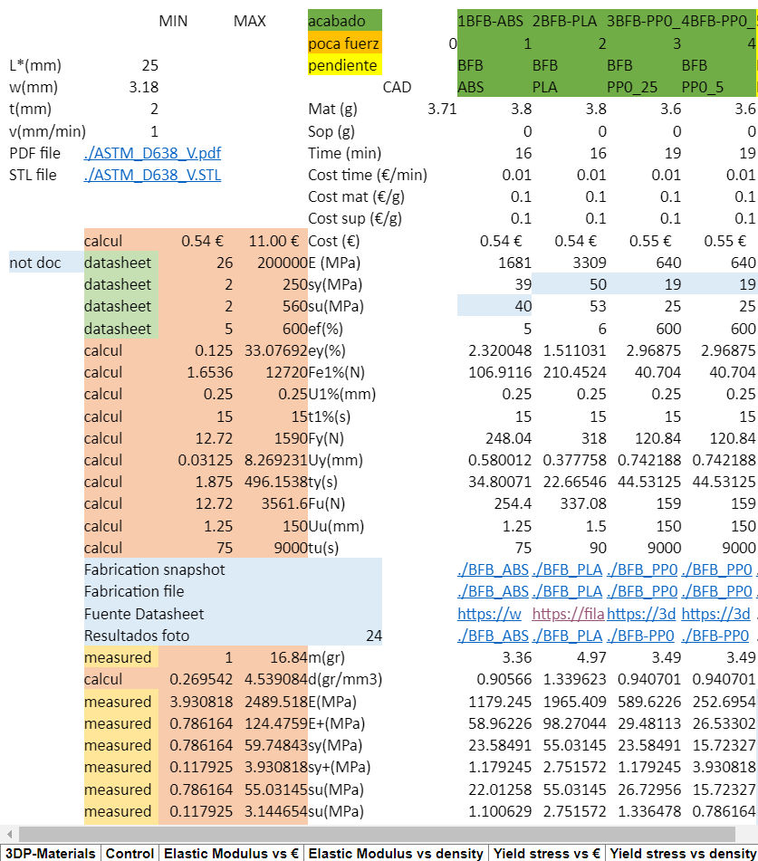
Figure 4. Example of data on material database.

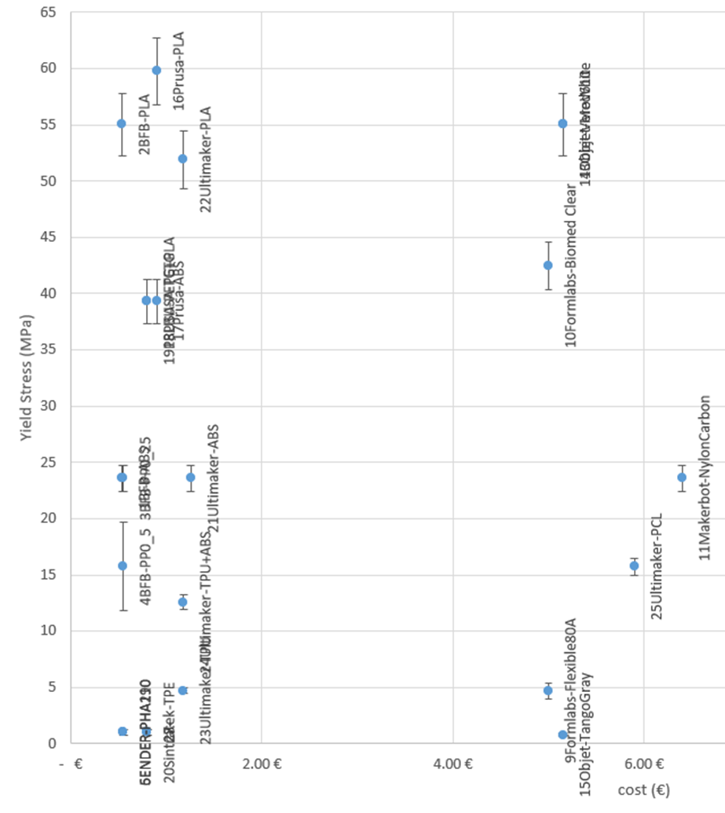
Figure 5. Example of chart showing measured yield stress versus cost.

The material database is producing results in a simplified model material based on a straight elastic line of Young’s modulus E up to yield stress σ_{y} and another straight line to ultimate stress σ_{u} and fracture strain ε_{f}. Figure 6, shows 9 different tensile tests performed on Prusa-PLA material with the same fabrication file. Finally, a PRUSA PLA-model is obtained considering E=2490±125 MPa, σ_{y}=59.5±3 MPa, σ_{u}=52.0±2.5 MPa and ε_{f}=4.0±0.8 %. These error bars are also shown in Figure 5.

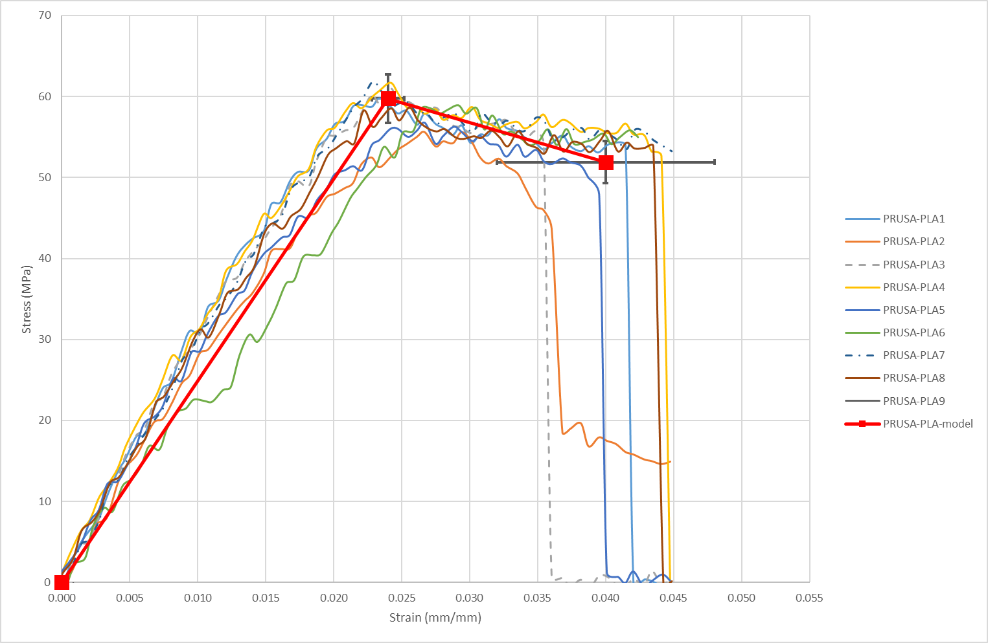
Figure 6. Stress strain curve for PRUSA PLA specimens to obtain variability.

After establishing an extensive overview of the fundamental parameters extracted from various sets of tensile curves, the subsequent step involves a comprehensive analysis of these parameters in relation to a range of relevant factors. These factors encompass density, cost, and variability, among others. Through this multi-faceted analysis, a deeper understanding emerges, shedding light on the intricate correlations and dependencies that underlie the mechanical behavior of the printed materials.

Elastic modulus
The elastic modulus, a fundamental metric, is derived by calculating the slope of the stress-strain curve. While there are distinct definitions for tangent and secant modulus within the realm of polymers, we opt for simplicity by employing a linear fit, illustrated in Figure 6, up to the yield stress.
Upon conducting this analysis across all specimens, the outcomes are synthesized into plots that offer insightful visualizations. These plots showcase the elastic modulus as a function of density in Figure 7, and as a function of cost in Figure 8. To elucidate the relationship between elastic modulus and density, reference lines are incorporated, demonstrating a proportional increase—when density doubles, elastic modulus also doubles.
Remarkably, within this framework, Ultimaker-PLA emerges as an exemplar, exhibiting a particularly favorable elastic modulus-to-density ratio. The same methodology is applied to cost considerations, revealing BFB-PLA's supremacy in the elastic modulus-to-cost ratio.
In essence, this systematic procedure not only determines the interplay between elastic modulus, density, and cost but also covers it within a visual narrative. These comparative insights serve as a compass, steering decisions towards materials that offer optimal trade-offs between elastic modulus, density, and cost parameters.

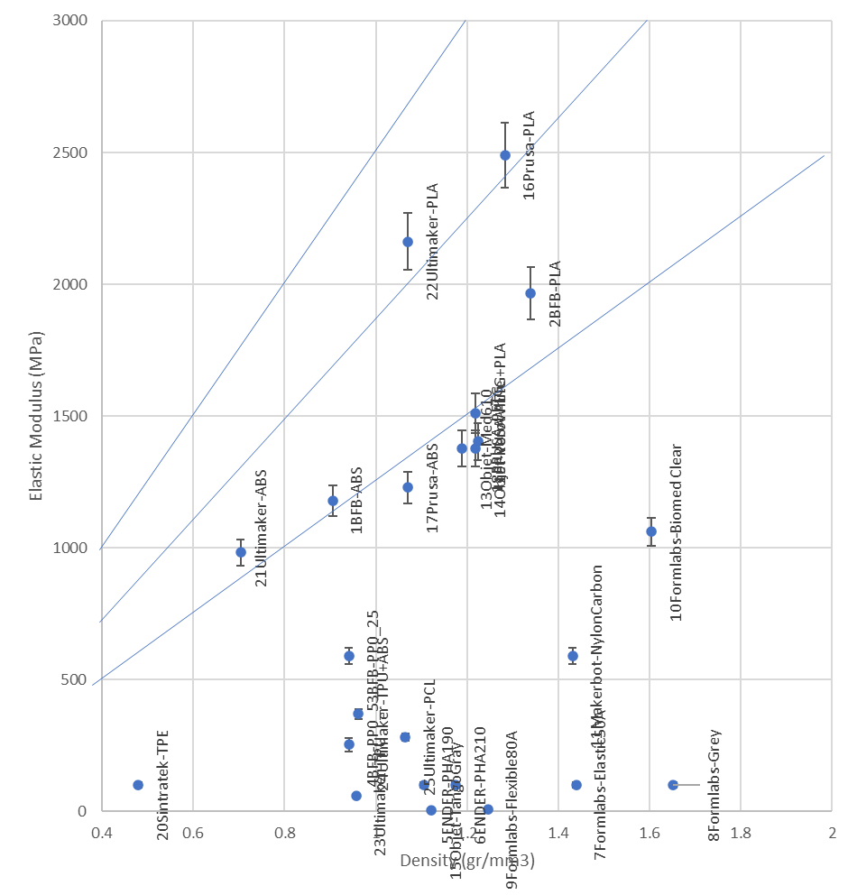
Figure 7. Elastic modulus versus density.

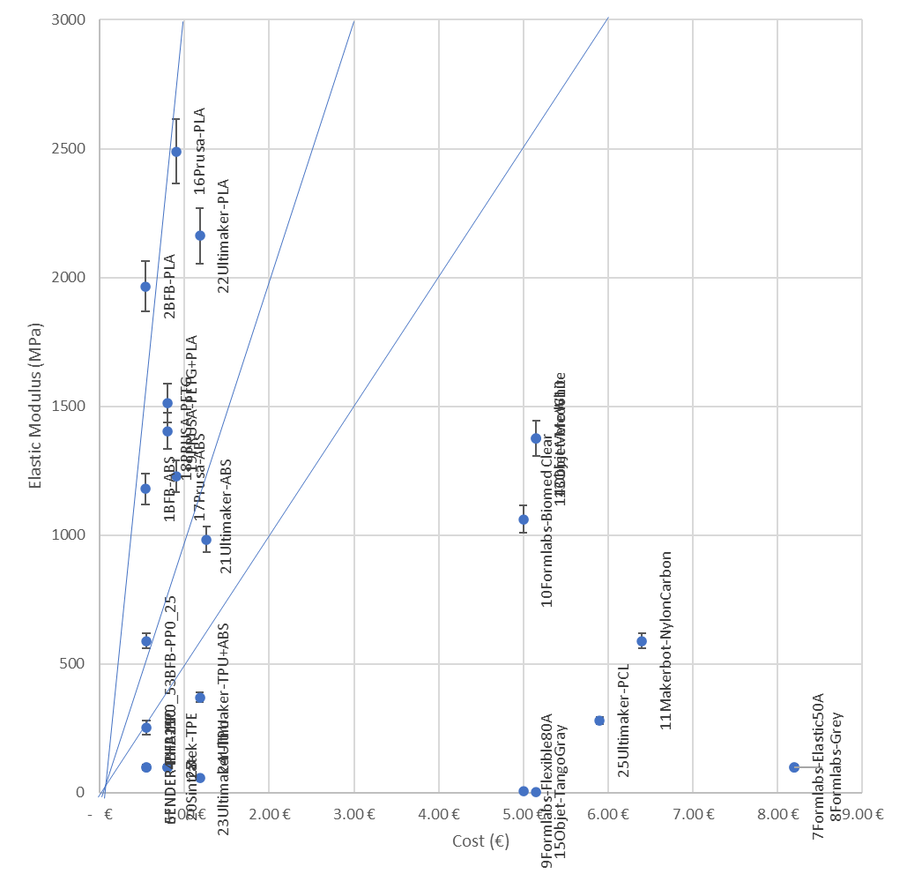
Figure 8. Elastic modulus versus cost.

Yield stress
Yield stress is deduced through the simplification of the stress-strain curve. As depicted in Figure 9, a discernible pattern emerges: Ultimaker-PLA boasts the most favorable yield stress-to-density ratio. Similarly, Figure 10 unveils another crucial insight: BFB-PLA emerges as the leader in the yield stress-to-cost ratio.

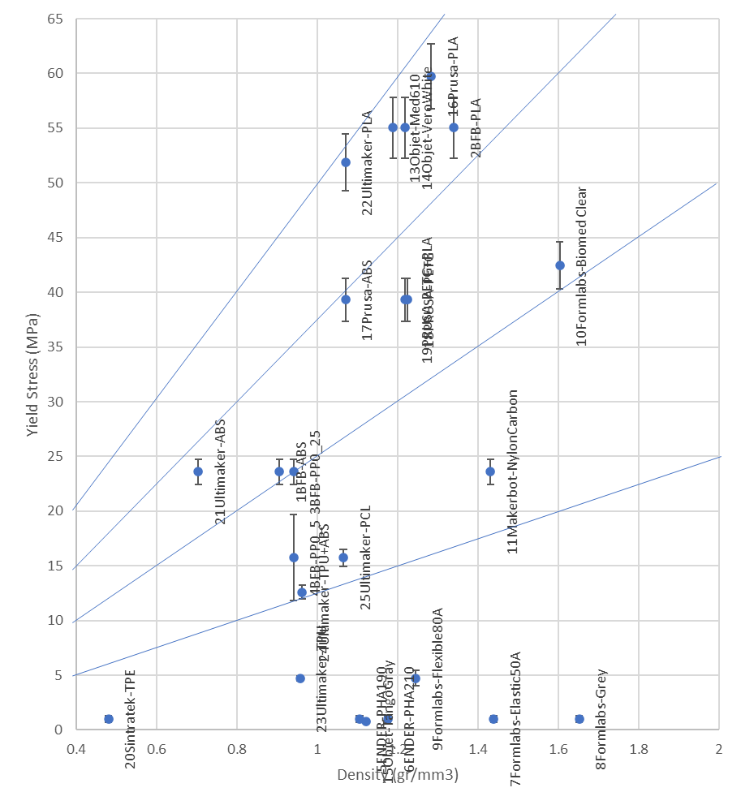
Figure 9. Yield stress versus density.

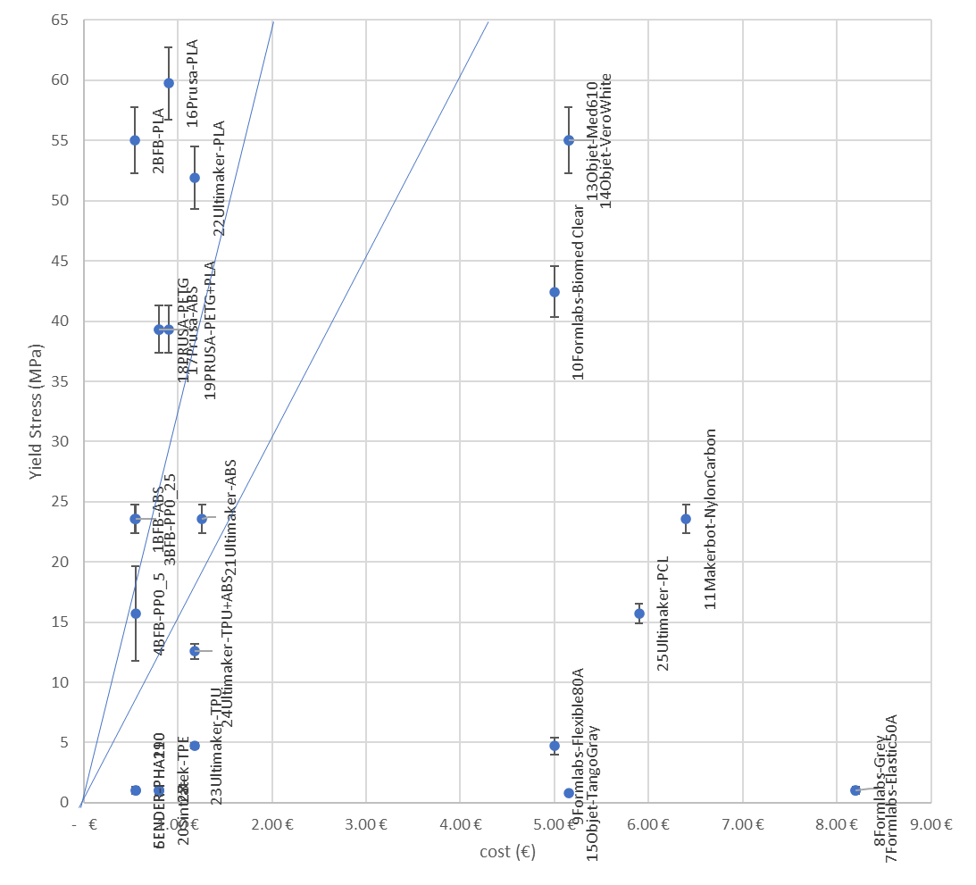
Figure 10. Yield stress versus cost.

Energy
Energy is computed by quantifying the area below the stress-strain curve, expressed in units of N/mm², mJ/mm³, or MJ/m³. To enable more meaningful comparisons, we normalize this energy by dividing it by the actual density of the component, resulting in units of mJ/g or J/kg. Notably, the highest energy yield is achieved by BFB-PP, a standout performer for both 0.5 mm and 0.25 mm layer thicknesses, as depicted in Figure 11. This elevated energy output can be attributed to the substantial deformation witnessed prior to fracture.

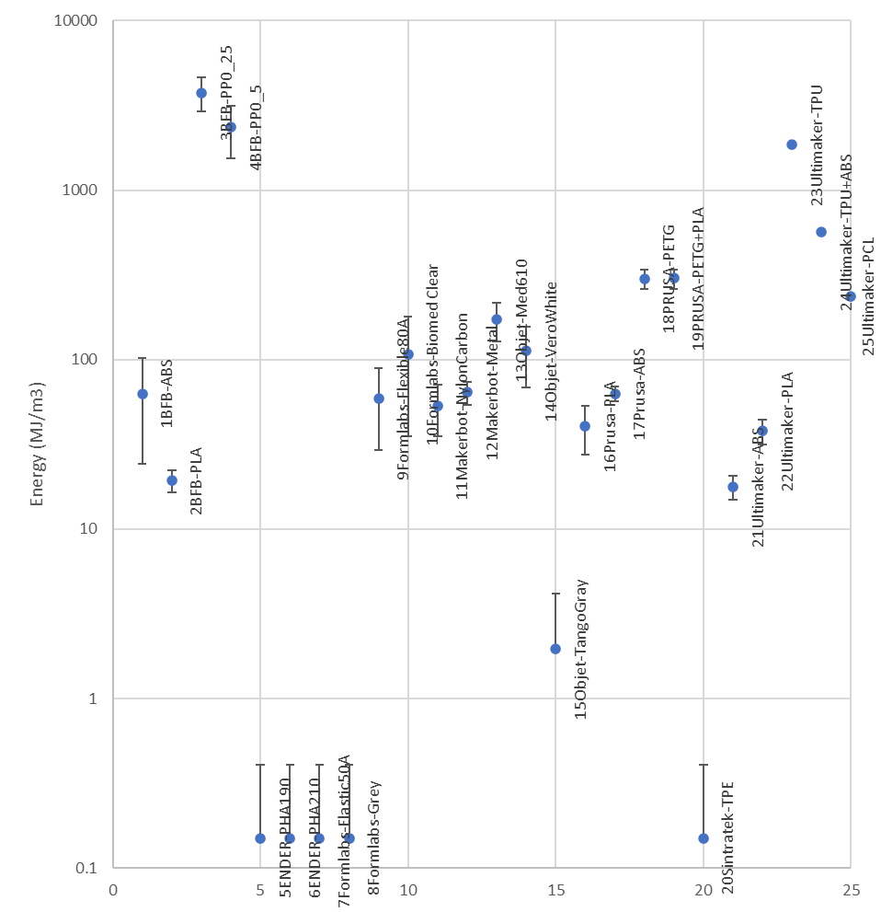
Figure 11. Energy for each material tested.

Interestingly, upon normalization by density, Figure 12 illustrates that there isn't a substantial shift in the observed trends. This suggests that, even when considering the influence of density, BFB-PP retains its position as the leader in energy-to-mass ratios. This stability underscores the robustness of BFB-PP's performance across varying contexts, further solidifying its position as an exceptional energy-absorbing material.

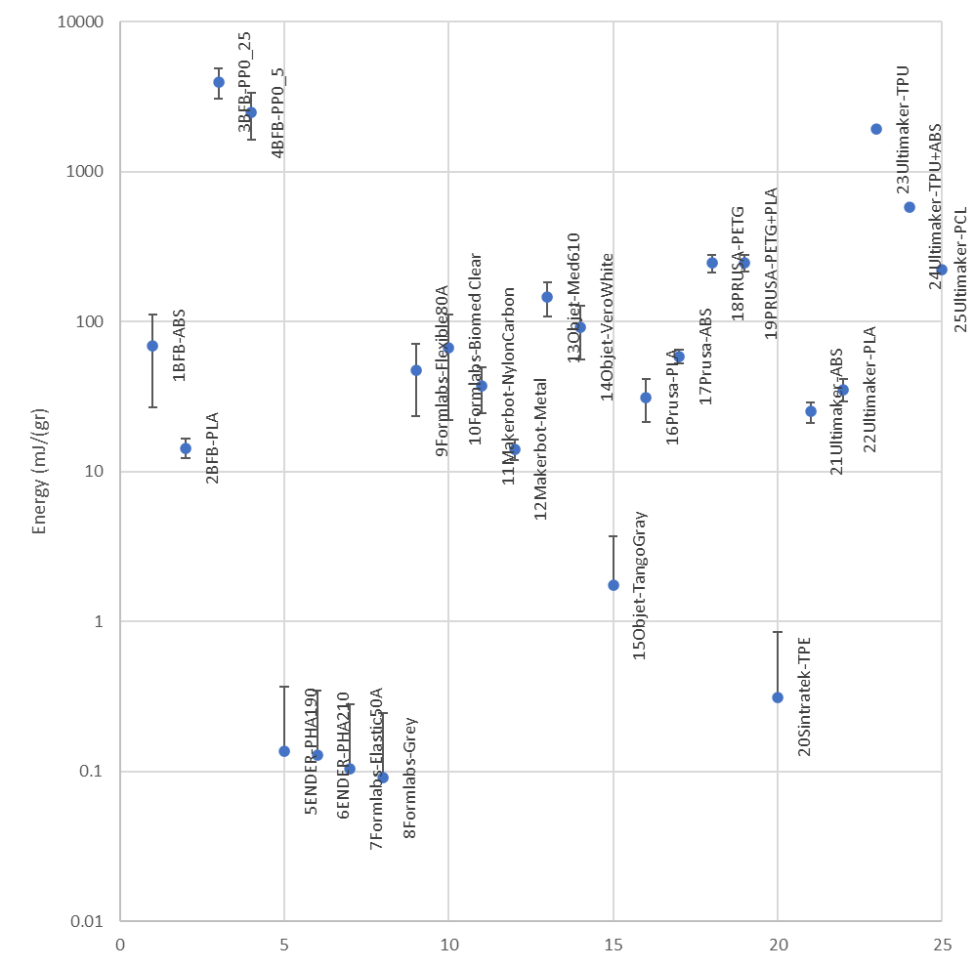
Figure 12. Energy for each material tested normalised for weight.

Stress strain for simplified models
Concluding our analysis, stress-strain relationships for all materials are visually represented using simplified models and a logarithmic scale, enclosed in Figure 13. The congruence with our previous findings is immediately apparent: Prusa-PLA prominently exhibits the highest Young's Modulus and yield stress, mirroring the observations in Figure 7. Similarly, the exceptional fracture strain of BFB-PP, as illustrated in Figure 11, is reaffirmed in this comprehensive depiction.
It is, however, prudent to acknowledge the unique case of Objet TangoGray and Formlabs-Elastic50A. Their values, although presented, warrant a note of caution as they should ideally be validated using a more suitable and smaller load cell. This consideration speaks to the inherent complexities that can arise when handling materials of distinct softness or flexibility and serves as a reminder of the nuanced approaches often required in their examination.

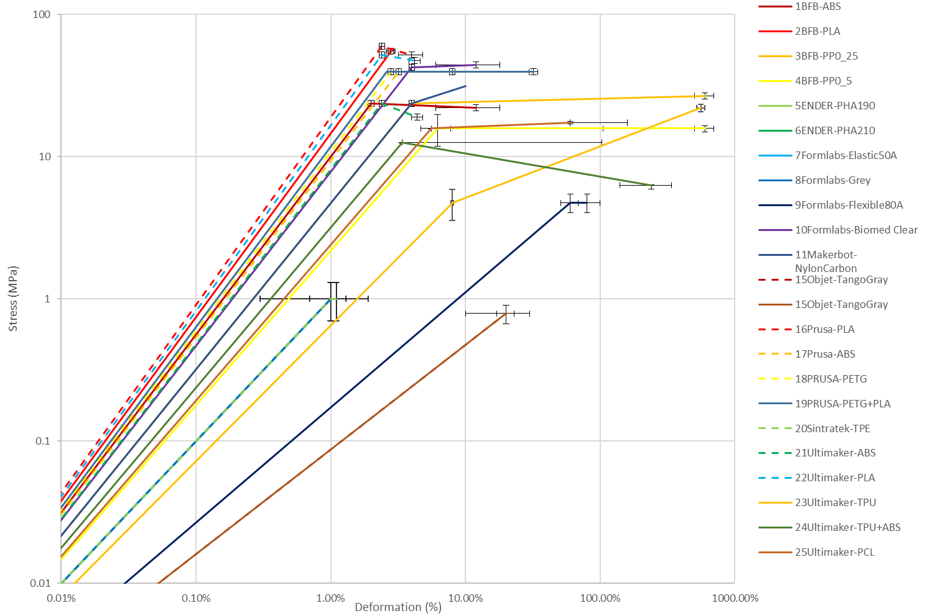
Figure 13. Stress strain for simplified models.

- Conclusions

Concluding this study, we have constructed a comprehensive material database that establish the principle of reproducibility. In this repository, a minimum of four specimens per fabrication file have been meticulously tested in the lab and documented. The adoption of a smaller specimen design for these tensile tests has allowed for reasonable resource management in terms of material and manufacturing time. However, it's important to note that this choice does impose limitations on certain parameters, particularly regarding infill design for experiments.
The material database is thoughtfully designed to facilitate user interaction and adaptation. Available for download in Excel format, it offers the flexibility to adjust material selections and manufacturing costs, thereby aligning with individual user experiences and needs.

From our initial set of experiments, these valuable conclusions have emerged:
- The variation within Young's modulus, yield stress, and ultimate stress remains acceptable within a 10% range, but there's a noticeable 80% scatter in fracture strain, significantly impacting energy absorption.
- Among printed specimens, Ultimaker-PLA leads in the ratio of Young's modulus to density, followed by Prusa-PLA.
- In terms of the ratio of Young's modulus to IQS (industrial quality standards) cost, BFB-PLA takes the lead, trailed by Prusa-PLA.
- Yield stress to density ratio highlights Ultimaker-PLA as a frontrunner, with Objet-MED and Objet-VeroWhite trailing closely.
- The ratio of yield stress to IQS cost identifies BFB-PLA as superior, followed by PRUSA-PLA.
- BFB-PP emerges as the top contender for energy absorption, evident for both 0.5 mm and 0.25 mm layer thickness.
- The creation of simplified stress-strain curves, presented in logarithmic scale with error bars, provides a succinct yet comprehensive means of comparing all materials.

This database marks a foundational step towards establishing a repository for reproducible experiments, supported by consistent testing procedures. As we advance, this resource holds the potential to foster deeper insights, impulse innovation, and facilitate the development of new materials and processes within the realm of additive manufacturing.

References

[1] Ngo, T.D.; Kashani, A.; Imbalzano, G.; Nguyen, K.T.Q.; Hui, D.; 2018 “Additive manufacturing (3D printing): A review of materials, methods, applications and challenges,” Composites Part B: Engineering, vol. 143, pp. 172-196, doi:10.1016/j.compositesb.2018.02.012.
[2] Bhuvanesh Kumar, M.; Sathiya, P.; 2021 “Methods and materials for additive manufacturing: A critical review on advancements and challenges,” Thin-Walled Structures, vol. 159, doi:10.1016/j.tws.2020.107228.
[3] Matweb Material Database 2023, accessed 20 September 2023, https://www.matweb.com/,
[4] Campusplastics material information system for the plastics industry 2023, accessed 20 September 2023, https://www.campusplastics.com/
[5] Grantadesign material selector database 2023, accessed 20 September 2023, https://www.grantadesign.com/
[6] Bourell, D.; Kruth, J.P.; Leu, M.; Levy, G.; Rosen, D.; Beese, A.M.; 2017 “Materials for additive manufacturing,” CIRP Annals, vol. 66, pp. 659-681, doi:10.1016/j.cirp.2017.05.009.
[7] Calignano, F.; Manfredi, D.; Ambrosio, E.P.; Biamino, S.; Lombardi, M.; Atzeni, E.; Salmi, A.; Minetola, P.; Iuliano, L.; Fino, P.; 2017, "Overview on Additive Manufacturing Technologies," in Proceedings of the IEEE, vol. 105, no. 4, pp. 593-612, April 2017, doi: 10.1109/JPROC.2016.2625098.
[8] Kumar, R.; Kumar, M.; Chohan, J.S.; 2021 "Material-specific properties and applications of additive manufacturing techniques: a comprehensive review". Bull Mater Sci 44, 181. doi:10.1007/s12034-021-02364-y.
[9] Garcia-Granada, A. A. ; Catafal-Pedragosa, J.; Lemu, H. G.; 2019 “Topology optimization through stiffness/weight ratio analysis for a three-point bending test of additive manufactured parts,” in IOP Conference Series: Materials Science and Engineering, vol. 700, no. 1, doi: 10.1088/1757-899X/700/1/012012.
[10] Penumakala, P.K.; Santo, J.; Thomas, A.; 2020 “A critical review on the fused deposition modeling of thermoplastic polymer composites,” Composites Part B: Engineering, vol. 201, doi:10.1016/j.compositesb.2020.108336.
[11] Domingo-Espin, M.; Puigoriol-Forcada, J. M.; Garcia-Granada, A. A.; Llumà, J.; Borros, S.; Reyes, G.; 2015 “Mechanical property characterization and simulation of fused deposition modeling Polycarbonate parts,” Mater. Des., vol. 83, pp. 670–677, doi: 10.1016/j.matdes.2015.06.074.
[12] Sola, A. ; Chong, W.J.; Simunec, D.P.; Li, Y.; Trinchi, A.; Kyratzis, I.; Wen, C.; 2023 “Open challenges in tensile testing of additively manufactured polymers: A literature survey and a case study in fused filament fabrication,” Polymer Test. vol. 117, doi:10.1016/j.polymertesting.2022.107859.
[13] Fico, D.; Rizzo, D.; Casciaro, R.; Esposito, C.C.; 2022 “A Review of Polymer-Based Materials for Fused Filament Fabrication (FFF): Focus on Sustainability and Recycled Materials”. Polymers (Basel). Jan 24;14(3):465. doi:10.3390/polym14030465.
[14] Arifvianto, B.; Satiti, B.E.; Salim, U.A.; Nuryanti, A.; Mahardika, M.; 2022, "Mechanical properties of the FFF sandwich-structured parts made of PLA/TPU multi-material". Prog Addit Manuf 7, 1213–1223. doi:10.1007/s40964-022-00295-6.
[15] Dimla, E.; Rull-Trinidad, J.; Garcia-Granada, A. A.; Reyes, G.; 2018 “Thermal comparison of conventional and conformal cooling channel designs for a non-constant thickness screw cap,” J. Korean Soc. Precis. Eng., vol. 35, no. 1, doi:10.7736/KSPE.2018.35.1.95
[16] Salazar-Martín, A. G.; García-Granada, A. A.; Reyes, G.; Gomez-Gras, G.; Puigoriol-Forcada, J. M.; 2020 “Time-Dependent Mechanical Properties in Polyetherimide 3D-Printed Parts Are Dictated by Isotropic Performance Being Accurately Predicted by the Generalized Time Hardening Model,” Polymers (Basel)., vol. 12, no. 3, p. 678, Mar., doi:10.3390/polym12030678.
[17] Criado-Gonzalez, M.; Dominguez-Alfaro, A.; Lopez-Larrea, N.; Alegret, N.; Mecerreyes, D.; 2021 “Additive manufacturing of conducting polymers: recent advances, challenges, and opportunities.” ACS Applied Polymer Materials, vol. 3, no. 6, p. 2865-2883, doi:10.1021/acsapm.1c00252.
[18] AMDB Additive Manufacturing Data Base 2023, accessed 20 September 2023, https://meaagg.com/AMDB/AMDB.html

