Hydrogen Safety Considerations: Mitigating Risks and Securing Operations in Enclosed Spaces

Slawosz Kleszcz11, *, Mohsen Assadi1

1 University of Stavanger, Norway

* slawosz.a.kleszcz@uis.no

**Abstract**. The increased interest in hydrogen as a versatile and environmentally friendly energy carrier has led to its recognition as a potential solution for addressing environmental concerns and challenges associated with transitioning to alternative energy sources. However, working with hydrogen requires careful consideration of safety measures to ensure the safe handling, storage, and utilization of this highly flammable gas. This article focuses on the important safety considerations related to working with hydrogen in enclosed spaces and emphasizes the steps taken to minimize risks. Essential calculations were conducted to determine the concentration of hydrogen within a container during a leak. The findings revealed that, without proper ventilation and safety precautions, the concentration of hydrogen in the container can quickly reach explosive levels. To ensure safe operation, a secure system has been designed and described, which includes the implementation of various detection devices. Additionally, the article discusses the recommended course of action in the event of an explosion. In summary, this study offers a safety analysis of hydrogen leakage in a container. The suggested security system, incorporating detection devices and a safety valve, guarantees the safe functioning of the hydrogen supply system.

# Nomenclature

|  |  |
| --- | --- |
| **Symbol** | **Description** |
| p1 | fuel pressure [bar] |
| p2 | pressure in the container [bar] |
| pb | pressure in gas bottle [bar] |
| pe | critical flow pressure [bar] |
| T1 | fuel temperature [K] |
| T2 | temperature in the container [K] |
| Te | critical flow temperature [K] |
| pt | stagnation pressure [bar] |
| Tt | stagnation temperature [K] |
| D | diameter of fuel pipe [m] |
| $$\dot{m_{H_{2}}}$$ | hydrogen mass flow [m/s] |
| $$γ_{H_{2}}$$ | hydrogen isentropic expansion factor [-] |
| M | Mach number [-] |
| $$ρ_{e}$$ | density at critical conditions [kg/m3] |
| Ae | surface area [m2] |
| ve | critical velocity of fluid [m/s] |
| $$R_{H_{2}}$$ | hydrogen gas constant [J/mol K] |
| ae | speed of sound [m/s] |
| $$\dot{V_{n}}$$ | volumetric flow [m3/h] |
| Vc | volume of container [m3] |
|  | concentration of hydrogen in the room [m3/m3] |
|  | amount of hydrogen added to the room [m3/h] |
| n | number of air volume changes per hour [1/h] |
| t | time [s] |
| c1 | concentration of hydrogen in the room at start [m3/m3] |
| c2 | concentration of hydrogen in the supply fluid [m3/m3] |
| Af | flame surface area [m2] |
| Ain | total internal surface area of the enclosure [m2] |
| Rcl | external cloud radius [m2] |
| pex | internal overpressure [m2] |

# Introduction

Due to the impacts of fossil fuels on climate change the rapid development of renewable power generation has been observed. However, the impact of their inherent intermittency, fluctuation, and difficulty in prediction on the existing electric grid attracts more and more concern. For this reason, hydrogen started to being considered as an important energy store that can maximize the advantages of renewable and sustainable energies [1][2]. The core principle underlying this idea involves a new system that utilizes hydrogen for energy delivery. Such system includes the integration of hydrogen production, storage, transportation, distribution, and applications, as well as other aspects such as education, safety, codes, standards, and regulations. Effective, dependable, and swift monitoring for hydrogen leaks is crucial in guaranteeing the safety of hydrogen storage. Encountering high temperatures, hydrogen embrittlement damage, or external impacts can easily trigger leaks and the spread of high-pressure hydrogen, leading to potentially catastrophic explosions [3]. Unfortunately, hydrogen tends to leak and disperse easily [4], possesses a low ignition energy threshold, has a substantial potential for fuel explosions, and carries a significant amount of explosion energy [5].

The range for ignition volume fraction spans from 4% to 74%, while the explosion volume fraction lies within 18% to 59%. Furthermore, the minimum ignition energy required is just 0.02 mJ [6], which poses a certain level of risk when there is a leak.

Despite of it, hydrogen has an excellent safety record and is as safe for transport, storage and uses as many other fuels. Nevertheless, safety remains a top priority in all aspects of hydrogen energy. The hydrogen community addresses safety through stringent design and testing of storage and transport concepts, and by developing codes and standards for all types of hydrogen-related equipment. [7]

Up to this point, there has been extensive research conducted on the efficiency of ventilation. Cerchiara et al. [8] studied ventilation conditions related to a minor leak situation in which the hydrogen concentration did not exceed 2 vol% in a fuel cell room with a ventilation opening and a ventilation fan. Hyon at al [9] performed experiments and analyses on higher volumes of hydrogen leakage from household fuel cell rooms and reduced hydrogen concentrations through a variety of methods such as ventilation openings, ventilation fans, and automatic supply shutoff devices. Although the hydrogen concentration in a small hydrogen fuel cell room for home use can rapidly increase, a rapid reduction in the concentration of hydrogen with an appropriate ventilation system has been experimentally proven. In addition, natural and forced ventilation were studied as a function of the sizes, positions, leak quantities, and flow rates of vents [10-13]. In accordance with these findings, a new method was proposed for forced ventilation based on real-time sensing.

As hydrogen-based research and applications continue to advance, the need for detecting and monitoring hydrogen gas has grown significantly to prevent the risks associated with its leakage and potential explosions [14]. Due to hydrogen lacks color, odor, and taste, it remains imperceptible to human senses [15]. The aspect for a reliable use of hydrogen sensors is its functional safety. This aims to evaluate possible malfunctions and their consequences, especially from the electronic part of systems or equipment, in order to avoid unacceptable risks of relating physical injuries or damages to the human health [14]. Hence, sensitive, and reliable detection of hydrogen gas has become a major need [16].

This study presents a risk assessment needed to be conducted to evaluate the operational safety of hydrogen turbine operating in the container. The primary objective has been to prevent the accumulation of explosive gas mixtures in case of fuel gas leakage into the container. Using the worst-case scenario as a basis, calculations were performed to design an evacuation system. Further safety margins have been incorporated by considering additional safety factors in the chosen parameters to enhance the overall safety level.

1. Case description

In the pursuit of researching and developing gas turbines capable of utilizing hydrogen and hydrogen blends, a decision was made to establish a test rig within a container to increase its portability (fig. 1). Therefore, it became essential to conduct a risk assessment to thoroughly appraise the operational safety of this unit. The primary objective has been to prevent the accumulation of explosive gas mixtures in the event of fuel gas leakage into the container. To ensure that the hydrogen concentration does not exceed the ignition limit of 4%, a continuous ventilation of the container needs to be upheld through an open intake system, supported by a blower. Considering the worst-case scenario, represented by a pipe rupture event, the fuel system safety valve will be automatically triggered by fuel detections sensor, leading to its closure. This safety measure, coupled with the continuous evacuation process, is intended to uphold hydrogen concentrations within the container well below the threshold for potential explosion.

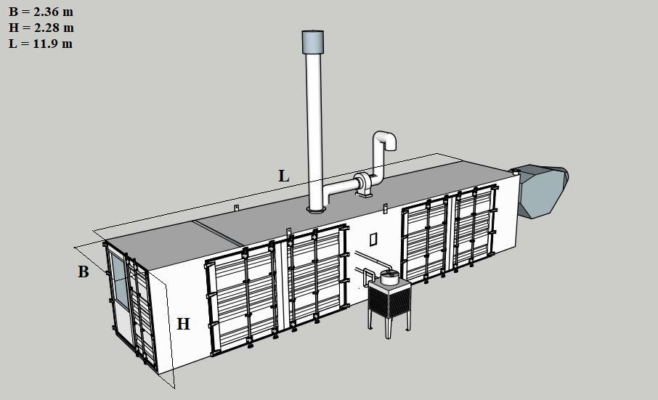

|  |
| --- |
| **Figure 1.** Steel container with basic dimensions. |

## Hydrogen supply system

To ensure the requisite fuel pressure within the combustion chamber a fuel delivery pressure of 10 bars (p1) is required. This pressure accounts for the anticipated losses incurred due to pressure drops in both pipes and fuel valves. In the unfortunate event of pipe damage, the fuel would be released into the container, which maintains atmospheric pressure (p2). Given that the fuel gas originates from a gas bottle pressurized at 200 bars (pb), it is reasonable to assume that the gas parameters after reduction valve can be represented using the concept of stagnation state.

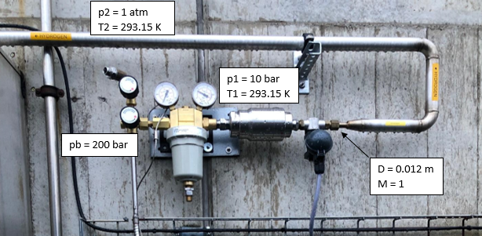

|  |
| --- |
| **Figure 2.** Photo of hydrogen supply system. |

During chocked flow conditions, the velocity at the system narrowest juncture – situated immediately after the safety valve within the pipeline – aligns with critical flow, denoted as Mach = 1. This circumstance restricts the mass flow rate that can traverse the system. The diameter of this specific pipe is designated as D = 0.012 m. The principal parameters for calculations are indicated in figure 2.

## Critical temperature and pressure for chocked flow

Assuming ideal gas behaviour, steady state choked flow occurs when the downstream pressure falls below the critical value. The value for the critical pressure (1) and temperature (2) can be calculated by the following equations:

$p_{e}=p_{t}{\left(\frac{2}{γ_{H_{2}}+1} {∙M}^{2}\right)}^{\frac{γ_{H_{2}}}{γ_{H_{2}}-1}}= 5.81 bar$ (1)

$T_{e}=T_{t}∙ \frac{2}{γ_{H_{2}}+1}{∙M}^{2}=244.3 K$ (2)

## Mass flow through the pipe rapture

Applying the conservation of mass (3), relationships for Mach number (4), the speed of sound (5), and the ideal gas law (6), the convenient equation that apply for the mass flow rate through the pipe is given by (7):

$\dot{m_{H_{2}}}= ρ_{e}A_{e}v_{e}=const$ (3)

$v_{e}=Ma_{e}$ (4)

$a_{e}=\sqrt{γ_{H_{2}}R_{H_{2}}T_{e}}$ (5)

$p_{e}=ρ_{e}R_{H_{2}}T_{e}$ (6)

$\dot{m_{H_{2}}}= ρ_{e}A_{e}V_{e}=\left(\frac{p_{e}}{R_{H_{2}}T_{e}}\right)A_{e}\left(M\sqrt{γ_{H_{2}}R_{H_{2}}T_{e}}\right)=0.0775 \frac{kg}{s}$ (7)

1. Leakage safety considerations

## Ventilation of the container

Any structure that incorporates components utilizing hydrogen must possess appropriate ventilation. The standard air exchange rate (as stipulated for continuous ventilation designed for the container) should be 0.3 m³ of air per minute and per square meter of solid floor space (8), as outlined in reference [17]. Consequently, the hourly evacuation volume count (9) is formulated as follows:

$\dot{V_{n}}= 11.9 m∙ 2.36 m∙0.3 \frac{m^{3}}{min}=8.43 \frac{m^{3}}{min}=505.8 \frac{m^{3}}{h}$ (8)

$n= \frac{\dot{V_{n}}}{V_{c}}=\frac{505.8 \frac{m^{3}}{h}}{45.64 m^{3}}= 11.1 \frac{1}{h}$ (9)

It is assumed that number of the volume changes per hour is going to be 12 for continuous ventilation of the container.

## Concentration of hydrogen in the container during leakage

The generic equation for hydrogen concentration can be calculated by equation (10). It is presupposed that the hydrogen is homogeneous mixture with air within the container:

$c_{H_{2}}= \frac{q_{H_{2}}}{nV_{c}\left(1-e^{-nt}\right)}+\left(c_{1}-c_{2}\right)e^{-nt}+c_{2}$ (10)

Where: $c_{H_{2}}$ – concentration of hydrogen in the room when perfectly mixed (m3/m3), – amount of hydrogen added to the room (m3/h), n – number of volume changes per hour (h-1), Vc – volume of the container (m3), t – time (h), c1 – concentration of hydrogen in the container at start (m3/m3), c2 – concentration of hydrogen in the supply fluid (m3/m3).

The results derived from the solved equation (10) have been visualized in figure 3. As showed on the graph, it becomes evident that the hydrogen contamination within the container surpasses 4% within a span of 2 seconds, rendering it to a combustible mixture.

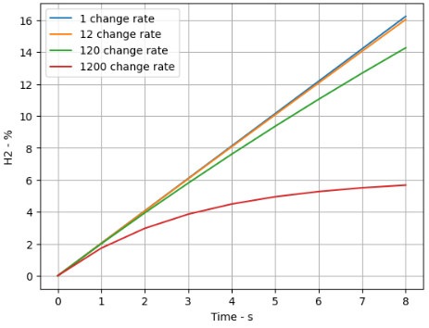

**Figure 3.** The hydrogen concentration in the container over time with ventilation.

It’s clear that almost no ventilation system can guarantee safe operation in the event of pipe rapture. The approach presented above is employed to evacuate hydrogen from the container after successful halted leak, and in instances of minor leaks within the system, it hinders the build-up of combustible mixtures.

1. Security system

The most secure option involves interruption of the fuel supply in the event of a malfunction, but the solution should be adaptable without disrupting the device standard functioning. Therefore, the main protection will be a shut-off valve triggered by a peripheral device. Positioned on the supply line, a safety valve halts hydrogen flow when leakage is detected. The valve is controlled by the PLC controller, and it is triggered by signals from three different sources of gas leakage detection, pressure transmitter, mass flow meter and hydrogen sensor.

The maximum closing time $t_{sc }$ of the safety valve (model Burkert type 6240) [18] is 0.1 second and the scan cycle speed $t_{PLC}$ for PLC controller is 0.015 second.

## The pressure transmitter

The pressure transmitter (model: WIKA E-10) [19] is continuously checking the pressure in the pipe. In case of pressure decrease in the fuel line closing signal for the safety valve is passed via PLC controller. The settling time for pressure transmitter $t_{pt}$ is 0.002 second. To prevent unintentional stoppage of the turbine due to fluctuation of pressure measurement the signal from transmitter must be filtered. It is assumed to take in average 100 samples as security signal (11):

$t_{av_pt}=100∙0.002=0.2 s$ (11)

According to this information the total time t1t needed from detecting the leakage to closing the valve is equal to or less than sum of the times above (12):

${t_{1t}=t}_{sc}+ t_{av_pt}+t_{PLC}=0.315 s$ (12)

## Mass flow meter

The mass flow meter is controlling amount of gas delivered to the turbine. In case of pipe rapture, the value will differ significantly from the set value.

The typical Indication Response Time $t_{mf}$ for this device (model Alicat 5000 SLPM) [20] is 0.01 second. Similarly, the signal should also be filtered (13) in this case:

$t_{av_mf}=100∙0.01 s=1s$ (13)

According to this information the total time t2t needed from detecting the leakage to closing the valve is equal to or less than the sum of the times above (14):

${t_{2t}=t}_{sc}+ t_{av_mf}+t_{PLC}=1.115 s$ (14)

## Hydrogen sensor

The hydrogen sensor is measuring the concentration of the hydrogen inside the container.

The response time for this device $t_{hs50}$ (model Oldham OLCT 100 XP) [21] is 30 second. Where ths50 refers to the time it takes for the sensor to respond with an output signal that is 50% of the full value of the gas being detected (15). Havin ths50 and knowing the concentration rate of hydrogen in the room over time (fig. 4) we can estimate the detection level of the sensor.

$t_{res}=c_{H_{2}}*(1-{0.5 }^{(\frac{t}{T50})})$ (15)

where: $c_{H_{2}}$ is concentration of hydrogen in the room, t is the time, and T50 is the response time of the device.

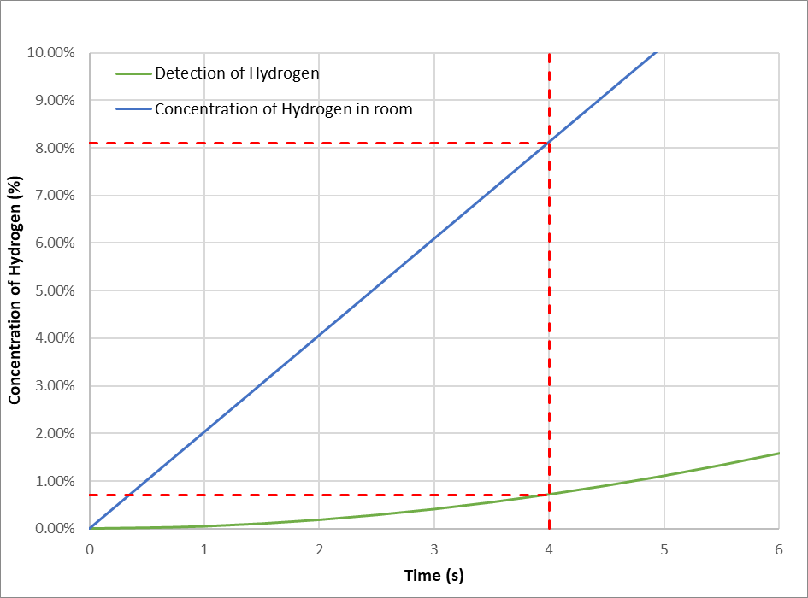

**Figure 4.** The response of detector over time during leakage.

Based on this data, the overall time t3t required from leak detection to valve closure is either equal to or less than the cumulative times (16) indicated above.:

${t_{3t}=t}_{sc}+ t_{hs90}+t_{PLC}=4.115 s$ (16)

The sensor must be set on alarm at 17% of LEL.

## The results

The 3-step secure solution for the gas leakage is presented in figure 5. Each security step operates autonomously, and in the event of a power failure, the safety valve will autonomously close (valve position: normally closed). The performance of the hydrogen sensor is significantly influenced by its installation position, and this factor can lead to further delays in the triggering time. Consequently, the following paragraph examines the scenario of an explosion.

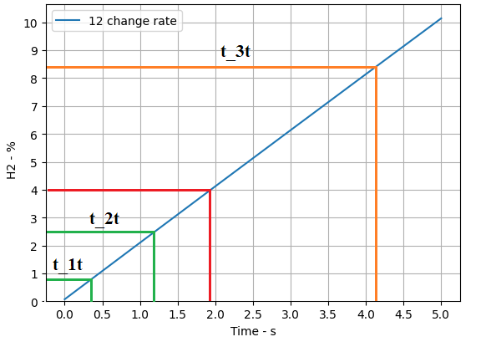

**Figure 5.** Hydrogen concentration in the container after activation of safety valve triggered by a) pressure sensor and mass flow meter (green line), b) hydrogen sensor (orange line).

Figure 6 displays the duration required for complete ventilation of the container when employing the hydrogen sensor as the triggering mechanism. After 200 seconds, it is anticipated that the air-hydrogen mixture will have reached a hydrogen concentration below the safety threshold of 4%.

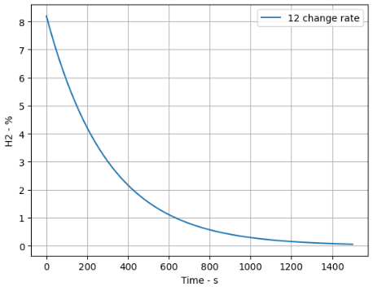

**Figure 6.** Concentration of hydrogen in time during ventilation process.

1. Explosion safety considerations

In the event of a hydrogen explosion, the emphasis was placed on constraining the highest level of overpressure generated by the explosion through careful sizing of the technical opening. The calculations for determining the vent size were derived from the referenced article [22], wherein the authors presented simplified formulas for estimating the highest peak pressure within a vented volume when a hydrogen explosion occurs. Steps for computing the Internal Overpressure (IO) are presented below:

1. Compute flame surface area for ignition at the centre of the enclosure (17) (Af):

(17)

where Ain is the total internal surface area of the enclosure (18):

$A_{in}=2∙\left(L∙B+B∙H+H∙L\right)$ (18)

1. Compute external cloud radius using Eq. (19)

$R_{CL}=0.5V^{0.3}$ (19)

where V is the volume of the enclosure.

1. Compute G1 and G2 using Eq. (20) and (21). Select β1 and β2 from table A2 in the reference.

$G1= \left[{\left(L_{eff}^{β1}\right)}^{2}\left\{{\left(\frac{A_{f}}{A_{v}}\right)}^{2}-1\right\}\right]$ (20)

$G2= {\left[R_{Cl}^{β2}\right]}^{2}$ (21)

Where Leff for ignition at the centre of the enclosure can be defined as:

$${ L}_{eff}=0.5 L$$

1. Compute internal overpressure using eq. 22. Select F1 and F2 from table A1 for hydrogen.

$p_{ex}= \left(F1∙G1\right)+ \left(F2∙G2\right)$ (22)

Results for the overpressure calculations for different vents opening sizes are shown at figure 7.

**Figure 7.** Peak pressure for different concentration of hydrogen with vent opening due to explosion.

Referring to Table 1, which outlines the correlation between damage and the resultant overpressure caused by an explosion, along with the information depicted on fig. 7, we can derive an estimation for the required opening size. As illustrated in fig. 6, if two security levels were to fail, the hydrogen concentration could potentially increase by up to 9%. Therefore, considering our approach, it was opted for an opening size of 1 m².

|  |  |
| --- | --- |
| **Table 1.** Level of damage expected at specific overpressure values. [23] | |
| Overpressure  (psig) | Expected Damage |
| 0.04 | Loud noise (143 dB), sonic boom glass failure |
| 0.15 | Typical pressure for glass failure |
| 0.40 | Limited minor structural damage |
| 0.50-1.0 | Windows usually shattered, some window frame damage. |
| 0.70 | Minor damage to house structures. |
| 1.0 | Partial demolition of houses, made uninhabitable |
| 1.0-2.0 | Corrugated metal panels fail and buckle. Housing wood panels blown in. |
| 1.0-8.0 | Range for slight to serious laceration injures from flying glass |
| 2 | Partial collapse of walls and roofs of house |
| 2.0-3.0 | Non-reinforced concrete of cinder block walls shattered |

1. Summary and conclusion

In conclusion, maintaining continuous ventilation is imperative when dealing with hydrogen systems, particularly in scenarios involving minor leaks, to avert the formation of potentially hazardous mixtures. However, it's essential to integrate this ventilation approach with other security measures to comprehensively ensure the safety of the entire system operation. Nowadays modern electronic devices exhibit rapid response times, enabling the detection of gas leaks within seconds. The key consideration lies in selecting the appropriate device and strategically deciding upon the installation location. Additionally, each system should undergo preliminary testing with inert gases to fine-tune the sensors responses and guarantee accurate system operation. In the event of an explosion, damage can potentially be mitigated by strategically weakening the construction at specific points. In summary, it is feasible to create a secure working environment for hydrogen-related operations.

References

[1] Zhang F, Zhao P, Niu M, Maddy J 2016 The survey of key technologies in hydrogen energy storage, Int. J. Hydrogen Energy 41, 14535–14552.

[2] Zainul A, Zafaranloo A, Rafiee A, Merida W, Lipinski W, Kaveh K 2020 Hydrogen as an energy vector, Renewable and Sustainable Energy Reviews 120.

[3] Xianfeng C, Chuncheng Z, Yi L 2022 Research and development of hydrogen energy safety, Emergency Management Science and Technology 2, 3.

[4] Hajji Y, Bouteraa M, ELCafsi A, Belghith A, Bournot P, Kallel F 2015 Natural ventilation of hydrogen during a leak in a residential garage, Renewable and Sustainable Energy Reviews 50, 810-818.

[5] Borman G L, Ragland K W 1998 Combustion engineering, (NewYork: McGraw-Hill).

[6] Herath I, Madeley D, Bradshaw B. Hydrogen Fuel Cell taxi: Safety analysis experiences. 4th IET International Conference on System Safety (November 2009).

[7] Momirlan M, Veziroglu T N 2005 The properties of hydrogen as fuel tomorrow in sustainable energy system for a cleaner planet, Int. J. Hydrogen Energy 30, 795–802.

[8] Cerchiara G M, Mattei N, Schiavetti M, Carcassi M N 2011 Natural and forced ventilation study in an enclosure hosting a fuel cell, Int. J. Hydrogen Energy 36, 2478–2488.

[9] Hyon W J, Hongcheol L, Inju H, Heela J 2022 Safe Ventilation Methods against Leaks in Hydrogen Fuel Cell Rooms in Homes, Energies 15, 5434.

[10] Matsuura K 2009 Effects of the geometrical configuration of a ventilation system on leaking hydrogen dispersion and accumulation, Int. J. Hydrog. Energy 34, 9869-9878.

[11] Matsuura K, Nakano M, Ishimoto J 2010 Forced ventilation for sensing-based risk mitigation of leaking hydrogen in a partially open space, Int. J. Hydrog. Energy 35, 4776-4786.

[12] Matsuura K, Nakano M, Ishimot J 2012 Sensing-based risk mitigation control of hydrogen dispersion and accumulation in a partially open space with low-height openings by forced ventilation, Int. J. Hydrog. Energy, 1972-1984.

[13] Matsuura K, Nakano M, Ishimoto J 2012 Acceleration of hydrogen forced ventilation after leakage ceases in a partially open space, Int. J. Hydrog. Energy 37, 7940-7949.

[14] Hübert T, Boon-Brett L, Palmisano V, Bader M A 2014 Developments in gas sensor technology for hydrogen safety, Int J Hydrogen Energy 39, 20474-20483.

[15] Spencer C L, Watson V, Hippler M 2012 Trace gas detection of molecular hydrogen H2 by photoacoustic stimulated Raman spectroscopy, (PARS) Analyst 137, 1384-1388.

[16] Buttner W J, Post M B, Burgess R, Rivkin C 2011 An overview of hydrogen safety sensors and requirements, Int J Hydrogen Energy 36, 2462-2470.

[17] <https://h2tools.org/bestpractices/ventilation>, access on day: 13.10.2023.

[18] Technical documentation of sensor: <https://www.burkert.com/en/type/6240>, access on day: 13.10.2023

[19] Technical documentation of sensor: <https://www.wika.com/en-in/e_10_e_11.WIKA>, access on day: 13.10.2023.

[20] Technical documentation of sensor: <https://store.alicat.com/products/m-5000slpm-d>, access on day: 13.10.2023.

[21] Technical documentation of sensor: <https://www.teledynegasandflamedetection.com/en-us/olct-100-olc-100-toxic-and-combustible-gas-detector>, access on day: 13.10.2023.

[22] Sinha A., Wen J. X 2019 A simple model for calculating peak pressure in vented explosions of hydrogen and hydrocarbons, International journal of hydrogen energy 44.

[23] Frank P 1980 Loss Prevention in the Process Industries, Lees Vol. 1 (London and Boston: Butterworths).

Appendix

|  |  |  |
| --- | --- | --- |
| **Table A1.** F1 and F2 values for various hydrogen concentrations. Here E refers to the power of 10. | | |
| **H2%** | **F1** | **F2** |
| 10 | 1.78E-05 | 1.04E-03 |
| 11 | 2.33E-05 | 1.52E-03 |
| 12 | 3.55E-05 | 2.57E-03 |
| 13 | 5.79E-05 | 4.61E-03 |
| 14 | 9.56E-05 | 8.29E-03 |
| 15 | 1.55E-04 | 1.46E-02 |
| 16 | 2.44E-04 | 2.47E-02 |
| 17 | 3.72E-04 | 4.02E-02 |
| 18 | 5.49E-04 | 6.30E-02 |
| 19 | 7.87E-04 | 9.52E-02 |
| 20 | 1.10E-03 | 1.40E-01 |
| 21 | 1.49E-03 | 1.98E-01 |
| 22 | 1.99E-03 | 2.75E-01 |
| 23 | 2.60E-03 | 3.72E-01 |
| 24 | 3.34E-03 | 4.92E-01 |
| 25 | 4.22E-03 | 6.38E-01 |
| 26 | 5.26E-03 | 8.12E-01 |
| 27 | 6.48E-03 | 1.02E+00 |
| 28 | 7.89E-03 | 1.25E+00 |
| 29 | 9.51E-03 | 1.52E+00 |
| 30 | 1.14E-02 | 1.82E+00 |

|  |  |  |
| --- | --- | --- |
| **Table A2.** Value of β1 and β2 used for various configurations for hydrogen. | | |
|  | **β1** | **β2** |
| **Ideal** | 0.243 | 0.243 |
| **obstacle-low congestion** | 0.243 | 0.243 |
| **obstacle-high congestion** | – | – |
| **Initial turbulence** | 0.5 | 0.243 |