Assessment of awarness levels towards additive manufacturing best practices in transforming traditional manufacturing: A case study in Ethiopian context
T Lemma^{1*}, H G Lemu²
¹College of Engineering and Technology, Wallaga University, Nekemte, Ethiopia;
²Faculty of Science and Technology, University of Stavanger, N-4036 Stavanger, Norway

* Email: - tekalignlemma507@gmail.com
Abstract:- The main objective of this study is to assess the awarness levels of acadamic staffs and industry experts towards the best practices of additive manufacturing (AM) in transforming traditional manufacturing (TM) in local context. The study used closed ended questionnaires with 1-5 liker scales to collect secondary data from the respondents. The collected data’s were analyzed using descriptive statistics (frequency and percentage) by using SPSS v20 software.The findings of this paper identified ten (10) AM best practice benefit factors (Resource consumption benefit factor, Waste management benefit factor, Pollution control benefit factor Material utilization benefit factors, Design optimization benefit factor, Manufacturing flexibility best practice factors, SC flexibility benefit factors, SC network improvement benefit factor, Cost reduction benefit factors, Ability of changing customer demand benefit factors) in transforming traditional manufacturing in local context. Among the eight AM best practices both academic staffs and industry experts have common awareness level on five factors. In addition, the findings of the study showed that 49% of academic staffs and 37% of industry experts have good awarness levels towards the identified AM best practices in transfornig traditional manufacturing.Based on the findings of this studyconceptual framework was developed for future research work to quantitatively investigate the effects of AM best practices on traditional manufacturing performmance.
Keywords: Additive manufacturing, Pros of additive manufacturing, traditional manufacturing, best practices, transforming, awareness levels
- Introduction
Additive manufacturingis the manufacturing process that joins materials to make objects based on 3D design data, usually in a layer-upon-layer manner and this technology was launched in the 1960s[1-3]. It is a means of rapid prototyping and manufacturing for components or products for actual end use, and it is a significant technology in the fourth industrial revolution [4, 5].Around the world different types of AM technologies (processes) are used such as:- Stereo-lithography Apparatus (SLA), Fused Deposition Modeling (FDM),Binder jetting (BJ), Selective Laser Sintering (SLS), Selective Laser Melting (SLM), and Electron Beam Melting (EBM). These technologies are classified into three categories base on the types manufacturing methods: liquid-based, solid-based, and powder-based. Among these, Liquid-based and powder-based systems dominate the industry today [6].Different types of materials can be utilized in these AM processes such as: - Plastics, Resins, Rubbers, Ceramics, glass, concretes, and metals [7].And AM technologies used these materials for different applications such as: lighter weight products, multilateral products, ergonomic products, efficient short production runs and fewer assembly errors. The benefits of AM has been studied and reported in different research papers. For example according to[7]AM has the potential to reduce cost of production, logistics, inventories, and in the development and industrialization of a new product; reduce time to market, minimize materials and energy usage, and cut down waste[8]. And also AM could promote shorter, localized, collaborative, and more sustainable supply chains[9];reduceraw material utilization and minimizes manufacturing and improveEnvironmental pollution [10, 11].
Even if the review parts of this paper indicated the best practices of AM in transforming traditional manufacturing(TM), the attention given varies from continent to continent. As shown in Figure 1(a), for the past decade, 49% of the studies were conducted in Europe, 22% in North America, 16% from Asia, 11% in South America and 3% in Africa. In addition, the availability of AM system as shown in Figure1(b) in the world indicated that 33% in North America, 26% in Europe, 24% in Asia and 17% in Central and South America.This indicated that still there is technological advancement difference and knowledge gap between developed and undeveloped countries like Ethiopia.

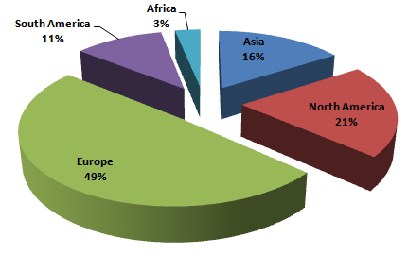
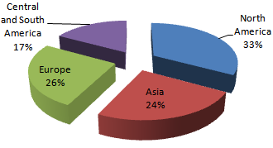
(a) (b)
Figure 1.(a) Published paper by continent, (b) AM installation per continent (Wohler’s report, 2022)
Observing the best practices of AM in transforming TM and the lower level of knowledge in undeveloped countries, this study aims to assess the awareness levels of industry experts and academic staffs in undeveloped countries in Ethiopia. The need of this study is twofold: - technically it helps to predict the acceptance levels for the implementation of the technology for the near future in the case country. In addition, by carrying out this study, Ethiopian academic staff and industry professionals might be inspired to accept this technology in order to offer solutions to numerous engineering and industry challenges.
- Literature review
Additive manufacturing also known as direct manufacturing or 3D printing is a digital technology for producing physical objects layer by layer from a three-dimensional computer aided design (CAD) file, rather than through subtractive techniques (such as lathe and milling operations) or molding [12, 13]. It was invented in the US in the 1980s and initially used as a method for producing rough physical prototypes of products. According to [10], AM production processes start with developing a 3D CAD model in solid modelling tools or scanning the object to generate its 3D CAD model with all its details and dimensions. In addition to 3D CAD, the initial three dimensional data can be generated by computer tomography, magnetic resonance imaging, or using 3D digitizing systems [14]. For the production of objects layer by layer, AM technology used different types of processes like powder bed fusion (laser or electron beam) by SLS, SLA and EBM), binder jetting by extrusion (injection) through indexing nozzles, etc. According to [15] the input materials used for these processes can be in the form of powders, filaments, liquids or sheets.
Different studies illustrated the best practices of AM in transforming TM systems. The study in [16, 17] illustrated its environmental impacts of AM in three aspects: -
(1) Resource consumption,
(2) waste management, and
(3) pollution control.
According to the study in [18,19] AM has an advantaged in the areas of supply chain which are:
(a) shorter manufacturing time,
(b) reduced inventory,
(c) reduced production batch,
(d) lower transportation costs,
(e) less production waste, and
(f) better sustainable practices.
The article by Huang et al.[20]reported that AM flexibility provides the printing of products only when needed or at the time they will be utilized in production. And this transforms the production chain, it makes manufacturing on-demand, reduces inventories and waiting times and contributing to just-in-time practices. The study in[21] indicated the ability of AM to produce complex shapes, which are often impossible to create using TM methods. This study also illustrated AM’s ability to convert raw materials directly into finished products and the device of AM are small and portable enough to fit on office desktop. In addition, 3D printers have the ability to create any shape or product without the need for any machine set-ups, which allows for levels of manufacturing flexibility that is hard to achieve in mass production.According to the study in [22] and [23] AM technology is growing rapidly with its unique features for producing an object without requiring any special, sophisticated tools or production lines. This unique feature of AM reduces the need for logistics, time from production to sale, and environmental impact [24].The paper in [25] examined the impact of AM on companies’ value creation on single areas in manufacturing sectors. And the result of their paper illustrated that AM changes time to market strategies, product variety and improve customer satisfaction. Based on this, the best practices of AM were summarized and illustrated in Figure 2.
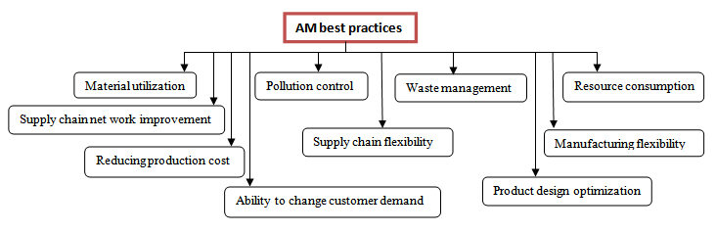
Figure 2. AM best practices
- Methodology
To meet the objective of this study, the authors used quantitative research approach. A survey study approach was used to collect primary data from the respondents, which comprised acadamic staffs from engineering disiplines (personnels) and industry experts such as production managers, supply chain and logistic experts, engineers…etc. The universities and case industries were selected by the use of convenient sampling, by considering the respondents' proximity, accessibility and availability. Based on this, sample sizes of the respondents were determined by using Yamane formula (1967).In regard to this, the sample size of the respondents were becomes 119 academic staffs and 251 industry experts. To collect data from the respondents’ questionnaire was designed and structured based on the identified best practices of AM as illustrated in Figure 2.The questionnaire consisted of two parts. The first part has respondents profile; while the second part surveyed their awareness levels towards the identified 10 AM best practices. And the respondents were requested to respond to the questionnaires based on 1-5 liker scales (1= strongly disagree, 2= disagree, 3= neutral, 4= agree, 5= strongly agree). The prepared questionnaires were printed in hard copy and distributed to the respondents. Among the distributed questionnaires, 78.8% (219) were properly filled and returned back for further analysis. And the collected data’s were analyzed using descriptive statistics (frequency and percentage) with SPSS V 21 software.
- Results and discussions
In this part of the study, the results of the survey assessments are presented and discussed.Both the awareness levels of academic and industry experts towards the identified 10 best practices of AM in transforming TM in local context was assessed and presented.
4.1Findings and results about awareness level of academic staffs and industry experts
The environmental impacts of AM are illustrated in three aspects as: - (1) resource, (2) waste management and (3) pollution control related benefit factors. Thus respondents are requested their awareness levels for the three benefit factors in terms of material utilization, waste minimization, use of pollutant like cutting fluids, cast release components, and forging lubricants…etc.
Resource consumption benefit factor: The survey results in Figure 3(a) illustrated that 52% of the respondents from academic staffs have high awareness level about resource consumption benefit factor of AM. But 32% have very low awareness level or understanding about this benefit factor. And 14% of them have neither low nor high awareness level. Concerning industry expert’s awareness level towards this factor, the survey findings illustrated that among the respondents only 32% have awareness about resource consumption benefit factors of AM. And 68 % (with 32% very low and 36% low response rate) have no awareness about this factor.
Waste management benefit factor: Concerning this factor, the result in Figure 3(b) illustrated that only 10% of the academic staffs have awareness about this factor. But almost 82% of the respondents are less aware (have low awareness) level (with 42% low and 40% very low response rate). The remaining 8% of the respondents are neither aware nor unaware towards this factor. Similarly, the findings in Figure 3(b) indicated that 28% (with 20% high and 8% very high response rate) industry experts have awareness about waste management benefit factors. But higher number of respondents that means 60% has no awareness about this factor. But 12% of the respondents are neither aware nor unaware about this factor.
Pollution control benefit factor: with regards to pollution control benefit factors, the findings in Figure 3(c) illustrated that 24% of the academic staffs have awareness about this benefit factor of AM (with 8% very high and 16% high response rate). But, 52% of academic staff respondents have no awareness about the pollution control benefit factor of AM (with 16% very low and 36% low response rate). The remaining 24% have neutral opinion about this factor. On the other hands, 60% of the industry experts have no awareness about pollution control benefit factor of AM (with 28% low and 32% very low response rate). However, only 12% of them are aware about this factor. And also 28% of the industry expert respondents are neither aware nor unaware about this factor.
These results indicated that the number of academic staffs and industry experts who were aware of waste management and pollution control benefit factors of AM was limited. This is because of non availability of the technology in the industry and lack of exposure towards environmental related activities, knowledge gap and academic study in the areas of environmental related activities.

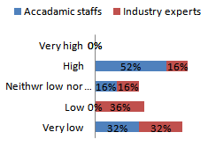 | 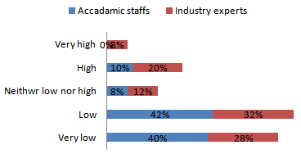
(a) Resource consumption benefit factor | (b) Waste management benefit factor
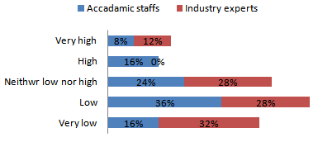 | 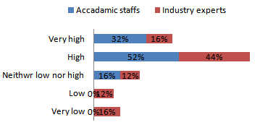
(c) Pollution control benefit factor | (d) Material utilization benefit factor
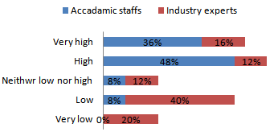  (e) Design optimization benefit factor | 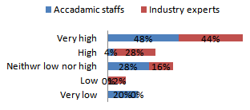  (f) Manufacturing flexibility benefit factor
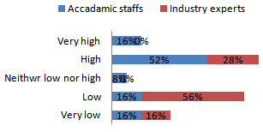 | 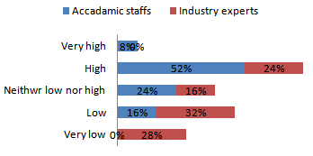
(g) Supply chain flexibility benefit factor | (h) Supply chain network benefit factor
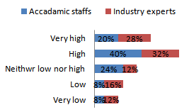  (i) Cost reduction benefit factor | 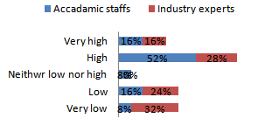  (j) Ability to change customer demand benefit factor
Figure 3.Respondents’ response towards the survey factors.
In the areas of Material utilization, design optimization and manufacturing flexibility best practice factors respondents were requested to respond their awareness level and perception. AM have best practices in the areas of novel materials and unique design solutions, mass reduction of components through highly efficient and lightweight designs, consolidation of multiple components and fabrication of complex parts without assembly process. It offers the ability to rapidly customize products at multiple scales and locations closer to consumers.AM allows production flexibility to create any shape or product without the need for any new machine set-ups and additional tooling.
Material utilization benefit factors: The findings in Figure 3(d) show that 84% of the academic staffs have high awareness level about the benefits of AM towards utilization of materials (with 52% high and 32% very high response rate). On the other hand, 16% of them have neutral perception concerning this factor. Similarly, majority of industry experts (60%) have heard and aware about material utilization benefit factors of AM (with 44% high & 16 % very high response rate).But 28% of them have no awareness (10% very low & 12% low response rate). In addition, 12% of them are neither aware nor unaware about this factor.
Design optimization benefit factor: In the areas of product design optimization benefit factor, as illustrated in Figure 3(e), majority of academic staffs (84%) have good awareness level (with 48% high and 36% very high response rate). But only 8% of them are unaware and neutral responses. With regards to this factor, the findings illustrated that 56% of industry experts have high awareness level (with 40% high and 16% very high response rates). On the other hand, 32% of them have no awareness about design optimization benefit of AM (with 12% very low and 20% low response rate). The remaining 12% of the respondents are neither aware nor unaware about this factor.

Manufacturing flexibility best practice factors: Among the academic staffs as the findings in Figure 3(f), illustrated, 52% have awareness about manufacturing flexibility best practice factors (with 4 % high and 48% very high response rate). And also 20% of them have no awareness about this factor. And 28% of the academic staff has neither aware nor unaware. On the other hand the finding indicated that 72% of industry experts have awareness about manufacturing flexibility benefit factors (28% high and 44% very high response rate). And 12% of them have no awareness about this factor. In addition, 16% of industry experts have neither aware nor unaware about this factor. The highest level of awareness level of respondents may be comes from the skill developed in the industry through and teaching and learning experiences and though the comparison of the existing SM and AM.
Adaptation of AM improves SC network by changing product distribution network to the final consumers by promoting shorter, localized, collaborative production system. Reduce manufacturing and assembly steps which results in internal supply chain improvements and reduces the number of suppliers. In addition, the decentralized approach of AM eliminates long distances that products move within the supply chain and SC net work is improved by reducing manufacturing time and inventory level. Furthermore, internal manufacturing SC is improved by minimizing suppliers, tools needed for production, by reducing number of labors and movement of components during manufacturing and stock of materials. AM supply chain shows greater mix and new product introduction flexibility with lower change over time and cost of new product introduction to the system.AM as one of the technology that improves efficiencies of the entire SC from the cost of distribution to assembly and carry, all the way to the component itself. Based on these, respondents are requested their awareness level towards SC flexibility and SC network improvement benefit factors.

SC flexibility benefit factors: Figure 3(g) shows that 52% of academic staffs have awareness about SC flexibility benefit factors (with 44% high and 28% very high response rate), 32% of them have no awareness (with 16% low and very low response rate). On the other hand, 16% of the academic staffs’ response is neutral. Among the industry experts, only 28% of them have high awareness about SC flexibility benefit factor. But 72% of them have no awareness about this factor (16% very low and 56% low response rate).
SC network improvement benefit factor: The findings in Figure 3(h) indicated that majority of academic staffs (60%) have awareness about the benefits of AM in improving SC network (with 52% high and 8% very high response rate). But 16% of the staffs have no awareness about this benefit factor, while, the response of 24% of them are neutral. If we see the awareness of industry experts in the areas of AM supply chain improvement benefit factor, the findings illustrated that only 24% of them have high awareness and understanding. And 60% of the industry experts have no awareness about of this factor (with 28% very low and 32% Low respondents rate). In addition 16% of them said that we are neutral about this factor.
The lower awareness level of industry experts in SC network and flexibility areas comes from knowledge gap in the areas of SC management and lack of training. But academic staffs’ especially engineering professionals have got the awareness about these factors through training.

In AM technology each product can be customized to the customer’s preferences. AM fulfill customer demand comes from continuously changing environment driven by changing customer needs, AM has the ability to respond to changing customer demands for new products and features. It reduces carbon foot print, logistics, transportation, distribution cost…etc. In this regards both industry experts and academic staffs were requested their opinion and awareness towards cost reduction and Ability of changing customer demand benefit factors.

Cost reduction benefit factors: The findings in Figure 3(i) indicated that 60% of the academic staffs have good awareness level about cost reduction benefit factors (with 40% high and 20% very high response rate). But 16% of them are unaware about this factor (with 8% low and very low response rate). On the other hand, 24% of the academic staffs are neither aware nor unaware towards this factor. Similarly the findings in this Figure confirmed that 60%of industry experts have aware about cost reduction benefit factor (32% high and 26% very high response rate). On the other hand 28% of them have no awareness about this factor (12% very low and 16% low response rate). In addition, 12% of industry experts are neither aware nor unaware about this factor.

Ability of changing customer demand benefit factors: Concerning ability of changing customer demand benefit factors, the finding results in Figure 3(j), indicated that 68 % of academic staffs have awareness about this factor (with 52% high and 16% very high response rate). And also the results under this factor indicated that 24% of the academic staffs have no awareness. In addition, 8% of them have neither aware nor unaware towards this factor. Similarly the findings in relation to ability of changing customer demand benefit factors, 44% of industry experts have awareness (28% High and 16% very high response rate). But 56%) of them has no awareness about this factor (32% very low and 24% low response rate.

4.2 Findings and results on awareness level towards AM best practices
In this section of the analysis, the aggregate awareness level of academic staffs and industry experts are presented and compared. The results of the study in Figure 4 (a) and (b) illustrated the awarness level of the acadamic staffs and industry experts towards the best practices of AM in transforming TM. The results of Figure 12 (a) illustrated that 51% of industry experts have low awarnes about the identified 10 best practices of AM. And 37% of them are awared about the best practices of the identified AM. But the results in Figure 12(b) confirmed that only 37% of the acadamic staffs have low awarness level, while 49% of them are awared about the best practices of AM in transforming TM in local context. From this we can observe that there is awareness level gap between academic staffs and industry experts in local context. In other words, academic staffs are more aware than industry experts about the identified 10 best practices of AM, and this was our initial expectation because this technology has been around within the academia.

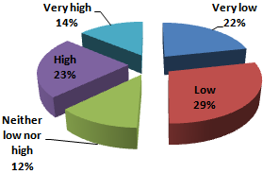
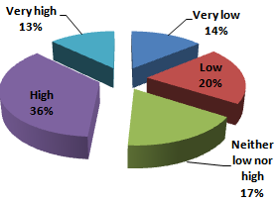
(a) (b)
Figure 4.Aggregateawarness level (a) industry experts (b) academic staffs
- Conclusion
The objective of this paper is to assess the awareness levels of industry experts and academic staffs towards the ten (10) best practices of AM in Ethiopian context. Knowing the level of awareness towards this best practices helps to predict the acceptability and easy implementation of the technology. As a methodology, through literature review, the best practices of AM were identified and categorized into 10 factors, and then the awareness level of the industry experts and academic staffs were assesses with 1-5 liker scale open ended questionnaires.
The findings of this paper identified that both academic staffs and industry experts have common understanding (awareness level) on material utilization benefit factors, product design optimization benefits factors, cost reduction benefit factors, ability of changing customer demand benefit factors, and manufacturing flexibility benefit factors. But on the remaining factors there are awareness level gap between academic staffs and industry experts in local context.

Reference
[1] Saberi S, Mohd R, Zulkifli N, Megat M(2010), Effective factors on advanced manufacturing ,technology implementation performance:a review,J. Appl. Sci., 2(10), 1229–1242
[2] ASTM Standard (2012), Standard Terminology for Additive Manufacturing Technologies, ASTM International, West Conshohocken, PA, 10(4).
[3] Mellor, S. Hao, L. and Zhang, D. (2014) Additive manufacturing: a framework for implementation, Int. J. Prod. Econ.149, 194-201
[4] Rifkin J(2012) The third industrial revolution: How the internet, green electricity, and 3-D printing are ushering in a sustainable era of distributed capitalism, The World Financial Review. Available at: https://www.feelingeurope.eu/Pages/thirdindustrialrevolutionrifkin.pdf
[5]Wong V, Hernandez A(2012) A review of additive manufacturing, ISRN Mech. Eng. 5(23) 1–10
[6] Bogue R(2013) 3-D printing: The dawn of a new era in manufacturing,Assem. Autom., 33(4), 307-311
[7] Radu G, Ines R, Florinda M, Bruna F, Helena C, Paulo P (2020), Impact assessment of additive manufacturing onsustainable business models in Industry 4.0 Context, Sustainability,12, 7066
[8] Bourell D, Leu M, Rosen DW(2009) Roadmap for additive manufacturing: identifying the future of freeform processing, Austin, The University of Texas
[9] Gebler M, Schoot U, Visser C(2014) A global sustainability perspective on 3D printing technologies,Energy Policy, 74, 158-167.
[10] Allwood J, Ashby MF, Gutowski TG, Worrelln E(2011) Material efficiency,a white paper Resource Conservation Recycling, vol.55, pp.362 –381
[11]Achillas, D. Aidonis, E. Iakovou, M. and Thymianidis, D(2015), A methodological
framework for the inclusion of modern additive manufacturing into the production
portfolio of a focused factory,Journal of Manufacturing System, 37,328 –339
[12] Khajavi S, Partanen J, Holmström J(2014), Additive Manufacturing in the Spare Parts Supply Chain,Comput. Ind. 65(1), 50–63.
[13] Gardan J (2016), Additive manufacturing technologies: State of the art and trends, Int. J. Prod. Res. 54(10), 3118–3132
[14] Gibson I, Rosen W,Stucker B(2009), Additive manufacturing technologies: Rapid prototyping to direct digital manufacturing, New York: Springer
[15] Manyika J, Chui M, Bughin J, Dobbs R,Bisson P, Marrs A (2013), Disruptive technologies: Advances that will transform life, business, and the global economy, 180, San Francisco, CA: McKinsey Global Institute.
[16] Allwood J,Ashby MF, Gutowski TG, Worrelln E (2011), Material efficiency: a white paper,Resour. Conserv. Recycl.55, 362 –381.
[17] Achillas D, Aidonis E, Iakovou M, Thymianidis D (2015), A methodological
framework for the inclusion of modern additive manufacturing into the production
portfolio of a focused factory,J. Manuf. Syst. 37, 328 –339.
[18] Attaran M(2017), The rise of 3-D printing: The advantages of additive manufacturing over traditional manufacturing,Bus.Horiz. 60(5), 677–688.
[19] Gebler M, Schoot U, Visser C(2014), A global sustainability perspective on 3D printing technologies,Energy Policy, 74, 158-167.
[20] Huang Y, Leu M C, Mazumder J, Donmez A(2015), Additive manufacturing: current state, future potential, gaps and needs, and recommendations,J. Manuf.Sci. Eng.137(1), 014001
[21] Cohen D, Sargeant M, Somers K (2014), 3-D printing takes shape,J. Serv. Sci. Manag.10(3), 89-99.
[22] Santos K, Loures E, Piechnicki F, Canciglieri O(2017), Opportunities assessment of product development process in Industry 4.0,Procedia Manuf. 11, 1358-1365.
[23] Dimitrov D, Beer N,Hugo P, Schreve K(2014), Three dimensional printing,In: Compr. Mater. Process., 10, 217-250.
[24] Paris H, Mokhtarian H, Coatanéa E, Museau M, Ituarte I F (2016), Comparative environmental impacts of additive and subtractive manufacturing technologies,CIRP Annals – Manuf. Technol., 65(1), 29–32.
[25] Kritzingera W, Steinwendera A, Lumetzberger S, Sihna W (2018), Impacts of additive manufacturing in value creation system, Procedia CIRP. 72, 1518 – 1523.

