Numerical Modelling of a High Temperature Borehole Thermal Energy Storage System: Norway Case Study.

**A A Ahmed1, M Assadi1,*, R Gholami1, N Ahmed1,2**

1 Department of Energy and Petroleum Engineering, University of Stavanger, 4021 Stavanger Norway

2 US Pakistan Centre for Advanced Studies in Energy (USPCASE), National University of Sciences & Technology (NUST), H-12 Sector, Islamabad, Pakistan

* Corresponding author: mohsin.assadi@uis.no

**Abstract**. Global warming is threatening life on earth. Utilising renewable energy is considered as the most effective measure to minimise anthropogenic CO2 emissions. High-temperature borehole thermal energy storage (BTES) systems have a world-wide potential to reduce energy consumption, increase energy utilisation of waste heat and provide efficient seasonal heat storage. Hybrid application of BTES and solar energy leads to net zero emissions. In this study HT-BTES is evaluated for seasonal thermal heat storage and recovery. To this end, a CMG STARS model was built and validated using the existing 100-wells BTES system in Norway. Then, the model was used to evaluate BTES thermal performance and thermal recovery efficiency. Sensitivity analysis was also conducted to study the dynamics of storage temperature in the BTES under different operating conditions, such as heat carrier flow rate, injection temperature, and charging period. Results of this case study show that the model-predicted temperatures during charging and discharging are in good agreement with the existing BTES system. In 5 years of operation, 35.5% of the heat injected into the BTES system was recovered, while the significant heat remained in the borehole region and lost to surrounding rock (64.5%). BTES was found very sensitive to flow rate, the charging period and injection temperature. Borehole depth has a minimal effect on BTES storage temperature at constant studied injection temperature.

1. **Introduction**

Anthropogenic climate change is threatening nature and society by altering temperatures and weather patterns. Floods, droughts, and wildfires are becoming more frequent in many parts of the world. Developing a sustainable energy strategy is imperative for protecting natural resources and ensuring future generations well-being. In response, most countries have joined an alliance to gradually reduce greenhouse gas (GHG) emissions as they strive to reach net zero emissions by 2050. Following the same energy transition policy, Norway is increasing its actions and responsibilities to tackle emissions despite having a low carbon-intensity energy system [1]. In its ambitious climate action plan, Norway aims to cut greenhouse gas emissions by at least 50% and towards 55 % by 2030 compared to 1990 emissions baseline [2]. That would result in less than 23 million tonnes of carbon dioxide equivalent emissions in 2030 compared with approximately 52 million tonnes in 1990 [3]. To achieve this ambitious goal, it requires electrification of various sectors, including transport, manufacturing and oil and gas extraction [1]. This in turn requires adequate, flexible and clean energy supply sources such as geothermal, wind and solar to reduce emissions. Solar power represents an almost insignificant share of renewable energy in Norway. However, the Norwegian Solar Energy market is expanding rapidly and is projected to increase from 358 MW in 2022 to 4943 MW by 2028 [4]. Furthermore, the intermittency of solar energy poses challenges to its broad application. However, seasonal borehole thermal energy storage (BTES), which includes technologies both for short- and long-term retention of heat, can create or improve the utility of solar energy.

The BTES system offers multiple opportunities as it offsets the mismatch between thermal energy production from solar and demand and reduces grid dependence [5]. The BTES are vertical boreholes that are piped in series or parallel to create concentric thermal zones (see Figure 1). Therefore, heat is stored in a rock environment near to the boreholes as a storage medium, and heat exchange occurs through vertical boreholes [6, 7]. It has the advantages of creating cold and warm zones as well as the possibility to switch to a reverse flow. Large solar thermal collector fields are promising technology for replacing fossil fuels in heating and cooling systems. So, BTES is a huge natural capacity to temporarily store this solar energy (harvested in summer) when the demand is low, and then recover it when the demand is high in the future. The recovered thermal energy can be used for heating buildings. The main drawbacks of BTES systems are their slow response time and high thermal losses. Heat transfer from the ground to the heat transfer fluid is relatively slow due to low heat transfer rates [8, 9].

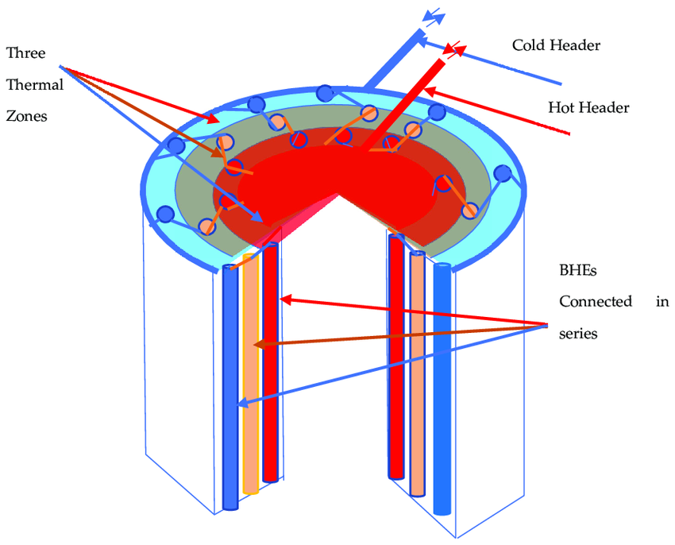

**Figure 1.** Schematic of Borehole Thermal Energy Storage (BTES and BHEs are connected in series).

This study, a simulation for BTES system, is performed to history-match an existing BTES system (GeoTermos Project) used to store heat in summer and provide space heating in winter for the Fjell School building (1000 m2) located in Drammen, Norway. The GeoTermos consists primarily of a thermal storage facility consisting of a total of 100 wells, each with a depth of approx. 50 meters, which are organised as a cylinder with a diameter of 40 meters. Energy is supplied directly from solar collectors (150 m2) and solar cells mounted on roofs (900 m2) and in façades (100 m2) as shown in Figure 2. The solar cells supply electricity for an air source heat pump that uses natural refrigerant CO2. Direct heating of the school, by 30°C water-based underfloor heating system. Injection of heat started in April 2020. After 6 months of heat injection the rock temperature recorded in Sept 2021 reached <43°C. Figure 3 illustrates fibre for distributed temperature sensing installed in 11 of the BHEs.

The incorporation of additional sensors, particularly the mass flow rate probe, introduces significant implications both technically and economically. While the advantages of enhanced data acquisition and system monitoring are evident in our current study, the potential cost implications of such sensor implementations are acknowledged. To address this issue, a supplementary cost evaluation will be conducted for the installation of these sensors in our ongoing borehole field project at the University of Stavanger. This assessment will encompass an analysis of initial setup costs, ongoing maintenance expenses, and the potential economic benefits resulting from improved data quality and enhanced system efficiency facilitated by these sensors. The resulting assessment to be presented in our future works will enable the readers to gain a better understanding of the trade-offs and advantages associated with sensor deployment in BTES system design and operation.

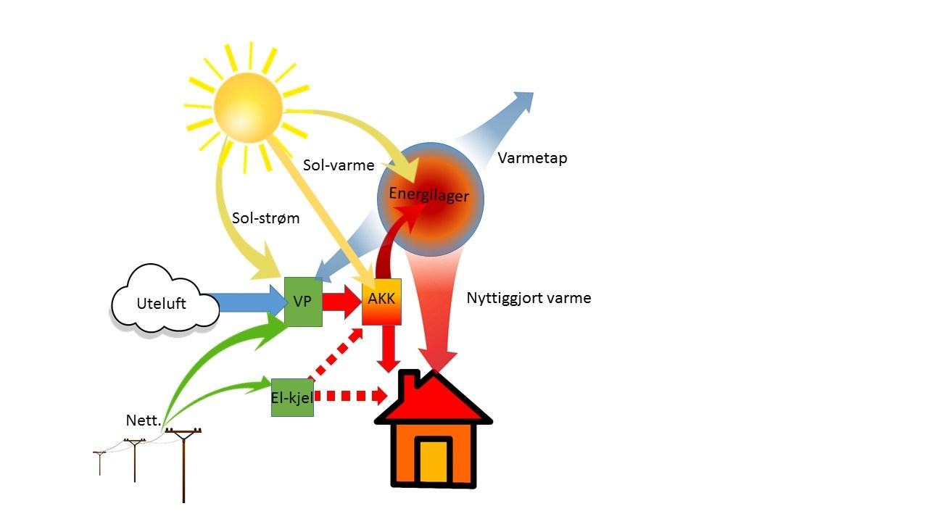

**Figure 2.** Schematic representation of the Fjell School BTES (GeoTermos) used in this study.

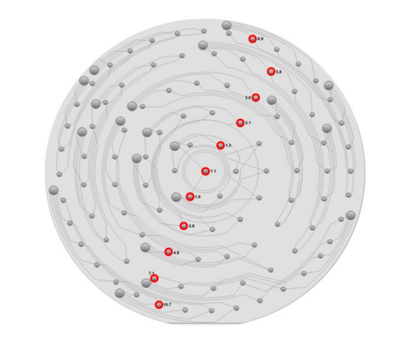

**Figure 3.** Fibre for distributed temperature sensing installed in 11 of the BHEs

The model was then used to investigate the effect of underground properties, depth of borehole exchangers, charging/discharge cycle time and discharge efficiencies to determine overall thermal efficiency. In addition, the impact of injected water temperature was explored. The underground thermal storage system is based on seasonal cyclic injection and production from BTES. The solar energy is used to directly charge the BTES or using a heat pump fed by electricity produced from solar. CMG STARS Software was used to model BTES using geological properties, heat transport in the subsurface, and well characteristics. Then, the model was used to run a sensitivity analysis to determine the impact of main operational parameters on the potential of storing solar energy, utilisation efficiency and overall performance.

1. **Methodology**

CMG-STARS simulator (Version 2022.10) is used to measure heat storage, thermal heat production, subsurface heat distributions and efficiency of BTES. CMG-STARS models the heat transfer from injected water to the rock matrix. A three-dimensional (3D) model was created to simulate heat transfer with 100 wells (50 to 55 m each) as shown in Figure 4. The model dimensions are 120x120x60 meters. A regular coordinate system having three dimensions (i, j, k) was applied to the model. High grid resolution (1 meter ) was used for the 3D grid to provide an improved accuracy in the area of drilled wells and avoid numerical diffusion. The main input parameters used for the simulation are summarised in Table 1.

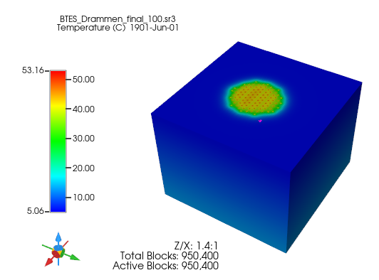

**Figure 4.** The 3D view of the numerical model

**Table 1.** Input parameters for HT-ATES CMG STARS Modelling

|  |  |
| --- | --- |
| Data | BTES |
| Length, I (120 cells), m | 120 |
| Width, J (120 cells), m | 120 |
| Thickness, K (60 cells), m | 60 |
| Porosity, % | 15 |
| Permeability, md | 25 |
| Undisturbed rock temperature, C | 8 |
| No. of wells | 100 |
| Well length, m | 50-55 |
| Distance between wells, m | 4 |
| Flow rate, m3/hr | 4.2 |
| Injection temperature (Charging), °C | 60 |
| Injection temperature (Discharging), °C | 25 |
| Rock thermal conductivity, W/mk | 2.5 |
| Seasonal cycle, month | 6 |

*2.1 Heating load*

The seasonal BTES system studied is assumed to have a heating mode in the winter (discharge) and a charging mode in the summer. Charging and discharging loads in the simulations are simplified to a 6-month heating period in winter and a 6-month charging period in summer. A constant flow rate and injection temperature are used during summer and the same flow rate is used during winter for discharge. The extracted heat is assumed to directly heat the school by a 30°C water-based underfloor heating system. The maximum pumping rate is set to 4.2 m3/h with an injection temperature of 25°C. The undisturbed ground temperature is 8°C and the model was run for 10 years with 20 repeated cycles.

*2.2 Thermal efficiency.*

From the model, the extracted energy ($Q_{ext}$) for each 6-month heating period during the lifetime of the system is determined following Eq1:

$Q_{ext}=C_{p} q ρ (T_{wh}- T_{inj})$ n (1)

Here, q is the total pumping rate, Twh is the temperature of the water that is extracted from the production well at the wellhead, Tinj is the temperature of the water that is injected in the injection well and n is a time increment. The injected heat during summer ($Q_{inj}$) for each 6-month charging period during the lifetime of the system is determined following Eq2:

$Q_{inj}=C_{p} q ρ (T_{inj}- T_{in })$ n (2)

Here, q is the total pumping rate, Tinj is the temperature of the water that is injected to the well at the wellhead, Tin is the temperature of the water that is fed to the heat exchanger. The thermal heat recovery efficiency (ηth) is defined by dividing the extracted energy by the energy that is loaded to ATES.

$η_{th}=\frac{Q_{ext}}{Q_{inj}}$ (3)

*2.2 Sensitivity Analysis and Optimization.*

The amount of energy that is provided by BTES varies with flow rates, ground temperature, and injected temperature. The effects of well depth on BTES thermal recovery efficiency were evaluated. Sensitivity analysis was extended to include well operation and control strategies. The injection temperature and cycle time were investigated to determine the optimum values that could result in better thermal recovery efficiency.

1. **Results and Discussions**

In the following section the results of the simulation study are presented and discussed.

## 3.1 Model Validation

To assess the validity of the model predictions, a history matching technique was employed, comparing the model outcomes with actual data obtained from the reference borehole field [10]. The validation procedure focused on a 2D cross-sectional representation of the BTES system, encompassing temperature distribution data from 11 wells equipped with temperature measurement sensors during the dynamic heat injection and extraction cycles. As illustrated in Figure 5, the temporal evolution of thermal distributions within the BTES system is presented, covering a 6-month heat injection cycle followed by a 6-month heat extraction cycle. Figure 6 reveals insights into the predicted reservoir temperature during the charging phase. It's noteworthy that the model projected a reservoir temperature of 45°C during this period, closely aligning with the measured temperature obtained from fiber optic sensors, which recorded a temperature just below 43°C. The variance between the modelled and actual temperature is less than 5%, well within an acceptable margin of error. While the pursuit of a perfect match between model and experimental data remains a goal, it is essential to consider the practical complexities and underlying assumptions inherent in the model such as variability in actual ground properties, changing dynamic behaviour of BTES system and the model assumptions. However, the existing level of error remains within an acceptable range. The alignment between the model's predictions and the measured data underscores the model's reliability in accurately simulating the behaviour of the BTES system, enhancing confidence in the results presented in the study.

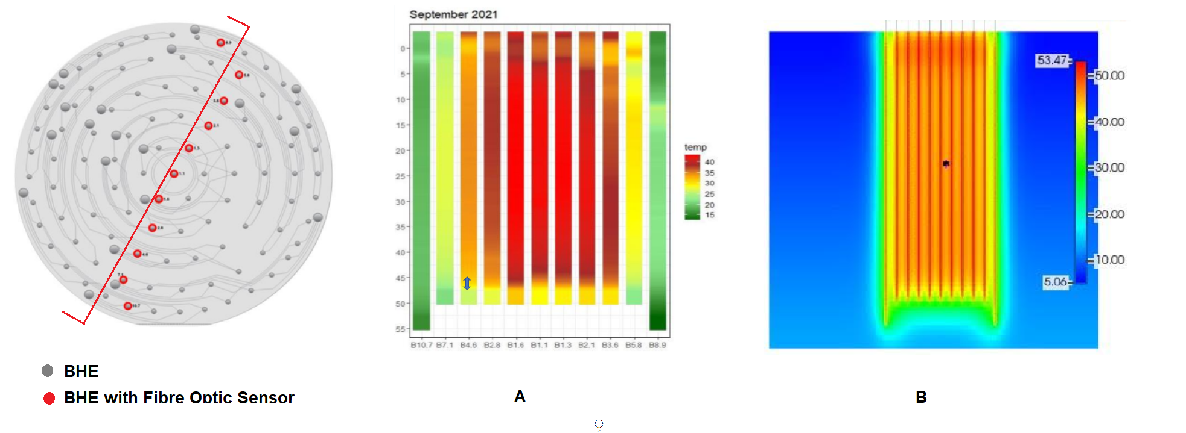

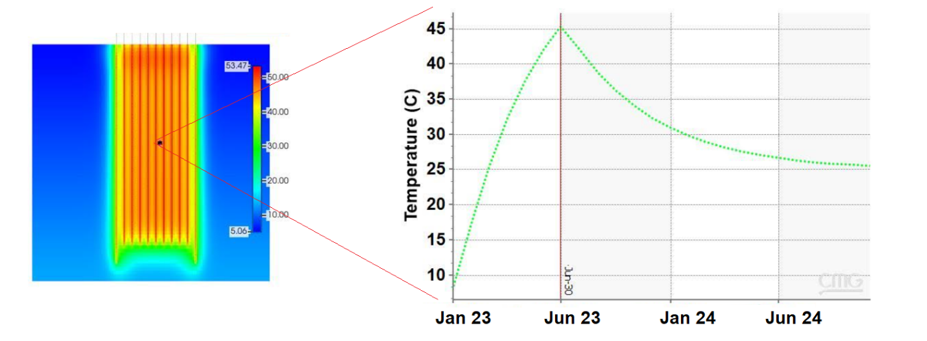**Figure 5.** Spatial temperature distribution across 11 borehole exchangers, (A) actual data and (B) CMG STARS model.

Discharging Limit

Charging

Discharging/

**Figure 6.** Reservoir temperature profile during charging and discharging cycles.

## 3.2 Temperature Distribution and Heat Extraction Efficiency

The evolution of thermal storage plumes with time is shown in Figure 7 for the cross section of BTES. The predicted temperature distributions are shown for charging and discharging periods. The BTES region shows a trend of increasing temperature with time. The average temperature at the centre of BTES reaches a maximum temperature of about 45°C. Heat distribution during the first cycle of heat extraction (Figure 7, discharge t=6 months) shows that the temperature remains higher than the original reservoir temperature (8°C). That resulted in a low thermal recovery efficiency of only 30.9%. It could be explained by the fact that more than half of the heat injected is lost to heat up the rock matrix. As time passes, the heat loss to the rock reduces and the thermal efficiency increases to 35.3% after 5 years of operation (see Figure 8).

|  |  |  |
| --- | --- | --- |
| **Charging: t= 0** | **t= 4 months** | **t= 6 months** |
| **Charging: t= 0** | **t= 4 months** | **t= 6 months** |
| **Figure 7.** Simulated temperature distribution at lateral cross-section across 11 BHEs. Results are shown for the ends of the charging (0, 2, 4, 6 months) and discharging (0, 2, 4, 6 months) for the first year of operation. | | |

The CMG STARS BTES model is adopted in order to study the long-term effect (5 years) of a warm well’s thermal performance. Figure 7 shows the repeated cycles of charging and discharging, in which heat carrier flow rate is kept constant to 4.2 m3/h. Two cases for the initial charging period were evaluated, 6 months (case-1) and 15 months (case-2), while the discharging periods were fixed to 6 months for both cases. The first thing to note in Figure 7 is that the average BTES temperature reaches a quasi-steady state behaviour after approximately 2 cycles with slightly higher temperature from year to year for case-2. During the 1st cycle, the average BTES temperatures reach 45°C and 53°C for case-I and case-2, respectively. The temperature is observed to increase to around 50°C before declining to 47°C after 5 years for case-I. In Case-2, temperature almost levelled at 50°C for all the 5 years. However, in the winter, local temperatures almost levelled near the boreholes at 35°C for both cases, at the minimum temperature required for space heating.

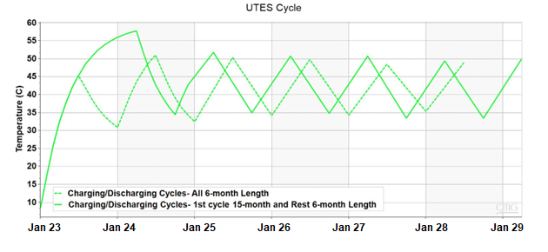

**Figure 8.** BTES temperatures for studied cases during charging and discharging over 5 years. Note: 6-month and 15-month charging for the 1st cycle are used, the following cycles fixed to 6-month for charging and discharging.

## 3.3 Sensitivity Analysis

*3.3.1 Effect of heat carrier flow rate*

[Figure](https://www.scirp.org/journal/PaperInformation.aspx?PaperID=76832#f7) 9 shows the effect of the flow rate on the average BTES temperature. It is clear that as the flow rate increases from 1.05 m3/h to 4.2 m3/h, the average BTES temperature increases. However, at a flow rate higher than 4.2 m3/s no increase in BTES temperature was observed. The corresponding BTES efficiency is observed to increase with increasing the flow rate from 34 % and reached a plate of 36% at flow rate higher than 4.2 m3/h.

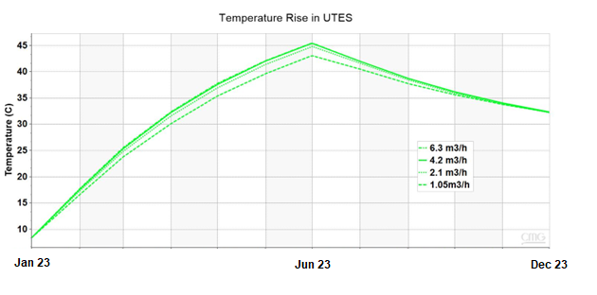

**Figure 9.** Impact of increased flow rate on average BTES temperatures.

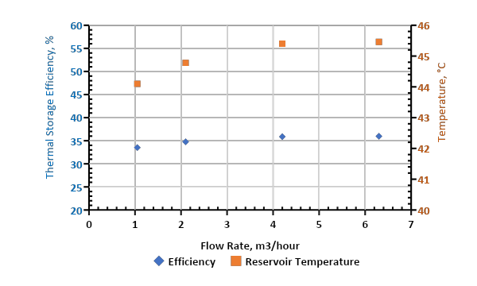

**Figure 10.** Impact of increased flow rate on average temperatures and efficiency of the BTES system.

*3.3.2 Effect of heat charging period*

In this section charging periods at constant injection temperature (60°C) were evaluated. As the charging period increased the BTES temperature increased and then almost levelled out at a longer charging time. Initially, BTES temperature increased by 12°C (from 33°C to 45°C) when the charging period was prolonged from 3 months to 6 months. However, only 4 to 3°C increments were observed when the charging period increased higher than 9 months. It's worth noting that at higher BTES temperature the discharging period takes longer before reaching the discharging temperature limit (i.e., 30°C).

**Figure 11.** Impact of charging time on average BTES storage temperatures.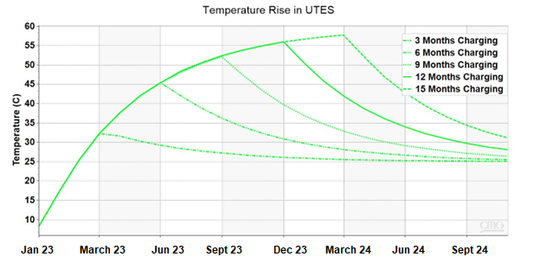

Discharging Limit

**Figure 12.** Impact of charging time on average BTES storage temperatures and thermal efficiency.

*3.3.3 Effect of Borehole exchanger depth.*

Increasing BHE depth has been found to have a minimal effect on BHE charging up. As can be seen from figure 12, at constant charging fluid temperature, BTES temperature decreases with increasing depth.

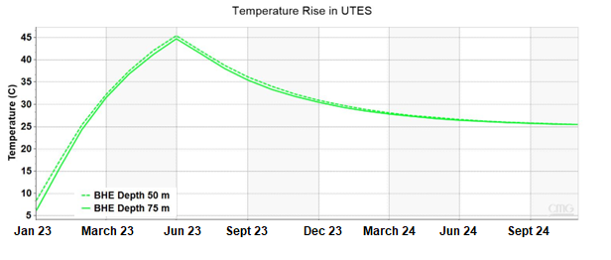

**Figure 12.** Impact of increased flow rate on average BTES temperatures.

*3.3.4 Effect of injection water temperature*

Figure 13 shows the influence of increasing injection temperature of heat carrier fluid. The BTES temperature steadily increases by increasing the injection temperature during charging up. BTES storage temperatures are found to increase linearly as injection temperatures increase (see figure 14). However, cooling down during discharge was faster at higher temperatures. As the temperature within the BTES increases, the rate of heat loss to the surrounding rocks also increases.

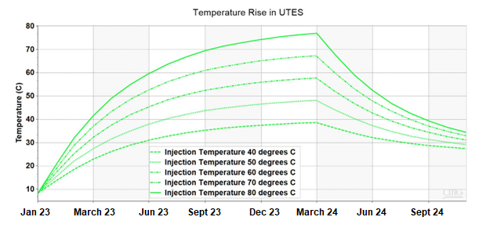**Figure 13.** Impact of increased flow rate on average BTES temperatures after 15-months charging and 6 months discharging.

15 months Charging

6 months Charging

6 months Discharging

**Figure 14.** BTES storge temperature after 15 months charging and corresponding thermal efficiency.

1. **Conclusions**

In this paper, a large-scale BTES in Norway with 100 boreholes was modelled in CMG STARS. This model was validated by temperature distribution in 11 boreholes across the BTES measured by fibre optic temperature sensors. Following are the conclusions reached in this study:

* The simulated temperatures matched well with the measured data.
* The BTES storage temperature increases to a maximum temperature of 45°C, however during production, the temperature decreases to 32°C.
* In 5 years of operation, 35.5% of the heat injected into the BTES system was recovered, while the significant heat remained in the borehole region and lost to surrounding rock (64.5%).
* BTES was found very sensitive to flow rate, the charging period and injection temperature. Well depth has minimal effect at constant injection temperature.

**ACKNOWLEDGEMENTS (OPTIONAL)**

We acknowledge POLNOR grand for funding the project. We are indebted to the staff of the department of energy and petroleum engineering (IEP) at the University of Stavanger and for allowing us to present this paper.

**References**

**[1]** Norwegian Ministry of Climate and Environment, 2021, ‘Norway’s Climate Action Plan for 2021–2030 available: [Meld St. 13 (2020–2021) (regjeringen.no)](https://www.regjeringen.no/contentassets/a78ecf5ad2344fa5ae4a394412ef8975/en-gb/pdfs/stm202020210013000engpdfs.pdf)

**[2]** [Norway’s new climate target: emissions to be cut by at least 55 % - regjeringen.no](https://www.regjeringen.no/en/aktuelt/norways-new-climate-target-emissions-to-be-cut-by-at-least-55-/id2944876/)

**[3]** ENERGY TRANSITION NORWAY 2021, Available: [Energy Transition Norway 2021 DNV](https://www.dnv.com/Publications/energy-transition-norway-2021-212201)

**[4]** Blackridge research and consulting, Norway solar power market outlook to 2028. Available: [Norway Solar Power Market Outlook | Blackridge Research & Consulting](https://www.blackridgeresearch.com/reports/norway-solar-power-market)

**[5]** Welsch, B., Göllner-Völker, L., Schulte, D.O., Bär, K., Sass, I. and Schebek, L., 2018, Environmental and economic assessment of borehole thermal energy storage in district heating systems. Applied energy, 216, pp.73-90.

**[6]** Rad, F.M., Fung, A.S. and Rosen, M.A., 2017. An integrated model for designing a solar community heating system with borehole thermal storage. Energy for sustainable development, 36, pp.6-15.

**[7]** Rapantova, N., Pospisil, P., Koziorek, J., Vojcinak, P., Grycz, D. and Rozehnal, Z., 2016. Optimisation of experimental operation of borehole thermal energy storage. Applied Energy, 181, pp.464-476.

**[8]** Chapuis, S. and Bernier, M., 2009. Seasonal storage of solar energy in borehole heat exchangers.

**[9]** Jokiel, M., Rohde, D., Kauko, H. and Walnum, H.T., 2020. Integration of a high-temperature borehole thermal energy storage in a local heating grid for a neighborhood. In International Conference Organised by IBPSA-Nordic, 13th–14th October 2020, OsloMet. BuildSIM-Nordic 2020. Selected papers. SINTEF Academic Press.

**[10]** Midttomme, k., 2022. Borehole Thermal Energy Storage (BTES) – development of high temperature BTES. Norce Norwageian Research Centre.