Material characterization of EN AC-Al Si12CuNiMg alloy in stress relaxation and creep conditions
G G Sirata *, K Waclawiak
Silesian University of Technology, Department of Materials Technologies, Poland

* Corresponding author e-mail: goftila.sirata@polsl.pl
Abstract. Al–Cu–Mg alloys are widely used in various applications, especially engine components, where it is subjected to elevated temperatures during operation. Prolonged exposure of these components to elevated temperatures gradually leads to creep and relaxation phenomena. This study aims to investigate the effects of temperature on stress relaxation and creep behavior of the aluminum-silicon alloy EN AC-Al Si12CuNiMg. Furthermore, this study evaluates the effect of temperature on the rheological model parameters of this alloy. Experimental tests were conducted to investigate the stress relaxation and creep behavior of this alloy at different temperatures of 150°C, 250°C, and 350°C. The rheological model parameters were then determined from the obtained experimental data. The Standard Linear Solid Model (SLSM) was used to fit the stress relaxation and creep curves obtained from the experiment. Overall, the results indicate that increasing temperature significantly affects the stress relaxation and creep behavior of the investigated alloy, with higher temperatures leading to increased relaxation and creep rates. Additionally, the rheological model parameters of the alloy were found to vary with temperature.
- Introduction
Aluminum alloys are commonly used in the automotive and aerospace industries due to their favorable properties, such as a high strength-to-weight ratio, ease of fabrication, good thermal conductivity, and good corrosion resistance [1–4]. Among these alloys, aluminum-silicon alloys are commonly used to manufacture combustion engine components, such as pistons and cylinder heads, which typically operate at elevated temperatures [5, 6]. The main challenge for these components while operating at elevated temperatures is the time-dependent deformation phenomenon. Deformation occurs gradually when these components operate at elevated temperatures for a long time. Understanding and analyzing these phenomena is essential for designers during material selection for such applications.
Stress relaxation and creep tests are two of the most widely used experimental approaches for determining the time-dependent behavior of materials when exposed to elevated temperatures [7, 8]. Stress relaxation is a mechanical behavior in which the material produces a certain strain at a specific temperature and initial stress. This phenomenon usually occurs when a material is subjected to elevated temperatures for a prolonged duration at constant strain [9]. During the experimental investigation, the temperature and total strain of the material are kept constant while the stress gradually decreases over time. Under the action of time, the elastic strain inside the material gradually transforms into the process of plastic strain [4]. During the relaxation test, stress reduction is measured as a function of time. Therefore, when evaluating structural response to thermally induced strains, it is essential to evaluate the stress relaxation in the structure of metal alloys. Creep is a time-dependent deformation behavior of a material under constant stress or load conditions at elevated temperatures. All materials deform first elastically and then plastically once the stress has exceeded the yield stress. However, creep can occur even at stress levels below the elastic limit under the effect of temperature and constant load over a long period [10].
Over the last few decades, numerous studies and models have been developed to characterize creep damage under various creep conditions. These studies have focused on the mechanisms of creep deformation and the factors that affect the creep life of the material. For example, the Larson-Miller model [11] is a widely used method for predicting the creep life of materials under high temperatures and constant stress levels. It considers the combined effects of time, temperature, and stress on creep deformation. However, the model has a limitation in its ability to accurately predict creep conditions because some other factors, such as material composition, variable loads, and variable temperature, that affect the creep life of the material have not been considered. Furillo et al. [12] modified the Larson-Miller parameter by incorporating additional factors, such as microstructure and alloy composition, to more accurately predict the creep life of materials. Considering these factors, the modified model achieved a better correlation between predicted and experimental creep-life results. This suggests that the original Larson-Miller model did not adequately account for these factors, highlighting a limitation in its accuracy.
Similarly, Pavlou [13] proposed a non-linear cumulative creep damage model that considers the damage history and loading effect to describe the creep deformation behavior of metallic materials under variable stresses and temperatures. However, this model may not accurately predict the creep deformation of metallic materials with shorter lifespans under variable temperature conditions, mainly when high temperatures are initially applied under varying temperature conditions [14]. Batsoulas [15] proposed a non-linear model for creep damage accumulation that considers loading sequence damage and creep strain. However, contradictions were found in the model, making it difficult to establish a correct creep damage accumulation rule for the strain under the same loading conditions. Hu, et al. [16] proposed a new creep damage assessment model based on Batsoulas’ model. The model considers the loading process and the material's creep behavior under various conditions. However, the proposed model lacks clear physical significance, which is essential for its practical implementation.
Similar to other metallic materials, the primary factors affecting the stress relaxation and creep behavior of aluminum alloys are loading conditions and operating temperature. According to the studies by Mansoor and Shahid [17], Lyu F. et al. [18], and Hamasaki H. et al. [19], operating temperature generally leads to enhanced stress relaxation in aluminum alloys. Mansoor and Shahid [17] studied the stress relaxation behavior of polycrystalline aluminum of different grain sizes, annealed at 500°C, and aged at room temperature for six months. The results show that stress relaxation is affected by aging time. Lyu F. et al. [18] examined the influence of temperature levels on the stress relaxation and aging behavior of the Al-Zn-Mg alloy AA7B04-P. The study proved that increasing temperature increases stress relaxation with a predominant dislocation creep mechanism. Hamasaki H. et al. [19] conducted stress relaxation tests at 25, 100, 200, and 300°C for the AA5182-O aluminum alloy sheet to observe the temperature and strain rate dependence on its flow stress and stress relaxation. The results showed that the dominant relaxation mechanism is grain boundary slip due to the influence of temperature.
Other studies also reported that the operating temperature plays an important role in influencing the creep behavior of aluminum alloys. The two important creep parameters, creep strain and creep strain rate, tend to increase with temperature, as reported by the studies conducted by Yu W. et al. [20], Zhang et al. [21], and Golshan A. et al. [22]. Zhan L. et al. [23] investigated the creep behavior of 2A14 aluminum alloy at different temperatures by conducting a creep test, and the results show that the creep strain and creep strain rate increase with temperature. Another study by Zhang et al. [21] found that the creep resistance of cast aluminum alloys decreases with increasing temperature, particularly between 200°C and 300°C. Golshan A. et al. [22] analyzed the effects of temperature on the creep behavior of the AlSi12CuNiMg aluminum alloy. They found that an increase in temperature resulted in a decrease in the creep lifetime and an increase in the minimum strain rate. Zhan L. et al. [23] studied the creep behavior of the Al-Cu-Mg alloy and constitutive models that describe the high-temperature creep behavior of the alloy. They reported that the creep behavior of the Al-Cu-Mg alloy depends on temperature. These studies showed the significant impact of temperature on stress relaxation and creep behavior of different aluminum alloys. However, the variation of stress relaxation and creep model parameters with temperatures has not been studied so far. Understanding the variation of stress relaxation and creep model parameters with temperature is essential for accurately predicting the behavior of different aluminum alloys under different temperature conditions.
The aim of this article is to evaluate the influence of temperature on stress relaxation and creep behavior as well as on the constitutive model parameters of the EN AC-Al Si12CuNiMg alloy.
- Materials and Methods

Material and Specimen Preparation
In this study, experimental investigations were conducted on a cast EN AC-Al Si12CuNiMg alloy. Each prepared specimen had a gauge length of 60 mm and a diameter of 10 mm. The chemical composition of the investigated aluminum alloy was determined using optical emission spectroscopy (OES) and is given in table 1. The specimens for stress relaxation and creep experiments were prepared by stir casting method. Figure 1 shows the prepared specimens for the stress relaxation and creep tests.
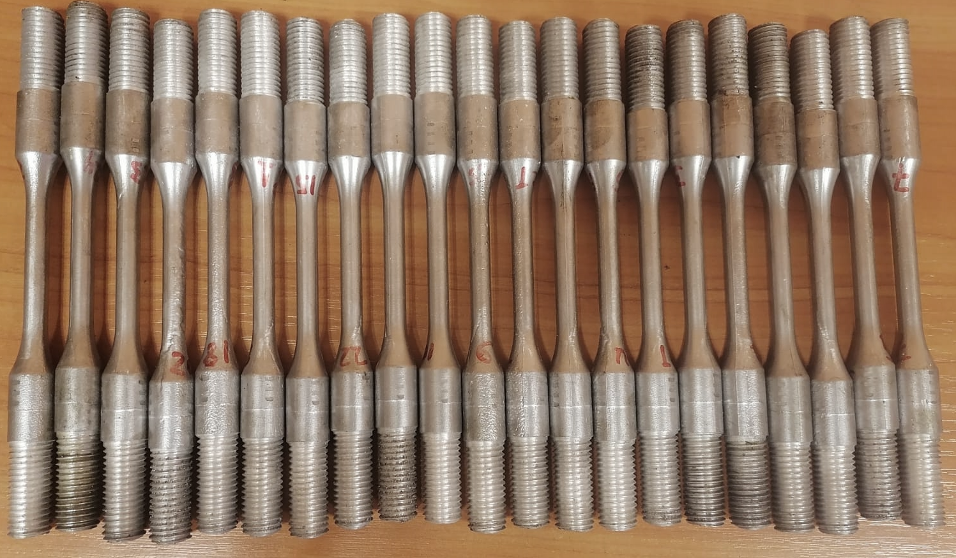
Figure 1. Relaxation and creep test specimens.

Table 1. The determined chemical composition of the investigated alloy in weight percentage.
Fe | Si | Cu | Mg | Zn | Mn | Ti | Ni | Al
0.4 | 11.4 | 1.27 | 1.24 | 0.18 | 0.18 | 0.04 | 1.48 | rest

Experimental procedures
The stress relaxation and creep tests were conducted on a universal testing machine (Z100) manufactured by Zwick/Roell. The testing machine was fitted with a furnace and universal 3-zone furnace controller, as indicated in Figure 2. A 3-zone universal furnace controller is used to control the furnace temperature and specimen surface temperature via six thermocouples. The Zwick testXpert software was used to monitor and control the load application and temperature through a digital closed-loop control system. The stress and creep tests were carried out at temperatures of 150, 250, and 350°C. To study the effect of these temperatures on the stress and creep properties of the alloy, an initial stress level equivalent to 50% of the alloy's yield strength was used. The authors carried out the study of the mechanical properties of the alloy at each corresponding temperature [24] as presented in table 2.

Figure 2. Stress relaxation and creep test set-up.

Table 2. Mechanical properties of the studied alloy [24].
Temperature, °C | E, GPa | Yield Strength, MPa | Ultimate Strength, MPa | Fracture Strain, %
150 | 82 | 100 | 125 | 0.6
250 | 55 | 90 | 115 | 0.8
350 | 55 | 60 | 65 | 1.9

Initially, the specimen was installed and aligned in the center of a furnace, then heated for about one hour until steady state temperature was reached. Throughout the process, heat was controlled using a 3-D universal furnace controller through thermocouples. Once the target temperature was attained, 50N of preload was applied to ensure no slippage occurred during the testing process. The relaxation tests were conducted in accordance with ASTM E328-21 [25]. During the relaxation test, the load was applied at a strain rate of 2 × 10-4 sec-1 until initial stress was imposed. Once the initial stress level was reached, the strain was kept constant while the stress was relieved until the end of the test. Throughout the process, the load was monitored as a function of time, and the test was generally continued for about 24 hours. During the creep test, the load was applied until the initial stress was reached, which was kept constant for about 45 hours. The extensometer was used to measure the elongation of the specimen.

Rheological model of stress relaxation and creep behavior of EN AC-Al Si12CuNiMg alloy
The Standard Linear Solid Model (SLSM) is a constitutive model commonly used in the field of engineering to describe the mechanical behavior of materials under different loading and temperature conditions. It is based on the assumption that the material can be represented as a linear combination of springs and dashpots. It is commonly used to characterize the stress relaxation and creep behavior of materials [26, 27]. This model assumes that the material is a linear combination of a spring element and a dashpot element, with the spring element representing the elastic response of the material and the dashpot element representing the viscous response of the material. It is usually represented by two different forms: the Maxwell form and the Kelvin form. Figure 3 illustrates the differences between the Maxwell form and the Kelvin form of the standard linear solid model [cite]. The Maxwell form consists of a spring element and a dashpot element arranged in series, while the Kelvin form consists of a spring element and a dashpot element arranged in parallel. For this study, the Kelvin form of the SLSM.
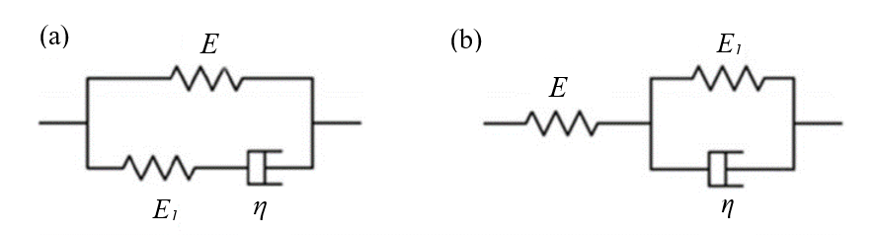
Figure 3. The three parametric standard linear solid model: (a) the Maxwell form of SLSM and (b) the Kelvin form of SLSM [27].

Based on a standard linear solid model, the stress relaxation behavior of the material can be described using either equation (1) or equation (2):
 | $$σ\left(t\right)=Eε_{1}\left(\frac{E_{1}}{E_{1}+E}+\frac{E}{E_{1}+E}exp\left(-\left(\frac{E_{1}+E}{η}\right)t\right)\right)$$ | (1)

 | $$σ\left(t\right)=Eε_{1}\left(\frac{H}{E}+\left(1-\frac{H}{E}\right)exp\left(\frac{-t}{n}\right)\right)$$ | (2)
Where, $ε_{1}$ stands for the constant strain during relaxation, E =E_{e} stands for the relaxation modulus at the beginning of stress relaxation, E₁ stands for the relaxed modulus that describes how much the relaxation modulus drops from the beginning of stress relaxation to the end, $η$, stands for viscosity which describes the material's ability to flow under applied stress, and H stands for the relaxation modulus as time approaches to infinity ($t→∞$) and n is a time constant. The model parameters of equation 1 can be related to the model parameters of equation (2), which can be described by equations (3) and (4).
 | $$\frac{1}{H}=\frac{1}{E}+\frac{1}{E_{1}}$$ | (3)
 | $$n=\frac{η}{\left(E+E_{1}\right)}$$ | (4)
The creep strain, as per the SLSM model, can be described as a function of time by using either equation (5) or (6).
 | $$ε\left(t\right)=\frac{σ_{1}}{E}\left[\frac{E}{H}+\left(1-\frac{E}{H}\right)exp\left(-\frac{H}{nE}t\right)\right]$$ | (5)

 | $$ε\left(t\right)=\frac{σ_{1}}{E}\left(1-\frac{E}{H}\right)\left[1-exp\left(-\frac{H}{nE}t\right)\right]exp\left(-\frac{H}{nE}t\right)$$ | (6)
where σ₀ is the constant stress during the creep test, the other parameters are the same as the relaxation parameters.
- Results and Discussion

Stress relaxation curves
Figure 4 shows the stress relaxation curves obtained at different temperatures and the fitted curves achieved through the SLSM of equation (1). The relaxation curves indicate a good agreement between experimentally obtained results, and the SLSM curve fits with coefficients of determination (R2) values more than 0.99. The value of the stresses is expressed as a function of time. The initial stress level used at this temperature was about 50% of the yield stress (50, 45, and 30 MPa) at each corresponding temperature. As clearly indicated in Figure 4, relaxed stress increases with increasing temperatures. For example, at 150°C, the relaxed stresses are 23 MPa, indicating that the material is able to release 46% of its initial stress. As the temperature increases to 250°C, the relaxed stresses increase to 33 MPa, with a temperature drop of 73%. Finally, at 350°C, the relaxed stresses reach 27 MPa, with a temperature drop of about 90%. The most significant drop in the stress level occurs within approximately 2 hours of loading. Depending on the level of stress relief, the entire relaxation process can be categorized into three distinct stages. In the initial phase, stress exhibits rapid relaxation; however, in the subsequent phase, stress demonstrates a slower relaxation rate. After a long period of relaxation, the stress eventually approaches a steady state where the relaxation rate becomes almost constant in the third phase. In the first stage of relaxation, the relaxation behavior is non-linear and decreases with the duration of the test as it progresses. In the second stage of stress relaxation, the material develops compressive stress, and the stress relaxation rate decreases significantly. Finally, in the third stage, the stress relaxation rate becomes almost constant.

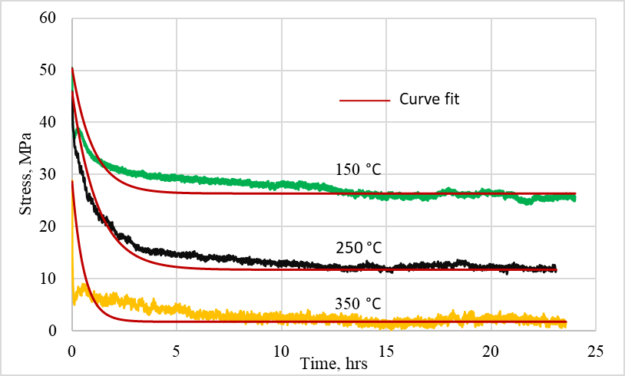
Figure 4. Experimental stress relaxation curves and fitted curves under different temperatures.

Creep curves
Figure 5 shows the obtained creep-strain curves of the investigated alloy. These curves were obtained at different temperatures of 150, 250, and 350°C with the corresponding 50% of the yield stress of the material, 50, 45, and 30 MPa, as presented in Table 2. As clearly shown in Figure 5, the creep strain increases as the temperature increases. For example, at a time of 10 hours and a temperature of 150°C, 250°C, and 350°C, the creep strain values are 0.09%, 0.19%, and 0.48%, respectively. This indicates the significant effect of temperature on the creep behavior of the investigated alloy. It also shows that the material is more vulnerable to creep deformation at higher temperatures. There are similarities between the plotted creep curves and typical creep curves defined by two stages: the primary stage, where the creep rate decreases, and the secondary phase, where the creep rate becomes constant [28, 29]. As stated in reference [30,31], the creep rate in the primary creep stage is initially high due to the initial formation and movement of dislocations. It is followed by a rapid decrease as the dislocations accumulate and their mobility decreases. As shown in Figure 6, the creep strain curve corresponding to a temperature of 350°C shows higher creep rates than the creep rate associated with temperatures of 250°C and 150°C. This suggests that a higher creep temperature results in higher creep strain.

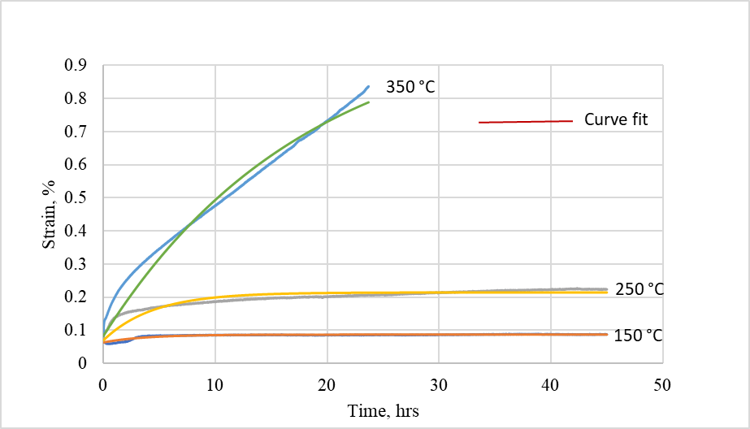
Figure 5. Creep curves under different temperatures.

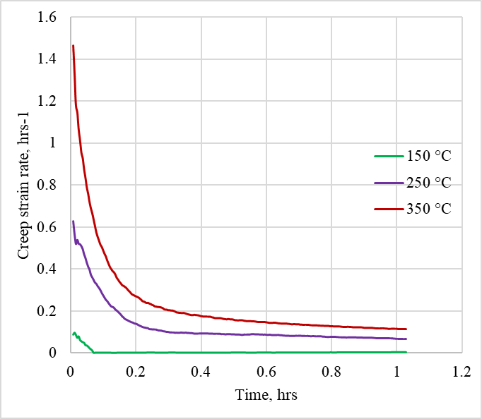
Figure 6. Creep rate curves of the primary stage under different temperatures.

The standard linear model of solids (SLSM) parameters determination
The test result indicates that all parameters of the SLSM relaxation model vary significantly with temperature. For example, the relaxation modulus at the beginning of relaxation (E) decreases as the temperature increases. When the temperature increased from 150°C to 250°C, it decreased by about 7%. However, a significant reduction was observed when the temperature increased from 150 to 350°C, with its value reduced by approximately 32%. For the relaxation modulus E₁, there is no significant change in temperature from 150°C to 250°C. However, when the temperature increases from 150 to 350°C, it decreases by 45%.
Additionally, the viscosity decreases significantly as the temperature increases. The viscosity values decreased by 30 to 70% as the temperature increased from 150 to 250 C and 350°C. This shows that temperature significantly affects the relaxation model parameters of the investigated alloy. The chart in Figure 7, which displays the relaxation model parameter values as a function of temperature, clearly illustrates the trend of decreasing values as the temperature increases.

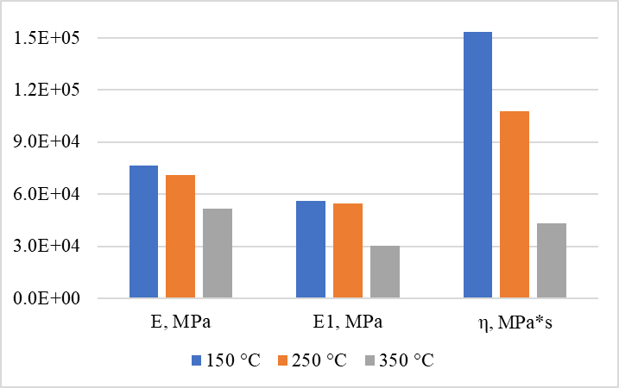
Figure 7. Relaxation model parameters of the investigated alloy at different temperatures.

The creep model parameters of the studied alloy are influenced by temperature. Figure 8 illustrates how these parameters change with temperatures. The three standard model parameters (E, E₁, and η) all decrease with increasing temperature, with E₁ experiencing a more significant reduction than the other parameters. Specifically, as the temperature increased from 150°C to 250°C, the value of E₁ decreased by approximately 85%. This reduction becomes even more noticeable as the temperature increases from 150°C to 350°C, with E₁ decreasing by approximately 95%. Since E₁ measures the material's resistance to creep deformation, these substantial decreases in this parameter indicate that the alloy's ability to resist creep deformation decreases at elevated temperatures. This means that the alloy may experience more plastic deformation and structural changes at elevated temperatures. As the temperature increases, the thermal energy within the material increases and promotes the mobility of dislocations and the diffusion of atoms [31]. The enhanced mobility of dislocation and diffusion of atoms are likely attributed to these changes in creep behavior.
In stress relaxation and creep, model parameters (E and η) decrease as temperature increases by almost the same values. However, E₁ drops significantly as the temperature increases from 150 to 350°C during creep rather than during stress relaxation. This indicates that the increase in temperature has a greater impact on E₁ during creep compared to stress relaxation.
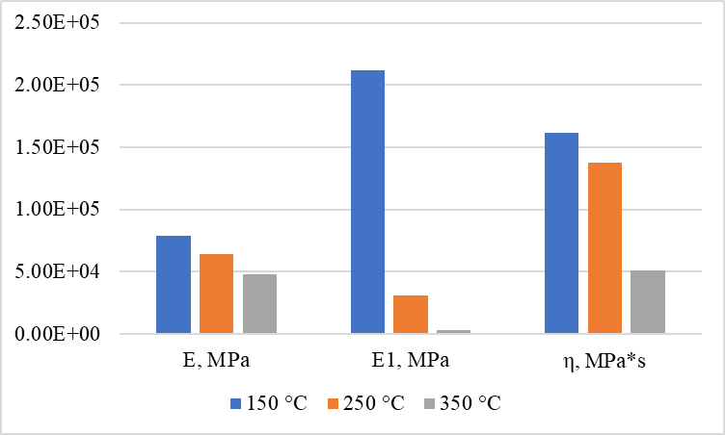
Figure 8. Creep model parameters of the investigated alloy at different temperatures.

- Conclusion
In this study, stress relaxation and creep behavior of EN AC-Al Si12CuNiMg alloy were studied at different temperatures: 150, 250, and 350°C. To do so, the stress relaxation and creep tests were carried out. By fitting the stress relaxation and creep curves using the standard linear solid model (SLSM), the model parameters were determined for each test temperature. The results showed that the model parameters vary with temperature. The fitted curves showed good agreement with the experimental data, indicating that the determined SLSM model parameters can define the investigated alloy's stress relaxation and creep properties under different temperatures.
In the case of stress relaxation, the stress level of the alloy decreases rapidly in the initial phase. The most significant reduction in stress levels occurs around 2 hours after loading. The rate of relaxation also increases with temperature. Unlike stress relaxation, creep deformation does not show any reduction; however, it increases with temperature.
The trends of creep and relaxation rates are almost similar. In the initial phase, the rapid change in relaxation and creep rates is attributed to the rearrangement of dislocations within the alloy. As the dislocations gradually rearrange and realign, the rates of relaxation and creep decrease, leading to the second phase, where the rates become almost constant. This indicates that the material has reached a more stable state of stress relaxation and creep behavior. By reaching this steady state, the material has balanced the rearrangement of dislocations and the applied stress. Relaxation rate and creep strain rate increase with temperature, leading to accelerated deformation of the alloy.

References

- Sáenz de Argandoña E, Galdos L, Ortubay R, Mendiguren J and Agirretxe X 2015 Room temperature forming of AA7075 aluminum alloys: W-temper process Key Eng. Mater. 651 199–204.
- Wang R, Ram D, Stauder B, Gutiérrez R F, Gariboldi E and Poletti M C 2022 Stress Relaxation during Artificial Aging of an AlSi7Cu0. 5Mg Cast Alloy Crystals 12 1168.
- Polmear I 2005 Light alloys: from traditional alloys to nanocrystals (Elsevier) P437.
- Puspitasari P, Soepriyanto O R, Sasongko M I N and Dika J W 2018 Mechanical and physical properties of aluminium-silicon (Al-Si) casting alloys reinforced by Zinc Oxide (ZnO) (MATEC Web of Conferences: EDP Sciences) vol 204 p 05003.
- Lee J A and Chen P S 2002 Aluminum-silicon alloy having improved properties at elevated temperatures and articles cast therefrom. U.S. Patent 6,399,020.
- Lee J A 2003 Cast aluminum alloy for high temperature applications (132nd TMS Annual Meeting and Exhibition).
- Lee J 2012 Elevated-temperature properties of ASTM A992 steel for structural-fire engineering analysis PhD Thesis.
- Mishra S, Yadava M, Kulkarni K N and Gurao N P 2018 Stress relaxation behavior of an aluminium magnesium silicon alloy in different temper condition, Mech. Mater. 125 80–93.
- Costa Junior P R, Moura Neto C de and Wade D A 2014 Evaluation of a 7050-TAF aluminum alloy submitted to creep age forming Mater. Res. 17 603–11.
- Vattur Sundaram M 2014 Low Temperature Creep/Relaxation Behaviour of PM Steels under Static Load Master’s Thesis.
- Larson F R and Miller J 1952 A time-temperature relationship for rupture and creep stresses Trans. Am. Soc. Mech. Eng. 74 765–71.
- Furillo F T, Purushothaman S and Tien J K 1977 Understanding the larson-miller parameter Scr. Metall. 11.
- Pavlou D G 2001 Creep life prediction under stepwise constant uniaxial stress and temperature conditions Eng. Struct. 23 656–62.
- Zhao X, Niu X, Song Y and Sun Z 2022 An investigation of the non-linear creep damage accumulation of different materials: Application of a novel damage model Fatigue Fract. Eng. Mater. Struct. 45 530–45.
- Batsoulas N D 2009 Creep Damage Assessment and Lifetime Predictions for Metallic Materials under Variable Loading Conditions in Elevated Temperature Applications Steel Res. Int. 80 152–9.
- Hu X, Ye W, Ma X and Song Y 2019 A new creep damage assessment method for metallic material under variable load conditions at elevated temperature Fatigue Fract. Eng. Mater. Struct. 42 2725–37.
- Mansoor M and Shahid M 2018 Stress relaxation behavior of annealed aluminum-carbon nanotube composite Sci. Eng. Compos. Mater. 25 1015–9.
- Lyu F, Li Y, Shi Z, Huang X, Zeng Y and Lin J 2020 Stress and temperature dependence of stress relaxation ageing behaviour of an Al–Zn–Mg alloy Mater. Sci. Eng. A 773 138859.
- Hamasaki H, Morimitsu Y and Yoshida F 2017 Stress relaxation of AA5182-O aluminum alloy sheet at warm temperature Procedia Eng. 207 2405–10.
- Yu W, Zhan L, Xu Y, Chen K, Yang Y, Xu L, Peng N, Ma B, Liu C and Chen Z 2022 Temperature-dependent creep aging behavior of 2A14 aluminum alloy J. Mater. Res. Technol. 19 1343–54.
- Zhang S, Zhang Y, Chen M, Wang Y, Cui Q, Wu R, Arola D and Zhang D 2018 Characterization of mechanical properties of aluminum cast alloy at elevated temperature Appl. Math. Mech. 39 967–80.
- Golshan A M A, Aroo H and Azadi M 2021 Sensitivity analysis for effects of heat treatment, stress, and temperature on AlSi12CuNiMg aluminum alloy behavior under force-controlled creep loading Appl. Phys. A 127 1–18.
- Zhan L, Wu X, Wang X, Yang Y, Liu G and Xu Y 2018 Effect of process parameters on fatigue and fracture behavior of Al-Cu-Mg alloy after creep aging Metals 8 298.
- Sirata G G, Wacławiak K and Dyzia M 2022 Mechanical and Microstructural Characterization of Aluminium Alloy, EN AC-Al Si12CuNiMg Arch. Foundry Eng. 22.
- ASTM E328-21 2008 Standard Test Methods for Stress Relaxation for Materials and Structures (West Conshohocken, US: Annual Book of ASTM Standards).
- Plaseied A and Fatemi A 2008 Deformation response and constitutive modeling of vinyl ester polymer including strain rate and temperature effects J. Mater. Sci. 43 1191–9.
- Lin C-Y 2020 Alternative form of standard linear solid model for characterizing stress relaxation and creep: Including a novel parameter for quantifying the ratio of fluids to solids of a viscoelastic solid Front. Mater. 11.
- Beddoes J and Mohammadi T 2010 Comparison of stress relaxation and creep strain rates for the superalloy IN738LC J. Strain Anal. Eng. Des. 45 587–92.
- Zhan L H, Li Y G, Huang M H and Lin J G 2011 Comparative study of creep and stress relaxation behavior for 7055 aluminum alloy Adv. Mater. Res. 314 772–7.
- Zheng J-H, Jin Y, Xu L, Fan C, Song W and Chen Y 2023 Comparative Study of Creep and Stress Relaxation Behaviour during Ageing of 7050 Aluminum Alloy Metals 13 778.
- Naumenko K and Altenbach H 2016 Modeling high temperature materials behavior for structural analysis (Springer) Vol. 112.

