Ship Emission Projections based on Time Series Forecasting Model for Sustainable Shipping in the Strait of Malacca and Singapore
Ki-Hong Ten¹, Hooi-Siang Kang^{1,2,*}, Kuan-Yew Wong¹, Chee-Loon Siow^{1,2}, Choon-Hee Ong³, Kok-Chee Hoo⁴, Yiliu Liu⁵
¹ Faculty of Mechanical Engineering, Universiti Teknologi Malaysia, Johor Bahru, Malaysia
² Marine Technology Center, Institute for Vehicle System & Engineering, Universiti Teknologi Malaysia, Johor Bahru, Malaysia
³ Azman Hashim International Business School, Universiti Teknologi Malaysia, Johor Bahru, Malaysia
⁴ Software and Advanced Technology Group, Intel Corporation, Penang, Malaysia
⁵ Department of Mechanical and Industrial Engineering, Norwegian University of Science and Technology, Oslo, Norway

* kanghs@utm.my
Abstract. As maritime activities continue to play a pivotal role in global trade, concerns over ship emissions' environmental impact have intensified. This study presents detailed projection of ship emissions in Strait of Malacca and Singapore (SOMS), based on Automatic Identification System (AIS) data. By harnessing the rich AIS dataset, emission profiles were developed out of the ship activities data. To envision a sustainable maritime future, we incorporate some possible scenarios around the region combined with a time series forecasting model to project the future conditions of ship emission in SOMS. By analysing the conditions in each scenario, essentials for shaping intelligent systems for efficient maritime traffic can be discovered. Our analysis considers evolving factors such as various ship properties, operational modes, and trajectories. The results provide insights for policymakers, industry stakeholders, and environmental planners seeking to mitigate the local maritime sector's carbon footprint. This study signified the value of AIS data-driven approach to facilitate regional strategist in confronting resolutions for greener maritime operation, aligning with the transition to intelligent and sustainable practices in the maritime industry within the SOMS.

Introduction
Moving forward with the synergies of Sustainable Development Goals (SDGs) in combating climate change, maritime authorities were also committed to extend their effort into the fulfilment of net zero emissions by 2050. In the course of transitional phase of technical advancement to completely resolve the greenhouse gases (GHGs) emissions from ships, an institutional platform should be in place for collectively monitoring and analysis of the maritime carbon footprint relative to the ambient air quality. For this platform is not only for awareness raising to the society, but also to enhance the surveillance of maritime activities in conjunction with emissions tracking, AIS data were predominantly utilized for the assessment from environmental aspects, especially being an enabler for the use of machine learning model such as neural network. With the study of historical ship emissions over certain regions, it is also possible to project a logical trend of emissions that is likely to be foreseen with certain conditions applied. Relatively, SOMS is a critical region where ship traffic is dense and complex that is prone to congestions and form basin of emissions, yet lacking the tracks of maritime carbon footprint in this region that many have concerned.
As the major conduit linking the international East-West shipping routes, SOMS is estimated to have enabled the transit of one-third of global trades annually, corresponded to 15 millions of oil barrel [1]. Aside from bringing prosperities to many countries that benefits from this shipping routes, the heavy marine traffic of about 120,000 vessels annually in the compact area of SOMS also brought about challenges, such as marine environmental and safety hazards, for the littoral countries to deal with. Upon the development of maritime safety awareness and environmental protection over the years, the partnerships of Tripartite Technical Experts Group (TTEG) between the members of Indonesia, Singapore and Malaysia are still continuing to address the latest maritime issues in SOMS, including further enhancement in ship reporting and routing system [2]. This suggested that the conventional Traffic Separation Scheme (TSS) alone has become overwhelmed to accommodate the current traffic size while ensuring a regulated traffic flow along the strait, leading to unwelcomed accumulation of emissions.
In order to maintain efficient traffic flow with minimum environmental impact in SOMS, it is essential to ensure an effective reporting of navigational status of transiting ships to the Vessel Traffic Service (VTS) authorities for in situ assessment and make necessary control. Besides upholding the mandatory reporting procedure (STRAITREP) in SOMS, AIS can be more reliable as a track record of ships trajectories with various instantaneous navigational parameters, such as speeds, headings, etc. While the improved ship routing system is expected to provide optimal routing alternatives for ships based on the distance to destination, available voyage time, and the instantaneous traffic conditions, to prevent disruptive traffic system and deteriorate shipping schedule. For such a complex problem, the effectiveness of the VTS in handling SOMS maritime data and feedback with appropriate aids is in concern. On the other hand, projections of maritime emissions in SOMS may help to reveal piecewise information about the ship traffic from bottom-up approach, demonstrating the outcomes of different scenarios.
Despite the ambitious targets to reduce GHGs, the trend of CO₂ emissions from international shipping was reportedly showing bad signs, with 5% rebound to 706 Mt CO₂ in 2022 since the dip in 2020 pandemic time [3]. To investigate whether the seemingly adverse trend will be replicated in SOMS even with decarbonization measures in place, this paper presents the projection of emission using a time series forecasting model based on the available AIS data from SOMS. The preceding computation of shipping emissions are conducted based on different scenarios to assess the effectiveness of different measures implementation against the maritime emission in SOMS. The results of this paper are expected to provide insights about AIS data-driven emission profile and future projections, as well as assessing the mechanism of each measure with regards to the resulted carbon footprint in compliance with the requirements.

Related Works
The AIS-based emission estimation methodologies are commonly known as bottom-up approach or activity-based approach, which literally indicates the consideration of various activity parameters into the inference of emission factors (EF) rather than direct derivation from fuel consumptions that may be more susceptible to uncertainties in macro-estimation of emissions. Notwithstanding the dependency of fuel oil consumption (FOC) variable on the ship operational condition, considering the real harsh meteorological conditions in the ocean will be more coherent with the parameters recorded by AIS data, thus forming the legacy for weather routing [4]. Thanks to the varieties of parameters recorded by AIS, the data could also be served as indicator for different performance indexes of the overall ship traffic operations, determining the tradeoff between different technologies or policies towards decarbonized shipping. For instance, Dettner and Hilpert [5] attempted to model the resultant CO₂ emissions from Northern European shipping if E-methanol is used as the main substitute for conventional fuel-powered ships, and has demonstrated its potential to reduce CO₂ emission by up to 50% by 2030 while abiding with the energy demands of the ships.
As such, for more detailed understanding of the environmental impact from maritime transportation, trend projections based on current the emission trend computed from AIS-based methodologies can provide much direct implications to reason the likelihood of the worst conditions in future with all variables being examined. In order to construct a reliable projection model, the predictive element is required to sustain precisions over a time series of period, where machine learning methods are often used to handle big data for processing the prediction part [6]. With the prevailing AIS-based emission estimation, the emission data pivoted with spatiotemporal and other navigational data can be further processed to form the elements for projection to visualize future emission trend [7]. Likewise, with consideration of scenarios like policies implementation and technological maturity, the most optimal alternatives could be reverse engineered from the projections. To incorporate different scenarios, certain level of parameter alteration can be done during the computation of input data, initializing another iteration of modified runs that will show a different projections than the baseline scenario [8].
Apparently, the overall emission trend from freight transportations can be envisioned by various projections including transport demands, energy consumption and finally, associated emissions. However, a national extent of projection may not be intended to project a precise trend of emission [9], but its value is to compare the outlook of different policies enforcement, as policies are often implemented over a macro scale of area. For instance, the common policy scenarios are implementation of Emission Control Area (ECA) and restriction use of conventional fuel oil, together with other conditions, like Business-As-Usual (BAU) and High-Growth (HiG) traffic conditions, to set the range of results to best- and worst-case scenarios [10]. Such qualitative study has to be carefully considered as the resultant differences of scenarios may unintentionally be deviated by external factors, such as the ship navigational behaviors in ECA, increasing traffic in narrow waterway, etc. Alternatively, a systematical investigation with discrete scenario design for certain parameters like fuel ratio, speed mode, ship properties and route selection can be considered for more precise reasoning [11].
Following the necessity of machine learning algorithm to handle big data, many studies had proposed varieties of approaches to assess and forecast the shipping emission based on the carbon footprint quantified from maritima data, majorly AIS data. As a general example, Paternina-Arboleda et al. [12] employed different machine learning algorithms, including Artificial Neural Network (ANN), linear regression, gradient descent, and AutoML-TPOT, as attempts to examine the best models for their predictions of SO₂ emission from ships based on AIS data. Beyond that, there were also other suggested algorithm worth to be used, such as Long Short-Term Memory (LSTM) [13], Recurrent Neural Network (RNN) [14], Gated Recurrent Units (GRU), Convolutional Neural Network (CNN) [15], etc. ANN, being a much robust generic algorithm in handling big complex data, can be utilized directly based on varieties of input data, to study the correlations of parameters on resulting different size of emissions. With that, Bilgili and Buğra Çelebi [16] concluded that the effect of harsh meteorological conditions on emission rates is seemingly greater than route distance.
Beside direct projection on emissions, computation of other variables would also be useful for indirect deduction or provides insights to the underlying factor of excess emissions. A comprehensive ship activity modelling is also able to calculate the ship power consumption and other derivatives as a preceding process for forecasting the attainable carbon footprint [17]. As such, numerical methods were employed to predict ship power in order to discover the substantial demand for FOC under different navigational conditions by means of data-driven machine learning methods [18]. Studies by Ren et al. [19] also reveal the consistency of utilizing AIS data for FOC estimation in way of predicting ship emissions, compared to direct reference on daily fuel oil measurement data. Similarly, Kaklis et al. [4] also demonstrated FOC estimation by a deep-learning model (SplineLSTM) to reflect the associated emissions of a ship. Correspondingly, ship speed as the primary parameter that dictated the FOC of ships constituting major part of ship emissions is to be optimized to maintain efficient operational condition [20].
Nevertheless, the operational factors of the ship navigation are not to be neglected during the midst of exploiting the primary substitute of cleaner fuels, as we expect to resolve the GHG emissions entirely. Given the stagnant condition for existing stage, some focus should be directed to the operational viewpoint of decarbonization like route-based action plan, which also required some efforts to pull together interest of funding to coordination span across jurisdictions for setting up smooth and safe voyage line [21]. For SOMS being the only channel to connect maritime from the East and West, it is important to sustain the maritime activities in the waterway without much interference with one another [22] . In that sense, reducing the energy demand works on another way in lowering the ship emissions, such as route planning [23], weather routing [24], just-in-time arrival [25], Speed optimization [26], etc. Fundamentally, the shipping network need to be established with explicit routes identification [27] so as to facilitate aforementioned strategies.

Methodology
The AIS data-driven emission estimation is processed based on a well-established framework of Methodologies for Estimating air pollutant Emissions from Transport (MEET) [28]. This framework facilitates micro-scale of derivation from ship properties and navigational parameters to the resulted emissions for every trajectory of the voyage. The subsequent future projection of ship emissions required a machine learning method to assimilate the underlying patterns of emission temporally. The extracted information through certain logical interpretation of curve fitting and trend modelling by the machine learning model allow more practical predictions of the future emission forming the trend of projections.

Data Preparation
The AIS data are collected within a one-month period in September 2019, corresponded to a total of 4,552 ships activities that were captured in SOMS with range of 1.0°N to 4.5°N in latitude and 102°E to 106°E in longitude. The extent of ship data covers the open sea areas in South China Sea, significant port waters in Malaysia, Singapore and Indonesia, and some inland waterways, suggesting a diversified yet rational inference of the local maritime emissions. The information that is maintained for the process of emission estimation includes MMSI, date and time as timestamp, longitude and latitude of ship position and speed over ground (SOG). Besides, ship properties information such as ship type and gross tonnage are lookup from web-based database. The attributes of ships that are used to segregate data for specific energy demand variables are ship type and operational mode [29].
During data cleaning process, inappropriate status or extreme outliers were removed from the dataset. Data segregation is subsequently carried out based on the ship types and modes of operation based on the methodology demonstrated by Ten et al. [29]. Taking into consideration that the parameters applicable for each specific ship type may varied, every AIS data of specific MMSI were pivoted with normalized ship type, namely dry bulk, liquid bulk, general cargo, container, passenger, Ro-Ro, fishing, and others. Furthermore, the range of ship speed for classification of operational modes by different ship type were also being determined as provision for load factor assignment to compute the energy demand of each ship during their voyage.

Emission Profile
The fundamental formulation of emission estimation for every voyage, $E_{Trip,i,j,m}$ in this study is based on derived equation justified in the report by Trozzi [28]. Owing to limited access to fuel-related information, this paper handles the derivation of emissions based on energy demand viewpoint, which imply the energy required to arrive at each trajectory with the required time and speed with consideration of possible tonnage, nominal power rating and associated load factor at specific operational modes.
In order to compute the trend of ship emissions along its voyage, the nodal emission product on each trajectory were computed to form an emission profile following the voyage captured by the AIS data along SOMS. Consequently, all ships will form their own specific emission profile corresponding to their ship type, geographical locations, and operational mode. For the context of being practical for making subsequent projections, influences of the granularity of data were being concerned as projection may be biased. Time series were constructed in daily and hourly units for comparison of the effect on projections.
Aside from the principal parameters of navigational behavior that determine the energy demand, other attributes are normalized to streamline the computational process of the projections. For instance, $P_{e}$ and EF that is determined by the engine type and fuel type respectively are prorated into generic parameter for all ship type classifications with probabilistic approach based on the percentage of each engine-fuel type found from investigation of each particular ship type stated in Trozzi [28] reports. Correspondingly, this study only considered the dominating pollutant, carbon dioxide (${CO}_{2}$) emissions as indicator of the corresponded shipping emissions in SOMS.

Emission Projection
Based on the resulted profile computed from the AIS data, this study used the Prophet Forecasting Model, as attempt to make subsequent forecasts of the emissions for the maritime activities in SOMS. This model basically uses temporal component as regressor and is effective in decomposing trendline by different level of time series [30]. As there are different extents of projections, this study made reference to the guideline by EEA [31] to construct an appropriate projection methodology to adapt the context of this study, as shown in Figure 1. Taking the activity data as the fundamental basis for estimating the shipping emissions, the projection serves as an indicator of the impact brought about by the operational variables of the ship. While other influential variables, such as ship properties, engine-fuel type and retrofit technologies, correlated to emissions were not enumerated as aforementioned.

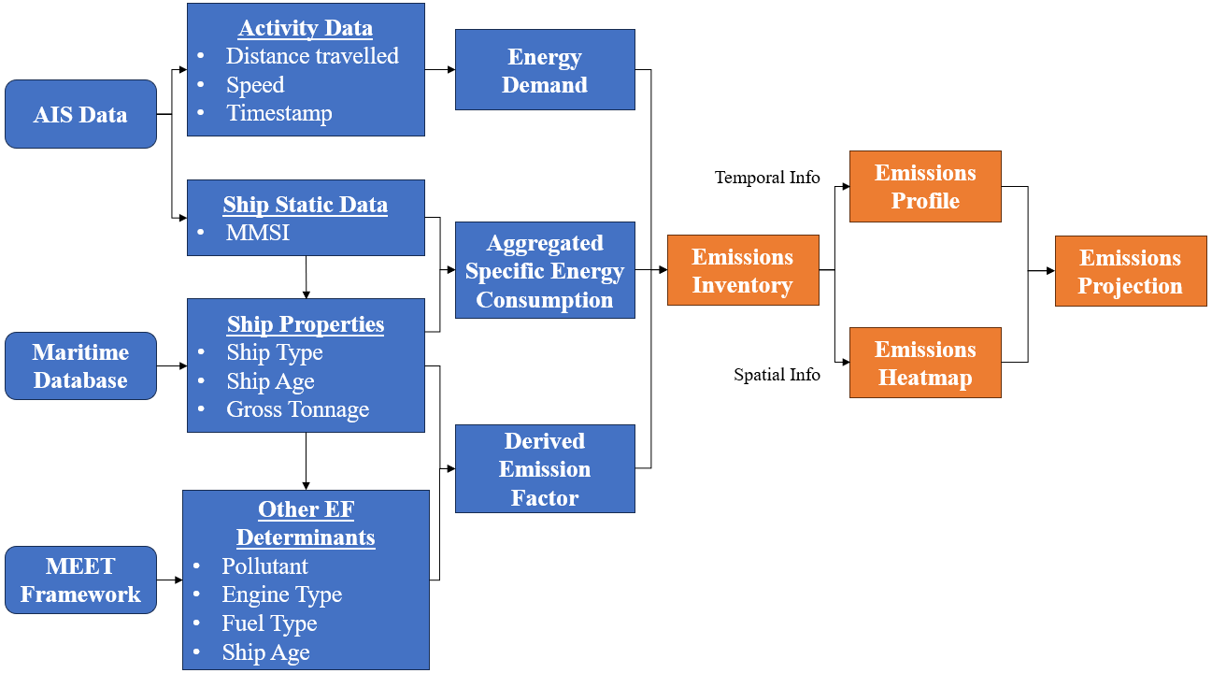
Figure 1. Schematic chart of the feature engineering for emission estimation as provision of emission projection.

The AIS data-driven energy demand as a derivative of ship activity data is the focal point of the basis for detailed assessment of emission projection. These AIS provided information are stratified with respect to the ship type classification, in order to segregate the distinct behaviours or traffic patterns in the region of SOMS and ease to subsequent assessment of the ship operational mode impact on emissions.

Scenario Formulation
Without considering hypothetical scenario such as measure implementation and technological advances, the projections based on a one-month data is barely feasible for short-term projections. Hence, this study also considered several scenarios of possible measure implementations in SOMS that may enforce compliances of operational limit for ship navigating in this area to reinforce the regional decarbonization efforts, as shown in Table 1.
Table 1. Scenario formulation and application criteria.
Scenario | Parameter Change | Application Criteria | Ref
BAU | - | - | [10]
Speed Limit | Speed < 12 knot | Apply to ship type: Container, Dry Bulk, Liquid Bulk, General Cargo | [32]
HFO banned | CO₂ EF < 524 g/kWh | HFO EF substituted with other cleaner fuel | [33]
JITA | Energy demand - 15% | Apply to ship type: Container, Dry Bulk, Liquid Bulk, General Cargo | [34]
BAU: Business As Usual; HFO: Heavy Fuel Oil; JITA: Just-in-time Arrival

Considering the projection of emissions under existing circumstance, business as usual (BAU) scenario is considered the baseline other scenario analysis as the reference for assessment [10]. This is essentially applied to all scenario analysis where assumptions of specific conditions are modified on top of the BAU case. The scenarios considered are basically a soft demonstration of the possible measures being enforced to certain categories of ships where applicable, as shown in the application criteria. Nevertheless, the measures would be executed more deliberately in real cases, to which the policies would cover this part.
Speed limit in SOMS is actually undefined by the officials, but 12 knot is the only restriction that apply to Very Large Crude Carrier (VLCC) and deep draught vessels when navigating in certain areas of high risk [32]. In the context of this study, cargo carrying ships (container, dry bulk, liquid bulk and general cargo) are considered under this restriction, whereas the remaining ships (passenger, Ro-Ro, fishing and others) are restricted under 16 knots abiding to the speed limit scenario.
HFO is conventionally used as the primary source of fuel for maritime vehicles, to which global authorities were going against due to its high sulfur content and other pollutants emissions as a result of burning it. On the other hand, Marine Diesel Oil (MDO) was the main substitute for HFO during the time when alternative fuels were not yet well developed. Taking into account that before a green fuel can take over as the dominance of maritime power source, this study considered about substituting HFO with MDO as a progressive step towards maritime decarbonization.
JITA is conceptually an ideal operational measure to be achieved by active coordination of optimal shipping schedule and port operations to streamline the entire process of shipping. However, the optimal speed for each ship, subjected to respective schedule and ship properties, would turn into improvement of operational modes unproportionally. Owing to different typical hoteling durations reported [35] due to varying schedule arrangement and port handling methods, this study apply the scenario of JITA based on the change in energy demand. It is reported that by the best case of JITA, the energy demand corresponded by fuel consumption of the ships can be reduced up to 15% if operating at optimal speed [34].

Results & Discussions

Emission Profile
For every CO₂ emission instance pivoted to the trajectorial date, the emission profile by ship type under different scenarios are illustrated in Figure 2. It can be noticed there is no significance differences of profile pattern despite additional formulations on respective trajectories. Only the extents of CO₂ generation are being reduced by 8.07%, 3.14% and 15% with the implementation of speed limit, HFO banned, and JITA. On the other hand, an obvious upward trend can be noticed over the timeframe of the emission profile, which could be a misleading intuition that could possibly be due to skewing in data distribution and unfavourable aggregation of data. When comparing the CO₂ emission profile by level of time series in daily and hourly as shown in Figure 3, it can be noticed that this trend is smoothen when temporal data is granularized into hours. Hence, by this perception, it is believed that the hourly emission profile would generate more realistic emission projection.

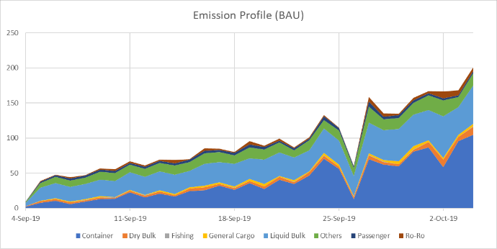  (a) | 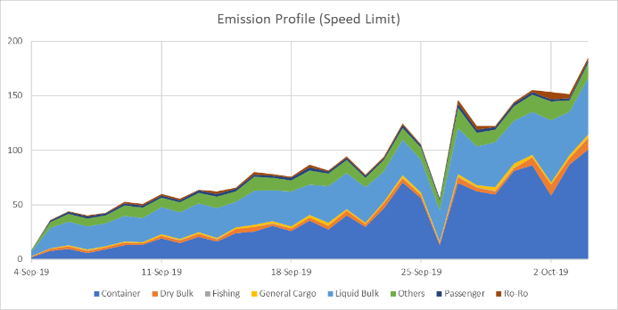  (b)
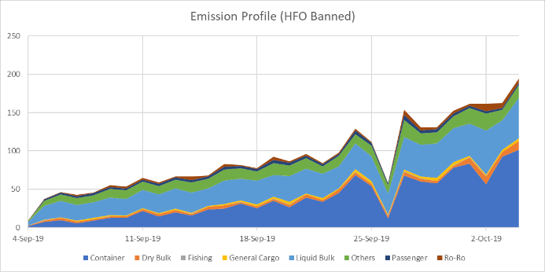  (c) | 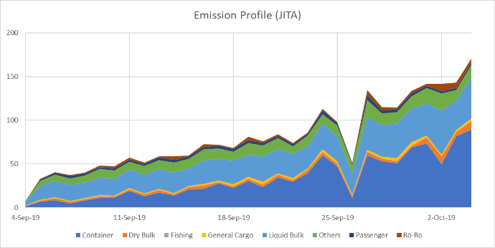  (d)
Figure 2. CO₂ emission profile (in tonnes) by ship types under scenario of (a) BAU, (b) Speed Limit, (c) HFO Banned, and (d) JITA.

(a) | 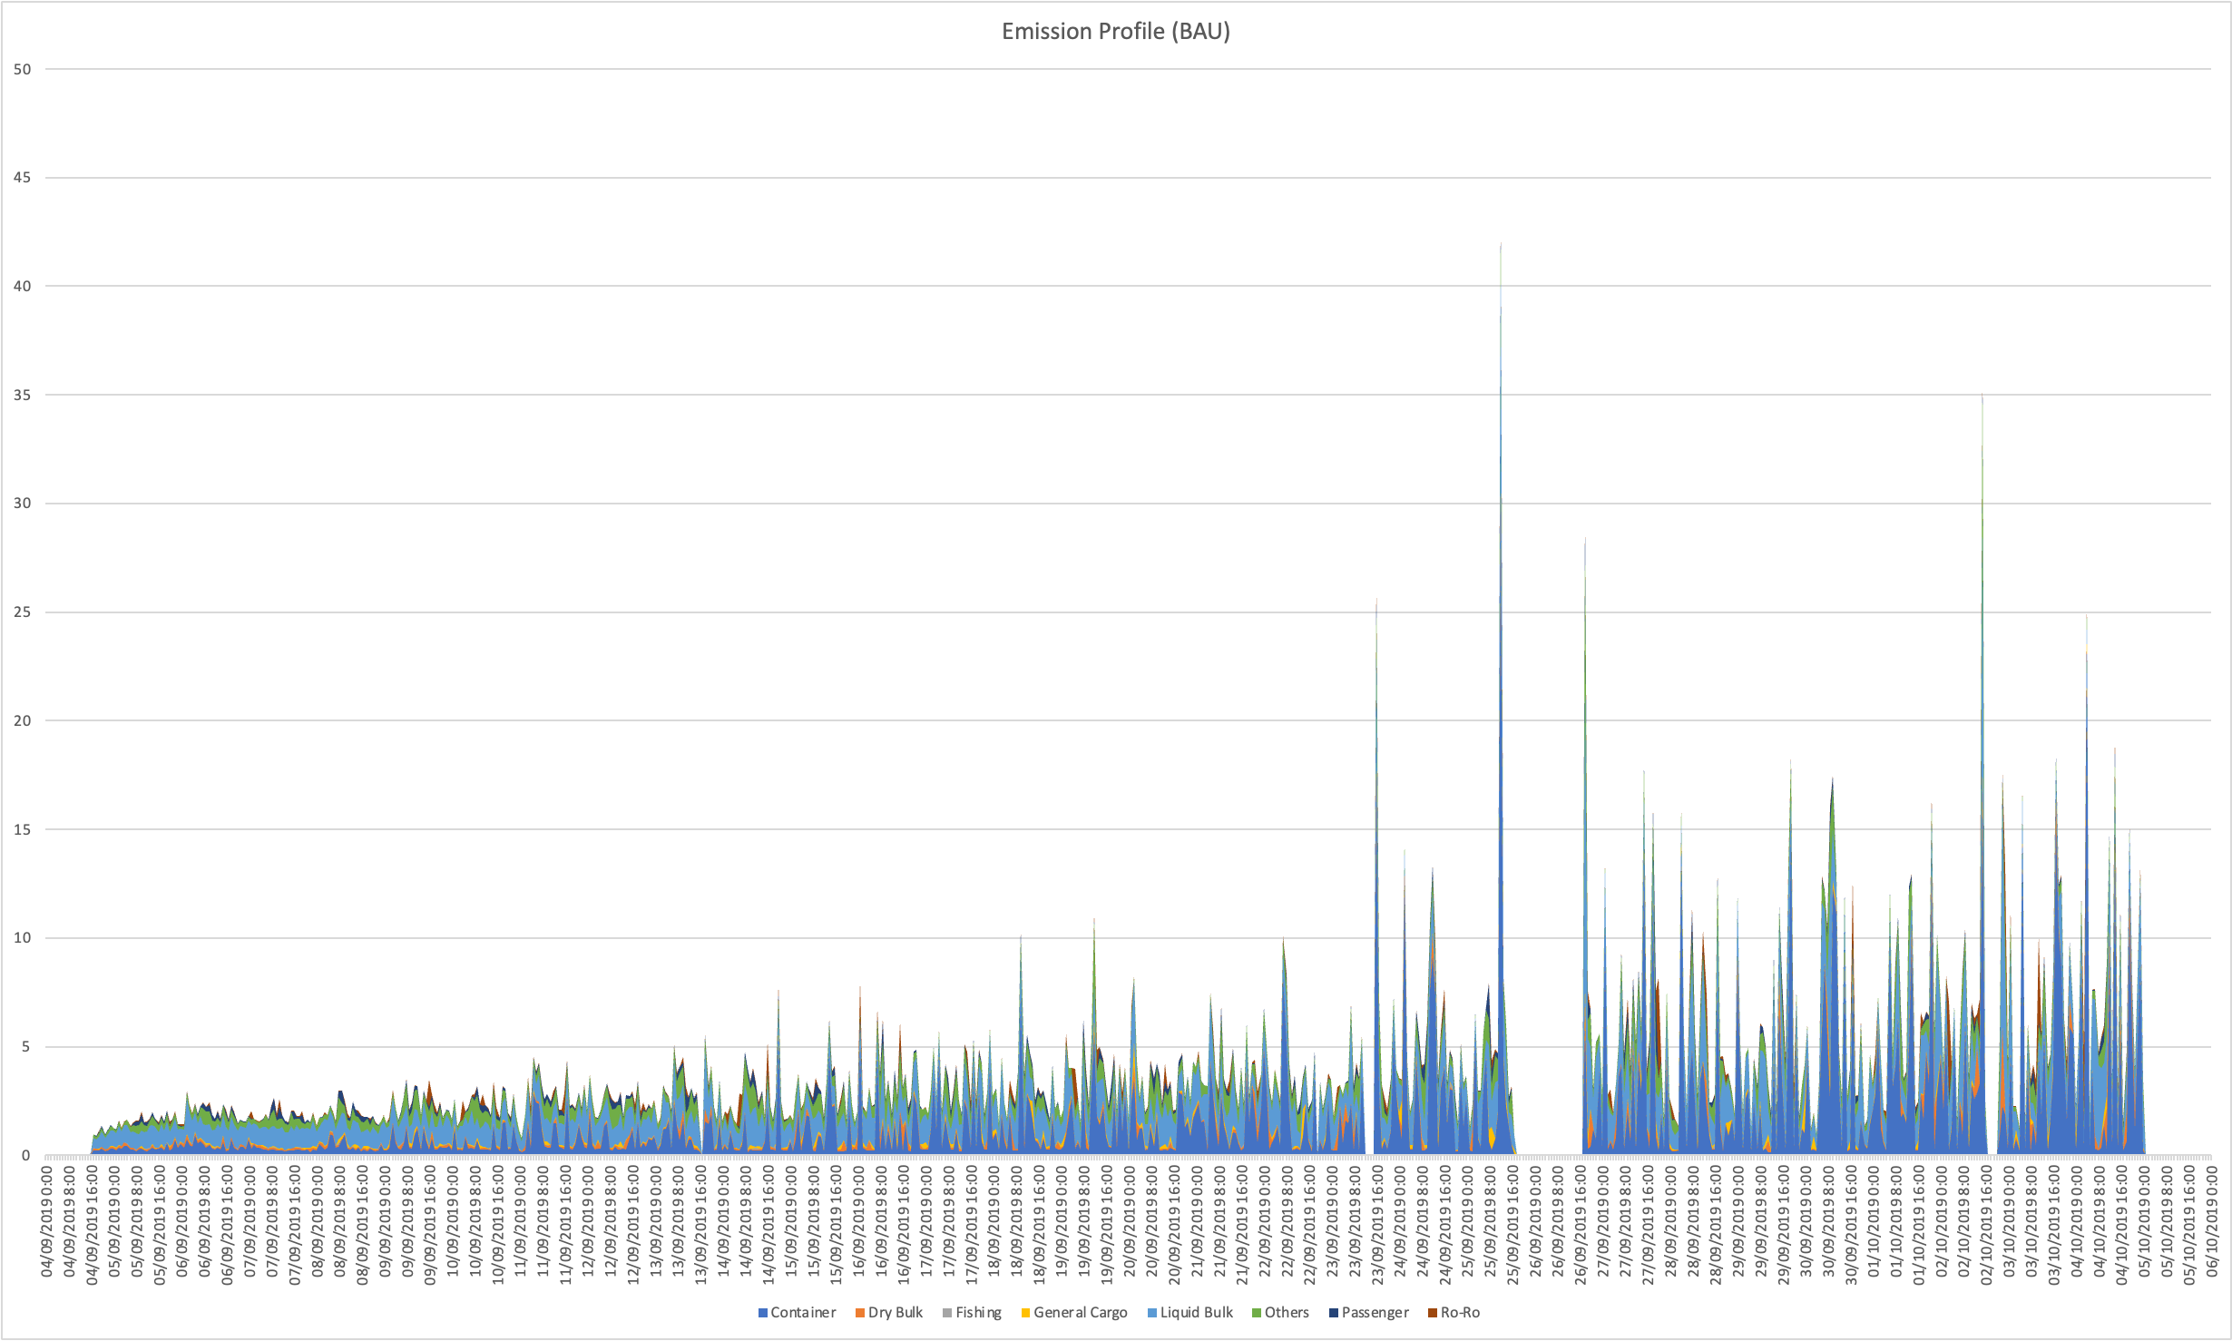  (b)
Figure 3. CO₂ emission profile (in tonnes) under scenario of BAU by level of time series in (a) Daily, and (b) Hourly.

Emission Projection
As presented in Figure 4, the daily and hourly emission profile generated projections apparently diverged with one another. Following the trend of each data series, the way Prophet Forecasting model fits the trendline curve to make subsequent projections are seemingly coherent considering this is only a short-term projection. It is also worth to note that there is an uncertainty interval projected along with the projection to indicate the level of confidence for these projections made. The uncertainty interval ranged around 4.64 tonnes emission on average for the hourly emission projection under BAU scenario. While it would be irrational to concede the daily emission projection, considering that the CO₂ emission would be doubled within a period of one-month with a peak of 200 tonnes of CO₂ emission per day.

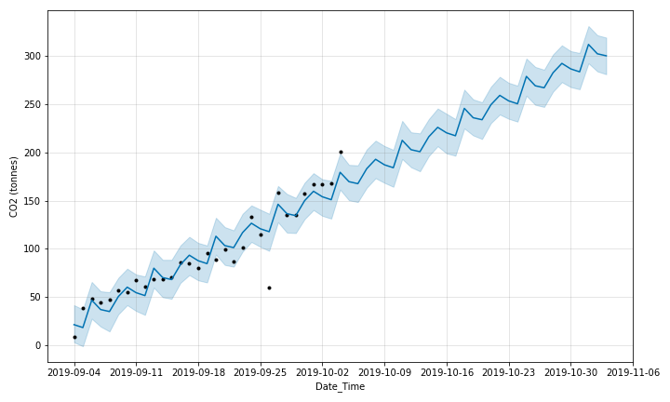 (a) | 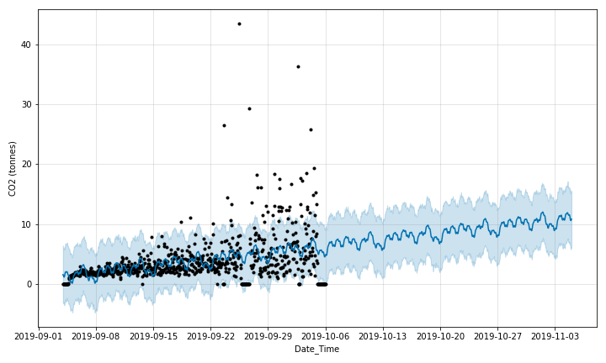  (b)
Figure 4. Overall CO₂ emission profile (in tonnes) under scenario of BAU based on data granularity of (a) Daily and (b) Hourly.

(a) | 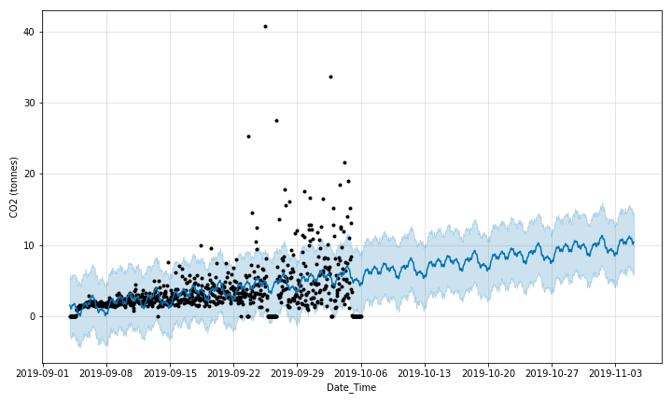  (b)
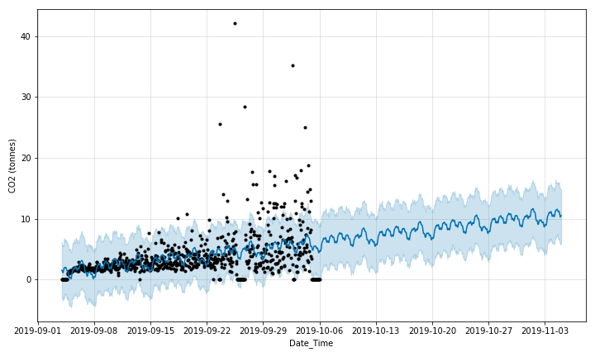  (c) | 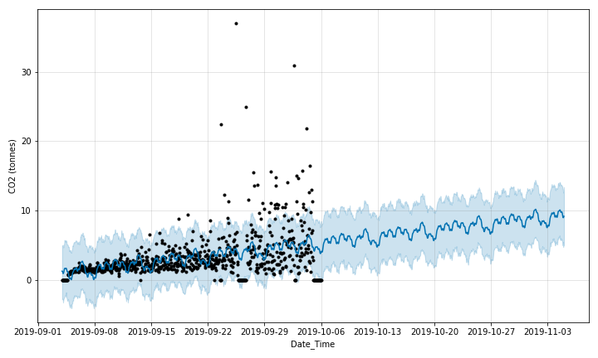  (d)
Figure 5. Overall CO₂ emission projection (in tonnes) under scenario of (a) BAU, (b) Speed Limit, (c) HFO Banned, and (d) JITA.
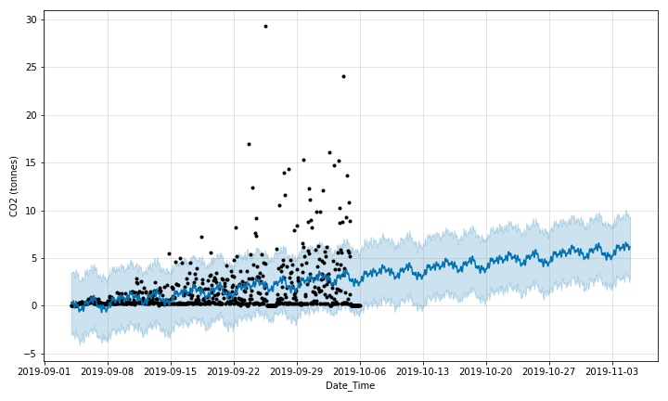  (a) |  | 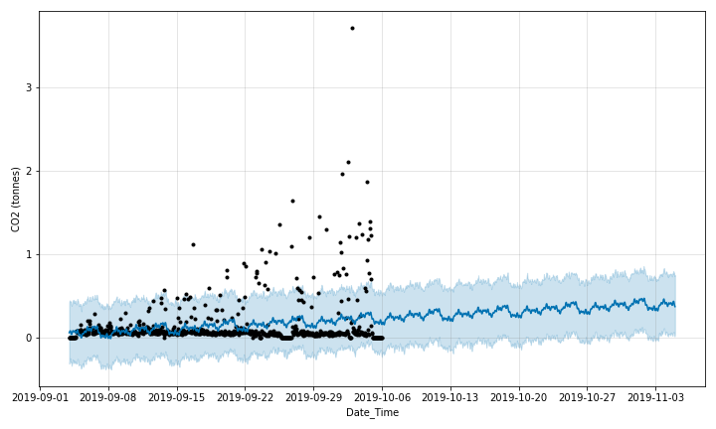  (b)
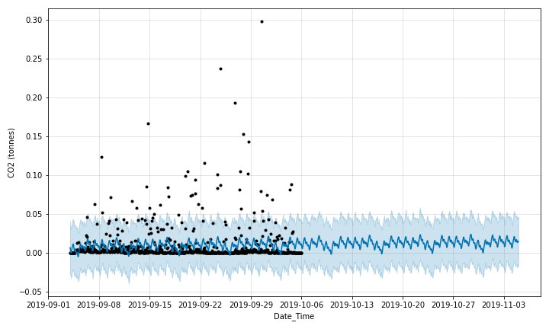  (c) |  | 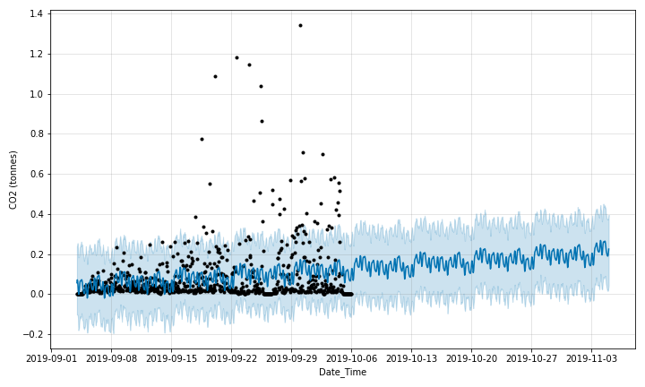  (d)
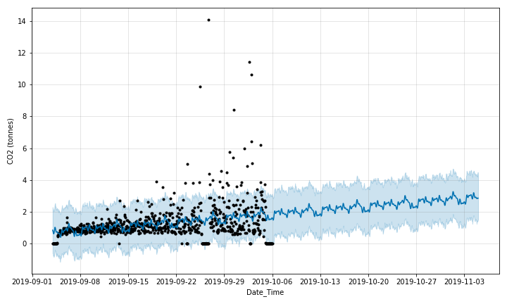  (e) |  | 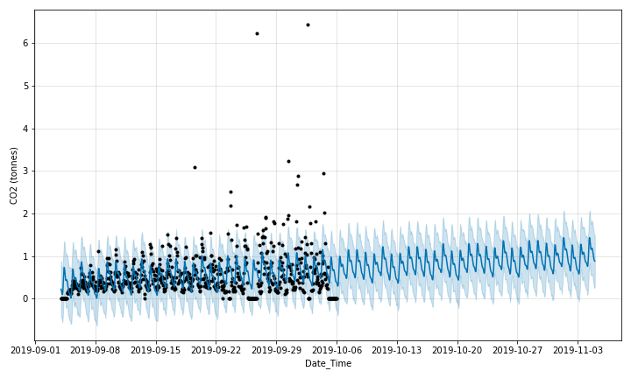  (f)
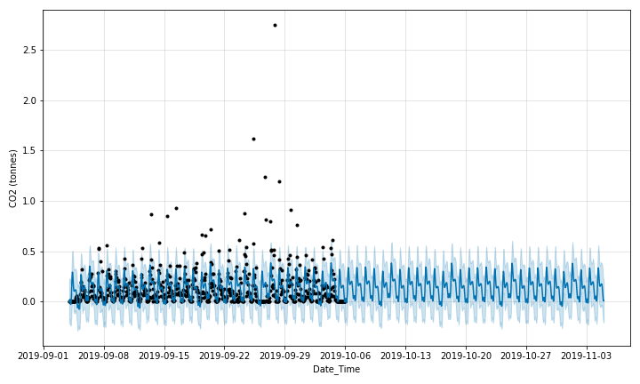  (g) |  | 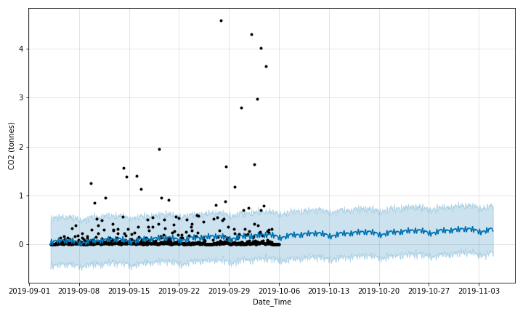  (f)
Figure 6. CO₂ emission projection (in tonnes) under scenario of BAU by ship type of (a) Container, (b) Dry Bulk, (c) Fishing, (d) General Cargo, (e) Liquid Bulk, (f) Others, (g) Passenger, and (h) Ro-Ro.

Accordingly, hourly emission profile is computed with the parameters of other scenarios, as illustrated in Figure 5. Surprisingly, the total emission projected by speed limit, HFO banned, and JITA respectively attained reduction of 6.06%, 3.06% and 55.32% respectively compared to the BAU scenario. Both speed limit and HFO banned were showing declining effect on decarbonizing maritime, whereas JITA is able to further leverage the decarbonization if fully established. Nevertheless, projection in each of the scenario were showing consistent uncertainty interval, indicating a steady trend and consistent pattern of the timeframe of AIS data.
Correspondingly, hourly projection was also taken into account for further stratified projections, to which overall emission projections in SOMS may not be practical enough either, as the Prophet Forecasting model only considered time series regression. For that, emission profile for each ship type under the scenario of BAU were computed to iterate independent projections through all ship types. It can be noted that the shipping emissions in SOMS were mainly originated from container and liquid bulk, to which the projections showed both of these ship types may have greater potential of bringing about additional emissions that burden to local ambient atmosphere, considering the overall global shipping capacity will continue to grow in near decades. While other ship types, including dry bulk, fishing, general cargo, passenger and Ro-Ro are less likely to bring about significant impact on the carbon footprint in SOMS, with projected emissions below 1 tonne.

Conclusion
The shipping capacity in SOMS are showing an increase and so do the carbon footprints. Considering the maritime decarbonization was showing stagnant progress while awaiting for a promising solution, this paper demonstrated projection of emission with the incorporation of progressive measures implementation to reduce local shipping emissions. The overall outcome in estimating CO₂ emissions generated by marine traffic in SOMS from this paper is showing a critical condition, where lack of active measure was being in place despite maritime carbon footprints can be seen in growth. In the scenario of BAU, 92 tonnes on average of CO₂ emission are found. While the scenario analysis implied that up to 15% of reduction of shipping emission could be achieved by operational measures. Despite the good sign shown, a more detailed assessment of measures need to be done to eliminate any possible trade off for such implementations to ascertain the value for worthwhile effort.
Based on the assessment through different scenario, it is discovered that JITA is the most effective measures to optimally reduce emissions operationally, notwithstanding the challenges to establish an effective traffic management framework to realize JITA. While using the best case of JITA, the projected emission could be leveraged to more than 50%. However, this study only considered the projections by utilizing pattern extraction in time series, but it may need to be technically validated on the deliverables required for such a forecast trend. Owing to limited timeframe of AIS data collection, it is recommended for a thorough projection model being developed based on AIS data of at least one year, in order to form solid basis for long-term projection.
In account to the lacking information about maritime carbon footprint in SOMS, the emission profile developed from the AIS data to make subsequent emission projection provides insights to local industrial players and global maritime authorities on the urgent need of focus on expediting decarbonization measures. Moreover, a deep focus on the value of AIS data for being an enabler for initiating emission profile and emission projection, there are plenty of other machine learning models, such as ANN, LSTM, deep learning models, etc. worth for trying to explore a much comprehensive model for better precision of analytics or artificial intelligence application. With well utilization of AIS data, intelligent systems are expected to be exploitable to foster the sociotechnical environment in maritime industry.

References
[1] RFC. Revolving Fund – 40 years of Excellence. 2021; Available from: https://rfcsoms.org/wp-content/uploads/2022/06/mobile/index.html.
[2] Benardy Ferdianshay, R.S. Indonesia, Singapore, and Malaysia Discuss Shipping Safety. 2023; Available from: https://en.antaranews.com/news/290250/indonesia-singapore-and-malaysia-discuss-shipping-safety.
[3] IEA. CO2 emissions from international shipping in the Net Zero Scenario, 2000-2030. 2023; Available from: https://www.iea.org/data-and-statistics/charts/co2-emissions-from-international-shipping-in-the-net-zero-scenario-2000-2030-3.
[4] Kaklis, D., et al., A big data approach for Fuel Oil Consumption estimation in the maritime industry, in 2022 IEEE Eighth International Conference on Big Data Computing Service and Applications (BigDataService). 2022. 39-47.
[5] Dettner, F. and Hilpert, S., Modelling CO2 emissions and mitigation potential of Northern European shipping. Transportation Research Part D: Transport and Environment, 2023. 119: 103745-103759.
[6] Sim, S., Park, J.-H., and Bae, H., Deep collaborative learning model for port-air pollutants prediction using automatic identification system. Transportation Research Part D: Transport and Environment, 2022. 111: 103431-103450.
[7] Li, Y., et al., Research on the carbon emissions traceability inventory and multi-horizon prediction of ship carbon emissions: a case study of Tianjin Port. Frontiers in Marine Science, 2023. 10: 1174411.
[8] Lamboll, R.D., et al., Modifying emissions scenario projections to account for the effects of COVID-19: protocol for CovidMIP. Geoscientific Model Development, 2021. 14(6): 3683-3695.
[9] Yan, S., de Bruin, K., Dennehy, E., and Curtis, J., Climate policies for freight transport: Energy and emission projections through 2050. Transport Policy, 2021. 107: 11-23.
[10] Geels, C., et al., Projections of shipping emissions and the related impact on air pollution and human health in the Nordic region. Atmospheric Chemistry and Physics, 2021. 21(16): 12495-12519.
[11] Jing, D., et al., CO2 emission projection for Arctic shipping: A system dynamics approach. Ocean & Coastal Management, 2021. 205: 105531-105544.
[12] Paternina-Arboleda, C.D., Agudelo-Castañeda, D., Voß, S., and Das, S., Towards Cleaner Ports: Predictive Modeling of Sulfur Dioxide Shipping Emissions in Maritime Facilities Using Machine Learning. Sustainability, 2023. 15(16): 12171.
[13] Wang, K., et al., A novel GA-LSTM-based prediction method of ship energy usage based on the characteristics analysis of operational data. Energy, 2023: 128910-128939.
[14] Wang, Y., Watanabe, D., Hirata, E., and Toriumi, S., Real-Time Management of Vessel Carbon Dioxide Emissions Based on Automatic Identification System Database Using Deep Learning. Journal of Marine Science and Engineering, 2021. 9(8): 871.
[15] Guo, T. and Xie, L., Research on Ship Trajectory Classification Based on a Deep Convolutional Neural Network. Journal of Marine Science and Engineering, 2022. 10(5): 568.
[16] Bilgili, L. and Buğra Çelebi, U., Estimation of ship flue gas emissions in dynamic operational conditions with ANN. Proceedings of the Institution of Mechanical Engineers, Part M: Journal of Engineering for the Maritime Environment, 2020. 235(2): 432-447.
[17] Guo, B., Liang, Q., Tvete, H.A., Brinks, H., and Vanem, E., Combined machine learning and physics-based models for estimating fuel consumption of cargo ships. Ocean Engineering, 2022. 255: 111435-111450.
[18] Lee, J.-B., Roh, M.-I., and Kim, K.-S., Prediction of ship power based on variation in deep feed-forward neural network. International Journal of Naval Architecture and Ocean Engineering, 2021. 13: 641-649.
[19] Ren, F., Wang, S., Liu, Y., Han, Y., and Prabowo, A.R., Container Ship Carbon and Fuel Estimation in Voyages Utilizing Meteorological Data with Data Fusion and Machine Learning Techniques. Mathematical Problems in Engineering, 2022. 2022: 1-21.
[20] Bassam, A.M., Phillips, A.B., Turnock, S.R., and Wilson, P.A., Artificial neural network based prediction of ship speed under operating conditions for operational optimization. Ocean Engineering, 2023. 278: 114613-114624.
[21] GCMD. Dual Actions: National and Route-Based Plans to Tackle GHG Emissions from International Shipping. 2022; Available from: https://www.gcformd.org/_files/ugd/95aa28_2666a77dc9e84b89ae7735302ad8235c.pdf.
[22] MSC. 50 Years of Cooperation in the SOMS by Malacca Strait Council of Japan. 2019; Available from: http://www.cm-soms.com/uploads/2/75/CF12%20-%204.3.2%2050%20years%20of%20Cooperation%20(by%20MSC).pdf.
[23] Li, H. and Yang, Z., Incorporation of AIS data-based machine learning into unsupervised route planning for maritime autonomous surface ships. Transportation Research Part E: Logistics and Transportation Review, 2023. 176: 103171-103202.
[24] Borén, C., Castells-Sanabra, M., and Grifoll, M., Ship emissions reduction using weather ship routing optimisation. Proceedings of the Institution of Mechanical Engineers, Part M: Journal of Engineering for the Maritime Environment, 2022. 236(4): 856-867.
[25] IMO, Just In Time Arrival Guide - Barriers and Potential Solutions. 2020, London, UK: GloMEEP Project Coordination Unit, International Maritime Organization (IMO)
[26] Andersson, P. and Ivehammar, P., Green approaches at sea – The benefits of adjusting speed instead of anchoring. Transportation Research Part D: Transport and Environment, 2017. 51: 240-249.
[27] Liu, L., et al., Data-driven framework for extracting global maritime shipping networks by machine learning. Ocean Engineering, 2023. 269: 113494-113512.
[28] Trozzi, C., Emission Estimate Methodology for Maritime Navigation, in Task Force on Emission Inventories and Projections. 2010, Techne Consulting srl: Convention on Long-range Transboundary Air Pollution.
[29] Ten, K.H., et al. Assessment of Ship Emission Inventory in Strait of Malacca and Singapore based on Automatic Identification System Data. in 2022 IEEE International Conference on Industrial Engineering and Engineering Management (IEEM). 2022.
[30] Taylor, S.J. and Letham, B., Forecasting at Scale. The American Statistician, 2018. 72(1): 37-45.
[31] EEA, EMEP/EEA Air Pollutant Emission Inventory Guidebook 2019. 2019, Copenhagen K, Denmark: European Environment Agency
[32] MPA. Safety of Navigation in the Singapore Strait. 2006; Available from: https://www.mpa.gov.sg/docs/mpalibraries/circulars-and-notices/port-marine-circulars/-pc06-20.
[33] Gilbert, P., et al., Assessment of full life-cycle air emissions of alternative shipping fuels. Journal of Cleaner Production, 2018. 172: 855-866.
[34] Merkel, A., Kalantari, J., and Mubder, A., Port call optimization and CO2-emissions savings – Estimating feasible potential in tramp shipping. Maritime Transport Research, 2022. 3: 100054-100064.
[35] Wärtsilä. Port Call Optimisation paves the way towards a higher port performance. 2019; Available from: https://www.wartsila.com/insights/article/port-call-optimisation-paves-the-way-towards-a-higher-port-performance.

