Selecting the inlet configuration for gas-liquid cylindrical cyclone separator
Le Van Sy^{1*}, Nguyen Thi Lan²
¹ PetroVietnam University (PVU), Vietnam
² Ho Chi Minh University of Technology (HCMUT), Vietnam

*sylv@pvu.edu.vn
Abstract. Gas-Liquid Cylindrical Cyclone Separator (short for GLCC) is a compact separator that has been widely used in petroleum production. The inlet configuration has significant impact of the GLCC capacity separation. By utilization of both FEM simulation and practical experiments, three inlet configurations and twelve inclined angles are investigated to find the steadily-operating inlet configuration for industrial applications. In this study, the flow pattern and kinematic behaviour of each configuration are thoroughly analysed. Besides, the distribution of three velocity components of the body flow in GLCC is compared with one of the practical experiments. The result shows that the current inclined-inlet angle of 27° is not the steadily-operating angle for industrial applications. Insteady, it is a range of inclined inlet angle from 0o to 35o for three inlet configurations. The dual-inlet configuration indicates better properties for separating efficiency.
- Introduction
The Gas Liquid Cylindrical Cyclone (GLCC) separator is an attractive compact separator, which is an alternative to the conventional vessel-type one and widely used in the petroleum industry with potential field applications. This separator has been studied in many countries all over the world, especially researchers from Tulsa University in the US (TUSTP). Most of the researchers have focused on hydrodynamic flow behavior, separating efficiency, and mechanistic models [1-7]. Kouba [1] performed experiments on three GLCCs with downward inclined inlet that have equal diameter of body and inlet. The models including two GLCCs with small diameters of 2.54 cm and 5.08 cm are used in the experiments while TUSTP make a test on GLCC separator with larger diameter of 7.62cm. Nissan [2] has made the first experimental study by injecting water through two tangential inlets of GLCC. Then, the ratio between GLCC body and inlet in terms of area is increased. As a result, axial velocity distribution changes flow direction near the center of GLCC. Wang [3] has also studied phenomena of liquid carry-over inside GLCC and recommended to use a configuration of a gradually reduced inlet nozzle for wider ranges of operation but he has not mentioned flow behavior and gas carry-under inside these GLCCs. Iozia [4] has examined a decay of swirling flow inside GLCC body. They have observed tangential velocity distribution and found that there are two flow regions: a region of forced-vortex flow near the center of the GLCC and a surrounding region of free-vortex flow. A few researchers have successfully built mechanistic models of GLCC. Movafaghian [5] has acquired experimental data for the GLCC at several operating pressures first. Then he measured the operational envelope for liquid carryover and the equilibrium liquid level. They have also developed an initial mechanistic model capable of predicting the global flow behavior in a GLCC. The authors have used the developing mathematical models and numerical codes for the prediction of the hydrodynamic flow behavior in the GLCC and verifying these models with experimental data.
Erdal [6] has presented CFD (Computational Fuid Dynamics) simulations utilizing a commercial code called CFX. These simulations have shown details of the hydrodynamic flow behavior in the GLCC for both single-phase and two-phase flow. Their simulation model is only specified as a GLCC with inclined inlet angle at 27º as experiment model. Erdal [7] has also measured axial and tangential velocities as well as turbulent intensities across the GLCC diameter at 24 different axial locations using a Laser Doppler Velocimeter (LDV). In their experiment, inlet water in wide range of Reynolds Numbers from 5000 to 67,000 is injected with flow rates of 10, 30 and 72 gpm for different inlet configurations. These experiment results are used to make contour plots of axial velocity, tangential velocity, and turbulent kinetic energy. Hreiz [8] has also made study of swirling hydrodynamics of different inlet configurations of GLCC separator via CFD simulations. The author has conducted many different turbulent models for GLCC and shown that the high-Reynolds realizable k-epsilon model performs the best for predicting the local mean axial and tangential velocities.
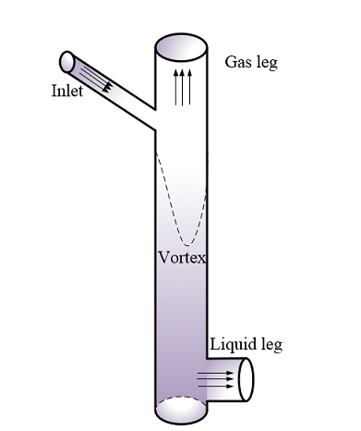
Figure 1. Normal Configuration of GLCC separator.
Most of the research has been done to help thoroughly understand the effect of inlet area, inlet dimensions, inlet section shape, number of inlets, and inlet position in terms of flow pattern and performance of conventional hydro-cyclone separators [1-7]. There are few studies of the effect of inlet angle on the performance carried out, the results; however, remain contradictory [8-9]. For cylindrical cyclone separators, there are no mechanistic models and fundamental work published on the effect of different inlet configurations on the performance of compact separators [10-11]. How to define a range of steadily operating inlet angle and inlet geometry for industrial application of petroleum sector is still an issue that most researchers need to study, especially for GLCC in which inlet diameters are smaller than its body diameter. A majority of experimental laboratory and pilot plant studies conducted so far of flow in cyclones have covered the influence of operating parameters or changes in geometry on the separation efficiency. For example, higher inlet velocity gives higher separation efficiency for most cyclones, but this also increases the pressure drop across the cyclone.
In this study, different GLCC configurations with different inclined inlet angle, number & cross section of inlet are investigated to understand the hydrodynamic behavior of GLCC - inner flow by using numerical simulation in 2 cases: only one single and gradually reduced inlet nozzle, together with dual inclined inlets nozzle of GLCC. The simulation results with different inlet configurations have been compared with experimental data of axial and tangential velocities. This is the best way to investigate the steadily operating range of the inlet configuration of GLCC for industrial applications. The study has performed eleven CFD models with different inclined inlet angles for both single and dual inlet GLCCs. The distribution of radial, axial and tangential velocity profiles and their maximum magnitudes with respect to the change of inlet angle were carefully considered in this study.
- Experimental setup and CFD simulation

Experimental setup
a) b) c)
(1) (2) (3)
Figure 2. Configurations of Inlet Nozzle GLCC.

Erdal [7] has performed local measurements of axial and tangential velocities and turbulence quantities at TUSTP by using LDV (Laser Doppler Velocimetry). The practical experiment used three kinds of inlet configurations such as single inclined inlet (Figure 2a), single reduced inlet (Figure 2b) and dual inclined inlet (Figure 2c). The single-phase flow with operating parameters has presented in Table 1. Local measurements are conducted along the diameter at different locations from 317 mm to 899 mm below the inlet. The inclined angle of inlet in all inlet configurations is 27º. The axial and tangential velocities obtained from practical experiments were used to verify the accuracy of simulating models at this inclined angle.
Table 1. Former experiment parameters.
Case | Working fluid | Flow rate (m³/s) | Average Velocity (m/s) | Reynold number | Viscosity (cP)
1 | Water | 0.00063 | 0.102 | 9285 | 1
1 | Water | 0.00454 | 0.731 | 66855 | 1
2 | Water | 0.00063 | 0.102 | 9285 | 1
2 | Water | 0.00454 | 0.731 | 66855 | 1
3 | Water | 0.00063 | 0.102 | 9285 | 1
3 | Water | 0.00454 | 0.731 | 66855 | 1

CFD simulation
The experimental investigation to clearly understand the complex flow behavior within the GLCC body is an expensive and time - consuming method while CFD simulation with a proper turbulence model and boundary condition shows potential advantages such as no dedicated measurement, short time and low cost. The CFD simulation is the best way to study the steadily operating performance of GLCC before they are fabricated. Comparisons between simulated result and experimental data are very important which exhibited the appropriate CFD model to be able to predict well the complex flow behavior of GLCC separator. This model can be utilized to study the effect of operating parameters on GLCC performance that have not been investigated by practical experiments.
a)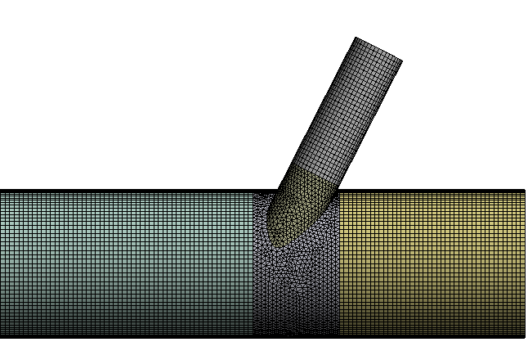 b)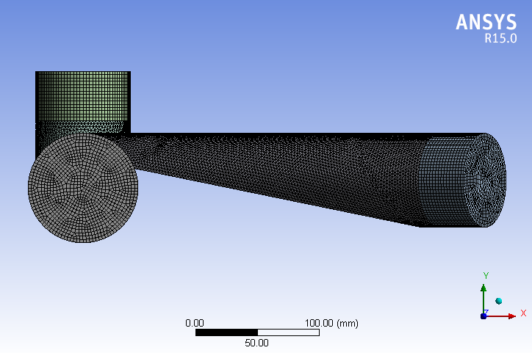 c)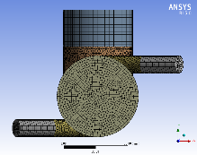
Figure 3. CFD meshing of three Inlet Nozzles of GLCC.

Selection of a proper turbulence model for CFD simulation of swirl flow inside cyclone separator is a very important task which affects directly on the obtained results. The swirl flow within cyclone separator is almost turbulence, complex and anisotropic behavior [3-10]. In CFD simulation of GLCC separator, Sy [8] has shown that Reynolds stress turbulence model is the best choose for predicting the kinematic behavior of the flow inside GLCC body. In this study, the 22-models of GLCC with three inlet configurations are modeled for CFD simulations. The mesh for numerical analysis was generated by dividing GLCC body into many dependent geometric blocks. Most of these blocks are accurately identified to generate the mesh with hexahedral elements by using intelligent tools of ANSYS Meshing 15.0 (Figure 3). Three refinement meshes are generated to test for the grid dependent (number of cells is 950.000, 1.500.000, and 1.650.000, respectively) which all important measures (mesh orthogonality, skewness, aspect ratio, etc.) suggested for mesh quality are kept in the best range of high mesh quality [7-8]. Comparing the results of model with 1.500.000, and 1.650.000 cells presents a small discrepancy. For all simulations of this study, pressure-velocity coupling scheme is used with the SIMPLEC algorithm (Semi-Implicit Method Pressure-Linked Equations Consistent). The schemes of pressure interpolation such as standard, linear, body force weighted, second order and PRESTO (Pressure Staggered Option) have been evaluated. The results show that the second-order interpolation scheme is best suited for pressure interpolation. Concerning the discretization of turbulent kinetic energy and turbulence dissipation rate, two schemes of QUICK (Quadratic Upstream Interpolation for Convective Kinetics) and first order upwind have also been compared. The QUICK scheme derived high accuracy in predicting the swirl flow of GLCC separator. After each CFD simulation is completed, the axial and tangential component of flow velocity at each measuring position are extracted to compare to the practical experiments.
- Verification of simulated results
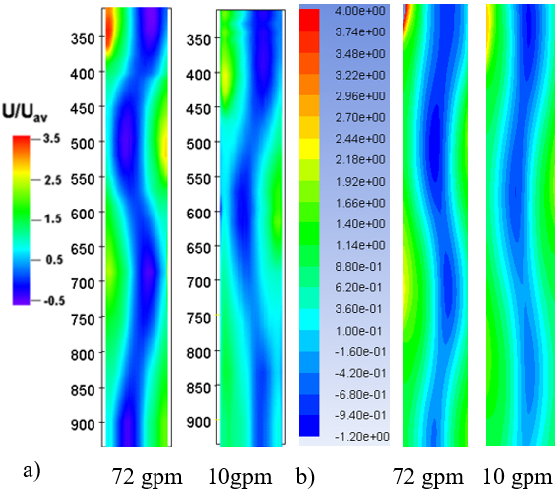
Figure 4. Comparison in contour of Axial Velocity between experiment.
(a) and the simulation (b) for Gradually Reduced Inlet

Axial velocity is an important component of the flow in GLCC body which presents the movement of fluid flow in axial direction toward the outlet. The axial velocity profile presents two flow streams (upward and downward flow) existing in GLCC body. The upward flow is near the cylindrical centerline directed to the inlet while the downward flow near the wall directed to the bottom of GLCC at narrow radial distance. The 22 simulated models extract the axial and tangential velocity components with three inlet configurations. In Figure 4, there is a good agreement between measured contour of axial velocity from Erdal’s experiments (left side) and simulated contour (right side) for both inlet configuration of 2 and 3 with flow rate of 72 gpm and 10 gpm [6].
The shape of axial velocity profiles also depends on the vortex helical pitch (vortex wavelength). The top (negative region) of axial velocity profiles locating on the left or right side of GLCC centerline is due to the measured locations and viscous flow conditions which affect the wavelength of vortex inside GLCC. In Figure 5, the shape of axial velocity profiles is different depending on the inlet configuration. The single inlet configurations have the same shape as axial velocity profiles which the peak of axial velocity distributed in one side (Figure 5 a, b). However, the shape of axial velocity profiles are distributed equally into both side (Figure 5c). The simulated results of axial velocity components are good agreement to the practical experiments for three inlet configurations.

a) b) c)
Figure 5. Comparison of Axial Velocity for three inlet configurations.

The inclined inlet of GLCC separator is used for enhancing the stratification of multiphase flow before entering the GLCC body in tangential direction. Thus, tangential velocity component has been of dominant role to create the centrifugal force for separating the phases within GLCC. The tangential inlet of GLCC produces the larger intense centrifugal force pushing radially the fluid flow to the cylindrical wall which increases the separating performance. Tangential velocity is positive on one side (left) and negative on the other side (right) (Figure 6 a, b). This is due to the rotation of the flow. Positive velocities represent the tangential velocity out of the page and negative ones represent flow into the page. Tangential velocity is high near the wall region, and it decreases towards the center. However, the tangential velocity profiles of dual inlet configuration are equally distributed because two inlets were asymmetrically positioned in the GLCC body (Figure 6c). There is a decay of tangential velocity in the axial direction towards the outlet or downward axial direction. Location of zero or low tangential velocity for one incline inlet configuration has a helical (spiral) shape similarly to the one observed in the axial velocity contours (Figure 4).
a) b) c)
Figure 6. Comparison of Axial Velocity for three inlet configurations.

Single inclined inlet
    - Axial velocity
a) b)
Figure 7. Axial velocity profiles with different inlet angles.

For single inclined inlet configuration (Figure a), the distribution of axial velocity profiles with respect to different inlet angles measured at distance of 317 mm below the inlet for flow rate of 0.00063 m3/s (Figure 7a) and 0.00454 m3/s (Figure 7b) are shown Figure 7. The shape of the axial velocity profiles near the wall are significantly affected by the inlet angle. A larger inlet angle derives a higher magnitude of axial velocity; however, this trend only occurs at the wall side. This may be explained by the movement of swirl flow inside GLCC. Variation of axial velocities is slightly small in the range of inlet angle from 5º to 35º. However, they vary significantly for inlet angles that are larger than 35º. In range of inlet angle from 5º to 35º, the magnitude of axial velocities near wall region decreases at one side and increases in the other side while they only increase in the region near the central axis of GLCC body (Figure 7). This means that upward flow near GLCC centerline always increases when inlet inclined angle increases. This trend of axial velocity is kept in the section near the inlet while they are reversed about GLCC centerline on the measured plans toward the bottom of GLCC. The velocity of downward flow near the wall has high positive magnitude and is decayed as the fluid flow moves far from inlet toward the outlet. This decay triggers off an increase of the vortex wavelength in axial direction toward outlet (Figure 7b). Thus, the vortex of the flow is stretched in this direction which can contribute into the effect of gas-carried under (GCU) phenomenon (gas bubbles move down toward the liquid leg) on the GLCC performance [10].
The change of maximum axial velocities of upward (lower graph) and downward (upper graph) flow with respect to different inlet angles at four measured plans are shown in Figures 8 a-b-c. This graph clearly shows that the maximum axial velocities are very small change in the range of 5-35o. In this range, a slight decreasing trend is found in the maximum axial velocity of both downward and upward flow while an opposite trend of the flows is exhibited for larger inlet angles. However, the maximum axial velocities of the downward flow at right below inlet section increase significantly with inlet angle from 5º÷20º but then they decrease considerably in the range of inlet angle of 45º÷50º. However, it increases sharply at the inlet angles which are larger than 50º. This may be explained by the effect of the flow entering GLCC body interacting with the swirl flow in the vortex region which results in a negative pressure pushing the fluid flow toward the bottom of GLCC. Hence, the axial velocity of downward flow increases in this region near the inlet section. Particularly, the maximum axial velocity of downward flow fluctuates remarkably in the case of large inlet angle and high flow rate (Figures 8 b-c).
a)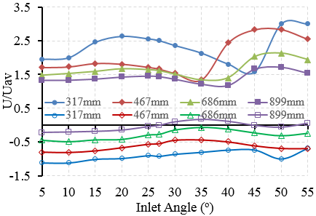 b) 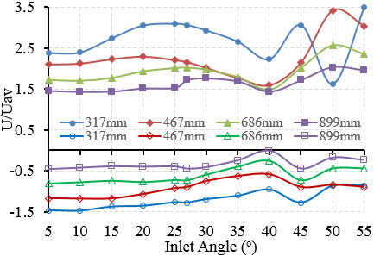
Figure 8. Distribution of maximum axial velocity.

The maximum axial velocity of upward flow has rarely depended on the change of inlet angles. There is a very small change of the maximum axial velocity at the inlet angle which is larger than 35o. This can be explained that the same mass flow rate (same mean axial velocity) is provided for the simulations with different inlet angles.
    - Tangential velocity
The variation of the tangential velocity profiles with various inlet angles are presented in Figure 9 for both flow rates, respectively. Due to the viscous flow rotating inside the GLCC body, the distribution of tangential velocity profiles is divided into the positive region on the left side and negative region on the right side. Like in the case of axial velocities, the magnitude of tangential velocities is significantly decayed when the GLCC flow moves toward the outlet (Figure 9). The distribution of flow in GLCC also has a helical shape under the actions of centrifugal force, thus, the tangential velocities are low in radial region toward the GLCC center but are very high in the region near the wall. The effect of the inlet angle on the tangential velocity is not significant at small angles (less than 35o) but rather at inlet angles are larger than 35o. Surprisingly, the variation of tangential velocity with respect to different inlet angles is only very high on one side and does not vary on other side. For small inlet angles, the location of zero tangential velocities will decide the location where high variation of tangential velocity occurs near the wall via the variation of inlet angle. If the location of zero-tangential velocity is on the left side of y-axis, high variation region of tangential angle near the wall falls in the fourth quadrant, and vice versa. (Figure 9).
a) b)
Figure 9. Tangential velocity profiles in different inlet angles.

The maximum tangential velocity depends on the inlet angle which happens mainly at the wall region (Figure 10). This is one of the most important factors affecting GLCC performance. In the GLCC with large inlet angle, the tangential velocity near the wall region has the largest change. Figure 9 shows the effect of inlet angle on the maximum tangential velocity at four measured plans. The (lower) upper graph presents the change of maximum (negative) positive tangential velocity with respect to different inlet angles. The maximum tangential velocity does rarely depend on the change of inlet angle at the nearest and the farthest from inlet plan where has less effect of swirl flow. The maximum tangential velocity is increased slightly at the inlet angles which is larger than 35º because the fluid flow is pushed in axial direction and interacts to the upward flow which is decrease the intensity of tangential velocity. The flow is high turbulence at a very large inlet angle which reduces the separating performance of GLCC.
a)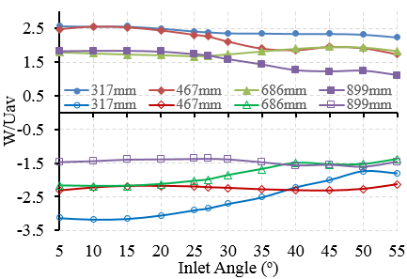 b)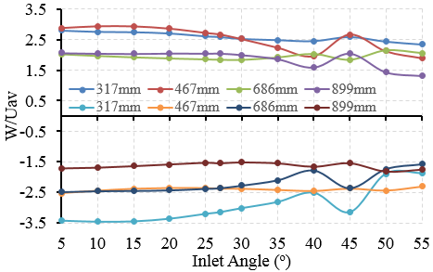
Figure 10. Distribution of maximum tangential velocity.

Single gradually reduced inlet
    - Axial velocity
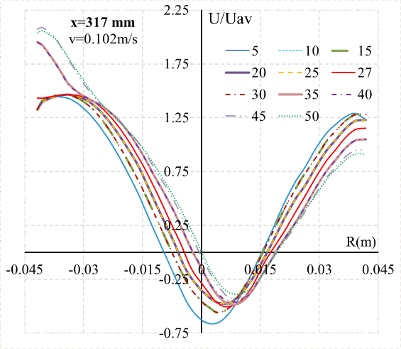
Figure 11. Axial velocity profiles with different inlet angles.

The distribution of the axial velocity profiles with different inlet angles for flow rate of 0.0063 m3/s measured at the distance of 317 mm are shown on Figure 11. Similar to the single inclined inlet configuration, the velocity of downward flow near the wall has high positive magnitude and decays as the fluid flow moves far from inlet toward the outlet. This graph shows clearly that the maximum axial velocities are very small change in the range of 5º÷30º. However, it increases sharply and almost reaches the peak at the inlet angle 40º. This may be explained by the effect of the flow entering GLCC body interacting to the swirl flow in the vortex region which results in a negative pressure pushing the fluid flow toward the bottom of GLCC.
The variation of axial velocities is slightly changed in the range of inlet angle from $5°$ to $30°$ (Figure 12). However, they vary significantly for inlet angles that is larger than $30°$. The magnitude of axial velocities near the wall region decreases on one side and increased on the other side while they are only increase in the region near the central axis of GLCC body according to the inclined inlet angle increase (Figure 12). This means that upward flow near GLCC center line always increases when inlet inclined angle escalation. This trend of axial velocity is kept in the section near the inlet while they are reversed about GLCC centerline on the measured plans toward the bottom of GLCC.
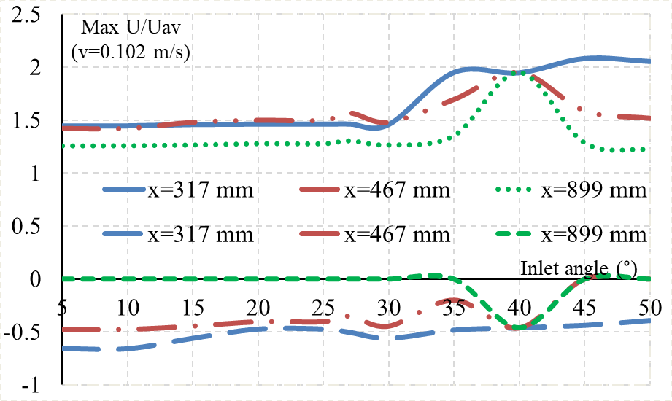
Figure 12. Distribution of maximum axial velocity in different inlet angles.

    - Tangential velocity
The distribution of the tangential velocity profiles with different inlet angles for flow rate of 0.0063 m3/s measured at the distance of 317 mm are shown on Figure 13. The maximum tangential velocity depends on the inlet angle which happens mainly at the wall region. This is one of the most important factors affecting GLCC performance. For the GLCC with high inlet angle, the tangential velocity near the wall region has slightly changed. The maximum tangential velocity is increased significantly at the inlet angle which is larger than $35°$ because the fluid flow is pushed in axial direction and interacts to the upward flow which is decrease the intensity of tangential velocity (Figure 14).
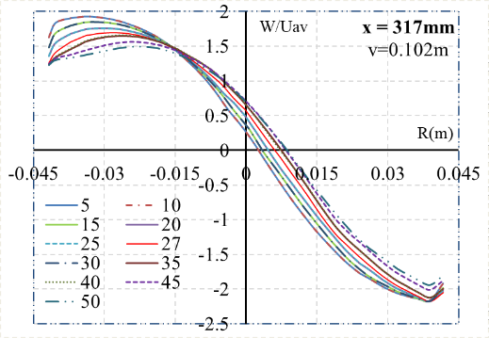
Figure 13. Tangential velocity profiles in different inlet angles.

Figure 14. Distribution of maximum tangential velocity in different inlet angles.

Dual inclined inlet
    - Axial velocity
The distribution of the axial velocity profiles with different inlet angles for flow rate of 0.0063 m3/s measured at the distance of 317 mm for dual inclined inlet are shown on Figure 15. For two asymmetrical inlet configurations, the swirl decay is very low near the inlet. Erdal [6-7] has noticed that swirl decay is more rapid for a single inlet than for two inlets which make the flow more symmetric. As the single incline inlet configuration, the minimum axial velocity is almost focused at the center of GLCC. Larger inlet angle creates higher magnitude of axial velocity. The axial velocity is prone to reducing from the wall to near the cylindrical centerline then increasing again to another wall of GLCC and axisymmetric. Compared with the single inclined inlet configuration, the distribution of axial velocity profiles with different inlet angles smoothly changes in Figure 16.
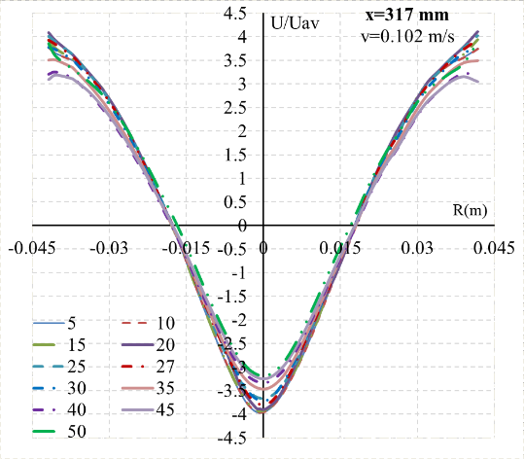
Figure 15. Axial velocity profiles in different inlet angles.

Figure 16. Distribution of maximum axial velocity in different inlet angles.

    - Tangential velocity
The distribution of the tangential velocity profiles with different inlet angles for flow rate of 0.0063 m3/s measured at the distance of 317 mm for dual inclined inlet are shown on Figure 17. In this case, the minimum tangential velocity is almost focused at the center of GLCC. There is not much change in magnitude of tangential velocity in different inlet angles GLCC. The tangential velocity tends to reduce from the wall to near the cylindrical centerline then increases again in negative direction to another wall of GLCC and symmetric in centerline. Downward to bottom, there is a gradual decrease in the tangential velocity. It means that the turbulence of flow also reduces downward to bottom of GLCC. There is not much change in distribution of maximum tangential velocity component for dual inclined inlet configuration. The distribution of maximum tangential velocity has a little bit changed in angle range from 25º to 40º.
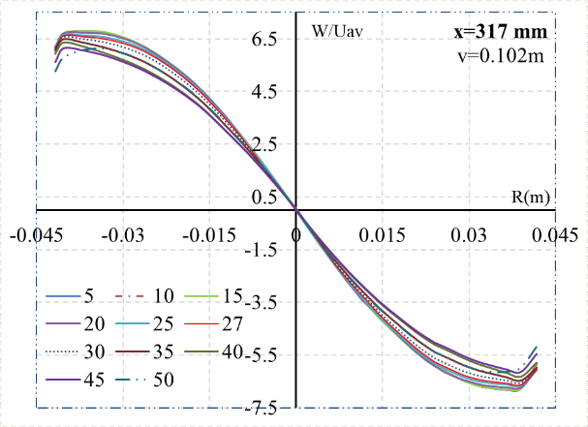
Figure 17. Tangential velocity profiles in different inlet angles.

Figure 18. Distribution of maximum tangential velocity in different inlet angles.

- Conclusion
This paper performed CFD simulations with 22-GLCC models to understand deeply the kinematic behavior of complex flow inside GLCC separator. The 3D models for CFD simulation with a suitable turbulent model has shown changes in kinematic behavior of GLCC flow when the inclined angle and inlet configuration are varied. There is excellent agreement between simulated results and practical experiments for three inlet configurations. The main results obtained from this study are steadily operating of inlet angles from 0º to 35º for three inlet configurations. This result helps the manufacturers of GLCC separator to have many designing solutions for inlet configurations in narrow space in the oil platform. The other conclusions can be extracted from this study as following:
- The flow pattern of tangential and axial velocities and their maximum magnitude do not change significantly when the inclined inlet angles vary from 5º to 35º, but they increase significantly and reach the peak at 40º. The velocity changes of single inlet GLCC are more significant and clearly recognized than the dual inlet one.
- The axial velocities of downward flow decrease at one side and increase at the other side. The velocities of downward flow decay as the flow move far from inlet downward to the outlet.
- The maximum tangential velocity depends significantly on the inlet angle which occurs mainly in the wall region. The maximum tangential velocity does not almost depend on the change of inlet angle at the nearest and the farthest from inlet section. The minimum tangential velocity almost focuses on centre of GLCC. The maximum tangential velocity of single inlet GLCC increases significantly at the inlet angle of 35º while there is not significant change in dual inlet one.
- The radial velocity profiles have an axial symmetry, and their magnitudes are much smaller than ones of axial and tangential velocity. A bigger inclined inlet angle of GLCC results in a higher maximum radial velocity. There is lots of change in maximum radial near the inlet area more than bottom area for different inclined angle configurations of GLCC.
References
- Kouba G. E. A, O. Shoham 1996 Review of Gas-Liquid Cylindrical Cyclone Technology International Conference of Production Separation Systems (Aberdeen, UK: April, 1996).
- Nissan, A.H. and Bresan V.P. 1961 Swirling Flow in Cylinders A. I. Ch. E. Journal, 7(4), 543-547.
- Wang, S., Mohan, R.S., Shoham, O., Marrelli, J. D. and Kouba, G.E. 2000 Performance Improvement of Gas Liquid Cylindrical Cyclone Separators Using Integrated Liquid Level and Pressure Control Systems ASME Transactions, Journal of Energy Resources Technology (Tulsa: December 2000).
- Iozia D.L., D. Leith 1989 Effect of cyclone dimensions on gas flow pattern and collection efficiency, Aerosol Science and Technology, 10(3), 491–500.
- S. Movafaghian, J.A. Jaua-Marturet, R. Mohan, O. Shoham, G. Kouba 2000 The effects of geometry, fluid properties and pressure on the hydrodynamics of gas–liquid cylindrical cyclone separators, International Journal of Multiphase Flow 26(6), 999–1018.
- Erdal, F., Shirazi, S., Shoham, O., Kouba, G. 1997 CFD simulation of single-phase and two-phase flow in gas–liquid cylindrical cyclone separators SPE Journal 2, 436–446.
- Erdal, F., Shirazi, S. 2011 Local velocity measurements and computational fluid dynamics (CFD) simulations of swirling flow in a gas–liquid cylindrical cyclone separator, Engineering Technology Conference on Energy, (Houston, Texas: 2011, 23–30).
- Rainier H, Caroline G, Noël M. 2011 Numerical investigation of swirling flow in cylindrical cyclones. Chemical engineering research and design, 89, 2521–2539.
- Le Van Sy 2017 Influence of inlet angle on flow pattern and performance of gas-liquid cylindrical cyclone separator Particulate Science and Technology 35(5), 555-564.
- Gomez L. E., Ram S. Mohan, O. Shoham, J. D. Marrelli, G. E. Kouba 1999 State-of-the-Art Simulator for Field Applications of Gas-Liquid Cylindrical Cyclone Separators. SPE Annual Technical Conference and Exhibition (Houston, Texas, Oct-1999).
- Gupta, A., Kumar, R. 2007 Three-dimensional turbulent swirling flow in a cylinder: experiments and computations International Journal of Heat and Fluid Flow, 28, 249–261.

