Service and inventory model for maintenance workshop in the short cycle operation region: Agent-based Simulation Approach
Majid Shalfawi ^{1*} Idriss El-Thalji^{1 ,} and Ali Turkyilmaz¹
¹ University of Stavanger, Norway.
* Email: mf.shalfawi@stud.uis.no
Abstract. Tools used in the North Sea region has a high cycle and come very often to maintenance workshop to be checked, repaired if needed and prepared for the next operations. The availability of spare parts at the workshop plays a significant role to keep the flow time as short as possible and meet such high-cycle operations. Supplying spare parts from the best-cost countries to the North Sea region with about one-year lead time makes the situation more critical and the economic order quantity and reorder point need to be found. However, having inventory at the workshop and ordering a batch of spare parts increases operational expenditures. Moreover, frequent supplies increase the environmental impacts of shipping CO2 and spare scrap rates, whereas repairing the used spare parts and reusing them again can offer a more sustainable solution. Therefore, the purpose of this paper is to develop a simulation model that can quantify the cost and benefits of reusing repaired spares compared to supplying newly built spares from the best-cost countries. To achieve this purpose, a case study has been implemented on a specific maintenance workshop within the North Sea region and the entire tool repair and spare part supply operations are conceptualized and modelled with the help of the simulation modelling approach. Two scenarios have been simulated: (1) the maintenance workshop fully depends on supplying newly built spares from the best-cost countries with no inventory stock or spare reuse, and (2) the Maintenance workshop is primarily dependent on repaired spares with an optimal level of spares stock. The simulation results, from the studied case, support the second scenario where a repair path cycle is introduced to the maintenance workshop, as a 78% reduction in lead times, a 116% improvement in worker utilization, a 73% reduction in crowding levels, a 52% reduction in scrap rate, and a potential profit increase of roughly three million NOK (20%). Therefore, it can be concluded that a local repair service is required to keep maintenance workshops in high-cycle regions at high-performance levels.
- Introduction
Spare part inventory management is full of critical trade-off decisions where you need to ensure the availability of parts and effective cycle service level whilst limiting the investment in inventories [1]. Kosanoglu found that the unavailability of spare parts accounts for 80% of all system downtime [2]. On the other hand, spare parts inventories can tie up large amounts of cash and incur significant costs due to write-offs, duplication and insurance. Schultz claims that a firm’s ability to meet short lead times, without excessive inventories, requires short manufacturing cycle times [3]. Reducing a firm’s average cycle time without costly increases in capacity or expedited engineering processing times can often be accomplished through an inventory of spare components. Maintaining an inventory of spare components decreases the mean time to repair resulting in increased machine availability and reduced cycle times. Determining the appropriate investment in spare component inventories requires a tradeoff between increasing inventory carrying costs and improvements in service performance. Inventory-service models are capable of predicting and analyzing average cycle times, departure variability, and average inventory levels in order to enable managers to determine the best allocation of spare inventories for machines at a given workstation.
Several studies have shown that maintenance workshop services have better cycle time and net profit using a stocking strategy over the just-in-time strategy due to their unexpected demand variability or lead time variations [4, 5]. Sha Zhu highlights that an uneven distribution of maintenance tasks over time is an important cause of intermittency in spare parts demand, and this intermittency complicates spare parts inventory control severely [6]. Therefore, the stocking strategy by itself has several policies depending on whether it is time-based, historical demand based or real-time demand based: (1) Fixed Order Interval (FOI) where orders occur at fixed time intervals, regardless of the current inventory level (2) Lot-for-Lot (L4L) where replenishment order is for the exact quantity required to satisfy the current demand, (3) Reorder Point (ROP) or Reorder and Quantity (R,Q) that sets a predetermined inventory level at which a replenishment order is triggered, (4) The Min-Max policy (s,S) that When the inventory level reaches the minimum threshold, a replenishment order is placed to bring the stock back up to the maximum level, (5) Demand-driven replenishment policies which utilize real-time demand data to trigger replenishment orders [7]. The selection of a specific reordering policy depends on factors such as the demand pattern, lead time, cost considerations, desired service levels, and the organization's inventory management goals. It is common for organizations to implement a combination of reordering policies tailored to different spare parts or equipment based on their specific characteristics and requirements. Maintenance workshops tend to utilize the ROP or Min-Max policies as demand variability or long lead time to get the spare parts, which might be not optimal when it comes to investment in inventories. Therefore, there are three main approaches to reducing the lead time by utilizing the repaired spare parts instead of totally ordering newly built spares: (1) Repair and Stock (RS) where spare parts are repaired or refurbished as needed and then stocked in inventory, (2) Stock and Queue (SQ) spare parts are stocked in inventory without repair or refurbishment and waiting to be repaired by an external supplier when it is needed, (3) Stock and Serve (SS) spare parts are stocked in inventory without repair or refurbishment, and waiting to be repaired internally when it is needed. Utilizing the repaired spare parts has various economic and environmental impacts, such as reduced CO2 emissions due to the logistical operations involved in procuring new build parts through the reuse of what could have been scrapped.
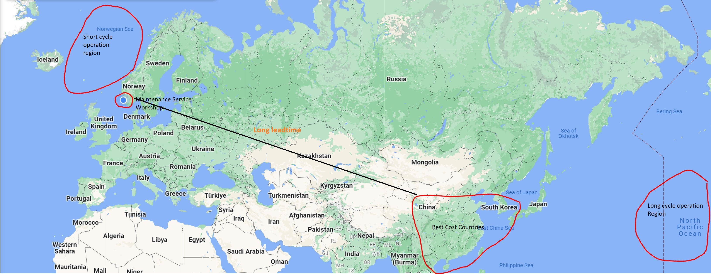
Figure 1. Maintenance logistics for Short Cycle Operation Region.

The spare parts inventory is further challenging for maintenance services in short-cycle operation regions, e.g. North Sea, compared to the long-cycle operation regions, e.g. Pacific Ocean, as the maintenance service workshops have limited time to repair the tools and send them for the next operations, especially when their best cost countries (BCC) are quite far, as illustrated in Figure 1.
The stocking strategy with the repairing spare parts approach can potentially solve such a challenge. Thus, the purpose of the paper is to explore the potential cost and benefits of applying the Reorder Point policy with the Stock and Serve (SS) approach for maintenance service workshops in short-cycle operation regions. It means we are going to study the effect of spare parts inventory policies and levels on the average maintenance workshop cycle time, departure variability, and associated cost and cost-saving parameters.
To achieve this purpose, a case study has been implemented on a specific maintenance service workshop within the North Sea region and the entire tool repair and spare part supply operations are conceptualized and modelled with the help of the simulation modelling approach. Two scenarios have been simulated: (1) the maintenance workshop fully depends on supplying newly built spares from the best-cost countries with no inventory stock or spare reuse, (2) the Maintenance workshop mainly depends on repaired spares with an optimal level of spares stock. The tools and critical parts are classified based on criticality, where the most critical tool and its five most critical parts were considered in the study. In this paper, we first present the literature, methods and data sources that provide the theoretical background and modelling inputs of this study. Then in section 3, the results from the simulation model are presented and discussed. We end this paper with conclusions regarding how cost-beneficial the Reorder Point policy with the Stock and Serve (SS) approach is for maintenance service workshops in short-cycle operation regions.
- Materials and Methods

Replenishing spare parts strategies
Replenishing spare parts strategies can be categorized into three main approaches: Repair and Stock (RS), Stock and Queue (SQ), and Stock and Serve (SS). In the RS strategy, spare parts are repaired or refurbished as needed and then stocked in inventory to fulfil future demands. When a spare part is depleted from inventory, the repair process is initiated to replenish the stock. This strategy aims to strike a balance between repair costs and inventory levels. In the SQ strategy, spare parts are stocked in inventory without repair or refurbishment. When a spare part is depleted, a replenishment order is placed with the supplier. The lead time for the replenishment order creates a queue or waiting time before the spare part is available for use. This strategy prioritizes fast response times by relying on supplier availability. In the SS strategy, spare parts are stocked in inventory without repair or refurbishment, similar to the SQ strategy. However, instead of relying on external suppliers, the spare parts are serviced internally. This means that the organization has the capability to quickly address and replace depleted spare parts from its own inventory. The SS strategy offers greater control over lead times and response times. The selection of the most appropriate replenishment strategy depends on various factors, including the criticality of the spare parts, their lead time, the cost and availability of repair services, the organization's repair capabilities, and the desired balance between inventory costs and response times. However, the Lot-for-Lot policy may not be suitable for all scenarios. If there are significant costs associated with each order or if lead times are long, frequent ordering may not be practical or cost-effective. In such cases, other reordering policies like the Economic Order Quantity (EOQ) or Min-Max may be more appropriate.
In certain areas of the North Sea, particularly in more mature fields where the infrastructure is well-established, drilling operations can be considered a relatively short cycle. These operations may involve drilling exploration wells, appraisal wells, or development wells in fields with known reserves. However, in other areas of the North Sea, such as deepwater or frontier exploration regions, drilling operations can be more complex and time-consuming, falling into the long-cycle category. These operations often require specialized equipment, extensive planning, and longer drilling durations due to challenging environmental conditions, deeper water depths, or the exploration of unconventional resources.

The Case Study and Simulation Model Development
In this section, the case study will be presented together with the entire simulation model building. The case study is about a maintenance workshop that serves several tools operated in the North Sea. Each tool may be used for several operations and holds over 50 different components. Therefore, the inventory of spare parts is crucial for this workshop, especially due to the high operational cycle of these tools (they should be fixed and go back to operation). On average, the workshop receives five to ten tools every month. The workshop has a designed process, illustrated in Figure 2, where it receives the tool, checks if it is used or not, disassembles the tool and inspects the component. If the tool just needs standard replacement components, the replacement work will be performed and followed by cleaning and preservation to be ready for upcoming operations. If the tool needs to be repaired and the workshop is not able to perform that, it will be replaced with a new component from the stock. It is clear, the current maintenance service process is highly dependent on the spare parts stock, its safety stock, reorder point, batch size and lead times to BCC. Therefore, the enhanced maintenance service process is proposed, illustrated in Figure 3, to enable the dispatch of tools within seven working days from their receipt. This is done by introducing the local repair path. So, the failed components within the serviced tools will be replaced by spares in the stock, however, the stock will be filled by both repaired spares from previous jobs, and the newly ordered spares from BCC. In this case, the stock will be more dependable, and spare purchases and spare scraps will be reduced. It is worth mentioning that the failed components which will be repaired, are batched three units together and then sent to the local repair service for increased cost savings.

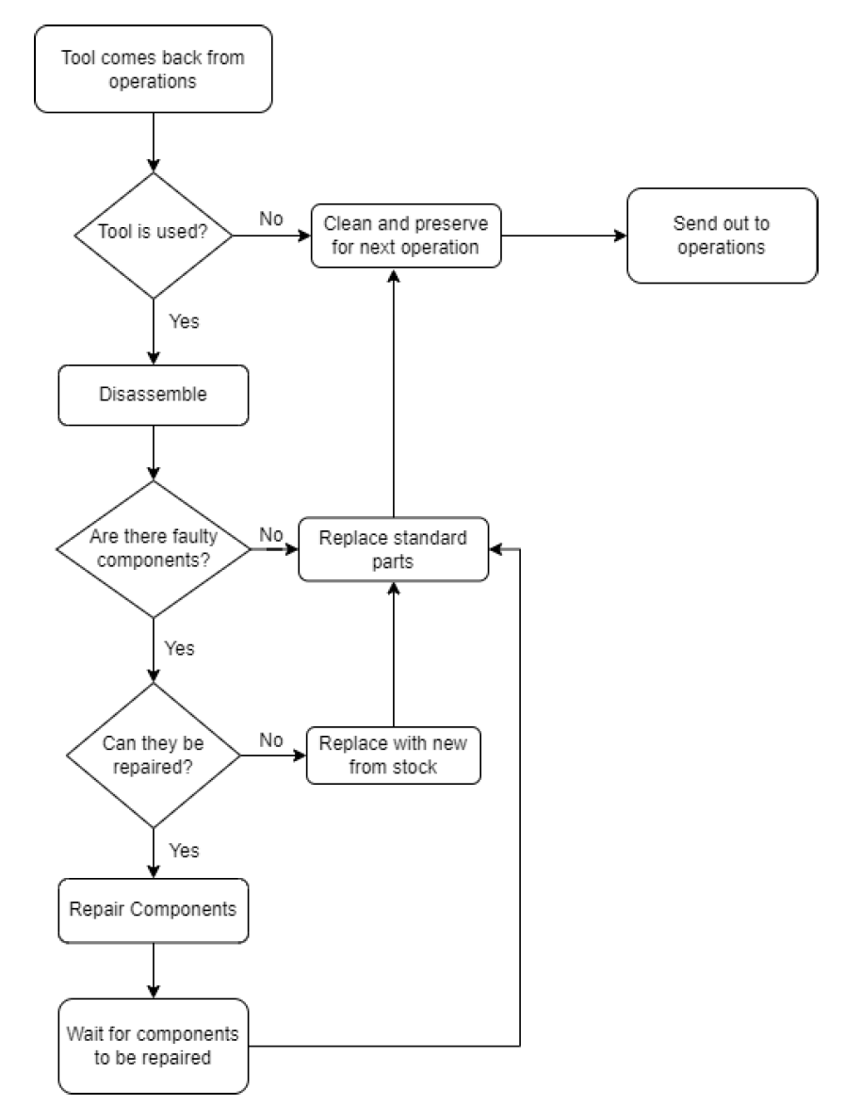 |  | 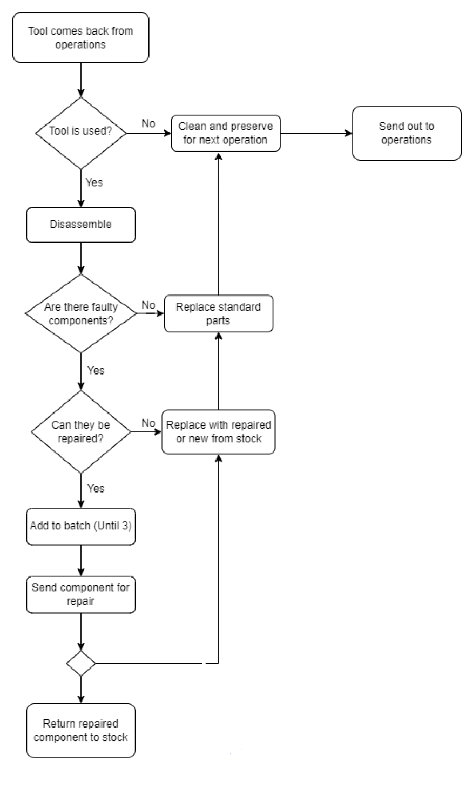
Figure 2. Process flowchart for the current scenario. [8] |  | Figure 3. Process flowchart for the enhanced scenario with repair path. [8]

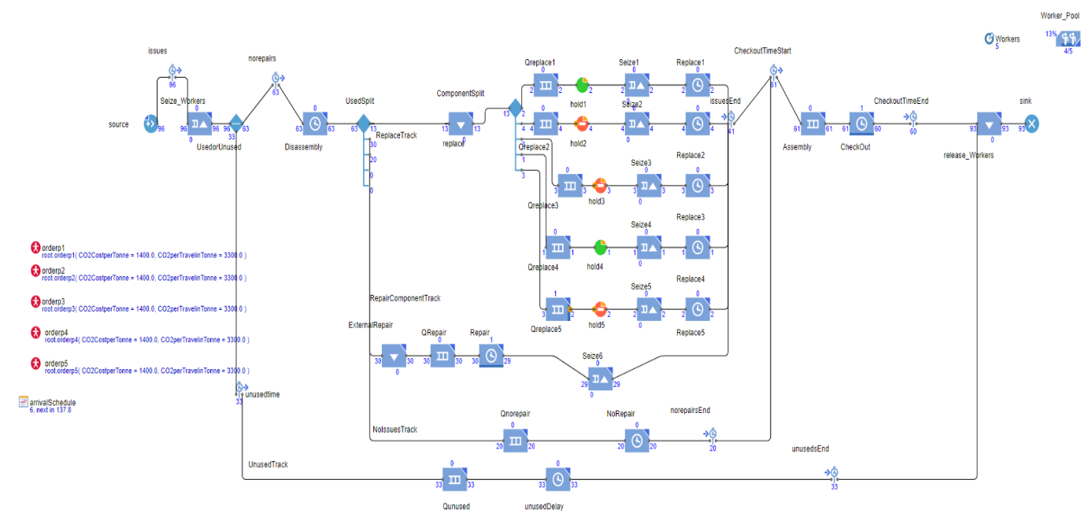
Figure 4. Simulation model for the current scenario. [8]

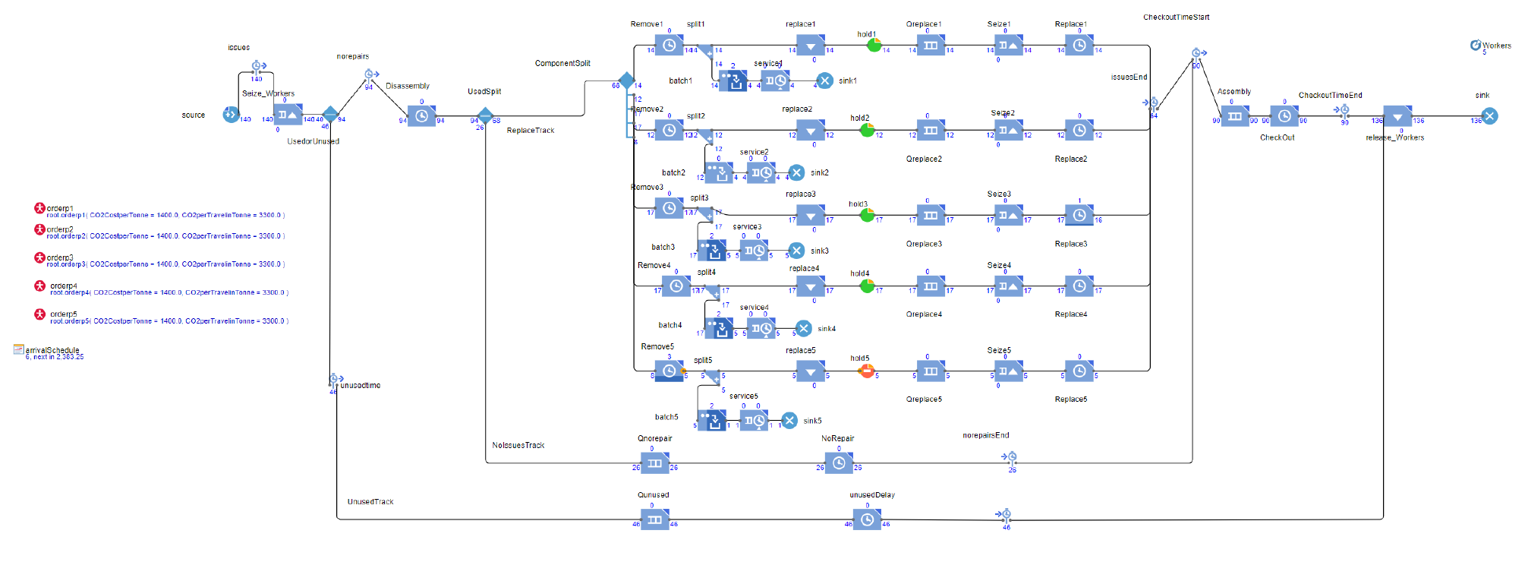
Figure 5. Simulation model for the enhanced scenario. [8]
In summary, there are four paths in this process, as seen in Figure 4: unused tools that require only cleaning and preserving, tools with no issue as nothing was detected after the disassembly task, tools that need external repair and tools that require replacement work and will be locally performed. However, the replacement path is further split into five sub-paths based on the tools' criticalities (frequency and consequences). The simulation model for the enhanced process, shown in Figure 5, is almost similar to the current scenario model, except that it splits each replacement path (five sub-paths) into two tracks, one for the tool by itself and the second for the repair path for the failed component that will be batched in threes, repaired and sent to stock. The simulation model in both scenarios considered the worker capacity of the workshop (5 workers) and spare parts inventory capacity. Therefore, the “seize and release” functions are presented in the simulation model. Besides, the “hold” function is used to hold the replacement work once the spare parts stock is empty.

The simulation model has two more agents, one is the spare part inventory or stock and the second is the spare parts logistics from BCC. In Figure 6, the spare part inventory is modelled using system dynamics and state machine libraries in the Anylogic software.
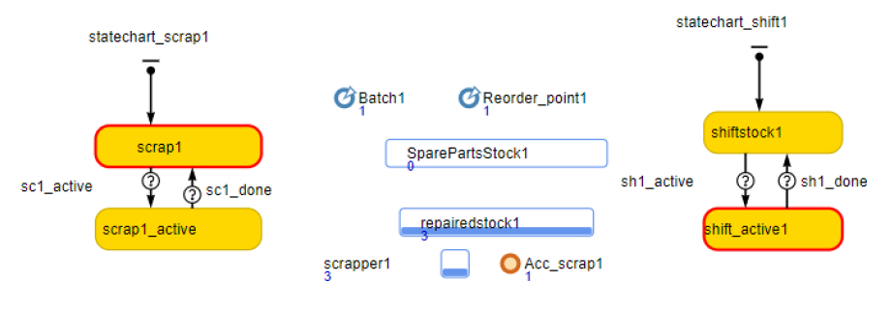
Figure 6. Spare parts inventory modelled as an agent. [8]
The spare parts logistics is modelled as a discrete event process, where the order enters the process and after waiting in the order queue the supply process starts and takes on average around 365 days. The order is triggered by the state chart (shown in Figure 7, left side) when the condition of the spare parts stock goes below a certain level. Once the spare parts arrive at the workshop, the ordering state will receive a message to indicate that the spare parts are available. The simulation time unit is hours, and the simulation time interval is 26000Hrs.
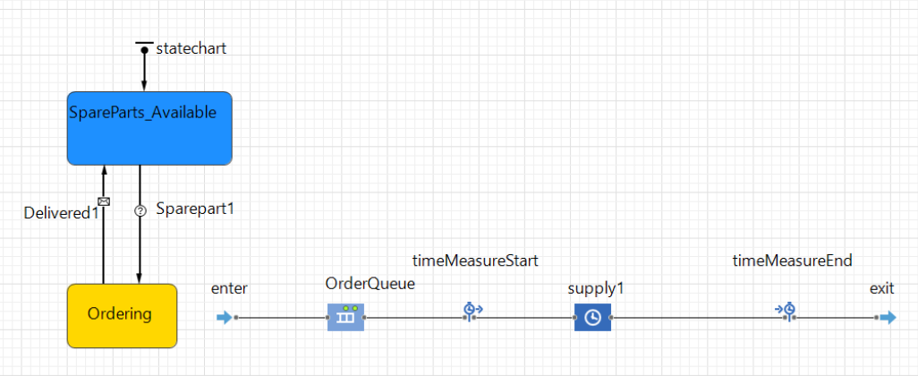
Figure 7. Spare parts logistics modelled as an agent. [8]
- Results and Discussion
The simulation model provides an estimation of several key performance indicators such as the number of served tools (which is a direct indicator for the revenue), average lead time (please remember the workshop seven days target), average worker utilization, workshop crowding and spare parts scrap rate.
In Table 1, the key performance indicators, obtained by the simulation model, are summarized. The total served tools increased in the enhanced scenario as the workshop had short lead and flow times and was able to receive and repair more tools. The service lead time (from receiving the tool until it is ready for the next operation) was reduced to 193 hours, which is almost near to the target of seven days. There are around 5% of the tools still take more than 500 hours and further enhancement is required. The workshop crowding has also enhanced and instead of having on average 5 or 6 tools at once, it has on average 1 to 2 tools. The scrap rate has reduced and more components are repaired.

Table 1. Key performance indicator comparison between current and enhanced scenarios.
 | Current  scenario | Enhanced scenario with repair path | Difference
No. of tools served | 207 | 243 | 17% increase
Average lead time in Hrs | 888.65 | 193.09 | 78% reduction
Average worker utilization | 0.73 | 1.58 | 116% increase
Tools with a lead time of less than 500 hrs | 20% | 90% | 70% improvement
Average workshop crowding (number of tools in the workshop) | 5.33 | 1.59 | 73% reduction
Scrap rate | 21 | 10 | 48% reduction

The lead time histograms in Figures 8 and 9 illustrate the mean time for the workshop to prepare the tools ready for the next operation. It is clear that depending on the spare parts availability, some tools must wait more than 500 hours and some need in total 5500 hours. The enhanced scenario has shortened the lead time in general, however, there is a room for further enhancement to handle some cases where the lead time is still 3000 and 5000 hours.
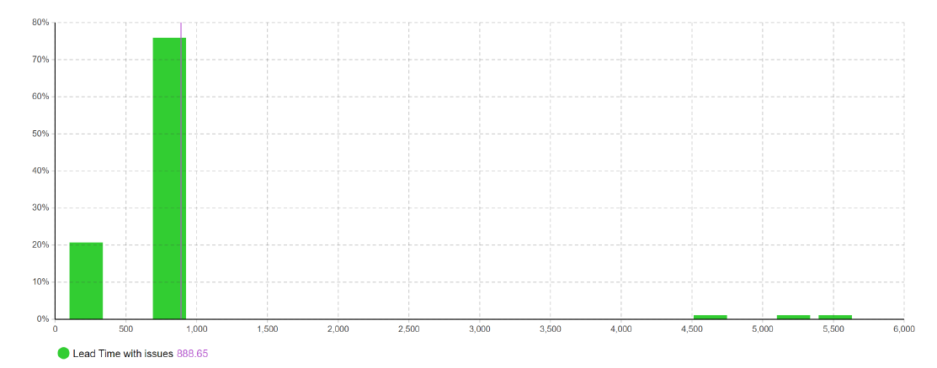
Figure 8. Lead time histogram for the current scenario.
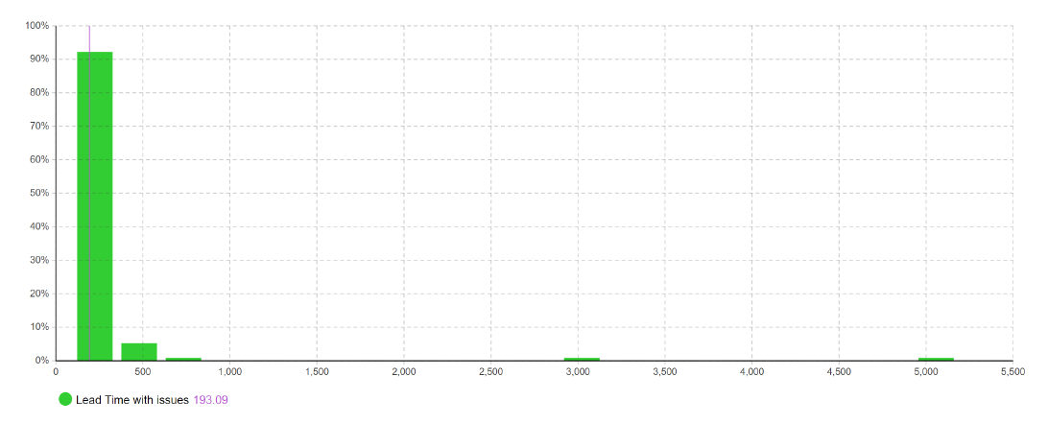
Figure 9. Lead time histogram for the enhanced scenario.
Figures 10 and 12 illustrate how the five workers are utilised over time and it is clear that the enhanced scenario has increased the utilization rate. However, the utilisation rate for the enhanced scenario is still low, which is 1.58 out of five, as shown in Figure 13.

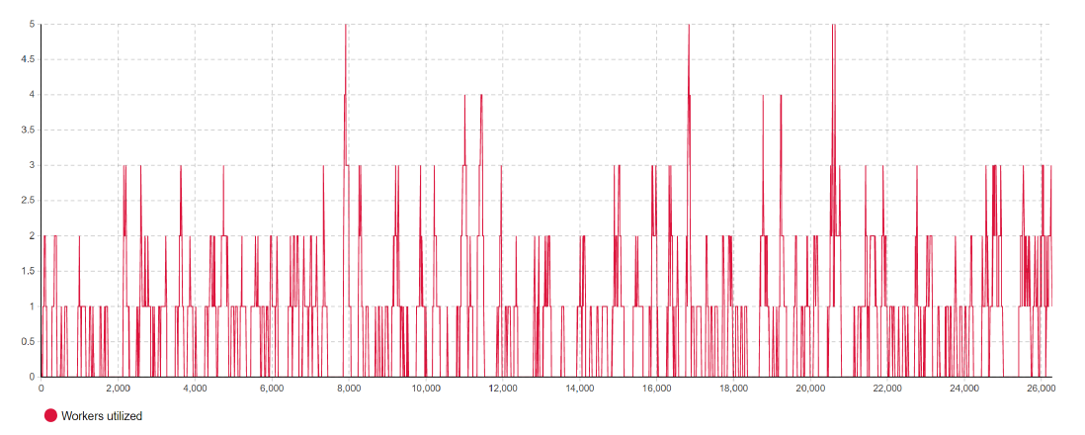
Figure 10. Worker utilization per hour for the current scenario.
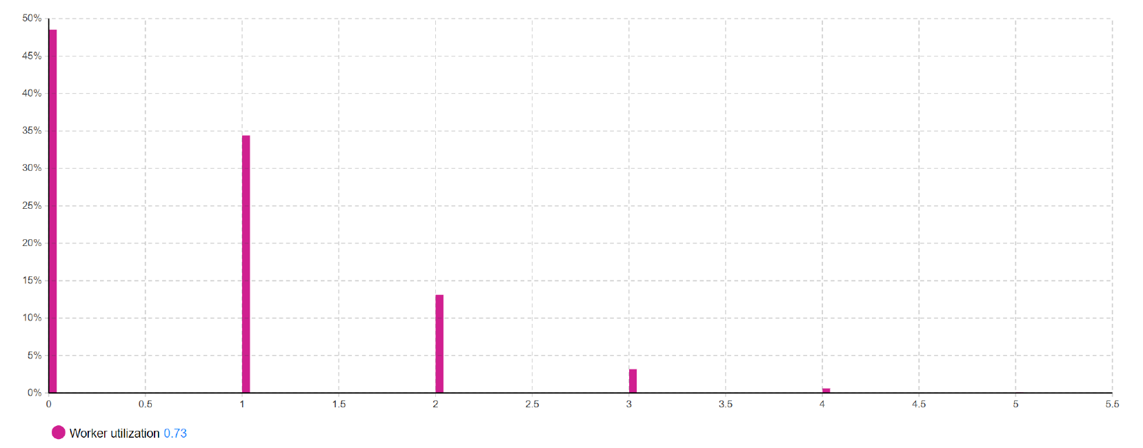
Figure 11. Average worker utilization for the current scenario. The worker utilization is 0.73 workers out of 5 workers.
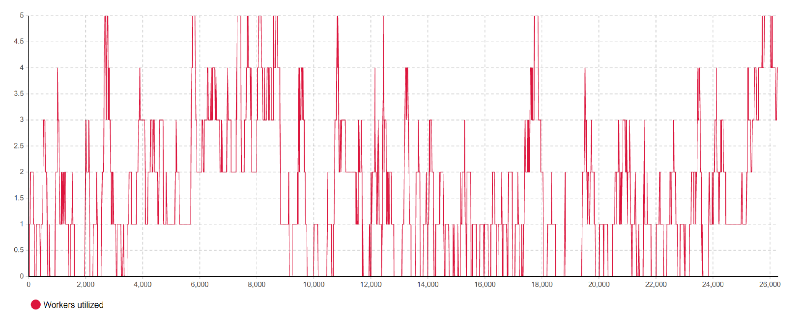
Figure 12. Worker utilization per hour for the enhanced scenario.
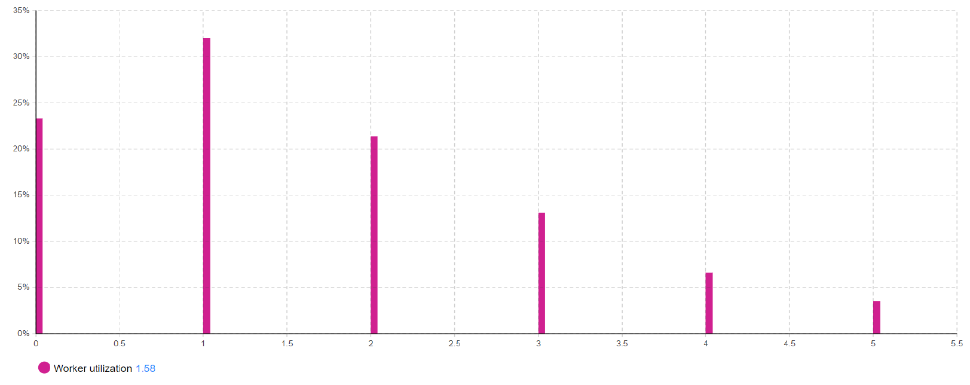
Figure 13. Average worker utilization per hour for the enhanced scenario. The worker utilization is 1.58 workers out of 5 workers.

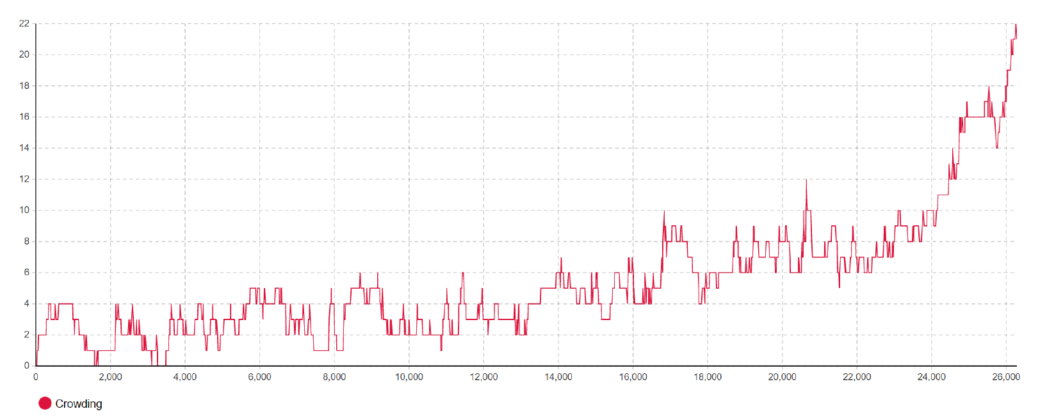
Figure 14. Crowding per hour for the current scenario.
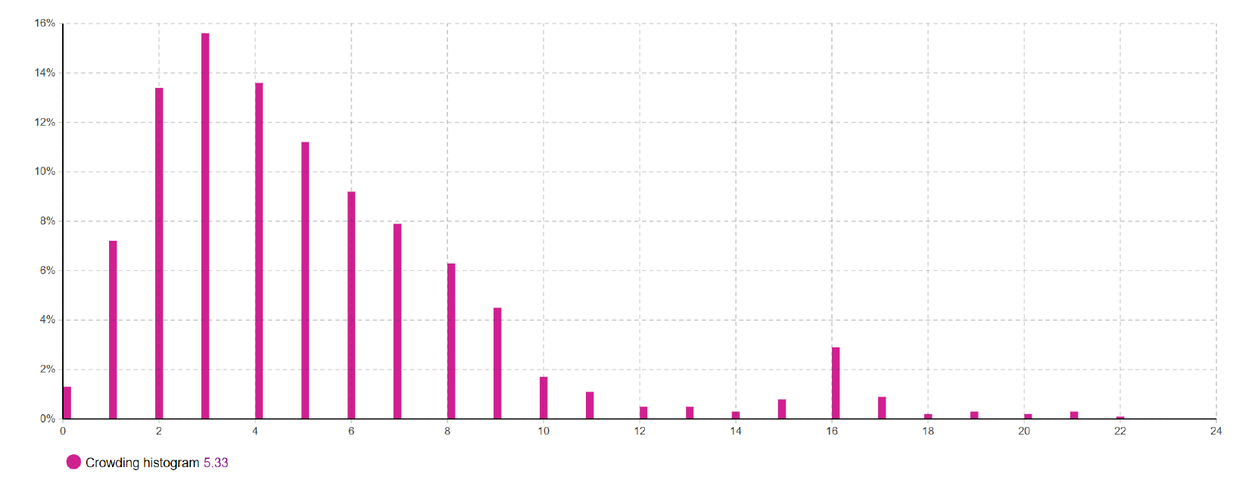
Figure 15. Average crowding for the current scenario.
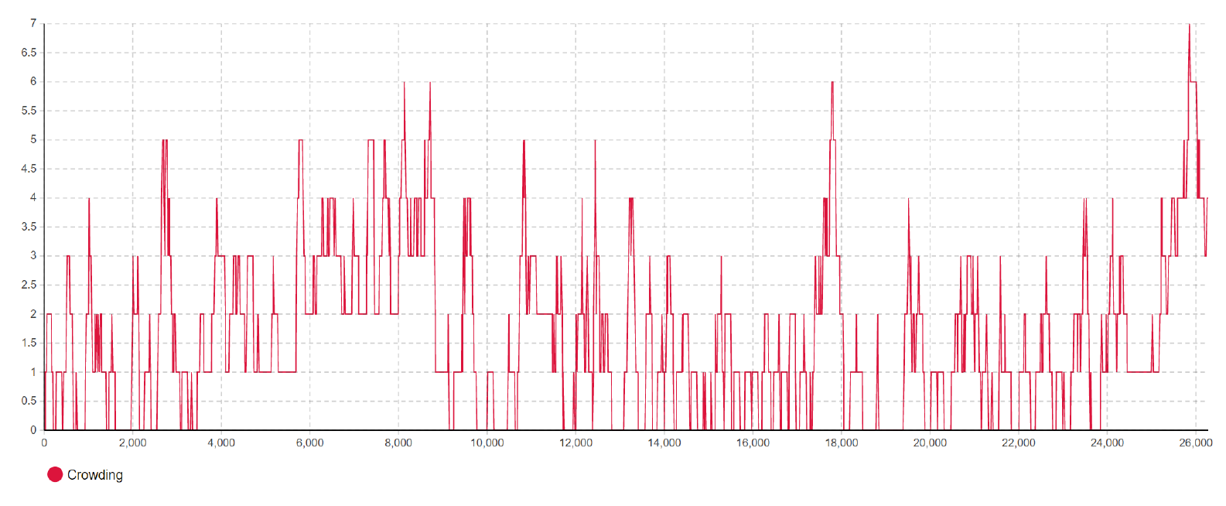
Figure 16. Crowding per hour for the enhanced scenario.
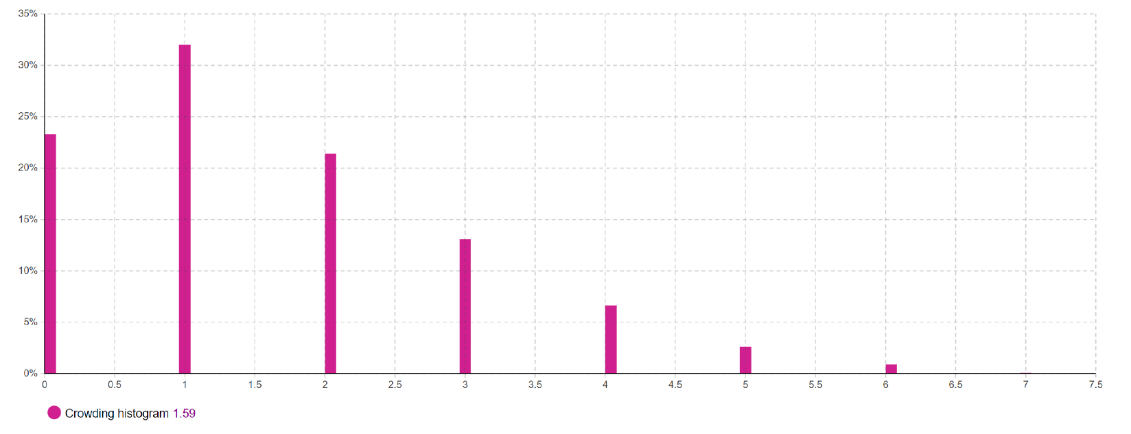
Figure 17. Average crowding per hour for the enhanced scenario.

Workshop crowding here refers to the number of tools that are simultaneously served in the workshop. In Figure 14, the number of tools in the workshop for the current scenario is increasing over time, whereas the crowding for the enhanced scenario fluctuates around two tools at once, as shown in Figure 16, allowing for easier navigation and less physically strenuous tasks, where it develops a safer, and more reliable work environment. Future research can be done to enhance operational efficiency and tool life-cycle management. One area is the development of alternative future-proofing strategies or improvements to the repair-path cycle stock inputs. This exploration can identify a leaner approach to finding optimal stock values that minimize inventory levels. Additionally, investigating advanced stock management techniques, such as dynamic stock optimization using real-time data, holds promise for improving the model's performance. Integrating advanced optimization algorithms like Particle Swarm Optimization and Simulated Annealing could further enhance the effectiveness of the inventory management system.
- Conclusion
The simulation results for the study case support the conclusion that a local repair service is required to keep maintenance workshops in high-cycle regions at high-performance levels. The repair path cycle that was proposed for the current maintenance workshop has several benefits for the workshop, the region and the globe. For the workshop, 78% reduction in lead times, a 116% improvement in worker utilization, a 73% reduction in crowding levels, a 52% reduction in scrap rate, and a potential profit increase of roughly three million NOK (20%). For the region, the repair path cycle creates jobs for local repair and reduces the scrap rate. For the globe, the repair path cycle reduces the maintenance logistics between Norway and BCC and the associated CO2 emissions.

References
- Van der Auweraer S and Boute R 2019 Forecasting spare part demand using service maintenance information Int. J. of Production Economics 213 138–149
- Kosanoglu F Turan H H Atmis M 2018 A simulated annealing algorithm for integrated decisions on spare part inventories and cross-training policies in repairable inventory systems In Proceedings of Int.Conference on Computers and Industrial Eng 1-14
- Schultz C R 2004 Spare parts inventory and cycle time reduction Int. J. of Production Research 42(4) 759-776
- Li X Zhang K Tan Z 2015 Spare part management in a testing workshop
2015 Winter Simulation Conference (WSC) 3170–3171
- Saeed M F Osman F 2022 Modeling and simulation for inventory management of
repairable items in maintenance systems Simulation 98(11) 1013–1037
- Zhu S van Jaarsveld W Dekker R 2020 Spare parts inventory control based
on maintenance planning Reliability Engineering & System Safety 193
- Tagaras G Vlachos D 2001 A periodic review inventory system with emergency
replenishments Management Science 47(3) 415–429
- Shalfawi M 2023 Modelling of Maintenance ServiceWorkshop and Inventory Operations for a Short Cycle Operational Region University of Stavanger Norway

