Calculation and Prediction of Suspended Span Caused by Erosion of Deep Water Submarine Pipelines

Xu Jia1,Kankan Ni1,Yancheng Li1,Lusheng Jia1

1Engineering Research&Design Dept. CNOOC Research Institute Ltd.

nikk@cnooc.com.cn

**Abstract**. Submarine pipelines can be divided into three types based on their laying status: pipelines laid flat on the seabed, pipelines without buried, and pipelines buried in shallow trenches. In addition, there is also a suspended span state caused by waves and currents erosion. The four laying states of submarine pipelines indicate that the seabed, as the foundation supporting the pipeline, must provide sufficient support to ensure the stability of the pipeline. This article studies the erosion span data of existing pipelines, evaluates and predicts the pipeline span state through theoretical calculation and analysis, and then uses numerical simulation calculation methods to predict the pipeline span depth, and compares and verifies it with measured data.

1. Introduction

Liwan 3-1 Gas Field is located in the Pearl River Mouth Basin of South China Sea, about 310km southeast of Hong Kong. The project had built an subsea production system consisting of 8 sets of subsea wellhead, east and west manifolds, and central manifolds in the deep water area. 2 of 22 inch multiphase pipelines, 1of 6 inch MEG pipeline, a new central platform and a 30 inch of 260km oil and gas transportation submarine pipeline in the shallow water area.

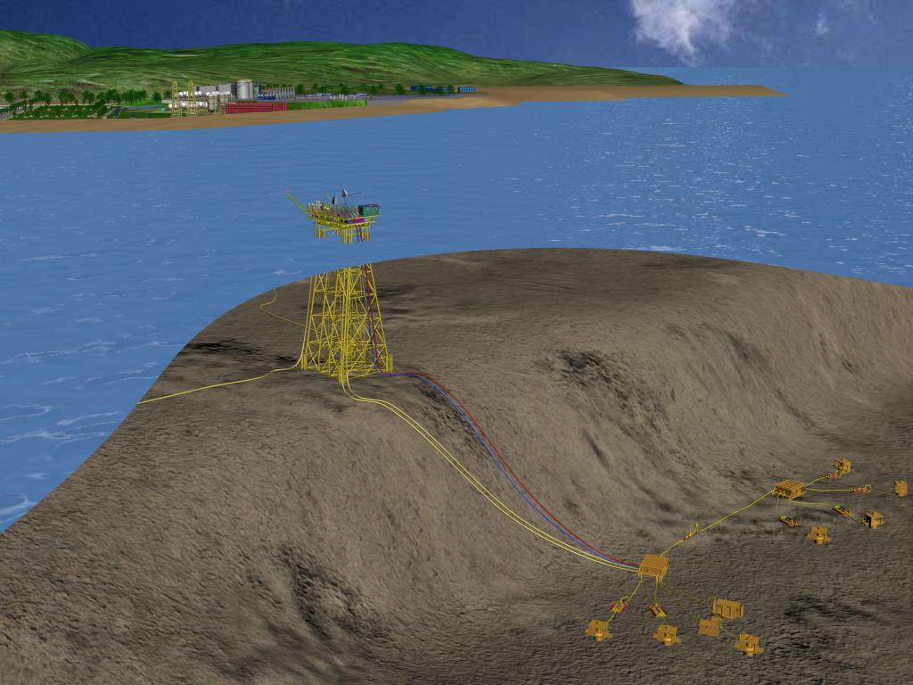

**Figure 1**. Schematic diagram of Liwan 3-1 development

The 30 inch pipeline of the Liwan 3-1 project has a long route length and the route direction is close to perpendicular to the bottom flow direction, making it highly likely to experience erosion. Therefore, regular in situ status surveys will be conducted on this pipeline, including the use of multi beam, side scan sonar, and other methods to investigate the burial status of the pipeline. Evaluate the situation of pipeline scouring suspended span through annual survey data, and provide theoretical basis for suspended spans management.

1. Evaluation Method For Pipeline Suspension Span

## Theoretical Analysis Method for Pipeline Suspension Span

The free span analysis of submarine pipelines is based on the DNV-RP-F105 standard [1], and the main analysis and calculation includes two parts: VIV calculation and ULS ultimate strength verification. There are two methods for VIV calculation: one is based on avoiding resonance frequency, with VIV Screening and Onset criteria; the other is VIV fatigue calculation, which is based on cumulative damage stress/strain fatigue calculation method. In theory, the results of Screening and Onset calculations are relatively conservative, while VIV fatigue calculations can quantitatively analyze the service life of offshore pipelines under working and environmental loads, which is closer to engineering practice.

According to the DNV-RP-F105 specification, when the length of the suspended span exceeds the allowable value of the Screening or Onset criteria, the VIV fatigue calculation method can be chosen for reanalysis. If the VIV fatigue calculation meets the requirements and the ULS strength verification also meets the requirements, the suspended span can be left untreated.

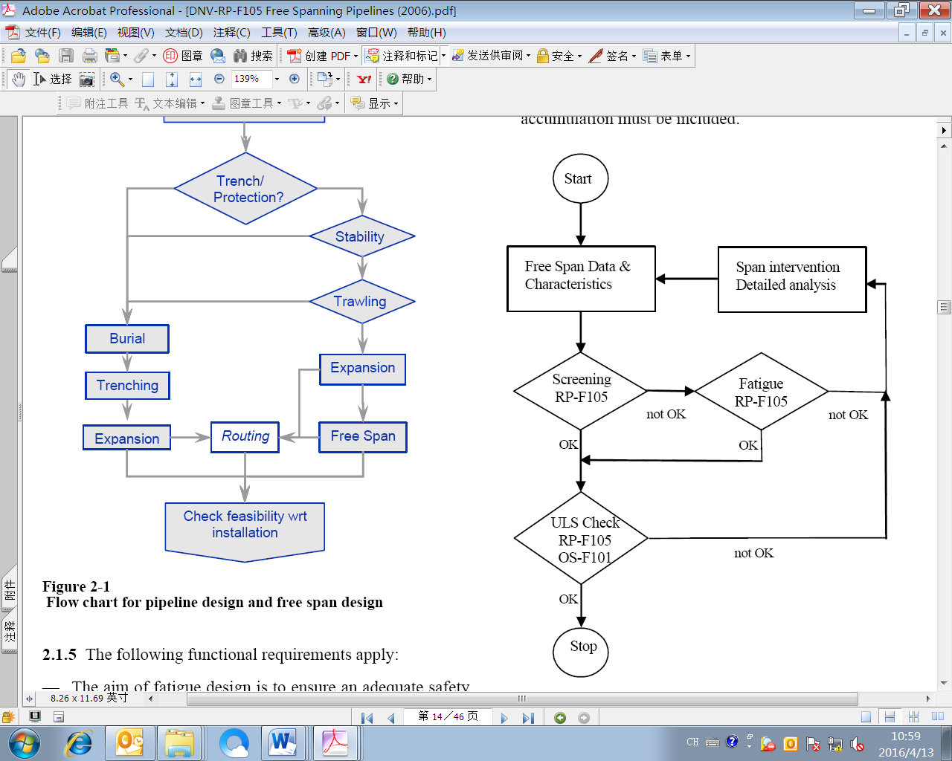

**Figure 2**. Suspended Span Analysis Process

## VIV Suspension Fatigue Analysis

The main calculation method for VIV suspension span fatigue is to verify the response model and mechanical model recommended in DNV-RP-F105 separately. The response model calculates the alternating stress of vortex induced vibration in the cross flow direction and inline direction based on the curve of attenuation speed and vibration amplitude recommended by the experimental model. The mechanical model mainly calculates the alternating stress in the inline direction caused by wave drag force on a suspended pipeline based on empirical formulas.

After calculating the alternating stress, calculate the fatigue life according to the standard S-N curve recommended in DNV-RP-C203 [2]. Firstly, based on the probability distribution of wave periods, calculate the fatigue life of the entire distribution of ocean current velocity under a certain wave height, frequency, and wave direction. Based on the probability distribution of waves, frequency, and direction in the sea area, calculate the overall fatigue life in both the cross flow and in line directions. After obtaining the fatigue life under the suspended span length, evaluate whether the fatigue life meets the design life requirements.

1. CFD Numerical Simulation Prediction

Compared with analytical methods, numerical methods have significant advantages in simulating complex wave conditions and considering the characteristics of seabed soil. The numerical simulation of pipeline erosion span was carried out using the OpenFOAM program.

## \Scour Calculation Model

The Euler Euler two-phase flow sediment model is composed of the flow phase and the sediment phase. Water flow and sediment are independent continuous media that satisfy the control equations of the fluid. At the same time, the model describes turbulent motion using momentum exchange, turbulent stress, and sediment particle stress based on the influence of the interaction between sediment particles and fluid sediment particles.



**Figure 3**. Schematic Diagram of Submarine Pipeline Erosion

## Governing Equation

$\frac{∂（1−c）}{∂t}+\frac{∂（1−c）u_{i}^{f}}{∂x_{i}}=0$（1）

$\frac{∂c}{∂t}+\frac{∂cu_{i}^{s}}{∂x_{i}}=0$（2）

*c* is volume fraction of sediment in water flow., $u_{i}^{f}$, $u_{i}^{s}$ Represent the velocity of water flow and sediment respectively, with i=1 and 2 representing the horizontal and vertical directions.The momentum continuity equation can be expressed as:

 （3）

 （4）

$ρ^{f},ρ^{s}$ Denotes the density of the water flow phase and the sediment phase, respectively. $p^{f}{,p}^{s}$ are fluid pressure and sediment normal pressure, respectively. $F_{i}^{sf}$ and $F_{i}^{fs}$ is the interaction force between the fluid phase and the sediment phase, following the Newton's Third Law .

## Turbulent closure equation

Based on the work of Hsu [3]and Cheng [4], an improved two-phase K-Epsilon turbulence model can be obtained:

$\frac{∂k^{f}}{∂t}+u_{j}^{f}\frac{∂k^{f}}{∂x_{i}}=\frac{R_{ij}^{ft}}{ρ^{f}}\frac{∂u_{i}^{f}}{∂x_{j}}+\frac{∂}{∂x_{j}}\left[\left(ν^{f}+\frac{ν^{ft}}{σ_{k}}\right)\frac{{∂k}^{f}}{{∂x}_{j}}\right]−ϵ^{f}−\frac{2β\left(1−α\right)ck^{f}}{ρ^{f}\left(1−c\right)}−\frac{1}{\left(1−c\right)}\frac{ν^{ft}}{σ_{c}}\frac{∂c}{{∂x}_{j}}\left(s−1\right)g_{j}$（5）

$\frac{{∂ϵ}^{f}}{∂t}+u_{j}^{f}\frac{∂ϵ^{f}}{∂x_{j}}=C_{1ϵ}\frac{ϵ^{f}}{k^{f}}\frac{R_{ij}^{ft}}{ρ^{f}}\frac{{∂u}_{i}^{f}}{{∂x}_{j}}+\frac{∂}{{∂x}_{j}}\left[\left(ν^{f}+\frac{ν^{ft}}{σ_{ϵ}}\right)\frac{{∂ϵ}^{f}}{{∂x}_{j}}\right]−C_{2ϵ}ϵ^{f}\frac{ϵ^{f}}{k^{f}}−C_{3ϵ}\frac{ϵ^{f}}{k^{f}}\frac{2β\left(1−α\right)ck^{f}}{ρ^{f}\left(1−c\right)}−C_{4ϵ}\frac{ϵ^{f}}{k^{f}}\frac{1}{\left(1−c\right)}\frac{ν^{ft}}{σ_{c}}\frac{∂c}{{∂x}_{j}}\left(s−1\right)g_{j}$（6）

|  |  |  |  |  |  |  |  |
| --- | --- | --- | --- | --- | --- | --- | --- |
| **Table 1.**Turbulence ModelCoefficients | | | | | | | |
| $$C_{μ}$$ | $$C_{1ϵ}$$ | $$C_{2ϵ}$$ | $$C_{3ϵ}$$ | $$C_{4ϵ}$$ | $$σ_{k}$$ | $$σ_{e}$$ | $$σ_{c}$$ |
| 0.09 | 1.44 | 0.92 | 1.2 | 0 or 1 | 1.0 | 1.3 | 1.0 |

## Sediment Stress Closure Equation

In the model, the sediment volume fraction *c* is used as the basis for determining sediment stress[4]. When $c>c^{∗}(c^{∗}=0.635)$, it was believed that sediment was stationary and sediment stress was ignored;When $c_{∗}<c<c^{∗}$ ($c_{∗}=0.57)$, the sediment was in the transition stage from solid to liquid, and the sediment stress was considered as continuous contact stress, calculated using the Johnson&Jackson friction stress model. When $0.001<c<c_{∗}$, the sediment phase was dominated by collision stress, and calculated using collision theory simulation. When c<0.001, the sediment was considered as a diluted flow, ignoring the influence of interaction.

The calculation equation for the temperature of sediment particles $θ$ is:

$ρ^{s}\left(\frac{∂cθ}{∂t}+\frac{∂cθu_{j}^{s}}{{∂x}_{j}}\right)=τ_{ij}^{sc}\frac{{∂u}_{i}^{s}}{{∂x}_{j}}−\frac{{∂q}_{j}}{{∂x}_{j}}−γ+2βc\left(αk−θ\right)$（7）

Calculation equation for collision stress of sediment particles:

$τ_{ij}^{sc}=−p^{sc}δ_{ij}+μ^{sc}\left(\frac{{∂u}_{i}^{s}}{{∂x}_{j}}+\frac{{∂u}_{j}^{s}}{{∂x}_{i}}\right)+\left(λ−\frac{2}{3}μ^{sc}\right)\frac{{∂u}_{k}^{s}}{{∂x}_{k}}δ_{ij}$（8）

Calculation equation for frictional force of sediment particles:

$τ_{ij}^{sf}=−p^{sf}δ_{ij}+μ^{sf}\left(\frac{{∂u}_{i}^{s}}{{∂x}_{j}}+\frac{{∂u}_{j}^{s}}{{∂x}_{i}}\right)−\frac{2}{3}μ^{sf}\frac{{∂u}_{k}^{s}}{{∂x}_{k}}δ_{ij}$（9）

$p^{sf}=\left\{\begin{aligned}0，c<c_{∗} \\ F\frac{{(c−c_{∗})}^{m}}{{(c^{∗}−c)}^{n}},c≥c^{∗}\end{aligned}\right.$（10）

$μ^{sf}=\frac{p^{sf}sin⁡(θ_{f})}{\sqrt{2S_{ij}^{s}S_{ij}^{s}}}$（11）

|  |  |  |
| --- | --- | --- |
| **Table 2.**Sediment Stress Model Coefficients | | |
| $$C_{μ}$$ | $$C_{1ϵ}$$ | $$C_{2ϵ}$$ |
| 0.09 | 1.44 | 0.92 |



**Figure 4**. Model Diagram Of Submarine Pipeline Erosion

1. Case Analysis Calculation

## Design Basis

The typical cross-section of a 30 inch single layer pipeline with a cement weight layer is shown in the following figure.

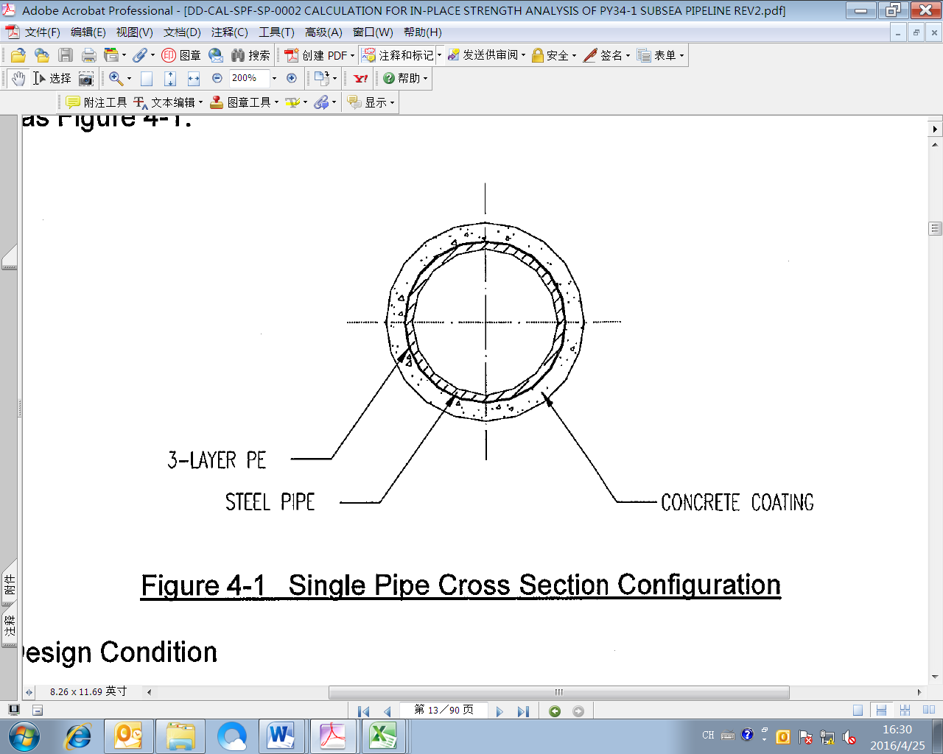

**Figure 5**. Cross Section Of Submarine Pipeline

The specific design parameters of the pipeline are shown in Tables 3.

**Table 3.**Pipeline Properties and Design Parameters

|  |  |  |  |  |  |  |  |
| --- | --- | --- | --- | --- | --- | --- | --- |
| KP | O.D.  (mm) | Wall Thickness  (mm) | Corrosion Allowance  (mm) | Design Pressure  (Mpa) | Design Temperature  (℃) | Material Grade | |
| 0.0-0.50 | 762 | 30.2 | 2 | 23.6 | 60 | | API 5L X65 PSL2 |
| 0.50-192 | 762 | 28.6 | 2 | 23.6 | 60 | | API 5L X65 PSL2 |
| 192-260 | 762 | 30.2 | 2 | 23.6 | 60 | | API 5L X65 PSL2 |
| 260-261.026 | 762 | 31.8 | 2 | 23.6 | 60 | | API 5L X70 PSL2 |

By comparing and analyzing the survey data of pipeline in-service status over the years, it can be concluded that the evolution trend of pipeline suspension spans is from short discontinuous suspension spans to long continuous suspension spans; The suspended span height generally shows an increasing trend.

**Table 4.**Comparison of 30 inch Pipeline Survey Data

|  |  |  |  |  |  |  |  |  |  |  |  |
| --- | --- | --- | --- | --- | --- | --- | --- | --- | --- | --- | --- |
| 2014 Data | | | | 2016 Data | | | | 2018 Data | | | |
| KP | No. | Total Length  (m) | Max  .Length  (m) | KP | No. | Total Length  (m) | Max.  Length  (m) | KP | No. | Total Length  (m) | Max  Length  (m) |
| 0-20 | 41 | 274.8 | 18.1 | 0-20 | 50 | 343.9 | 18 | 0-5 | 1 | 14.52 | 14.5 |
| 15-20 | 13 | 209.9 | 12.8 |
| 20-30 | 5 | 25.2 | 9.0 | 20-30 | 54 | 457.7 | 24.2 | 20-30 | 49 | 1085.2 | 33.5 |
| 30-40 | 35 | 196.7 | 11.1 | 30-40 | 100 | 818.3 | 27.2 | 30-40 | 81 | 1521.6 | 27.8 |
| 40-50 | 40 | 267.3 | 17.9 | 40-50 | 149 | 1339.8 | 27.4 | 40-50 | 159 | 4206.1 | 42.2 |
| 50-60 | 35 | 292.0 | 17.8 | 50-60 | 58 | 495.9 | 19.1 | 50-60 | 73 | 1500.7 | 44.6 |
| 60-70 | 8 | 34.8 | 7.1 | 60-70 | 37 | 261.7 | 22.5 | 60-70 | 53 | 895.0 | 33.3 |
| 70-80 | 31 | 217.2 | 17.5 | 70-80 | 27 | 174.2 | 11.9 | 70-80 | 30 | 456.1 | 15.1 |
| Total | 195 | 1308.0 | 18.1 | Total | 475 | 3891.5 | 27.2 | Total | 459 | 9889.1 | 44.6 |

## Theoretical Analysis And Calculation Results

Based on the VIV fatigue theory analysis method mentioned earlier, fatigue analysis was conducted using the DNV professional software FATFREE for the 14 overhanging sections of the LW3-1 to Gaolan terminal subsea natural gas pipeline that exceeded the design value. The specific analysis results are shown in Table 6.

The analysis results show that the fatigue life of all suspended VIV spans is relatively large, far greater than the design life of 50 years, and there is no need for treatment.

**Table 5.**Fatigue Analysis Results Of Suspended Span Section

|  |  |  |  |  |  |  |  |  |
| --- | --- | --- | --- | --- | --- | --- | --- | --- |
| No, | From  KP | | To  KP | | Span Length  (m) | Span Height  (m) | Allowable Span Length  (m) | Fatigue Life  (year) |
| 1 | | 25.062 | | 25.0956 | 33.54 | 0.36 | 25 | 2.98×104 |
| 2 | | 25.1339 | | 25.1603 | 26.41 | 0.66 | 2.97×104 |
| 3 | | 25.5621 | | 25.5878 | 25.71 | 0.52 | 2.97×104 |
| 4 | | 30.6083 | | 30.6361 | 27.83 | 0.63 | 2.92×104 |
| 5 | | 40.0462 | | 40.0818 | 35.69 | 0.41 | 2.97×104 |
| 6 | | 42.7018 | | 42.7288 | 26.96 | 0.55 | 2.8×104 |
| 7 | | 47.3948 | | 47.4288 | 33.95 | 0.48 | 2.96×104 |
| 8 | | 48.3554 | | 48.381 | 25.59 | 0.63 | 2.98×104 |
| 9 | | 48.5254 | | 48.5676 | 42.21 | 0.62 | 2.98×104 |
| 10 | | 48.6179 | | 48.6467 | 28.79 | 0.75 | 2.98×104 |
| 11 | | 48.7408 | | 48.7661 | 25.31 | 0.40 | 2.98×104 |
| 12 | | 49.4085 | | 49.4424 | 33.94 | 0.43 | 2.98×104 |
| 13 | | 55.484 | | 55.5286 | 44.56 | 0.47 | 2.98×104 |
| 14 | | 61.3216 | | 61.3549 | 33.32 | 0.41 | 2.98×104 |

## Comparison of Numerical Simulation Prediction Results

In the Liwan 3-1 project, according to a survey conducted in 2018, it was found that there was a large scour hole between the Kp48.52-Kp48.57 sections of the 30 "pipeline. Conduct a suspension span prediction evaluation for this location.

**Table 6.**Pipeline Properties and Design Parameters

|  |  |  |
| --- | --- | --- |
| Time(S) | Scour Depth S (m) | S/D |
| 0.00 | 0.00 | -0.01 |
| 0.10 | 0.00 | -0.03 |
| 0.30 | -0.01 | -0.10 |
| 0.50 | -0.01 | -0.19 |
| 0.80 | -0.01 | -0.27 |
| 1.00 | -0.02 | -0.32 |
| 2.00 | -0.02 | -0.44 |
| 5.00 | -0.03 | -0.56 |
| 10.00 | -0.03 | -0.62 |
| 20.00 | -0.04 | -0.73 |
| 30.00 | -0.04 | -0.76 |
| 40.00 | -0.04 | -0.78 |
| 50.00 | -0.04 | -0.80 |
| 60.00 | -0.04 | -0.83 |
| 70.00 | -0.04 | -0.89 |
| 80.00 | -0.05 | -0.91 |
| 90.00 | -0.05 | -0.94 |
| 100.00 | -0.05 | -0.94 |



**Figure 6**. Curve of the variation of the diameter ratio of the deep flushing pipe over time

The depth of erosion rapidly increases in the initial stage of erosion, and then the rate of change in the depth of the erosion pit decreases with time. The scouring depth enters a stable scouring state within 90 seconds of simulation, but by the 5th second of simulation, the maximum scouring depth can reach 60% of the stable scouring depth.

The maximum scouring depth of the pipeline is about 0.94D (D is the diameter of the pipeline), and it can be predicted that the maximum depth of scouring pits generated by the pipeline under this environmental condition is about 0.72 meters. According to the statistical data of the 30 "pipeline in the key investigation section, the depth of the scouring pit at Kp48.52-Kp48.57 section is 0.62 meters, which has not yet reached the predicted maximum value. The future pipeline erosion phenomenon will enter a slow development stage, gradually reaching the maximum erosion depth and then entering a stable state.

1. Conclution

This article summarizes the development law of pipeline suspension span through the analysis of on-site survey data of pipelines over the years as follows:

1. Developing from short discontinuous suspension spans to long continuous suspension spans;
2. The suspended span height generally shows an increasing trend.

Based on the survey data, theoretical analysis and evaluation were conducted on the suspended span of the pipeline. The evaluation conclusion shows that the fatigue life of the pipeline at the suspended span meets the original design life requirements and can be temporarily left untreated. Review should be conducted at any time based on the latest evaluation conclusions.

The numerical simulation method is used to predict the height of pipeline erosion span, and the calculated results are basically consistent with the measured results. This method can be used for span prediction and provides a theoretical basis for pipeline span control.

References

1. DNV-RP-F105 Free Spanning Pipeline
2. DNV-RP-C203 Fatigue Strength Analysis of Offshore Steel Structures
3. Hsu T J , Jenkins J T , Liu L F . On two-phase sediment transport: sheet flow of massive particles[J]. Proceedings of the Royal Society A Mathematical Physical & Engineering Sciences, 2004, 460(2048):2223-2250.
4. Cheng Z , Hsu T J , Calantoni J . SedFoam: A multi-dimensional Eulerian two-phase model for sediment transport and its application to momentary bed failure[J]. Coastal engineering, 2017, 119(JAN.):32-50.