Numerical investigation on pillow plate heat exchangers: Effects of nanofluid and geometry

Ali Karimi 1,*

1 Department of Industrial Engineering, University of Naples Federico II, Italy

* ali.karimi@unina.it

**Abstract**. The current research involves a comprehensive numerical simulation of nanofluid flow within a pillow-plate heat exchanger. Al2O3-water nanofluid and water are used as the working fluids, simulated using a two-phase mixture model. The study explores the influence of geometric properties on the heat exchanger's hydrodynamic and thermal performance. It also delves into the utilization of nanofluids as the working medium and its impact on dimensionless pressure drop, Nusselt numbers, and dimensionless temperature. An innovative aspect of this research lies in the integration of artificial intelligence (AI) techniques for heat exchanger design optimization. Specifically, a Random Forest Regressor (RFR) AI model is employed to predict crucial parameters, including heat transfer coefficient (HTC) and pressure drop, based on input design variables. Key findings reveal that non-linear hole layouts in heat exchangers significantly improve Nusselt numbers by up to 25 percent. Conversely, larger holes result in higher pressure drops. The use of nanofluids enhances thermal efficiency by up to 10 percent while increasing pressure drop by around 7 percent.

# 1.Introduction

Heat exchangers stand as fundamental components within various industries. The imperative need to enhance their efficiency holds the key to substantial reductions in fuel consumption [1], pollution levels, and overall industry efficiency [2]. Notably, achieving higher heat exchanger efficiency presents a tangible pathway to addressing global warming concerns and optimizing [3] energy utilization.

Numerous investigations have addressed the field of heat exchangers, spanning both numerical [4,5] and experimental [6–8] approaches. Several modifications in heat exchanger design, including the utilization of nanofluids [9], highly conductive materials[10], and geometry optimization[11], have been explored to enhance their thermal efficiency. For instance, Karimi et al. [12] conducted a numerical simulation study on a double-tube heat exchanger with a twisted tape, examining the impact of alumina/water nanofluid and pure water as working fluids. Their findings highlighted a 22% Nusselt number improvement with twisted tape and a 40% rise in pressure drop.

A recent passive heat transfer enhancement method, the "pillow plate heat exchanger," [13,14] has been applied to conventional plate heat exchangers. The pillow plate gets its name from its distinctive pillow-shaped surface, created by inflating two parallel plates at specific points through a welding process. This design results in continuous changes in the cross-sectional area and the presence of welding spots [15], both of which induce turbulent flow within the pillow channels, enhancing lateral mixing and heat transfer coefficients.

A limited number of literatures focused on evaluating the performance of pillow plate heat exchangers. Piper et al. [16] were pioneering researchers on this topic. Their study proposed a novel approach for determining key geometric parameters, such as hydraulic diameter, cross-sectional area, and heat transfer area, tailored explicitly for pillow-plate geometries. They have proposed a correlation for calculating these parameters to determine the Reynolds and Nusselt numbers. Furthermore, they have reported that pillow plate heat exchangers exhibit approximately 2-7% surface area enlargement compared to conventional plate heat exchangers, attributable to surface waviness.

Tran et al. [17] achieved similar outcomes in their research, focusing on pillow-plate condensers' performance and applicability in process industries. By using experimental setups at lab and pilot scales, their study incorporated non-conventional fiber-optic measurements to determine condensation channel axial temperature profiles, and their results were compared to calculated values for virtual plain tube bundles, presenting measured axial temperature profiles and heat transfer coefficients for comparison with conventional geometries.

In another study, Kumar et al. [18] conducted a numerical investigation on the flow and heat transfer characteristics of wavy pillow plate channels employed in pillow plate heat exchangers. Their findings revealed that in the thermally developing region, the recirculation zone significantly contributes to heat transfer compared to the thermally developed section, with high heat transfer occurring in the developing region due to lower average temperatures of the hot recirculating zones. Additionally, they conducted a parametric study involving variations in channel geometric parameters, focusing on transversal and equal-pitch pillow plate configurations. Furthermore, a sensitivity analysis was performed to quantify the influence of different geometric parameters and Reynolds numbers on the thermo-hydraulic performance of the pillow plate channel.

Based on existing literature, pillow plate heat exchangers have exhibited significant potential in enhancing heat transfer by promoting turbulent flow regimes. However, a crucial area that warrants exploration is the influence of spot layouts and their respective sizes and using different working fluids. Therefore, in this research, the study delves into assessing the effects of various spot layouts, sizes, and using nanofluids on the thermal and hydraulic performance of the pillow plate heat exchanger.

# 2. Mathematical Modeling

## 2.1 Geometry of the problem

Figure 1 represents the geometry of the research problem. In this study, cold flow entered the pillow-plate heat exchanger through the inlet and exited after the heat transfer due to hot external walls of the heat exchanger. The hydraulic diameter is the same in all geometries and equal to 0.315 meters. In this paper, six different geometries with different hole sizes and layouts are investigated.

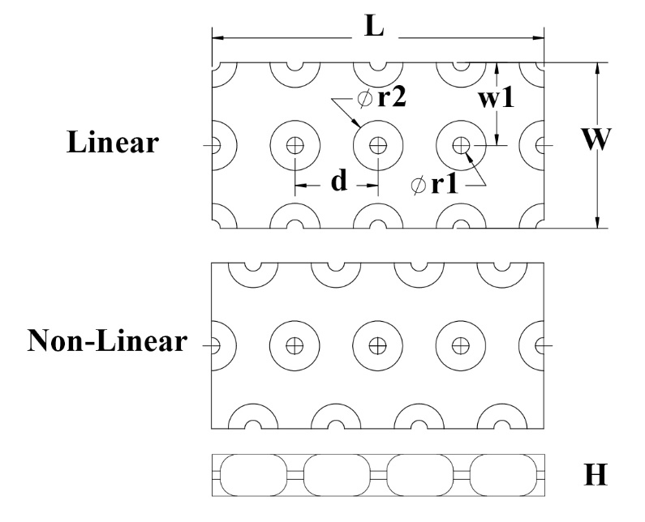

Figure . Geometry details of heat exchanger.

Table 1 presents the dimensionless dimensions of geometry.

Table . Specifications of Linear (L) and Non-Linear (NL) pillow plate heat exchanger

|  |  |  |  |  |  |  |
| --- | --- | --- | --- | --- | --- | --- |
| Geometry type | W/L | H/L | w1/W | d | r1/r2 | r1/d |
| L1 | 0.5 | 0.25 | 0.5 | 0.25 | 0.2 | 0.05 |
| L2 | 0.5 | 0.25 | 0.5 | 0.25 | 0.3 | 0.1 |
| L3 | 0.5 | 0.25 | 0.5 | 0.25 | 0.5 | 0.2 |
| NL1 | 0.5 | 0.25 | 0.5 | 0.25 | 0.2 | 0.05 |
| NL2 | 0.5 | 0.25 | 0.5 | 0.25 | 0.3 | 0.1 |
| NL3 | 0.5 | 0.25 | 0.5 | 0.25 | 0.5 | 0.2 |

The L for all geometries is 1 meter, the rest of dimensions can be calculated based on table 1.

## 2.2 Mixture model

Numerous methods are available for simulating nanofluids, with the single-phase model offering cost and speed advantages. However, it should be noted that this approach typically exhibits reduced accuracy compared to two-phase models. To enhance precision in this study, the mixture model is employed. Within the framework of the mixture model, the resolution of the conservation equations for mass, momentum, and energy necessitates the solution of the volumetric concentration equation for the second phase. Consequently, the relative velocity between the two phases is derived using algebraic methods. Subsequently, the conservation equations for mass, momentum, and energy in the context of the mixture model are provided [19]:

Mass:

|  |  |
| --- | --- |
| $$∇.\left(ρ_{nf}\vec{V}\right)=0$$ | (1) |

Momentum:

|  |  |
| --- | --- |
|  | (2) |



Energy:

|  |  |
| --- | --- |
|  | (3) |

Volumetric concentration equation:

|  |  |
| --- | --- |
|  | (4) |

Its parameters are calculated as follows [20]:

|  |  |  |  |  |
| --- | --- | --- | --- | --- |
|  | (5) | | | |
|  | (6) | | |
|  | | (7) | | |
|  | | | (8) |

In the momentum equation, drift velocity in the second phase (such as nanoparticles) is defined as follows:

|  |  |
| --- | --- |
|  | (9) |

Relative velocity (shear velocity) is defined as second-phase velocity (p) that is dependent on base-phase velocity:

|  |  |
| --- | --- |
|  | (10) |

Relative drift velocity is defined as follows:

|  |  |
| --- | --- |
|  | (11) |

Relative velocity Vpf in the equation above is obtained from the following equation [21]:

|  |  |
| --- | --- |
|  | (12) |

Where:

|  |  |
| --- | --- |
|  | (13) |

Table 2 shows the physical properties of the base fluid and nanoparticles that are used in this simulation. In this study, Al2O3- water is used as the working fluid of heat exchanger.

In addition, nanofluid properties are calculated as follows:

Nanofluid density [22]:

|  |  |
| --- | --- |
|  | (14) |

Nanofluid specific heat [23]:

|  |  |
| --- | --- |
|  | (15) |

Nanofluid dynamic viscosity [24]:

|  |  |
| --- | --- |
|  | (16) |

Nanofluid thermal conductivity [25]:

|  |  |
| --- | --- |
|  | (17) |

SST k-w transport equations [26]:

|  |  |  |
| --- | --- | --- |
|  | (18) | |
|  | (19) |

**Table 2.** Physical properties [27] of the base fluid and nanoparticles at T=293 K.

|  |  |  |
| --- | --- | --- |
| Al2O3 | Water | Properties |
| 880 | 4182 | Cp (J/kg K) |
| 36 | 0.6 | K (W/m k) |
| 3890 | 998.2 | ρ (kg/m3) |
|  | | µwater= 0.001003 kg/m s  size nanoparticles (nm)= 20 |

## 2.3 Boundary conditions

In the inlets, constant velocity and dimensionless temperature are used. Also, non-slipping and constant temperature conditions are applied on external walls of heat exchangers. In the outlets, the pressure outlet condition is used. In this study, the outlet pressure assumed to be zero in order to facilitate the computation of absolute pressure differences. Symmetry conditions are used on sidewalls of heat exchangers too. Figure 2 presents the boundary conditions of geometry. The fluid enters to the heat exchanger at T=310.15 K and cools the walls of heat exchanger with T = 311.15 K.

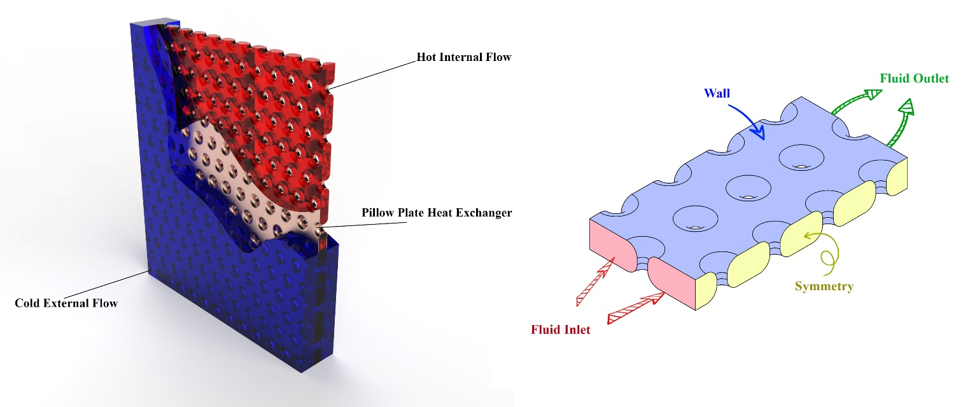

Figure . Geometry overview.

## 2.4 Numerical and evaluation methods

Various methods are available for simulating fluid flows and heat transfer. The Simple method, which has demonstrated high precision in numerous previous studies [28], is also employed in this research. Convergence criteria were set to a level of 10-6 to ensure accurate results.

Grid independence is a critical consideration in numerical simulations. The chosen mesh should not unduly influence the outcomes. Conversely, excessively fine grids can lead to increased computational costs and longer simulation times. To optimize the grid, a range of grid sizes was examined. Table 3 presents Nusselt numbers for different grid sizes. SP7.0 with an advanced meshing algorithm for structured grids is used in this research [29].

**Table 3.** The results of mesh study for pure water at Re= 3500

|  |  |  |  |  |  |  |  |  |  |  |  |  |
| --- | --- | --- | --- | --- | --- | --- | --- | --- | --- | --- | --- | --- |
| NL3 | | NL2 | | NL1 | | L3 | | L2 | | L1 | | Geometry type |
| Nu | Elements no. | Nu | Elements no. | Nu | Elements no. | Nu | Elements no. | Nu | Elements no. | Nu | Elements no. |
| 88.95 | 1245124 | 118.45 | 1234542 | 123.68 | 1245484 | 88.65 | 1235484 | 110.12 | 1236584 | 118.54 | 1254895 | Mesh 1 |
| 90.18 | 1354512 | 124.05 | 1345844 | 128.94 | 1345984 | 91.48 | 1486531 | 115.45 | 1364484 | 119.48 | 1324548 | Mesh 2 |
| 93.65 | 1456224 | 126.77 | 1453215 | 130.48 | 1453258 | 93.14 | 1564521 | 116.48 | 1436551 | 125.13 | 1456845 | Mesh 3 |
| **95.91** | **1565423** | **128.89** | **1568754** | **134.09** | **1568456** | **94.29** | **1598942** | **117.85** | **1598654** | **126.64** | **1578964** | **Mesh 4** |
| 95.96 | 1648543 | 128.93 | 1687563 | 134.18 | 1687984 | 94.31 | 1689753 | 117.89 | 1699465 | 126.73 | 1687954 | Mesh 5 |

In Figure 3 structured mesh is presented for L3 geometry.

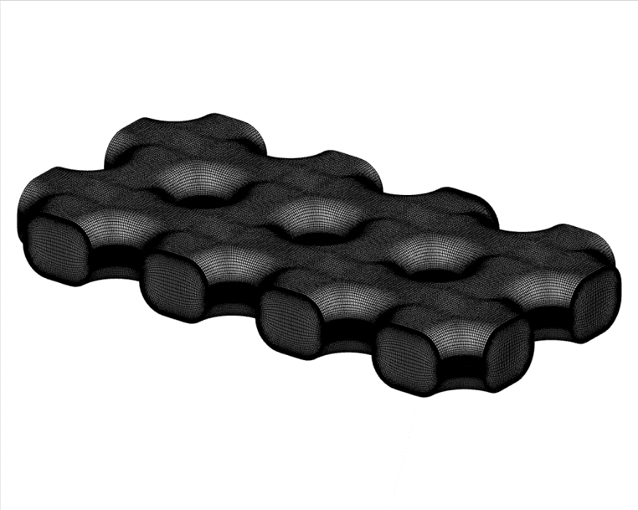

Figure . Mesh file of L3 geometry.

To ensure correctness and precision, the numerical findings were compared to experimental data. Specifically, a pillow-plate heat exchanger with varying Reynolds numbers, containing water, was compared to the findings reported by Tran et al. [30] findings. According to Figure 4, the given numerical results were in good agreement with the experimental results.



Figure . Comparison of Nu/Nomex number obtained in the simulation with experimental data [30] for Re= 1500, 2000, 4000, 6000 and 8000.

# 3. Results and discussions

In this section, an examination of heat transfer analysis, and flow components for a pillow plate heat exchanger is conducted employing the two-phase mixture method. Numerical results have been acquired across a range of Reynolds numbers, spanning from 3000 to 5000, with varying volumetric concentrations from 0% to 3%.

## 3.1. Effect of hole size on thermal performance

In this paper, a pivotal aspect of the research revolves around the examination of how hole size impacts the thermal and hydrodynamic performance of heat exchangers. Within the scope of this study, three distinct hole sizes were thoroughly investigated to elucidate the relationship between hole dimensions and thermal performance.

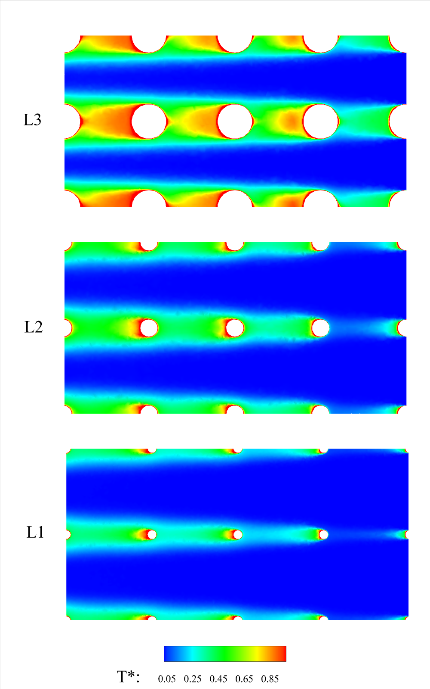

Figure . T* contours for pure water at Re= 3000 for different hole sizes.

Figure 5 illustrates the impact of varying hole sizes on the non-dimensional temperature, denoted as T*. In order to evaluate the performance of the pillow-plate heat exchanger, a non-dimensional temperature metric, T*, has been introduced. Equation 20 provides the formulation for calculating T*.

|  |  |
| --- | --- |
|  | (20) |

As per Equation (20), the optimal operating mode is achieved when the fluid temperature within the heat exchanger approaches the wall temperature, resulting in a T* value nearing 1.

Figure 6 displays the non-dimensional velocity for three distinct geometries. The non-dimensional velocity is defined by Equation (21).

|  |  |
| --- | --- |
|  | (21) |

As shown in Figure 6, the size of the recirculation region exhibits a proportional increase with the enlargement of the hole diameters. Notably, the figure indicates that the size of the recirculation region closely approximates the dimensions of the hole sizes. Additionally, the streamlines visibly illustrate the presence of circulation zones situated behind the holes, which exert a substantial influence on both pressure drop and heat transfer. This topic will be further elaborated upon in the subsequent section.

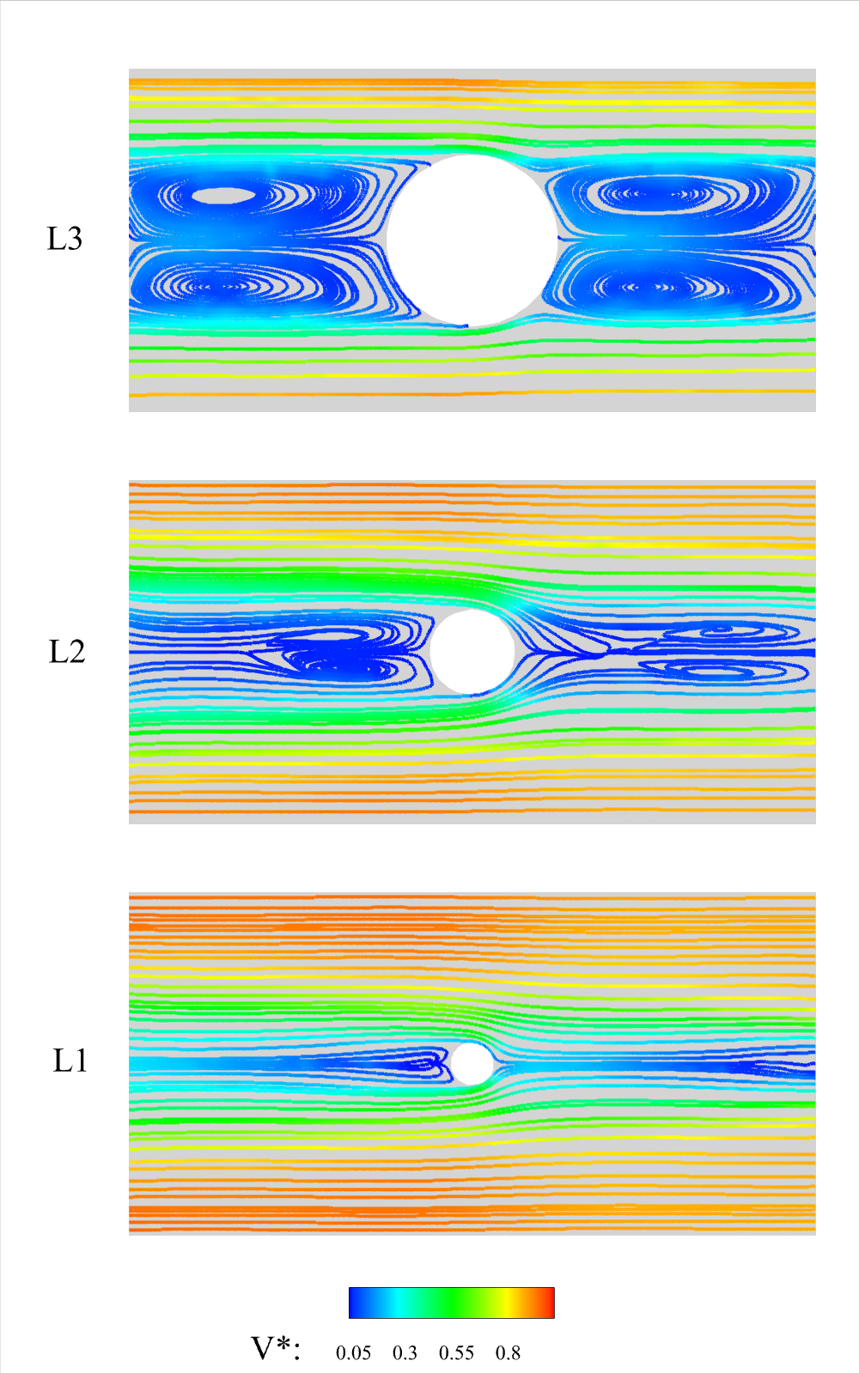

Figure . Streamlines for pure water at Re= 3000 for different hole sizes.



Figure . Nusselt number versus Reynolds number for different geometries.

As illustrated in Figure 7, the utilization of larger holes resulted in an increment of up to 25 percent in the Nusselt number. This observation underscores the notable impact of hole sizes on the design and performance of heat exchangers. Furthermore, Figure 7 reveals a positive correlation between the Nusselt number and the Reynolds number. As the Reynolds number escalates, the boundary layer diminishes in size, leading to heightened velocity and temperature gradients on the pipe wall, subsequently enhancing heat transfer rates.



Figure . P* versus Reynolds number for different geometries.

Figure 8 presents non-dimensional pressure for different geometries versus Reynolds number. As evident in Figure 8, in accordance with expectations, the L3 case exhibits the highest pressure drop. This outcome can be attributed to the presence of bigger holes in the L3 case, resulting in the partial occlusion of the fluid path within the pipe. Consequently, this restriction leads to an elevation in pressure drop, indicating an adverse impact on flow dynamics.

The graphical representation further highlights the similarity in pressure drop trends across various hole sizes concerning their response to changes in the Reynolds number. Specifically, the data indicates that with an increase in Reynolds number, the pressure drop consistently rises, underscoring the relationship between Reynolds number and increased pressure drop.

## 3.2 Effect of hole layout on heat performance

Another influential parameter in the performance of pillow plate heat exchangers is the hole layout. This section delves into an examination of two distinct hole layouts. As Figure 9 illustrates, non-linear hole layouts tend to exhibit larger hot zones. However, as evident from Figure 10, these layouts correspond to higher flow turbulence, ultimately enhancing heat transfer performance. This phenomenon is further corroborated by the data presented in Figure 11.

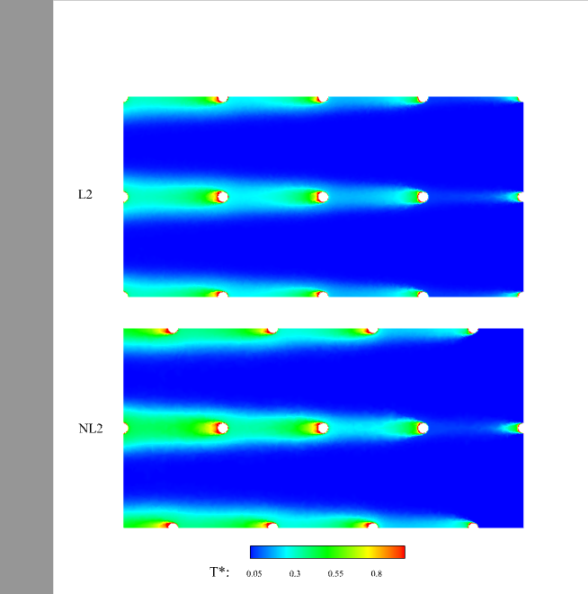

Figure . T* contours for pure water at Re= 3000 for different hole layout.

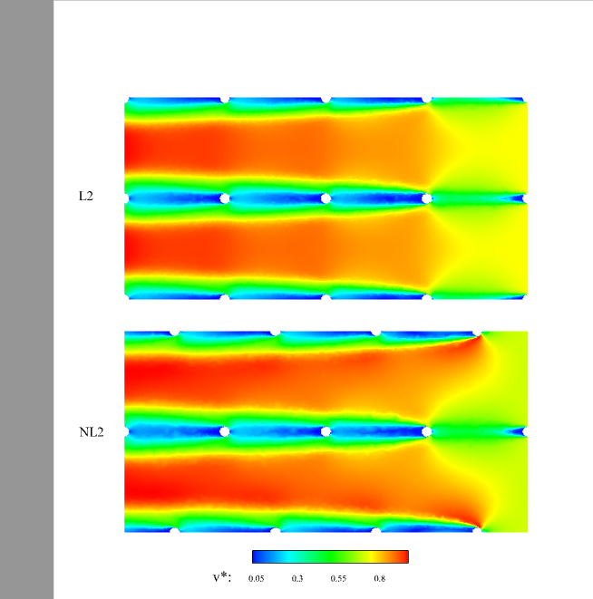

Figure . V* contours for pure water at Re= 3000 for different hole layout.

Figure 11 provides a visual representation of the Nusselt number versus Reynolds number for different hole layouts. As depicted in the figure, it becomes apparent that the choice of hole layout exerts a substantial influence on enhancing the Nusselt number. Notably, among the geometries with identical hole sizes, the non-linear hole layout geometry demonstrated a noteworthy increase in Nusselt number, reaching up to 25 percent, underscoring the significant impact of hole layout selection on heat transfer performance.



Figure . Nusselt number versus Reynolds number for different geometries.

This effect is attributed to the introduction of holes within the pillow-plate channels, which results in a pronounced deflection of the flow patterns and the emergence of secondary-flow phenomena, as evidenced in Figure 12. Near to these holes, the fluid pathway narrows significantly, introducing substantial flow resistance. Consequently, the fluid trajectory deviates radially away from the holes, giving rise to extensive recirculation regions in their wake.

In the case of the NL2 geometry, as depicted in Figure 12, the presence of holes causes a pronounced redirection of the primary flow, and the recirculation zones assume an approximately sinusoidal path. This intricate flow behavior contributes to an appreciable increase in pressure drop, a trend perceptible in Figure 13.

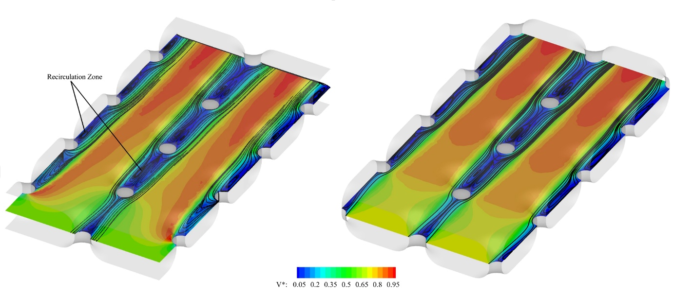

**Figure 12**. V* contours and streamlines for pure water at Re= 3000 for L2 and NL2.



Figure . Nusselt number versus Reynolds number for different geometries.

Passive methods, while effective, are often more costly as they necessitate alterations to the specifications of the heat exchanger. There are scenarios where modifying the heat exchanger specifications is either impractical or unfeasible, such as when a heat exchanger has been procured. In such instances, active methods become a viable approach to enhance the heat exchanger's efficiency.

One of the active, and cost-effective strategies for optimizing the performance of a heat exchanger involves the adjustment of its operating conditions. Achieving an optimal flow rate, ensuring suitable ambient temperature, altering the inlet temperature, and selecting the appropriate working fluid can all significantly enhance the heat exchanger's performance. Although, in many cases, the operating conditions and inlet temperature of the exchanger cannot be controlled, changing the working fluid of the exchanger remains a potent avenue for effecting substantial improvements in the heat exchanger's overall efficiency.

## 3.3 The effect of nanofluid use on exchanger performance

The base fluids employed in heat exchangers typically possess low thermal conductivity. To enhance the heat transfer coefficient of these working fluids, numerous researchers have explored the introduction of nanoparticles into the base fluid. In this particular study, the influence of using alumina particles on the water-based fluid utilized in the heat exchanger has been rigorously investigated. Figure 14, Figure 15, and Figure 16 present the Nusselt numbers as a function of Reynolds number, elucidating the effects of varying nanofluid concentrations.



Figure . Nusselt number versus Reynolds number for different volume fractions in the NL1 geometry.



Figure . Nusselt number versus Reynolds number for different volume fractions in the NL2 geometry.



Figure . Nusselt number versus Reynolds number for different volume fractions in the NL3 geometry.

As indicated by Figure 14 to Figure 16, the performance of the heat exchanger exhibits enhancement as the nanofluid concentration increases. The incorporation of nanoparticles into the fluid leads to an elevation in the fluid's thermal conductivity, subsequently bolstering heat transfer, as reflected in the observed Nusselt numbers. It is noteworthy that even a slight 1% increase in nanofluid concentration yields a remarkable up to 10% increase in the Nusselt number.

However, it is imperative to acknowledge that while heat transfer is positively affected by higher nanofluid concentration, the introduction of nanoparticles into the fluid concurrently increases its viscosity. This heightened viscosity directly contributes to an increase in pressure drop, a negative factor within heat exchangers. The escalation in pressure drop necessitates greater pumping force, leading to associated cost increments. Hence, a trade-off emerges between improved heat transfer and the associated elevated operational costs incurred due to heightened viscosity and pressure drop.



**Figure 17**. P* versus Reynolds number for different volume fractions in the NL1 geometry.

Figure 17 provides a visualization of the dimensionless pressure drop versus Reynolds number at various nanofluid concentrations for the NL1 geometry. As evident from the figure, an increase in nanofluid concentration, and the resultant rise in fluid viscosity, leads to a notable increase in pressure drop. Furthermore, it is noteworthy that pressure drop also rises in direct correlation with increasing Reynolds number.

## 3.4. Data-driven optimization

In this study, the initial focus was on utilizing CFD simulation to create a comprehensive dataset outlining the performance of the heat exchanger. The CFD model was instrumental in simulating various design configurations and provided results for critical parameters. These simulations served as the foundation upon which the subsequent optimization efforts were built.

To enhance the optimization process and alleviate computational demands, an artificial intelligence (AI) model is used. The primary objective of this AI model was to predict two crucial parameters: HTC and pressure drop, based on the input design variables. The chosen AI model for this predictive task was the Random Forest Regressor (RFR) [31].

The RFR was selected for its proficiency in handling regression tasks and its ability to capture intricate, nonlinear relationships within the dataset. It was trained on the extensive dataset generated through CFD simulations, thus enabling it to provide precise predictions of HTC and pressure drop for various heat exchanger designs.

The development of the AI model for predicting HTC and pressure drop began with a meticulous selection and definition of the input variables. These variables were chosen to represent essential attributes of the heat exchanger design, including geometric features and operating conditions. Input variables encompassed hole geometry, nanofluid volume concentration, and Reynolds number, all carefully chosen due to their profound influence on heat exchanger performance. The model’s input and output variables, along with the associated error, are detailed in table 4.

**Table 4.** Model variables and associated error.

|  |  |  |
| --- | --- | --- |
| Model | Random forest regressor | |
| Input variables | Hole layout, r1, r2, φ, Re | |
| Output variables | Toutlet, P*, HTC, voutlet | |
| Model parameters | n_estimators | 100 |
| Random_state | 42 |
| error | Mean absolute err. | 0.92 |
| Mean squared err. | 4.67 |
| Root mean squared err. | 2.16 |
| R-squared | 0.93 |

RFR serves as an ensemble learning technique that amalgamates multiple decision trees to provide accurate predictions. Each decision tree in the ensemble is constructed through iterative data splits, ultimately leading to a leaf node where predictions are made. By aggregating the results from these individual trees, the RFR model leverages the independence of errors among them, culminating in robust and accurate predictions. Pertinent parameters in the model, such as 'n_estimators' (representing the number of decision trees) and 'random_state' (ensuring consistency), were meticulously configured to optimize predictive performance. Figure 18 shows the algorithm in this model.

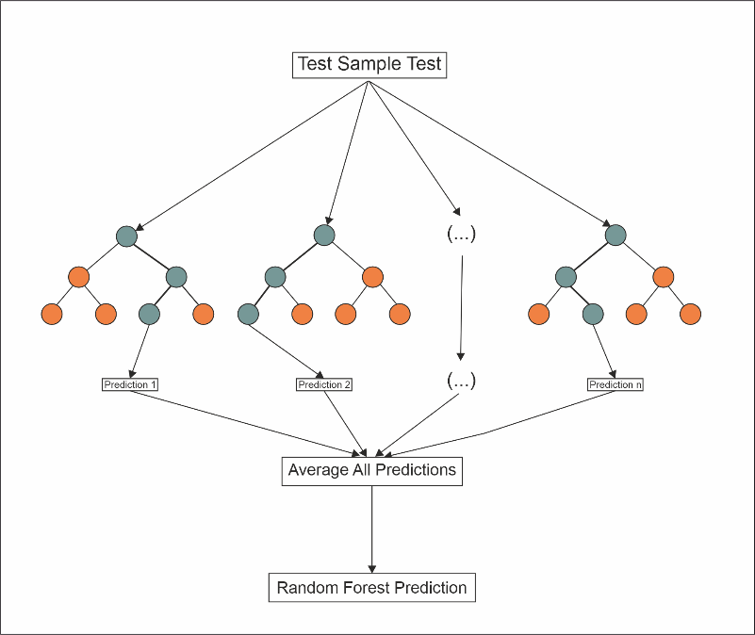

**Figure 18**. Random forest regressor algorithm.

By harnessing an AI model, the research conducted an optimization procedure to refine the geometric design parameters. This involved employing a systematic grid search method, fine-tuning the heat exchanger's configuration. The parameter space explored during this process included key variables such as r1, r2, nanofluid volume concentration, and Reynolds number. The aim was to identify the most favorable combination of these design parameters, maximizing HTC while minimizing pressure drop. To ensure the viability of the design, a well-balanced approach was maintained by assigning weights to HTC and P*. Subsequently, the model's predictions were tested for their validity by conducting CFD simulations, a critical step to cross-verify the optimization results with actual CFD data. The entire optimization and validation procedure is depicted in Figure 19. This comprehensive approach not only significantly reduced computational resources and time requirements but also effectively realized the desired design objectives.

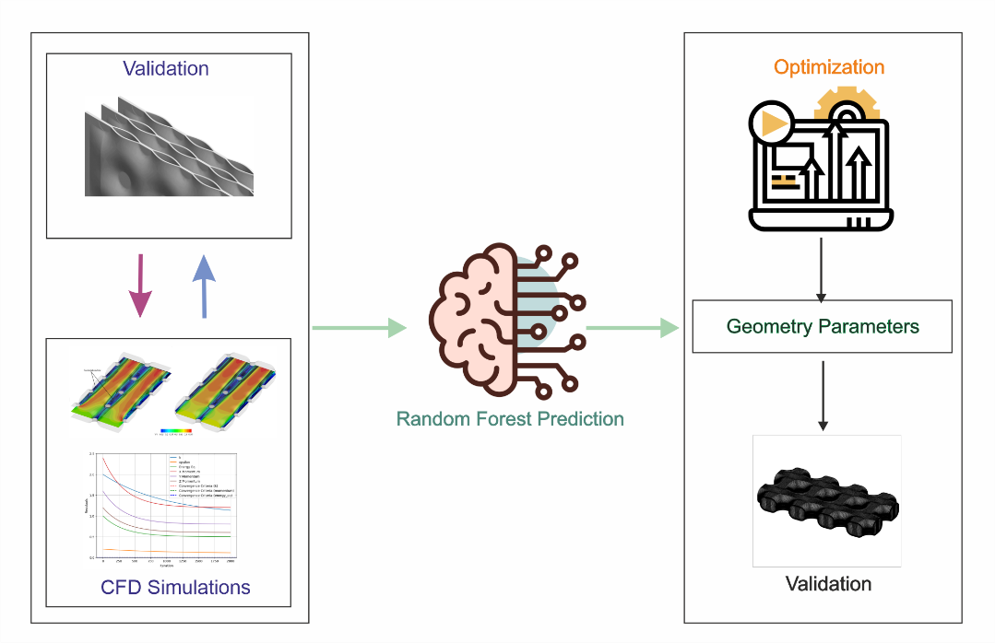

**Figure 19**. Procedure for AI-Driven Optimization and CFD Validation of Heat Exchanger Design Parameters.

The parameter correlation heatmap, as demonstrated in Figure 20, provides insights into the relationships between various design parameters in the heat exchanger optimization process. The heatmap showcases the strength and direction of correlations between parameters, aiding in the identification of influential factors. Notably, the heatmap reveals that HTC exhibits a positive correlation of 0.70 with P* and 0.67 with Re. Furthermore, a correlation of 0.57 is observed between HTC and nanofluid volume concentration. In contrast, HTC demonstrates a negative correlation with the r1 at -0.22 and r2 at -0.25. For P*, it displays a robust positive correlation of 0.70 with HTC, 0.71 with Re, and 0.54 with φ, while maintaining relatively weaker positive correlations with r1 and r2, with values of 0.21 and 0.22, respectively.

**Figure 20**. Parameter correlation heatmap.

Figure 21, depicting the results of the comprehensive optimization process, offers a clear visualization of the trade-offs in heat exchanger performance. This scatter plot highlights the relationship between HTC and P*, two key performance metrics. What's notably striking in the plot is the distinct presence of a Pareto line, which elegantly separates the optimized points from the non-optimal ones. The Pareto line signifies the boundary where further improvements in HTC can only be achieved at the expense of increased pressure drop, and vice versa. This graph serves as a valuable tool for design decision-making, enabling pinpointing the optimal design configurations by balancing the essential trade-offs between HTC and P* for efficient and effective heat exchanger design.

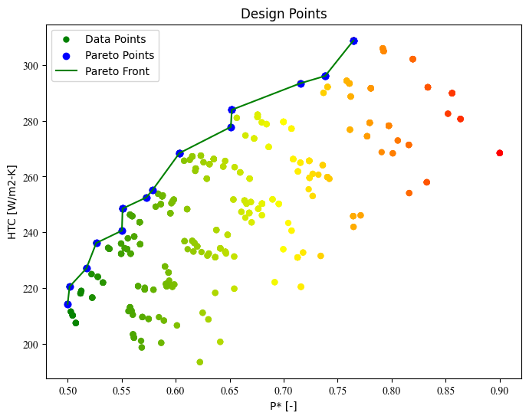

**Figure 21**. Scatter plot showing optimization results and pareto front.

After finishing the optimization process, a verification step was undertaken to assess the accuracy and reliability of the optimized Pareto Points. This was achieved through a CFD simulation conducted on Pareto Points to compare the predicted and actual results. The outcome was a thorough examination of the predictive capabilities of the AI model. The precision of these predictions was reaffirmed as the error, thoughtfully detailed in Table 4, indicated a good agreement between CFD and AI model: the error remained consistently less than 5%. This congruence between the predicted and actual results further strengthens the trustworthiness and applicability of the AI model in optimizing heat exchanger design, thereby offering a compelling avenue for future advancements in heat exchanger engineering.

**Table 4.** Optimization results vs CFD results.

|  |  |  |  |  |  |  |  |  |
| --- | --- | --- | --- | --- | --- | --- | --- | --- |
| **Results from Optimization** | | | | | |  | **CFD Results** | |
| **r1 (mm)** | **r2 (mm)** |  | **Re** | **HTC [W/m2.K]** | **P\*** |  | **err. HTC [%]** | **err. P* [%]** |
| 25 | 125 | 0.02 | 3500 | 255.1079 | 0.5785 |  | 2.62 | -1.98 |
| 25 | 125 | 0.01 | 4000 | 252.4526 | 0.572619 |  | -0.17 | 5.15 |
| 25 | 100 | 0 | 3500 | 227.0102 | 0.517353 |  | 0.03 | -4.15 |
| 25 | 125 | 0.01 | 4500 | 265.6777 | 0.607828 |  | -0.56 | -2.59 |
| 25 | 100 | 0.02 | 4000 | 266.0003 | 0.613052 |  | 0.28 | 0.64 |
| 25 | 125 | 0.01 | 3000 | 220.4693 | 0.501797 |  | -3.73 | -4.36 |
| 25 | 100 | 0 | 5000 | 265.6102 | 0.645832 |  | 3.89 | -2.05 |
| 25 | 125 | 0.02 | 3000 | 235.938 | 0.549503 |  | 3.53 | -0.09 |
| 25 | 100 | 0.02 | 3500 | 255.1079 | 0.5785 |  | -1.40 | 0.66 |
| 25 | 100 | 0.04 | 5000 | 308.9095 | 0.764645 |  | -0.01 | 3.23 |
| 25 | 125 | 0 | 3500 | 227.0102 | 0.517353 |  | 3.31 | 2.33 |
| 25 | 100 | 0 | 4000 | 240.5783 | 0.550246 |  | -2.52 | 5.06 |
| 25 | 100 | 0.01 | 4000 | 252.4526 | 0.572619 |  | 3.15 | 4.17 |
| 25 | 125 | 0 | 4500 | 253.8293 | 0.583698 |  | 1.47 | -3.07 |

Although the pressure drops increase with increasing nanofluid concentration, the choice of the optimal mode depends on the application of the exchanger. In cases such as reactors and sensitive systems where there is an urgent need to control the system temperature, thermal efficiency is more critical, and pumping cost is less important. The heat exchanger is very important in these applications.

# 4. Conclusion

The present study represents a comprehensive two-phase numerical study on the performance of a pillow-plate heat exchanger, with specific focus on heat exchangers featuring both linear and non-linear hole configurations and utilizing fluids with varying nanofluid concentrations. This research has sought to elucidate the impact of nanofluids, hole size, and hole arrangement on heat exchanger performance. The salient findings of this study are distilled as follows:

* The utilization of heat exchangers featuring larger holes leads to a notable improvement in Nusselt numbers and consequently enhances heat transfer efficiency. For instance, the transition from model L1 to L3 configurations yielded a substantial 25% increase in Nusselt numbers.
* It is imperative to recognize that augmenting the size of the holes also results in elevated pressure drop. The L3 geometry, when contrasted with the L1 geometry, exhibited a pressure drop increase of approximately 27%.
* Heat exchangers characterized by linear hole layout demonstrate lower pressure drops in comparison to their non-linear counterparts. This difference is about 20%
* Heat exchangers featuring non-linear hole configurations exhibit higher Nusselt numbers, denoting a superior heat transfer performance in comparison to heat exchangers with linear hole arrangements.
* The use of nanofluids as working fluids enhances heat transfer. A mere 1% increase in nanofluid concentration led to a significant up to 10% improvement in Nusselt numbers.
* However, the incorporation of nanoparticles also contributes to augmented pressure drops by elevating the fluid's viscosity. A 1% increase in nanofluid concentration leads to an approximate 7% increase in pressure drop.

These findings collectively underscore the intricate interplay of parameters affecting heat exchanger performance, thereby shedding light on the nuances of optimizing heat transfer efficiency while navigating the associated trade-offs, an essential endeavor in heat exchanger engineering.

# References

[1] Cuan Z and Chen Y 2023 Evaluating two-phase fluid flow and heat transfer in pillow-plate heat exchangers with nanofluids for organic Rankine cycle in municipal solid waste power plant: A numerical simulation study *Eng Anal Bound Elem* **155** 814–25

[2] Trafczynski M, Markowski M and Urbaniec K 2023 Energy saving and pollution reduction through optimal scheduling of cleaning actions in a heat exchanger network *Renewable and Sustainable Energy Reviews* **173** 113072

[3] Cuan Z and Chen Y 2023 Evaluating two-phase fluid flow and heat transfer in pillow-plate heat exchangers with nanofluids for organic Rankine cycle in municipal solid waste power plant: A numerical simulation study *Eng Anal Bound Elem* **155** 814–25

[4] Saedodin S, Zaboli M, Rostamian S H and Kharabati S 2023 Statistical analysis and shape optimization of a finned corrugated heat exchanger using RSM *Chem Eng Commun* **210** 716–39

[5] Arsenyeva O, Piper M, Zibart A, Olenberg A and Kenig E Y 2019 Investigation of heat transfer and hydraulic resistance in small-scale pillow-plate heat exchangers *Energy* **181** 1213–24

[6] Suresh S, Venkitaraj K P, Selvakumar P and Chandrasekar M 2012 A comparison of thermal characteristics of Al2O3/water and CuO/water nanofluids in transition flow through a straight circular duct fitted with helical screw tape inserts *Exp Therm Fluid Sci* **39** 37–44

[7] Suresh S, Venkitaraj K P and Selvakumar P 2011 Comparative study on thermal performance of helical screw tape inserts in laminar flow using Al2O3/water and CuO/water nanofluids *Superlattices Microstruct* **49** 608–22

[8] Amanowicz Ł 2018 Influence of geometrical parameters on the flow characteristics of multi-pipe earth-to-air heat exchangers – experimental and CFD investigations *Appl Energy* **226** 849–61

[9] Karimi A and Afrand M 2018 Numerical study on thermal performance of an air-cooled heat exchanger: Effects of hybrid nanofluid, pipe arrangement and cross section *Energy Convers Manag* **164** 615–28

[10] Jadhav P H, Gnanasekaran N and Mobedi M 2023 Analysis of functionally graded metal foams for the accomplishment of heat transfer enhancement under partially filled condition in a heat exchanger *Energy* **263** 125691

[11] Zeinali S and Neshat E 2023 Energy, exergy, economy analysis and geometry optimization of spiral coil heat exchangers *Case Studies in Thermal Engineering* **42** 102708

[12] Karimi A, Al-Rashed A A A A, Afrand M, Mahian O, Wongwises S and Shahsavar A 2019 The effects of tape insert material on the flow and heat transfer in a nanofluid-based double tube heat exchanger: Two-phase mixture model *Int J Mech Sci* **156** 397–409

[13] Arsenyeva O, Tran J, Piper M and Kenig E 2019 An approach for pillow plate heat exchangers design for single-phase applications *Appl Therm Eng* **147** 579–91

[14] Yao Y, Ding J, Zhang Y, Wang W and Lu J 2022 Heat transfer performance of pillow plate heat exchanger with molten salt and supercritical carbon dioxide *Int J Heat Mass Transf* **183** 122211

[15] Mastani Joybari M, Selvnes H, Sevault A and Hafner A 2022 Potentials and challenges for pillow-plate heat exchangers: State-of-the-art review *Appl Therm Eng* **214** 118739

[16] Piper M, Olenberg A, Tran J M and Kenig E Y 2015 Determination of the geometric design parameters of pillow-plate heat exchangers *Appl Therm Eng* **91** 1168–75

[17] Tran J M, Sommerfeld S, Piper M and Kenig E Y 2015 Investigation of pillow-plate condensers for the application in distillation columns *Chemical Engineering Research and Design* **99** 67–74

[18] Kumar S, Premachandran B and Subbarao P M V 2019 Study on thermo–hydraulics in a Pillow Plate Channel *International Journal of Thermal Sciences* **145** 106020

[19] Nuim Labib M, Nine M J, Afrianto H, Chung H and Jeong H 2013 Numerical investigation on effect of base fluids and hybrid nanofluid in forced convective heat transfer *International Journal of Thermal Sciences* **71** 163–71

[20] Mojarrad M S, Keshavarz A and Shokouhi A 2013 Nanofluids thermal behavior analysis using a new dispersion model along with single-phase *Heat and Mass Transfer/Waerme- und Stoffuebertragung* **49** 1333–43

[21] Naumann Z and Schiller L 1935 A drag coefficient correlation *Z. Ver. Deutsch. Ing* **77** e323

[22] Moraveji M K and Ardehali R M 2013 CFD modeling (comparing single and two-phase approaches) on thermal performance of Al2o3/water nanofluid in mini-channel heat sink *International Communications in Heat and Mass Transfer* **44** 157–64

[23] Siginer D A and Wang H P 1995 Developments and applications of non-Newtonian flows 1995. Proceedings of a conference, San Francisco, November 1995 *[No source information available]*

[24] Kakaç S and Pramuanjaroenkij A 2009 Review of convective heat transfer enhancement with nanofluids *Int J Heat Mass Transf* **52** 3187–96

[25] El Bécaye Maïga S, Palm S J, Nguyen C T, Roy G and Galanis N 2005 Heat transfer enhancement by using nanofluids in forced convection flows *Int J Heat Fluid Flow* **26** 530–46

[26] Menter F R Two-equation eddy-viscosity turbulence models for engineering applications *AIAA Journal* **32** 1598–605

[27] Asadi A, Asadi M, Rezaniakolaei A, Rosendahl L A, Afrand M and Wongwises S 2018 Heat transfer efficiency of Al2O3-MWCNT/thermal oil hybrid nanofluid as a cooling fluid in thermal and energy management applications: An experimental and theoretical investigation *Int J Heat Mass Transf* **117** 474–86

[28] Wang Z, Wang R, Li Z, Wang M and Wan L 2023 Numerical investigation on the effect of cylindrical turbulator on performance of corrugated plate-fin heat exchanger *Appl Therm Eng* **230** 120726

[29] Company P D 1989 GridPro v7.0SP1

[30] Tran J M, H X and Kenig E Y 2015 Experimentelle Untersuchung des konvektiven Wärmeübergangs und Druckverlustes in einphasig durchströmten Thermoblechen. (Experimental investigation of convective heat transfer and pressure drop in pillow plates under single-phase through-flow conditions) *Chemie Ingenieur Technik* **87** 226–34

[31] Pedregosa F, Varoquaux G, Gramfort A, Michel V, Thirion B, Grisel O, Blondel M, Prettenhofer P, Weiss R, Dubourg V, Vanderplas J, Passos A, Cournapeau D, Brucher M, Perrot M and Duchesnay É 2011 Scikit-learn: Machine Learning in Python *Journal of Machine Learning Research* **12** 2825–30