W-beam Guardrail Crash Analysis and Evaluation using Finite Element Method

Y. S. LERABO1 and H. S. HABTE 2,*

1,2Addis Ababa University, Ethiopia

*haileleoul.sahle@aait.edu.et

**Abstract:** Guardrails are highly recommended to be erected in the median and side corner of a highway road to secure vehicle accidentally loss it track, supports the safety of the vehicle driver and passenger from catastrophic accidents. The design and constructions of different guardrails are done confirming standard to retain their performance that related to energy absorption capacity. Besides, damaged guardrails that compromise their performance are seen in highways due to poor maintenance or repair. This study was conducted to investigate the structural integrity of W-beam guardrail damage. An impact test which leads to non-linear material deformation behavior was simulated using commercially available software, ABAQUS. The geometrical models of the guardrail were modeled adopting AASHTO standard, and a representative Jeep truck used to impact the guardrail at 90o with 42.26km/hr speed. The non-conforming W-beam guardrail was modeled considering a loss connection of supporting leg with the W-beam. Results of the study showed that the structural integrity of the damageed guardrail is affected as the internal and plastic energy was decreased from the W-beam guardrail without damage. More, the damaged W-beam was displaced more, by 14.15%, to the restricted area as compared to the W-beam guardrail without damage.

**Keywords:** Crash simulation, non-conforming W-beam guardrail, dynamic explicit FEA.

1. **Introduction**

Road traffic accident (RTA) is one of the causes for human life threatening problems for different citizens especially in developing counties and also leads to traffic jamming on highway and results for huge economic losses. A report on RTA has shown that the death of rate pedestrians followed by passengers and drivers dynamically increased.

To reduce the risks of drivers and pedestrian, different road side guardrail are used. The guardrails usually design and constructed following regulation set by countries that their design and manufacturing categorized under flexible, semi-rigid or rigid in relation to the road location risk. Standard risk management is used test the quality of the guardrail taking an evaluation criteria; structural adequacy, occupant risk, and Post-Impact vehicular trajectory [1], [2], [3].

In the study of the performance or innovation on guardrail, researcher follows experimental, analytical and numerical simulation for guardrail performance tests. Besides, the experimental investigation of guardrail crashworthiness performance required complex test set-up and costly operation investment owing to the destructive operation; hence number researcher used FEA using commercial software like ABAQUS and LS-DYNA to simulate the complex nonlinear impact behavior of guardrail with different vehicle types. Martin and Wekezer [4] conducted a validation for numerical approach for full-scale crash impact to supplement the highway roadside safety hardware (guardrail) test, where the research result shows that the nonlinear explicit dynamic FE code using LS DYNA supplements the experimental test. And more, the finite element method for road safety guardrail, W-beam guardrail, crash test adopting the European standard EN 1317 supports to comply as alternative option of test standard proposed by the AASHT, Teng et al., [5]. Paweł and Sebastian [6] used FEA code on LS-DYNA for simulating the road guardrail subjected to a bus crash to investigate the effective material modeling of the guardrail. They have considered three zones guardrail model, their material properties characterized by different constants to comply with the real one, and their results shows a close match to the experimental ones. Ren and Vesenjak [7] conducted a nonlinear elastic-plastic dynamic crash simulation for designing a new roadway guardrail and result closely matches to the experimental one.

Nevesa et al. [8] in their investigation on the performance of flexible and rigid road guardrails to vehicle impact according to test TB11 from EN 1317 standard showed that the flexible guardrail is much safer than the concrete guardrail. Amirarsalan et al. [9] have investigated the effective impact variables for both flexible and rigid barriers, the hight of the barriers yield as the main parameter to influence the efficiency of the barriers. Teng et al. [5] develop a finite element analysis for W-beam guardrail using Euroapean standard EN 1317 which the research was validated with experimental tests. The same authors identified the effect of different space for W-beam barrier using numerical simulation apporach [10].

However, roadside guardrails can be observed with non-confirming construction due to poor construction processes or poor maintenance provision after they are damaged or long term of operations. As can be seen from Figure 1 (a), the w-beam supports the leg bend and loss of the connections with the beam, which potentially leads to sagging for the vehicle during post collision period. And in Figure 1(b), the joint connection between these two different types of guardrails is not constructed using the conforming guardrail assembling and installation procedure [2].

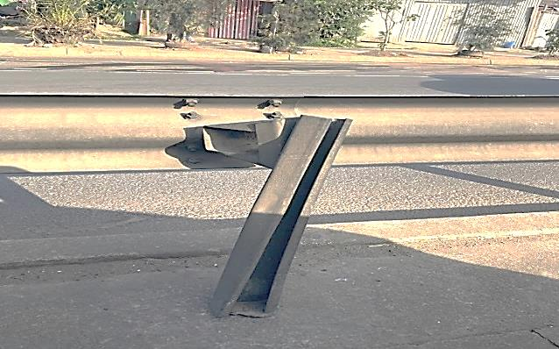

(a) Damaged spacer and support of W-beam guardrail

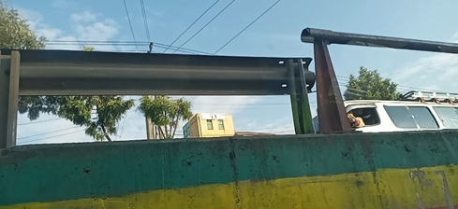

(b) Loss connectivity between guardrails

**Figure 1. W-beam guardrail without proper maintenance and construction**

For W-beam guardrail which is very popular among the flexible guardrail category, countries are following their supervision and maintenance procedure for maintaining the good conditions of the guardrails. Following the site supervision and the status of the damage conditions, damage category between low to high severity, maintenance and/or replacement recommended. It is evident that with the low rate for maintaining or replacing the damaged guardrails in urban and rural streets, this condition promotes a catastrophic accident when it crash happened at these areas once again.

The objective of this study is to investigate the crashworthiness performance of damaged deformable guardrails using nonlinear finite element analysis adopting a numerical simulation on vehicle crash on deformable guardrail. For the numerical simulation a W-beam representing the deformable guardrail, guardrail and a Pickup, Jeep, use to represent the crashing body.

1. **Method and Material** 
   1. *Method*

According to AACRA’s standard, level 3 test model for guardrail structural adequacy for urban area was adopted. MASH 2016 manual test level 3 recommended a pickup truck with the weight of 2.27 Tonne impact the guardrail at impact angle 25o with maximum speed 100k/hr [12], [13]. The guardrail structural adequacy and occupant risk was considered as main evaluation criteria which were done by evaluating the deformation of the guardrail and energy absorption.

The deformable guardrail material and geometrical data were adopted from the AASHTO. This study considered two cases to represent damageed deformable guardrail, where the first case considered the deformable guardrail losses it support column connection with ground, and the second considered a lose connection between beam to beam in longitudinal segment arrangement. The selected model of damage W-beam guardrail represents the mild sever damage (Category 2) that observed in field when a proper maintenance failed to be done after a damage occur on the guardrail[15].

Since the standard longitudinal segment W-beam guardrail length is 30m which required minimum five segments for performance test, this study consider two segments to represent the second damaged guardrail.

Common guardrail evaluation conditions are related with holding a vehicle at collision period, proper workable space after crash and safety of the occupant at crash period. The evaluation criteria are summarized with set safety levels related with the impact severity, containment level and deformation of the guardrail [5], [10].

* 1. *Material*

The study considered the standard flexible/deformable guardrail, W-beam, which is constructed and assembled in urban and rural dangerous vehicle pathways to protect vehicle not to overpass their track to the other side.

The specification of the W-beam guardrail specification was adopted from AASHTO. This guardrail type is developed using special steel structures, like MIT 180. The beam has a W-shape profile with an overall dimension of (310 x 3 x 4,128) mm and the support leg is designed with a C shape profile with an overall dimension of (150 x 5 x 1,820) mm, length o 1120mm is expected to be earthen. For assembling the beam with the support leg, a steel connector with an overall dimension (150 x 5 x 350) mm is used. Figure 2 illustrates a single segment W-beam guardrail assembled on three legs whose center-to-center distance is 1,905.0mm.

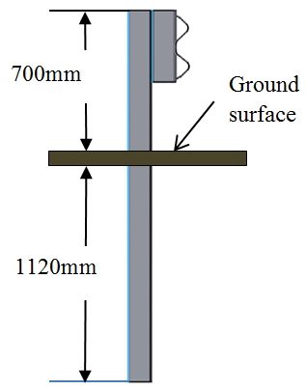 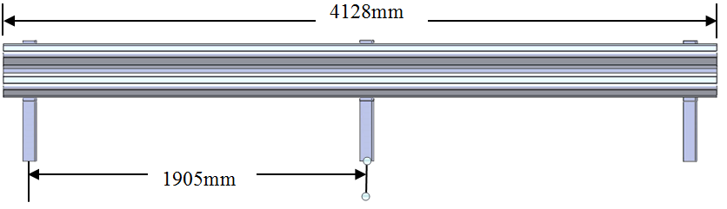

(a) (b)

**Figure 2.** Single segment W-Beam guardrail (a) side view and (b) front view

The study considers a special steel material AASHTO MIT 180 which is one of the standard materials adopted in manufacturing the W-beam guardrail. The elastic material behavior is depicted in Table 1 while to capture the plastic behavior of the special steel structure, a Johnson-Cook material model is adopted, and its constants are listed in Table 2.

**Table 1.** Material behavior of W-Beam guardrail parts [14]

|  |  |  |  |  |
| --- | --- | --- | --- | --- |
| Material | Density ( t/mm3) | Modulus of Elasticity ( MPa) | Yield strength (MPa) | Poisson’s ratio |
| Special steel MIT 180 | 7.813e-9 | 2.00e3 | 419.0 | 0.29 |

1. **Finite Element Analysis**

This study used a non-linear dynamic explicit FEA considering the deformation process following the impact load will be elastic-plastic. For the selected FEA approach, the guardrail parts were modeled as deformable bodies and the vehicle as rigid body. Parts of the guardrail were modeled as shell considering the thickness is small compared with other geometrical data. Adopting Test 3 of MASH standard, the full longitudinal arrangement was modeled using five segments to get 30m length [11], Figure 3.

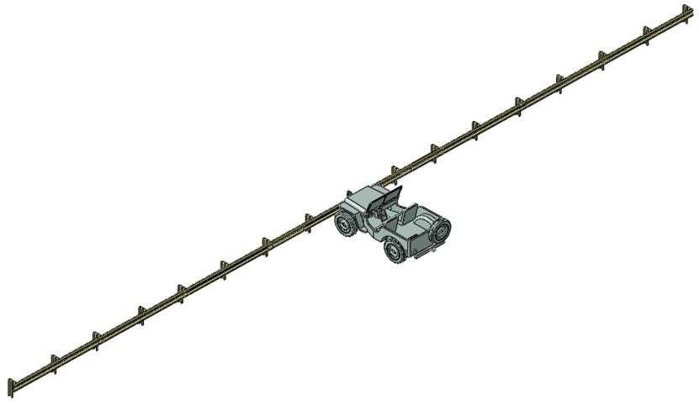

**Figure 3.** W-beam segments with Jeep truck impact orinted at 90o.

The first and second conditions for damaged W-beam guardrail are depicted in Figure 4, which the condition consider for support leg losses its connection to ground, hence a model of W-beam where a support leg removed was used to represent damage, see Figure 4.

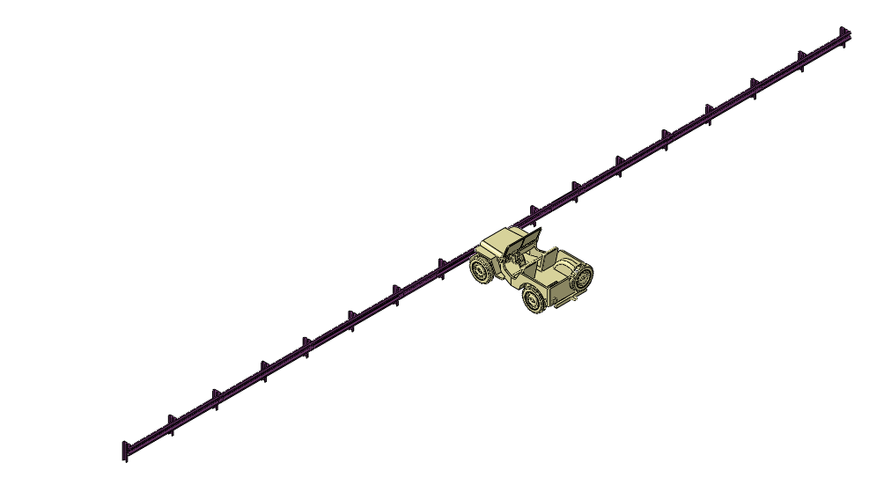

**Figure 4.** W-beam guardrail with Single Support leg removed, SSupport damage.

For representing the impacting body, a medium scale vehicle for impact test, Jeep, was used, Figure 5. Model effective impact height and front bumper geometry (1,440mm) meets the interest of the research as suggested in MASH. The model is imported from free-access CAD models [3]. The mass of the Jeep used 2.27tonne.

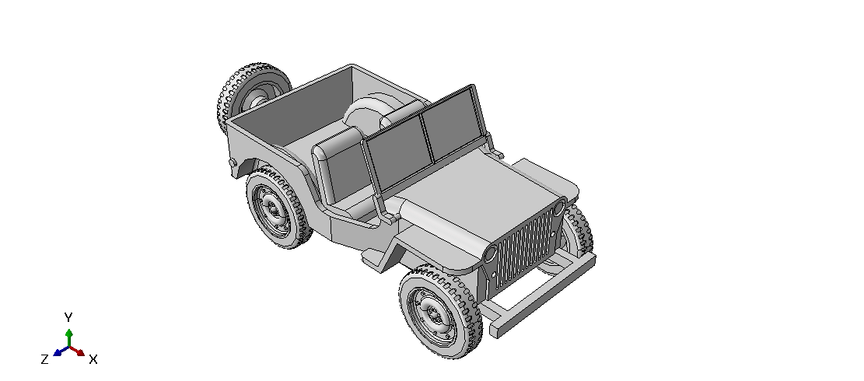

**Figure 5.** Jeep truck to represent Vehicle model.

The crash simulation targeted an elastic-plastic material behavioral change. Hence, the elastic and plastic behavior of the selected material was defined in ABAQUS. To model the plastic behavior of the W-beam guardrail material, Johnson-Cook non-linear material modeling equation was adopted. Its material constants are listed in Table 2. For the Johnson-Cook model, the effect of temperature is neglected for this study.

$σ=\left[A+Bε^{n}\right].\left[1+Cln\left(\frac{ε^{.}}{ε_{0}}\right)\right].\left[1-\left(\frac{T-T_{0}}{T_{m-}T_{0}}\right)\right]$…………………… (1)

Where:- $σ:stress$, A: Yield Stress, B: Hardening constant, C: Hardening coefficient, $n$: Hardening exponent, ${ ε}^{.}$:strain rate, $ε:$ strain $T_{m}:$ Melting Temperature, $T_{0 }:$ Transition Temperature, $m:$ Thermal Softening exponent.

**Table 2.** Johnson-Cook Parameters for Special steel [14].

|  |  |  |  |
| --- | --- | --- | --- |
| **Material Property** | **Symbol** | **Value** | **Unit** |
| Yield Stress | $$A$$ | 792 | MPa |
| Hardening constant | $$B$$ | 510 | MPa |
| Hardening exponent | $$n$$ | 0.26 |  |
| Thermal Softening exponent | $$m$$ | 1.03 |  |
| Melting Temperature | $$T_{m}$$ | 1793 | K |
| Transition Temperature | $$T_{room}$$ | 293 | K |

The time increment ${ T}_{cr}$ was estimated by eqn. (2),[2]

$T_{cr}=\frac{l}{\sqrt{c_{d}}}=l*\sqrt{\frac{δ}{E}}$…………………… (2)

Where: $c_{d}:$– Material property, $l:$ the smallest element dimension, E - Young’s modulus, $δ$- Density

Using equ. (2) the minimum time increment was estimated to get reliable simulation result, where the geometrical values of mesh element and material data of the W-beam was used, the time increment for analyzing the W–beam under dynamic impact model yields approximately 2.62E-6s. The total of 0.08 step time was used for the dynamic explicit. The increment time was chosen automatically and the stable increment estimator was selected globally. The maximum time increment was selected as unlimited with a time scaling factor of 1.

To define the interaction between deformable self-surface contact and contact between rigid and the deformable bodies, a general contact was defined. The penalty algorism was selected to specify the coefficient of friction, μ=0.35, and hard contact to assert zero relative motion between surface after contact. The bolt and nut joints to connect guardrail in serious were not considered as a single entity for the guardrail rather a tie constraint was adopted for the connections.

The deformable bodies were discretized with reduced shell element, S4R. Fine mesh size was focused on the areas where the rigid body in contact first and to the area where the rigid bodies complete displaced for defined analysis period. The mesh sizes for deformable bodies were optimized to achieve the mesh convergence that would supports to get reliable results. As it can be seen in the Figure 6, the fined element size was 15mm seen in center of the guardrail and the larger element size was 210mm. The rigid body was discretized with R3D4 solid element, and the minimum element size was 100mm.

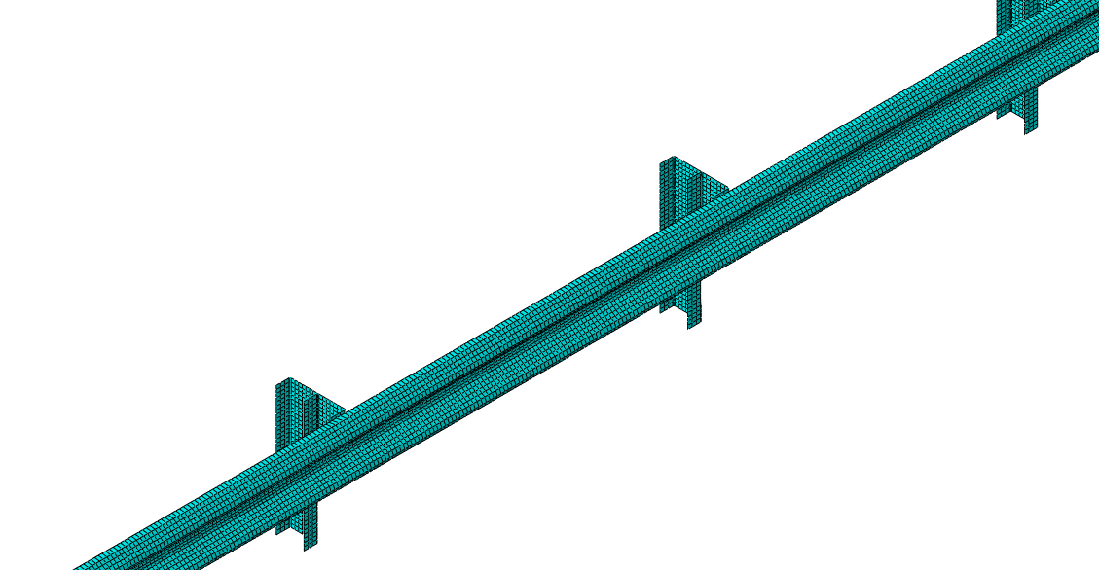

**Figure 6:** Discretized W-beam segment

The boundary conditions were defined using a connection between the W-beam support with the ground and the impact inertia condition. With the consideration of that 1120mm of the support length are embedded and casted, an Encastered constraint condition. Supporting legs lower nodes were constrained with a rigid point to act as a rigid connection, see Figure 7.

For the impacting inertia, zero angle impact orientation was used for the study. The Jeep truck was targeted to impact the W-beam in full front face with a vehicle speed of 42.26km/hr which is 90 degree vehicle impact speed of 100km/hr. The vehicle impact speed magnitude is adopted from MESH standard.

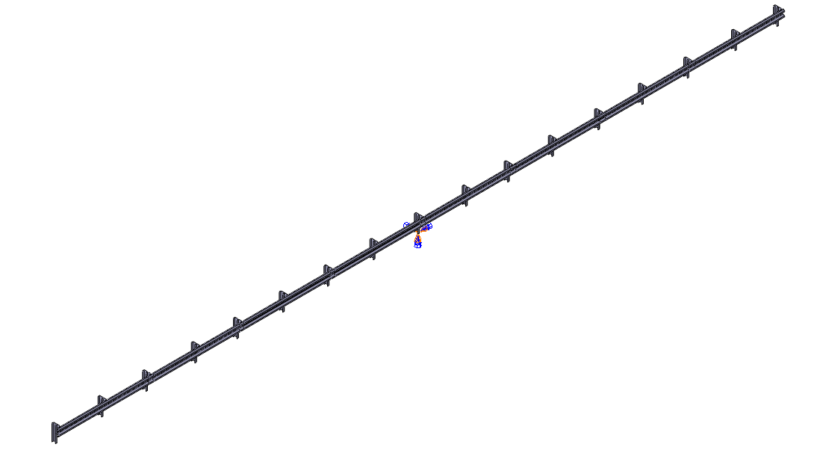

**Figure 7:** The fixed boundary condition applied to Rigid point constrained in rigid body form to lower nodes of support legs

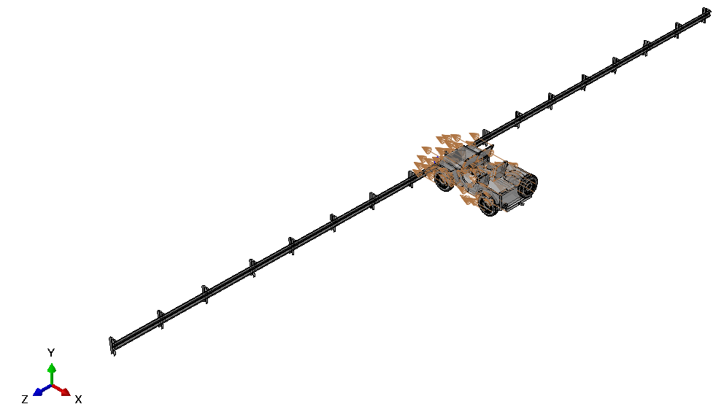

**Figure 8.** Impact speed orientation of the Jeep truck

1. **Result and discussion**

W-beam guardrail is one of the popular guardrails observed in dangerous roads or highways. In this study, W-beam guardrail was modeled using AASHTO design standard to simulate and study crash behavior due vehicle crash. Guardrail with single support damage (condition of removed support due previous crash or poor maintenance) was considered as a damaged W-beam guardrail model.

Herewith, results of energy balance that assure the reliability of crash simulation on the W-beam guardrail, results of internal and potential energy, displacements of W-beam guardrail with and without damages results are discussed.

* 1. *Energy balance*

Figure 9 illustrates the energy balance for the W-beam guardrail impacted with vehicle oriented at 90degree, and supported to check the reliability of the dynamic explicit FEA in simulating the crash behavior of the W-beam. Figure 9 (a) shows, W-beam guardrail without damage yielding the total energy been constant during impact period. The kinetic energy of the structure decreases gradually with time as the internal energy of the structure increases gradually. This condition supports to validate the simulation imitate crash behavior. Further, figure 9(a) shows the artificial energy of the structure is in minimum range (<1%) compared to total energy that supports to justify minimum element distortion [5].

And Figure 9 (b) shows the simulation result of W-beam guardrail with SSupport damage in relation to the energy relationships. It illustrates the total energy constant across the impact period while the kinetic and internal energy illustrate inverse relations that justify the change of kinetic energy due to the vehicle crash with energy absorption by the W-beam guardrail in the system. Further, the same figure shows the artificial energy is in very low range compared to the total energy.

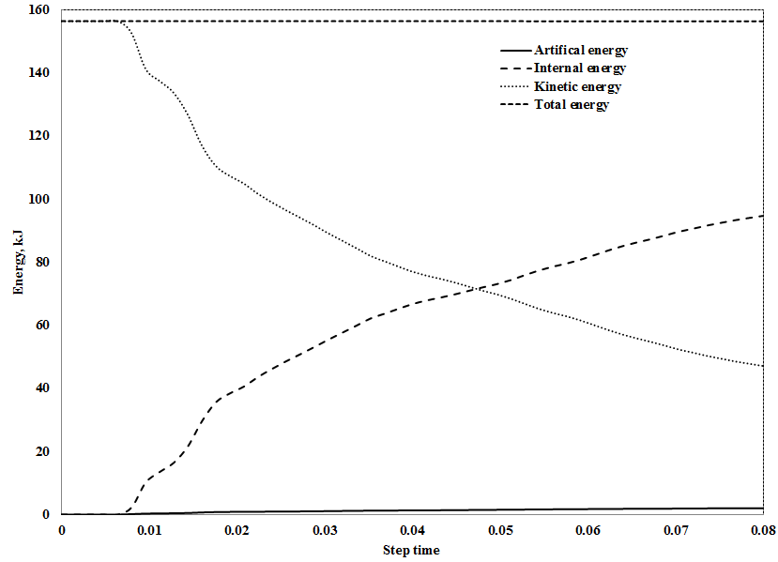

(a) Energy balance for W-beam guardrail without damage

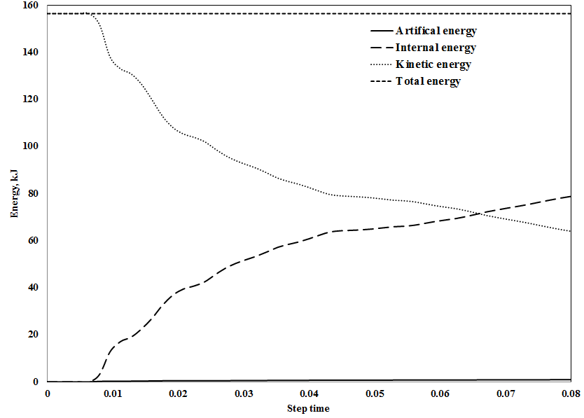

(b) Energy balance for W-beam guardrail with SSupport damage

**Figure 9.** Energy balance for W-beam guardrail without and with damage impacted by vehicle oriented at 90o.

* 1. *Internal and plastic energy*

The internal and plastic energies for W-beam guardrail with and with damages were retrieved from the crash simulation to identify the energy absorption capacity of the guardrail. Results shows, for both models, energy absorption process through the crashing period, the internal energy been developing in conversion to the kinetic energy, and the plastic energy related with the permanent deformation of the material through the crashing. The results of damaged W-beam guardrail for internal and plastic energies are minimum compared to guardrail without damage, depicting the damage compromise its efficiency in relation to energy absorption capacity.

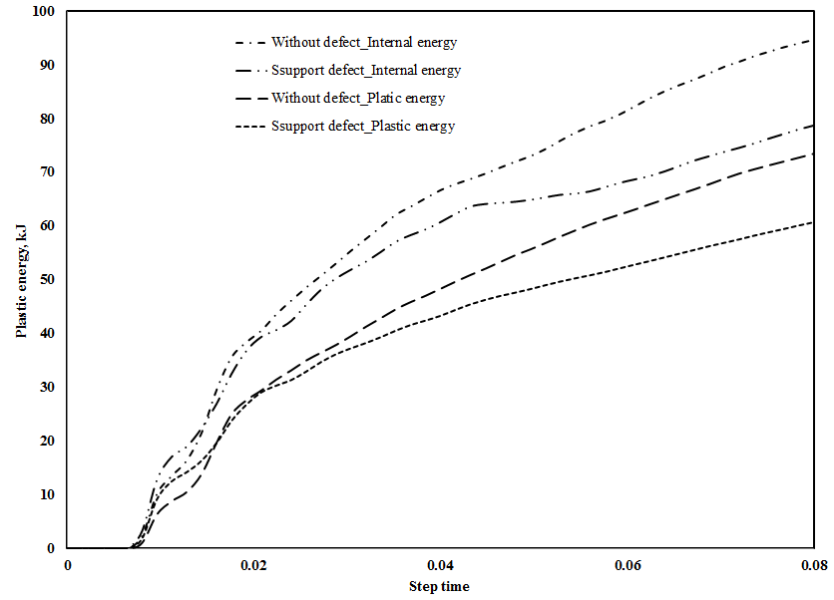

**Figure 10.** Internal and Plastic energies results of the W-beam guardrails without and with damages.

* 1. ***Displacement***

The displacements of W-beam guardrails with and without damages were identified and illustrated in Figure 11. As it can be seen from Figure 11(a), the maximum displacement, 402.9mm, of the W-beam guardrail without damage is observed close to the vehicle crash direction. While the maximum displacement for damaged ones identified with 459.9mm, see Figure 11 (b). With the consideration of the identified displacements for both models that lies in the W1 Level of working width (W1≤0.6m), the W-beam guardrail with damage displaced more, 14.15%, compared to W-beam guardrail without damage.

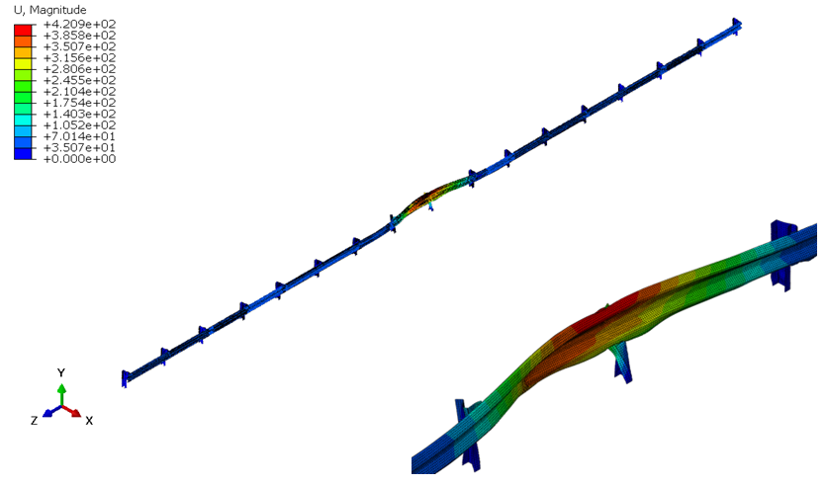

( a ) Displacement of W-beam guardrail without damage

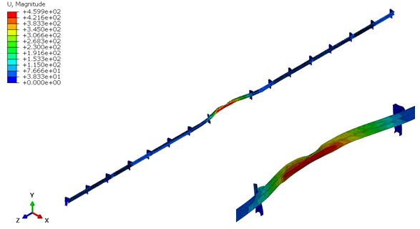

( b ) Displacement of W-beam guardrail without and with damage

**Figure 11.** Overall displacement of W-beam guardrail without and with damage

1. **Conclusion**

A non-linear finite element analysis was done to analyze the crash of Jeep truck on W-beam guardrail which is modeled using AASHTO design standard. For the crash test, for guardrail without and with damage, the standard MASH parameters for vehicle speed, impact angle, and vehicle inertia load and front bumper width was adopted.

The energy balance results show that the simulations for crash tests are reliable to investigate other performance criteria. The internal and plastic energies conversions for W-beam guardrail without damage shows higher compared to the damaged one, hence the energy absorption capacity can be considered to be compromised when damage on the guardrail processed. Further, the total displacement of the W-beam guardrail with damage increase by 14.15% compared with guardrail without damage, limits its future use under safe level of working width.

**REFERENCE**

[1] Michie J D, Calcite L R, and Bronstad M E 1971, *Guardrail performance and design, National Cooperative Highway research Program Report 115*, Southwest Research Institute, San Antoni, Texas.

[2] Ross H E , Sicking D L, Zimmer R A, and Michie J D 1993, *Recommended Procedures for the Safety Performance Evaluation of Highway Features,* National Cooperative Highway research Program Report 350, National Academy Press, Washington, D.C.

[3] <https://obexsystems.com/about/en-1317-specification/> accessed August 28, 2023.

[4] Martin O S and Wekezer J W 1998 *Crash impact analysis of the G2 guardrail, FAMU-FSU College of Engineering Computer Impact Simulation Laboratory (CISL) TRB National Research* Council, Annual Meeting.

[5] Teng T L, Liang C L, and Tran T T 2016,Development and validation of a finite element model for road safety barrier impact tests, Simulation: *Transactions of the Society for Modeling and Simulation International* **92(6)**, 565-578.

[6] Dziewulski P and Stanisławek S 2019 The impact of forming processes on road barrier strength, **AIP Conf. Proc. 2078, 020003**, <https://doi.org/10.1063/1.5092006>

[7] Ren Z, Vesenjak M 2005 **Computational and experimental crash analysis of the road safety barrier**, The University of Maribor, Faculty of Mechanical Engineering, Engineering Failure Analysis 12.

[8] Nevesa R R, Fransplassb H, Langsethb M, Driemeiera L., Alvesa M Performance of Some Basic Types of Road Barriers Subjected to the Collision of a Light Vehicle, *J Braz. Soc. Mech. Sci. Eng.* **40**, 274 (2018). <https://doi.org/10.1007/s40430-018-1201-x>

[9] Molan A M, Rezapour M andd Ksaibati K. 2019 Modeling traffic barriers crash severity by considering the effect of traffic barrier dimensions. *J. Mod. Transport.* ***27*,** 141–151.

[10] Teng T L, Liang C L, and Tran T T 2015 Effect of various W-beam guardrail post spacing and rail heights on safety, *Advances in Mechanical Engineering* **7(11),** 1–16.

[11] AASHTO Standard Specifications for Transportation Materials and Methods of Sampling And Testing, 26th Edition, 2007.

[12] Dobrovolny C S, Arrington D R, Schulz N D, Xavier C B 2015 *Design and Finite Element Analysis of a MASH 31-inch W-Beam Guardrail System for Placement on 3H:1V Sloped Terrain Configuration (2014 WV-62)*, Test report 12-602951-00001, Texas A&M Transportation Institute, Texas.

[13] Dassault Systemes. Abaqus 6.14 Online Documentation: 9.3.2 Definition of the stability limit. Dassault Systemes, <http://abaqus.sys.kth.se/v6.14/books/gsa/default.htm>

[14] Plaxico C A, Hacket R M, and Uddin W, 1997, Simulation of a Vehicle Impacting a Modified Thrie-Beam Guardrail. *Transportation Research Record*, **1599(1)**, 1–10.

<https://doi.org/10.3141/1599-01>

[15 Fitzgerald W J 2008 *W-Beam Guardrail Repair: A Guide for Highway and Street Maintenance Personnel* Report FHWA-SA-08-002 Federal Highway Administration Office of Safety, United States. <https://rosap.ntl.bts.gov/view/dot/49224>