Numerical study on the lifting operation of a gravity-type fish cage

Andrè Gjerdea, [1], Xueliang Wena, Muk Chen Onga

a Department of Mechanical and Structural Engineering and Materials Science

University of Stavanger, NO-4036, Stavanger, Norway

**Abstract** The dynamic behaviours of the lifting operation of a gravity-type fish cage under calm sea conditions are investigated in this study using an extended position-based dynamics (XPBD) method to obtain the structural deformations of the aquaculture nets. The original XPBD is improved to accurately predict the tensions of the aquaculture nets by applying correction forces. The present XPBD is validated by comparing the experimental results of a flexible horizontal net. The time-step sensitivity is verified for the case of the lifting operation of the fish cage. Results show that the lifting force increases rapidly resulting from the weight of the sinkers at the bottom of the side net. The maximum tension of the net is located at the net ropes connected to the centre point of the bottom net. The structure of the bottom net should be enhanced for safety lifting operations.

1. Introduction

Fish cages are the most used equipment in aquaculture [1-3]. As technology advances, the number of different types of fish cages used in aquaculture are becoming less [4]. The gravity-type fish cages have become the more frequently used as a fish cage for the aquaculture in many countries such as Norway, China, and Japan. The gravity-type fish cages usually consist of aquaculture nets made of nylon or polyethylene (PE), high-density polyethylene (HDPE) floating collars and sinker tube, concrete centre sinker at the bottom of the net and related mooring system. All the materials can be produced in the manufactories and transported to specific sea sites to be assembled. The usage of the gravity-type fish cages can help reduce the capital cost for the industrial-scaled fish farming. Another important way to increase to the harvest and the profits of the industrial-scaled fish farming is to ensure the health and the good quality of the fish by monitoring the sea lice and conducting the de-lice operations [5]. One type of de-lice operations is to pump the fish into the de-lice machines and clean the fish by fresh water. Before the de-lice of the fish, the aquaculture nets need to be lifted and the fish will gather for pumping. The extra oxygen supply is required when the fish is gathering. The lifting operation is conducted by a crane installed on a vessel, which is very similar to the harvest operation. The lifting operations of a gravity-type fish cage are important for the fish farming and the dynamic response of the fish cage during the lifting operation is investigated in the present study.

A numerical method is adopted to study the dynamic response of the fish cage during the lifting operation in the present study. For numerical simulations, there are a few approaches and methods that can be used, such as finite element method (FEM) [6], OrcaFlex [7], and mass-spring model [8]. Rui Dou [6] used the FEM method together with a panel model, a mass model and Morison model [2] to model and analyse a semi-submersible fish cage. Cifuentes and Kim [7] calculated the current load acting on a fish cage using a Morison-force model applied at instantaneous positions of equivalent-net modelling using Orcaflex [7]. Lee et al. (2005) used the mass-spring model to simulate the flexible structures' behaviour to understand the movements and design an appropriate system [8]. A new efficient method called extended position-based dynamic (XPBD) method [9-10] was proposed to simulate the cloth dynamics in games. It is an implicit method and more robust compared with the explicit method of mass-spring model. The method will be used in the present study to simulate the dynamic behaviors of the flexible fish cage.

The present study focuses on the dynamic analysis of the lifting operations of a gravity-type fish cage using the XPBD method. The present paper is organized as follows. The fish cage specifications and the XPBD method is given in Section 2. Section 3 presents a validation case of a flexible horizontal net, and the results and discussions of the dynamic process of the lifting operations of the fish cage. The conclusion is summarized in Section 4.

1. Numerical Model

## Fish cage specifications

Figure 1 displays the full-scale structure of a gravity-type fish cage. The cage has a circumference of 160m and a total height of 35m. It consists of two main parts: a 30m high side net and a 5m high bottom net. The fish cage includes thousands of panels which are enclosed by net ropes. The net ropes are constructed using PE lines. For the side net, each net rope has a length of 1.25m. The bottom net has 8 net ropes from the centre to the outer boundary and 128 net ropes at the outer boundary. Inside the net panels, there are small inner nets made of nylon with square mesh patterns. These inner nets have a diameter of 2.85mm and a length of 25mm. There are side net sinkers installed at the bottom of the side net and centre sinker installed at the centre point of the bottom net. Table 1 shows the specifications of the gravity-type fish cage, including the dimensions, materials, and key features.

During the lifting operation of the fish cage, the centre point of the bottom net is lifted from the lowest point to a specific position. The present lifting speed is 0.5m/s, as shown in Figure 2, chosen based on the mechanism of the lifting crane. The crane starts at 0s and accelerates to the normal lifting speed in 10s. The crane totally stops at 100s.

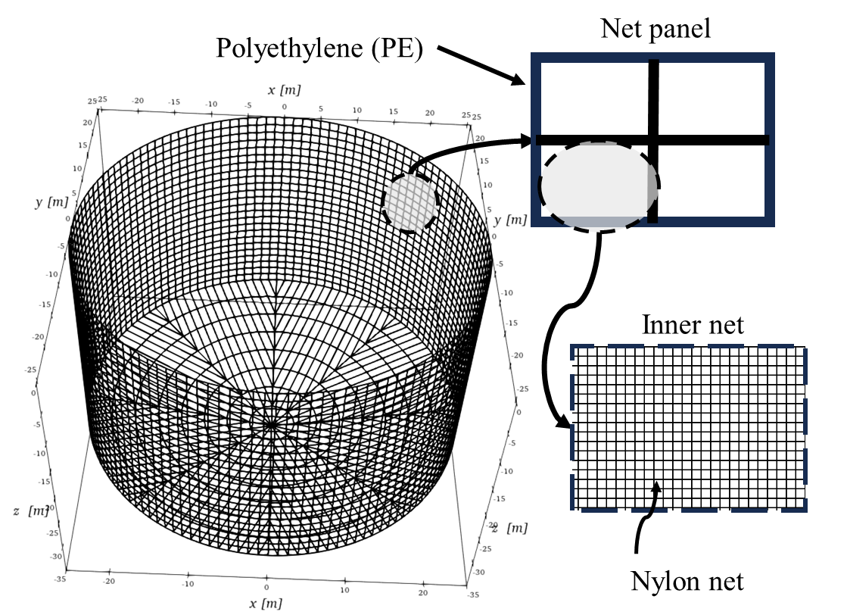

Figure 1 Illustration of the fish cage structure and the net design.

Table 1 Specifications of the gravity-type fish cage.

|  |  |  |
| --- | --- | --- |
|  | Unit | Value |
| Cage circumference | m | 160 |
| Cage height | m | 35 |
| Side net height | m | 30 |
| Bottom net height | m | 5 |
| Side net sinkers’ mass | kg/m | 80 |
| Bottom net sinker’s mass | kg | 200 |
| Polyethylene Density | kg/m3 | 960 |
| Nylon Density | kg/m3 | 1140 |
| Elastic modulus polyethylene | Pa | 1.5e9 |
| Net rope diameter (PE) | mm | 10 |
| Inner twine diameter (nylon) | mm | 2.85 |
| Length inner net | mm | 25 |
| Solidity Sn | - | 0.2 |

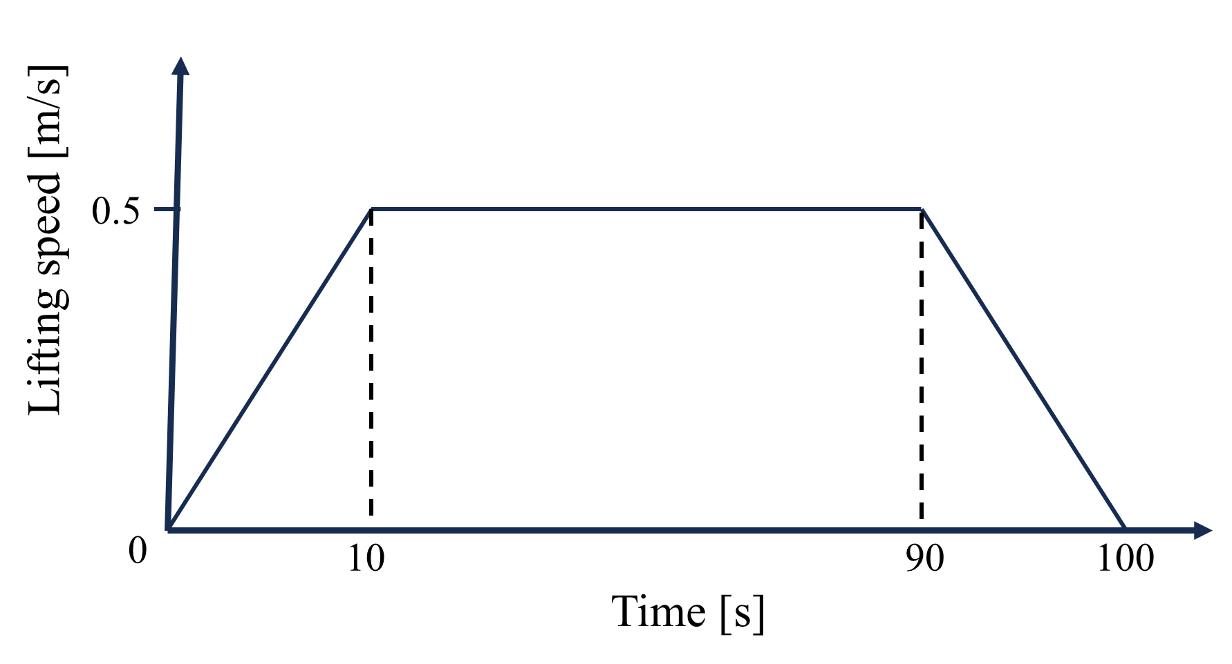

Figure 2 Description of the lifting speed during the lifting operation of the fish cage.

## XPBD Method

The extended position-based dynamics (XPBD) is an implicit method and serves as a numerical simulation technique used for simulating complex dynamic behavior of deformable objects, making it a valuable tool for investigating the fish case behavior and optimizing the design parameters. XPBD was developed as an extension of the position-based dynamics (PBD) approach, introducing distinct advantages in terms of stability, easy implementations, and computational efficiency. The details of the original XPBD simulation loop are shown in Algorithm 1.

|  |  |
| --- | --- |
| **Algorithm 1**: original XPBD simulation loop | |
| 1: | predict position $\tilde{x}←x^{n}+Δtv^{n}+Δt^{2}M^{-1}F_{ext}$ |
| 2: | **for all** constrains **do** |
| 3: | compute $Δλ$ using Equation (7) |
| 4: | compute $Δx$ using Equation (6) |
| 5: | **end for** |
| 6: | update positions $x^{n+1}←\tilde{x}+Δx$ |
| 7: | update velocities $v^{n+1}←\frac{1}{Δt}\left(x^{n+1}-x^{n}\right)$ |

The method first updates the positions of the nodes based on the external forces $F_{ext}$ using Newton's second law. Then, the positions of the nodes need to be corrected according to the inner force resulting from every constraint. For a single constraint, the changing of the positions of these two nodes is given by evaluating Equation (1).

|  |  |  |
| --- | --- | --- |
|  | $$\begin{matrix}Δx_{1}=+Δλm_{1}^{-1}q \\ Δx_{2}=-Δλm_{2}^{-1}q\end{matrix}$$ | (1) |

The changing of Lagrange multiplier $λ$ is given by Equation (2).

|  |  |  |
| --- | --- | --- |
|  | $$Δλ=\frac{-C}{m_{1}^{-1}+m_{2}^{-1}+\tilde{α}}$$ | (2) |

where $\tilde{α}=\frac{1}{kΔt^{2}}$ and $C=l-l_{0}$.

Compared with the mass spring model, XPBD can provide a quick result for the net dynamics in an implicit way. However, XPBD has its inevitable error for calculating the tensions of the constraints. It is because the masses of the nodes are involved when evaluating the Lagrange multiplier change. It is against the physics intuition that the elastic force is only determined by the stiffness and the constraint. To correct the results of XPBD, the term of $m_{1}^{-1}+m_{2}^{-1}$ in the denominator of Equation (2) should be removed. However, the simulation loop as shown in Table 1 will become unstable if $m_{1}^{-1}+m_{2}^{-1}$ is removed. To maintain the stable simulation loop and correct the results of XPBD at the same time, an XPBD correction is proposed by applying extra forces acting on the two nodes of the constraint, where the expression is shown in Equation (3)

|  |  |  |
| --- | --- | --- |
|  | $$\begin{matrix}F_{1}=+γq \\ F_{2}=-γq\end{matrix}$$ | (3) |

where $γ$ is evaluated by Equation (4).

|  |  |  |
| --- | --- | --- |
|  | $$γ=\frac{-C\left(m_{1}^{-1}+m_{2}^{-1}\right)}{\left(m_{1}^{-1}+m_{2}^{-1}+\tilde{α}\right)\tilde{α}Δt^{2}}$$ | (4) |

The new simulation loop is shown in Algorithm 2. Before predicting the position, the correction forces $F_{cor}$ are calculated for every constraint. It will increase the computational cost when using the same time step and the same structure configuration. However, a small-time step close to the mass-spring model as shown in Equation (3) is required to ensure a close prediction accuracy, which reduces the advantage of an implicit method of XPBD. The present modified XPBD not only enhances the precision of predictions and but also significantly lowers computational expenses. As a result, the previously incurred drawback of introducing correction force calculations is effectively mitigated.

|  |  |
| --- | --- |
| **Algorithm 2**: modified XPBD simulation loop | |
| 1: | **for all** constrains **do** |
| 2: | compute $γ$ using Equation (4) |
| 3: | compute correction force $F_{cor}$ using Equation (3) |
| 4: | **end for** |
| 5: | predict position $\tilde{x}←x^{n}+Δtv^{n}+Δt^{2}M^{-1}\left[F_{ext}+F_{cor}\right]$ |
| 6: | **for all** constrains **do** |
| 7: | compute $Δλ$ using Equation (2) |
| 8: | compute $Δx$ using Equation (1) |
| 9: | **end for** |
| 10: | update positions $x^{n+1}←\tilde{x}+Δx$ |
| 11: | update velocities $v^{n+1}←\frac{1}{Δt}\left(x^{n+1}-x^{n}\right)$ |

An in-house code is developed based on the MATLAB platform. More functions of the present code will be added in the future. The comparison between the original and modified XPBD methods will be given in our further study.

1. Results and discussions

## Validation study

The validation case is based on Lee et al.’s [8] experimental test of a flexible horizontal net, as shown in Figure 3 in its top view. The net consists of 214 nodes and 424 line elements. The twine length is 100mm in the inner net and 141.4mm on the boundaries. The twine diameter is 0.4 mm. Additionally, the net incorporates three sinkers with masses: F1 = 1.5kg (middle), F2 = 0.5kg (left), and F3 = 0.7kg (right). The specifications of the flexible horizontal net are shown in Table 2. During the experiment, the four corner nodes were fixed. The three sinkers are dropped from the initial positions and reached their final positions as shown in Figure 4(a). During the calculations, the velocities of each node are damped into 99% at every 0.5ms to approach the final convergent position of the flexible horizontal net. Figure 4(b) presents the results of the final position of the flexible horizontal net obtained using three time-steps of 0.025ms, 0.05ms and 0.1ms. The results of the three time-steps exhibit a good agreement and they show good consistent with the experiment result, which confirms the feasibility of the present XPBD method used to simulate the flexible fish cage. The validation is based on the visual comparison because of the limited data from the experiment of Lee et al.’s [8].

Figure 3 Initial position of the flexible horizontal net (top view).

Table 2 Validation case specifications.

|  |  |
| --- | --- |
| Parameters | Values |
| Net Dimensions (meshes) | 12x8 |
| Node count | 214 |
| Element count | 424 |
| Stiffness | 15.000 N/m |
| Mass | 0.0015 kg |
| Twine diameter | 0.4 mm |
| Half mesh size | 100 mm |
| Sinker 1’s mass | 1.5 kg |
| Sinker 2’s mass | 0.5 kg |
| Sinker 3’s mass | 0.7 kg |

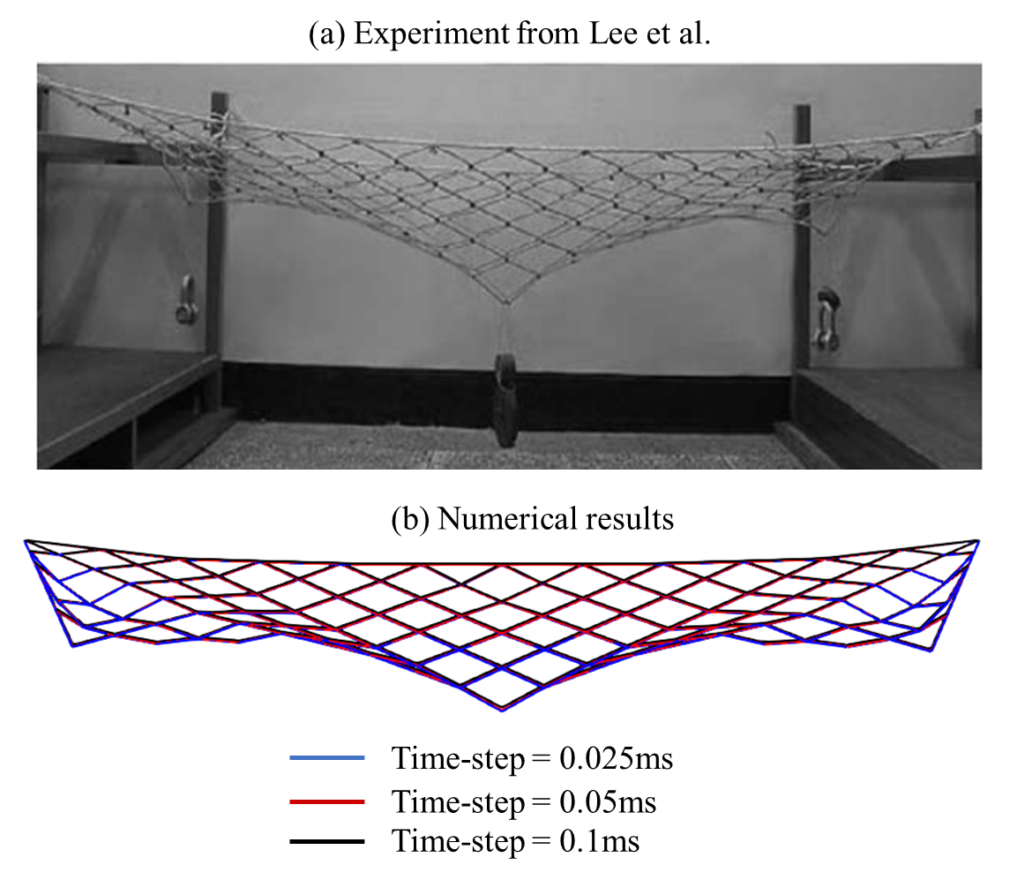

Figure 4 Comparison between the experiment result of Lee et al. [8] (a) and the numerical results of the present XPBD (b).

## Dynamic process of the lifting operation

Before the lifting operation, the initial position of the fish cage is calculated using the similar way of the validation case. Figure 5 shows a time-step sensitivity study of the lifting force acting on a fish cage in a still water. Three time-steps of 0.25ms, 0.5ms and 1ms are examined in this analysis. The results of all the tested time-steps exhibit remarkable agreement. Consequently, the time-step of 1ms is chosen as the preferred time-step for subsequent calculations to reduce the computational cost.

Figure 6 shows the time-step sensitivity studies of the tensions of the fish cage in XZ- and YZ-planes at 50s. There is a slight reduction in tension on one side of the cage during the initial phase of the lifting operation, specifically at the time-step of 0.25ms in XZ-plane. The overall tensions remain consistent across all time-steps, while some variations in tension are observed during the lifting of the net. Looking at the results of the time-step of 0.25ms in Figure 6, the maximum tension reaches 1400N.



Figure 5 Time-step sensitivity study of the lifting force acting son the fish cage.

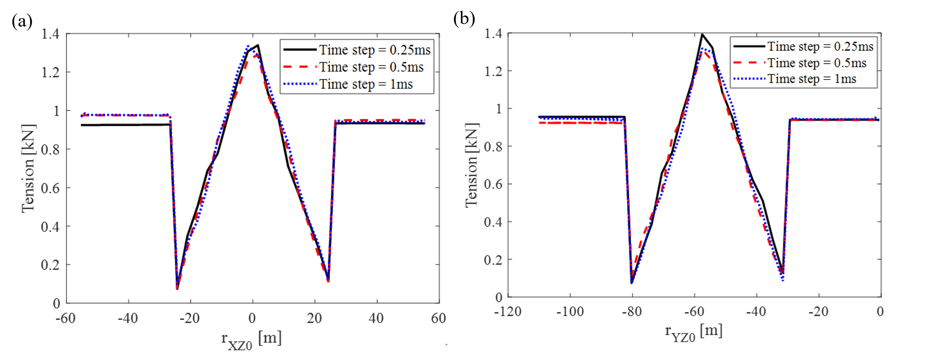

Figure 6 Time-step sensitivity study of the tensions of the fish cage in XZ and YZ-planes at 50s.

As shown in Figure 5, the lifting force is small in [0s, 50s] and quickly increases over a short duration of [50s, 100s]. The force keeps the same value as the crane stops operation. The reason for the rapid increase of the lifting force is that the bottom net starts to support the weight of the sinkers at the bottom of the side net in [50s, 100s]. Figures 7 shows the comparisons of tensions in XZ- and YZ-planes at different time during the lifting operation. The time instants shown in this figure are chosen as 50s, 75s, and 100s. As can be seen, the tension on the bottom net has a significant increase in [50s, 100s]. The maximum tension can reach 12.5kN, which is almost 13 times of the value of the side net in Figure 7. The reason can be attributed to the special structure of the bottom. As can be seen form the deformations and tensions of the fish cage in side and top views at different time in Figure 8, the maximum tension of the net is observed to be located at the net ropes connected to the centre point of the bottom net. Only eight net ropes support the sinkers’ weight, while for the side net, there are 128 net ropes supporting the total sinkers’ weight. It can be concluded that the net ropes of the bottom net experience the maximum tension during the lifting operation of a fish cage. The structure of the bottom net, especially for the eight net ropes, should be enhanced.

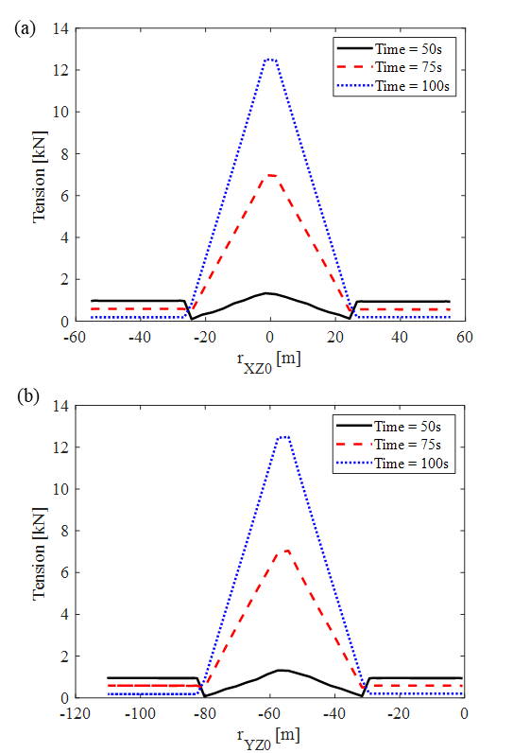

Figure 7 Comparisons of tensions in XZ- and YZ-planes at different time during the lifting operation.

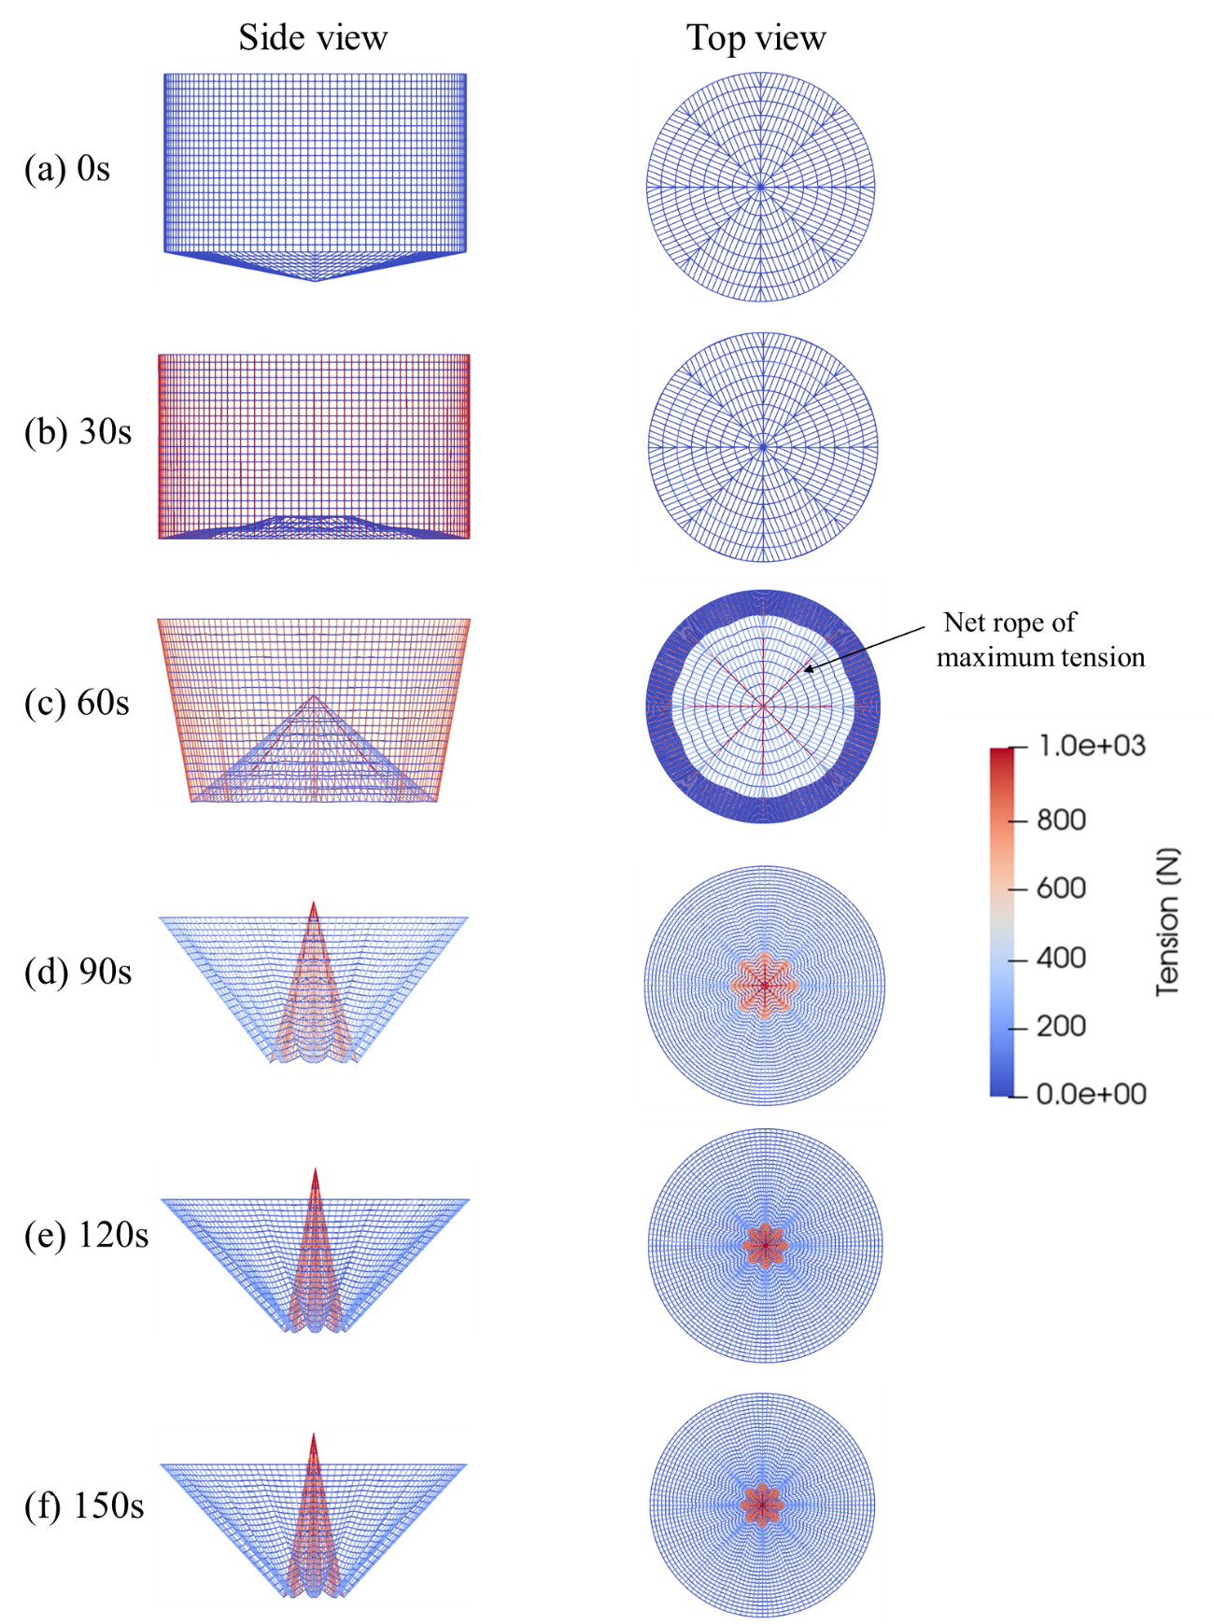

Figure 8 Deformations and tensions of the fish cage at different time.

1. Conclusion

The dynamic behaviors of the lifting operation of a gravity-type fish cage under calm sea conditions are investigated in this study. The structural deformations of the aquaculture net are obtained using an improved XPBD method. Correction forces are applied to the aquaculture net to predict the accurate tensions. The present XPBD is validated by comparing the experimental results of a flexible horizontal net. The time-step sensitivity study is conducted for the lifting operation of the fish cage. Results show that the lifting force increases rapidly resulting from the weight of the sinkers at the bottom of the side net. The maximum tension of the net is located at the net ropes connected to the centre point of the bottom net. The structure of the bottom net should be enhanced for safety lifting operations. In future study, the structure of the bottom net will be investigated in detail under failure conditions of the net ropes.

Acknowledgment

This study was supported by the Research Council of Norway through the project “Unleashing the sustainable value creation potential of offshore ocean aquaculture” (Project number: 328724).

References

[1] Huguenin, J.E., 1997. The design, operations and economics of cage culture systems. Aquacultural Engineering 16, 167–203.

[2] Guo, Y.C., Mohapatra, S.C., Guedes Soares, C., 2020. Review of developments in porous membranes and net-type structures for breakwaters and fish cages. Ocean Engineering, 200, 107027.

[3] Sievers, M., Korsøen, Ø., Warren-Myers, F., Oppedal, F., Macaulay, G., Folkedal, O., Dempster, T., 2021. Submerged cage aquaculture of marine fish: a review of the biological challenges and opportunities. Reviews in Aquaculture, 14(1), 106-119.

[4] Beveridge, M.C., 2008. Cage Aquaculture, Third ed. Oxford, UK. Blackwell Iowa.

[5] Berstad, A. J., Tronstad, H., Sivertsen, S. A. Leite, E., 2005, January. Enhancement of design criteria for fish farm facilities including operations. Proceedings of the 24th International Conference on Offshore Mechanics and Arctic Engineering (Vol. 41960, pp. 825-832).

[6] Dou, Rui., 2018. Numerical modelling and analysis of a semi-submersible Fish-cage, Master's thesis, Norwegian University of Science and Technology (NTNU).

[7] Cifuentes, C., Kim, M.H., 2017. Numerical simulation of fish nets in currents using a Morison force model. Ocean Systems Engineering. 7 (2), 143-155.

[8] Lee, C.W., Lee, J.H., Cha, B.J., Kim, H.Y., 2005. Physical modelling for underwater flexible systems dynamic simulation. Ocean Engineering 32 (3-4), 331-347.

[9] Müller, M., Heidelberger, B., Hennix, M., Ratcliff, J., 2007. Position based dynamics. Journal of Visual Communication and Image Representation, 18(2), 109-118.

[10] Miles, M., Müller, M., Chentanez, N., 2016. XPBD: position-based simulation of compliant constrained dynamics. Proceedings of the 9th International Conference on Motion in Games.

1. Corresponding author: andr.gjerde@stud.uis.no (André Gjerde)