Early Detection of Bipolar Disorder through fMRI Analysis employing Machine Learning Algorithms: A Comparative Study

Iulia-Andreea Ion 1 and Camelia Chira 1

1 Faculty of Mathematics and Computer Science, Babeș-Bolyai University, Mihail Kogălniceanu 1, 400084, Cluj Napoca, Romania

**Abstract.** Mental illness is becoming more and more commonplace in today's environment, affecting a growing number of people. Functional Magnetic Resonance Image (fMRI) is the most effective technique for preventing and detecting mental disease. Specialists can quickly diagnose patients by using fMRI analysis to detect changes in the brain.­ fMRI data processing helps map neural activity in specific brain regions, enabling accurate localization of cognitive functions and improving our understanding of functional connectivity and brain region interactions. This paper focuses on the **use of Machine Learning techniques for fMRI analysis with the aim of identifying brain features that may be associated with Bipolar Disorder (BD**). The first step in the proposed approach is the preprocessing of fMRI data using two distinct methods, the first one combining Statistic Parametric Mapping and CONN-Box for a better outcome and the second one focusing on Melodic software, comparing them to determine which yields the cleanest and most reliable results. Given that BD is associated with abnormal brain interconnectivity, machine learning techniques such as Support Vector Machines and Random Forests are well-suited for analyzing this complex data. These approaches are implemented and analyzed in the current work to facilitate a detailed comparison and identify the optimal model or combination of models. The results depicted that Connbox-SPM preprocessing and SVM attained the best performances, reporting an **accuracy of 72.3%**.

**Keywords:** Bipolarity Disorder, fMRI analysis, ML algorithms, SPM, Connbox, Melodic, SVM, Random Forest

1. Introduction

Bipolar disorder (BD) is a chronic and severe psychiatric condition characterized by recurrent episodes of depression and mania or hypomania, affecting mood, energy, and cognitive functions [12]. It has an estimated lifetime prevalence of approximately 1–2% in the general population, and misdiagnosis remains common, with nearly one-quarter of BD patients initially misdiagnosed as having major depressive disorder [13]. Early and accurate diagnosis is crucial to guide appropriate treatment and improve long-term outcomes. Advances in neuroimaging, particularly functional magnetic resonance imaging (fMRI), and the application of machine learning techniques offer promising tools for better understanding and detecting bipolar disorder.

Functional Magnetic Resonance Imaging (fMRI) has emerged as a significant diagnostic and monitoring technique for a variety of neurological and mental illnesses, such as epilepsy, depression, schizophrenia, and stroke. fMRI helps professionals identify anomalies, comprehend how different parts of the brain interact, and forecast how a treatment will work by mapping brain activity and analyzing functional connectivity. Preserving vital brain regions for surgery is particularly crucial in preoperative planning, as it enables doctors to perform more precise operations [3]. One of the most useful ways fMRI data processing deepens our understanding of brain function is by mapping neural activity in response to events or stimuli. Machine learning (ML) has evolved into a leading approach for the investigation of fMRI data, based on its adeptness at processing intricate, high-dimensional datasets and identifying patterns that standard statistical techniques might fail to recognize. Owing to their capacity for identifying subtle and nonlinear interrelations in cerebral activity, ML methodologies such as support vector machines (SVM) and deep learning exhibit considerable efficacy in endeavors including disease classification, brain region segmentation, and functional connectivity analysis. The utility of ML methodologies within the domain of fMRI research is further heightened by their scalability and adaptability, which facilitate real-time data analysis and more accurate modeling of cerebral function.

This study proposes a machine learning framework for the classification of bipolar disorder (BD) using functional connectivity features derived from resting-state functional magnetic resonance imaging (fMRI) data. Specifically, two preprocessing pipelines are evaluated: one that integrates Statistical Parametric Mapping (SPM) with the CONN Toolbox, and another based on the MELODIC component of the FSL suite. The primary aim is to assess which pipeline yields cleaner, more reliable functional connectivity patterns for classification tasks. Functional connectivity is estimated via region-of-interest (ROI)-to-ROI correlation analysis, capturing inter-regional neural interactions. The resulting features are then used to train and evaluate two supervised machine learning classifiers—Support Vector Machines (SVM) and Random Forests—on a publicly available dataset consisting of individuals diagnosed with BD and healthy controls. This work makes several key contributions: it provides a systematic comparison of fMRI preprocessing strategies, introduces a reproducible pipeline for connectivity-based feature extraction, and benchmarks the performance of two widely used classifiers in BD detection. The results demonstrate that the combination of SPM-CONN preprocessing and SVM classification achieves the best performance, with an accuracy of 72.3%, highlighting the significance of methodological choices in optimizing machine learning applications for neuropsychiatric diagnosis.

To provide a clear overview of the study, the paper is structured as follows. Section 2 reviews related work, focusing on previous applications of machine learning to fMRI data for the diagnosis of bipolar disorder and related conditions. Section 3 outlines the proposed methodology, including preprocessing steps, functional connectivity analysis, feature extraction, and classification models. Section 4 presents the experimental design, dataset, evaluation metrics, and results. Section 5 discusses the findings, their clinical implications, and the limitations of the study. Section 6 concludes the paper and outlines directions for future research.

1. Related Work

Bipolar disorder (BD) is characterized by abnormal brain interconnectivity, making it suitable for analysis using machine learning techniques such as Support Vector Machines (SVM) and Random Forests. Recent studies have applied these methods to fMRI data to identify biomarkers and improve early diagnosis, particularly in high-risk and misdiagnosed populations.

The authors of study [1] sought to characterize anomalies in the brain connectome of affected kids at family risk for BD in order to find biomarkers underlying risk. An emotional continuous performance task was used to perform functional magnetic resonance imaging (fMRI) on 119 depressed and/or anxious youth (n = 119, age = 14.9 ± 1.6 years) with a family record of BD but not previous exposure to antidepressants, as well as typically developing controls (n = 57, age = 14.8 ± 1.7 years). Brain connectome patterns were compared using a generalized psychophysiological interaction (gPPI) analysis, and then machine learning was applied to topological measures. The default mode network (DMN) had the weakest connectivity patterns among high-risk kids, whereas the visual network (VN) had the strongest aberrant connections. . The cross-validation accuracy of the classifier was 78.4%.

In [11], the authors aimed to differentiate between individuals with BD and those with MDD, specifically to detect BD that was misdiagnosed prior to the start of mania or hypomania. They also wanted to investigate potential trait markers that allow for reliable differential diagnosis regardless of mood state. 92 patients with MDD and 48 patients with BD had baseline functional magnetic resonance imaging scans. Using a new region-based feature selection technique, a support vector machine classifier was trained on the amygdala-based functional connectivity (FC) of 50 UD and 48 BD patients. A dataset that included both tBD and the remaining UD patients was subsequently used to test the classifier. It was able to accurately distinguish between known cases of BD and UD, with an accuracy of 81%, sensitivity of 82.6%, specificity of 79%, and an AUC of 74.6%. The classification was mostly influenced by eleven regions of the cortico-limbic neural circuit, according to the results of feature selection.

1. Proposed Method to fMRI Analysis

The detection of bipolarity from functional magnetic resonance imaging (fMRI) data relies on identifying abnormal patterns of functional connectivity, a characteristic feature of the disorder described in [1]. Following functional connectivity analysis, two ML classifiers, SVM and RF, are evaluated for their effectiveness in distinguishing bipolar cases. SVM is particularly suited to scenarios where the division between classes is distinct, leveraging clear connectivity differences for classification. In contrast, RF demonstrates robustness in managing noisy data and reducing overfitting, often resulting in higher predictive performance in complex datasets. A comparative analysis of these approaches enables a deeper assessment of their respective strengths in detecting bipolarity from fMRI data.

The main goal of this work is to apply ML algorithms for analyzing complex patterns of brain connectivity, where abnormalities are often subtle. The proposed approach is depicted in Figure 1 for a better understanding of the workflow and will be detailed in the following paragraphs. We start by analyzing the fMRI inputs, followed by preprocessing phase. As outlined in Section 1, we perform two different preprocessing methods, to observe which one performs better. Following up, Functional Connectivity Analysis is performed independently on the resulting preprocessed data, followed by Feature Extraction. In the ML Modelling step, the featured matrix obtained in the previous step is used as input for SVM and Random Forest. Here four operations will be performed: Connbox-SPM preprocessed data and SVM, Connbox-SPM preprocessed data and RF, Melodic preprocessed data and SVM, Melodic preprocessed data and RF, followed by the last step, Model Evaluation.

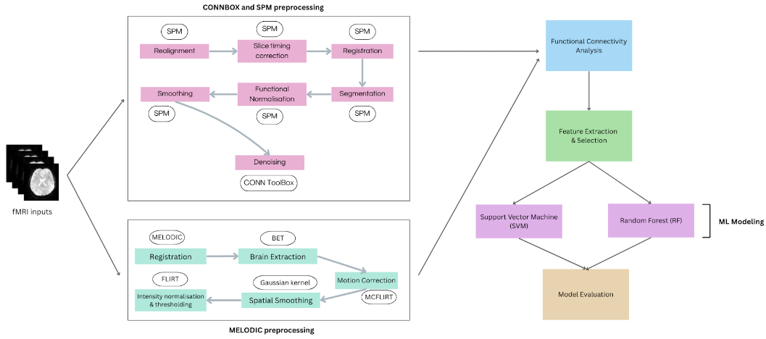

**Fig. 1.** Flowchart of the proposed approach

* 1. Preprocessing

This subsection focuses on presenting both preprocessing methods that have been implied in the approach. We start by presenting the Connbox-SPM preproceesing, where we describe all the used methods that have been showed in the above displayed flowchart, followed by the Melodic preprocessing, which is described accordingly.

### **Connbox-SPM preprocessing [5],[6]**

**Realignment** corrects for head motion during fMRI acquisition by estimating and applying six rigid-body transformation parameters—three translations (x, y, z) and three rotations (pitch, roll, yaw)—to align each functional volume to a reference image, typically the first or mean image. Using SPM's Realignment [6] and Unwarping tool, additional corrections are made for susceptibility-by-motion interactions. The outputs include motion-corrected images and motion parameters, which are crucial for quality control and can be included as covariates in subsequent analyses, thereby improving the precision of functional connectivity.

**Slice timing correction [6]** compensates for temporal discrepancies caused by sequential slice acquisition during echo-planar imaging (EPI). This step interpolates the voxel time series to a common reference time, usually aligning all slices to the acquisition time of the first or middle slice. By correcting temporal misalignment, slice timing improves the accuracy of connectivity and activation analyses, particularly in event-related designs where precise timing is critical.

**Registration [6]** spatially aligns each subject’s images to a standardized space, such as the Montreal Neurological Institute (MNI) template, facilitating inter-subject comparisons. Figure 2 presents the transformation of anatomical images and the segmentation of brain tissues into probability maps for gray matter (c1), white matter (c2), and cerebrospinal fluid (c3). Proper registration and segmentation enhance the accuracy of subsequent statistical analyses by reducing anatomical variability and enabling precise localization of brain regions.

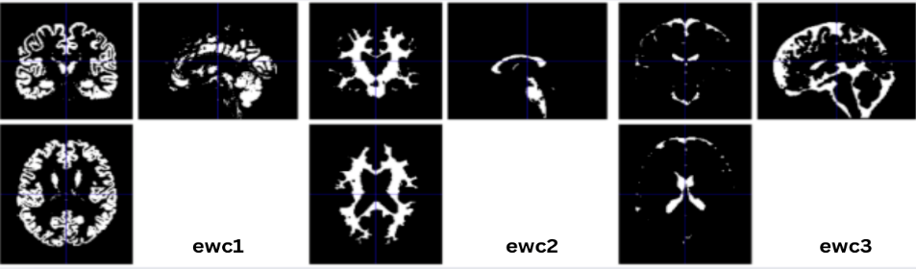 **Fig. 2.** Registration for sub-60001[2]

During **segmentation [6]**, tissues are classified into multiple probability maps, including gray matter (c1c), white matter (c2c), cerebrospinal fluid (c3c), skull (c4c), and extracerebral soft tissues (c5c), which can be observed in Figure 3. This detailed classification enables voxel-based morphometry and other structural analyses. Quality checks are recommended to address intensity variations, particularly in non-brain tissue maps, ensuring accurate tissue boundary delineation.

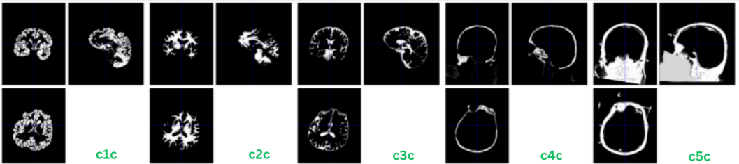

**Fig. 3.** Segmentation for func/sub-60001[2]

Functional **normalization [6]** warps motion- and slice-timing-corrected functional images into MNI space by applying deformation fields obtained during anatomical segmentation. Following normalization, spatial smoothing with a Gaussian kernel (typically 6 mm FWHM) is performed to enhance the signal-to-noise ratio, reduce intersubject anatomical variability, and increase the statistical power of group-level analyses.

**Denoising [5]** is critical for improving the quality of functional connectivity analyses by removing motion artifacts, scanner drifts, and physiological noise from the BOLD signal. Post-denoising evaluations show smoothed voxel time series and more stable global signals. Quantitative metrics, such as the percentage of BOLD signal variance explained, provide insight into the effectiveness of denoising, ensuring that subsequent analyses are based on neural rather than non-neuronal signals.

After all the above preprocessing is performed we obtain the clean data that will be used in the Functional Connectivity Analysis.

### **Melodic preprocessing**

**Registration [7]** aligns fMRI data into a standard coordinate space, such as the MNI152 template, minimizing interindividual anatomical variability and improving group-level statistical power. Registration parameters have been optimized using option *–regstandard* for template selection, *–mmthresh=0.5* for intensity-based masking, and *–bgthreshold=10* to reduce background noise. This standardized alignment ensures that functional signals are anatomically meaningful and comparable across subjects, strengthening reproducibility and inference in neuroimaging studies, as it can be observed in Figure 4.

**Fig. 4.** Registration for func/sub-60001[2]

**Motion correction [7]** was performed using MCFLIRT [4], applying rigid-body transformations to minimize motion artifacts. Displacements were minimal, with average absolute and relative movements of 0.17 mm and 0.07 mm, respectively, and no rotational or translational movement exceeding 0.3 mm. Consequently, no additional scrubbing or regression was required.

The first plot displayed in Figure 5 represents estimated **rotations in radians** about the x, y, and z axes, with minimal fluctuations indicative of little head rotation stability, with an increase in movement seen mid-scan. The second one, Figure 6, illustrates estimated **translations in millimeters** along the x-, y-, and z-axes. From this scenario, in the first half of the scan, more motion (~0.3 mm) occurs in the x-axis than in either of the other two axes.

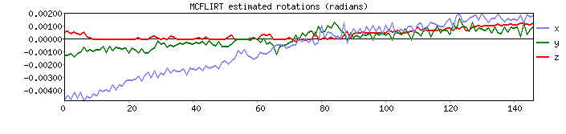**Fig. 5.** Rotation in radius about x,y,z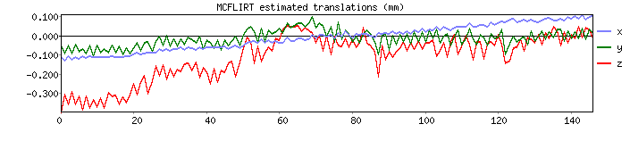**Fig. 6.** Rotation in estimated translation in millimeters along the x,y,z axes

The third plot presented in Figure 7 features the **mean absolute displacement and mean relative displacements**: while absolute displacement gives an idea as to how much the movement changes from the reference volume, the relative displacement measures the intra-frame shifting or moving among the frames. Mean absolute displacement ( 0.17 mm) and mean relative displacement ( 0.07 mm) are rather low values, indicating that there has been little overall motion, suggesting that the dataset is indeed high quality and prepared for further analyses without important motion artifacts within them.

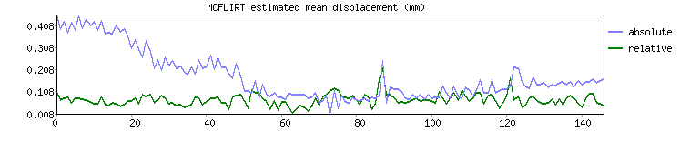**Fig. 7.** Mean absolute displacement and mean relative displacement

**Brain extraction** [7] was conducted using FSL's BET tool, producing a binary brain mask to isolate brain tissue from non-brain structures. Axial, sagittal, and coronal views of the mask revealed successful skull stripping, preserving relevant brain regions for analysis while excluding the skull, cerebrospinal fluid, and extracerebral tissues. Accurate brain extraction is essential for focusing analyses on meaningful neural signals.

Voxel intensity **normalization [7]** was applied to harmonize signal intensities across scans, compensating for scanner-related and acquisition-induced variability. Additionally, a lower threshold at the 2nd percentile and an upper threshold at the 98th percentile of the intensity distribution was imposed to remove low-signal voxels. After normalization and thresholding, a brain mask was applied to restrict analyses to relevant brain regions, enhancing the reliability of subsequent functional assessments.

**Spatial smoothing [7]** was integrated with Independent Component Analysis (ICA) via MELODIC, extracting statistically independent spatial patterns from resting-state fMRI data. The first ICA component, explaining 5.23% of the variance, revealed activation across cortical and subcortical regions, indicative of coherent functional networks. ICA maps were thresholded at p=0.5 to ensure statistical robustness, effectively minimizing noise and isolating meaningful neural components for network-based analyses.

## 3.2 Functional Connectivity Analysis

In this study, functional connectivity (FC) analysis was conducted using the **nilearn** Python library [10], selected for its efficiency, flexibility, and seamless integration with machine learning pipelines. Inspired by the study [11], which focused solely on traditional statistical analysis without direct application of machine learning, we extended the methodology by implementing an ML-ready pipeline using nilearn. Two distinct preprocessing strategies were applied separately: one based on independent component analysis (ICA) using FSL's MELODIC, and the other based on volume-based structured preprocessing using CONN Toolbox combined with SPM. For data preprocessed with **Melodic**, functional connectivity maps were generated following motion correction, brain extraction, intensity normalization, and ICA-based denoising. A seed-based analysis was carried out using a spherical Region of Interest (ROI) centered at canonical MNI coordinates for the left amygdala. As presented in Figure 8, the resulting connectivity maps display relatively homogeneous positive correlations (warm colors), covering large areas of the brain including frontal, temporal, and occipital regions. Blue areas represent negative correlations. The overall diffuse and broad distribution of connectivity suggests residual structured noise or global signal effects, a known challenge when relying solely on automated ICA-based denoising without manual component curation.

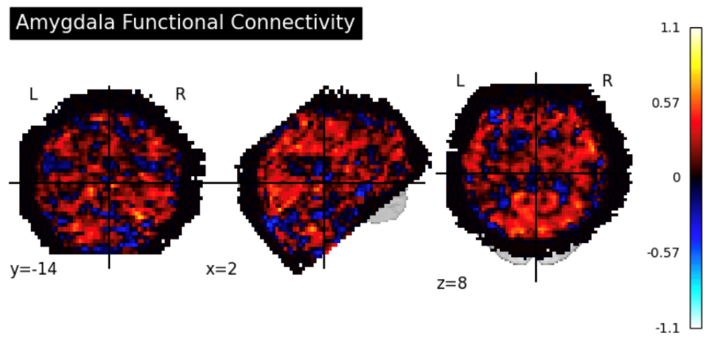

**Fig. 8.** Amygdala Functional Connectivity map for Melodic preprocessed data

Conversely, for data preprocessed with **Connbox-SPM**, where explicit noise regression was performed (including removal of white matter, cerebrospinal fluid, motion parameters, and rest effects), a much more anatomically constrained connectivity pattern was observed. As illustrated in Figure 9, the amygdala seed connectivity was predominantly localized to subcortical and limbic regions, including the medial temporal lobe and parts of the ventromedial prefrontal cortex. The focused and specific distribution of positive connectivity (blue clusters) in this case reflects a more biologically plausible mapping of intrinsic amygdala networks during resting-state conditions, consistent with known amygdala connectivity profiles.

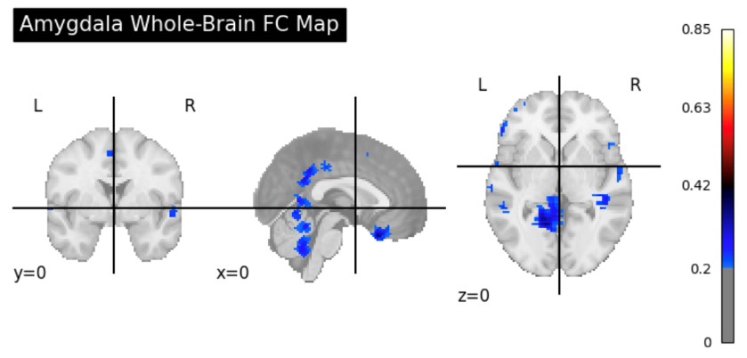

**Fig. 9.** Amygdala Functional Connectivity map for Connbox-SPM preprocessed data

By employing nilearn throughout the FC analysis pipeline, including seed definition, time series extraction, voxel wise correlation computation, and 3D map reconstruction, we ensured reproducibility, computational efficiency, and seamless integration with subsequent machine learning classification. Unlike the inspiration article, where functional connectivity was analyzed purely through traditional means, the extracted connectivity features in our study are prepared to be used directly in machine learning models such as Support Vector Machines (SVM) and Random Forests. This integrated pipeline provides not only more biologically interpretable connectivity maps but also builds a foundation for predictive modeling of bipolar disorder from resting-state fMRI data.

Following both preprocessing pipelines, FCA maps were generated using a seed-based approach centered on the left amygdala. **Feature extraction** was performed by computing the whole-brain correlation maps for each subject, resulting in high-dimensional feature sets representing the strength of connectivity between the amygdala and all other brain voxels. As observed in the Melodic preprocessed FC maps (Figure 8), widespread positive connectivity patterns suggest the presence of globally distributed correlation features, while the more localized and anatomically specific patterns seen in the Connbox-SPM preprocessed maps (Figure 9) suggest a feature set more concentrated in limbic and subcortical regions. To reduce dimensionality and enhance model performance, feature selection was subsequently applied, prioritizing voxels showing the strongest or most discriminative connectivity patterns relative to the amygdala. This step ensures that only the most informative connectivity features are used for ML classification, enabling the subsequent application of SVM and Random Forest algorithms for the detection and characterization of bipolar disorder-related connectivity alterations.

3.3 ML Classification

At the final stage of the analysis pipeline, machine learning models were used to classify subjects based on the extracted functional connectivity features. As shown in the methodological flowchart (Figure 1), two supervised learning algorithms were applied: SVM and Random Forest. The SVM aimed to find the optimal structure that separated subjects according to their connectivity patterns, employing a linear kernel to handle effectively the high-dimensional feature space. In parallel, the Random Forest algorithm built an ensemble of decision trees to model more complex, non-linear relationships between the features and class labels. Before applying SVM, the features were standardized to ensure consistent scaling, while Random Forest was trained directly on the original selected features, as it is stable to differences in feature scaling. Both models were trained and validated using cross-validation, helping to ensure reliable performance and to account for any potential class imbalance in the data.

1. Experimental Results

This section presents the dataset used for the proposed method, followed by a description of the evaluation metrics and the results. The final subsection provides a discussion of the outcomes.

* 1. Dataset

In order to evaluate the proposed approach, we used the UCLA Consortium for Neuropsychiatric Phenomics LA5c Study [2] that includes 138 healthy individuals, and 49 individuals diagnosed with bipolar disorder, aged 21-50, recruited through community advertisements in Los Angeles. Participants underwent extensive neuropsychological testing and fMRI scanning. Inclusion required being either "White, Not of Hispanic or Latino Origin" or "Hispanic or Latino, of Any Race," with at least 8 years of education. Bipolar participants were verified using the SCID-IV diagnostic interview. Screening excluded individuals with neurological diseases, significant head injuries, substance dependence, psychoactive medication use, or current mood disorders beyond bipolar. Drug use was checked via urinalysis. A subset participated in two fMRI sessions after passing additional screenings, such as MRI contraindications or mood-altering medications.

* 1. Evaluation Metrics

For an accurate evaluation of the proposed preprocessing techniques, the following metrics are used:

* **Accuracy [9]** - the percentage of voxels correctly categorized, calculated using the following formula:

$Accuracy = \left(\frac{TP+TN}{TP+TN+FP+FN}\right)$ (1)

TP – true positive, TN – true negative, FP – false positive, FN – false negative

* **Precision [10]** - the percentage of pixels correctly categorized as foreground, computed as:

$PRECISION = \left(\frac{TP}{TP +FP}\right)$ (2)

* **Sensitivity [10]** - the proportion of correctly recognized foreground pixels, or the completeness of the positive predictions:

$Sensitivity = \left(\frac{TP}{TP+FN}\right)$ (3)

* **Area Under Curve (AUC) [10]** - plot of the true positive rate (TPR) against the false positive rate (FPR):

(4)

* 1. Results

The proposed methods were tested on the above-described dataset, that initially contained 138 controls and 47 bipolarity subjects. For an effective evaluation the dataset was divided into 80/20 train-test split, hence the training dataset contained 110 controls and 39 bipolarity subjects, and 28 controls and 10 bipolarity subjects for the testing set.

**Table 1.** Performance indicators for Proposed Approach

|  |  |  |  |  |
| --- | --- | --- | --- | --- |
|  | Connbox-SPM and SVM | Connbox-SPM and RF | Melodic  and SVM | Melodic  and RF |
| Accuracy | 0.723 | 0.705 | 0.678 | 0.698 |
| Precision | 0.806 | 0.798 | 0.772 | 0.794 |
| Sensitivity | 0.709 | 0.692 | 0.656 | 0.675 |
| AUC | 0.798 | 0.766 | 0.759 | 0.765 |

Final classification results from the ML process serve exactly as anticipated, given the nature of the preprocessing pipelines and classifier considerations. Connbox-SPM preprocessing and SVM attained the best performances, reporting an accuracy of 72.3%, 80.6% precision, 70.9% sensitivity, and an AUC of 79.8%. The results signify an advantage provided by structured noise regression pre-processing, which produced cleaner, localized functional connectivity features. These features matched the strengths of SVM, a classifier that performs optimally with high-dimensional, clearly separable data. The Connbox-SPM preprocessing and Random Forest combination also performed well, with a slightly lower accuracy of 70.5% and an AUC of 0.766. Although Random Forest is robust to noise and can capture complex feature interactions, it may not exploit the clear boundary between classes as effectively as SVM in cleaner datasets. In contrast, both Melodic-based preprocessing combinations resulted in lower classification performance. While MELODIC plus SVM achieved an accuracy of 67.8% and an AUC of 0.759, the combination of MELODIC and Random Forest slightly raised accuracy to 69.8% and AUC to 0.765. The less specific connectivity patterns performed by Melodic preprocessing likely injected noise and thus diminished class separability and Random Forest performed better than SVM in this noisy feature space. Overall, the above results emphasize the need to be selective when matching preprocessing strategy with ML modeling approach. Structured preprocessing involving explicit confound regression is able to significantly improve the presence of detectable brain connectivity alterations associated with bipolarity when paired with classifiers that capitalize on clean feature boundaries such as SVM.

1. Conclusions and Future Work

Leveraging multiple deep learning methodologies for the segmentation of brain tumors proves to be a valuable yet challenging endeavor. This challenge arises from the exceptional feature learning capability inherent in deep learning approaches, contributing to the manifold benefits of automated picture segmentation. The noteworthy prowess and capacity of deep learning approaches and algorithms in handling extensive datasets are evident, as substantiated by a thorough comparative study. This study outlines that structured preprocessing pipelines, such as Connbox-SPM, combined with ML classifiers for high-dimensional, well-separated data, like SVM, can enhance the ability to detect alterations in bipolarity-related functional connectivity. These results underscore the necessity of providing optimal performance for the models by aligning preprocessing strategies with classifier characteristics, with structured noise regression and clean feature extraction as big pluses. While Random Forest was slightly better at dealing with noise in the Melodic preprocessed data, the conclusion was that approaches preserving maximum anatomical specificity and minimum confounding variability are preferable.

Future work should focus on increasing sample sizes, incorporating longitudinal datasets, and employing more advanced feature selection techniques alongside deep learning methodologies to improve predictive model performance and clinical relevance. Moreover, further research could investigate the generalizability and robustness of these models across varied patient populations and clinical environments.

# Acknowledgement

This work was supported by the project “Neural mechanisms of trauma-related psy- chopathology in high-risk populations: A multi-method and prospective investigation into the roles of social-affective and social-cognitive processes” funded by European Union – NextGenerationEU and the Romanian Government, under National Recov- ery and Resilience Plan for Romania, contract no. 760246/28.12.2023/28.12.2023, code PNRR-III-C9-2023-I8-CF103/31.07.2023, through the Romanian Ministry of Re- search, Innovation and Digitalization, within Component 9, Investment I8.

References

1. Pan, N., et al.: Aberrant brain network topology in youth with a familial risk for bipolar disorder: a task-based fMRI connectome study. J. Child Psychol. Psychiatry 65(8), 1072–1086 (2024).
2. Bilder, R., Poldrack, R., Cannon, T., London, E., Freimer, N., Congdon, E., Karlsgodt, K., Sabb, F.: UCLA Consortium for Neuropsychiatric Phenomics LA5c Study. OpenNeuro (2018).
3. Sörös, P., Witt, K.: Book review: Introduction to neuroimaging analysis. (2018) 674.
4. Jenkinson, M., Smith, S.: A global optimisation method for robust affine registration of brain images. Med. Image Anal. 5(2), 143–156 (2001).
5. Nieto-Castanon, A.: Handbook of functional connectivity Magnetic Resonance Imaging methods in CONN. Hilbert Press, Boston (2020).
6. SPM12 Software. <https://fil.ion.ucl.ac.uk/spm/> (Accessed: 7 May 2025).
7. MELODIC: Multivariate Exploratory Linear Optimized Decomposition into IndependentComponents. <https://web.mit.edu/fsl_v5.0.10/fsl/doc/wiki/MELODIC.html>
8. Zhang, H., Fritts, J.E., Goldman, S.A.: Image segmentation evaluation: A survey of unsupervised methods. Comput. Vis. Image Underst. 110(2), 260–280 (2008).
9. Taha, A.A., Hanbury, A.: Metrics for evaluating 3D medical image segmentation: analysis, selection, and tool. BMC Med. Imaging 15(1), 1–28 (2015).
10. Abraham, A., et al.: Machine learning for neuroimaging with scikit-learn. Front. Neuroinform. 8, 14 (2014).
11. Jiang, X., et al.: Identifying misdiagnosed bipolar disorder using support vector machine: feature selection based on fMRI of follow-up confirmed affective disorders. Transl. Psychiatry 14(1), 9 (2024)
12. Grande, I., Berk, M., Birmaher, B., Vieta, E.: Bipolar disorder. Lancet 387(10027), 1561–1572 (2016).
13. Baldessarini, R.J., Vázquez, G.H., Tondo, L.: Bipolar depression: a major unsolved challenge. Int. J. Bipolar Disord. 8(1), 1–8 (2020).