Robust 3D Reconstruction and Rut Localization for Asphalt Pavements Using Multi-Sensor RGB-D Vision

Yipeng Liu1 , Jianqing Wu1,* , Xiuguang Song1 , Hongbo Zhang1 and Yuan Tian1

1 Shandong University, Lixia District JN 250000, CHN

jianqingwusdu@sdu.edu.cn

**Abstract.** Accurate and comprehensive characterization of rut morphology over extended asphalt pavement surfaces remains a critical challenge for large-scale, high-frequency road condition monitoring. This study introduces a novel multi-view RGB-D vision-based framework that leverages automatic stereo image fusion and precision-oriented rut profiling. The proposed method integrates ORB feature-based homography estimation with geometry-constrained rotational correction to achieve seamless RGB-D data fusion across multiple viewpoints. This approach outperforms conventional registration techniques, including FPFH+ICP, 3DSC+ICP, SHOT+ICP, and NDT-based ICP, by producing dense, continuous, and geometrically consistent 3D point clouds without prior pose constraints. Furthermore, an adaptive cross-sectional extraction algorithm is developed to localize rutting features laterally with high precision, employing surface fitting and differential geometry analysis to identify valley bottoms and edge inflections. Compared to single-metric depth assessments, the framework enables richer morphological quantification. Experimental results confirm the method's robustness and spatial accuracy, indicating its strong potential for scalable, real-time rut damage assessment across transportation networks.

**Keywords:** Multi-view rut detection, 3D point cloud fusion, Adaptive rut profiling.

1. Introduction

The accurate assessment of pavement surface distress, particularly rutting, has been recognized as a critical task for ensuring the structural integrity and safety of road networks [1]. Traditional rut measurement techniques, including straightedge methods and 2D profilometry, have been limited by sparse sampling, insufficient coverage, and low spatial resolution [2]. In recent years, the use of RGB-D sensors has emerged as a cost-effective alternative for 3D surface reconstruction [3]. However, challenges remain due to limited field-of-view [4], natural light interference, and geometric distortions across viewpoints [5]. Moreover, existing approaches often rely on single-view depth data or global alignment strategies that lack the robustness and precision required for accurate rut feature extraction. To address these limitations, a novel framework is proposed in this study, wherein multi-sensor RGB-D vision is utilized to perform stereo image fusion, dense point cloud alignment, and cross-sectional rut profiling. By integrating homography-based registration, geometry-aware rotational correction, and differential shape analysis, a more comprehensive and reliable representation of rut morphology can be achieved. The proposed method is validated through comparative experiments against state-of-the-art point cloud registration techniques, demonstrating superior spatial accuracy and structural interpretability.

1. Methodology
   1. Multi-View RGB-D Fusion and Geometric Alignment

Accurate and dense 3D reconstruction over wide asphalt pavement surfaces requires overcoming two core challenges: limited field-of-view and occlusion-related discontinuities inherent in individual RGB-D sensors [6]. To this end, we propose a multi-view fusion framework that performs geometric alignment at both the image and point cloud levels, establishing a continuous and globally consistent 3D representation of the pavement surface.

### Homography-Based Color-Depth Registration Across Views. Given a stereo pair of RGB-D images ($I_{L},D_{L}$) and ($I_{R},D_{R}$), fusion is initiated through the alignment of the RGB images using an ORB-based homography estimation strategy. Let $x_{L},x_{R}∈p^{2}$ denote corresponding feature points extracted from $I_{L}$ and $I_{R}$. The planar projective transformation is modeled by a homography matrix $H∈R^{3×3}$, such that:

|  |  |
| --- | --- |
| $$x_{L}\sim H∙x_{R}$$ | (1) |

where $\sim$ denotes equality up to scale in homogeneous coordinates. Feature correspondences are refined through RANSAC, which maximizes geometric consistency and reduces mismatches arising from parallax or non-rigid surface effects.

Depth maps $D_{L}$, $D_{R}$ are warped using the estimated $H$ and a compensatory translation transform $T_{cv}$, ensuring that both depth and color images are co-registered in the left camera's coordinate system. The result is a synthesized panoramic RGB-D image, ($I_{P}$, $D_{P}$), that contains overlapping road regions with minimal misalignment artifacts.

### Projective Reconstruction of Panoramic Point Cloud. Using the calibrated intrinsics $K=[f_{x},f_{y},c_{x},c_{y}]$, the registered panoramic depth map is transformed into a structured point cloud $P=\{p_{i}\}∈R^{3}$ via inverse perspective projection:

|  |  |
| --- | --- |
| $$p_{i}=[\frac{(u_{i}-c_{x})∙z_{i}}{f_{x}},\frac{(v_{i}-c_{y})∙z_{i}}{f_{y}},z_{i}]$$ | (2) |

where ($u_{i}$*, $v_{i}$* ) and $z_{i}=D_{P}(u_{i}$*, $v_{i})$*  denote the pixel coordinates and depth of the $i^{th}$ point, respectively. A binary validity mask filters invalid or zero-depth pixels to maintain geometric fidelity.

### Slope-Aware Point Cloud Rectification. Due to physical misalignments and variations in sensor installation angles, naive fusion of left and right point clouds results in vertical misalignment and geometric distortion, especially over sloped road surfaces. To correct this, we perform local ground plane fitting on each viewpoint’s point cloud subset. The ground profile is modeled as a 2.5D plane:

|  |  |
| --- | --- |
| $$z=mx+b$$ | (3) |

Least squares estimation is used to compute the slope mmm, and the corresponding inclination angle $θ=arctan(m)$ is used to construct a corrective rotation matrix about the Y-axis:

|  |  |
| --- | --- |
| $$R_{y}(θ)=\left[\begin{matrix}cosθ & 0 & sinθ \\ 0 & 1 & 0 \\ -sinθ & 0 & cosθ\end{matrix}\right]$$ | (4) |

To further enhance inter-viewpoint alignment, we introduce a local optimization scheme over a bounded angular domain θ∈[−1.5°,+1.5°], evaluating alignment quality by minimizing the mean absolute difference in Z-coordinates between corresponding midline point strips of the left and right clouds:

|  |  |
| --- | --- |
|  | (5) |

where $Δz$ is a vertical bias compensation term ensuring mean-level alignment. This refinement ensures sub-centimeter vertical consistency across viewpoints, which is critical for detecting shallow rut depths.

* 1. Cross-Sectional Rut Profiling and Localization

While full 3D reconstruction enables comprehensive visualization of the pavement surface, quantitative evaluation of rutting severity requires precise extraction of geometric features along representative transverse profiles. To address this, we propose an adaptive and slope-compensated cross-sectional analysis pipeline, designed to accurately locate rutting valleys and lateral boundaries, and to extract morphometric parameters in a spatially consistent coordinate frame.

### Adaptive Cross-Section Localization via Depth Distribution Analysis. Given a dense, fused point cloud $p=\{p_{i}=x_{i},y_{i},z_{i}\}∈R^{3}$, the first task is to identify a physically meaningful cross-section plane $y=y_{0}$ that intersects the rut valley. Rather than selecting fixed sampling lines, we estimate $y_{0}$ based on the statistical depth distribution:

|  |  |
| --- | --- |
|  | (6) |

where $Q_{1\%}(z)$ denotes the first percentile of the Z-axis values, representing the deepest surface regions. This strategy minimizes the influence of outliers while ensuring the extracted profile intersects the most critical rut segment.

The cross-sectional band is then defined as:

|  |  |
| --- | --- |
|  | (7) |

where $∆y$ is a tunable half-width controlling the thickness of the sampling strip.

### Profile Realignment and Tangent Space Flattening. Due to varying road slopes and possible acquisition misalignments, the extracted section may lie in an oblique plane. To restore metric accuracy, the profile is rotated into a canonical x-z plane using least-squares linear regression:

|  |  |
| --- | --- |
| $z=mx+b$*, $θ=arctan(m)$* | (8) |

This yields a rotation matrix $R_{y}(-θ)$ that removes the longitudinal tilt and aligns the rut profile horizontally:

|  |  |
| --- | --- |
| $$R_{y}(-θ)=\left[\begin{matrix}cosθ & 0 & -sinθ \\ 0 & 1 & 0 \\ sinθ & 0 & cosθ\end{matrix}\right]$$ | (9) |

The rotated profile $P_{R}=\{(x_{i}^{,},z_{i}^{,})\}$ enables direct geometric analysis in a standardized coordinate system.

### Profile Denoising and Morphological Filtering. The raw profile often contains quantization artifacts and local noise. To extract structural shape descriptors while preserving curvature details, we apply a Savitzky-Golay smoothing filter:

|  |  |
| --- | --- |
| $$z_{s}(x)=\sum_{k=-n}^{n}{c_{k}∙z(x+kh)}$$ | (10) |

where, $h$ is step size; $c_{k}$ represent convolution coefficients. This polynomial-based filtering technique preserves higher-order derivatives, making it suitable for subsequent differential geometry analysis.

The first derivative (slope) and its magnitude are computed:

|  |  |
| --- | --- |
| *,* | (11) |

Sharp changes in the derivative magnitude signal the locations of lateral edge transitions, whereas local minima in $z_{s}(x)$ correspond to rut valley points.

1. RUTTING INDEX AND EXPERIMENT
   1. Rut depth index

To quantitatively evaluate rut severity, we define a Rutting Index (RI) as a composite metric that integrates multiple geometric features extracted from the cross-sectional profile:

|  |  |
| --- | --- |
| $$RI = α∙D_{r}+β∙∆h+γ∙(1-\frac{W}{W_{ref}})$$ | (14) |

where, $D_{r}$: Rut Depth, the vertical distance from the ridge crest to the valley bottom. $∆h$: Edge Height Difference, elevation difference between the left and right shoulders. $W$: Measured Road Width, estimated from edge peak distance. $W_{ref}$: Reference standard width (e.g., 3.5 m for one lane). α,β,γ: Tunable weight coefficients.

This index emphasizes both vertical deformation and lateral structural asymmetry, and penalizes road narrowing or shoulder subsidence, offering a more holistic characterization than single-depth-based metrics.

* 1. Experimental Setup

To evaluate the effectiveness of the proposed method, experiments were conducted on three asphalt pavement sections (denoted S1–S3) exhibiting varying levels of rutting distress. As shown in Figure 1, data acquisition was performed using a dual Gemini 336L RGB-D sensor system mounted on a linear rail fixed to a vehicle platform, with both sensors oriented vertically downward at a height of 1.2 meters to ensure full road surface coverage. For each section, synchronized left and right RGB-D frames were captured and processed using the proposed stereo fusion framework. Panoramic point clouds were reconstructed, and cross-sectional profiles were automatically extracted at the locations corresponding to the lowest 1% of Z-values. For performance benchmarking, three conventional registration pipelines—FPFH + ICP, SHOT + ICP, and NDT + ICP—were implemented using the same input data and evaluated under identical conditions. Structural metrics, including rut depth, edge height difference, and the composite Rutting Index (RI), were computed for all methods to enable quantitative comparison.

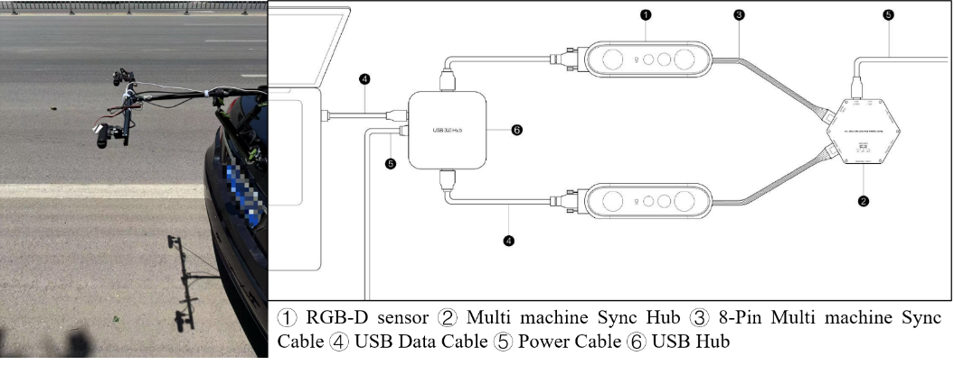

**Fig. 1.** Schematic diagram of multi RGB-D visual detection framework.

* 1. Results and analysis

Figure 2 shows the visualization image of point cloud collected and processed on road segment S2. The average registration error in the Z-axis across the centerline was computed after fusion. As shown in Table 1, the proposed method achieved significantly lower mean alignment errors compared to traditional ICP-based methods, demonstrating higher geometric consistency.

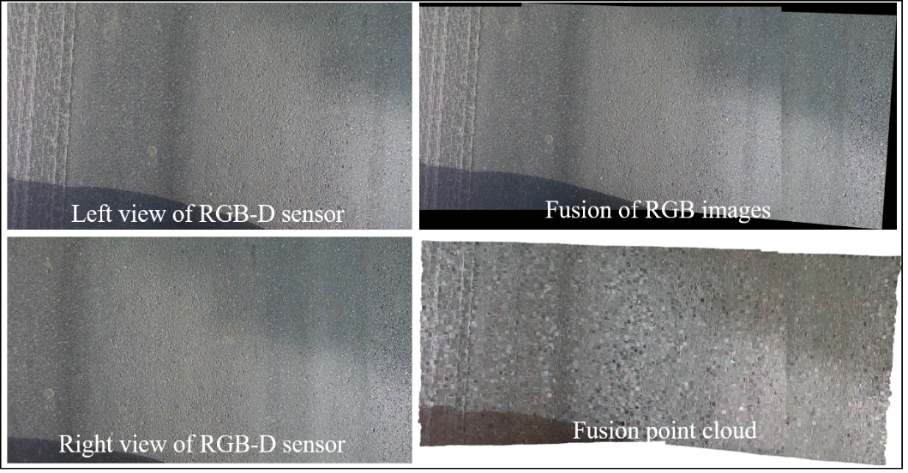

**Fig.2.** Road segment S2 collects and processes visualized images of point clouds.

**Table 1.** Quantitative Evaluation of Point Cloud Alignment Accuracy across Registration Methods.

| **Method** | **Mean Z Error (mm)** | **Std. Dev. (mm)** |
| --- | --- | --- |
| FPFH + ICP | 6.42 | 3.97 |
| SHOT + ICP | 5.78 | 3.21 |
| NDT + ICP | 4.63 | 2.58 |
| **Proposed** | **2.12** | **1.05** |

The proposed method was applied to all three test sections (S1–S3) to extract cross-sectional rut profiles and compute key geometric indicators, as shown in Figure 3. Results demonstrated consistent identification of rut valleys and edge transitions across varying pavement conditions. Specifically, the measured rut depths ranged from 7.4 mm to 29.1 mm, while edge height differences varied between 4.2 mm and 13.7 mm, reflecting the structural asymmetry present in deteriorated lanes. The computed road widths closely approximated the standard single-lane dimension (3.5 m), confirming the lateral accuracy of the profile localization algorithm. The composite Rutting Index (RI) exhibited strong differentiation across test segments, with higher values corresponding to deeper and more asymmetric rut formations. These outcomes validate the robustness of the proposed framework in capturing both vertical deformation and lateral profile structure, enabling reliable discrimination between mild and severe rutting patterns.

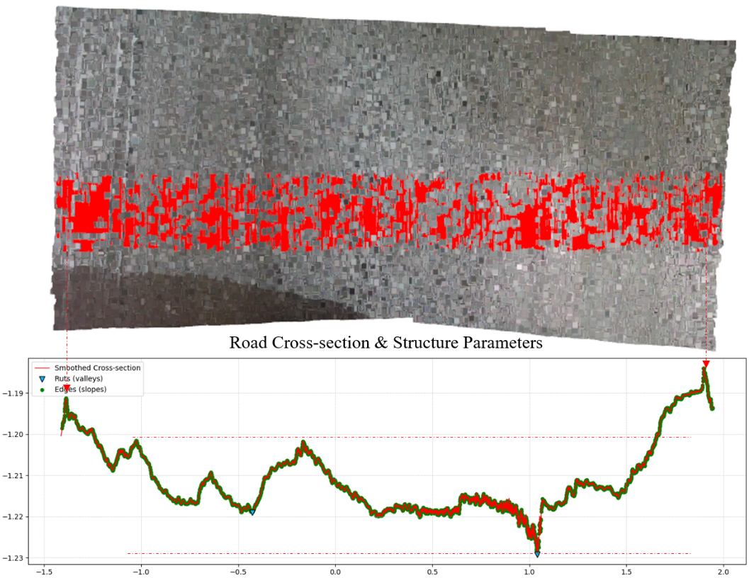

**Fig. 3.** Visual analysis of rutting point cloud for road section S2.

**Table 2.** Comparative Analysis of Cross-Sectional Rut Geometry and Computed Rutting Indices.

| **Road** | **Rut Depth $D_{r}$**  **(mm)** | **Edge Diff $∆h$**  **(mm)** | **Width $W$**  **(m)** | **RI Index** |
| --- | --- | --- | --- | --- |
| S1 | 18.6 | 9.3 | 3.45 | 13.21 |
| S2 | 29.1 | 13.7 | 3.31 | 19.84 |
| S3 | 7.4 | 4.2 | 3.52 | 6.27 |

1. Conclusion

A robust and scalable method for 3D reconstruction and rut localization on asphalt pavements using multi-sensor RGB-D vision was presented. Through the integration of stereo RGB-D fusion, slope-compensated point cloud alignment, and adaptive cross-sectional analysis, high-resolution pavement surface models were successfully constructed and analyzed. The proposed homography-based fusion mechanism was shown to outperform conventional feature-based registration methods in terms of geometric consistency and alignment accuracy. Furthermore, the adaptive rut profiling approach enabled precise localization of structural features, including rut valleys and shoulder edges, facilitating the computation of a composite rutting index that captures both vertical deformation and lateral asymmetry. Experimental results across multiple pavement scenarios validated the method’s reliability, demonstrating its potential for automated, high-frequency pavement condition assessment. Future work may involve real-time implementation, longitudinal rut progression analysis, and extension to multi-lane or curved road environments.

References

1. Fares A, Zayed T, Abdelkhalek S, et al. Rutting measurement in asphalt pavements[J]. Automation in Construction, 2024, 161: 105358.
2. Firoozi Yeganeh S, Golroo A, Jahanshahi M R. Automated rutting measurement using an inexpensive RGB-D sensor fusion approach[J]. Journal of Transportation Engineering, Part B: Pavements, 2019, 145(1): 04018061.
3. Azim T Y, Rahman M, Abed A, et al. Low-cost automated image based rutting identification and measurement[M]//Bituminous Mixtures and Pavements VIII. CRC Press, 2024: 476-483.
4. Tseng T Y, Lyu H, Li J, et al. M2S-RoAD: Multi-Modal Semantic Segmentation for Road Damage Using Camera and LiDAR Data[J]. arxiv preprint arxiv:2504.10123, 2025.
5. Mudabir M, Mosavi A, Imre F, et al. Modeling Remaining Service Life and Structural Health Monitoring of Roads with Machine Learning and Deep Learning[C]//2025 IEEE 23rd World Symposium on Applied Machine Intelligence and Informatics (SAMI). IEEE, 2025: 000413-000422.
6. Lin W, Li X, Han H, et al. A novel approach for pavement distress detection and quantification using RGB-D camera and deep learning algorithm[J]. Construction and Building Materials, 2023, 407: 133593.