Site-specific seismic hazard assessment incorporating near-fault effects for a soil site with embedded lava layers

Victor M. Hernández-Aguirre1 and Rajesh Rupakhety1

1 Earthquake Engineering Research Center, University of Iceland, 800 Selfoss, Iceland

vmh5@hi.is

**Abstract.** This paper presents results of a site-specific seismic hazard study for a wind farm in South Iceland. The site was characterized using ambient vibration tests, resonant column and down-hole testing. The stratigraphy consists of sand with embedded lava layers, which is commonly found in Iceland due to the extensive volcanism. The effect of local geology on expected ground motion is included by means of a period-dependent soil (de)amplification function, AF(T), where T is a generic oscillator period. AF(T) is defined as the ratio of the spectral acceleration including non-linear site-effects to the spectral acceleration at the bedrock. The estimates of the statistics of the amplification function are obtained by linear-equivalent analyses of the soil column with uncertain properties. The probabilistic seismic hazard assessment (PSHA) is based on Monte Carlo simulation of synthetic earthquake catalogues. This approach allows for a straightforward implementation of the soil effects in calculating hazard at the site. Epistemic uncertainties are also easily handled, without having to rely on logic trees, by switching over different candidate models of ground motion prediction through roulette sampling approach. Near-fault effects, which are important for long-period structures such as the ones considered here, are incorporated deterministically from the results of physics-based numeral simulations of wave propagation of the most relevant earthquake scenarios from the deaggregation of the seismic hazard. Design ground motions and response spectra are therefore defined from a combination of probabilistic hazard assessment and simulation of potential scenario events incorporating aleatory uncertainties in key parameters defining the seismic rupture.

**Keywords:** Site-effects, Amplification factors, PSHA, Site response.

1 Introduction

This paper presents results of a site-specific seismic hazard assessment for a wind farm in South Iceland. This project represents the first wind farm to be constructed in Iceland. Since the site is located close to the South Iceland Seismic Zone (SISZ), large earthquakes occurring at short distances have the most important contribution to the seismic hazard. The ground motions from this type of earthquakes are likely to present near-fault effects which result in long-period directivity pulses that can severely affect tall structures such as wind turbine towers [1]. This can result in excessive displacements which affect the functioning of the turbines. This can also result in excessive foundation moments that can potentially cause overturning. Current design codes do not consider such effects in their recommendations. Although such effects are not critical for stiff structures, such as 2-3 storey buildings, tall towers can be more severely affected. It is therefore essential to quantify such effects.

The focus of the study is on examination of two important issues for seismic design of wind turbine towers: namely, local site effects and near-fault effects in design seismic ground motion. Fig. 1 summarizes the methodology used in this study. The first part consists in modelling local site-effects by means of amplification functions (AF) obtained from one-dimensional equivalent linear site response analyses performed for two reference sites. Then, probabilistic seismic hazard assessment (PSHA) based on Monte Carlo simulation of synthetic earthquake catalogues is performed, including the site response via the amplification functions established in the first step. Near-fault effects are incorporated in a latter stage by means of physics-based numeral simulations of wave propagation of the most relevant earthquake scenarios obtained from the deaggregation of the PSHA results. Aleatory uncertainties are incorporated in key parameters defining the seismic ruptures. Finally, a deterministic design spectrum including site-effects and near-fault effects is defined from the response spectra of the time histories obtained from the numerical simulations and from the uniform hazard spectrum (UHS) from the PSHA.

**Fig. 1.** Overview of the methodology used in this study.

2 Site-effects modelling

The local geology at project site, Búrfellslundur, consists of layers of basalt with some layers of soft sediments and tephra/scoria sandwiched between them, a condition that is common in Iceland due to active volcanism. Local site conditions influence amplitude and frequency content of seismic ground motion, known as site-effects. The stiff basalt and the softer tephra/scoria/sand layers constitute sharp impedance contrasts at which ground-motion features get altered. Depending on the geotechnical properties of the site, ground motion amplitudes at certain frequencies may be amplified (in comparison to that at outcropping bedrock) while those at other frequencies may be reduced.

This chapter describes the methods used and the results obtained from site response analyses aimed to quantify the site-effects at two reference sites considered as representative of the whole studied area, TH-03b and TH-02.

* 1. Site characterization

Boreholes were drilled at the planned locations of all the wind turbines, marked in Fig. 2. All drillings passed through a lava layer (THi), varying in thickness from 3 meters to over 20 meters, followed by a thin sediment layer, which was in turn underlain by a second basalt layer (THf). All these drillings stopped at the THf layer and none of them reached the bedrock. However, the stratigraphic profiles of three boreholes (marked with blue squares in Fig. 2) from a previous site investigation are available. TH-03b and TH-04 reached the old bedrock at 52 m and 30 m, respectively. Two, four and one lava layer were encountered at TH-03b, TH-02 and TH-04, respectively.

**Fig. 2.** The Búrfellslundur wind farm area. Red squares indicate the proposed location of the wind turbines, where boreholes were drilled. Blue squares indicate the location of boreholes drilled in the past. The labels DH and HV show the location of down-holes and HVSR measurements performed as part of this study.

With the aim defining the mechanical properties needed for site response analyses, laboratory tests , resonant-column tests at different confining pressures were performed on soil samples retrieved from sites T14 and T20, with results presented in Fig. 3. These samples were classified as well-graded sand with silt (SW-SM). The model of Darendeli and Stokoe [2] fitted to the experimental results was used for site response analyses. Additionally, down-hole tests and ambient vibration measurements were performed at the locations shown in Fig. 2.

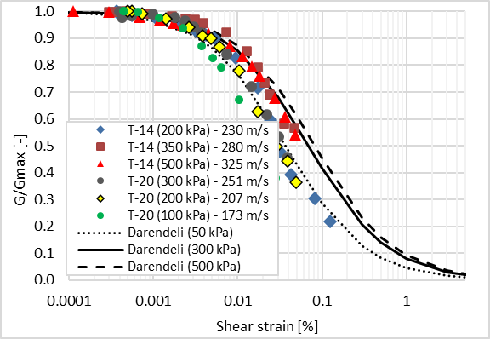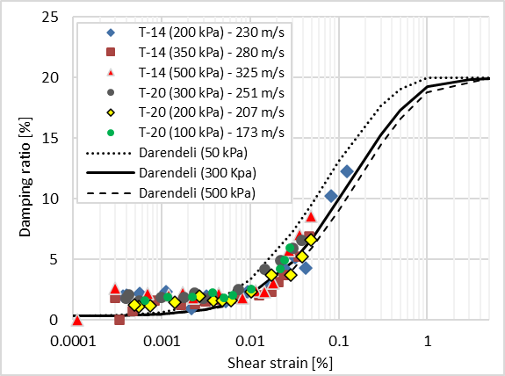

**Fig. 3**. Shear modulus degradation curves and damping ratio curves obtained from resonant column tests performed on samples retrieved from the sediment layer between lavas THf and THi at sites T14 and T20.

Based on the geotechnical investigation, two sites were considered as representative of the whole studied area, TH-03b and TH-02. The geotechnical properties relevant for site response analysis, i.e., shear wave velocity (Vs), mass density (ρ) and thickness of each material layer, are presented in Table 1 for site TH-03b. Since the mechanical properties were obtained from few experiment tests, there is some uncertainty in their values, hence, it was decided to include some random variability. The thicknesses of some layers were allowed to vary randomly, following a uniform probability distribution with the bounds shown in Table 1. Shear wave velocity was varied randomly using a Monte Carlo type simulation of random numbers. Since the effect of density was less important with respect to the effect of Vs, density was kept constant.

**Table 1.** Geotechnical properties for site TH-03b.

|  |  |  |  |  |  |  |  |
| --- | --- | --- | --- | --- | --- | --- | --- |
| Layer | Thickness (m) | | | Density, ρ (kg/m3) | Shear-wave velocity, Vs (m/s) | | |
| Min | Mean, μ | Max | μ - σ | Mean, μ | μ + σ |
| Overburden, Tephra and sand | 2 | 2 | 2 | 1900 | 236 | 275 | 319 |
| Scoria | 0.5 | 0.5 | 0.5 | 2500 | 955 | 1110 | 1289 |
| Basalt THi | 13 | 14 | 15 | 2800 | 1713 | 1800 | 1893 |
| Interbed I | 8.5 | 9.5 | 10.5 | 2000 | 270 | 313 | 364 |
| Scoria | 0.5 | 1 | 1.5 | 2500 | 955 | 1110 | 1289 |
| Basalt THf | 14 | 15 | 16 | 2800 | 1713 | 1800 | 1893 |
| Interbed II | 12 | 13 | 14 | 2000 | 346 | 383 | 423 |
| Bedrock | - | | | 2850 | 1857 | 2050 | 2268 |

* 1. Amplification functions

As it will be detailed in Chapter 3, an amplification function is needed to include non-linear site response into PSHA[3]. The amplification function AF(T) is defined as:

$AF\left(T\right)=\frac{{Sa}_{s}^{}(T)}{{Sa}_{r}^{}(T)}$ (1)

where Sar is the spectral acceleration on rock and Sas is the spectral acceleration including non-linear site-effects. The AF is assumed to be lognormally distributed, so:

$P\left[AF>\frac{z}{x}|x\right]=\hat{Φ}\left(\frac{\log{[\frac{z}{x}]}-log⁡[μ_{AF|X}\left(x\right)]}{σ_{logAF|X}}\right)$ (2)

The AF is developed from a large suite of linear-equivalent site response analyses (LESRA) performed for a range of input rock motion intensities and multiple site property realizations defined through Monte Carlo. The AF predictive relationship and its standard deviation are developed by statistical regression of the AF data generated by the NLSRA. The functional form used for predictive relationship is:

$log(AF)=a+b*log({Sa}_{r})+c*log{({Sa}_{r})}^{2}+ɛσ$ (3)

A dataset of 147 ground motion records was used as input for the LESRA. Approximately 60% of the records are from Icelandic earthquakes, including the two June 2000 Mw6.5 South Iceland earthquakes and the 2008 Mw6.3 Ölfus earthquake. Since there are no Icelandic records from earthquakes with magnitudes larger than 6.5, we supplemented the dataset with records from strike-slip earthquakes in Turkey, Japan, United States and New Zealand. The dataset covers magnitudes from 5 to 7.5 and Joyner-Boore distances from 0 to 80 km. The coefficients a, b and c of the predictive model for the amplification function in Eq. 3 were obtained from regression on amplification functions computed from the LESRA. Fig. 4 shows the median and median plus/minus one standard deviation of the amplification function (AF) for site TH-03b for three different structural periods (T). The model for PGA (T=0s) has the largest standard deviation, as evident from. Furthermore, the median AF for PGA is lower than zero for all values of Sar, since the non-linear behaviour leads to a reduction of PGA. In general, as Sar increases AF decreases, since for larger demands (larger values of Sar) the non-linearity increases and so does the damping ratio, leading to a de-amplification.

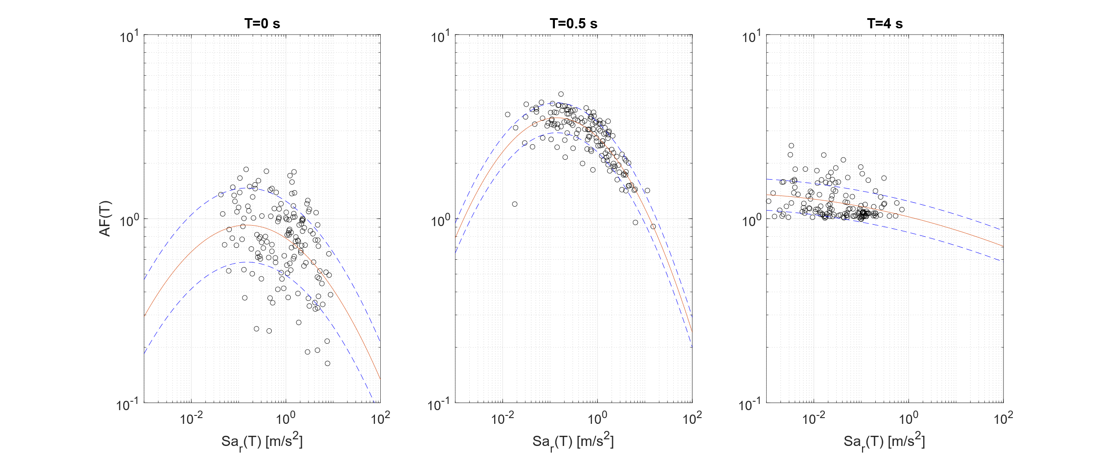

**Fig. 4.** Median and median plus/minus one standard deviation of the predictive relationships for the amplification function (AF) for site TH-03b for three different structural periods (T).

**3 PSHA**

Probabilistic seismic hazard assessment (PSHA) is based on Monte Carlo simulations [4, 5]. In this method, synthetic earthquake catalogues are simulated in a region in a reference period (for example 50 or 100 years) to represent expected temporal and spatial distribution of earthquakes consistent to past behaviour. For each simulated event, probability of exceeding a certain ground motion level is estimated from appropriate ground motion prediction models (GMPEs). By performing a large number of simulations, probabilities of exceedances can be calculated by counting the relative number of simulations exceeding a critical value.

The conventional method for accounting for site response PSHA involves using the rock Uniform Hazard Spectrum (UHS) as input for LESRA. The UHS is utilized to select a set of time series that, on average, match the UHS. These time histories are then input into one-dimensional LESRA to determine site amplification as a function of period. The median amplification and its standard deviation are used to compute a median and plus/minus one standard deviation surface response spectra. However, the hazard level corresponding to the computed surface motion remains unknown, as the uncertainty in site amplification is not accounted for in the PSHA. To develop a surface response spectrum with a defined hazard level, both site amplification and its associated uncertainty must be integrated into the PSHA through a probabilistic approach [6].

Bazzurro and Cornell [3] proposed what is known as the convolution approach to compute a seismic hazard curve including local site conditions by convolving the rock hazard curve with the probability density function for site amplification (AF). Assuming that AF is a function of the spectral acceleration on rock (Sar) and is independent of earthquake magnitude and distance, the soil hazard calculation becomes:

$λ_{s}(z)=\int_{{Sa}_{r}}{P\left[AF>\frac{z}{x}|x\right]}f_{{Sa}_{r}}\left(x\right)dx$ (4)

where fSar(x) is the derivative of the rock hazard curve and $P\left[AF>\frac{z}{x}|x\right]$ is the probability that AF is greater than z/x given Sar=x.

Instead of computing the convolution in Eq. 4, we apply the amplification functions directly in the Monte Carlo approach for PSHA. Some of the results from the PSHA are shown hereafter.

**3.1 Uniform hazard spectra**

For the horizontal component three uniform hazard spectra (UHS) for a 475-year return period were computed, for rock, TH-03b and TH-02 site conditions. The spectra for a point located at the center of the windfarm are shown in Fig. 5. In the UHS for site profiles TH-03b and TH-02 peaks are observed at approximately 0.6 s and 0.8 s, respectively. These peaks coincide with the fundamental site periods. The spectral acceleration for T<0.3 s is larger when considering rock conditions, but it is larger for T>0.3 s when introducing the non-linear site response. An envelope for the three spectra was defined, represented by a black line in Fig. 5.

**Fig. 5** Horizontal uniform hazard spectra at turbine 14 for rock conditions (green line) and including site-effects considering the soil profiles TH-03b (blue line) and TH-02 (red line). An envelope (black line) of the three spectra was defined. Damping ratio is 5% of critical.

**3.2. Deaggregation**

Deaggregation of hazard for a given annual rate of exceedance provides information about the relative contributions of different earthquake size and source-site distance scenarios to the total hazard at a site. Deaggregation results of the hazard considering rock conditions for horizontal spectral acceleration at 4 s corresponding to mean return periods of 200, 475, and 1000 years are presented in Fig. 6. The period of 4 seconds was selected since it is close to the fundamental period of the turbines. Deaggregation results when considering site profiles TH-03b and TH-02 were very similar to the deaggregation for rock conditions. In all cases the deaggregation results indicate that the most important contribution to the hazard is due to the earthquakes in the magnitude range Mw 6.5 to 7 at epicentral distance of 5-15 km. These are earthquakes occurring in the eastern part of the SISZ.

**Fig. 6.** Hazard deaggregation for Sa at 4 s corresponding to a mean return period of 200 years (left), 475 years (center), and 1000 years (right).

**4 Near-fault effects**

Considering the deaggregation results that indicate that earthquakes with Mw>6 within 7-15 km of Búrfellslundur have the most important contribution to the seismic hazard, and that for these conditions near-fault effects, which are detrimental for the response of wind turbines, are likely to occur, we incorporate near-fault effects deterministically from the results of physics-based numeral simulations of wave propagation of the most relevant earthquake scenarios from the deaggregation of the seismic hazard

## 4.1 Physics-based simulations

Three-dimensional physics-based numerical simulations (PBS) of ground motion were carried out using the open-source computer code SPEED [7]. The numerical mesh for the simulations, shown in Fig. 7, was created using the software CUBIT. It extends over a volume of about 113x87x25 km3, and it is discretized using an unstructured hexahedral conforming mesh. The mesh, consisting of 572’760 spectral elements, is designed so that simulations are accurate up to fmax = 1.8 Hz, to limit the computational load. The shear wave velocity at the ground surface is 1500 m/s, hence the simulations’ results are valid for rock conditions.

A kinematic representation of the fault rupture process was adopted to model the seismic source. Five slip scenarios with Mw6.5 and three scenarios with Mw6.8 were generated. Rupture times are computed considering a local rupture velocity ~0.85Vs with some added variability. Rakes are vectors pointing towards the south to have a strike-slip right-lateral fault mechanism. For each slip distribution different rise times and hypocenter locations were considered, so a total of 20 earthquake simulations were performed.

**Fig. 7.** Three-dimensional mesh for South Iceland consisting of 572’760 spectral elements with spectral degree SD=3. The location of the wind farm is represented by the yellow triangle. The blue line represents the trace of the fault for a scenario earthquake close to the edge of the SISZ, whose slip distribution is shown to the right.

Since the results from the PBS are limited to the long-period range T≥T*, with T*=1/fmax=0.55 seconds, the low-frequency simulated waveforms from SPEED are enriched in the high-frequency range to produce time histories with a realistically broad frequency content. This is an essential step to treat the simulated waveforms in the same way as recordings, and, therefore, make them usable in earthquake engineering applications. The ANN2BB approach [8], which is based on ANNs (Artificial Neural Networks) trained on strong ground motion recordings, allows to predict short-period response spectral ordinates from the long-period ones coming from PBS, then a stochastic waveform matching the ANN2BB spectrum is selected, and the high-frequency part of this waveform is merged with the low-frequency part from the PBS.

## 4.2 Seismic actions including near-fault effects

A total of 600 broadband (BB) three-component time histories were obtained, 30 (one for each turbine) from each of the 20 simulations. These BB time histories are valid for rock conditions, i.e., they do not include site-effects. Therefore, LESRA was applied to each of the 1200 horizontal BB accelerations, considering both the TH-03b and the TH-02 site profiles, resulting in 2400 acceleration time histories including site-effects. The PSA (damping ratio of 5%) of these time histories are shown in Fig. 8, together with their 80th percentile (green line) and 90th percentile (blue line). Both the 80th and 90th percentiles are larger than the 475-year return period UHS model for periods larger than 1.5 s, due to the near-fault effects that are intrinsically included. These spectra present a “bump” in the 1.5-2 s period range, which coincides with the predominant period observed in near-fault record from earthquakes of magnitudes 6.5 to 6.8 [9].

**Fig. 8.** PSA (damping ratio of 5%) of BB time histories with their 80th percentile (green line) and 90th percentile (blue line).

For design purposes it is proposed to take the largest of the envelope of the UHS (red line), which do not include near-fault effects, and the 90th percentile response spectrum from the physics-based simulations.

A significant advantage of employing physics-based simulations lies in the direct accessibility of ground motion time histories. For instance, it is possible to select a suite of ground motions corresponding to the 90th percentile of the response spectrum for use in time history analyses.

**5 Conclusions**

A detailed analysis of seismic hazard for the proposed wind farm construction site in Búrfellslundur area is presented in this paper. Design parameters of engineering interest being investigated are peak ground acceleration (PGA) and elastic response spectra. Hazard curves have been computed by using PSHA. In addition, uniform hazard spectra are provided, and a design spectrum model is proposed.

Effects of local site conditions are incorporated into PSHA through a probabilistic approach, in which one-dimensional LESRA is used to define the probability distribution of site amplification given a specific rock motion amplitude. This is an improvement with respect to previous studies [10]. Simplified models were used for site response analysis. Three-dimensional effects and effects of lateral heterogeneities are not considered. Considering the volcanic geology of the proposed construction area, such simplifications are judged to be reasonable. Some uncertainties are present in the extent and details of available geotechnical information of the proposed construction site. Only one borehole in the study area reached the old bedrock, TH-03b, so the bedrock depth at other locations is unknown. Since depth to bedrock affects frequencies of site vibration, some uncertainty in the reported site response results can be expected. However, to account for this uncertainty we computed the hazard for three reference site profiles, TH-03b, TH-02 which is deeper than TH-03b, and for rock conditions, i.e., with no site-effects. The proposed design spectrum is an envelope of the UHS for the three reference site conditions, hence we are accounting for the uncertainty in the bedrock depth. It is also important to consider the fact that the site response frequencies are not close to the expected vibration frequencies of the wind turbines. Even if there was a thicker, soft layer beneath the known profile, it is not expected to be so thick that it will reduce the site frequency to bring it close to resonance with the proposed structures.

Since near-fault effects, such as long-period directivity pulses, can severely impact tall structures like wind turbine towers [1], these effects are incorporated deterministically in the seismic hazard assessment. This is done using results from physics-based numerical simulations of wave propagation for the most relevant earthquake scenarios identified through seismic hazard deaggregation, which are earthquakes with Mw>6 within 7-15 km of Búrfellslundur, at the eastern edge of the SISZ. Aleatory uncertainties in key parameters defining the seismic ruptures are incorporated. 17 earthquakes of Mw6.5 and 3 of Mw6.8 were simulated using the code SPEED. Broadband (BB) ground motion time histories were generated from the physics-based simulations’ results using artificial neural networks trained on Icelandic ground motion data. Then, LESRA was applied to the horizontal BB accelerations, resulting time series including both, near-fault effects and site-effects. The 80th and 90th percentiles of the PSA of these time histories were computed. Both the 80th and 90th percentiles are larger than the 475-year return period UHS model for periods larger than 1.5 s, due to the near-fault effects that are intrinsically included and affect primarily the long-period motion. For design purposes it is recommended to take the largest of the model spectrum from PSHA and the 90th percentile response spectrum from the physics-based simulations.

References

1. Sigurðsson, G., Rupakhety, R., Rahimi, S. E. & Olafsson, S.: Effect of pulse-like near-fault ground motions on utility-scale land-based wind turbines. Bulletin of Earthquake Engineering 18, 953–968 (2020).
2. Darendeli, M. & Stokoe, K.: Development of a new family of normalized modulus reduction and material damping curves. Geotechnical Engineering Report GD01-1, University of Texas (2001).
3. Bazzurro, P. & Cornell, A.: Nonlinear Soil-Site Effects in Probabilistic Seismic-Hazard Analysis. Bulletin of the Seismological Society of America 94, (2004).
4. Musson, R.: The use of Monte Carlo simulations for seismic hazard assessment in the UK. Annali di Geofisica 43, (2000).
5. Solnes, J., Sigbjörnsson, R., Eliasson, J.: Probabilistic Seismic Hazard Mapping of Iceland. In: Proceedings of the 13th World Conference on Earthquake Engineering, Vancouver, Canada (2004).
6. Rathje, E., Pehlivan, M., Gilbert, R. & Rodriguez-Marek, A.: Incorporating Site Response into Seismic Hazard Assessments for Critical Facilities: A Probabilistic Approach. Geotechnical, Geological and Earthquake Engineering 37, 93–111 (2015).
7. Mazzieri, I., Stupazzini, M., Guidotti, R. & Smerzini, C.: SPEED: SPectral elements in elastodynamics with discontinuous galerkin: A non-conforming approach for 3d multi-scale problems. Int J Numer Methods Eng 95, 991–1010 (2013).
8. Paolucci, R. et al.: Broadband ground motions from 3D physics-based numerical simulations using artificial neural networks. Bulletin of the Seismological Society of America 108, 1272–1286 (2018).
9. Rupakhety, R., Sigurdsson, S. U., Papageorgiou, A. S. & Sigbjörnsson, R.: Quantification of Ground-Motion Parameters and Response Spectra in the near-Fault Region. Bulletin of Earthquake Engineering vol. 9 (2011).
10. Rupakhety, R., Ólafsson, S., & Sigurðsson, G.: Site response analysis and near-fault effects for seismic resistant design of wind turbine towers in the Búrfellslundur area. Landsvirkjun Report Number LV-2016-040, (2016).