Autonomous Drone-based System for Precision, Non-contact Surface Finishing in Construction
Tianyu Ren¹, Xiayu Zhao¹ and Houtan Jebelli²
¹ Ph.D. Student, University of Illinois Urbana-Champaign, Champaign, IL 61820, USA, tianyur2@illinois.edu, xiayuz3@illinois.edu
² Assistant Professor, University of Illinois Urbana-Champaign, Champaign, IL 61820, USA, hjebelli@illinois.edu
Abstract. Precision surface manipulation is increasingly needed in modern construction, particularly in areas that are difficult to access or sensitive to excessive pressure. Existing methods often rely on heavy machinery, which risks damaging delicate surfaces and lacks flexibility in confined or irregular spaces. This paper presents a novel drone-based platform for non-contact surface operations that ensures both adaptability and high precision. The system is built on a hexacopter drone equipped with a lightweight rotating disc designed to uniformly distribute mechanical energy, enabling consistent surface refinement without physical contact. A dual-layer control system governs drone stability and path accuracy: the lower layer integrates Proportional-Integral-Derivative (PID) and Model Predictive Control (MPC) to maintain stable altitude and attitude in real time; the upper layer dynamically adjusts the flight trajectory using a predictive surface attention model and iterative refinement based on real-time sensor feedback. This attention model fuses Light Detection and Ranging (LiDAR) and camera data via a convolutional neural network to identify and prioritize high-importance regions. Simulation results show that the system achieved 98.2% refinement completeness on smooth surfaces, 95.6% on moderately rough, and 91.3% on rough surfaces, with height deviations ranging from 0.03 to 0.05 meters and latency between 147 and 152 milliseconds, demonstrating its potential for adaptive, high-precision surface operations in construction.
Keywords: Construction Robotics, Unmanned Aerial Vehicle, Construction Automation, Machine Learning
- Introduction
Surface manipulation is a critical component of construction, directly impacting the quality, durability, and aesthetic appeal of built structures [1]. Tasks such as floor finishing, wall plastering, concrete leveling, surface preparation for painting or sealing, and tiling are integral to achieving the desired specifications of any construction project. These tasks require meticulous execution to ensure smooth, even surfaces that meet precise tolerance levels, especially in large commercial projects [2]. For instance, extensive floor spaces must be leveled and finished to exact standards to comply with building codes and facilitate subsequent installations, while interior walls require uniform plastering to maintain aesthetic consistency. As construction projects increase in size and complexity, the demand for efficient and precise surface manipulation grows proportionally, consuming a significant portion of project timelines, labor resources, and overall costs [3].
Despite the critical importance of surface manipulation, these tasks are predominantly carried out manually [4]. Skilled laborers depend on conventional tools such as trowels, screeds, and power floats to achieve desired surface finishes. For example, floor finishing involves manually maneuvering mechanical floats over wet concrete, which requires skill, experience, and physical effort to ensure evenness and remove imperfections. Similarly, plastering tasks require the manual application and smoothing of layers, often demanding precision across large surfaces to achieve uniform results. Manual surface manipulation, while capable of delivering high-quality results under optimal conditions, has inherent drawbacks: it is labor-intensive, time-consuming, and subject to variability in quality. The outcomes are highly dependent on the skill and fatigue levels of workers, making it challenging to maintain consistent quality across large or intricate surfaces. Furthermore, accessing certain areas may be difficult, further complicating the process and contributing to inefficiencies and delays as project requirements become more intricate.
The advent of construction robotics offers a potential solution to the challenges of manual surface manipulation [5]. Robots have already made significant progress in automating various construction tasks, such as bricklaying, welding, and material transport. In the context of surface manipulation, robotic systems possess the capability to perform repetitive tasks consistently without the limitations of human fatigue, ensuring uniform results over large areas. Robotic systems can be equipped with precision tools programmed to follow exact paths, maintaining consistent pressure and force throughout the treatment process [6]. This controlled approach theoretically facilitates faster task completion, improved quality control, and reduced labor costs, making robotic solutions promising alternatives for many types of surface work. As such, the integration of robots into surface manipulation tasks has the potential to enhance both efficiency and consistency in construction processes.
However, despite the apparent advantages, current robotic systems face significant limitations in surface manipulation applications. Many existing robotic solutions rely on ground vehicles with direct physical contact with surfaces, mirroring traditional manual methods [7]. This reliance can lead to unintended damage, particularly on delicate surfaces that require minimal disturbance. The weight and pressure exerted by robotic systems can cause imperfections, undermining the benefits of automation in settings where surface protection is crucial. Additionally, while robots perform well in large, open areas, they often struggle in confined or irregularly shaped environments that require precise maneuverability and fine adjustments. Most robotic systems are pre-programmed to follow rigid paths, lacking the adaptability to respond to dynamic construction environments. As a result, these robots cannot make real-time adjustments to account for surface irregularities, unexpected obstacles, or external factors like vibration, limiting their effectiveness in ensuring consistent surface quality in complex construction scenarios.
In light of the limitations of existing surface manipulation technologies, this paper introduces a novel, non-contact drone-based platform tailored for precision surface manipulation in construction. Unlike traditional robotic systems, this approach utilizes a hexacopter drone equipped with a lightweight aluminum rotating disc, allowing it to perform surface adjustments while hovering above the target area. This design minimizes the risk of surface damage by eliminating direct contact, thereby offering enhanced protection for treated surfaces. The drone’s flight control relies on a PID (Proportional-Integral-Derivative) algorithm, which uses real-time data from an Inertial Measurement Unit (IMU) and LiDAR sensors to maintain consistent altitude relative to the surface, ensuring precise and uniform treatment even under changing conditions. To further ensure stability, a Model Predictive Control (MPC) algorithm manages the drone’s pitch, roll, and yaw, adjusting to external disturbances like wind gusts or vibrations from the rotating disc. This real-time adjustment capability allows for optimal flight stability and consistent surface manipulation in challenging environments. Moreover, a systematic sweeping path algorithm directs the drone to cover large areas uniformly with minimal overlap, maximizing efficiency and addressing existing gaps in robotic surface manipulation methods. The proposed system offers a flexible and adaptive solution for surface treatment in complex construction settings, where both precision and surface protection are critical.
- Current Developments in Surface Operations and Drone-Based Platforms in Construction
The integration of automated systems has revolutionized the construction industry, particularly in tasks that require repetitive precision and involve hazardous environments. Technologies such as drones, autonomous robots, and advanced control systems have reshaped many aspects of construction processes, offering significant improvements in efficiency, accuracy, and safety [8]. Among these advancements, surface manipulation—a critical aspect of construction involving tasks like floor finishing, wall plastering, and concrete leveling—has benefited from the adoption of robotic solutions.
Historically, surface manipulation in construction has relied heavily on ride-on and walk-behind robotic systems, developed to handle large-scale operations such as concrete finishing and floor leveling. These systems are designed to increase efficiency in expansive, open areas by using mechanical components like trowels or floats to achieve desired surface finishes [9]. While effective for large spaces, these systems typically operate through direct physical contact with the surface. This approach can lead to surface damage, particularly when the pressure is not well-regulated. Additionally, the large size and weight of these systems limit their flexibility, making them unsuitable for confined or irregular spaces where greater precision is required [10]. Consequently, their applicability is restricted to specific environments, leaving more delicate tasks or complex geometries inadequately addressed by existing robotic solutions.
In contrast, drones have emerged as a versatile tool in construction, capable of accessing hard-to-reach areas, providing real-time aerial monitoring, and performing tasks traditionally reliant on scaffolding or cranes [11]. UAVs (Unmanned Aerial Vehicles) have primarily been used for site inspection, surveying, and progress tracking, integrating cameras and LiDAR sensors to collect comprehensive data [12]. These applications have underscored drones' capabilities in capturing surface details, evaluating quality, and monitoring progress without direct human involvement. However, the use of drones for surface manipulation tasks remains relatively underexplored. Initial research has focused on drone-based systems capable of manipulating objects or tools through grippers or actuators. While these systems demonstrate potential, they often lack the necessary precision and stability required for delicate surface work, limiting their effectiveness in applications that demand consistent results over varying terrains and complex geometries [13].
Given these limitations, achieving high-precision control of drones or robotic systems becomes critical for surface manipulation. The control system must ensure not only stability but also accurate movement adjustments in response to real-time data. Modern control algorithms play a pivotal role in this regard, regulating system behavior and facilitating precise operations. For instance, PID (Proportional-Integral-Derivative) control algorithms are widely employed in drones and autonomous robots to achieve accurate movement by continuously adjusting the system’s response based on sensor feedback [14]. PID control is particularly effective in maintaining steady movement and compensating for minor disturbances during operation. However, its performance can be limited in more complex, dynamic environments where greater adaptability is required.
To address more variable and unpredictable conditions, Model Predictive Control (MPC) has been adopted in advanced systems. MPC algorithms are capable of predicting future system states and making real-time adjustments to optimize performance [15]. They are especially useful in environments where external disturbances—such as wind, vibration, or surface irregularities—are common. By anticipating and counteracting these disturbances before they impact the task, MPC algorithms enhance the precision and stability of surface manipulation efforts. Despite its advantages, MPC alone may not always be sufficient for complex surface tasks, as its predictive capabilities depend heavily on accurate modeling and sensor feedback.
Despite these advancements, studies on the combination of PID and MPC algorithms in surface manipulation remain limited. An integrated approach could offer a more robust framework for maintaining stability and precision, particularly in dynamic construction environments where conditions frequently change [16]. The potential synergy between PID’s ability to make fine adjustments and MPC’s predictive capacity could provide a more adaptable and precise solution for UAV-based surface manipulation. Exploring this integration could pave the way for more flexible and reliable systems capable of meeting the diverse demands of modern construction projects.
Recent advances in perception-driven automation have emphasized the importance of integrating geometric and visual data to support fine-grained decision-making in UAV-based systems [17]. In surface manipulation tasks, the ability to identify and prioritize critical regions—such as uneven textures, material transitions, or localized defects—is essential for optimizing both coverage efficiency and final quality. LiDAR sensors offer reliable height and geometry data, while RGB cameras provide complementary appearance information. However, isolated use of either modality often fails to capture the full complexity of construction surfaces. To address this, convolutional neural networks (CNNs) have been widely adopted for multi-modal data fusion, enabling robust extraction of spatial features and semantic patterns from combined inputs [18]. Despite the proven capabilities of CNNs in defect detection and surface classification, their application in real-time UAV trajectory guidance for construction remains limited. This gap motivates the integration of a predictive surface attention model that fuses LiDAR and RGB inputs to inform adaptive path planning and trajectory refinement during flight.
In summary, despite advances in construction automation, existing systems still face challenges in maintaining precision and adaptability in dynamic environments. Drones offer a promising alternative for surface manipulation, but their effectiveness is often limited by control and stability constraints. This paper introduces a perception-guided drone platform that integrates LiDAR and camera data with a dual-layer control system combining PID and MPC, enabling adaptive and high-precision surface operations in complex construction scenarios.
- Non-Contact Two-Layer Flight Control and Area Sweeping Algorithm
This methodology introduces a unified system for UAV-based surface coverage, combining a two-layer control architecture with an adaptive area-sweeping algorithm, as illustrated in Figure 1.

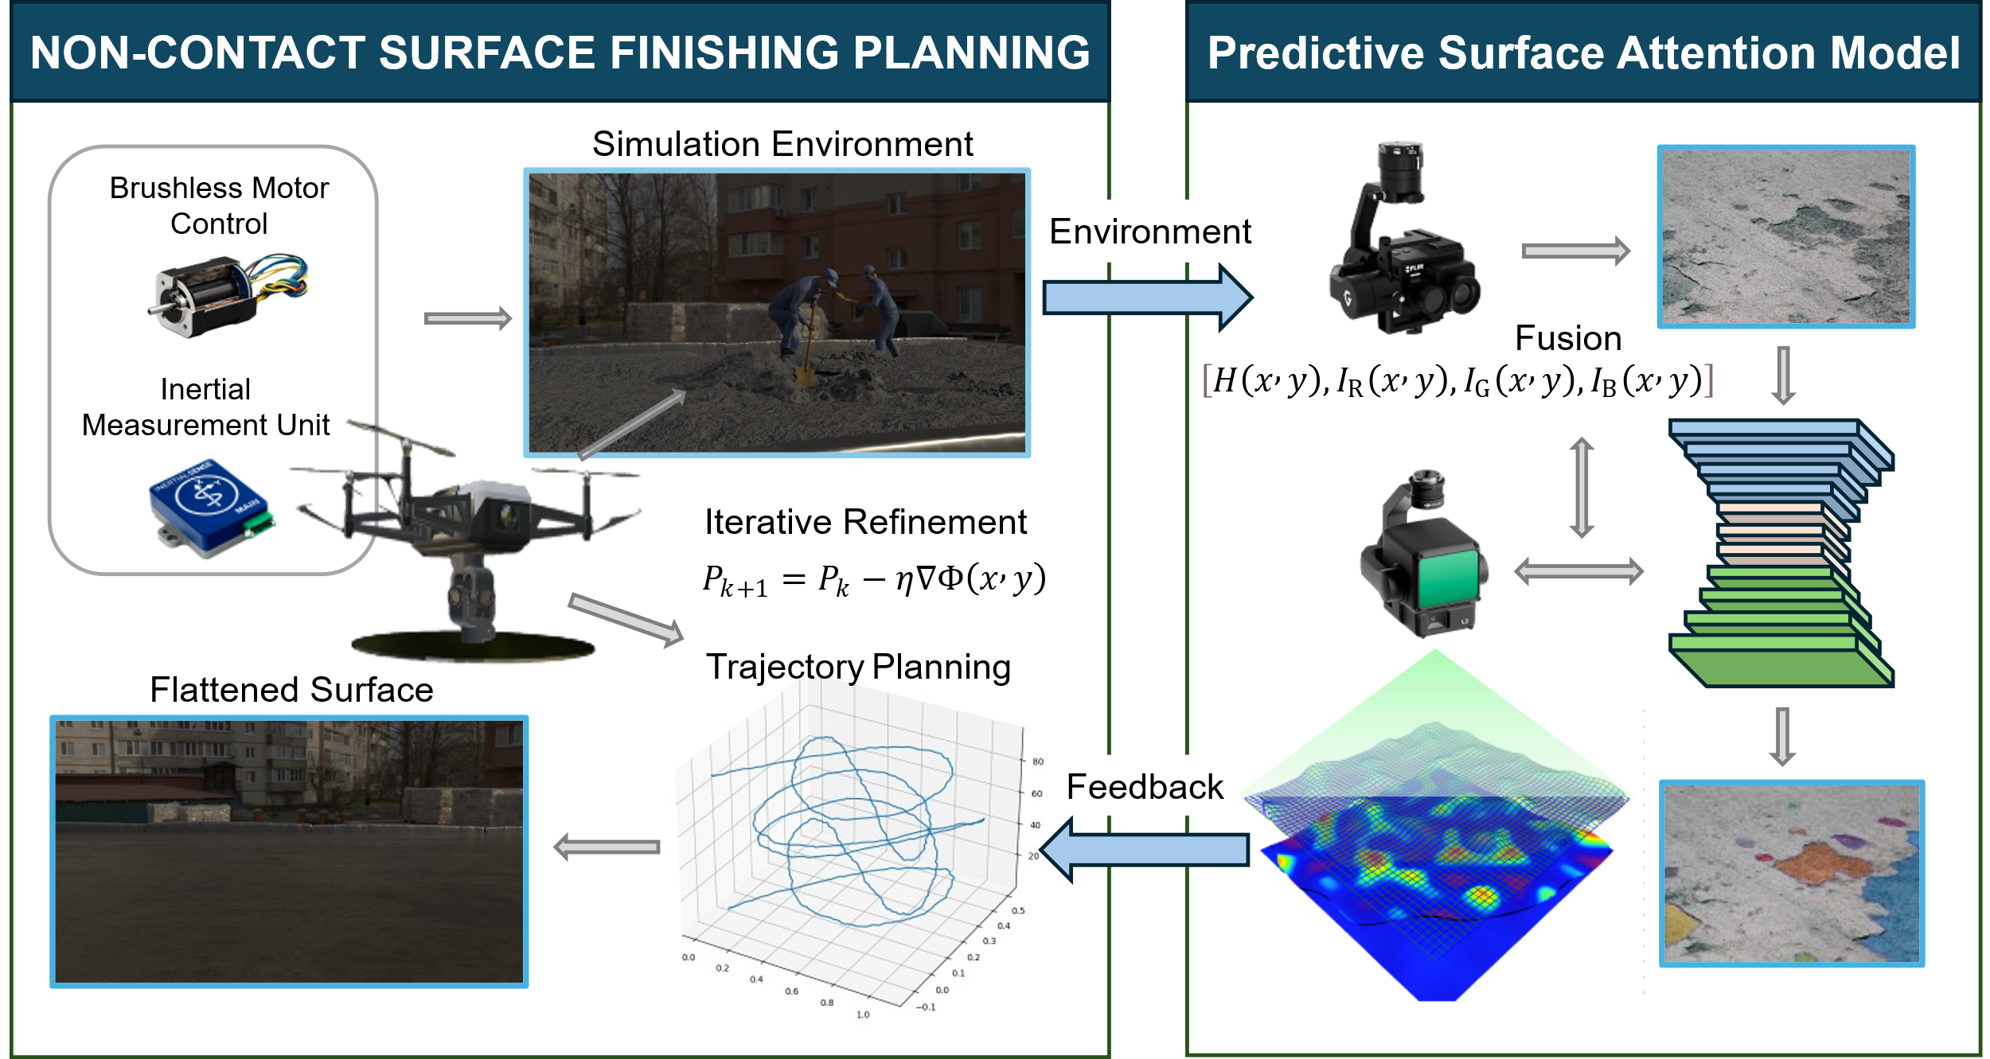
Fig. 1. Non-contact surface finishing with two-layer flight control and planning.
The upper layer focuses on high-level trajectory optimization for energy-efficient and complete surface coverage, while the lower layer is responsible for trajectory execution through a hybrid control framework combining Proportional-Integral-Derivative (PID) control and Model Predictive Control (MPC). An attention-driven surface model based on convolutional neural networks (CNNs) dynamically informs path refinements in real time to prioritize high-importance surface regions.
  - High-Level Navigation and Path Optimization
The high-level navigation layer formulates the global trajectory, ensuring coverage efficiency and prioritization of critical areas. The optimization problem minimizes energy consumption and adjusts for surface irregularities:
$$\min_{x(t),y(t)} \int_{t_{0}}^{t_{f}}{ }\left[α‖\dot{x}(t)‖^{2}+β‖\dot{y}(t)‖^{2}+γΦ(x(t),y(t))\right]dt$$
where $x(t)$ and $y(t)$ represent drone positions, $\dot{x}(t)$ and $\dot{y}(t)$ are velocity components, $Φ(x(t),y(t))$ represents surface anomalies, and $α$, $β$ and $γ$ are weights for energy efficiency and priority balancing.
Constraints include : Minimum coverage: $\int_{A}{ }1(x,y)dxdy≥C_{min}$​, where $C_{min}$ is the required threshold; Position boundaries: $x\left(t_{0}\right)=x_{0},y\left(t_{0}\right)=y_{0},x\left(t_{f}\right)=x_{f},y\left(t_{f}\right)=y_{f}$
  - Low-Level Control for Stability and Precision
The lower control layer executes the planned trajectory by ensuring UAV stability and responsive motion tracking. To achieve robust control, this layer integrates traditional PID regulation with MPC’s predictive adjustments. The instantaneous position error is expressed as:
$$e(t)=\sqrt{{\left(x_{ref}(t)-x(t)\right)}^{2}+{\left(y_{ref}(t)-y(t)\right)}^{2}}$$
with stabilization managed by a PID controller:
$$ν(t)=K_{p}e(t)+K_{i}\int_{0}^{t}{ }e(τ)dτ+K_{d}\frac{de(t)}{dt}$$
The gains $\left(K_{p},K_{i},K_{d}\right)$ are tuned to ensure smooth, responsive control.
To enhance future-state awareness and account for multivariate dynamics, MPC is incorporated by predicting the control input $ν_{MPC}(t)$ over a finite horizon $N$ through:
$$\min_{u} \sum_{k=0}^{N}{ }\left[{\left\|x_{k+1}-x_{ref,k+1}\right\|}_{Q}^{2}+{\left\|u_{k}\right\|}_{R}^{2}\right]$$
Subject to UAV dynamics: $x_{k+1}=f\left(x_{k},u_{k}\right)$. Here, $x_{k}$ denotes the UAV’s state vector (position, velocity, attitude), $u_{k}$​ denotes the control input (thrust and torque commands), and $Q$, R are weight matrices that penalize tracking error and control effort, respectively.
  - Predictive Surface Attention Model
The predictive surface attention model integrates LiDAR and camera data to provide comprehensive surface analysis. The LiDAR captures height variations, offering precise topographical information, while the camera provides visual data on surface appearance, including texture and color variations. These datasets are fused and processed through a convolutional neural network (CNN) to identify and prioritize critical surface areas. The CNN is designed with multiple convolutional layers followed by pooling layers for feature extraction. The architecture consists of the following components:
Input Layer: Combines height maps from LiDAR $H(x,y)$ and RGB images from the camera $I_{RGB}(x,y)$, forming a multi-dimension input tensor.
Convolutional Layers: Apply multiple 2D convolution operations to extract spatial and contextual features. Each layer employs kernels $W_{k}$ to learn features such as edges, textures, and height variations:
$$f_{l}(x,y)=σ\left(\sum_{k}{ }W_{k}*f_{l-1}(x,y)+b_{k}\right)$$
where $f_{l}(x,y)$ represents the output feature map at layer $l$, $*$ denotes the convolution operator, $σ$ is the activation function (Leaky-ReLU), and $b_{k}$ is the bias term.
After convolutional layers, pooling layers reduce spatial dimensions while retaining key features, and fully connected layers transform extracted features into a compact representation for predicting regional importance scores. Output layer computes the importance score $S(x,y)$ for each region:
$$S(x,y)=\sum_{i=1}^{n}{ }w_{i}f_{i}$$
where $w_{i}$ are learned weights, and $f_{i}$ are feature activations corresponding to the region$(x,y)$.
  - Adaptive Area-Sweeping Algorithm
The adaptive area-sweeping algorithm dynamically adjusts the drone's trajectory based on real-time inputs from the predictive surface attention model and onboard sensors. The objective is to achieve efficient and thorough coverage while prioritizing high-importance regions identified by the predictive model. The algorithm operates in iterative stages, refining the path to address both pre-identified priorities and unforeseen anomalies.
Initial Baseline Trajectory: The process begins with the computation of a baseline trajectory P0P_0P0​, which is designed to provide comprehensive coverage of the surface. This trajectory is derived by solving the optimization problem:
$$P_{0}=arg⁡\min_{P} \int_{P}{ }Φ(x,y)ds$$
where: $P$ represents the candidate paths. $Φ(x,y)$ is the cost function reflecting the surface properties. It combines inputs from LiDAR (height variations) and the predictive model (importance scores for regions).
Iterative Path Refinement: After the baseline trajectory is established, the algorithm refines the path iteratively. Each refinement step adjusts the trajectory to incorporate real-time data and address deviations or newly identified priorities. The updated path at the $(k+1)$-th iteration is calculated as:
$$P_{k+1}=P_{k}-η∇Φ(x,y)$$
where: $P_{k}$​ is the current trajectory; $∇Φ(x,y)$ is the gradient of the cost function, indicating the direction of steepest ascent in cost (areas requiring attention); $η$ is the step size, controlling the magnitude of the adjustment to balance precision and computational efficiency.
- Implementation
The system was tested in a simulated environment using Gazebo integrated with the Robot Operating System (ROS). This approach allowed for precise control over testing conditions and the ability to evaluate the system’s performance in a variety of scenarios before deployment in real-world environments. An example of this environment is shown in Figure 2.
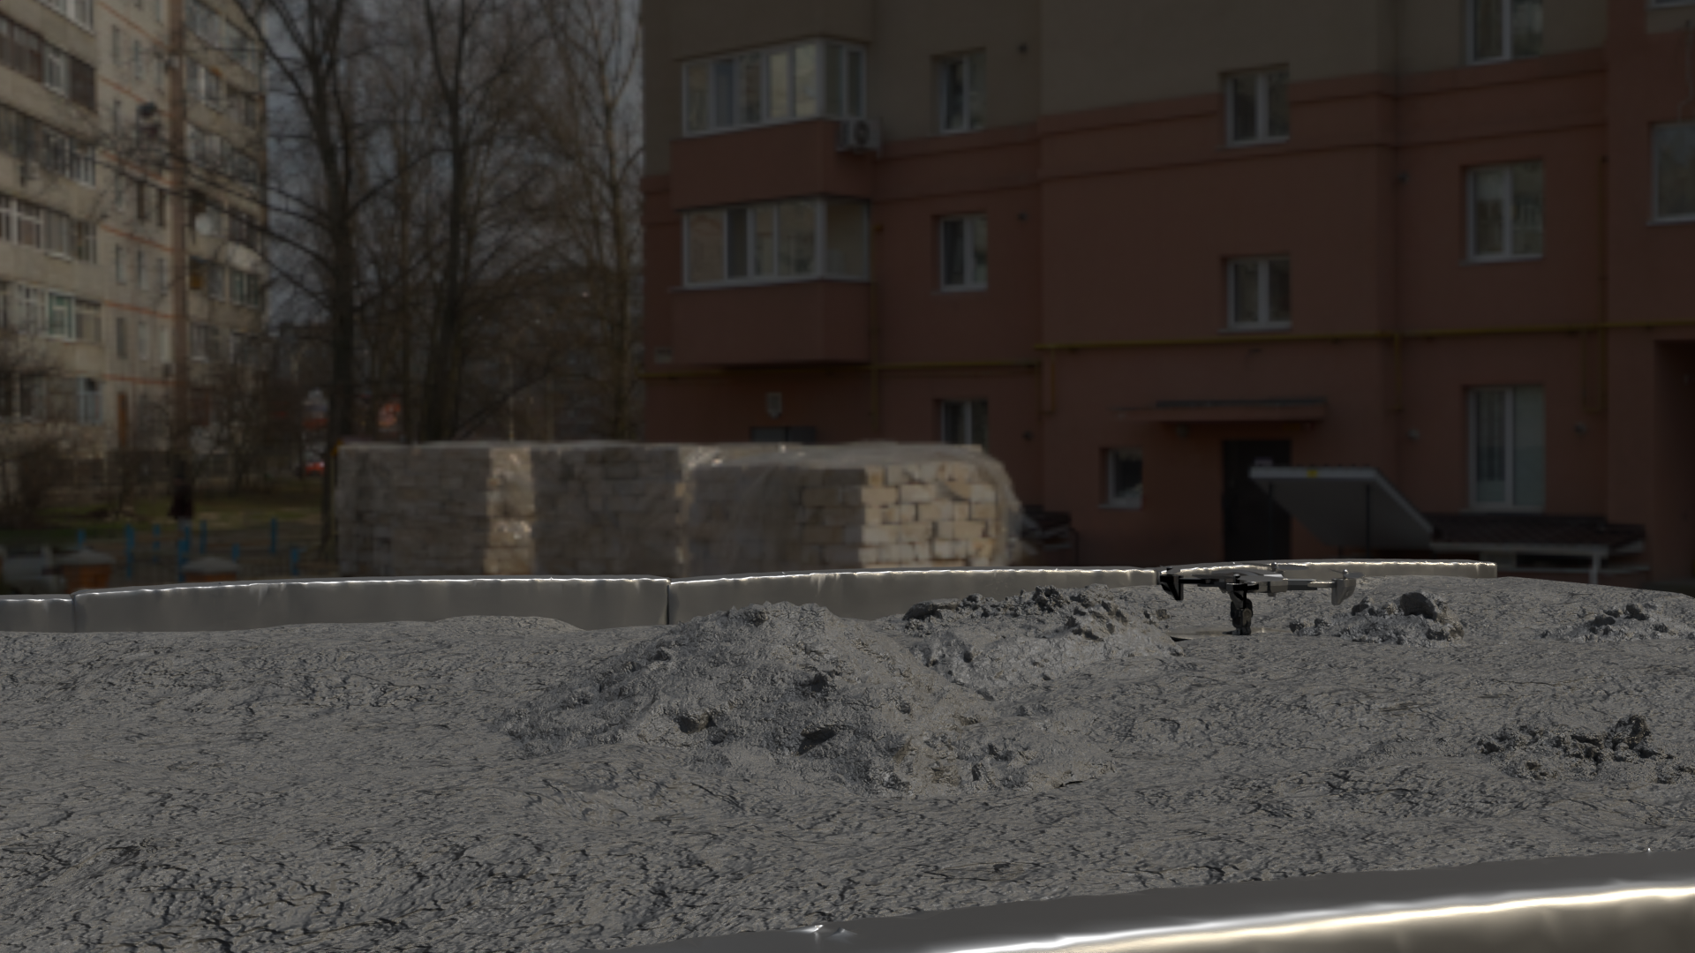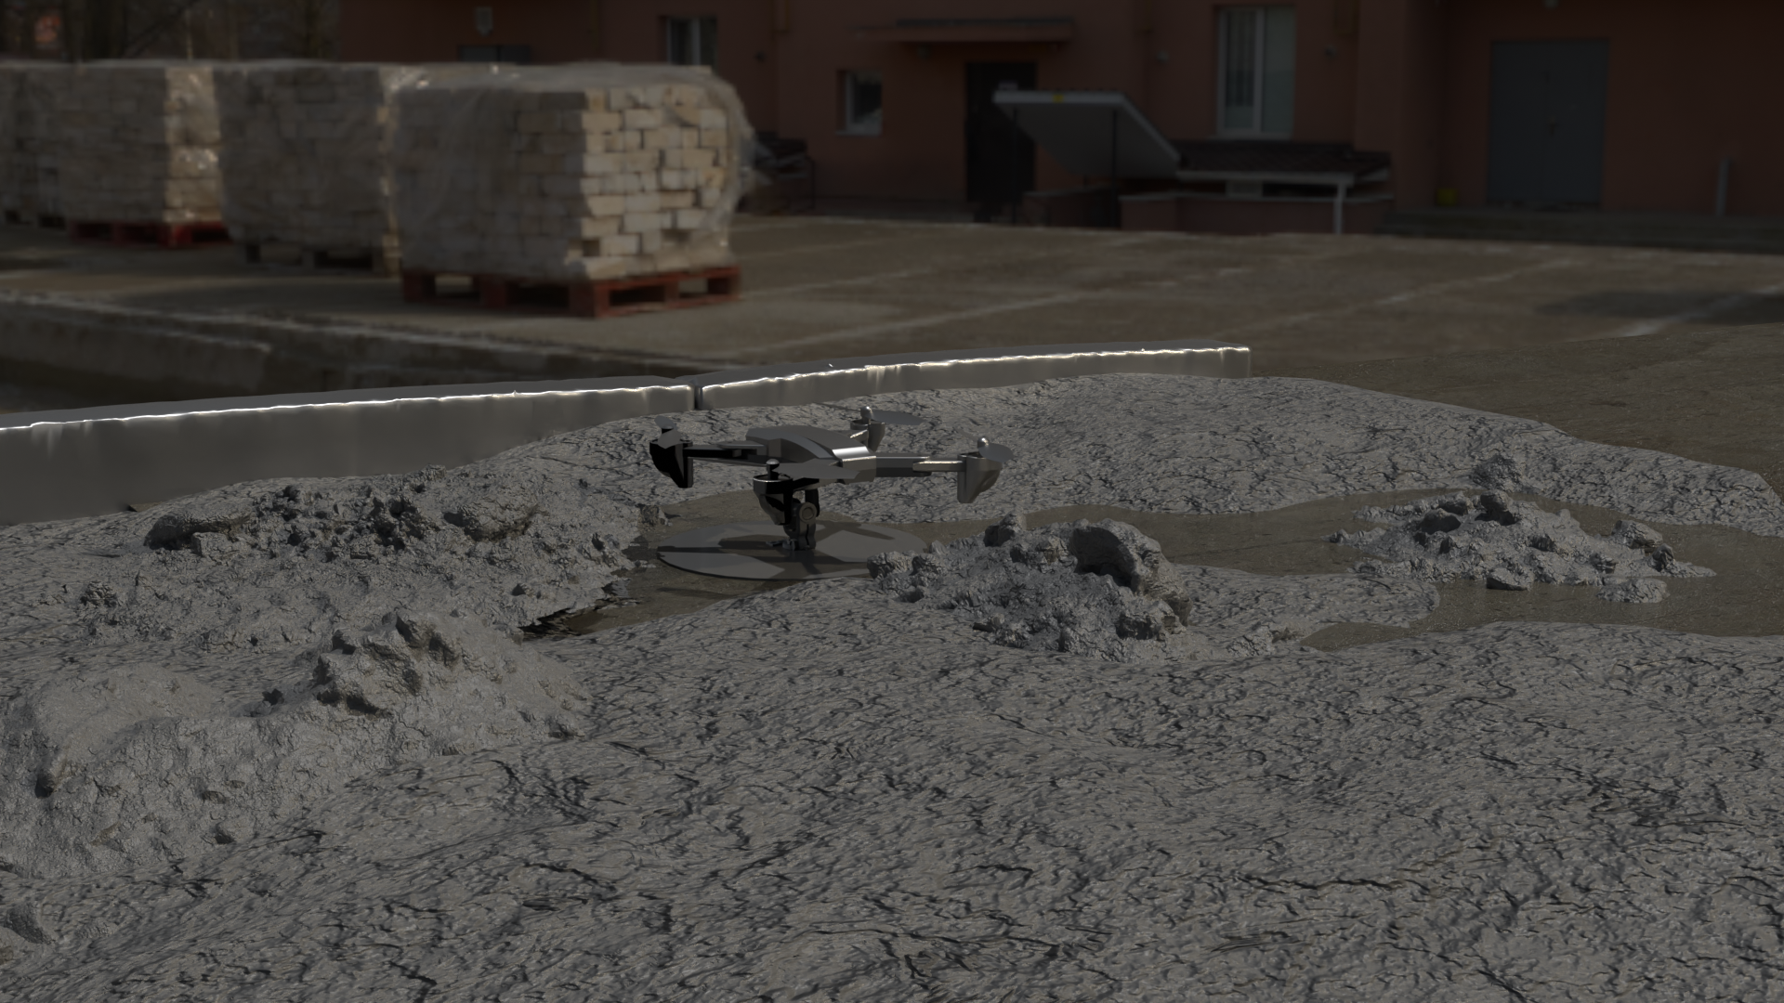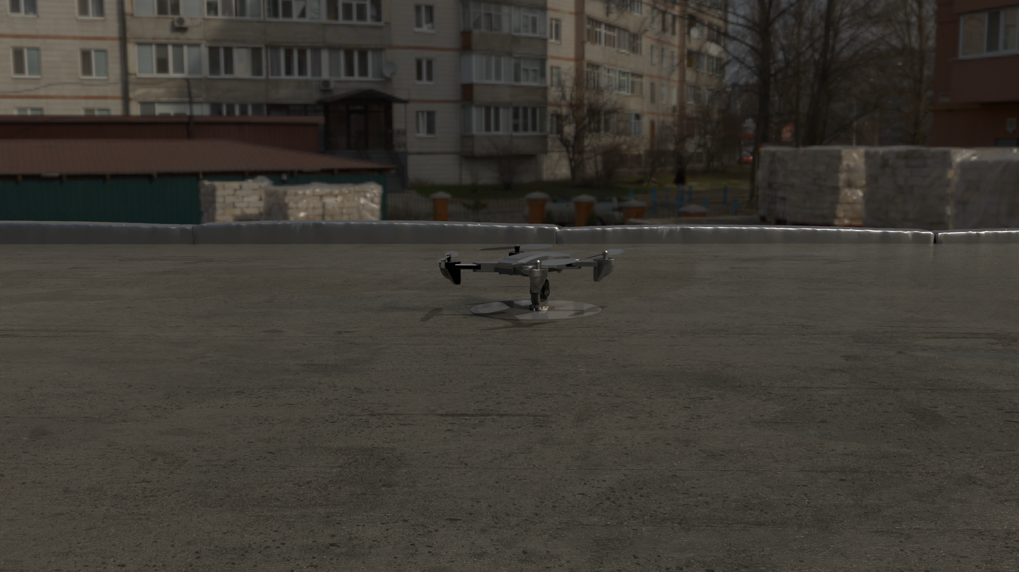
Fig. 2. Example Testing Environment before (Left), during (Middle) and after (Right) Concrete Finishing Task
  - Simulation Environment Setup
The simulation environment in Gazebo was designed to replicate conditions typically encountered in construction surface inspection tasks. The simulated setup included a UAV model equipped with virtual LiDAR and RGB sensors to emulate the real-world hardware configuration. The environment featured surfaces with varying textures, heights, and simulated defects, such as cracks, discolorations, and uneven regions, to test the system’s capability to adapt and respond dynamically.
The LiDAR sensor was configured to provide scans of the target surface with a range of up to 10 meters and a resolution of 0.05 meters. This enabled the generation of high-resolution height maps of the simulated surface. The RGB camera was configured with a resolution of 1920x1080 pixels and a field of view of 90 degrees, providing detailed visual data for the predictive surface attention model.
  - Testing Workflow
The UAV was initialized at a predefined starting position within the simulation environment. After calibrating all virtual sensors, a preliminary surface scan was conducted to establish baseline data. This data was used to compute the initial trajectory P0P_0P0​, which was then executed by the high-level flight control system.
As the UAV traversed the surface, LiDAR and RGB camera data were processed in real time by the predictive surface attention model. This model prioritized regions based on anomalies and visual features, dynamically updating the trajectory using the adaptive area-sweeping algorithm. Feedback from the sensors, including height deviations and surface irregularities, was continuously integrated to refine the UAV’s path.
Metrics were monitored and recorded throughout the testing process, with specific emphasis on evaluating how well the system-maintained coverage completeness, minimized redundancy, adhered to planned heights, and processed adjustments efficiently.
  - Metrics for System Evaluation
To assess the performance of the system in the simulation, specific metrics were monitored throughout the testing process. These metrics included the following:
Coverage Completeness: Measured as the percentage of the surface area inspected during the operation. This metric provided insight into the thoroughness of the UAV’s trajectory planning and execution.
Redundancy Ratio: Calculated as the ratio of the overlapping area inspected multiple times to the total inspected area. This metric evaluated the efficiency of the trajectory.
Height Deviation: This metric assessed the precision of the UAV’s altitude control by calculating deviations between the planned height $H_{\text{planned }}(x,y)$ and the actual height $H_{\text{actual }}(x,y)$:
$$D_{\text{height }}=\sqrt{\frac{\int_{A}{ }{\left(H_{\text{actual }}(x,y)-H_{\text{planned }}(x,y)\right)}^{2}dxdy}{\int_{A}{ }dxdy}}$$
Processing Latency: Recorded as the time delay between receiving sensor input and applying trajectory adjustments. This metric gauged the computational efficiency of the predictive model and adaptive sweeping algorithm.
- Results
The UAV system's performance in refining surface roughness was evaluated across three surface categories, characterized by their initial roughness levels. These categories included smooth surfaces (roughness < 1 mm), moderately rough surfaces (roughness 1–5 mm), and rough surfaces (roughness > 5 mm). The goal was to quantify the system's ability to reduce surface roughness to below a target threshold while maintaining operational efficiency and precision. The key metrics assessed were refinement completeness, redundancy ratio, height deviation, and processing latency. The results are summarized in Table 1.

Table 1. Metrics evaluation results across different surfaces types.
Metric | Smooth Surface (Roughness < 1 mm) | Moderately Rough (Roughness 1-5 mm) | Rough Surface (Roughness > 5 mm)
Refine Completeness (%) | 98.2 | 95.6 | 91.3
Redundancy Ratio | 0.12 | 0.16 | 0.27
Height Deviation (m) | 0.03 | 0.03 | 0.05
Processing Latency (ms) | 147 | 146 | 152

Refinement Completeness: Refinement completeness was defined as the percentage of the surface area where roughness was successfully reduced to below the target threshold. On smooth surfaces, the system achieved a refinement completeness of 98.2%, indicating its effectiveness under minimal initial roughness conditions. For moderately rough surfaces, the completeness decreased to 95.6%, reflecting the increased challenge posed by higher initial roughness. On rough surfaces with initial roughness exceeding 5 mm, the refinement completeness dropped further to 91.3%, highlighting the system’s diminishing efficiency as surface complexity increased.
Redundancy Ratio: The redundancy ratio measured the extent of overlapping efforts in the refinement process. For smooth surfaces, the ratio was 0.12, signifying a relatively efficient trajectory with minimal overlap. On moderately rough surfaces, the ratio increased to 0.16, while on rough surfaces, it rose to 0.27. This trend indicates that greater surface complexity necessitated additional passes to achieve the desired refinement level.
Height Deviation: Height deviation quantified the system's precision in maintaining the planned altitude during operation. Across smooth and moderately rough surfaces, height deviation remained consistent at 0.03 meters. On rough surfaces, deviation increased slightly to 0.05 meters, reflecting the added difficulty of maintaining stability over highly irregular terrain.
Processing Latency: Processing latency represented the time delay between sensor data acquisition and trajectory adjustments. On smooth surfaces, latency was recorded at 147 milliseconds. For moderately rough surfaces, latency remained comparable at 146 milliseconds. On rough surfaces, latency increased slightly to 152 milliseconds, suggesting that higher surface complexity imposed additional computational demands.
- Conclusions
This research demonstrated the effectiveness of an autonomous UAV-based system for precision surface refinement, achieving notable results across a range of simulated surface conditions. The system consistently reduced surface roughness with refinement completeness reaching 98.2% on smooth surfaces (roughness < 1 mm), 95.6% on moderately rough surfaces (roughness 1–5 mm), and 91.3% on rough surfaces (roughness > 5 mm). Throughout these tests, the system maintained low height deviations, with an average deviation of 0.03 meters on smoother surfaces and only 0.05 meters on the roughest surfaces. Processing latency remained efficient, ranging from 147 milliseconds on smooth surfaces to 152 milliseconds on rough surfaces. These results underscore the system's robustness and adaptability in addressing surface refinement challenges while ensuring operational precision and computational efficiency.
While these outcomes validate the system’s capabilities, the study was conducted within a controlled simulation environment. Future work will focus on extending the system to real-world applications, optimizing its computational efficiency, and improving adaptability to broader operational challenges. These efforts aim to further solidify the system as a scalable and effective solution for UAV-based surface refinement in construction

References

1. Smith, Geoff B., Angus R. Gentle, Matthew D. Arnold, Marc A. Gali, and Michael B. Cortie. 2017. The importance of surface finish to energy performance. Renewable Energy and Environmental Sustainability 2. EDP Sciences: 13. https://doi.org/10.1051/REES/2017047.
2. Megid, Wael A., and Kamal H. Khayat. 2020. Variations in surface quality of self-consolidation and highly workable concretes with formwork material. Construction and Building Materials 238. Elsevier: 117638. https://doi.org/10.1016/J.CONBUILDMAT.2019.117638.
3. Love, Peter E. D., Pauline Teo, and John Morrison. 2018. Revisiting Quality Failure Costs in Construction. Journal of Construction Engineering and Management 144. American Society of Civil Engineers (ASCE): 05017020. https://doi.org/10.1061/(ASCE)CO.1943-7862.0001427/ASSET/1593CB98-3DFF-4C69-9E95-9D988A97B54B/ASSETS/IMAGES/LARGE/FIGURE15.JPG.
4. Mohd Fauzi, Harris Shamshuri. 2022. Finishing work / Harris Shamshuri Mohd Fauzi. Universiti Teknologi MARA, Perak.
5. Automation and Robotics in the Architecture, Engineering, and Construction Industry. 2022. Automation and Robotics in the Architecture, Engineering, and Construction Industry. Springer International Publishing. https://doi.org/10.1007/978-3-030-77163-8.
6. Ren, Tianyu, and Houtan Jebelli. 2024. Efficient 3D robotic mapping and navigation method in complex construction environments. Computer-Aided Civil and Infrastructure Engineering. John Wiley & Sons, Ltd. https://doi.org/10.1111/MICE.13353.
7. Garcia, Alberto, David A. Marlow, and Alan S. Echt. 2019. In-Depth Survey Report: Concrete Surface Preparation Tools Machines 7. https://doi.org/10.26616/NIOSHEPHB36816A.
8. Zhao, Xiayu, and Houtan Jebelli. 2025. A Computational Method for Real-time Roof Defect Segmentation in Robotic Inspection. Computer-Aided Civil and Infrastructure Engineering.
9. Allen, E, and J Iano. 2019. Fundamentals of building construction: materials and methods.
10. Dandan, Kinan, Houssam Albitar, Anani Ananiev, and Ivan Kalaykov. 2016. Confined Spaces : Cleaning Techniques and Robot-based Surface Cleaning. American Scientific Research Journal for Engineering, Technology and Science 22. Global Society of Scientific Research and Researchers: 210–230.
11. Ren, Tianyu, and Houtan Jebelli. 2025. Robotic Navigation and Obstacle Avoidance System for Advancing Attic Insulation. In 2024 International Conference on Computing in Civil Engineering (i3CE). Pittsburgh.
12. Lee, KW, and JK Park Materials. 2019. Comparison of UAV Image and UAV LiDAR for Construction of 3D Geospatial Information. Sensors & Materials.
13. Ali, Zain Anwar, and Xinde Li. 2019. Modeling and controlling of quadrotor aerial vehicle equipped with a gripper. Measurement and Control (United Kingdom) 52. SAGE Publications Ltd: 577–587. https://doi.org/10.1177/0020294019834040/ASSET/BBF134AB-A269-41DC-8A8B-C1DACFC72F24/ASSETS/IMAGES/LARGE/10.1177_0020294019834040-FIG13.JPG.
14. Kang, Dongho, and Young Jin Cha. 2018. Autonomous UAVs for Structural Health Monitoring Using Deep Learning and an Ultrasonic Beacon System with Geo-Tagging. Computer-Aided Civil and Infrastructure Engineering 33. John Wiley & Sons, Ltd: 885–902. https://doi.org/10.1111/MICE.12375.
15. Vaquero-Serrano, Miguel A., and Jesus Felez. 2023. A decentralized robust control approach for virtually coupled train sets. Computer-Aided Civil and Infrastructure Engineering 38. John Wiley & Sons, Ltd: 1896–1915. https://doi.org/10.1111/MICE.12985.
16. Peicheng, Shi, Long Li, Xuan Ni, and Aixi Yang. 2022. Intelligent Vehicle Path Tracking Control Based on Improved MPC and Hybrid PID. IEEE Access 10. Institute of Electrical and Electronics Engineers Inc.: 94133–94144. https://doi.org/10.1109/ACCESS.2022.3203451.
17. Ren, Tianyu, and Houtan Jebelli. 2025. Developing an Advanced Perception System for Robotic Attic Insulation Using Large Vision-Language Models and LiDAR. In 2024 International Conference on Computing in Civil Engineering (i3CE). Pittsburgh.
18. Zhao, Xiayu, and Houtan Jebelli. 2025. A computational method for real-time roof defect segmentation in robotic inspection. Computer-Aided Civil and Infrastructure Engineering. John Wiley & Sons, Ltd. https://doi.org/10.1111/MICE.13471.

