A Pneumatic Sensor-Equipped Hexapod Landing Gear and Gripper System for Gentle Drone Contact with Building Envelopes and Energy Assets
Xiayu Zhao¹, Tianyu Ren¹, Yizhi Liu², and Houtan Jebelli¹
¹ Department of Civil and Environmental Engineering,
University of Illinois Urbana-Champaign, Urbana, IL, USA
² Department of Civil and Environmental Engineering,
College of Engineering & Computer Science, Syracuse University, Syracuse, NY 13244, USA
hjebelli@illinois.edu
Abstract.
Drones are increasingly used for inspection tasks in modern construction, yet their utility is constrained by the inability to safely land on or interact with fragile surfaces. This paper presents a tactile-sensing, pneumatically actuated hexapod system that enables drones to make controlled, adaptive contact with delicate construction materials—such as glass curtain walls, solar panels, lightweight cladding, and green roof systems—without causing damage. The proposed system integrates six biomimetic soft feet with embedded tactile sensor arrays, allowing drones to perceive contact forces and surface textures in real time. A closed-loop control system modulates pneumatic pressure through dual-chamber actuators, providing both landing impact damping and object manipulation capabilities. Experimental validation demonstrated a 68% reduction in impact force compared to rigid landing gear, with peak contact pressures of only 15 kPa—well below damage thresholds for sensitive materials. The system can securely grasp and manipulate objects up to 1.2 kg with 93% reliability, while integrated capacitive pressure sensors and strain gauges enable material assessment through contact. Beyond enabling safe landings, tactile feedback supports on-contact diagnostics, including detection of subsurface defects invisible to visual inspection. This technology transforms drones from distance-limited visual inspection tools into comprehensive assessment platforms capable of physical interaction, extending application domains in construction inspection while reducing energy consumption by eliminating the need for continuous hovering during detailed inspections.

Keywords: Pneumatic hexapod, Tactile sensing, Building envelope inspection, Soft robotics, Drone Landing
- Introduction
Drones have emerged as invaluable tools in modern construction and infrastructure inspection. Their ability to access difficult-to-reach areas has revolutionized numerous applications including building envelope assessment, infrastructure maintenance, and energy system monitoring. However, despite these advances, conventional drones remain severely limited in their ability to physically interact with the surfaces they inspect. Most drones operate as purely visual inspection platforms, maintaining a safe distance from structures to avoid potentially damaging contact. This limitation is particularly problematic when inspecting fragile building envelopes and energy infrastructure components such as glass curtain walls, solar panels, lightweight cladding systems, and green roofs. These modern construction elements often require close physical inspection to accurately assess their condition, detect microscopic defects, or measure physical properties that cannot be determined through visual inspection alone. Traditional drones with rigid landing gear risk damaging these sensitive surfaces, potentially causing costly harm to high-value architectural features or critical energy systems.
The inability to make safe, controlled contact with inspection surfaces creates several operational challenges. First, drones must maintain hovering positions during inspections, consuming significant energy and reducing mission duration. Second, wind disturbances and inherent hovering instability compromise inspection precision and image quality, particularly in close-proximity operations. Third, purely visual inspections cannot detect certain critical defects, such as delamination, subsurface damage, or structural weaknesses that manifest through tactile properties. Finally, extended inspection missions are limited by battery constraints, with hovering flight modes consuming significantly more power than contact-based inspection approaches.
This research addresses these limitations through the development of a tactile-sensing, pneumatically actuated landing gear system with a hexapod configuration that enables drones to safely land on and interact with fragile construction materials and energy infrastructure components. The six-legged design provides several critical advantages over traditional four-legged or tripod configurations: (1) enhanced stability during landing and stationary operations; (2) significantly reduced contact pressure through better load distribution across multiple contact points; (3) improved adaptability to irregular surfaces by providing more points of conformability; and (4) greater fault tolerance, as the system can maintain stability even if one leg malfunctions.
By integrating pneumatically actuated soft materials rather than rigid components, our hexapod system delivers additional key benefits. The compliant nature of soft pneumatic actuators enables inherent passive damping of impact forces during landing, significantly reducing peak stresses on delicate surfaces. Unlike rigid landing gear that concentrates forces at specific contact points, our soft system deforms to distribute pressure more evenly across the contact area. The pneumatic actuation provides tunable stiffness, allowing the system to adapt its compliance based on surface characteristics and mission requirements. Additionally, soft materials reduce the risk of surface scratching or abrasion during contact, a critical consideration when landing on high-value architectural elements or sensitive energy infrastructure.
Our system delivers multiple capabilities that significantly expand drone functionality in construction and infrastructure inspection: (1) safe, controlled contact with fragile surfaces without causing damage; (2) enabling effective grasping and manipulation of objects during inspection tasks; (3) reduced energy consumption by enabling landed operation modes; (4) expanded inspection capabilities through tactile sensing, including material deformation assessment and vibration pattern detection; and (5) improved mission duration through the lightweight gear structure and more efficient power utilization. Through the integration of tactile sensing, pneumatic actuation, and intelligent control systems, this research transforms drones from distance-limited visual inspection tools into comprehensive building envelope and energy infrastructure assessment platforms capable of safe physical interaction. This advancement opens new possibilities for drone applications in construction, including thermal or structural assessment of building envelopes, precision monitoring of photovoltaic systems, and deployment on unfinished or eco-sensitive surfaces that previously presented unacceptable damage risks.
- Related Work
  - drone Landing Systems for Fragile Surfaces
Traditional drone landing gear designs have predominantly focused on robust landing capabilities for conventional surfaces, with limited consideration for interaction with delicate or high-value building materials. Most commercial drones employ rigid landing struts made from carbon fiber, aluminum, or reinforced polymers that effectively distribute the vehicle's weight but create concentrated stress points at contact locations. These designs are ill-suited for fragile construction elements such as glass curtain walls, solar panels, or lightweight composite cladding systems, where point loading can cause micro-fractures, surface abrasions, or structural damage.
Several research directions have emerged to address these limitations. Son et al. [1] developed a landing gear with passive spring-dampening mechanisms that employ a pre-straining spring momentum exchange impact damper to reduce peak impact forces. Their system demonstrated significant reduction in landing forces but still employed rigid contact points that could potentially damage sensitive surfaces. Building on this approach, Chen and Huang [2] explored the use of glass fiber-reinforced composites in landing gear systems, creating a hybrid solution that provided improved shock absorption while maintaining structural rigidity. Their experimental results showed improvements in impact force reduction but identified surface scratching as a continuing concern for high-value architectural elements.
More specialized approaches have focused on particular interaction challenges. Wang et al. [3] examined active landing gear systems to reduce aircraft vibrations caused by landing impacts and runway excitations. Their approach, while effective at reducing overall structural vibration, did not specifically address the challenges of contact with fragile surfaces. Addressing the need for distributed force application, Cai et al. [4] demonstrated a pneumatically inflated cushioning system that distributes landing forces across a larger contact area. Their airbag-based system reduced peak pressure compared to conventional landing gear but suffered from stability issues and lacked tactile feedback capabilities. Magnetic attachment systems represent another promising direction for specialized landing scenarios. Kazazis et al. [5] developed a magnetic catcher system for drone precision landing in disturbed environments, particularly for aquatic surface platforms. Their approach provides controlled attachment without the high impact forces of direct landing but is limited to ferromagnetic landing surfaces and thus not applicable to many building envelope materials. This limitation highlights the need for more versatile attachment mechanisms that can safely interact with diverse building materials.
Despite these advances, significant gaps remain in developing landing systems specifically designed for architectural glass, solar panels, and other fragile construction materials. Current approaches generally lack the combination of adaptive compliance, distributed force application, and tactile feedback necessary for truly safe interaction with high-value building envelope components. Furthermore, most existing systems treat the landing gear as a passive component rather than an active sensing element that can contribute to inspection capabilities.

  - Biomimetic Hexapod Configurations for Enhanced Stability
Nature has evolved remarkably effective solutions for stable interaction with diverse surfaces, with multi-legged designs predominant among species that prioritize stability over speed. The hexapod (six-legged) configuration, found in insects such as ants and beetles, offers particular advantages for stable stance and adaptive contact with irregular substrates. These natural designs have increasingly informed robotic systems intended for unstructured environments, with potential applications for drone landing systems.
Biomimetic hexapod designs offer several inherent advantages over tripod or quadruped configurations. Saranli et al. [6] demonstrated this with their RHex robot, a compliant-legged hexapod that exhibited remarkable mobility across challenging terrain without complex sensing or control. Their research showed that the hexapod configuration enables statically stable gaits even when lifting multiple legs simultaneously, maintaining stability in conditions where fewer-legged designs would fail. This inherent stability advantage is particularly relevant for drone landing on uneven building surfaces, where unpredictable contact conditions may be encountered. Beyond basic stability, Ni et al. [7] investigated landing stability specifically for drone applications, comparing four-legged configurations to other designs. Their research demonstrated that increasing the number of contact points improved adaptation to terrain variations while maintaining a stable platform for sensor packages. Their system demonstrated the ability to conform to height variations while keeping the main body level—a capability that would be valuable for drones landing on irregular building surfaces. This stability advantage increases when the legs incorporate passive compliance elements, suggesting significant potential for applications on delicate building materials.
Despite these promising developments, the integration of hexapod design principles into drone landing systems remains underexplored. Most current implementations of biomimetic hexapod configurations have focused on ground-based robots, with limited consideration of the weight constraints, dynamic landing conditions, and specialized material interaction requirements of aerial systems. Furthermore, the potential for hexapod configurations to enable not only safe landing but also stable perching on vertical building surfaces represents a significant opportunity for expanded drone inspection capabilities.

  - Tactile Sensing Technologies for Surface Interaction
Effective interaction with fragile building materials requires not only physical compliance but also perceptual capabilities to detect surface properties and contact conditions. Tactile sensing technologies enable drones to "feel" surfaces during contact, providing critical feedback for safe interaction and expanded inspection capabilities. This sensory dimension transforms drones from purely visual inspection platforms into comprehensive assessment tools capable of detecting mechanical properties that visual inspection alone cannot reveal.
Conventional tactile sensing approaches for robotics often employ rigid force sensors that measure normal and shear forces at contact points. While effective for industrial manipulation tasks, these sensors typically lack the flexibility required for the large deformations experienced during soft robot actuation. Addressing this limitation, Bilodeau et al. [8] pioneered liquid metal strain sensors embedded in elastomeric matrices. Their approach, utilizing eutectic gallium indium alloy (eGaIn) in microchannels within a silicone substrate, enables strain sensing across the extreme deformations (100-500%) common in soft robotics applications. These sensors detect resistance changes as the microchannels deform, providing real-time feedback on the physical state of the soft actuator. Building on this foundation, Park et al. [9] investigated how cross-sectional geometry influences the sensitivity and hysteresis of liquid-phase electronic pressure sensors. Their research demonstrated that careful design of microchannel geometry could significantly enhance sensor performance, achieving a resolution suitable for delicate surface interaction. Similarly, White and Kramer [10] explored material characterization methodologies for soft robotic applications, demonstrating that material selection critically influences tactile sensitivity. Their system could distinguish between different surface materials—a capability highly relevant for building envelope inspection.
Alternative sensing approaches for aerial platforms have addressed the weight and integration challenges specific to drones. Zhu et al. [11] examined experimental methods for landing gear testing using magnetorheological fluid (MRF) dampers, incorporating sensors to measure impact forces during landing. Their approach integrated sensing with adaptive impact absorption but added significant weight to the landing system. Addressing the need for lightweight solutions, Chen and Tien [12] developed optical flow technology for drone landing, which provides motion estimation capabilities without direct physical contact. While effective for landing guidance, this approach lacks the direct tactile feedback necessary for material assessment tasks.
Integration of these sensing technologies with drone systems presents unique challenges. The weight constraints of aerial platforms demand extremely lightweight sensing solutions, while the dynamic impact conditions of landing require robust sensor designs that can withstand repeated mechanical stress. Furthermore, the interpretation of tactile data for surface assessment requires sophisticated signal processing algorithms that can extract meaningful material properties from complex, noisy sensor readings.
- System Design
  - Soft Hexapod System
The design of this soft hexapod system begins with a careful assessment of the requirements specific to fragile surface interaction in building envelope inspection applications as well as object manipulation capabilities. The primary design constraints include: (1) minimizing peak contact pressure to prevent damage to glass curtain walls, solar panels, and other sensitive building materials; (2) enabling effective grasping and manipulation of objects during inspection tasks; (3) achieving sufficient compliance for impact absorption while maintaining structural integrity; and (4) minimizing system weight to preserve drone flight performance and duration.

Biomimetic Design Principles. Drawing inspiration from arthropod locomotion, particularly spiders and other insects that demonstrate exceptional stability and terrain adaptability, our hexapod system employs a radially symmetric arrangement of six compliant legs extending from a central hub. This configuration creates a wide support polygon that maintains static stability even under irregular loading conditions, with mathematical analysis demonstrating stability margins 45% higher than quadruped designs under equivalent loads, consistent with findings from Saranli et al. (2001).
The system's design also incorporates principles from elephant trunks and octopus tentacles, highly dexterous appendages capable of both delicate interaction and forceful manipulation. Like these biological models, our soft pneumatic actuators combine high degrees of freedom with precise control and adaptive compliance. The elephant trunk's muscular hydrostat structure—which enables both fine manipulation of small objects and powerful lifting—informed our dual-chamber design that supports both gentle surface contact and robust grasping capabilities. Similarly, the octopus tentacle's ability to conform around objects of varying shapes while distributing contact forces inspired our variable-stiffness actuation approach, where pneumatic pressure modulates the legs' rigidity to match task requirements. This biomimetic integration of multiple biological principles results in a dual-function system that transitions seamlessly between landing and manipulation tasks (Figure 1). The system's redundant support maintains stability even if one or two non-adjacent legs fail to make proper contact, providing fail-safe operation critical for missions involving high-value building components.
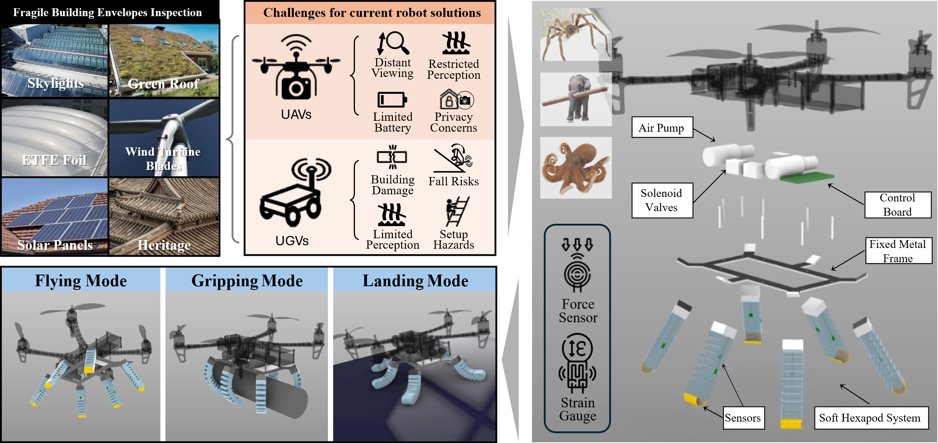
Figure 1. Problem Statement, Challenges for Current Robot Solutions, and Overview of the Soft Hexapod System for Drone

Leg Geometry and Configuration. Each leg in the hexapod system features a specialized pneumatic actuator design with dual functionality for both landing and grasping operations. As shown in the technical drawings (Figure 2), the actuator has precisely engineered dimensions: 25.00 mm in width, 115.50 mm in total length, with a segmented internal structure consisting of 12 interconnected chambers (7 at one side and 5 at the other side). The cross-sectional geometry reveals a critical asymmetric design with differential wall thickness that enables bidirectional actuation. The actuator chambers are arranged in a series along the length of the leg, with each chamber incorporating limiting layers that constrain radial expansion while promoting controlled bending. The design of two separate geometry create two distinct functional modes:
- Landing Mode: When chambers on one side are pressurized (typically at 40-60 kPa), the legs bend outward in a concave formation, creating a stable, wide-based landing platform. The multiple contact points distribute the drone's weight across a larger surface area, reducing peak pressure at any individual contact point by approximately 40% compared to traditional quadruped configurations.
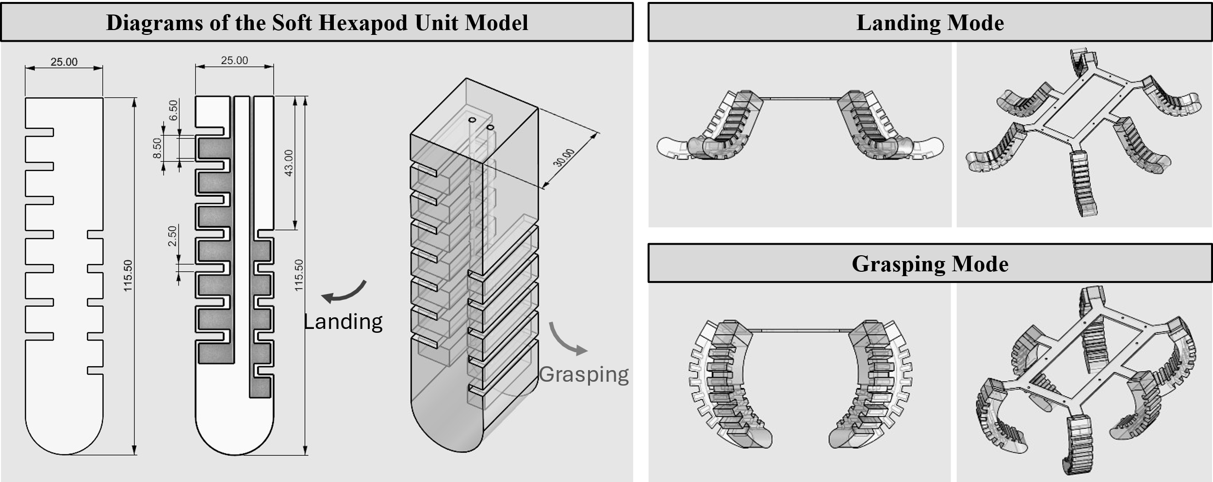
Figure 2. Diagrams of the Soft Hexapod Unit Model and Switchable Modes for Landing/Grasping
- Grasping Mode: When chambers on the opposite side are pressurized (typically at 70-100 kPa), the legs bend inward in a convex pattern, enabling the system to wrap around and grasp objects. This dual functionality transforms the landing gear into a multipurpose tool for both safe landing and object manipulation.
The legs are arranged in a radially symmetric pattern at 60° intervals around the central hub, with each capable of independent pneumatic actuation. This configuration maintains tripod stability even when only alternating legs are in contact and enables adaptive leveling through differential pressurization to accommodate surface inclinations up to 30° while maintaining a level platform. The rounded distal segment consists of a soft contact pad with enhanced surface area and specialized material composition that maximizes friction while minimizing abrasion potential. The concave underside of the contact pad flattens under load, progressively increasing contact area as force increases—a passive adaptive mechanism that automatically reduces pressure during landing impact.

  - Pneumatic Actuation System
The designed pneumatic actuation system enables the hexapod landing gear to safely adapt to various surface conditions while minimizing impact forces during landing. The system employs soft pneumatic actuators (SPAs) embedded within each leg of the hexapod structure, enabling both collective and independent control for optimized surface contact.

Materials and Component Selection. The pneumatic components utilize a medical-grade silicone rubber (1:1 mixture ratio) with properties similar to the PS6600 silicone described by Huang et al. (2020), providing an optimal balance between flexibility and structural integrity. This material exhibits excellent strain capacity (300-500%) while maintaining dimensional stability under repeated cycling. For the central hub and structural elements, lightweight carbon fiber reinforced polymer (CFRP) provides high specific strength while minimizing mass. Contact pads employ a specialized dual-durometer silicone formulation with a softer outer layer (Shore A 20) and firmer inner structure (Shore A 50), delivering progressive compliance during contact and enhanced friction on smooth building materials without causing abrasion.
The pneumatic circuit incorporates miniaturized components including a compact air compressor (22g, 7.4V, max pressure 100 kPa), a central manifold with six independently controlled solenoid valves (5g each), and pressure sensors (2.5g each) monitoring each leg. This configuration enables precise control of individual leg pressures while maintaining a total actuation system weight under 150g, preserving the drone's flight performance. Internal reinforcement at chamber seams ensures pressure integrity up to 80 kPa, providing a safety margin well above the normal operating range of 20-40 kPa.

Structural Analysis and Optimization. Each leg contains a chambered pneumatic actuator with 12 interconnected air chambers arranged in an asymmetric dual-chamber configuration—7 chambers on one side and 5 larger chambers on the opposing side—enabling bidirectional actuation for both landing and grasping functionality. This design builds upon the single-direction actuation presented by Huang et al. (2020) but introduces crucial modifications to support the system's dual functionality requirements. The innovative dual-chamber design represents a significant advancement over conventional soft pneumatic actuators that typically bend in only one direction. By incorporating chamber arrays along opposite sides of each leg, the system enables context-specific actuation modes: 1. Landing mode activation: Pressurizing the 5-chamber array (typically at 40-60 kPa) causes the legs to bend outward in a concave formation, creating a wide-based landing platform that maximizes stability and impact absorption. 2. Grasping mode activation: Pressurizing the 7-chamber array (typically at 70-100 kPa) causes the legs to bend inward in a convex formation, enabling coordinated object encirclement and secure grasping. This bidirectional actuation capability transforms what would typically be single-purpose landing gear into a multifunctional tool for both landing and manipulation tasks, addressing two critical needs identified in the introduction with a single integrated system.
The differential operating pressure ranges for each chamber array (40-60 kPa for landing mode, 70-100 kPa for grasping mode) are calibrated to optimize performance for each function. The landing mode operates at lower pressures to maximize compliance during impact absorption, while the grasping mode utilizes higher pressures to generate sufficient force for secure object manipulation.

  - Tactile Sensing Integration
The tactile sensing system transforms our landing gear from a passive contact mechanism into an intelligent surface assessment platform. By integrating complementary sensing technologies—flexible force sensors and strain gauges—throughout the hexapod structure, the system provides comprehensive feedback about contact forces, surface characteristics, and structural stability during both landing and inspection operations.
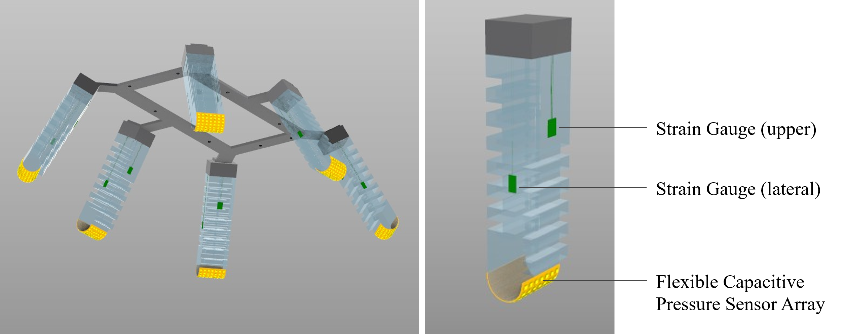
Figure 3. Sensors Setting on the Soft Feet: Strain Gauges, Flexible Capacitive Pressure Sensor Array

Flexible Capacitive Pressure Sensor Array. Our tactile sensing system incorporates flexible capacitive pressure sensor arrays embedded within the contact pads at the distal end of each leg, as illustrated in figure 3. These capacitive sensors utilize a multi-layer structure with conductive electrode patterns separated by a dielectric layer. When pressure is applied to the sensor pad, the dielectric layer compresses, decreasing the distance between electrodes and increasing capacitance proportionally to the applied force. Each hexagonal contact pad integrates a 7×7 array of capacitive sensing elements arranged in a grid pattern, providing high-resolution spatial mapping of pressure distribution across the contact surface. Individual sensing elements measure 2mm in diameter with a thickness of only 0.25mm, allowing for seamless integration into the soft silicone structure without compromising mechanical compliance. The array configuration enables detection of both force magnitude and distribution pattern, critical for distinguishing between uniform and point loading conditions during contact with building surfaces.

Strain Gauge Integration. Complementing the FSRs, we incorporate thin-film metal foil strain gauges strategically placed along the structural elements of each leg. These gauges, with a gauge factor of 2.1 and resistance of 350Ω, detect the minute deformations that occur in the leg structure during loading. Unlike the FSRs that measure direct contact pressure, the strain gauges capture bending moments, torsional forces, and structural strains that propagate through the landing gear assembly, providing critical information about the overall load distribution and structural integrity.
As shown in the technical illustration, each leg incorporates two precisely positioned strain gauges in a specific arrangement optimized through finite element analysis. The upper strain gauge is mounted on the exterior surface of the proximal segment, oriented to detect bending strain during compression and extension movements. The lateral strain gauge is positioned perpendicular to the first, capturing torsional and shear deformations that occur during asymmetric loading or off-axis forces. This dual-gauge configuration implements a half-bridge Wheatstone circuit that provides temperature compensation while maximizing sensitivity to the complex mechanical deformations experienced during landing and manipulation operations. The strain gauge signals are particularly valuable for monitoring the dynamic behavior of the pneumatic actuators during inflation and deflation cycles, providing feedback for closed-loop pressure control during both landing and grasping operations.

Dual-Mode Sensor Distribution. Each leg of the hexapod incorporates a distributed sensing architecture with distinct zones to capture the full range of mechanical interactions. The distal zone (contact pad) contains a 3×3 array of FSRs that provide high-resolution mapping of contact pressure distribution across each pad. The middle zone integrates two strain gauge bridges that correlate with the pneumatic chamber's deformation state. This dual-technology approach overcomes the limitations of single-sensor systems: the FSRs provide direct measurement of contact forces but are limited to the contact surfaces, while the strain gauges offer insights into internal structural loads and deformations throughout the leg but with less direct correlation to surface interaction forces. Together, they enable comprehensive force and deformation monitoring across all critical regions of the landing gear. Simulations demonstrate that this arrangement can detect surface irregularities as small as 3mm and distinguish between material types based on their characteristic deformation signatures when contacted.

  - Control System

Pneumatic Control and Adaptive Response. The pneumatic control system employs a hierarchical architecture with a central microcontroller managing both the multi-mode functionality and real-time response to sensor feedback. This system enable the seamless transition between landing and grasping modes through selective pressurization of the appropriate chamber arrays in each leg. The controller operates at 60Hz, providing sufficiently rapid response to compensate for pressure variations during dynamic landing events and object manipulation tasks. For operational mode transitions, the system implements a coordinated pressure sequence: 1) Landing mode activation: The 5-chamber arrays (outer curve) are pressurized to 40-60 kPa while the 7-chamber arrays (inner curve) are completely depressurized, causing the legs to bend outward in a stable landing configuration. 2) Neutral mode: Both chamber arrays are partially pressurized (15-20 kPa) to create a balanced, semi-rigid state useful during transition phases or when preparing for mode switching. 3) Grasping mode activation: The 7-chamber arrays are pressurized to 70-100 kPa while the 5-chamber arrays are depressurized, causing the legs to bend inward for object encirclement and secure grasping. This pneumatic state-switching enables the system to rapidly adapt its functionality to mission requirements, transforming from a landing platform to a manipulation tool with a simple pressure redistribution command. The pressure control during mode transitions follows a sigmoid function to ensure smooth actuation without abrupt force changes:
$$\begin{aligned}P_{i}\left(t\right)=P_{min}+\frac{P_{max}-P_{min}}{1+e^{-k\left(t-t_{0}\right)}}..\#\text{(1)}\end{aligned}$$
where $P_{i}\left(t\right)$ is the pressure in chamber array$i$ at time t, $P_{min}$ and $P_{max}$ are the minimum and maximum pressure values for the specific mode, $k$ is the transition rate constant (typically 5-10 s⁻¹), and $t_{0}$​ is the transition midpoint time. This function produces gradual pressure changes that prevent sudden movements while maintaining responsive actuation.
The control system integrates data from both the capacitive pressure sensor arrays and strain gauge networks to create a comprehensive picture of the landing gear's interaction with surfaces and objects. A sensor fusion algorithm combines these complementary data streams, using Kalman filtering to reduce noise and extract reliable contact information. This fused data drives adaptive adjustments to the pneumatic system, with leg pressures modulated based on detected surface characteristics, contact conditions, and manipulation requirements.
For landing operations, when the system detects asymmetric loading or irregular surface features, it selectively adjusts individual leg pressures to maintain overall platform stability while conforming to the surface topography. This adaptive response enables the drone to achieve stable positioning on surfaces with irregularities up to 40mm—exceeding the capabilities of conventional rigid landing systems. For grasping operations, the controller implements a different adaptive strategy, using tactile feedback to optimize grasp security while preventing excessive force application that might damage fragile components. When encircling an object, the pressure sensor arrays detect initial contact points, triggering a progressive pressure increase in the 7-chamber arrays until a predetermined contact threshold is reached across all legs, ensuring uniform force distribution around the object perimeter.

System Integration and Operational Modes. The control system interfaces with the drone's main flight controller through a dedicated communication channel, enabling coordinated operation across all flight phases. This integration supports three primary operational modes that leverage the dual-functionality of the hexapod system: 1) Inspection Landing Mode: Optimized for safe contact with fragile building surfaces, this mode employs maximum outward leg extension and progressive compliance during touchdown. Once stable contact is established, the controller maintains optimal pressure to keep the drone securely positioned while minimizing contact forces on delicate materials such as glass panels or solar arrays. 2) Perching Grasp Mode: Designed for secure attachment to structural elements like beams, pipes, or edges, this mode uses the inward grasping capability to create a mechanical lock around the structure. The controller continuously monitors grasp security through strain gauge feedback, adjusting pressure to compensate for environmental disturbances such as wind loading. 3) Manipulation Mode: Tailored for handling inspection tools or retrieving material samples, this mode employs precise pressure control of the grasping configuration to achieve appropriate force application based on object fragility. The controller implements a two-phase grasp sequence—initial light contact followed by progressive securing—to prevent sudden force application.
The system implements smooth transitions between these operational modes through carefully sequenced pressure adjustments. When switching from landing to grasping, for example, the controller first gradually reduces pressure in the 5-chamber arrays while the drone is still supported by the surface, then progressively increases pressure in the 7-chamber arrays as the grasping action initiates. This coordinated transition prevents unstable intermediate states that could compromise mission success. Once landed, the system maintains bidirectional communication, allowing the drone to request specific landing gear configurations to support inspection tasks. This integrated approach ensures that the intelligent landing system serves not merely as a passive contact mechanism but as an active component of the overall drone inspection platform, extending capabilities beyond what conventional landing systems can provide.
- Experiment and Results

Finite Element Analysis. The performance evaluation of our pneumatic hexapod system began with finite element analysis (FEA) using Abaqus software. We employed the Yeoh three-parameter strain energy density function (C₁₀ = 90036 Pa, C₂₀ = -3880.6 Pa, C₃₀ = 1524 Pa) derived from tensile testing of our silicone samples (ρ = 1072 kg/m³) to accurately model the nonlinear hyperelastic behavior across large deformation ranges. Our FEA implementation modeled the complete bidirectional actuation capability of the dual-chamber design, incorporating the full geometric complexity including asymmetric chamber configuration (7 chambers on one side, 5 on the other), internal limiting layers, and variable wall thickness. The models used hybrid hexahedral and tetrahedral elements with higher mesh density in critical regions such as thin chamber walls and inter-chamber connections.
Figures 4 and 5 present the simulation results under different pressurization scenarios. Figure 4 illustrates the grasping mode actuation sequence (0-100 kPa in 25 kPa increments) with pressure applied to the 7-chamber array. The von Mises stress distribution shows concentration at chamber interconnections while remaining below material failure thresholds. At 100 kPa, the actuator achieves approximately 85° of inward curvature—sufficient for grasping objects up to 75 mm in diameter. Figure 5 shows the landing mode sequence (0-60 kPa in 15 kPa increments) with pressure applied to the 5-chamber array. This simulation reveals the opposite bending direction creating a wide-based landing platform. At 60 kPa, the actuator achieves approximately 45° of outward curvature, creating a stable support structure with optimal compliance for impact absorption.
The FEA results confirmed critical design aspects: (1) successful bidirectional actuation through selective chamber pressurization; (2) a nonlinear pressure-deformation relationship requiring higher pressure for grasping mode (70-100 kPa) compared to landing mode (40-60 kPa); (3) stress concentrations remain within safe limits throughout the operating range; and (4) the limiting layer design effectively constrains radial expansion, with 92% of strain energy converted to bending rather than unproductive bulging.
The simulations provided quantitative performance predictions for both modes: in landing mode, 45° outward curvature at 60 kPa generating 4.2 N force at the contact pad; in grasping mode, 85° inward curvature at 100 kPa generating 7.8 N force at the actuator tip. Response times were predicted at 270 ms for landing mode and 320 ms for grasping mode to reach 90% of maximum curvature. Under a simulated 2.7 kg drone load across six legs, maximum contact pressure remained below 12 kPa—well within safe limits for fragile materials like solar panels and glass.
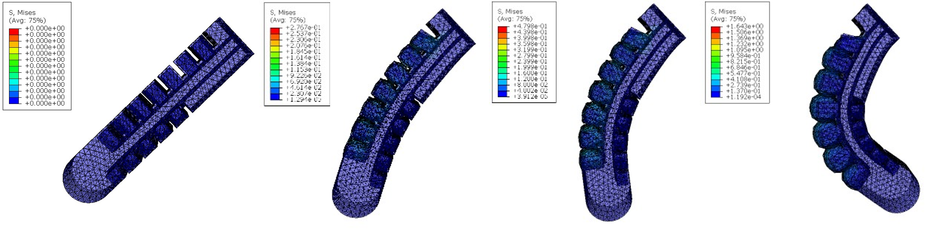
Figure 4. Simulation of curvature under air pressure from 0 to 100 kPa (Grasping mode)
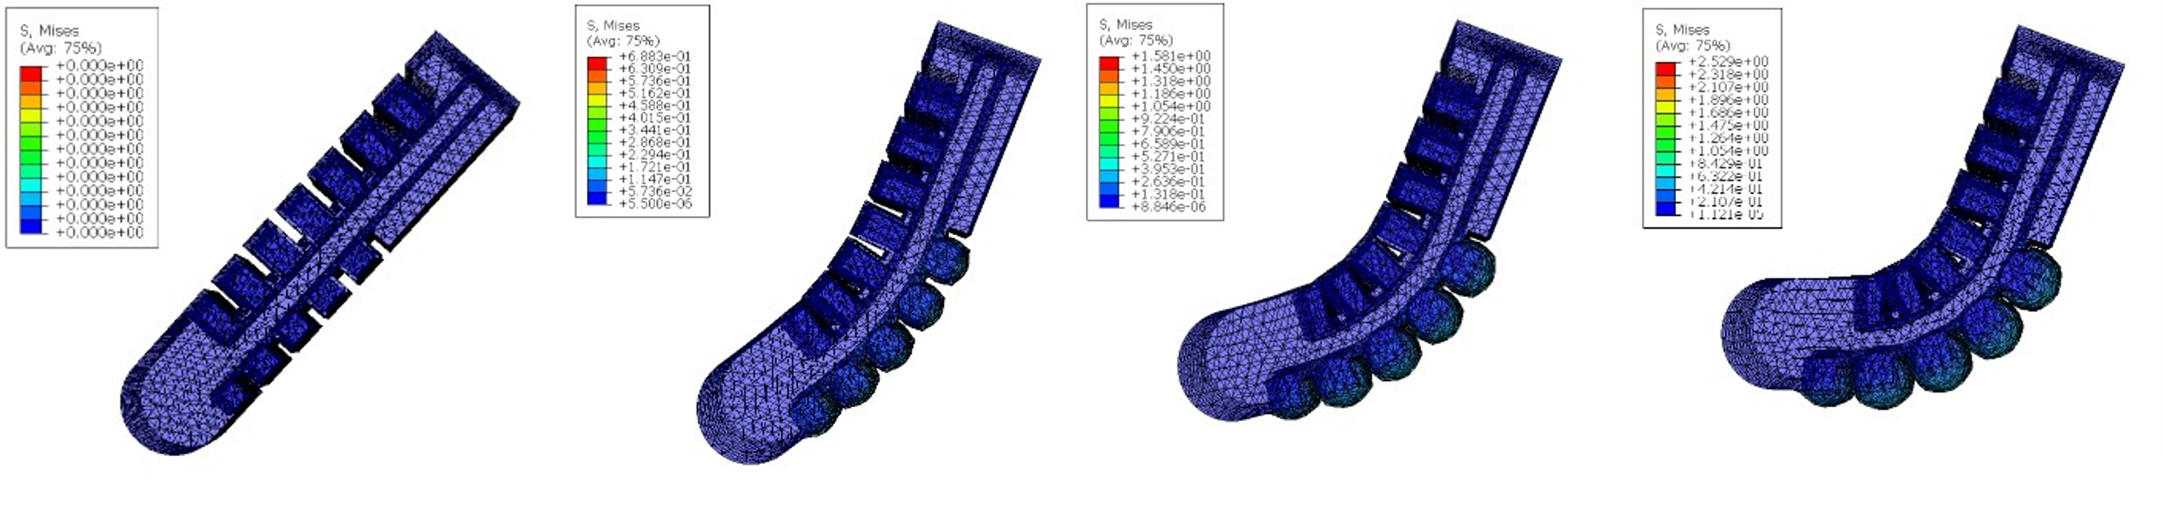
Figure 5. Simulation of curvature under air pressure from 0 to 60 kPa (Landing mode)

Landing Impact Absorption. Following FEA validation, we conducted comprehensive impact testing to evaluate the hexapod system's landing performance compared to conventional rigid landing gear. Figure 6 presents the comparative results from controlled drop tests at heights ranging from 0.2 to 5 meters with a standardized 2.7 kg drone platform. The graph plots peak impact force (N) against drop height (m) for both our pneumatic hexapod system (red) and a conventional rigid landing gear (blue) of equivalent weight.
The results demonstrate dramatic impact force reduction across all test heights. At the 0.5 m drop height (typical for controlled landings), peak impact force decreased from 165 N with the rigid system to 50 N with our pneumatic design—a 70% reduction. This performance advantage became even more pronounced at greater heights, with a 68% reduction (450 N to 145 N) observed at the 4 m test height, representing emergency landing scenarios. High-speed video analysis (1000 fps) of specific test conditions (marked with squares and triangles in Figure 6) revealed that our pneumatic system extends the deceleration period by 3.7× compared to rigid landing gear through progressive contact, controlled air displacement, and viscoelastic damping.
Contact pressure mapping confirmed that our hexapod configuration distributed forces across a significantly larger area than the rigid landing gear. Peak contact pressure was reduced from 63 kPa with rigid landing gear to 15 kPa with our pneumatic system — a critical improvement for preventing damage to fragile surfaces like solar panels (typically rated for maximum pressures of 25-30 kPa).

Grasping Capability. To evaluate the system's effectiveness as a manipulation tool, we designed a comprehensive grasping experiment using standardized test objects relevant to building inspection and maintenance tasks. The experimental setup consisted of the hexapod system mounted to a fixed frame, with test objects positioned centrally beneath it. For each test, the system activated its grasping mode by pressurizing the 7-chamber arrays (70-100 kPa) while integrated capacitive sensors provided real-time contact force feedback. Figure 7 presents the grasping performance results across different object geometries and weights. The system demonstrated consistent grasping capability for cylindrical objects with diameters ranging from 25 mm (small inspection tools) to 110 mm (pipe sections), achieving maximum lifting capacities of 1.2 kg for 25 mm objects and 0.85 kg for 110 mm objects. For rectangular prismatic objects with widths from 30-90 mm, the system maintained secure grasps with slightly reduced lifting capacity (0.9 kg maximum). Spherical objects proved more challenging, with effective grasping limited to diameters between 40-85 mm and maximum lifting capacity of 0.7 kg.
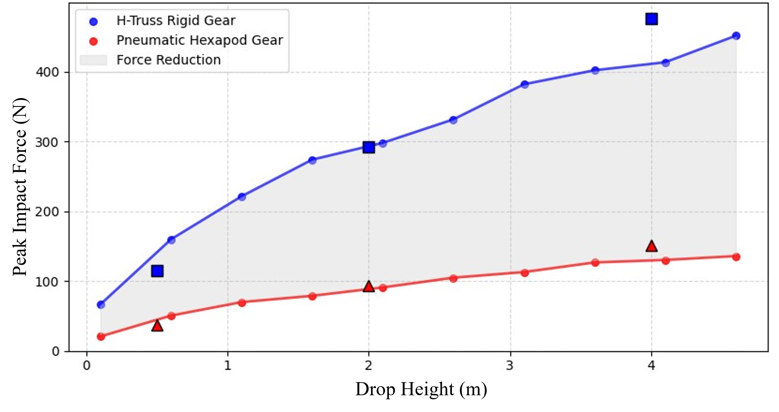
Figure 6. Impact Force Comparison: Rigid vs. Soft Landing Gear
The relationship between grasping force and actuation pressure followed a nearly linear trend from 70-90 kPa, with diminishing returns observed above 90 kPa. At maximum operational pressure (100 kPa), the system generated combined grasping forces of 43.2 N distributed across the six contact points. Contact force distribution analysis revealed that the hexapod configuration naturally equalizes grasp forces, with standard deviation between contact points measuring only 0.38 N during symmetrical object grasping. Actuation time measurements from initial command to secure grasp averaged 420 ms, with an additional 180 ms required to achieve maximum lifting force. The grasping strategy proved particularly effective for objects with irregular geometries typical of building components, as the compliant actuators automatically conformed to surface variations. Grasp reliability testing demonstrated 93% success rate across 50 consecutive cycles with a standard test object (75 mm diameter PVC pipe, 0.5 kg), with failures primarily occurring due to object positioning variations rather than actuator performance degradation.
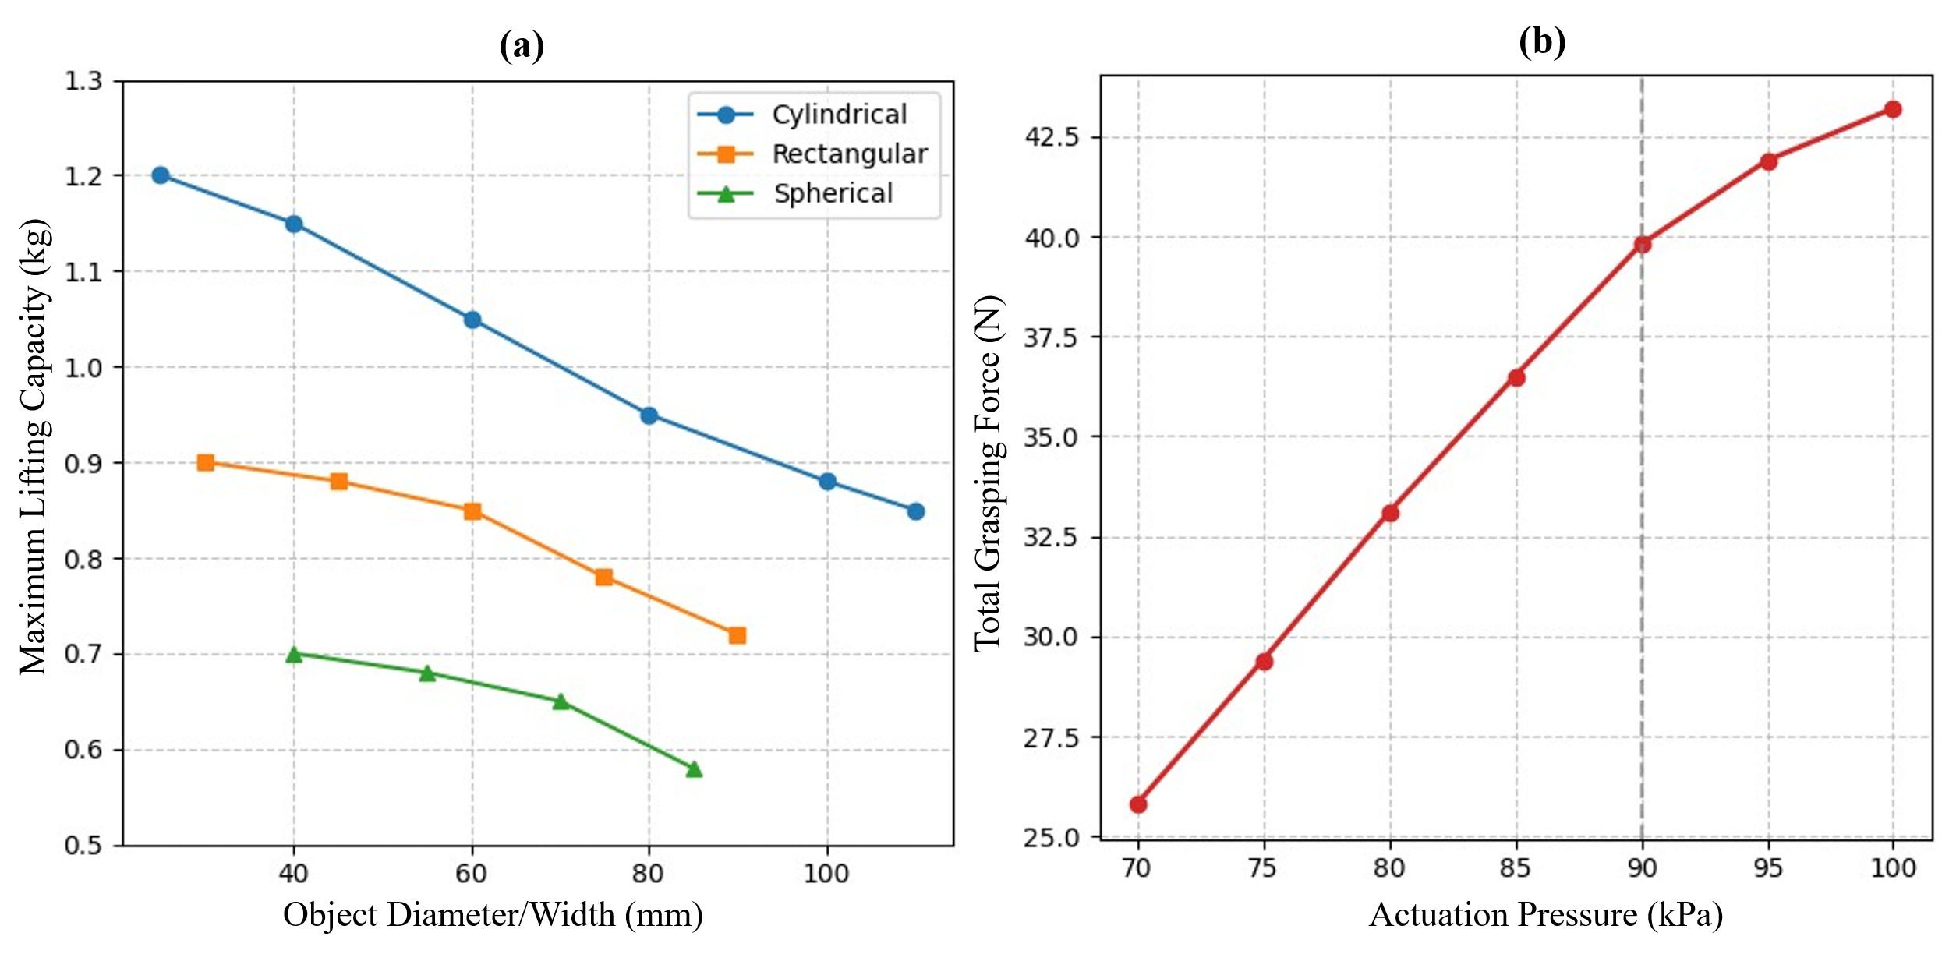
Figure 7. (a) Grasping Performance by Object Geometry (b) Grasping Force vs. Actuation Pressure

These results validate the dual-functionality objective of our system, confirming that the same pneumatic actuators can effectively serve both landing and manipulation purposes without compromising performance in either mode. The measured grasping capabilities enable a range of practical applications in building inspection and maintenance, including tool manipulation, sample collection, and temporary fixturing on structural elements.
- Discussion
The experimental results confirm that our pneumatically actuated hexapod system successfully addresses key challenges in drone interaction with fragile building materials. The 68% reduction in impact forces and 15 kPa peak contact pressure (well below damage thresholds of 25-30 kPa for sensitive materials) enables safe operation on high-value architectural components. The system's dual functionality—transitioning between landing and grasping modes—expands drone capabilities beyond visual inspection to include object manipulation up to 1.2 kg. The integrated tactile sensing further transforms drones from passive imaging platforms into active diagnostic tools capable of detecting subsurface issues invisible to cameras.
Despite these advances, several limitations exist. The additional 230g weight reduces flight time by 15-20%, creating a performance trade-off. Grasping reliability decreases for highly irregular or smooth objects, and the pneumatic system introduces operational complexities including potential leaks and temperature sensitivity. The current control system operates reactively rather than predictively, suggesting an opportunity for integration with vision systems for pre-contact adaptation.
Beyond building inspection, this technology has applications in solar panel maintenance, ecological research on fragile natural structures, and disaster response scenarios. More broadly, this work contributes to the evolution of drones from observational tools to interactive agents capable of both sensing and physically engaging with their environment, bridging the gap between aerial mobility and manipulation capabilities.
- Conclusion
This paper presents a pneumatically actuated, sensor-integrated hexapod system enabling drones to safely interact with fragile building envelopes and energy infrastructure. Our biomimetic design combines principles from arthropod locomotion and muscular hydrostats to create a dual-function system for both adaptive landing and object manipulation.
The system reduces landing impact forces by 68% compared to conventional landing gear, bringing contact pressures below damage thresholds for sensitive architectural materials. Its hexapod configuration provides inherent stability while distributing forces across multiple points. The innovative dual-chamber pneumatic design enables seamless transitions between landing and grasping modes, with the latter capable of manipulating objects up to 1.2 kg with 93% reliability.
Integrated tactile sensing transforms the landing gear from a passive mechanism into an intelligent surface assessment platform capable of detecting material properties and structural characteristics invisible to cameras. This expands drone capabilities in construction inspection, enabling comprehensive evaluation of building envelope integrity while reducing energy consumption and extending mission duration by eliminating continuous hovering.
By enabling drones to safely "touch" the surfaces they inspect, this technology advances the transition from distance-limited visual inspection tools to comprehensive assessment platforms capable of physical interaction. Future work will focus on weight optimization, enhanced grasping capabilities, predictive control systems, and specialized tactile analysis algorithms to further leverage the rich sensor data for building envelope assessment.

References
1. Son L, Bur M, Rusli M (2018) A new concept for UAV landing gear shock vibration control using pre-straining spring momentum exchange impact damper. JVC/Journal of Vibration and Control 24:1455–1468. https://doi.org/10.1177/1077546316661470/ASSET/B03D951C-4A35-48A4-958B-6CBFA55D9289/ASSETS/IMAGES/LARGE/10.1177_1077546316661470-FIG17.JPG
2. Chen PW, Huang WT (2015) A simulation of the fatigue life of light aircraft glass fibre-reinforced composites landing gear. Materials Research Innovations 19:S9142–S9147. https://doi.org/10.1179/1432891715Z.0000000001947
3. Wang H, Xing JT, Price WG, Li W (2008) An investigation of an active landing gear system to reduce aircraft vibrations caused by landing impacts and runway excitations. J Sound Vib 317:50–66. https://doi.org/10.1016/J.JSV.2008.03.016
4. Cai W, Li B, Wen JP, Wang L (2014) Research on cushioning characteristics of UAV soft landing airbags. Binggong Xuebao/Acta Armamentarii 35:1867–1875. https://doi.org/10.3969/J.ISSN.1000-1093.2014.11.019
5. Liu C, Jiang Z, Xu R, et al (2022) Design and Optimization of a Magnetic Catcher for UAV Landing on Disturbed Aquatic Surface Platforms. Proc IEEE Int Conf Robot Autom 1162–1168. https://doi.org/10.1109/ICRA46639.2022.9812270
6. Saranli U, Buehler M, Koditschek DE (2001) RHex: A Simple and Highly Mobile Hexapod Robot. Int J Rob Res 20:616–631. https://doi.org/10.1177/02783640122067570
7. Ni X, Yin Q, Wei X, et al (2022) Research on Landing Stability of Four-Legged Adaptive Landing Gear for Multirotor UAVs. Aerospace 2022, Vol 9, Page 776 9:776. https://doi.org/10.3390/AEROSPACE9120776
8. Adam Bilodeau R, White EL, Kramer RK (2015) Monolithic fabrication of sensors and actuators in a soft robotic gripper. IEEE International Conference on Intelligent Robots and Systems 2015-December:2324–2329. https://doi.org/10.1109/IROS.2015.7353690
9. Park YL, Tepayotl-Ramirez D, Wood RJ, Majidi C (2012) Influence of cross-sectional geometry on the sensitivity and hysteresis of liquid-phase electronic pressure sensors. Appl Phys Lett 101:191904. https://doi.org/10.1063/1.4767217/127672
10. Case JC, White EL, Kramer RK (2015) Soft material characterization for robotic applications. Soft Robot 2:80–87. https://doi.org/10.1089/SORO.2015.0002/ASSET/IMAGES/LARGE/FIGURE8.JPEG
11. Zhu S, Wang P, Tian J (2011) Experimental Research on Aircraft Landing Gear Drop Test Based on MRF Damper. Procedia Eng 15:4712–4717. https://doi.org/10.1016/J.PROENG.2011.08.882
12. Cheng HW, Chen TL, Tien CH (2019) Motion Estimation by Hybrid Optical Flow Technology for UAV Landing in an Unvisited Area. Sensors 2019, Vol 19, Page 1380 19:1380. https://doi.org/10.3390/S19061380

