Design and Experimental Evaluation of a Lunar Resource Extraction Drill Using Regolith Simulant

Hee-Chan Jang1[0009-0002-4836-9520], Dong-Hoon Kim1[0009-0003-9100-6386], Young-Jun Lee1, Yoo-Kyung Lee2 and Joo-Hyung Kim 1 [0000-0001-8658-768X],

1 Department of Mechanical Engineering, Inha University, Incheon, 22212, South Korea

2Korea Polar Research Institute, Incheon 21990, South Korea  
[joohyung.kim@inha.ac.kr](mailto:joohyung.kim@inha.ac.kr)

**Abstract.** Obtaining and supplying oxygen and hydrogen for the space program are essential to continue space exploration from the existing icy soil on the Moon. As reported, the moon including icy water on the surface is the only planet near earth will provide the required resources as known *In-Situ* Resource Utilization (ISRU). In this study, we evaluated the performance of a drilling system that can be mounted on a lunar exploration rover for icy water extraction and its efficiency. To achieve this, we used a test environment chamber capable of replicating low-pressure and low-temperature conditions like the harsh environment on the Moon. The system was tested under various operational conditions to analyze its performance in these extreme environments. The test conditions were set to simulate the harsh lunar environment, focusing on low temperature. Key metrics such as time required to drill to specified depths in simulant soil, efficient regolith removal, power consumption, and drilling speed were used to evaluate the system. The system's responses to different conditions were measured to determine the optimal operational range for maximum performance. This study provides valuable data that can enhance the reliability and efficiency of the rover's drilling system for future lunar exploration missions, contributing to the development of practical exploration technologies.

**Keywords:** In-Situ Resource Utilization (ISRU), Extreme environment, Drilling system, Water extraction, Lunar exploration.

1. Introduction

As space exploration efforts extend toward sustained missions on the Moon and beyond space, the utilization of local resources from its planet becomes more important [1]. Among local resources, the extraction of oxygen and hydrogen from lunar soil or/and subsurface ice is very important to enable life support, re-fueling, and long-term mission autonomy [2-4]. This approach, known as *In-Situ* Resource Utilization (ISRU), seeks to reduce the logistical and economic challenges of transporting consumables from Earth by harvesting usable materials directly from the lunar environment.

The Moon, however, poses a uniquely hostile setting for mechanical systems. Its surface is covered by regolith—a layer of fine, abrasive, and loosely compacted soil produced by billions of years of micrometeorite impacts [5-7]. This material exhibits unpredictable behavior under mechanical stress, especially in low gravity, ultra-high vacuum, and extreme temperature conditions, with surface temperatures ranging from + 120 °C in day time to − 173 °C at night condition [8-10]. These harsh temperature conditions significantly impact icy soil drilling performance, including tool wear, friction, and material removal efficiency.

Previous works have focused on developing prototype drills and excavation systems for lunar or planetary applications, but many studies have either not addressed low-temperature performance or have only evaluated their systems in ambient conditions similar to Earth [8, 11, 12]. Given the temperature effect on both mechanical components and the physical state of regolith (particularly icy regolith), performance verification under realistic thermal environments is crucial [13].

To address this gap, this study presents the design and experimental evaluation of a lunar resource extraction drill system intended for use on an exploration rover. The prototype system was developed with consideration for deplorability and structural robustness in extreme lunar environments. It was tested inside a thermal chamber under low-temperature conditions to simulate the thermal aspects of the lunar surface.

We conducted experiments under controlled temperature conditions to assess the system’s drilling capability in regolith simulant. During these tests, we measured and analyzed key performance metrics including resource extraction time, extracted volume, and maximum drilling depth. This data provides meaningful insight into the thermal and mechanical behavior of the system and serves as a basis for optimizing future lunar drilling technologies.

1. Drilling System Design
   1. System Overview

The developed lunar drilling and regolith extraction system is designed for the assemble to lunar exploration rovers in order to perform subsurface excavation under Moon-like conditions. As illustrated in Fig. 1(a), the system features a vertically mounted Auger-based drill unit capable of both penetration and soil extraction from drilling. The overall system dimensions are 395 mm (W) × 300 mm (D) × 1600 mm (H), with a total weight of 12.6 kg, allowing for compatibility to fit a medium-sized planetary rover platform.

The system architecture includes an integrated drilling module, linear motion unit, and regolith collection and transfer components. The mechanism is mounted on a rigid aluminum frame that allows stable vertical translation of the drilling head through a linear guide rail and motorized station. Extracted regolith is conveyed via a helical auger to a storage compartment, as shown in Fig. 1(b). The internal screw-based transport mechanism then directs the material laterally to a collection container, as depicted in Fig. 1(c).

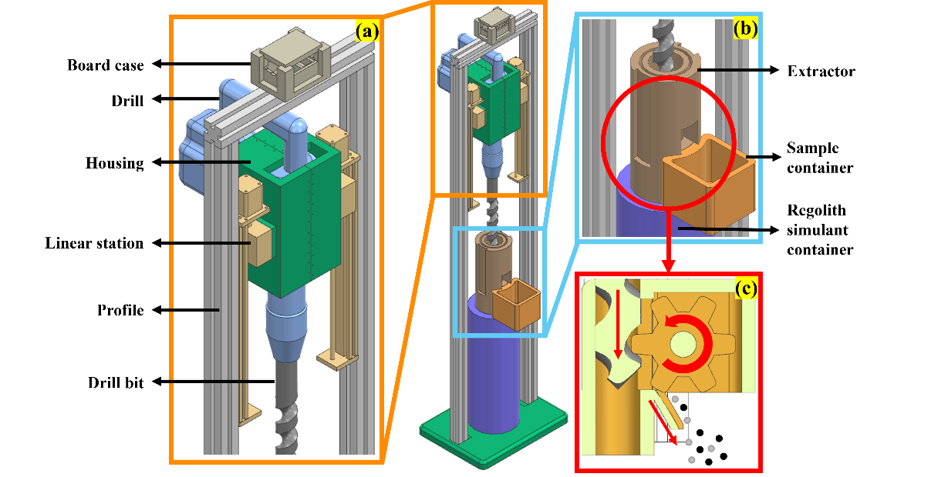

Fig. 1. Structural and operational overview of the lunar regolith drilling and extraction system: (a) Structural configuration of the drilling system, (b) Regolith extraction system and storage container for extracted materials, and (c) Internal transport mechanism for regolith simulant driven by an auger drill system.

* 1. Mechanical Structure

The drill unit consists of a high-power hammer drill operating at 1500 revolutions per minute (rpm) with 330 blows per minute (bpm) and an impact energy of 8.8 J. It consumes 1.150 kW and is mounted vertically to the rover system for efficient downward penetration into regolith simulant. The attached drill bit has a total length of 920 mm with an effective cutting length of 760 mm and an outer diameter of 36 mm. It is designed to both break through compacted regolith layers and convey loosened particles upward through the auger.

The vertical linear station, shown in Fig. 1(a), enables controlled descent of the drill up to 300 mm in stroke length at a travel speed of 20 mm/s. The linear station is powered by a 12 V, 3 A motor and uses guide rails for precise depth control during drilling. To prevent mechanical overtravel and ensure safe operation, limit switches are installed at the upper and lower ends of the *z*-axis travel range. These switches restrict the vertical motion of the drilling head, allowing precise control of drilling depth and preventing potential damage to the system. At the bottom end of the system, a regolith collecting encloses the base of the auger (see Fig. 1(b)). The Auger blade lifts the excavated material into this chamber, where it is guided into an internal channel. As shown in Fig. 1(c), a screw-based transport mechanism integrated with the rotating shaft moves the material laterally into a container.

All structural elements are primarily constructed from aluminum alloys and high-strength polymers to ensure durability under cyclic thermal stress and low-pressure conditions. Rotational and sliding components are selected with lubricants and materials suitable for vacuum and cryogenic environments.

* 1. Electronics and Control

The electronic control architecture is based on a microcontroller system powered by a 12 V supply, incorporating a 5 V operating Arduino-based controller and a Wi-Fi communication module for remote operation and monitoring. This configuration allows for both autonomous operation and manual override via a wireless interface.

The Auger and linear station motors are independently controlled. Motion is managed through feedback from encoders and limit switches to ensure safe and precise actuation. The control electronics are housed in an insulated, thermally managed enclosure to ensure consistent performance during operation in simulated lunar thermal environments. The total power consumption of the system components is summarized in Table 1.

Table 1. Electrical power consumption and weight distribution of the lunar drilling system components.

|  |  |  |  |  |
| --- | --- | --- | --- | --- |
| **Components** | **Voltage (V)** | **Power (W)** | **Unit (EA)** | **Weight (kg)** |
| Drill | 220 | 1150 | 1 | 6.8 |
| Stepper motor driver | 12 | 36 | 1 | 0.0018 |
| Linear station | 12 | 36 | 2 | 0.5 |
| Arduino | 5 | 0.2 | 1 | 0.025 |
| Limit switch | 5 | 5 | 2 | 0.008 |
| Housing | - | - | 1 | 3.5 |
| Profile | - | - | 1 | 1.25 |
| Total | - | 1268.2 | - | 12.5928 |

1. Experimental setup

To evaluate the performance of the lunar drilling system under simulated low-temperature lunar conditions, a controlled testbed was established. The primary component of the testbed was a thermal chamber capable of maintaining temperatures ranging from − 20 °C to − 50 °C. Although the chamber did not simulate vacuum, it allowed the evaluation of drilling behavior under cold conditions representative of the lunar subsurface environment.

The drilling tests utilized Korea Lunar Simulant—Type 1 (KLS-1), an artificial lunar regolith simulant developed by the Korea Institute of Civil Engineering and Building Technology (KICT). KLS-1 closely mimics the geotechnical and chemical properties of natural lunar regolith, making it suitable for evaluating excavation systems intended for lunar applications [14].

For the experiments, the KLS-1 simulant was mixed with water to achieve an 18 wt% water content. As shown in Fig. 2, to determine the optimal water content, mixtures with varying water concentrations were subjected to tests using a Universal Testing Machine (UTM) to evaluate their uniaxial compressive strength. In Fig. 3, the 18 w.t.% mixture exhibited the highest compressive strength among the tested samples, making it the most suitable for simulating moderate-strength frozen regolith found in lunar subsurface environments. Based on this result, the water-saturated simulant was frozen within the regolith simulant container to replicate icy regolith conditions for the drilling tests.

The drilling system was precisely aligned and secured within the chamber using a custom-fabricated profile that matched the dimensions of the regolith simulant container. This ensured stable and accurate vertical alignment during drilling operations.

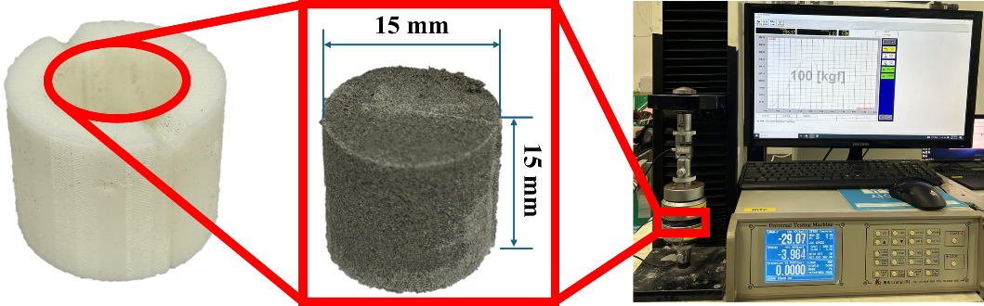

Fig. 2. Preparation and uniaxial compressive strength testing of frozen KLS-1 regolith simulant samples using a Universal Testing Machine (UTM).

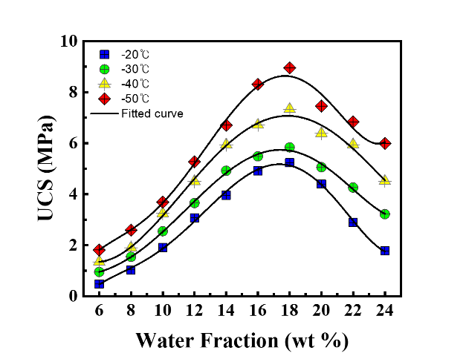

Fig. 3. Uniaxial compressive strength of frozen KLS-1 regolith simulant at varying water contents.

1. Results and Analysis
   1. Drilling Performance at Varying Temperatures

Each drilling test was conducted for a fixed duration of 10 seconds. This limited operation time was determined based on preliminary trials, during which longer drilling durations resulted in the drill bit becoming immobilized within the simulant due to adhesion between the frozen regolith and the bit surface. This sticking effect, caused by ice-regolith bonding under low temperatures and high contact pressure, made it impossible for the system to continue drilling beyond 10 seconds without risking damage or requiring external intervention [3, 13].

Despite this constraint, clear performance trends were observed across the tested temperature range − 20 °C to − 50 °C as shown in Fig. 4. The system extracted 90.7 g of simulant at − 20 °C with a drilling depth of 6 cm. As the temperature decreased, both extracted mass and penetration depth consistently declined: 84.2 g and 5.5 cm at − 30 °C, 74.6 g and 5 cm at − 40 °C, and 58.3 g and 4 cm at − 50 °C. The decreasing drilling performance is attributed to increased material strength and cohesion at lower temperatures, making penetration more difficult and reducing the effectiveness of the auger mechanism [15].

텍스트, 라인, 도표, 스크린샷이(가) 표시된 사진

AI가 생성한 콘텐츠는 부정확할 수 있습니다.

Fig. 4. Drilling depth and extraction amount according to temperature.

* 1. Drilling Efficiency Evaluation

Drilling efficiency, expressed in Equation (1), was evaluated by quantifying the mass of regolith simulant extracted per unit of energy consumed during the operation [16].

()

The drilling efficiency (*η*) is defined by relating the extracted mass to the power consumed over time, was calculated using Equation (2):

$η=\frac{m}{t ∙ P}$ (2)

where, *m* represents the extracted mass (unit: g), *t* is the drilling time (h), and *P* is the system’s power consumption (W), measured as 1268.2 W. All tests were conducted over a fixed duration of 10 seconds (*t* = 10 / 3600 h).

The calculated efficiencies were 25.747 g/Wh at − 20 °C, 23.902 g/Wh at − 30 °C, 21.176 g/Wh at − 40 °C, and 16.549 g/Wh at − 50 °C. Fig. 5 demonstrate a clear decline in efficiency as temperature decreases, highlighting the increased mechanical resistance of frozen regolith and its impact on extraction performance.

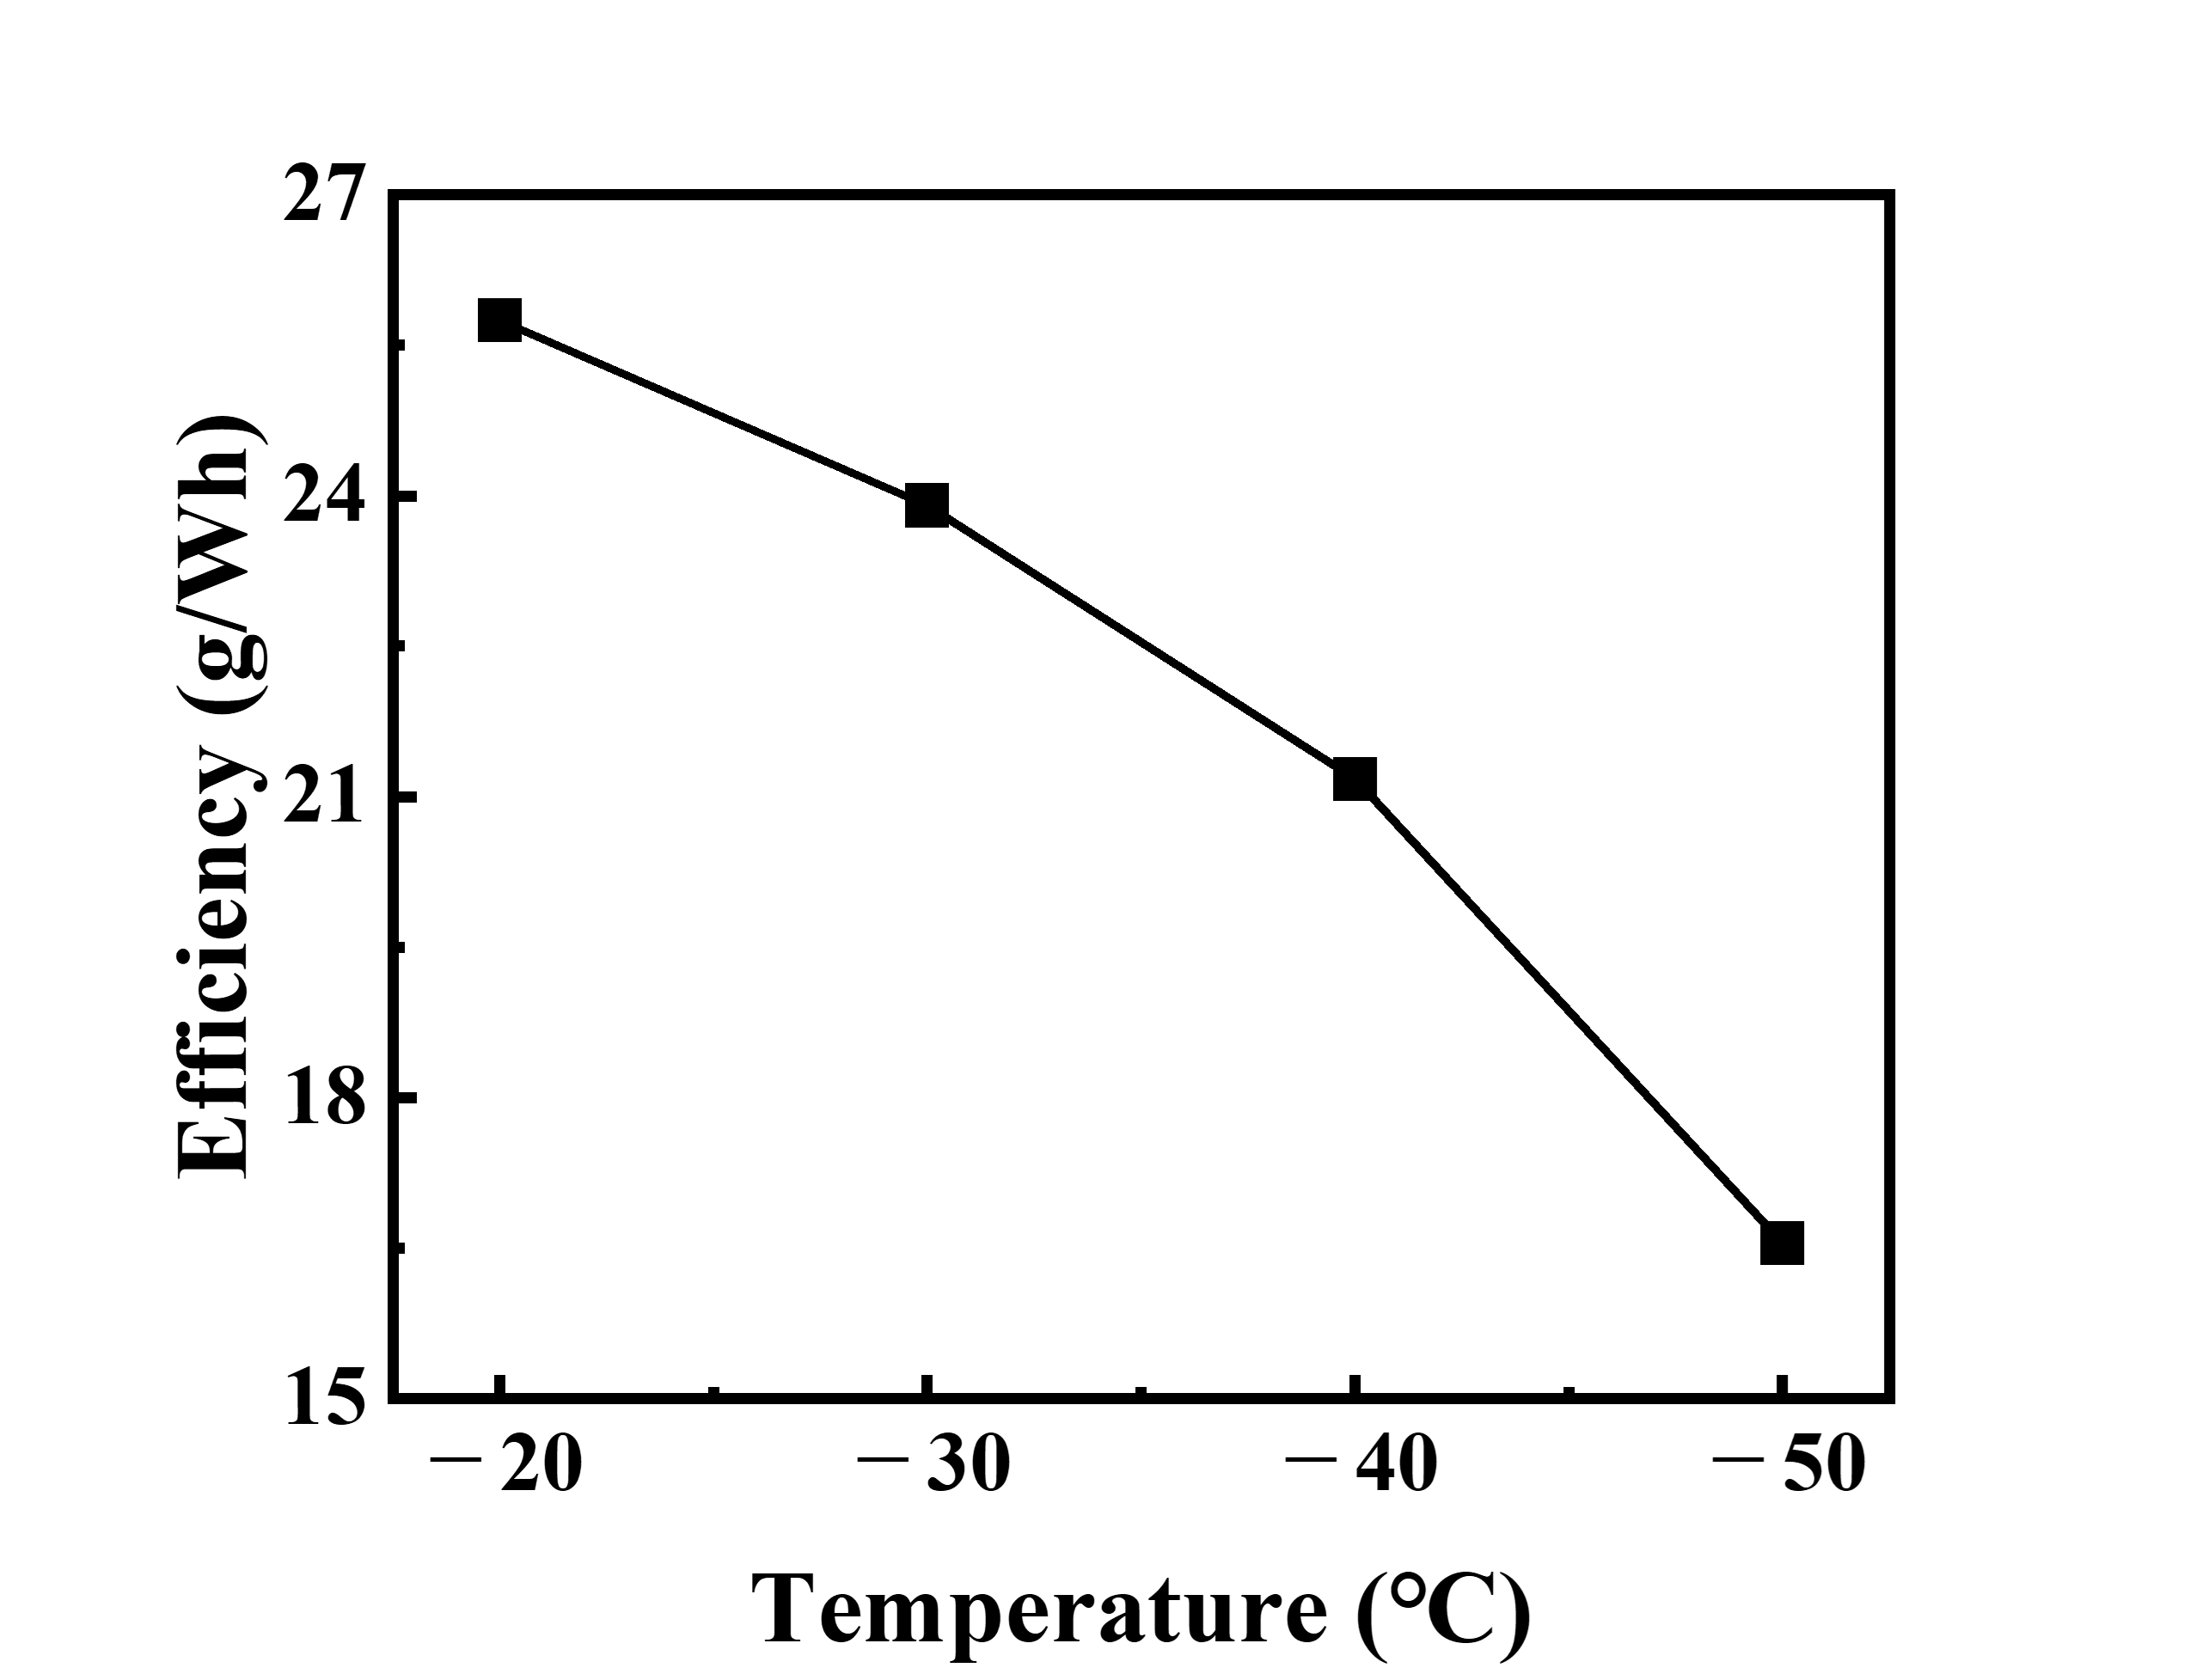

Fig. 5. Drilling efficiency of the system at various temperatures.

1. Conclusions and Discussion

This study presents a lunar regolith drilling design and experimental evaluation and extraction system intended for integration with exploration rovers. The drilling system is developed to operate under harsh conditions similar to the lunar environment and has been tested using a regolith simulant (KLS-1) with water contents to simulate icy soil layers on Moon. The drilling system demonstrated stable operation at temperatures as low as − 50 °C, although its performance was strongly influenced by temperature. As temperature decreased, both the mass of extracted regolith and the maximum drilling depth declined significantly due to increased material cohesion and mechanical resistance of the frozen simulant. Similarly, drilling efficiency, measured in grams per watt-hour (g/Wh), showed a consistent decrease from 25.747 g/Wh at − 20 °C to 16.549 g/Wh at − 50 °C.

These results highlight the critical role of thermal conditions in determining the effectiveness of lunar excavation systems. In particular, the reduced performance at lower temperatures suggests that future lunar drills must incorporate strategies to mitigate regolith freezing effects—potentially through localized heating, surface coating to reduce adhesion, or adaptive control based on sensing of drilling resistance. Future work will focus on the performance test with long operational time under vacuum and developing thermal and mechanical mitigation strategies to enhance drilling performance.

**Acknowledgement**: This work was supported by the National Research Foundation of Korea funded by the Ministry of Science and ICT under Grant (NRF-2022M1A3C2076483, Space HR&D Center)

References

1. NASA: NASA’s Plan for Sustained Lunar Exploration and Development. National Aeronautics and Space Administration (NASA) Washington DC (2020)

2. <https://www.nasa.gov/overview-in-situ-resource-utilization/>

3. Linne, D., Sanders, G., Kleinhenz, J., Moore, L.: Current NASA in-situ resource utilization (ISRU) strategic vision. In: Space Resources Roundtable Planetary & Terrestrial Mining and Sciences Symposium. (Year)

4. Zhang, P., Dai, W., Niu, R., Zhang, G., Liu, G., Liu, X., Bo, Z., Wang, Z., Zheng, H., Liu, C.: Overview of the lunar in situ resource utilization techniques for future lunar missions. Space: Science & Technology 3,0037 (2023)

5. Colwell, J., Batiste, S., Horányi, M., Robertson, S., Sture, S.: Lunar surface: Dust dynamics and regolith mechanics. Reviews of Geophysics 45,(2007)

6. McKay, D.S., Heiken, G., Basu, A., Blanford, G., Simon, S., Reedy, R., French, B.M., Papike, J.: The lunar regolith. Lunar sourcebook 567,285-356 (1991)

7. Noble, S.: The lunar regolith. In: Lunor Regolith Simulant Workshop. (Year)

8. Jiang, M., Xi, B., Arroyo, M., Rodriguez-Dono, A.: DEM simulation of soil-tool interaction under extraterrestrial environmental effects. Journal of Terramechanics 71,1-13 (2017)

9. Hayne, P.O., Bandfield, J.L., Siegler, M.A., Vasavada, A.R., Ghent, R.R., Williams, J.P., Greenhagen, B.T., Aharonson, O., Elder, C.M., Lucey, P.G.: Global regolith thermophysical properties of the Moon from the Diviner Lunar Radiometer Experiment. Journal of Geophysical Research: Planets 122,2371-2400 (2017)

10. Duffey, C., Lea, M., Brisset, J.: Measuring Regolith Strength in Reduced Gravity Environments in the Laboratory. arXiv preprint arXiv:2411.11571 (2024)

11. Mueller, R., Van Susante, P.: A review of lunar regolith excavation robotic device prototypes. In: AIAA Space 2011 Conference & Exposition, pp. 7234. (Year)

12. Wettergreen, D., Moreland, S., Skonieczny, K., Jonak, D., Kohanbash, D., Teza, J.: Design and field experimentation of a prototype lunar prospector. The International journal of robotics research 29,1550-1564 (2010)

13. Kleinhenz, J.E.: Lunar polar environmental testing: Regolith simulant conditioning. In: 7th Symposium on Space Resource Utilization, pp. 0689. (Year)

14. Ryu, B.-H., Wang, C.-C., Chang, I.: Development and geotechnical engineering properties of KLS-1 lunar simulant. Journal of Aerospace Engineering 31,04017083 (2018)

15. Dotson, B., Valencia, D.S., Millwater, C., Easter, P., Long-Fox, J., Britt, D., Metzger, P.: Cohesion and shear strength of compacted lunar and Martian regolith simulants. Icarus 411,115943 (2024)

16. Quan, Q.-Q., Chen, C.-B., Deng, Z.-Q., Tang, J.-Y., Tang, D.-W.: On modeling drilling load in lunar regolith simulant. Chinese Journal of Mechanical Engineering 31,1-12 (2018)