Module Construction of Multistory Buildings in Norway: A Comparative Study
Marius Ree and Nirosha D. Adasooriya
University of Stavanger, Mailbox 8600, 4036 Stavanger, Norway
marius.ree@grunn-service.no
Abstract. This study compares traditional cast-in-place concrete, precast concrete elements, and prefabricated modular systems in the context of multistory building construction in Norway. Traditional casting remains dominant due to its flexibility, familiarity, and adaptability to on-site changes, despite being labor-intensive and susceptible to environmental conditions. Precast elements, produced off-site and transported for assembly, offer improved quality control, reduced labor requirements, and faster construction but face logistical and customization limitations. Prefabricated modular construction, though rarely used in Norway, presents significant advantages, including shorter construction timelines, improved safety, reduced labor costs, and consistent factory-controlled quality. However, it suffers from limited flexibility and greater transport complexity. A case study of a three-story office building in Randaberg is used to compare the structural performance, cost, time efficiency, customizability, installation logistics, and safety aspects of each method. Structural elements were analyzed in accordance with Eurocode standards. The study finds that a hybrid approach combining precast and traditional methods is currently the most practical solution for Norwegian conditions. While modular construction offers promising benefits, broader implementation depends on further research, standardization, and increased industry confidence. This study focuses also on optimizing construction practices in Norway and highlights the potential of modular solutions in addressing housing and labour challenges, particularly in repetitive-use building types.
Keywords: Concrete structures, module construction, prefabricated elements, comparative study, cost and construction efficiency, structural performance, applicability
- Introduction
Modular construction focuses on making prefabricated modules and elements with preinstalled services in order to reduce the construction time, whilst also maintaining the structural performance and safety of the building. Though this have not been used much in Norway, it can be observed from other countries that this method has many advantages and disadvantages. To name a few, the construction time is faster, the cost can be reduced, inventory spacing can be managed more easily, labour cost can be reduced, labour safety can be improved, while still satisfying the structural requirements for the job. Furthermore, modular construction may be a more affordable solution to the housing crises in underdeveloped countries and a solution for cheaper student housing [1,2].
The use of prefabricated construction methods has been less common in Norway than in other countries such as China and North America [2]. This is partially due to the lack of knowledge and confidence in the construction method, and due to the country’s extensive length and mountainous terrain make transportation less optimal. In order to boost the confidence for build owners to use prefabricated manufacturing, it is important to study and analyze the many advantages, disadvantages and limitations of traditional construction and prefabricated construction methods. Factors such as installation, transportation and efficiency will affect the overall cost of the project. Therefore, it is important to compare these factors in each of the construction methods. It is of utmost importance that the structural performance of constructions is of high quality and safe for workers. Prefabricated element construction is used to some degree in Norway, but the use of full-scale modules with pre-installed services is almost completely excluded in the construction industry in Norway. However, it may become more included in future projects if contractors become more familiar with the method. A mix of precast elements with cast-in-place elements are sometimes used in projects in Norway.
The objective of the paper is to analyse and compare above mentioned three construction methods with respect to their potential in Norway. This includes a design calculation of the critical beam and column element of the model building in accordance with appropriate Eurocodes. This specifically includes a comparison of casting/molding approaches, transportation, installation, fabrication of elements, inventory management, installation services, customizability, cost and time efficiency, inspection and safety control, application and the connecting/jointing methods for assuring structural performance of the building
- Existing Construction Methodology
In-situ cast concrete is installed by preparing a formwork with the required reinforcement ready, which is termed as traditional casting or monolithically casting methodology. Later, this formwork is filled with the design concrete mix and vibrated thoroughly to remove any air bubbles trapped in the mix. After 28 days, the mix has reached the required design compressive strength [1] and the formwork can be removed from the hardened concrete element.
Prefabricated elements are created using a near identical approach. Instead of using a formwork at the installation place, the concrete mix is poured into a reusable mould in an off-site factory or on-site mini factory. Using this method, it is possible to use a vibrating floor or formwork vibrator as an external vibrator, instead of the traditional on-site vibrator. Another alternative is to use a self-compacting cement mix to reduce vibration work. When the element is ready, it can be transported to the installation place and connected by appropriate joining methods. If the element is not fabricated at the construction site, one must also consider adequate safety of transporting the element.
When using prefabricated modules, an entire module is cast as a combination of linear and planar elements [2]. The module is fitted with electrical work and piping services either during casting, or after casting, depending on whether internal or external services are desired in the finished build [2]. Later, the full module is transported to the installation place. The difficulty of transporting such modules will depend on the size and complexity of the module. Bigger modules may not be stacked as efficiently as smaller modules. Heavier modules are also more difficult to transport due to difficulty of fulfilling weight limitations on trucks in Norway. Typically, the module width can be up to 4.2 m according to [2], but lengthwise it can be up to 16 m.
Modular construction uses volumetric units composed of planar and linear concrete elements to form a full-sized module [2]. Manufacturers would require specialized workers who are familiar with the process and disciplined in the new construction method. Further optimalization of this construction method requires some degree of flexibility in planning of modules, while retaining some standardization of components for efficient manufacturing. For production, some degree of standardization is encouraged for flexibility in module design, economic manufacturing and material procurement. The contractors must decide for themselves whether modular construction or precast element construction is the most economical and practical solution for their project. The modules should be “standardized wherever possible” to make the casting, striking, lifting and installation process as simple as possible [2].
- Considered Case Study Building
This case study focuses on a three-storey building constructed by Harestad Bygg AS in Randaberg, Norway (see Fig.1). The building includes a fitness centre on the first floor and office spaces on the upper two floors. For analysis and comparison purposes, various simplifications and assumptions have been made. For example, walls are modeled without openings and are assumed to carry no vertical loads, while beams, columns, and slabs are assigned uniform material properties (see Fig.2).
The structure is treated as free-standing, despite being connected to another building in reality, to maintain symmetry in the analysis. Structural components are modeled in Revit 2023, with standard dimensions applied: 610x610 mm columns, 400x600 mm beams with pin supports, and 225 mm thick slabs. Only critical elements are identified as the central beam and column on the first floor due to the building’s symmetry are designed according to Eurocodes using Smath software for flexibility in calculations.
Regarding modular construction, the same design principles as traditional reinforced concrete are followed. However, a key distinction is the installation method. Entire modules are installed at once, unlike precast elements, which are typically installed individually. Despite this, all designs must comply with Eurocode requirements. These assumptions and limitations ensure a manageable and focused analysis, though they may limit the full accuracy of real-world conditions.

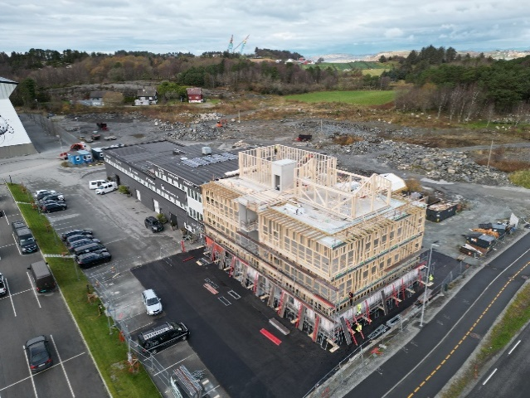

Fig. 1. Considered case study building

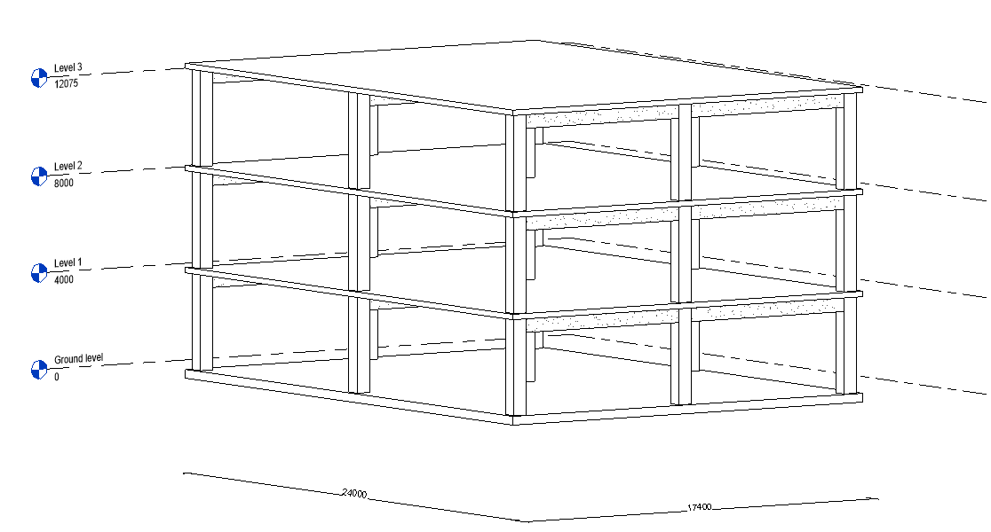

Fig. 2. 3D view of building without walls modelled in Revit. View direction from South- East toward North-West.
- Principles of Modular Construction and Case Study Application
Lawson et al. [2] highlight both general and specific principles related to the planning of modular construction buildings. This covers various types of modular structures, construction layouts, and the dimensions of example buildings. For instance, it discusses grid planning for different building types. The case study in this study is a three-storey office building. For office buildings, module lengths typically range from 6 to 12 meters, with increments of 600 mm. An internal planning dimension of 1500 mm is commonly used for office layouts [2]. Furthermore, the typical internal module width for office buildings is 3.6 meters, although this is only indicative. Actual dimensions may vary depending on the building’s specific requirements. External modules are generally "250 to 300 mm wider than their internal dimensions" [2].
  - Example Layout of Case Study Using Modular Form
In order to fit as many modules of the same size as possible, the width of the building has been increased from 17.4 m to 17.6 m. As previously stated, the office modules can have lengths between 6 and 12 m. Thus, allowing the length of the building to stay the same, with only minor adjustment to the width. An example layout of the building using corridor design with a stabilizing core can be seen in Fig. 3 below. Greater detail about the modules can be found in Table 1 below.

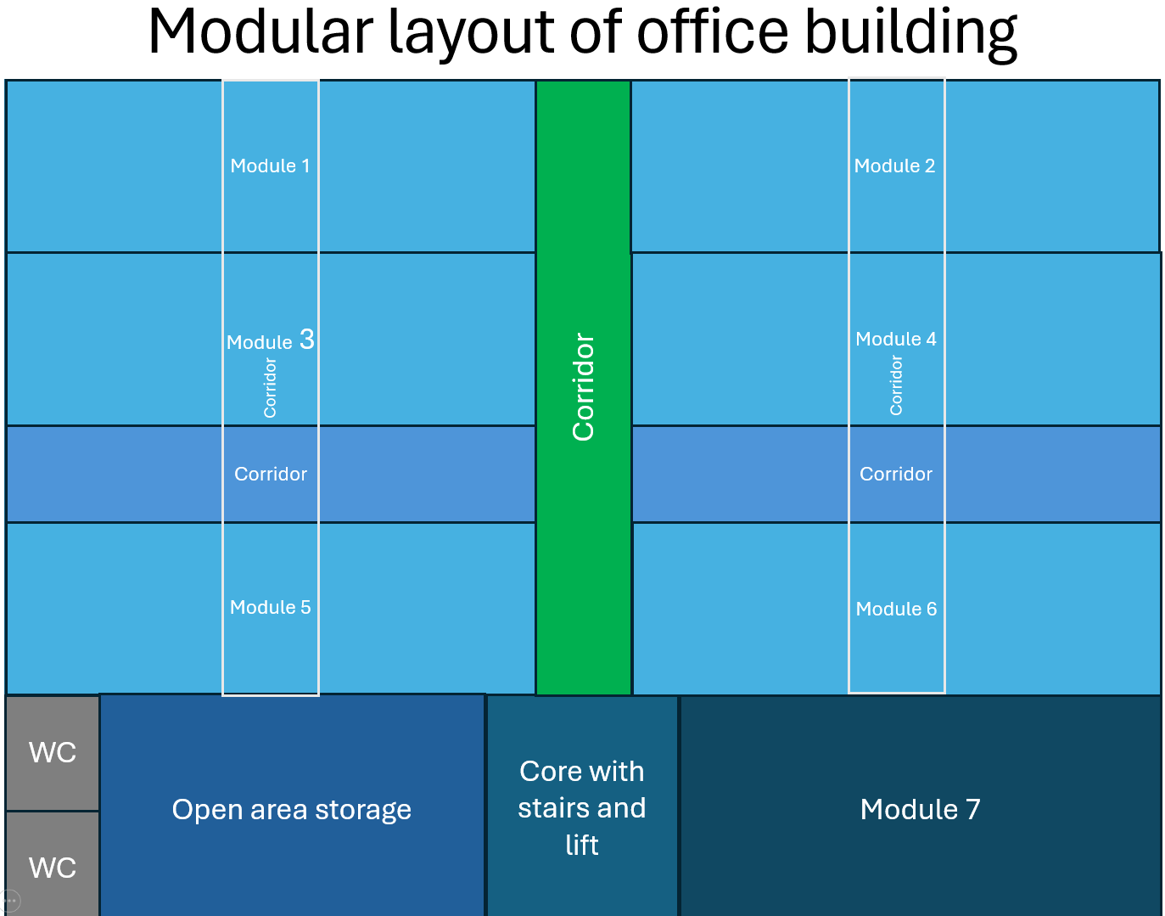

Fig. 3. Modular layout of office building (Office modules, Corridor modules (blue), Corridor modules (green), WC pods, Meeting room modules (module 7), Core modules, or Traditionally cast the entire core)

The modules can be stacked vertically across three storeys to match the case study building. While not necessarily optimal, this layout is chosen for simplicity. Alternatively, the 'Open Area Storage' module could span floors 1 and 3, and be removed from floor 2, allowing that space to be used for a larger bathroom serving the entire building.
Assuming an installation rate of 6–10 modules per day, the total installation time is estimated at 5–7 days. At approximately £2,000 per unit [2], the total cost is £82,000 or around 1,115,423 NOK [3]. Compared to the original 1,419,400 NOK cost, this represents a 21.4% reduction, aligning with the 20% theoretical savings reported by Lawson et al [2].
Table 1. Details of modular layout of office building

Module | Dimensions in metres (L x W x H) | Conforms to | Description
1-6 | 3.6 x 11 x 4 | Module width and length for offices, page 70 in [2] | Two separate offices with a corridor splitting the two apart
Corridor (blue) | 11 x 2 x 4 | One side less than 2,55 m for transport | Corridor which allows access to the other office modules
Corridor (green) | 2 x 12.8 x 4 | One side less than 2,55 m for transport | Corridor for access to the building after entering from the core. May require division into two modules
Core | 4 x 2.4 x 4 | One side less than 2,55 m for transport | Core with stairs and lift. Access from the bottom floor to the top floor. Module consists of two modules of given dimension to form the core. Alternatively, it can be cast traditionally for structural integrity
WC | 2 x 2.4 x 4 | [2] page 52 for typical bathroom module dimensions | Bathroom pod
Open area storage | 8 x 2.4 x 4 | One side less than 2,55 m for transport | Combination of two modules to form one room used for storage.
Module 7 | 10 x 2.4 x 4 | One side less than 2,55 m for transport | Meeting room. Combines two modules of given dimension two form one room
- Comparison: Casting, Installation and Transportation
The construction of concrete structures can be achieved through three primary methods: traditional casting, precast elements, and prefabricated modules, each with unique benefits and limitations. Traditional casting, or cast-in-place concrete, is especially effective in areas difficult to access with large precast elements. Its flexibility allows for on-demand adjustments and repairs on-site without waiting for new deliveries. However, it requires substantial inventory space, making it less suitable for tight urban environments. Additionally, Norway’s cold climate presents challenges, as freezing during the hydration phase can severely compromise concrete strength. Solutions like heated formwork and antifreeze admixtures can mitigate some of these risks, though controlled factory environments offer more reliable outcomes.
Precast elements are factory-made components transported to the site and installed using cranes. This method reduces on-site clutter and speeds up construction but depends on efficient logistics and transport planning. To meet Norwegian transport regulations, elements must not exceed width and height limits of 2.55 m and 4.5 m, respectively. Techniques like tilting elements during transit and using standardized, stackable designs can help comply with these rules and improve transport efficiency. Nevertheless, delays can result in costly crane downtime, making scheduling critical.
Prefabricated modules further integrate construction by combining multiple components into single units. These modules face similar transport constraints due to their size and weight. Calculations show that modules can remain within legal transport limits if appropriately dimensioned (e.g., max 6.5 m in length and 2.55 m in width). Factory fabrication enhances quality control and accelerates production using rapid curing techniques. However, modules must be carefully secured during transport to avoid damage, as repairs can delay the entire project. Weather protection and structural reinforcement during lifting are also key considerations in modular construction logistics.
The key findings are systematically compared in Table 2 below. To facilitate a comprehensive comparison of various construction methods, advantages and disadvantages are organized in a keyword-structured format. This approach enhances clarity and enables a more precise evaluation of critical factors and performance characteristics associated with each method.
Table 2. Comparison of casting, installation and transportation.
Factor or quality | Traditional Casting | Precast elements | Prefabricated modules
Reachability for tight spaces | Good | No, but can be ignored if project is planned carefully | No, but can be ignored if project is planned carefully
Element construction | On-demand casting, can fix element mistakes on-site | Depend on deliveries | Depend on deliveries
Inventory | On-site inventory must fit all equipment and materials.  No need to include big space for storage of elements. | Some inventory for storage of elements.  Can use on-site mini factories if desired.  Site must be fitted to include installation cranes. | No inventory for storage, modules are connected directly from transport  Site must be fitted to include installation cranes.
Weather effect | Weather effects is unfavourable  Freezing and Thawing cycles need more attention in Norway. Total Betong mention small measures reduce this risk. | Controlled environment in off-site factory lead to ignorance of weather effects | Controlled environment in off-site factory lead to ignorance of weather effects
Transportation | Transportation of equipment. | Stack elements for efficient transport.  Must keep size within transport limitation.  Bigger elements take more volume of trucks due to inclination | Size and weight of modules make it unfavourable to stack modules.  One module at a time should be transported.  Difficulty to transport modules of sufficient dimension and still achieving required structural performance
Lifting and installing | Install directly, no lifting points required | Additional steel for lifting points must be considered  Must be designed for induced tension during lifting. | Additional steel for lifting points must be considered  Must be designed for induced tension during lifting.
Damages | Only one element would need re-casting | Only one element would need replacement | Damage of module would create big holdup in the entire project
- Comparison: Customizability
Customizability plays a vital role in ensuring each construction project retains a sense of uniqueness. Different construction methods offer varying levels of adaptability, each with specific strengths and limitations in customization. Traditional casting is highly flexible in shape and form since unique moulds are created for each element, although it typically includes less finishing detail. Design patterns can still be added to the surface to enhance appearance. Precast elements, particularly those used by Veidekke Prefab, allow for extensive customization through reusable moulds and interchangeable finishing panels. Using magnetic wooden panels enables alterations in shape, slope, and dimensions, providing both variety and visual interest. In contrast, prefabricated modules offer limited customizability. Their design favors repetition and standardization to maintain cost and time efficiency. While facade finishes can be varied for a customized look, significant alterations reduce the modular system’s economic benefits. Thus, while all methods offer some level of customization, the extent and efficiency vary significantly across them.
A degree of customization is often desired in construction. Construction methods differ in their ability to accommodate customization, impacting element dimensions and finishes. Table 3 provides a concise summary of a comparative overview of how cast-in-situ concrete, precast construction, and modular approaches allow for modifications. while some techniques provide greater flexibility, all methods incorporate tailored design considerations. Evaluating these differences helps in selecting the most suitable approach for a given project.
Table 3. Comparison of customizability
Factor or quality | Traditional Casting | Precast elements | Prefabricated modules
Custom pattern | By rolling pattern over newly cast concrete | By pattern panels which is applied to mould | Custom modules reduce the advantages of faster construction by reducing the repetitiveness of modular construction.  Is possible, but not recommended practice.
Dimensions | Each mould created for each specific element.  Desired dimensions are easily achieved. | Highly adaptable factory moulds.  Desired dimensions can be achieved, but standardisation is recommended. | Best to use the same dimensions for the moulds to increase repetitiveness
Outside finish | Facades | Facades | Facades
- Comparison: Cost and Time Efficiency
Cost and time efficiency are critical considerations for construction projects, influencing both planning and execution. Traditional casting, while capable of high-volume concrete placement as demonstrated by Total Betong, involves substantial labor hours, site preparation, and material handling, which contribute to higher total project costs. Estimated costs from a case study show traditional casting reaching over 1.4 million NOK, with key expenses in concrete, steel reinforcement, and formwork. Although suitable for specific large-scale elements, it often requires more time and labor compared to off-site alternatives.
Precast elements, as used by Veidekke Prefab, offer significant gains in time efficiency and moderate cost reductions due to factory-based production and better coordination. Comparative analysis from ENECA shows that precast methods can cut construction time by up to 210 days and reduce labor hours fivefold, with only a slight increase (about 5%) in material cost. However, precast methods can incur higher transportation costs, especially when site and factory are far apart.
Modular construction offers the highest efficiency in both time and cost. It enables simultaneous site preparation and factory fabrication, reducing project timelines and material waste. Studies show potential savings of up to 20% in overall costs and 25% in labor costs. Modular methods also eliminate the need for formwork and scaffolding, further reducing on-site labor and resource demands. However, like precast elements, modular systems face logistical challenges and increased transport costs that must be managed for optimal efficiency.
Table 4 below shows a shortened comparison of the research connected to cost and time efficiency of each construction method. To get a better idea of which factors to consider when discussing how optimal each method is, the comparison below gives a clearer idea well.

Table 4. Comparison of cost and time efficiency

Factor or quality | Traditional Casting | Precast elements | Prefabricated modules
Production efficiency | 1750 m³ in 13.5h was the largest project for Total Betong.  Can produce more if necessary, but more labour workers are required. | 300-400 m³ per day.  Specialized and well-coordinated workers is necessary to achieve this. | 6-10 modules per day.  4-5 man-hours per m² floor area.
ENECA Comparison | More labour hours.  Slightly higher cost per m².  More construction days. | Less labour hours.  Slightly lower cost per m².  Less construction days. | N/A
Transportation cost | N/A | Transportation of material + Shipping of elements.  Highly dependent on relative distance to construction site. Not as high if on-site mini factories are used, but then weather effects must be considered for quality.  Multiple elements can be stacked to reduce the number of trips needed. | Transportation of material + Shipping of modules.  Highly dependent on relative distance to construction site.  Fewer modules can be stacked, possibly leading to more trips required. Difficult to compare with elements because many elements will form one module anyways.
On-site and factory efficiency | Workers must wait to cast elements until foundation is created. | Foundation can be made while elements are being constructed elsewhere. | Foundation can be made while modules are being constructed elsewhere.
Material waste | Spillage and some unforeseen waste must be accounted for. | Controlled environment, exact amount of concrete needed.  Less waste. | Controlled environment, exact amount of concrete needed.  Less waste.
ISY Calculus element cost | Lower for smaller elements.  Hollow-cores are generally more expensive. | Lower for bigger elements.  Hollow-cores are generally cheaper. | N/A
On-site resources | Necessary. | Necessary, but reduced. | Basic equipment, but vastly reduced.
- Comparison: Inspection and Safety Control
Inspection and safety control play a vital role in ensuring structural integrity and worker safety across construction methods. In traditional casting, after the mix has hardened into structural concrete, the element is ready for quality control. For on-site casting, this control has to be performed quickly after hardening, so that the work can continue to expand on the element. This timing is critical, as subsequent construction phases like placing a new column on a slab depend on the quality and safety of the previously cast element. However, these inspections are often constrained by on-site conditions such as weather and workspace limitations, which can affect the consistency and safety of the concrete.
In contrast, precast elements benefit from controlled factory environments, which eliminate weather-related variability and allow for thorough inspections before the elements are transported. These elements are checked for cracks and other defects in optimal conditions, ensuring they meet quality and safety standards prior to arriving on-site. This approach reduces risks during installation and improves overall site safety.
Modular construction further enhances safety and inspection efficiency. Modules are fabricated entirely in factories where conditions such as humidity, temperature, and ventilation are optimized for concrete curing. This controlled setting not only improves quality and reduces material defects but also separates the most hazardous work from the construction site. The absence of labour-intensive processes like formwork and striking significantly lowers on-site safety risks. Furthermore, factory-produced modules exhibit better consistency in texture, strength, and finish, minimizing delays and rework. Ultimately, the superior inspection environment and safety protocols of precast and modular methods offer clear advantages over traditional casting, especially in challenging climates like Norway.
A safe and stable working environment is critical to all construction projects. Contractors must follow rules and regulations for health, safety and environment and ensure that the working conditions are well suited for the on-site workers. A summary of the key points discussed regarding inspection and safety-control is presented in Table 5 below.
Table 5. Comparison of inspection and safety control

Factor or quality | Traditional Casting | Precast elements | Prefabricated modules
Quality control | Must be done before connecting new elements onto the previous. | Can be done before and after transportation.  Easier to perform because it is not placed in the place of installation. | Can be done before and after transportation.  Easier to perform because it is not placed in the place of installation.
Safety of workspace | Workers and elements are both on-site, must be careful around the non-hardened element.  Incidents can occur. | Elements are mostly separated from on-site workers, therefore they are safe. | Modules are mostly separated from on-site workers, therefore they are safe.
Quality of product | Must consider weather effects.  Faster water evaporation, faster shrinkage strain and bigger cracks. | Weather do not affect the element.  Higher accuracy and quality than in-situ. | Weather do not affect the module.  Higher accuracy and quality than in-situ.
- Comparison and Discussion: Applicability
The choice of construction method is highly context-dependent and should be guided by the project's scale, location, and functional requirements. With growing urban populations, particularly in metropolitan areas, high-rise buildings are increasingly favored over low-to-medium-rise structures [4]. In Norway, where population density varies significantly from densely populated cities like Oslo to smaller towns such as Randaberg. Selecting the appropriate construction approach requires careful evaluation of applicability.
Traditional concrete casting remains the most widely used method in Norway due to its adaptability and ability to accommodate design revisions during the construction process [5]. This flexibility is particularly valuable in projects where unexpected changes may occur, making prefabrication less efficient or cost-effective.
Precast elements, on the other hand, are commonly used in low-rise industrial and commercial buildings. Their use is constrained by the logistics of transportation and crane capacity, but companies like Veidekke Prefab have successfully implemented this method in buildings up to 10 storeys. Precast methods offer faster assembly and higher quality control but require careful planning and suitable equipment on-site.
Modular construction shows great promise, particularly for buildings with repetitive room layouts such as hotels, prisons, and student housing. Though its application in high-rise buildings is still limited due to engineering challenges such as structural stability and joint performance recent studies and projects demonstrate viable solutions. These include placing vertical load-bearing modules around a concrete core and clustering modules to enhance lateral stability [6]. Case studies have confirmed the feasibility of this method in buildings up to 32 stories tall [2], underscoring its potential in high-density urban development.
The applicability of each method depends on specific project constraints and goals. A summary of the key considerations for method selection is provided in Table 6.

Table 6. Comparison of Applicability

Factor or quality | Traditional Casting | Precast elements | Prefabricated modules
Building height | Low, medium and high. | Single-storey industrial buildings, car parks and low-rise office buildings.  Veidekke constructed 10 storeys building with precast elements. | Potential for high-rise, but low to medium rise is most common.
Adapts to revisions | Yes. Changes can be made during construction. | Revisions will hurt the progress plan. | Revisions will hurt the progress plan.
Common Norwegian practice | Yes. | To some degree.  Used in some constructions, or as a mix of precast and and in-situ cast. | Very little or in small parts.  Business have used modules sometimes, but not to the same degree as with full volumetric frame modules.
Construction type | All types can be constructed. | Industrial buildings, car parks and low-rise office buildings most common. | Buildings with a high number of repetitive rooms. Such as prisons, hotels and secure accommodations.
- Comparison and Discussion: Structural Performance
Structural performance is a fundamental consideration when selecting the most appropriate construction method for any project. It encompasses the stability, integrity, and robustness of a building under various design loads, and is especially influenced by the joining and connection techniques employed. The effectiveness of these connections is critical in cast-in-place concrete, precast elements, and prefabricated modular systems.
Traditional casting relies on direct joining and anchoring of structural elements, providing continuous load paths and strong monolithic behavior. The anchorage length of reinforcement is calculated based on national standards [8], and when executed properly, this method ensures high structural integrity and seismic resistance.
Precast elements, although manufactured under controlled conditions, depend heavily on the design and execution of their joints. Mechanical devices or in-situ cast joints are commonly used to connect components on-site. However, studies indicate that precast structures may not achieve the same level of continuity and integrity as cast-in-place concrete, particularly under seismic loads [9]. Weaknesses at the joints have historically contributed to catastrophic failures, such as those seen in the 2009 L’Aquila earthquake.
Modular construction, while offering potential advantages in terms of efficiency and quality control, presents unique challenges in connection/joint design. The lack of standardized joining techniques has limited industry confidence and hindered widespread adoption, especially for high-rise applications [10]. Common connection methods, such as bolted plates, can face issues with alignment, corrosion, and sleeve grouting [11]. Nonetheless, recent studies have shown that with proper design, bolted connections can achieve structural performance comparable to monolithic beams up to 88% in experimental tests, exceeding calculated strength requirements under ACI 318-19 [11].
Moreover, modular systems benefit from their inherent structural stability, requiring less reinforcement than traditional approaches [12]. Corner connections in modular units play a crucial role in maintaining overall building integrity, effectively distributing loads and energy from abnormal events. Additional advantages of modular construction include improved fire resistance, acoustic insulation, and thermal mass [2]. Field applications, such as the Kiwi renovation project in Randaberg, have validated the practical efficiency of modular connection techniques, confirming their potential when executed correctly. Thus, while structural performance varies between methods, advancements in connection design continue to enhance the viability of modular and precast systems in modern construction.
Common for all three methods, is the connection method being the determining factor for overall structural performance of the construction. The three methods may use different connection types, but they must all be designed to withstand forces and achieve structural safety. Researchers point to the existence of earthquakes to be a common failure for many constructions. This should therefore be considered. Norway is located such that there is a very small chance of destructive earthquakes occurring. Table 7 below give a clearer comparison between the three construction methods with regards to the structural performance.

Table 7. Comparison of structural performance

Factor or quality | Traditional Casting | Precast elements | Prefabricated modules
Connection type | Direct joining and anchoring.  Easy to grout connection sleeves. | Plates and bolts with filling.  Easy to grout connection sleeves. | U and I bolted plates.  Difficult to grout connection sleeves.
Guidelines | Equations and recommendations from [8] and [13] | Equations and recommendations from [8] and [13] | Lack guidelines for modular connection.
Additional reinforcement | Anchoring. | Connection reinforcement. | Less reinforcement needed to achieve stability. There is an inherent structural stability of modules.
- Overall Discussion and Practical Perspective
Each construction method presents distinct advantages and limitations that must be considered when determining the most optimal approach for a given project. In Norway, traditional casting remains the most widely used and trusted technique. Its adaptability, tolerance for minor measurement deviations, and compatibility with frequent on-site revisions make it particularly suitable in a national context where such challenges are common. However, this method also comes with disadvantages, including higher material wastage and vulnerability to environmental conditions, particularly during the concrete hardening stage. These issues can influence both project quality and timeline if not carefully managed.
Precast concrete elements offer a middle ground, combining off-site production with the flexibility to adapt to changes more easily than modular construction. This method is especially effective for projects involving repeated structural elements, as it enables standardization and efficient mass production. However, the practicality of this approach is limited by logistical constraints, such as the dimensional and weight limitations of Norwegian roads. Any deviation from standardized components requires re-casting specific elements, which is still more efficient than having to rebuild entire modules as in modular construction. Therefore, for larger projects or those in urban environments, precast elements can offer improved efficiency and reduced on-site labor requirements.
Modular construction, while promising in terms of time savings, safety, and quality control, faces significant barriers to adoption in Norway. Although countries like the UK and Australia have demonstrated successful implementation of modular construction for high-rise and specialised buildings (e.g., hotels and prisons), the Norwegian market remains skeptical. Challenges include the rigidity of modular systems, lack of market trust, difficulty with transporting large modules across mountainous terrain, and the substantial investment required to establish production facilities. Moreover, once a module is manufactured, any changes in the project’s progress plan could necessitate replacing an entire unit leading to increased cost and delays. This lack of flexibility remains a critical limitation compared to traditional and precast approaches.
Insights from a recorded conversation with experienced professionals at Total Betong confirm many of these points. They highlight several benefits of prefabricated methods, such as potential savings in cost and time, enhanced safety, and the ability to conduct early quality inspections in a controlled factory environment. However, they emphasize that these advantages are heavily reliant on optimal conditions particularly the assurance of timely deliveries. Based on their experience, prefabricated elements can occasionally be slightly more economical but are not significantly cheaper than traditional in-situ cast concrete. They also emphasize that hybrid solutions, which combine precast and in-situ methods, have proven effective in cases where traditional casting alone does not meet project requirements.
Despite their openness to prefabrication, the Total Betong team highlights several real-world challenges: the Norwegian climate and soil conditions hinder standardisation, and architects and build owners often resist modular designs due to their repetitive forms. Ultimately, the greatest benefit of traditional casting lies in its adaptability to project changes without disrupting timelines or increasing costs a flexibility that prefabricated methods struggle to match. Even with well-prepared plans, the uncertainty of delivery logistics remains a critical concern.
While the theoretical benefits of prefabrication such as reduced construction time, enhanced quality control, and good structural performance are well documented, these advantages have yet to translate into widespread practical application in Norway. The limited number of industry players, high production costs, and past business failures suggest a market that is not yet fully prepared for a shift toward prefabrication.
Ultimately, while traditional casting may appear more expensive on paper, it aligns better with current industry practices and stakeholder expectations in Norway. Build owners and architects tend to favour tried-and-tested methods over newer, less familiar alternatives. Safety and reliability remain paramount, and traditional methods provide both. If prefabricated elements or modular solutions are to gain ground, significant advancements in research, regulation, and industry confidence are required.
Given these constraints, a hybrid approach by combining in-situ cast elements with precast components may offer the most viable and efficient construction solution under current conditions. This strategy leverages the benefits of both methods while mitigating their respective drawbacks. Looking ahead, as research evolves and construction practices modernise, there may be greater potential for prefabrication to play a larger role in the Norwegian construction sector.
- Conclusions
Choosing the most suitable construction method for a given project in Norway requires careful consideration of a variety of factors, including practicality, adaptability, cost, and logistics. Traditional in-situ casting remains the most trusted and widely used method, particularly due to its flexibility and reliability in dealing with project revisions and Norway’s challenging environment. However, prefabricated methods such as precast elements and modular construction offer attractive benefits including time and cost savings, improved safety, and quality control when used under ideal conditions.
Despite their potential, prefabricated solutions face significant barriers in Norway. Transportation limitations, variable climate, lack of standardization, and limited market trust all contribute to the current dominance of traditional casting. Moreover, revisions in construction plans can be costly and difficult to accommodate in prefabricated methods, making them less adaptable during execution. Still, combining prefabricated components with traditional casting has proven to be an effective hybrid strategy in practice.
To increase the viability of prefabricated construction in Norway, more research and development are needed. Areas such as standardized design and connection methods, sustainability, factory production layouts, and structural behavior of modular systems should be further explored. With continued innovation and standardization, a gradual shift toward more prefabricated alternatives may be possible, leading to more efficient and sustainable construction practices in the future.

Acknowledgment
The authors would like to thank Harestad Bygg AS for providing valuable sketches and models of their ongoing construction project in Randaberg. Appreciation is also extended to ØsterHus AS, Veidekke Prefab, and Total Betong for their cooperation and insightful contributions. The interviews conducted with these companies offered essential perspectives on construction practices and real-world industry experience, which have been instrumental in shaping the content of this paper. Authors acknowledge ChatGPT for its assistance with English proofreading.

References
1. Mishra, G.: Concrete Compressive Strength Variation with Time. The Constructor (2018). https://theconstructor.org/concrete/concrete-compressive-strength-variation-with-time/5933/.
2. Lawson, M., Ogden, R., Goodier, C.: Design in Modular Construction. CRC Press, Boca Raton (2014)
3. CoinMill: Pound Sterling (GBP) og Norske kroner (NOK) Valutakurs Enhetsomregning. (2024). https://no.coinmill.com/GBP_NOK.html#GBP=82000
4. Wang, Z., Pan, W., Zhang, Z.: High-rise modular buildings with innovative precast concrete shear walls as a lateral force resisting system. Structures 26, 39–53 (2020). https://doi.org/10.1016/j.istruc.2020.04.006.
5. Total Betong AS: For en fantastisk dag! I dag har vi støpt hele dekke i en smell på Bussveien – Forus! Facebook. (2024). https://www.facebook.com/totalbetong/posts/pfbid034J8SAD8DkK5u3z83fZSsuyNM11kgU8YiWNZU7Kb1V1SGp9zkoCUXEgGnFpK6Naeyl.
Arellano, A.: Back-to-Basics: all about Cast-in-Place concrete. Giatec Scientific Inc. (2023). https://www.giatecscientific.com/education/all-about-cast-in-placeconcrete/
6. Pan, W., Wang, Z., Zhang, Y.: Module equivalent frame method for structural design of concrete high-rise modular buildings. J. Build. Eng. 44, 103214 (2021). https://doi.org/10.1016/j.jobe.2021.103214
7. Lawson, R.M., Richards, J.E.: Modular design for high-rise buildings. Proc. ICE Struct. Build. 163(3), 151–164 (2010). https://doi.org/10.1680/stbu.2010.163.3.151
8. Standard Norge: Eurocode 2 Design of concrete structures: Part 1-1 General rules and rules for buildings (NS-EN 1992-1-1:2004+A1+NA). (2021). https://lese.standard.no/product/2529475/nb
9. Chang, R., Zhang, N., Gu, Q.: A review on mechanical and structural performances of precast concrete buildings. Buildings 13(7), 1575 (2023). https://doi.org/10.3390/buildings13071575
10. Thai, H., Ngo, T., Uy, B.: A review on modular construction for high-rise buildings. Structures 28, 1265–1290 (2020). https://doi.org/10.1016/j.istruc.2020.09.070
11. Ro, K.M., Kim, M.S., Cho, C., Lee, Y.H.: Structural performance of a precast concrete modular beam using bolted connecting plates. Appl. Sci. 11(24), 12110 (2021). https://doi.org/10.3390/app112412110
12. Wenke, J.M., Dolan, C.W.: Structural integrity of precast concrete modular construction. PCI J. (2021). https://www.pci.org/PCI_Docs/Publications/PCI%20Journal/2021/March-April/20-0027_Dolan_MA21.
13. Larsen, P.K., Clausen, A.H., Aalberg, A.: Stålkonstruksjoner: Profiler og formler. 3rd edn. Fagbokforlaget, Bergen (2003).

