Evaluation of Specimen Geometry for Accurate Fatigue Testing of Girth Welds Fabricated at Close Proximity Using Numerical Modelling
Even Englund¹ and R.M. Chandima Ratnayake²
¹ Department of Mechanical and Structural Engineering and Materials Science
¹ University of Stavanger, N-4036 Stavanger, Norway.
² Department of Mechanical and Structural Engineering and Materials Science
² University of Stavanger, N-4036 Stavanger, Norway.

Abstract. Girth-welded structures, such as tubular trusses, risers, and pipelines, are often subjected to significant lateral loading, leading to large bending and low-cycle fatigue. Ensuring their structural integrity requires accurate fatigue testing, especially for welded joints in close proximity, such as after weld repairs. While standards define minimum weld spacing, they often lack sufficient technical justification or validated fatigue test geometries. This study addresses these limitations by investigating how specimen geometry and notches influence the accuracy and reliability of fatigue tests compared to full-scale tubular sections. Finite element modeling (FEM) is employed to assess the reliability of different specimen geometries for girth welds in close proximity, ensuring they accurately represent welded joints and contribute to the overall safety of these structures. A comprehensive numerical investigation is conducted using FEM combined with continuum damage modeling. Material parameters, obtained from experimental testing, are integrated into the numerical model. By simulating fatigue loads on various girth-welded specimen geometries and comparing the results to full-scale sections, the study identifies failure locations and examines how different configurations affect fatigue life and crack initiation. These insights inform the development of specimen geometries that most accurately replicate real-world fatigue conditions in girth welds. The numerical analysis reveals that specimen geometry significantly influences fatigue test accuracy for girth welds in close proximity. Through the assessment of stress distribution and crack propagation patterns, optimized specimen geometries are identified to enhance the reliability of low-cycle fatigue test results. These findings establish best practices for fatigue test specimen design, contributing to the development of more accurate testing methodologies. The research has significant implications for the structural integrity and safety of girth-welded structures, providing a more accurate approach to fatigue performance evaluation and supporting advancements in fatigue testing.
Keywords: Fatigue, Failure analysis, Welding, Steel.
- Introduction
Girth welded tubular structures such as trusses, risers, and pipelines are often exposed to cyclic loading, which can lead to fatigue failure [1, 2]. Due to the complexity of their load histories, these structures require thorough integrity assessments, necessitating an understanding of the loads they will experience over their service life. While assumptions about this loading can be made, engineers are still required to perform damage accumulation calculations [3, 4]. In addition to cyclic loading, tubular frames and pipelines are often exposed to extreme loading events, such as earthquakes, hurricanes, support settlements, and slamming loads from collisions, which induce large strain and plastic deformations associated with widespread yielding [4, 5]. These effects are typically linked to low-cycle fatigue (LCF) and ultra-low-cycle fatigue (ULCF). In recent years, fatigue testing of steel tubular sections under ULCF conditions has become a focus of research aimed at understanding the underlying damage mechanisms [5]. To evaluate fatigue resistance under such conditions experimental tests is performed using small-scale test specimens, where testing standards provide prescribed geometries for small-scale specimens [3]. However, steel tubular sections are generally joined by welds, which introduce complexities such as stress concentrations, material inhomogeneities, and residual stresses at the weld locations [3, 6]. Furthermore, girth-welded structures have often welds placed at close proximity such as in the case of weld repairs or intersecting joints, which can complicate matters even further and reduce fatigue life [7, 8]. The proximity welds will impact on the material characteristics, stress concentration factors (SCF) and welding residual stresses (WRS) [7]. Additionally, specific investigations into the structural integrity of proximity welds under extreme plastic loading remain limited, particularly for LCF and ULCF scenarios [5, 9]. Moreover, the global elastic response of a tubular structure, such as flexural or torsional stiffness, depends on the distribution of material properties across its entire length and circumference [10]. A small specimen, with uniform boundary conditions and limited geometry, may not replicate how these property gradients influence stress redistribution, crack initiation, or fatigue progression in a full-scale component [3, 11, 12]. As a result, there is a risk that conclusions drawn from small-scale fatigue tests may overestimate or underestimate the fatigue resistance of actual structures. To ensure that the test specimen geometry appropriately represents the behavior of welded joints, this study emphasizes the application of continuum damage modeling to evaluate the performance of candidate fatigue test specimens for girth welds placed in close proximity. Tensile and hardness tests, along with macro examinations, were conducted to accurately characterize the material. The results from these experimental tests enabled the derivation of material constants for the constitutive damage model, which led to a better understanding of material behavior under LCF. This was achieved through data processing, with the final output being input parameters for the material constitutive models in the finite element software Abaqus. The numerical simulations have been performed using Abaqus/Explicit and employing the Ductile damage model for damage accumulations and behavior of cyclic loading to final failure. The simulations were conducted in the ULCF regime, which requires relatively low computational time. A strain-based fatigue loading condition was applied in accordance with ASTM E606/E606M [13], as it is most suitable for capturing large plastic deformations. This approach was chosen to better represent local deformations and stress concentrations near welds and notches.

- Background
One of the most critical factors when performing experimental tests of girth welded structures is the reliability of the used test specimen geometry and its behavior during loading conditions for capturing the real structural behavior [3]. For instance, previous studies have showed that large full-scale specimens usually present shorter fatigue life compared to the smaller strip specimens for girth welded pipes at lower stress ranges during high-cyclic fatigue (HCF) force controlled testing [14, 15]. This is often attributed to the higher likelihood of material defects or microstructure inhomogeneities, in addition it is assumed that the weld residual stresses in small strip specimens gets relieved during processing of the test samples [16, 17]. Previous studies on pipes subjected to LCF have employed various small-scale specimen geometries to investigate the base material behavior of steel tubulars under different LCF conditions [5]. However, the representativeness of welded small-scale specimens in capturing the fatigue behavior of full-scale girth-welded tubular sections remains unclear and need further investigation [5, 9]. A deeper understanding of how specimen geometry influences fatigue response is critical to improving the predictive accuracy of fatigue assessments and developing more representative test methodologies for girth-welded tubular structures. Therefore, it is crucial to investigate the effects of specimen geometry and loading conditions in terms of its effect on fatigue life or fatigue strength to accurately represent the welded joint. Moreover, notched specimens with a large stress gradient at their most highly stressed location generally endure higher local stress amplitudes than smooth specimens for the same number of fatigue cycles [16]. Such localized stress concentration effects depend on the notch geometry and loading conditions and can significantly reduce the actual component fatigue life. The total localized notch stresses consist of components of membrane stresses, plate bending stresses, and the nonlinear stress component due to the notch effect on a weld toe or sharp edges [18, 19]. A normal recommended approach is to investigate the stresses by applying FEM to determine how the test sample and material behaves during loading [3]. One is encouraged to ensure proper sample geometry in order to state stresses at notches to ensure low stress conditions at the transient radius of the test samples, in addition several standards give different geometry factors and transient radiuses in order to ensure proper sample geometry [3]. Previous studies have shown the value of utilizing FEM in order to ensure proper notch tip profiles, and for determining SCF for the transient radius and for optimizing the variable tip radii of notches for both uniaxial and multiaxial load applications [20, 21]. However, stress concentrations on the samples are one aspect that can cause disturbance and affect the location of failure but what effects do the change in transient radius have on the fatigue behavior and overall reliability. Furthermore, fatigue testing of welded test samples advances the testing even more by implementing multiple material and geometric characteristics that makes the samples react differently in different parts of the sample [3]. Some parts of the samples are more elastic and ductile than other parts and the strain reaction is therefore different, however the slenderness of the sample may vary depending on the size of the transient radius of the sample [3]. In this context what are the consequences and how do we determine the reliability and whether the fatigue strength of the test sample determine on the transient radius. To accurately assess the damage caused by cyclic loading on welded test geometries, it is important to use a reliable deterministic analysis model [22, 23]. The most advanced models are making use of the finite element method and non-linear analysis in computer assisted analysis, using software packages such as ABAQUS or ANSYS [24]. A precise numerical analysis with damage accumulation due to large tensile and cyclic stresses on the test specimen can be a favorable tool to investigate the small-scale test samples response to cyclic loading including the stress concentrations and location of failure compared to full-scale sections [23]. The accuracy and performance of steel tubes undergoing progressive degradation due to cyclic loading has previously been investigated numerically by implementation of various damage models [5, 24]. This remains still an area of active research, given the uncertainties surrounding both the physical mechanisms of damage at the microscale and the metallurgical interpretations of applying continuum damage models [5]. Developing an effective digital twin for welded structures, however, requires a multidisciplinary approach. It involves the detailed modeling of material responses, welding-induced residual stresses, microstructural transformations, and geometric complexities.

- Challenges in Testing Girth-Welded Tubes
In this paper small-scale fatigue test specimens made from a girth welded tube is studied under cyclic loading and compared to full-scale sections. As there is a lack of standardization in welded fatigue test specimens, it is necessary to investigate their response and behavior, considering the complications introduced by the welded section [3]. In addition, there has not been prescribed or conducted specific fatigue testing of proximity welds. The fatigue testing specimens in this study is based on the recommended practice from DNV-RP-F108 [25], developed for testing and analyses for fracture control of pipeline and riser girth welds subjected to cyclic plastic deformation. The recommended specimen geometry in DNV-RP-F108 is prescribed for a single girth weld with the gauge section width and length of 50mm and a transient radius of 25mm, thus a radius to width of 0.5 [25]. While there are several other standards and codes for fatigue tests, such as ASTM E606 [13], ASTM E466 [26], ISO 1099 [27], and ISO 12106 [28], none of these specifically address fatigue testing of welds. Most of these standards prescribe a larger transient radius than DNV-RP-F108, and several previous studies have also employed a larger transient radius for the chosen geometries. Where the most comparable geometry, from ASTM E606 prescribes a radius to width of 1.0 [13]. Given this difference, along with observed variations in fatigue performance between small-scale and full-scale fatigue tests of girth welds, it is of interest to investigate the effects of the radius prescribed in DNV-RP-F108 against a larger radius as prescribed in ASTM E606 and others in order to evaluate the cyclic performance, stress concentrations and location of fracture for the test geometries for a best practice evaluation for fatigue testing of girth welds at close proximity. Therefore, this study will investigate the small-scale test samples with two transition radiuses and with an adjusted girth section for testing of proximity welds, three different distances between the proximity welds is analyzed using nonlinear finite element simulations. The specimens have the same dimensions in terms of the gauge section and total length. Additionally, two full-scale sections of different lengths were modeled and analyzed to compare and correlate the results from the small-scale test specimens. To realistically investigate cyclic performance using numerical modeling, a calibrated plasticity model was developed based on experimental tests. This model, combined with a ductile damage initiation criterion, was used to predict the performance of the fatigue specimens.

- Material and Methods
The outline of the procedures is presented in the flow-chart shown in Fig. 1.

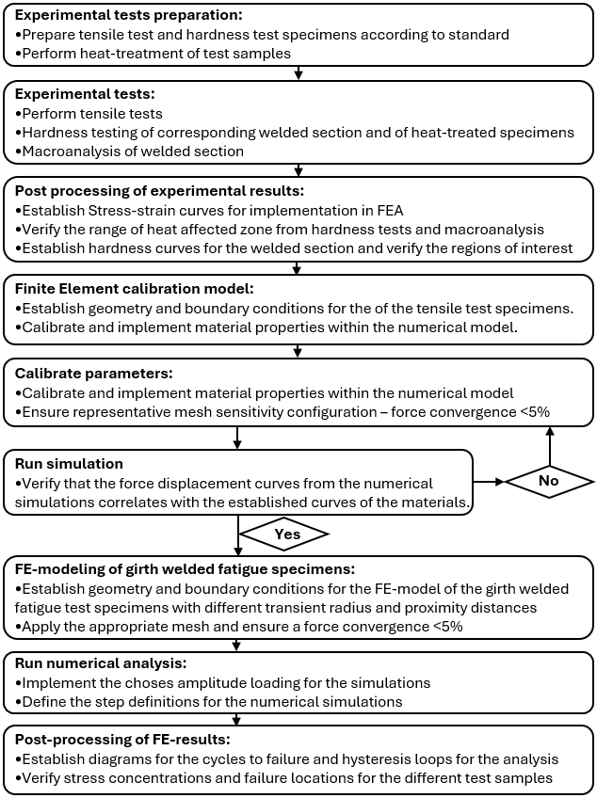
Fig. 1. Flow chart.

  - Description of the fatigue geometries
The fatigue test specimens investigated in this study are fabricated from girth-welded tubes with standardized dimensions for the gauge section, having an outer diameter of 219 mm and a wall thickness of 8.2 mm, as shown in Fig. 2. The two small-scale specimens investigated have two different transition radii of 25mm and 50mm and is presented in Fig. 4. In addition, two tubular sections with different total lengths were modeled to compare the fatigue behavior of the small-scale specimens with results from full-scale fatigue tests. The small-scale specimen and full-scale sections were modeled with two welds in close proximity and where three different distances between the welds of 5, 10 and 15mm was evaluated as precented in Fig. 3. The girth length of the small-scale test specimens was designed in accordance with the DNV-RP-F108 guideline, with some modifications. Where in order to include two welds the small-scale samples and was doubled in order to included parts of the unaffected base material in the girth section of the specimens [25]. To ensure realistic representation of the welded geometry, the weld profile was modeled in compliance with the requirements specified in EN ISO 5817 Table C.1 [29], for welded joints subjected to fatigue loading. Since analyzing the whole of the test specimen is more challenging in terms of computational time and effort, a subassembly of just 250mm of the small-scale test samples including the gage section and transition radii was chosen for the finite element analyses, while a 125mm and 150mm segment length was selected for the full-scale sections. As it is apparent for the small-scale samples shown in figure Fig. 4, this subassembly is representing the part of the test specimens that would be between the upper and lower grips of the test machine and will represent with boundary conditions applied at the interface points between the subassembly and the rest of the frame. The gauge section, where the load is concentrated in the small-scale specimens, corresponds to the test length of the full-scale sections and is intended to replicate the load experienced in the full-scale specimens.

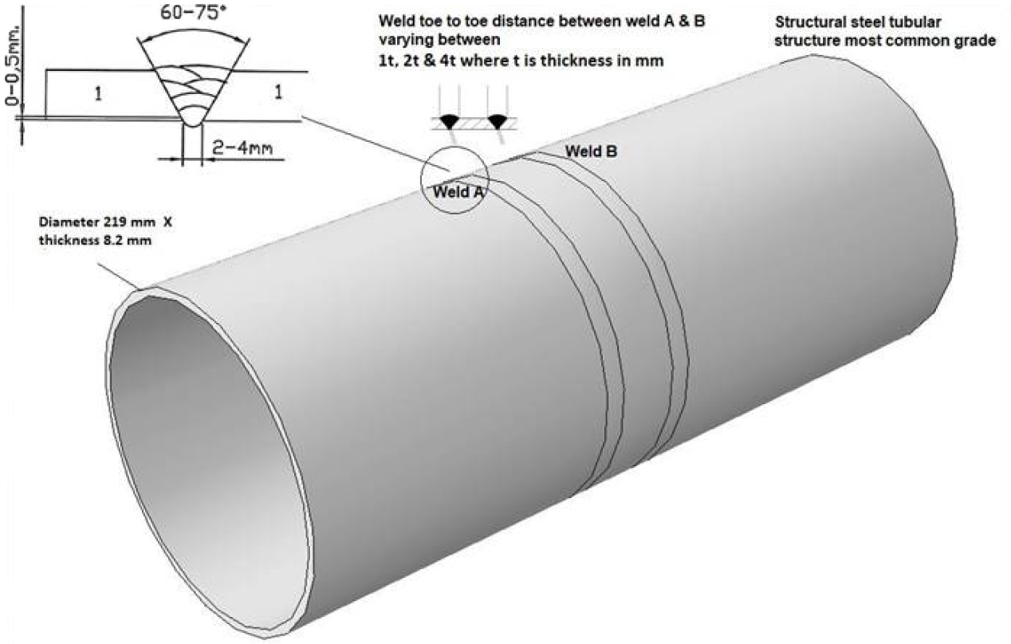
Fig. 2. Tubular section layout.

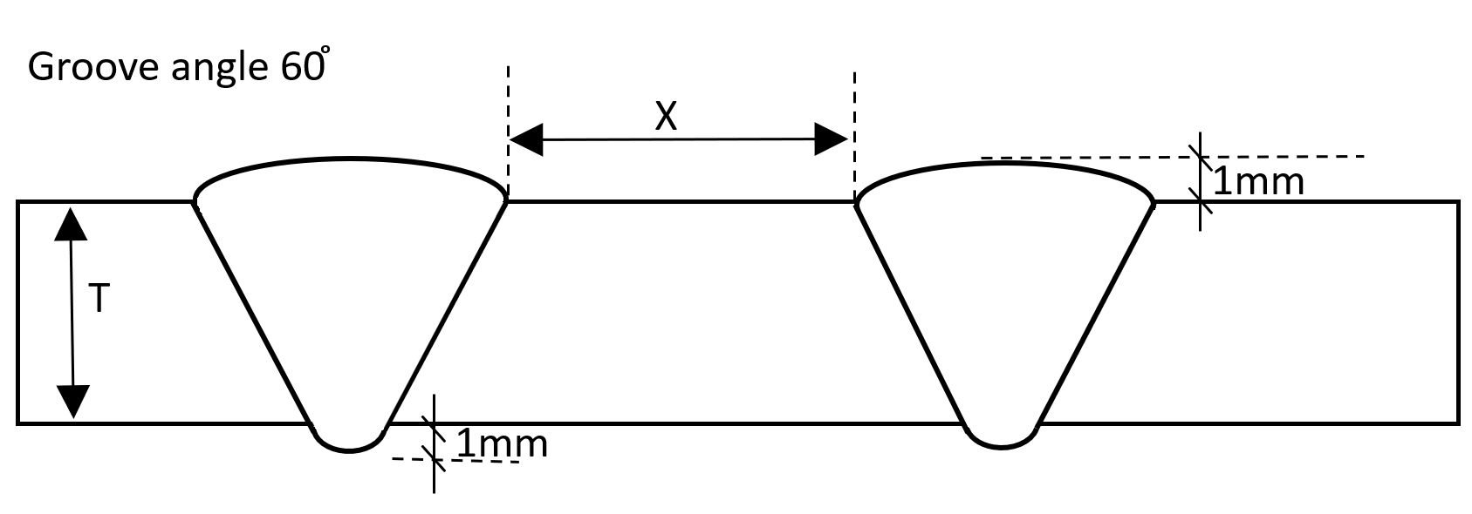
Fig. 3. Details of the welded section where, x, represents distance between the welds and T, represent the thickness of the tubular section.

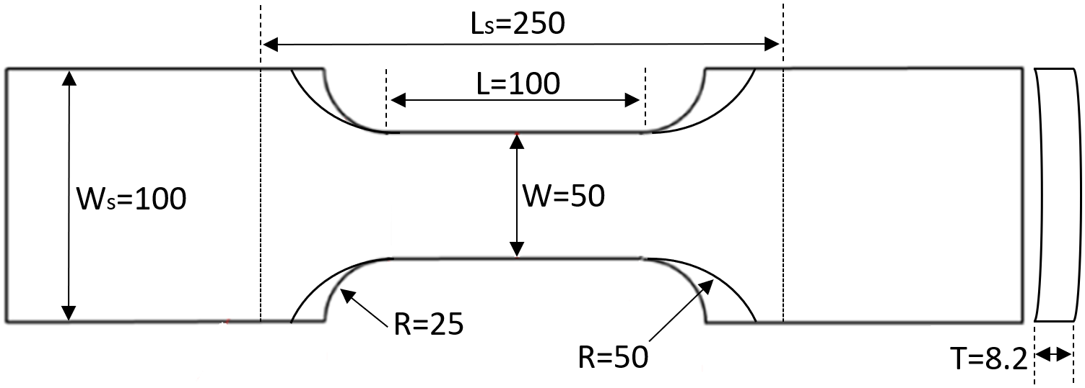
Fig. 4. Fatigue test geometry
  - Material characterization and testing
In this study, the ductile damage model for predicting the onset of ductile fracture was used to investigate the fracture location of the studied welded specimens and tube sections. Ductile fracture is known as a continuous process in which nucleation, growth, and coalescence of micro voids in ductile metals lead to form a new free surface in the material [30, 31]. In the Ductile damage model, it is assumed that the equivalent plastic strain at the onset of damage $(ɛ_{D}^{pl}$), is a function of stress triaxiality and strain rate [30, 31].

$ɛ_{D}^{pl}\left(η, {\dot{ɛ}}^{pl}\right)$ (1)

Where $η=σ_{m}/σ_{eq}$is the stress triaxiality, $σ_{m}$is hydrostatic pressure and $σ_{eq}$ is Mises equivalent stress and where $\left({\dot{ɛ}}^{pl}\right)$ denotes the strain rate. Based on this definition, the damage variable can be defined as follows [30, 31]:

$D=\int{\frac{d{\dot{ɛ}}^{pl}}{ɛ_{D}^{pl}\left(η, {\dot{ɛ}}^{pl}\right)}}$ (2)

This damage variable is an incremental state variable that increases monotonically with plastic deformations, $\left(ɛ^{pl}\right)$, to reach D=1 which indicates the fracture initiation [30, 31]. In order to incorporate and simulate realistic material behavior and response during numerical simulations, the material parameters in the numerical damage model were implemented from uniaxial tensile tests conducted on a tube section made of S355G14+N material. As the weld consists of unaffected, and heat affected regions as well as a region consisting of the deposited weld material as shown in Fig. 5, it also depends on the distance between the welds. Therefore, it is necessary to implement and verify the material characteristics for the subsequent numerical models. In this study three material regions with separate mechanical properties were defined; Base material (BM), Heat affected zone (HAZ) and weld metal (WM).

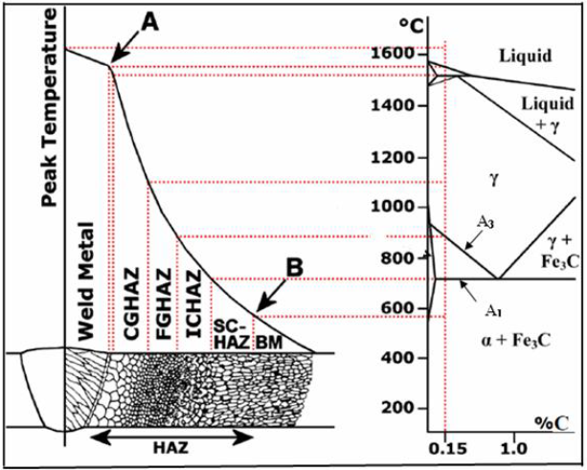
Fig. 5. Schematic diagram of the heat-affected zone of a 0.15 wt.% C steel indicated on the Fe-Fe3C phase diagram [32].
To calibrate the stress-strain behavior of the steel material, six flat dog bone samples was made in order to incorporate the material parameters for the base material and HAZ of the welded tubular section. Three round specimens were made from a typical deposit metal used for the type of steel tested, all the samples of each material section were tensile tested using a 250kN, INSTRON 5985 Dual Column Floor Frames tensile test machine. The sample specimen geometry for base material and HAZ is presented in Fig. 6 defined according to ASTM-E8/E8M [33], and they had a thickness of 5mm, the tested tensile samples and corresponding hardness samples is shown in Fig. 7, where the three samples representing the base material on the left, and the three heat-treated samples representing the HAZ on the right, with the corresponding hardness samples above each tensile test sample. In this study, the HAZ was characterized by a single material property, established through heat treatment of three of the dog-bone samples. In order to create the material characteristics representing the HAZ the three specimens were heated in a furnace up to 1200°C, well above the A3 temperature and held for 15 minutes to achieve full austenitization, and then rapidly cooled in air, following the time–temperature procedure illustrated in Fig. 8 to realistically simulate the HAZ after welding.

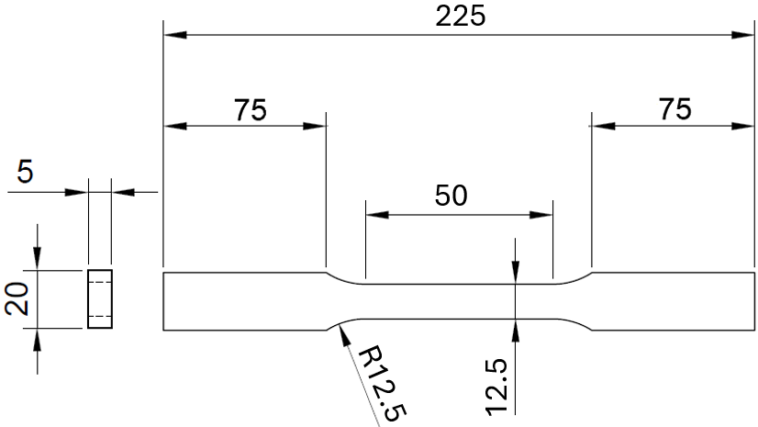
Fig. 6. The geometry of flat dog bone tensile samples used to determine the material properties of the base material and heat affected zone (HAZ).

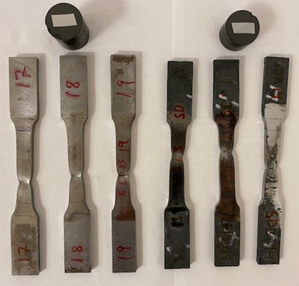
Fig. 7. The tested flat dog-bone tensile samples and hardness test samples.
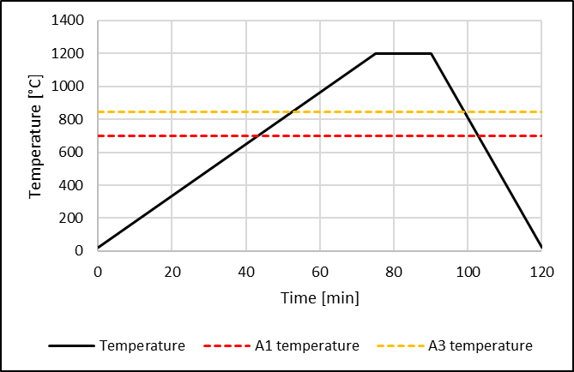
Fig. 8. Time tempering procedure for creating mechanical properties of the HAZ.
The resulting mechanical properties after heat treatment was compared and verified against the actual hardness properties of the HAZ of a welded section made from the corresponding base and weld material. The size of the HAZ was measured to approximately 2mm and was determined by hardness testing according to ISO 6507-1 [34], and through macroanalysis of a corresponding weld made from a tubular section with the same dimensions and properties as shown in Fig. 9 and where the hardness profiles is shown in Fig. 10.

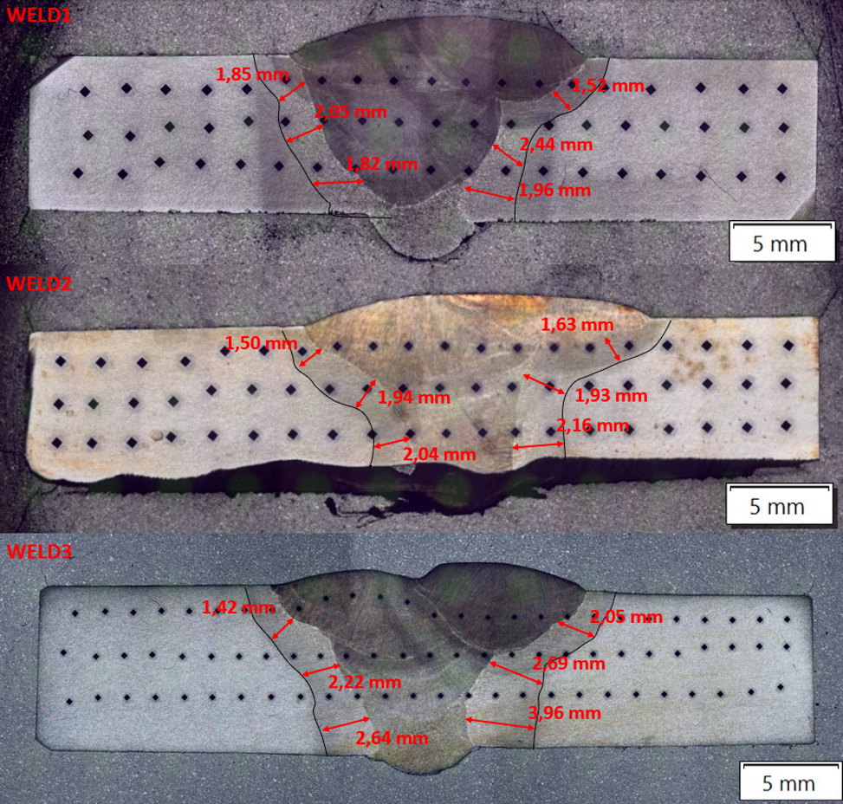
Fig. 9. Hardness tested samples of welded sections.
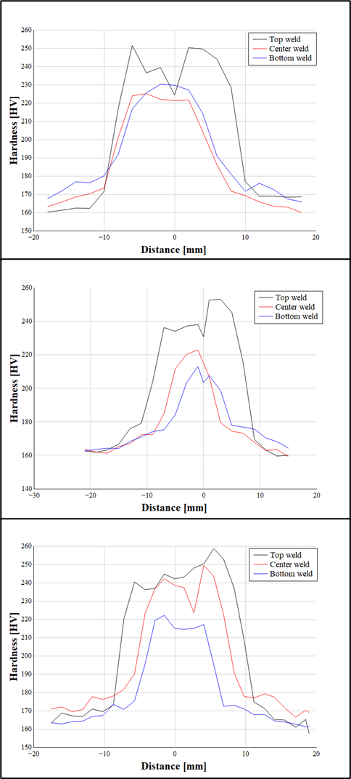
Fig. 10. Hardness profiles of the welded sections.
The hardness testing of the weld material showed that the welded section was harder, and thus stronger, than the base material, with hardness levels similar to the HAZ. The material parameters for the weld material were established for the weld material properties by testing three round dog bone samples that was extracted from a single sided but weld as shown in Fig. 11, and made from the same base material as previously described and where the testing was preformed according to ISO5178 [35]. The sample specimen geometry is presented in Fig. 12 defined according to ASTM-E8/E8M [33], and they had a gage diameter of 8mm, the produced samples is shown in Fig. 13.

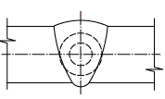
Fig. 11. The location of the extracted test specimen.

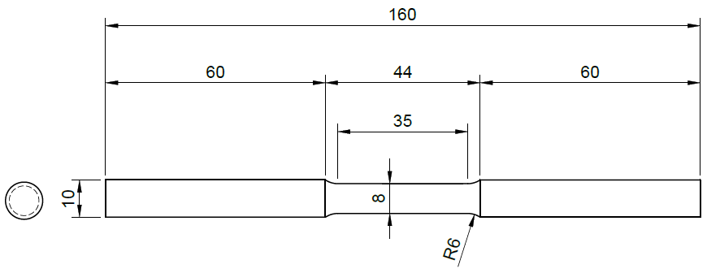
Fig. 12. The geometry of round dog bone tensile samples used to determine the material properties of the deposited weld material.
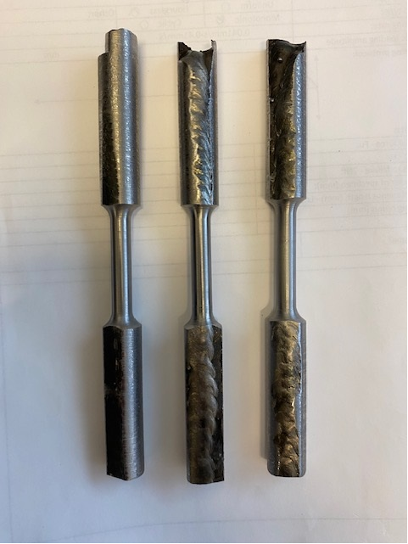
Fig. 13. The tested round dog-bone tensile samples used for determining mechanical properties of the deposited weld material.
The mechanical properties that were implemented in the numerical model are summarized in Table 1 and the Engineering stress-strain curves and Force-displacement curves is presented in Fig. 14 below.
Table 1. Mechanical properties of the base material, HAZ and weld bead determined from experimental tests.
Material section | Yield strength [Mpa] | Tensile strength [Mpa] | Elongation [%] | Hardness [HV]
Base material | 398 | 533 | 34 | 160
HAZ material | 401 | 592 | 24 | 188
Weld material | 548 | 592 | 29 | 220

In addition, in this study, the Young's modulus, 𝐸, was set to 210,000 N/mm², and Poisson’s ratio, ν, was set to 0.33 for the calculations and numerical simulations. The density of the implemented material, ρ, were set to 7.8 g/cm³.

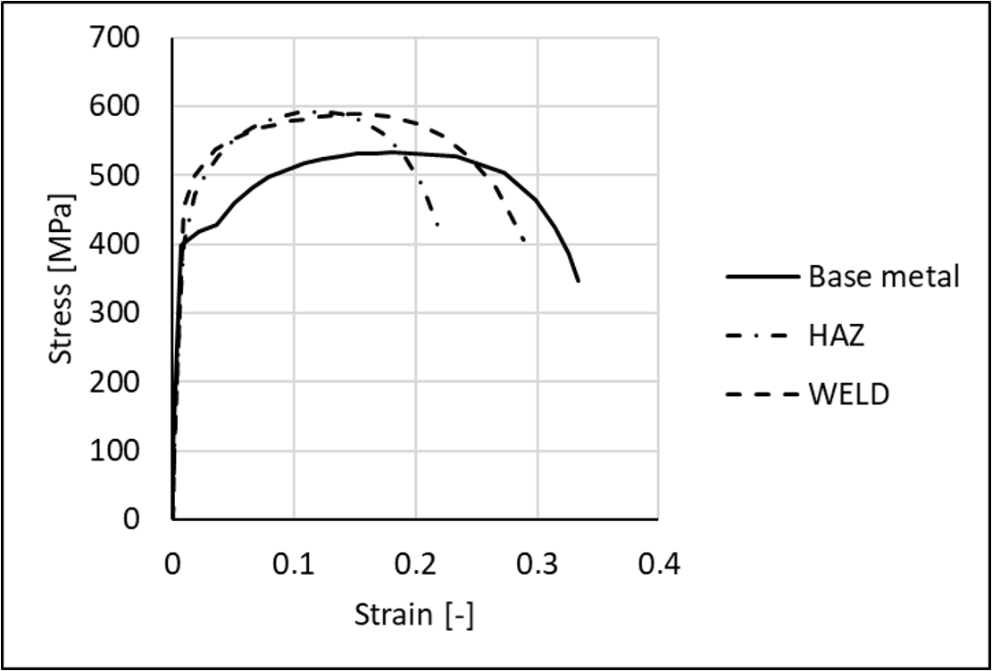
Fig. 14. Engineering stress-strain curves for the implemented materials, generated from experimental tests for the base material, HAZ and weld bead.
To use the test data in the material plasticity model, true stress-strain curves are required. Before necking, the material is governed by a uniaxial stress state, where true stress and true strain were calculated from engineering stress and strain using the following formulas [36, 37]:

$ε_{t}= ln\left(ε_{e}+1\right)$ (3)

$σ_{t}= \left(1+ε_{e}\right)σ_{e}$ (4)
Where $ε_{t}$ and $σ_{t}$ are true strain and stress respectively, while $ε_{e}$ and $σ_{e}$ denote engineering values. After necking, these relations are invalid due to stress triaxiality and strain localization. In this study a linear transition was assumed between the ultimate and the fracture point. The damage parameters for Ductile Damage were calibrated with the fracture strain, $ɛ_{f}$, from the experimental results and stress triaxiality, η. The stress triaxiality, η, was set to 0.33 as previously used for flat dog-bone test samples [5]. The calibrated material plasticity and damage model were verified by establishing a numerical model of the tensile test specimen shown in Fig. 6 and Fig. 12. The damage models was calibrated to follow the degradation of all the experimental force-displacement curves after necking by using the linear damage evolution and calibration of the degradation line using the power law for plastic strain established by Ramberg-Osgood to approximate the stress-strain curve for a material by applying the following expression [36].

$σ_{f}= Kɛ_{f}^{n}$ (5)
Where, $σ_{f}$, is the fracture strength, K, is the Strength coefficient, n, is the strain-hardening exponent and 𝜀𝑓 is the true fracture ductility. The true fracture ductility, strain at fracture 𝜀𝑓, is expressed as follows [36, 37].

$ɛ_{f}= ln⁡\left(\frac{A_{0}}{A_{f}}\right)$ (6)
The force-displacement behavior shown in, Fig. 15 was generated to validate the material plasticity response of the numerical model against experimental data for the base material, HAZ, and weld bead. As illustrated in the figure, there is a good agreement between numerical and experimental curves.

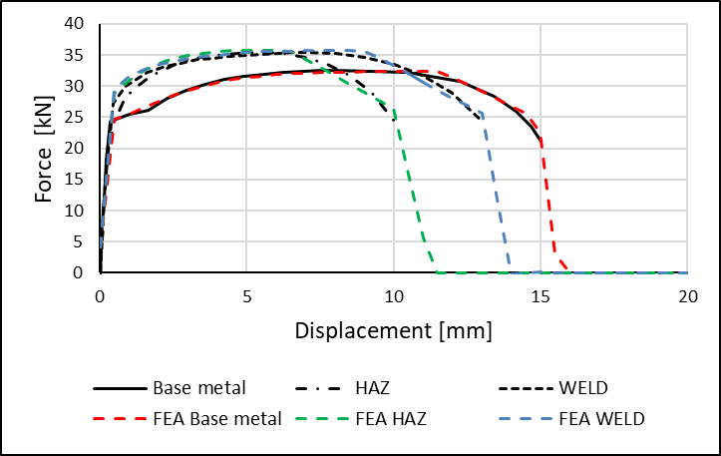
Fig. 15. Verification of the material plasticity comparing the force-displacement behavior from numerical results against the implemented materials, generated from experimental tests.
  - Numerical setup and procedure
Nine different numerical models have been defined, three full scale models and six small-scale specimen models corresponding to the two specimen radii, 25mm and 50mm (1 and 2). Both the full-scale and small-scale models was made with the three different proximity distances 5mm, 10mm and 15mm (A, B and C). Fig. 16 shows the mesh of the full-scale models and Fig. 17 shows the six small-scale models. The models had the defined geometry for the welded section with a 2mm heat affected zone, the meshed welded section is shown in Fig. 18 and the computational parameters for the models is shown in Table 2.

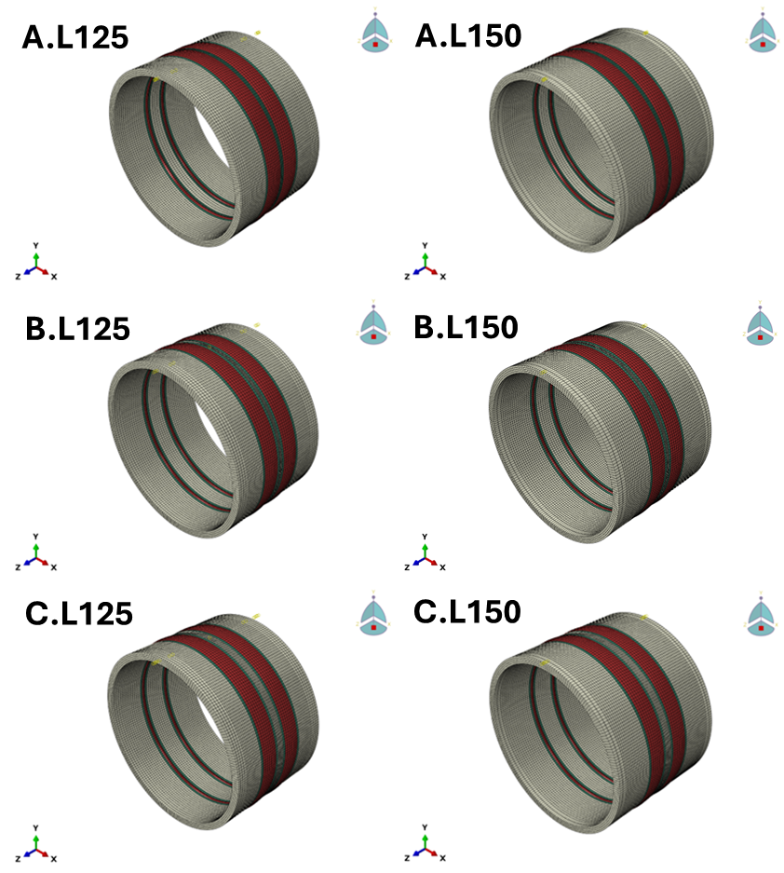
Fig. 16. Finite element model of the pipe sections (L125 and L150), with color-coded areas of defined material properties.

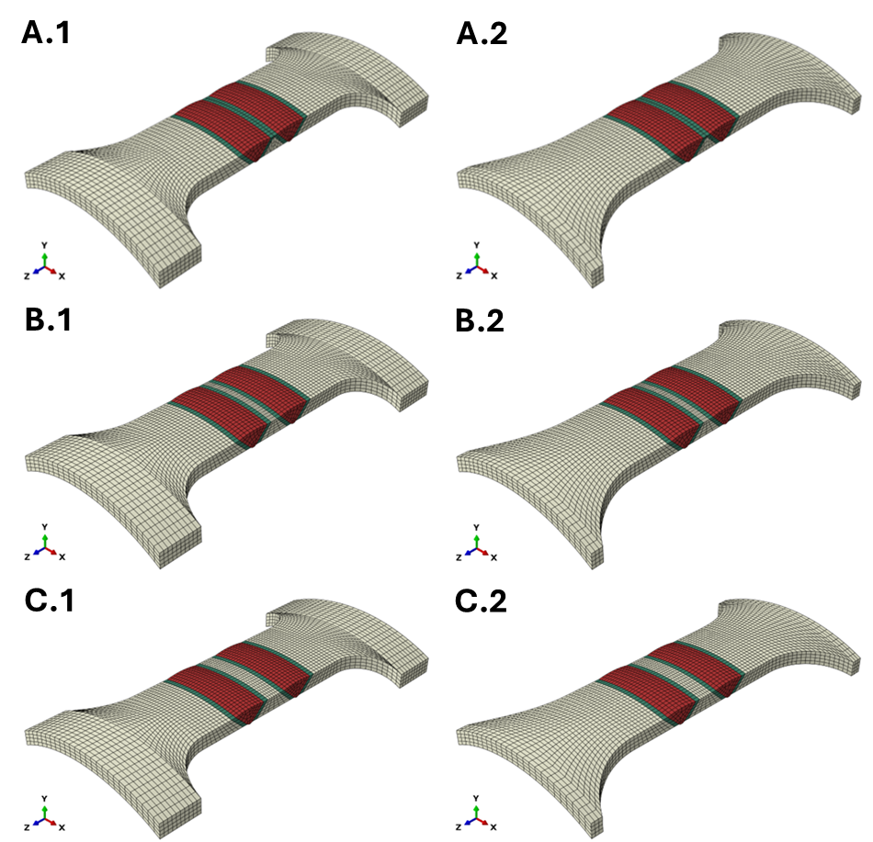
Fig. 17. Finite element model of the small-scale test specimens (1 and 2), with color-coded areas of defined material properties.

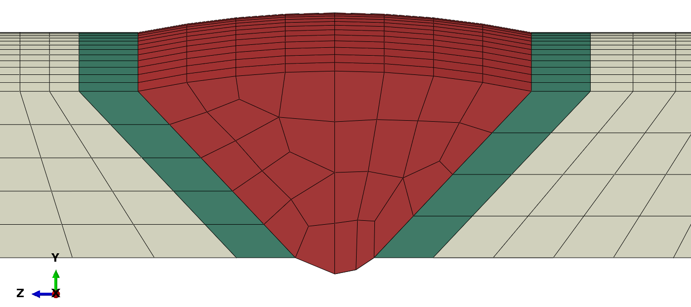
Fig. 18. Mesh configuration of the welded section.

Table 2. Computational parameters.
Parameter | Setting
Model type | 3D solid model
Simulation type | Dynamic, Explicit
Damage model | Ductile damage
Damage evolution | Linear Damage Evolution
Plasticity model | Isotropic hardening
Mesh type | 3mm, Hexahedral elements

The numerical small-scale models were constructed with a 3mm quadratic hexahedral elements, and they had four elements along its thickness direction. The mesh was selected after conducting a convergence analysis of the small-scale samples comparing three different mesh sizes in relation to the specimen thickness: 8mm (t), 4mm (t/2) and 3mm (t/3). The analysis indicated a force deviation of approximately 2% for the proximity distance of 5mm specimen with 25mm transition radii, which was considered acceptable using 3mm mesh. The full-scale models were given the same mesh size in the majority of the middle part of the model and a coarser mesh of 5mm at the ends at the boundary connections. The defined boundary conditions is presented in Table 3, where the right end surface of the model had the displacement and rotation fixed to zero in all its directions for all models, while the left end surface was defined with an imposed displacement amplitude in the sample longitudinal Z direction where the displacement and rotation was fixed to zero in X and Y direction.

Table 3. Boundary conditions.
Type | x | y | z
Displacement (in Z direction) | - | - | U3= 1, (Amplitude)
Boundary Condition (Z= 125) | - | - | (U1=U2=UR1=UR2=UR3=0)
Boundary Condition (Z= -125) | - | - | (U1=U2=U3=UR1=UR2=UR3=0)

The boundary conditions were applied to the first 12 mm at each end of the full-scale sections to ensure a smooth simulation and prevent stress concentrations at the boundaries and close to the welds. As a result, the effective free test length was approximately 100 mm for the 125 mm tubular section and 125 mm for the 150 mm tubular section. The simulations were conducted using strain-based loading to account for potential plastic deformations. The strain-based loading of 1% (±0.5%) was selected based on recommendation in ASTM E606/E606M [13], which specifies suitable strain amplitudes for sheet specimens, it should be mentioned that the originally prescribed loading is for homogeneous material. The ULCF loading was chosen to reduce simulation time, and in addition it was also run in tension-tension with a mean displacement of +1.0% and with a strain rate, $\dot{ɛ}i$, of 0.8mm/s. Strain based fatigue are normally chosen for low-cyclic fatigue where plastic deformation is prominent and where material response is no longer purely elastic [5, 13]. The choice of running tension based fatigue is a recommended procedure for account for potential harmful residual stresses inherent in the welds before processing of small-scale test specimens during fatigue testing [3, 14]. In addition, in structures where stress concentrations, such as welds or notches, exist, local plasticity can dominate fatigue behavior [13]. Strain-based methods help better represent the fatigue life of materials in those highly strained regions [13]. The loading was chosen based on previous studies done for small-scale specimen and for pipes undergoing low-cyclic loading [5, 14]. The displacement was calculated based on the girth of the small-scale specimens, and the same displacement was applied to the full-scale sections without adjustment. This approach was taken to evaluate how the results might vary depending on the length of the full-scale section. The applied cyclic tension-based displacement evolution is shown in Fig. 19, and all simulations were run to final failure.

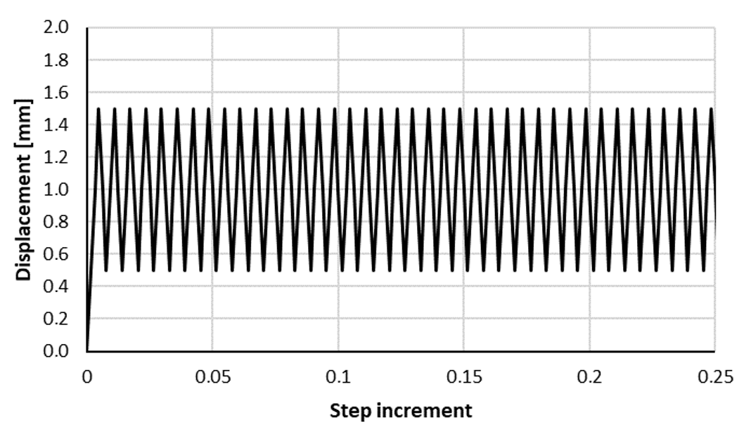
Fig. 19. Evolution of the applied displacement for the numerical simulations, here showing the first 0.25 step increments for the small-scale specimens.
  - Evaluations of stress concentrations
The resulting forces required to obtain the imposed displacement, and the stresses and strains were so postprocessed afterwards for the numerical models. The stress SCF for the welded section as well as for the transient radius were calculated at the max elastic displacement by employing the resulting force, F, and peak notch stress, $σ_{hot}$, at the region of interest obtained by the FEA, where the nominal stress, $σ_{nom}$, is in the specimen was calculated by using following expression [37]:

$σ_{nom}= \frac{F}{A}$ (7)

Where, A, is the gauge section area of the specimen. The SCF, $K_{t}$, were calculated by following expression [37]:
$K_{t}= \frac{σ_{hot}}{σ_{nom}}$ (8)
In cases when, $K_{t}$, cannot be obtained from standards, an experimental investigation or FE analysis must be carried out. When employing an FE analysis, a detailed model is required with the right geometrical features. For evaluation of the stress concentration the, $K_{t}$, was calculated by using the peak von Mises stress at the regions of interest (weld cap, weld root, and transient radius) [18, 38]. This is more conservative than using principal stresses but may be more realistic as the model dos does not capture all local geometrical variations that can impose further local stress concentrations [18, 39].
- Results and Discussion
When studying differences in welded fatigue samples with different transient radii and when evaluating welds with different proximity distances, several characteristics and factors become critical for understanding how these variables affect the fatigue behavior and reliability of the test specimens compared to full-scale tubular sections. When welds are placed in close proximity to each other, differences between the stress concentrations can affect the overall structural integrity, fatigue behavior, and failure mechanisms therefore the response of the chosen specimen geometry can differ from one another and also in relation to the actual full-scale structural component it is intended to represent. After modeling and including the material characteristics established for the simulations for the isotropic plasticity model the simulations where run with the defined cyclic loading until final failure, the hysteresis cycles is given in Fig. 20 for the small-scale samples and in Fig. 21 for the full scale samples. It is observed that the hysteresis loops display stable cyclic behavior run in tension with only minor asymmetry, indicating that the Bauschinger effect is present but remains relatively moderate in these configurations. This limited manifestation of the Bauschinger effect can be attributed to the strain-controlled nature of the cyclic loading, which constrains the influence of kinematic hardening and promotes a stabilized cyclic response [5]. Furthermore, the use of an isotropic plasticity model inherently restricts the accurate representation of back-stress evolution, thereby underestimating the real material's sensitivity to load reversals [5]. Fig. 22 presents the cyclic performance over the defined step increments for the simulations of the test specimens with the three different proximity distances with the two transient radiuses, and Fig. 23 shows the cyclic response of the same displacement acting on the two pipe sections. The Time-Force series display stable cyclic behavior with a progressive increase in reaction force during most of the first loading cycles, indicating a cyclic hardening effect. However, as the simulation approaches failure, a distinct reduction in force response is observed, reflecting material softening and damage accumulation leading to final fracture due to the element depletion.
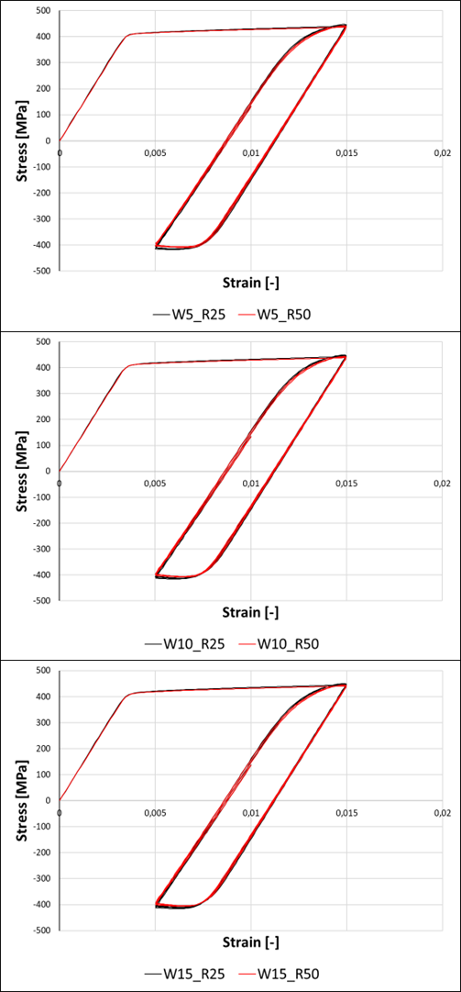
Fig. 20. Comparison of the first three hysteresis loops for test specimens with 25mm and 50mm transient radius and different weld proximity.
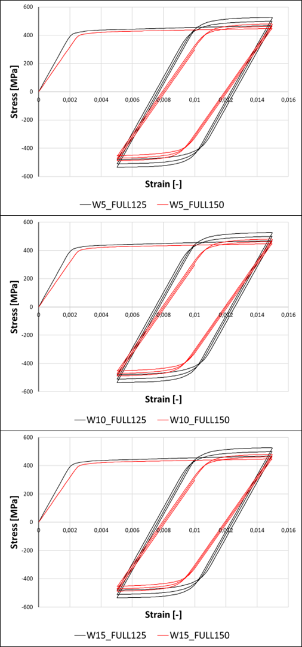
Fig. 21. Comparison of the first three hysteresis loops for the tubular sections with different total length and different weld proximity.
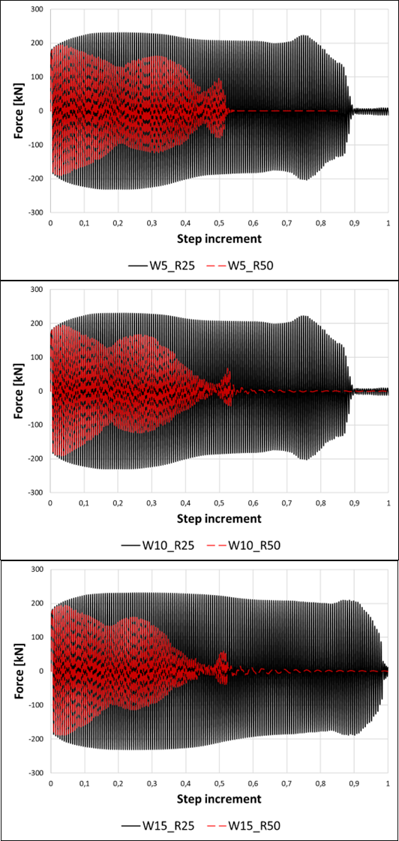
Fig. 22. Force evolution of the applied displacement for test specimens with different weld proximity.
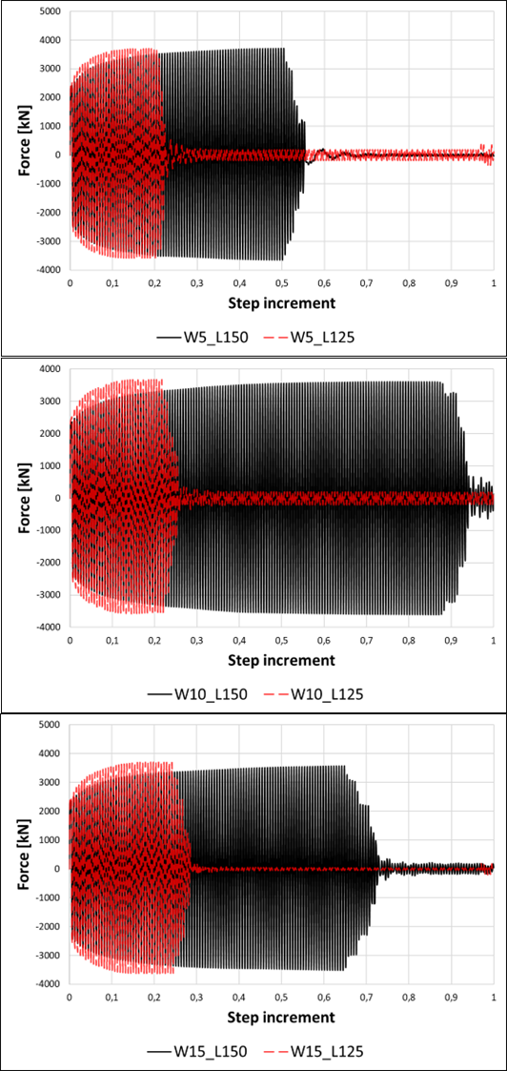
Fig. 23. Force evolution of the applied displacement for the tubular sections with different weld proximity.
As can be observed from Fig. 24 all simulations resulted in the failure occurring in the gauge region of the test samples as desired, and did not show any significant signs of local stress concentrations in the tested transient radiuses even if the simulations were run in the low cyclic fatigue range. However, specimen B.2 exhibited localized areas of elevated stress at the initial portion of the radius, attributed to bending stresses arising during the loading cycles. Overall, the most significant stress concentrations that were registered were located near the welds overall. The different full-scale pipe sections experienced also failure in the welded region of the simulated models as can be observed from Fig. 25.

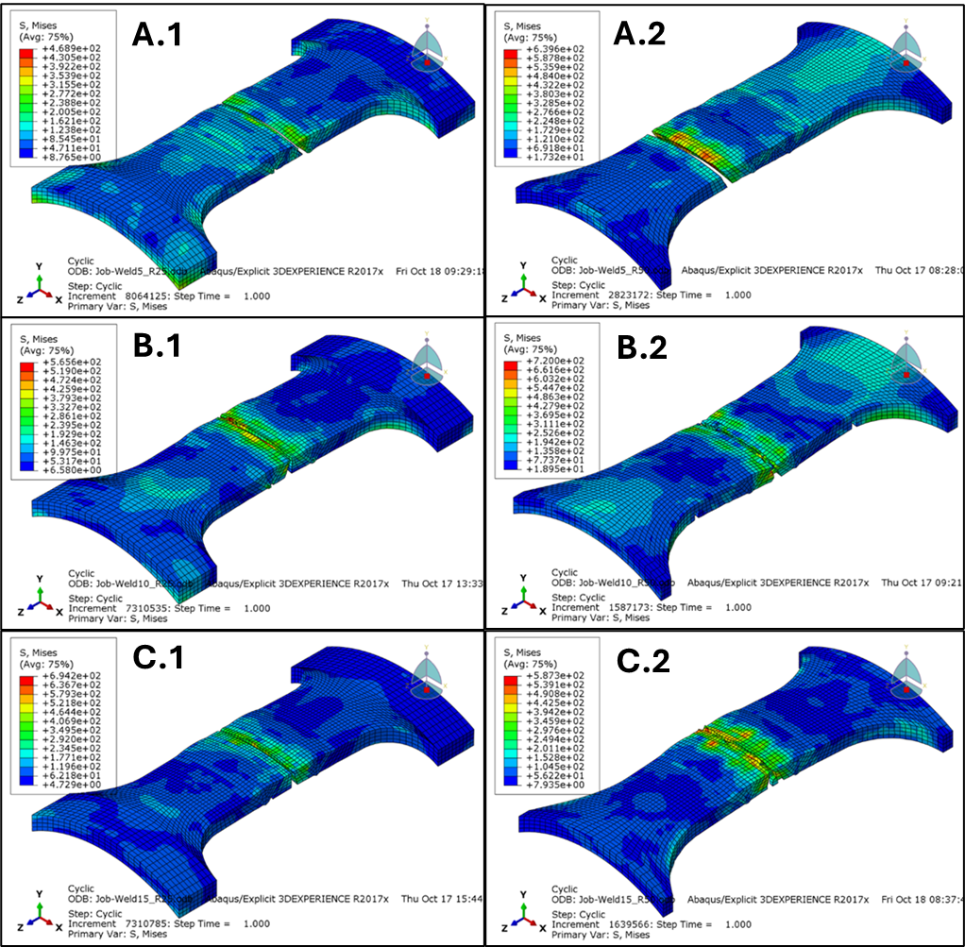
Fig. 24. Resulting fractured small-scale test specimens.

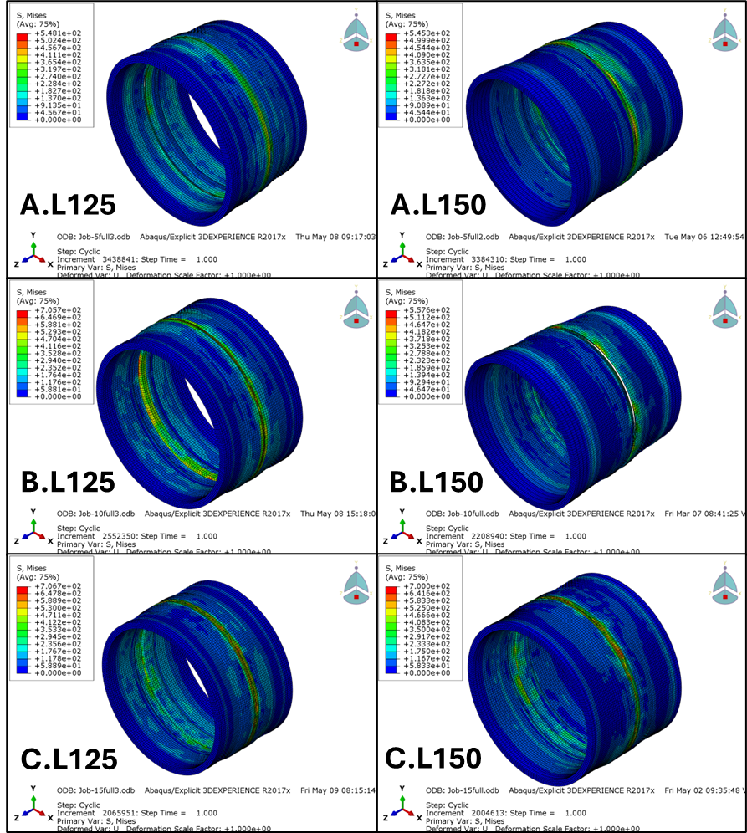
Fig. 25. Resulting fractured tubular sections.

As shown in Fig. 26 and Fig. 27, the specimen with the largest transient radius resulted in the lowest cycles to failure, as indicated by the registered cycles to failure for the simulations presented in Table 4. The simulations also show a clear indication that the largest transient radius of 50mm resulting in a more uneven fatigue strength which indicates a 59%, 63% and 72% decrease in cycles until crack initiation for the proximity of 5mm 10mmfor and 15mm proximity compared to a 25mm transient radius. The same tendency was evident for cycles to final failure. In terms of proximity distances and fatigue performance it was evident that the smallest proximity of 5mm had the least difference in fatigue strength for the two radiuses and showed an increase of 15% for the smallest radius and 6% for the largest radius for cycles to crack initiation compared to the 10mm. But there was a larger difference from 5mm to 15mm where the simulations of the smallest radius resulted in a 24% increase in cycles before crack was initiated compared to the largest radius which had a 12% decrease from 5mm to 15mm. It was also evident that there was a smaller difference in cycles to failure between the results for the largest radius with an approximate difference of not more than 12%. This was also evident for cycles to final failure as shown in Fig. 27.
Table 4. Overview of results from the finite element simulations.
Notation | Test specimen | SCF  Proximity Weld Cap | SCF  Proximity Weld root | SCF  Transient radius | Number of cycles until fracture initiation | Number of cycles until final failure
A.1 | W5_R25 | 1.17 | 1.35 | 1.23 | 111 | 114
A.2 | W5_R50 | 1.18 | 1.31 | 1.09 | 46 | 81
A.L125 | W5_L125 | 1.15 | 1.26 | - | 32 | 35
A.L150 | W5_L150 | 1.17 | 1.29 | - | 104 | 116
B.1 | W10_R25 | 1.16 | 1.35 | 1.23 | 131 | 138
B.2 | W10_R50 | 1.17 | 1.31 | 1.09 | 49 | 84
B.L125 | W10_L125 | 1.15 | 1.26 | - | 35 | 40
B.L150 | W10_L150 | 1.16 | 1.28 | - | 138 | 146
C.1 | W15_R25 | 1.17 | 1.29 | 1.23 | 147 | 154
C.2 | W15_R50 | 1.16 | 1.27 | 1.09 | 41 | 72
C.L125 | W15_L125 | 1.15 | 1.26 | - | 39 | 44
C.L150 | W15_L150 | 1.16 | 1.28 | - | 124 | 132

Fig. 26. Overview of the cyclic performance until crack initiation.

Fig. 27. Overview of the cyclic performance until final failure.
The number of cycles to failure is connected to the assumption of the smaller radius with the smaller transient region making the specimens stiffer and concentrates the cyclic movement and strain-loading more concentrated and evenly in the gauge section of the test specimen compared to the larger transient radius that has a larger transient region that will result in less stiffness. This can be seen in the Force-Displacement diagrams were the cyclic behavior of the larger transient radius needed slightly less force to achieve the same displacement compared to the smaller radius to achieve the same displacement, the behavior was also more unstable due to the buckling as shown in Fig. 22. In contrast, specimens with a 25mm transient radius displayed a more consistent cyclic behavior across different proximity distances, with fracture happening in the middle of the welded gauge section of the test specimens for all the proximity distances. In addition, the smaller transient radius that did not seemed to be inflicted by the change in proximity distances and provided a more uniform fatigue response across the proximity distances. The smaller transient radius showed an overall higher fatigue life compared to the larger radius that may also be more favorable in terms of providing a more realistic representation to the full-scale fatigue life that also do not experience any buckling. One thing that is evident is that the specimens generally experience more cycles to failure compared to full scale specimen even if the displacement is the same and the full-scale tubular sections has a longer free test length, this is the same tendencies as has previously been pointed out for real experimental tests comparing small-scale and full-scale tubular sections even as strain-based loading is considered in this study.

However, as shown in Fig. 23 there is a large difference in cycles to failure as anticipated when comparing different tubular sections applied with the same displacement of 1mm. As mentioned, the point of running the full-scale sections was to compare the cyclic response against the simulations done for the small-scale test specimens in order to evaluate to what extent the small-scale specimens are able to represent the behavior of full-scale sections. When calculating the strain loading of small-scale samples it is the girth section that will be the defined section for the calculated loading, thus the length of the girth section is the defined area of correlation to the full-scale detail. In this study the total free length between the supports of the two full scale sections of the tubular segments was slightly longer than the girth length of the small-scale specimens and was close to approximately 100mm and 125mm in order to not create stress concentrations at the boundary conditions set for the numerical models. It should be mentioned that the loaded side was not restrained in the loading direction and experienced some strain differences, but the results is still seen as valid for comparison of the cyclic response. As expected, the number of cycles to failure generally increases with the length of the tubular sections when the same displacement is applied. Nonetheless, geometric factors related to the weld introduce deviations, leading to inconsistencies in fatigue life. Although the girth section is defined as the primary region of interest, the total length of the specimen also contributes to the overall strain response. This is evident in the observation that the cycles to failure more closely resemble those of the longer pipe section. Whether this reflects actual physical behavior can only be confirmed through further experimental testing, but the presence of scale effects is clearly apparent.
As seen from the strain plots at the onset of fracture in Fig. 28, there is a higher level of strain at the weld root in the center of the test samples near the edges. This is caused by the sample geometry, which induces localized stress concentrations that are not representative of a full-scale girth weld. In contrast, the strain plots for the full-scale sections in Fig. 29, show that strains at the onset of failure are specifically concentrated near the welds on the root side, similar to the small-scale samples. However, a notable difference is observed for the full-scale B.L125 section with 10mm proximity distance, which failed between the welds on the cap side. This is believed to correlate with higher stress concentrations in this region, as the proximity distance is less compared to the 15 mm case. Additionally, unlike the section with a 5 mm proximity distance, the HAZ does not intersect the proximity region, resulting in a zone with relatively higher material strength. Nevertheless, due to the welds being positioned at a distance that is far enough to include some base material characteristics, yet close enough to generate significant stress concentrations, the failure occurs on the opposite side of the tubular section.

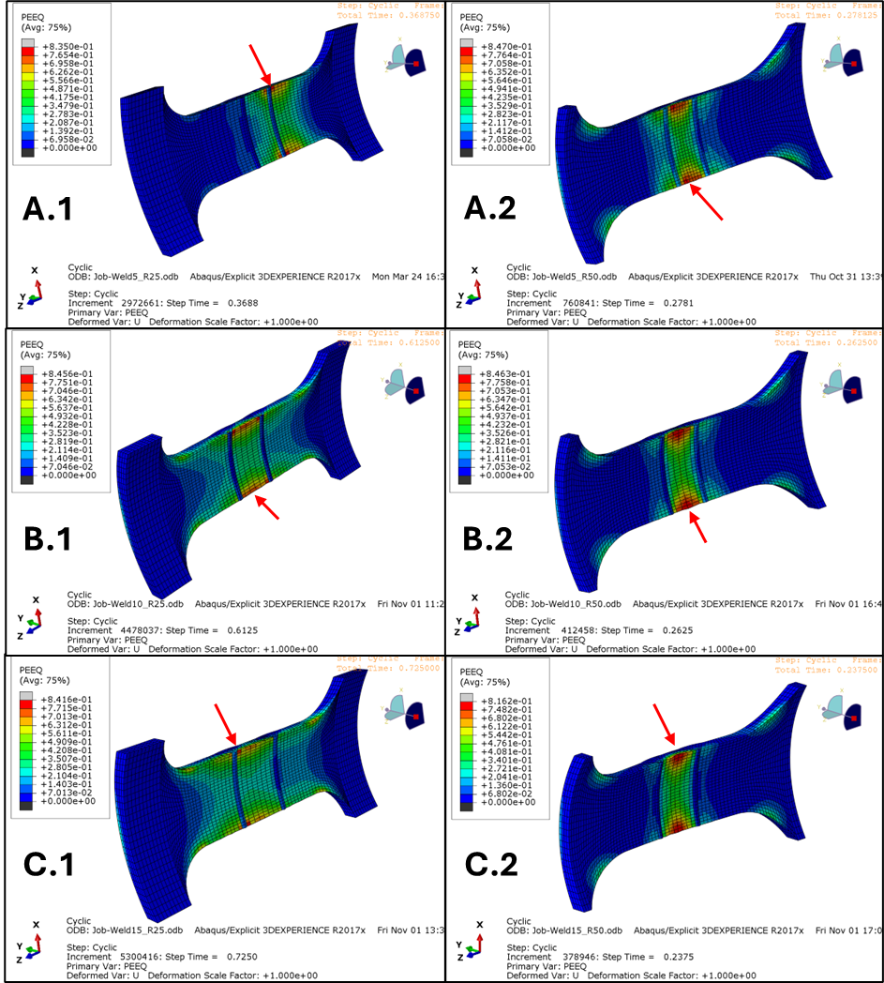
Fig. 28. Equivalent plastic strain at the onset of fracture in the small-scale test specimens.

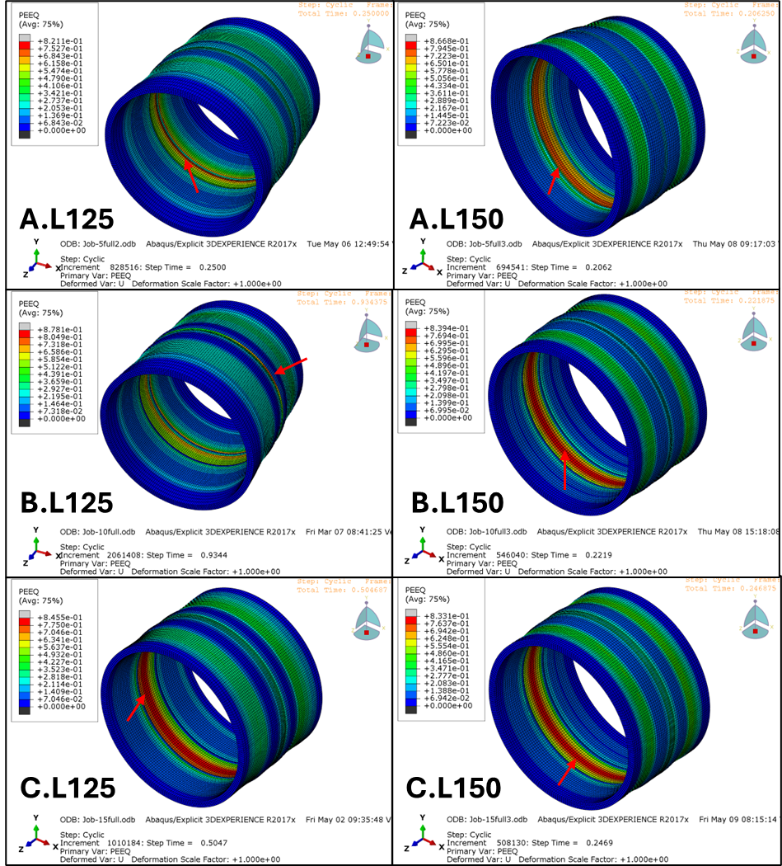
Fig. 29. Equivalent plastic strain at the onset of fracture in the full-scale tubular sections.

The SCF during the elastic regime of the first loading cycle were evaluated for various regions of the tubular sections and test specimens, namely the weld cap, weld root, and transient radius, as presented in Table 4. The SCF values varied slightly between specimens with 25 mm and 50 mm transient radii; however, the 50 mm radius generally exhibited lower SCFs at the transient radius, as expected. However, the occurrence of buckling in the 50 mm transient radius specimens under axial cyclic loading highlights a key limitation in the reliability of this geometry for LCF testing. Since buckling introduces non-fatigue failure mechanisms and additional bending stresses, it can obscure the true fatigue behavior and lead to premature failure not driven by material degradation. The proximity weld cap, and especially the weld root, consistently showed the highest SCF across all configurations, indicating that these regions are most susceptible to localized stress concentrations. This is particularly evident in configurations with 5mm proximity distances, which generally produced higher SCF at the weld cap side and root side compared to 10mm and 15mm distances, especially for specimens with the 50mm transient radius. The elevated SCFs at the weld cap and root side can be attributed to the variation in distance between the welds. As the simulations introduces plastic deformations the slenderness of the specimen with a 50mm radii causes more complex stress interactions and introduce moment and the deflections. The elevated SCF in these regions were due to the varying distance between the welds, while larger radii helped distribute stress more effectively across the transient region. Though stress concentrations were not analyzed in detail, the overall trend remains valid, suggesting that a more refined analysis with different weld geometries is needed. For future experimental fatigue testing, precise SCF measurement using strain gauges or Digital Image Correlation (DIC) should be applied to monitor the stress concentrations at the weld regions, particularly at the weld toe and in the proximity region, capturing the peak stress in both tensile and compressive directions during cyclic loading [3, 40, 41]. DIC would provide a more comprehensive understanding of the strain distribution, offering deeper insights into the material’s deformation behavior.
As previous full-scale tests have been compared to small-scale samples with an even larger transient radius than evaluated in this study one should also evaluate what effect the transient radius has in regard to fatigue performance within the requirements from established standards. Monitoring of strain and dynamic behavior will also be essential in this context in order to ensure similar behavior and cyclic response so that the comparison of small-scale samples is correlating to full-scale tests. Scale effects should be addressed by correlating small-scale results with full-scale performance, including the analysis of strain gradients across the weld and base metal interface, which may differ due to variations in material transitions. Techniques such as DIC during full-scale tests can enhance validation by capturing detailed strain responses and identifying peak stresses at the weld. Reliable extrapolation from small-scale tests and simulations depends on accurately capturing these behaviors. When carefully validated, such approaches offer a cost-effective means of analyzing complex structural details, reducing the reliance on expensive full-scale testing. High-fidelity numerical simulations can identify potential failure locations early in the design phase, supporting the development of more robust structures and potentially extending service life. Additionally, examining the interaction of material properties and geometric features can improve failure prediction beyond traditional static analyses, moving simulations closer to true digital twin representations.
It should also be noted that numerical models assume uniform geometry, toughness and defect-free welds that may overestimate the fatigue resistance of the welded test samples, leading to inaccurate predictions and can only be completely verified by experimental tests. Furthermore, given that closer weld proximities showed an increased cycles before crack initiation compared to the larger 10mm and 15mm distances for a 25mm transient radius without buckling, if this so where the true case would require further evaluation would be necessary by conduction of experimental tests in order to verify if this is the case.
Additionally, smaller proximity distances may induce localized stress concentrations, potentially affecting crack initiation and propagation at adjacent welds. Overlapping HAZ could alter local material properties, influencing fatigue performance and failure locations, and not fully captured in the current numerical simulations. Residual stresses, which can significantly impact fatigue life, were not explicitly included, and was based on the assumption that they are relieved during specimen preparation. However, in real structures, overlapping residual stress fields from closely spaced welds may create high-tensile zones between welds, increasing susceptibility to crack initiation. To approximate this, simulations were run under tension–tension loading, consistent with previous fatigue studies [14, 42]. However, if there is introduction of residual stress over the welds and considering the potential effects of heat cycles caused by variations in the welding sequence, these factors could alter the mechanical properties of each weld. Understanding how cracks initiated at one weld might influence the integrity of adjacent welds is essential for fatigue life prediction. Continuum damage modeling has proven effective in analyzing fatigue behavior and performance in welded test specimens, particularly in identifying critical regions and configurations with varying transition radii. However, it is important to recognize that the failure patterns and behavior observed in actual experiments may differ from those predicted by numerical models. Therefore, experimental validation is necessary to confirm the real-world behavior of proximity welds under fatigue loading.

- Conclusion
This study evaluated the fatigue behavior of welded test specimens with varying transient radii and proximity distances, providing valuable insights into how these geometrical parameters influence structural integrity under cyclic loading. Using numerical analysis supported by damage modeling, the research evaluated how different geometries affect stress distribution, crack initiation, and fatigue behavior. The simulations clearly show that transient radius influences the strain response and structural stiffness under high-strain cyclic loading. While the study primarily focused on material and geometric considerations, it also highlighted the importance and limitations of numerical simulations in accurately predicting fatigue performance. The main findings of the study are summarized as follows:

- Specimens with a 50 mm transient radius exhibited lower cycle counts and inconsistent behavior due to buckling effects, despite appearing consistent in other metrics. In contrast, the 25 mm transient radius provided more reliable and predictable fatigue results, suggesting that a smaller transient radius, approximately half the girth width, is preferable for LCF testing of welded specimens.
- The region near proximity welds experienced the highest stress concentrations, directly influencing failure locations and cycles to failure. Most failures occurred near the proximity-welded region for both transient radii. However, in one case (10 mm proximity distance with a 50 mm transient radius), showed the only instance of element depletion occurring at the transient radii, highlighting the complex interplay between proximity distance, transient radius, and structural stiffness. This supports the potential benefit of smaller transient radii in obtaining more predictable during LCF, due to reduced buckling and more consistent fatigue results.
- Small-scale specimens tend to exhibit more cycles to failure compared to full-scale tubular sections, even under similar displacement conditions. This behavior aligns with previous experimental observations and highlights the importance of accounting for potential scale effects in fatigue life predictions.
- Accurate stress concentration factors for proximity welds need to be established through experimental verification. The study highlights how stress concentrations can vary depending on weld spacing and geometry, impacting failure initiation points. Failure between welds on the cap side may occur when increased stress concentrations coincide with altered material strength, leading to reduced fatigue resistance.
- The findings also emphasize the limitations of numerical simulations when analyzing welded fatigue samples, given that the simulations rely on assumptions of uniform material toughness and defect-free welds, which may differ in real-world conditions.
- Additionally, continuum damage modeling has provided valuable predictions for understanding stress interactions and location of crack initiation even if it does not exactly can estimate precise cycles to failure and account for residual stresses and HAZ alterations, particularly where welds are in close proximity.
- For practical applications and to enhance the reliability of fatigue life predictions, correlating the peak stress observed in small-scale test results with that of full-scale structures remains essential. By adopting a combined approach of numerical and experimental validation, especially in configurations with overlapping stress fields where peak stress can be closely monitored, this research framework can be refined to more accurately predict fatigue life for larger, complex welded structures.

While numerical analysis offers valuable insights into potential failure locations and structural behavior, creating a true digital twin of a welded structure requires integrating detailed considerations of material properties, welding procedures, residual stresses, and design geometry. Future research could build upon the findings of this study for investigating the fatigue resistance, strain distribution, and stress response in proximity welds, as well as the influence of welding sequence, thermal cycling and residual stress.

References
[1] Inge Lotsberg, Stig Wästberg, Hugo Ulle, Per Haagensen, and M. E. Hall, "Fatigue Testing and S-N Data for Fatigue Analysis of Piles," (in English), J Offshore Mech Arct, vol. 132, no. 4, Nov 2010, doi: 10.1115/1.4001417.
[2] Agnes Marie Horn and I. Lotsberg, "The Rationale for Update of S-N Curves for Single Sided Girth Welds for Risers and Pipelines in DNV GL RP C-203 Based on Fatigue Performance of More Than 1700 Full Scale Fatigue Test Results," Journal of Offshore Mechanics and Arctic Engineering, 2018, doi: 10.1115/OMAE2018-78408.
[3] Even Englund and R. M. C. Ratnayake, "Fatigue Test Geometries Used for Girth Welds and Assessment of Residual Stress: State of the Art," The American Society of Mechanical Engineers, vol. Volume 3, August 9 2024, doi: 10.1115/omae2024-127267.
[4] Susanne Höhler, Hossein Karbasian, Alexander Gering, Christoph Kalwa, and B. Ouaissa, "Strain Capacity of Large Diameter Pipes: Full Scale Investigation With Influence of Girth Weld, Strip End Weld and Ageing Effects," The American Society of Mechanical Engineers, 2016, doi: doi.org/10.1115/IPC2016-64151.
[5] António Augusto Fernandes, Abílio M. P. de Jesus, and Renato Natal Jorge, Monotonic and Ultra-Low-Cycle Fatigue Behaviour of Pipeline Steels : Experimental and Numerical Approaches, 1st ed. Cham: Springer International Publishing : Imprint: Springer,, 2018, pp. 1 online resource (IX, 524 pages).
[6] Even Englund and R. M. C. Ratnayake, "Evaluation of material properties and hoop residual stress in proximity welded sections of S355 steel," The International Journal of Advanced Manufacturing Technology, 28 April 2025 2025, doi: https://doi.org/10.1007/s00170-025-15566-z.
[7] Sachin Bhardwaj and R. M. C. Ratnayake, "Challenges Due to Welds Fabricated at A Close Proximity On Offshore Structures, Pipelines, And Piping: State Of The Art," International Conference on Ocean, Offshore and Arctic Engineering, vol. ASME 2020 39th 2020, doi: 10.1115/OMAE2020-18586.
[8] S. Bhardwaj, R. M. C. Ratnayake, E. Polatidis, and J. Capek, "Experimental investigation of residual stress distribution on girth welds fabricated at proximity using neutron diffraction technique," (in English), Int J Adv Manuf Tech, vol. 121, no. 5-6, pp. 3703-3715, Jul 2022, doi: 10.1007/s00170-022-09574-6.
[9] John H.L. Pang, Hsin Jen Hoh, Kin Shun Tsang, Jason Low, Shawn Caleb Kong, and W. G. Yuan, "Fatigue crack propagation analysis for multiple weld toe cracks in cut-out fatigue test specimens from a girth welded pipe," (in English), Int J Fatigue, vol. 94, pp. 158-165, Jan 2017, doi: 10.1016/j.ijfatigue.2016.09.011.
[10] A. n. A. Fernandes, A. l. M. P. d. Jesus, and R. Natal Jorge, Monotonic and Ultra-Low-Cycle Fatigue Behaviour of Pipeline Steels : Experimental and Numerical Approaches, 1st ed. Cham: Springer International Publishing : Imprint: Springer,, 2018, pp. 1 online resource (IX, 524 pages).
[11] T. Tomaszewski, "Statistical Size Effect in Fatigue Properties for Mini-Specimens," (in English), Materials, vol. 13, no. 10, May 2020, doi: ARTN 2384
10.3390/ma13102384.
[12] A. Carpinteri, F. Montagnoli, and S. Invernizzi, "Scaling and fractality in fatigue resistance: Specimen-size effects on Wohler's curve and fatigue limit," (in English), Fatigue Fract Eng M, vol. 43, no. 8, pp. 1869-1879, Aug 2020, doi: 10.1111/ffe.13242.
[13] ASTM E606/E606M - 12: Standard Test Method for Strain-Controlled Fatigue Testing, A. Standards, 2012.
[14] S. J. Maddox and Y.-H. Zhang, "Comparison of Fatigue of Girth-Welds in Full-Scale Pipes and Small-Scale Strip Specimens," Journal of Offshore Mechanics and Arctic Engineering, 2008, doi: 10.1115/OMAE2008-57103.
[15] Y. H. Zhang and S. J. Maddox, "Fatigue Testing of Full Scale Girth Welded Pipes Under Variable Amplitude Loading," (in English), J Offshore Mech Arct, vol. 136, no. 2, May 2014, doi: 10.1115/1.4026025.
[16] C. Q. Sun and Q. Y. Song, "A method for evaluating the effects of specimen geometry and loading condition on fatigue life of metallic materials," (in English), Mater Res Express, vol. 6, no. 4, Apr 2019, doi: ARTN 046536
10.1088/2053-1591/aafbb8.
[17] A. Mirzaee-Sisan, "Welding residual stresses in a strip of a pipe," (in English), Int J Pres Ves Pip, vol. 159, pp. 28-34, Jan 2018, doi: 10.1016/j.ijpvp.2017.11.007.
[18] I. Lotsberg, Fatigue Design of Marine Structures (ISBN 9781107121331). 2016.
[19] B. Fustar, I. Lukacevic, and D. Dujmovic, "Review of Fatigue Assessment Methods for Welded Steel Structures," (in English), Adv Civ Eng, vol. 2018, 2018, doi: Artn 3597356
10.1155/2018/3597356.
[20] F. O. Sonmez, "Optimal shape design of shoulder fillets for flat and round bars under various loadings," (in English), P I Mech Eng C-J Mec, vol. 223, no. 8, pp. 1741-1754, Aug 2009, doi: 10.1243/09544062jmes1457.
[21] J. T. P. de Castro, D. D. Simoes, I. F. M. de Menezes, M. A. Meggiolaro, and L. F. Martha, "A note on notch shape optimization to minimize stress concentration effects," (in English), Theor Appl Fract Mec, vol. 84, pp. 72-85, Aug 2016, doi: 10.1016/j.tafmec.2016.03.005.
[22] T. Wierzbicki, Y. B. Bao, Y. W. Lee, and Y. L. Bai, "Calibration and evaluation of seven fracture models," (in English), Int J Mech Sci, vol. 47, no. 4-5, pp. 719-743, Apr-May 2005, doi: 10.1016/j.ijmecsci.2005.03.003.
[23] A. Pirondi and N. Bonora, "Modeling ductile damage under fully reversed cycling," (in English), Comp Mater Sci, vol. 26, pp. 129-141, Jan 2003, doi: Pii S0927-0256(02)00411-1
Doi 10.1016/S0927-0256(02)00411-1.
[24] E. Englund, "Finite Element Modeling of the Effect of Different Post-Weld Heat Treatment on Strength of Welded AISI 4130 Steel Pipe," presented at the ASME 2022 41st International Conference on Ocean, Offshore and Arctic Engineering, Hamburg, Germany, 2022, OMAE2022-79080, V003T03A002; 9 pages.
[25] DNV-RP-F108, FRACTURE CONTROL FOR PIPELINE INSTALLATION METHODS, DNV, 2006.
[26] ASTM-E466-15: Standard practice for conducting force controlled constant amplitude axial fatigue tests of metallic materials, A. Standards, 2015.
[27] ISO 1099 – Metallic materials - Fatigue testing - Fatigue Axial force-controlled method, I. Standard, 2006.
[28] ISO 12106 - Metallic materials - Fatigue testing - Axial strain-controlled method, S. edition, 2003.
[29] ISO 5817:2023, Welding - Fusion-welded joints in steel, nickel, titanium and their alloys (beam welding excluded), I. Standard, 2023.
[30] Mohammad Ali Mahdavipour and D. Vysochinskiy, "Effect of the joint strength on the performance of ordinary moment-resisting frames under a progressive collapse situation," presented at the XI International Conference on Structural Dynamics (EURODYN 2020), Athens, Greece, 2020.
[31] Dassault-Systèmes. D. S. Simulia Corp. (2016). Abaqus analysis user’s guide.
[32] K. Easterling, Introduction to the physical metallurgy of welding (Butterworths monographs in materials). London ; Boston: Butterworths & Co (in English), 1983, p. 231 pages : illustrations.
[33] ASTM E8/E8M - 22: Standard Test Methods for Tension Testing of Metallic Materials, A. Standards, 2022.
[34] ISO 6507-1, Metallic materials - Vickers hardness test, I. Standard, 2023.
[35] ISO 5178:2019(E) Destructive tests on welds in metallic materials — Longitudinal tensile test on weld metal in fusion welded joints, I. Standard, 2019.
[36] Z. P. Zhang, Q. Sun, C. W. Li, and W. Z. Zhao, "Theoretical calculation of the strain-hardening exponent and the strength coefficient of metallic materials," (in English), J Mater Eng Perform, vol. 15, no. 1, pp. 19-22, Feb 2006, doi: 10.1361/10599490524057.
[37] Yung-Li Lee, Jwo Pan, Richard Hathaway, and M. Barkey, Fatigue Testing and Analysis (ISBN 9780750677196). 2004.
[38] Tom Lassen and N. Récho, Fatigue Life Analyses of Welded Structures (ISBN 9781905209545). 2006.
[39] D. Radaj, Design and analysis of fatigue resistant welded structures. New York: Halsted Press, 1990, p. 378 p.
[40] X. Wu, J. Shuai, K. Xu, Z. Y. Lv, and K. Shan, "Determination of local true stress-strain response of X80 and Q235 girth-welded joints based on digital image correlation and numerical simulation," (in English), Int J Pres Ves Pip, vol. 188, Dec 2020, doi: ARTN 104232
10.1016/j.ijpvp.2020.104232.
[41] Gulshan Noorsumar, Dmitry Vysochinskiy, Even Englund, Kjell G. Robbersmyr, and S. Rogovchenko, "Effect of welding and heat treatment on the properties of UHSS used in automotive industry," DYMAT 2021 - 13th International Conference on the Mechanical and Physical Behaviour of Materials under Dynamic Loading, vol. 250, 2021, no. EPJ Web Conf, p. 7, 2021, Art no. 05015, doi: 10.1051/epjconf/202125005015.
[42] S. J. Maddox, J. B. Speck, and G. R. Razmjoo, "An investigation of the fatigue performance of riser girth welds," (in English), J Offshore Mech Arct, vol. 130, no. 1, Feb 2008, doi: 10.1115/1.2827956.

