A Study of Denoising Method of GPR Data based on Denoising Convolutional Neural Network

Haobang Hu1,2,3, Niannian Wang1,2,3*, Ziqiao Gao1,2,3

1 Yellow River Laboratory, Zhengzhou University, Zhengzhou 450001, China.

2 School of Water Conservancy and Transportation, Zhengzhou University, Zhengzhou 450001, China.

3 National Local Joint Engineering Laboratory of Major Infrastructure Testing and Rehabilitation Technology, Zhengzhou 450001, China.

**Abstract.** In ground-penetrating radar (GPR) data, noise can significantly degrade the signal-to-noise ratio and resolution, thereby negatively impacting the subsequent interpretation of subsurface anomalies. This paper introduces a deep learning denoising approach utilizing the Feedforward Denoising Convolutional Neural Network (DnCNN) and incorporates the Mish activation function. Multiple-step predictions are performed to construct GPR-DnCNN, enhancing denoising performance. The GPR-DnCNN, grounded in both neural network and statistical principles, autonomously extracts features through convolutional neural networks and utilizes a single residual unit to predict noise. Specifically, inputting noisy GPR data into the GPR-DnCNN, the model learns and outputs the predicted noise, which is then subtracted from the input to obtain denoised GPR data. Validation of the denoising effectiveness is conducted using synthetic GPR data. A comparative analysis with mean filtering and F-X predictive filtering methods is performed, demonstrating that the proposed method outperforms the original DnCNN in eliminating random noise from GPR data. In comparison to other denoising methods, GPR-DnCNN proves to be more effective in suppressing random noise. Furthermore, GPR-DnCNN exhibits applicability in real data denoising, achieving notable denoising results while preserving and emphasizing essential signals.

**Keywords:** underground defects, denoising, ground penetrating radar, GPR-DnCNN

1. Introduction

Ground-penetrating radar (GPR) is widely employed in tasks such as locating and classifying subsurface anomalies[1-5], estimating the depth of reinforcement bars, and detecting lining thickness due to its advantages of non-destructive testing, strong penetration capability, cost-effectiveness, rapid efficiency, and user-friendliness. The complexity of real-world engineering environments introduces various noises into GPR data obtained at test sites. Effectively eliminating mixed noises from the data has become a critical step in determining the accuracy of interpretation results[6-8].

Noise can be categorized into irregular random noise and regular coherent noise (additive noise, multiplicative noise) based on its characteristics. Early denoising methods include F-K filtering, F-X filtering, curvelet transformation, curvelet denoising, singular value decomposition, and polynomial fitting denoising. Among these, denoising methods based on sparse transformation have gained popularity in recent years due to their ease of implementation and strong applicability. However, these methods sometimes introduce new noise into denoising results due to the characteristics of the basis functions. They also face challenges in effectively removing noise from complex structural details.

Existing clutter suppression methods primarily achieve clutter reduction by decomposing signals to suppress clutter around the target signal. Geraads et al. proposed an F-K filtering method that removes clutter components in B-scan, successfully eliminating clutter generated by railway sleepers[9]. Terrasse et al. introduced a clutter suppression method based on curvelet transformation[10]. By incorporating prior information such as coefficient distribution and clutter direction, curvelet transformation is utilized in clutter, noise, and artifact removal steps. This approach reduces noise, clutter artifacts, and enhances the readability of ground-penetrating radar (GPR) data during buried pipeline localization.

Bi et al. presented a singular value decomposition method based on the local frequency-domain Hankel matrix of GPR data, suppressing noise and artifacts surrounding useful signals[11]. Kumlu et al. proposed a novel clutter suppression method based on robust orthogonal subspace learning. The original GPR image is decomposed into clutter and target components, achieving clutter suppression without the need for presetting algorithm parameters. Subsequently, a new clutter removal method based on non-negative matrix factorization is introduced, representing the original GPR data as the sum of clutter and target components. Compared to previous methods, non-negative matrix factorization offers faster processing speeds. Additionally, tensor decomposition is employed to decompose matrices into low-rank sparse components, addressing the shortcomings of tensor decomposition in clutter suppression[12-14]. Tivive et al. designed a sparse autoencoder with a low-rank projection function[15]. By learning to decompose GPR data into clutter and sparse components, this approach alleviates the impact of background clutter.

In recent years, with the rapid advancement of computer hardware and algorithms, artificial intelligence methods, particularly those represented by neural networks, have achieved remarkable success in various fields such as image classification, parameter inversion, target detection, and image denoising. Krizhevsky et al. trained large deep convolutional neural networks, achieving significantly improved top-1 and top-5 error rates of 37.5% and 17.0%, respectively, on test data compared to previous methods[16]. Jain et al. proposed the use of convolutional networks as the image processing architecture and an unsupervised learning process involving synthesizing training samples from specific noise models, demonstrating the effectiveness of this approach on the challenging problem of natural image denoising[17]. CNNs exhibit a structure designed specifically for image data, providing better results even with limited training data compared to ordinary multi-layer perceptrons (MLPs) [18]. MLPs can be considered universal function approximators, while CNNs restrict the category of possible learned functions[19]. Due to the non-requirement of specific prior conditions in neural network learning methods, some preliminary applications have also emerged in ground-penetrating radar data processing, such as coal seam interface recognition, automatic identification of tunnel lining structures, and parameter inversion.

GPR data denoising is a crucial step in data processing, providing high-quality information for subsequent interpretation. Traditional data denoising methods include spatiotemporal predictive filtering, polynomial predictive filtering, non-stationary predictive filtering, as well as frequency domain, spatial-frequency domain, time-frequency domain, sparse transform domain, and empirical transform domain filtering. Pattern decomposition denoising algorithms suffer from the drawbacks of being time-consuming and costly. The introduction of deep learning denoising can significantly save time and costs. Neural networks, especially deep neural networks like Convolutional Neural Networks (CNN) and Autoencoders, have been widely applied for noise suppression. Unlike traditional data processing methods, these methods do not require assumptions about the prior distribution of the signal or the modeling of the signal.

Most deep learning methods employ multi-layer network structures and supervised learning strategies. By constructing training sets with large amounts of noisy-clean signal pairs, these methods effectively learn signal features. Through layer-wise feature transformations, noisy signal spaces are mapped to clean signal spaces. Commonly used deep network models for noise reduction include CNN, DnCNN, Autoencoders, and U-net.

However, deep learning networks may suffer from issues like excessive data loss and weak event energy prediction. To address this, a multi-step prediction method based on DnCNN is proposed, utilizing data from multiple main frequencies as the network's training set. Leveraging DnCNN and introducing the Mish activation function for multi-step prediction, the GPR-DnCNN network is constructed to further enhance denoising performance. This method not only resolves the problem of large prediction loss in DnCNN but also improves noise suppression capabilities. Subsequent testing on synthetic and real data indicates that this approach provides improved data denoising results. The rest of the paper is organized as follows. Section 2 outlines the proposed method and procedure used to establishing the dataset. Section 3 explains the denoising algorithm. Section 4 gives details of the testing and validation of the model, and a comparison of results. The effectiveness of the proposed method is also verified. Section 5 concludes this study.

1. Dataset

Datasets form the basis for the training and application of deep learning models. The original data included 732 field ground-penetrating radar B-scans and 48 model test ground-penetrating radar B-scans, which were collected in Zhengzhou, Henan Province. The radar systems used to collect the actual data were an Impulse Radar CO730 and CO1760, and a GSSI SIR-4000, and the center frequency of the antenna was set to 70, 170, 200, 300, 400, and 600 MHz. The number of sampling points and the channel spacing of the GPR equipment were set to 512 and 0.01 m, respectively.

Due to the various types of complex noise in underground spaces, radar images collected during practical engineering work are insufficient in quantity and poor in quality, and cannot meet the requirements of model training. In order to reduce the adverse effects of strong interference and low-quality images on the training of the network, screening and preprocessing are first carried out. The preprocessing of B-scans involves the following five steps. The DC offset of each signal is removed, so that the normal value of the signal corresponds to zero, and time-zero correction is performed to cut off the direct wave to locate the surface. Following this, bandpass filtering is applied to remove possible high- and low-frequency noise, and background removal is carried out to eliminate the highlighting reflection caused by normal structural stratification and to highlight abnormal signals. Next, gain is used to increase the magnitude of the deep reflected signal to the same as that of the shallow signal. The processing method is consistent within the same area. The data were added with 25% Gaussian random noise as noise label, and samples were made for deep learning model training and testing. The data is divided into the training set and the test set in the ratio of 8:2.

1. Methodology
   1. Normalization of data

Normalization and serialization are applied to ground-penetrating radar (GPR) echo signal data. The GPR echo signal data is conceptualized as a two-dimensional matrix. Linear transformation is employed to normalize the data, followed by serialization to ensure a preserved sequential relationship upon unfolding. This process involves defining the data in the form of a two-dimensional matrix and utilizing linear transformation for data normalization. Subsequently, serialization is implemented to maintain a specific sequence structure in the unfolded data.

(1)



where denotes the temporal sampling point at time step , represents the GPR echo signal data collected from the trace, and indicates the data sampled at time step from the trace.



By employing the min-max linear transformation, the preprocessed GPR echo signal data, which has been enhanced to highlight effective signals, is mapped to the range [0, 1]. This approach aims to expedite the convergence speed of the model's loss function during subsequent training processes and enhance the accuracy of GPR echo signal data.

* 1. Model Architecture

The DnCNN is a deep convolutional neural network denoising method based on residual learning and batch normalization processing. This algorithm demonstrates remarkable effectiveness in image denoising and performs well in the denoising of geophysical exploration data. A study on the removal of random noise from ground-penetrating radar data has been conducted based on DnCNN, and optimizations have been made to the network. MISRAC introduced the smooth non-monotonic Mish activation function, demonstrating a significant improvement in the final results through validation with multiple tasks and training sets. The Mish activation function is applied to optimize the DnCNN network, and the denoising capability of the optimized network is validated using metrics such as Peak Signal to Noise Ratio (PSNR), Signal to Noise Ratio (SNR), Mean Square Error (MSE), and Structural Similarity (SSIM). What sets this approach apart from a regular DnCNN network is the multiple predictions, wherein the clean data predicted by the first network is input into the second network to predict the clean data for the second iteration, and this process is iteratively repeated until the final output is obtained.

DnCNN is a modification of VGG, where the network architecture involves a cascading structure of convolutional layers, Batch Normalization (BN), and Rectified Linear Unit (ReLU). Unlike ResNet, DnCNN does not incorporate skip connections within the network but employs residual learning at the output of the network. The residual learning strategy entails inputting observed images containing noise into the network and implicitly removing the clean image through the hidden layers, resulting in noise data as the output. The network structure is illustrated in Fig. 1.

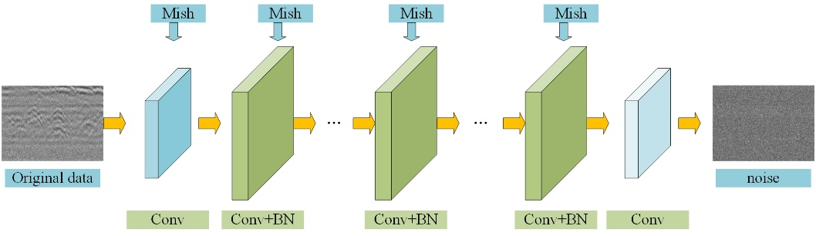

**Fig. 1.** GPR-DnCNN

The first convolutional layer (Convolution) has a kernel size of 3×3, a stride of 1, 64 convolutional kernels, and utilizes the Mish activation function. Layers 2 to 16 follow the same convolutional approach as the first layer, with the addition of Batch Normalization to accelerate network convergence, ensuring the size of feature maps matches the input and preventing feature loss due to convolution. Mish activation function is then applied. The neural network can be viewed as a sequential model composed of stacked computational modules, where each module is represented by a function f with parameters w∈R, input x, and output y. The last convolutional layer also features a kernel size of 3×3 and 1 convolutional kernel. At this point, the result represents the signal, and subtracting this result from the input data yields the noise.

* 1. Mish

The activation function refers to a function applied to neurons in a neural network, mapping the input of a neuron to its output, thereby introducing non-linear transformations to the neural network model. In the original DnCNN network, the activation function used is ReLU (Rectified Linear Unit). Assuming the activation function f for an activation layer, the mathematical expression for the ReLU function is given by the following.

 (2)

The role of the ReLU activation function is unilateral suppression: when the input is negative, the output is set to 0, preventing the neuron from being activated; when the input is positive, the output remains unchanged. This design ensures that only a portion of neurons is activated at any given time, leading to network sparsity and improved computational efficiency. However, ReLU has a notable drawback: when z<0, the gradient is 0. As a result, this neuron and subsequent neurons will always have a gradient of 0, leading to the issue that the corresponding parameters will never be updated.

The Mish function is a smooth and non-monotonic activation function with properties of being unbounded from above, bounded from below, smooth, and non-monotonic. These characteristics play a crucial role in enhancing the training results of neural networks. The unbounded feature of the Mish activation function helps avoid the issue of rapid training speed decline, while the bounded-from-below property contributes to strong regularization effects. The smoothness enhances the model's generalization ability during training, and the non-monotonic property aids in maintaining a small portion of negative values, stabilizing the network's gradients and mitigating the risk of gradient vanishing observed in ReLU. Mish function demonstrates significant advantages over 15 different activation functions across more than 70 tasks, including image classification and segmentation.

 (3)

* 1. Loss Functions and Evaluation Metrics

In order to expedite network convergence and minimize the loss function, an optimization algorithm for loss function is proposed. The Adam (Adaptive Momentum Estimation) optimization algorithm updates neural network weights iteratively based on training data, serving as a first-order optimization algorithm that can be an alternative to traditional stochastic gradient descent. Due to its good adaptability across various problems, the Adam optimization algorithm is chosen for optimizing network parameters.

 (4)

where *R*( )represents the deep learning network; denotes the parameters trained in the network; *W* stands for weights; *b* is the bias. represents pairs of training samples, and denotes the Frobenius norm. Through network training, noise is extracted, and the difference between the noise and the noisy data of the original input is calculated, achieving the purpose of denoising.



To evaluate the denoising performance of deep learning, the following metrics are selected as evaluation criteria.

 (5)

where  represents the maximum numerical value for the color of image pixels, assuming image pixels range from 0 to 255.  denotes the radar data with noise.  represents the radar data without noise.

Local image quality assessment can highlight more information related to image quality grading, while Mean Squared Error (MSE) is a macroscopic difference evaluation metric based on pixel errors, lacking directional references for highlighting and evaluating the effective information details in noisy data recovery. Therefore, this paper introduces the Structural Similarity Index (SSIM) method to evaluate images, representing the degree of distortion between clean images and noisy images.

 (6)

 (7)

where g represents the radar data without noise. h represents the radar data with noise. M is the number of Gaussian-weighted window functions.

1. Results and discussion

In our experiments, the deep learning platform used was PyTorch, an open source Python library based on Torch that was developed by Facebook. It provides a rich set of deep learning components that can be customized to develop new algorithms, so that the amount of duplicate code is reduced. Modeling was conducted using a system equipped with 16-core 24-thread 12th Gen Intel Core i9-12900KF processor working at a frequency of 3.20 GHz, with 64.0 GB of memory, and an NVIDIA GeForce RTX 3080Ti graphics card. The GPR image test platform was built using the Windows 10 operating system, the Python programming language version 3.7, the CUDA Toolkit 11.3, and the NVIDIA CUDA® Deep Neural Network library (cuDNN) 8.2.1.

* 1. Synthetic Data Experiment

The essence of deep learning is to utilize massive training data to learn more useful features, thereby improving the accuracy of the final predictions. The dataset is divided into two parts: the training set and the test set. The training set is used during the training process of the deep learning model for network model fitting. The test set is used to assess whether the network model is sufficiently effective and to evaluate the generalization ability of the final network model.

To validate the denoising effect of the GPR-DnCNN network, 25% Gaussian random noise is manually added to the data as noise labels. Samples are created for deep learning model training and testing. The data is split into a training set and a test set in an 8:2 ratio. The number of iterations (epochs) is incrementally set, and the initial learning rate is set to 0.001, decreasing to 0.0002 after 30 iterations. The Adam optimization algorithm is employed for optimization, with a batch size of 128. To speed up network training and save memory, the data is sliced into 64×64 patches. Data augmentation techniques such as flipping and rotating are applied during the training data generation process to enhance the data. The network model training process is illustrated in Fig. 2.

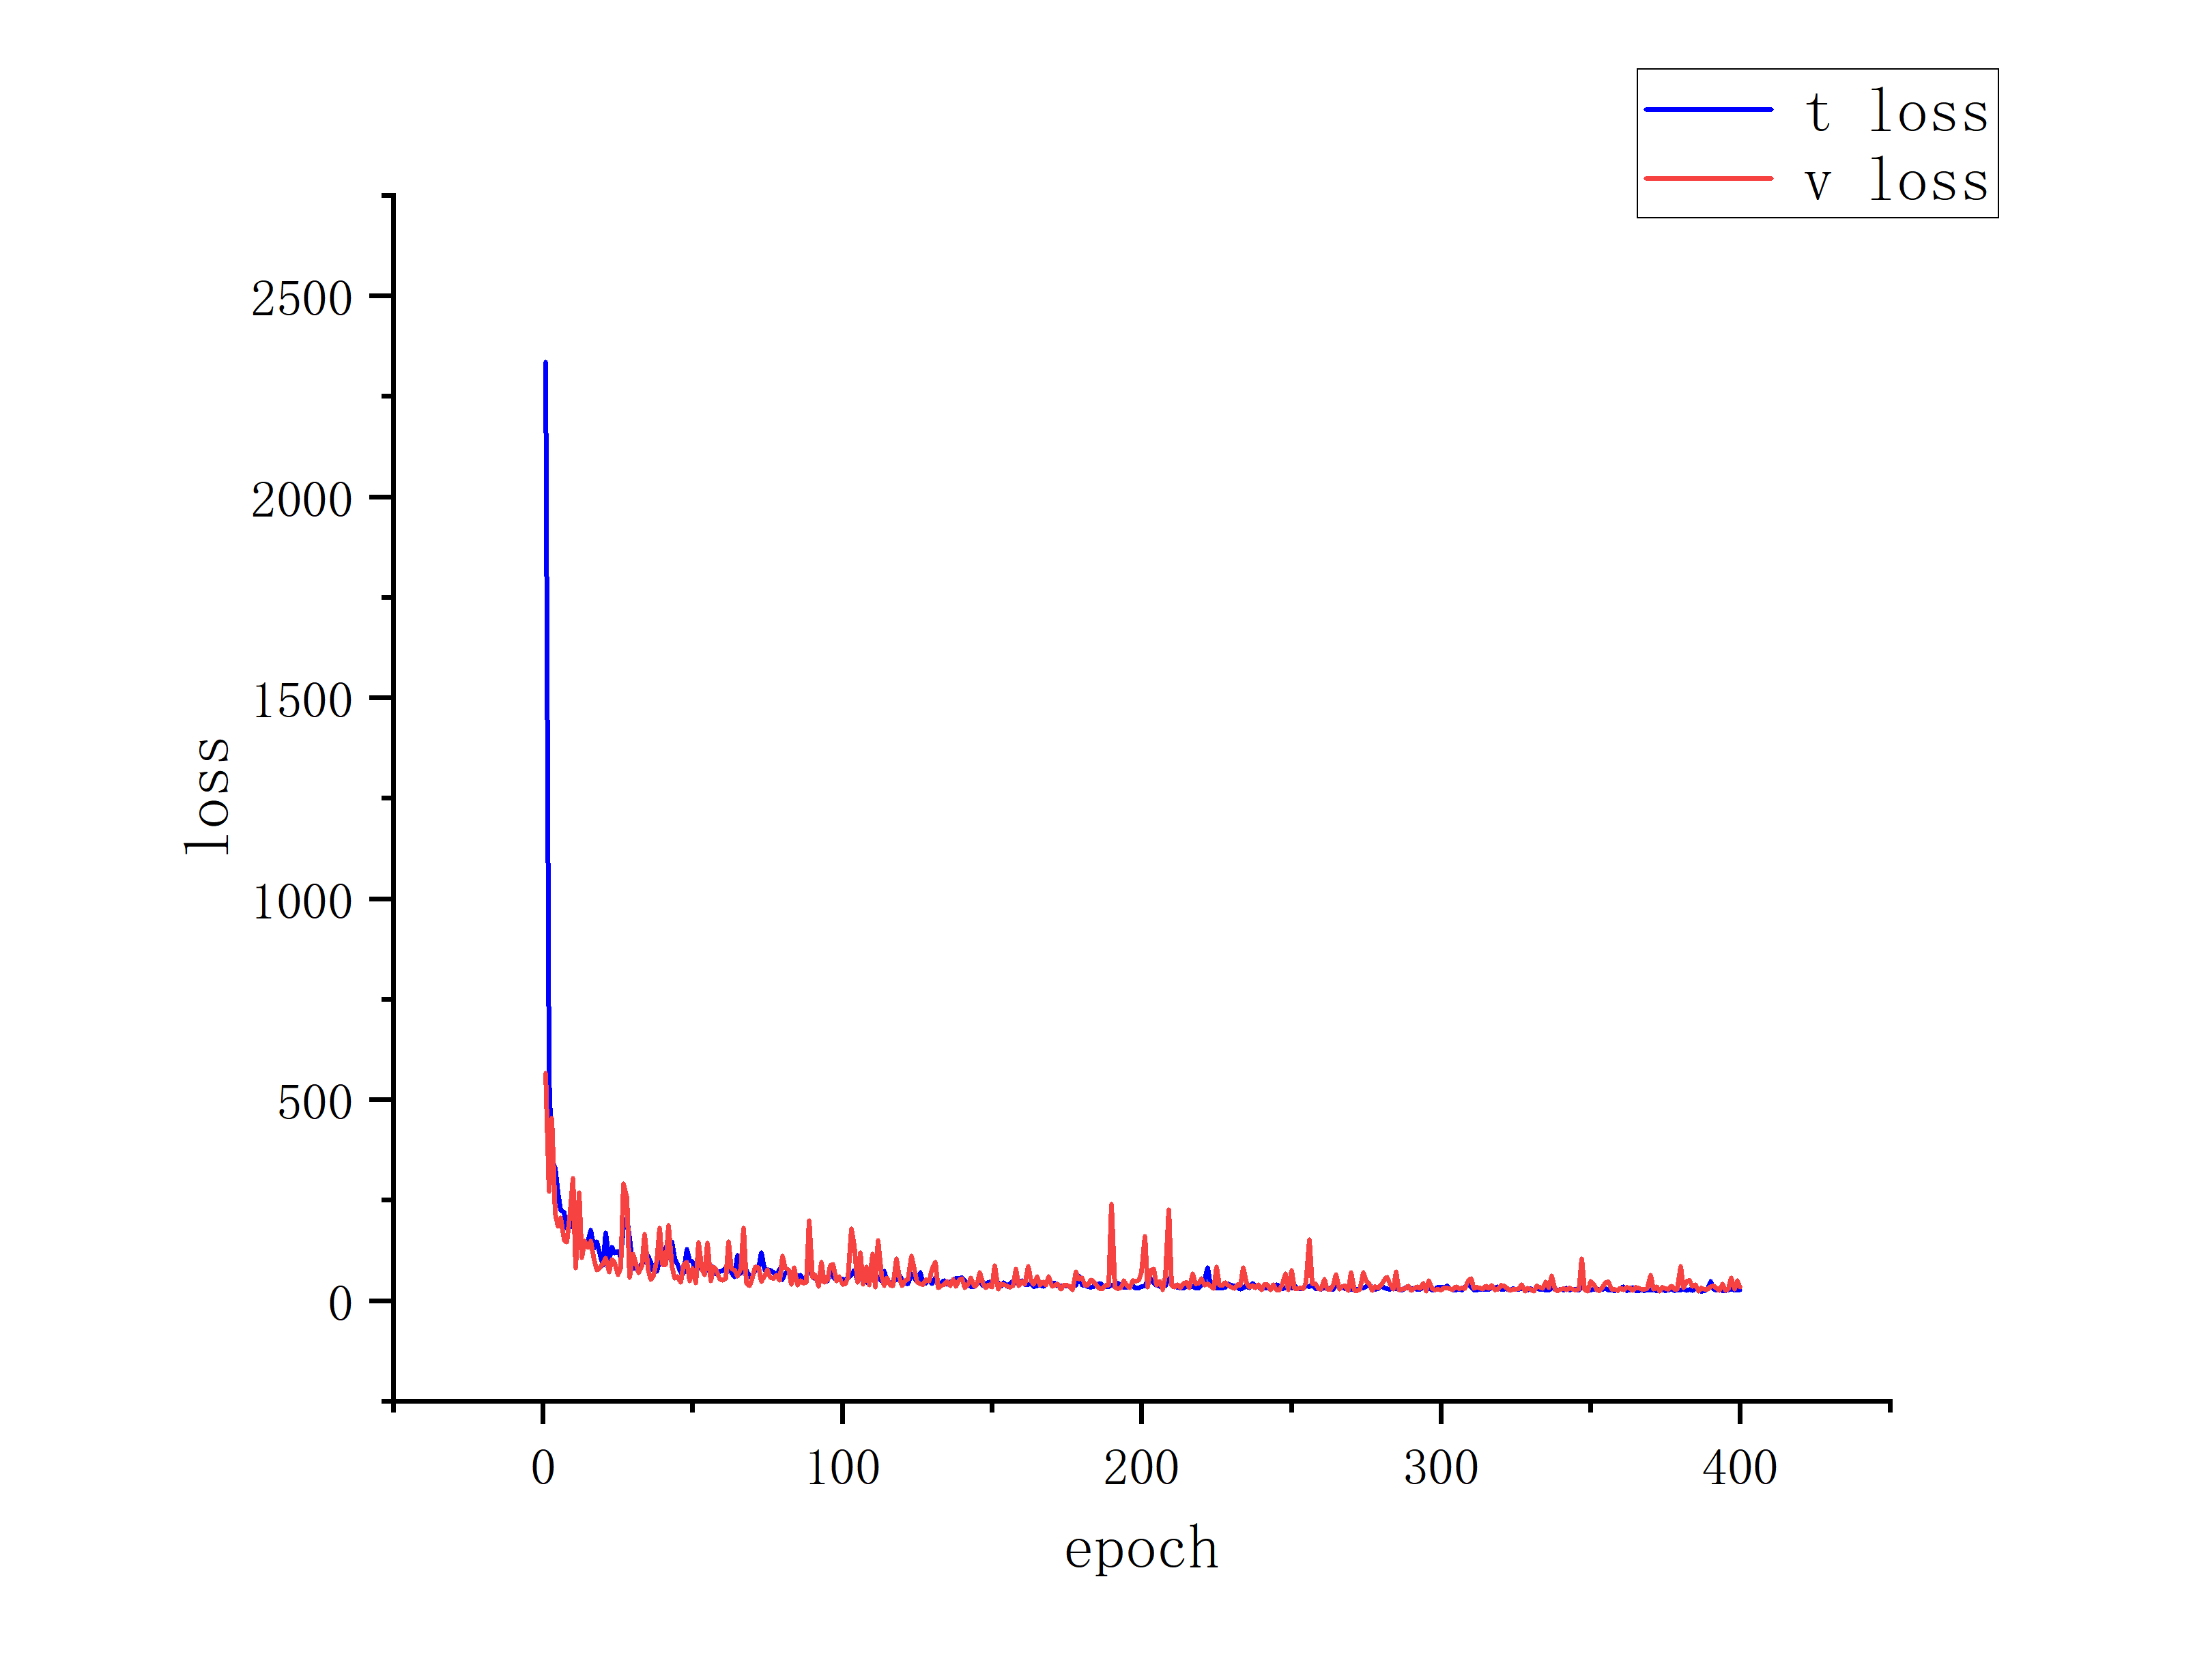

**Fig. 2** loss&epoch

The network model is tested using the test set of synthetic data, as shown in Fig. 3. The leftmost column represents the data profile after adding 25% Gaussian random noise. It can be observed that the synthetic data is heavily affected by noise, and the hyperbolic events become blurred. Although DnCNN suppresses some random noise, there are still visible random noise points in the data, and some details are lost. The denoising effect of GPR-DnCNN is superior to DnCNN, with fewer residual random noise, closer resemblance to the clean data before adding noise, and better preservation of details. At the level of single trace data, in the overlapping area of effective signal and random noise, the deep learning denoising method is superior to the traditional denoising method, and more random noise is removed. Compared with DnCNN, GPR-DnCNN has a better ability to restore the original signal.

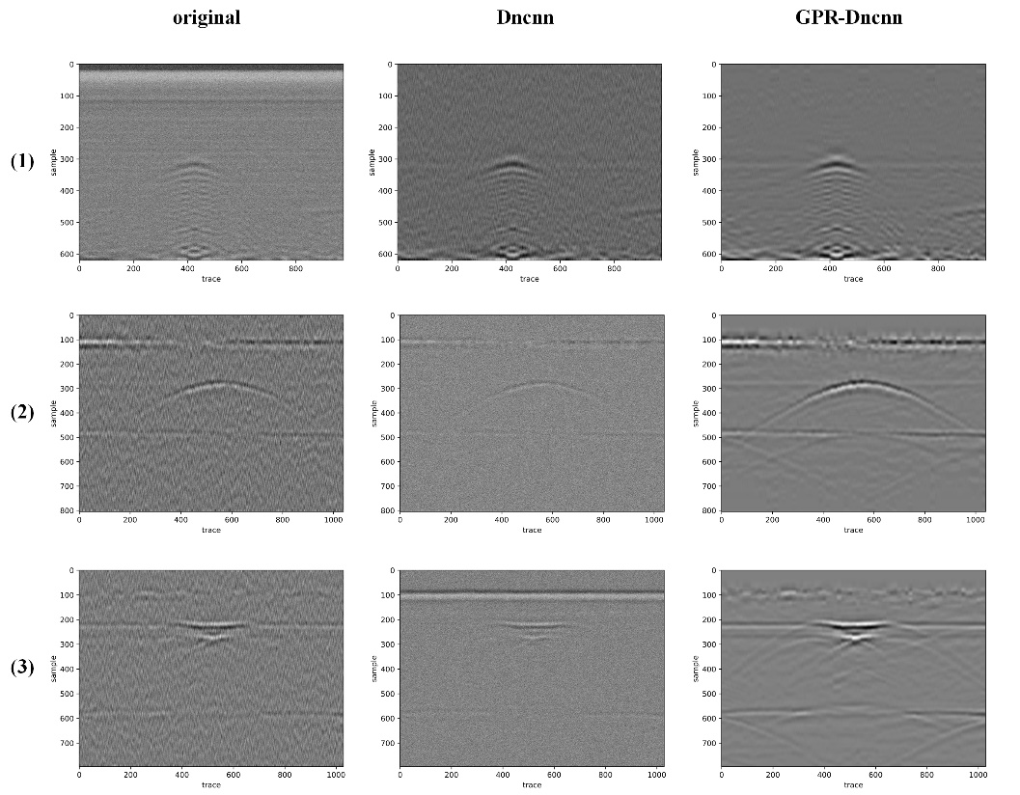

**Fig. 3** Denoising results on synthetic data

* 1. Real Data Experiment

The denoising experiment using GPR-DnCNN on synthetic data demonstrates significant advantages compared to DnCNN and classical traditional denoising methods. Now, the approach is applied to real ground-penetrating radar (GPR) data to further evaluate its denoising effectiveness. In order to retain the features learned from synthetic data and adapt to the characteristics of real data, the model is fine-tuned on the basis of the synthetic data-trained model for denoising real data. Synthetic data with specified levels of Gaussian random noise can be directly used as labeled data for network training. Since the noise in real data is unknown, obtaining noise labels is a prerequisite for training the denoising network on real data.

Typical cross-lines for city road detection are selected to construct two-dimensional data samples. The dataset consists of 200 profiles, each containing 64 traces with a time sampling interval of 2 ms and 512 sampling points. Noise reduction is performed using mean filtering and f-x domain predictive filtering. Analyzing and comparing their spectra and signal-to-noise ratios reveal that f-x domain predictive filtering outperforms mean filtering in terms of denoising and amplitude preservation. Therefore, the denoising results from f-x domain predictive filtering are used as noise labels. The real data is divided into training and testing sets in an 8:2 ratio. Network hyperparameters such as learning rate, optimization algorithm, batch size, etc., are kept consistent with those used for synthetic data training. The network model is further trained based on the model trained on synthetic data.

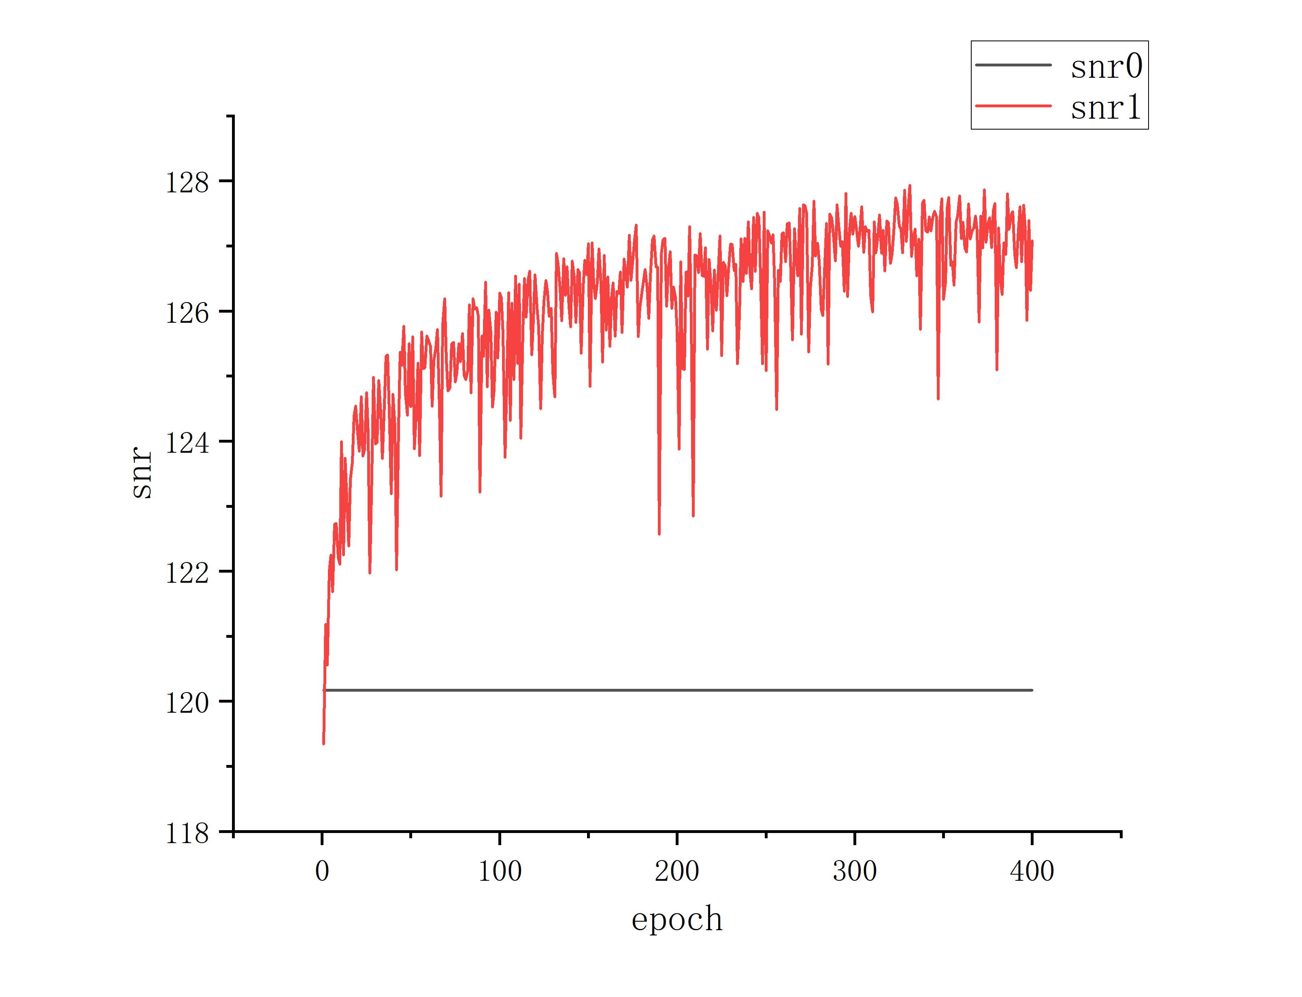

**Fig. 4** snr&epoch

From Fig. 4, it is evident that the original data is disturbed by random noise, exhibiting characteristics of overall phase axis blurring and low signal-to-noise ratio (SNR). The strong background noise significantly affects the accuracy of data picking, impacting subsequent data processing. After denoising with the DnCNN network model, the data shows a noticeable suppression of random noise, an increase in SNR, and clearer phase axes. This is attributed to the network's ability to learn features not only from synthetic data but also from the characteristics of data denoised using the f-x domain predictive filtering method.

The denoising results of the GPR-DnCNN method exhibit only minor differences compared to DnCNN in the profile, but a quantitative comparison using evaluation metrics such as PSNR reveals that GPR-DnCNN outperforms DnCNN. Table 1 illustrates that GPR-DnCNN achieves higher PSNR and SNR after denoising compared to DnCNN. In terms of the structural similarity index (SSIM), GPR-DnCNN also surpasses DnCNN. These results indicate that GPR-DnCNN excels in all 4 evaluation metrics, including SNR, PSNR, MSE, and SSIM.

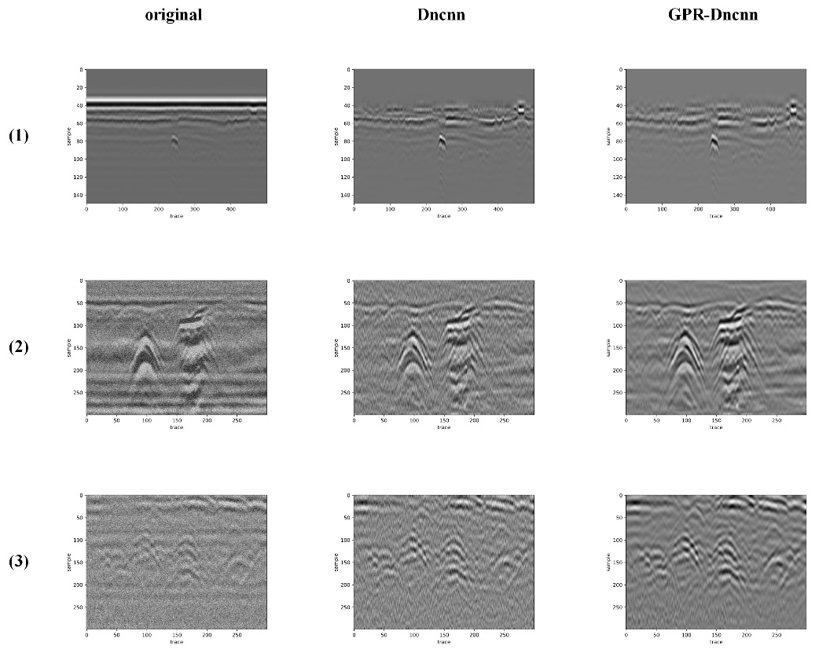

**Fig. 5** Denoising results on real data

**Table 1.** Evaluation metric comparison

|  |  |  |  |  |
| --- | --- | --- | --- | --- |
|  | SNR | PSNR | MSE | SSIM |
| Mean Filtering | 11.8845 | 24.8425 | 0.0031 | 0.7782 |
| F-X | 11.5626 | 23.4134 | 0.0045 | 0.7865 |
| DnCNN | 11.9524 | 24.9657 | 0.0043 | 0.7872 |
| GPR-DnCNN | 12.5327 | 25.8335 | 0.0041 | 0.7958 |

1. Conclusion

A multi-step prediction method based on DnCNN was proposed, utilizing data from multiple main frequencies as the training set for the network. Building upon DnCNN, the GPR-DnCNN network was constructed by introducing the Mish activation function for multi-step prediction, aiming to further enhance the denoising performance of the network model. Through denoising validation on synthetic and real data, the method demonstrated an ability to improve data SNR while preserving data details and effectively removing random noise. In comparison to DnCNN, GPR-DnCNN exhibited a 0.8678dB improvement in PSNR and outperformed DnCNN in SNR, MSE, and SSIM evaluation metrics. When compared to traditional denoising algorithms such as mean filtering and f-x domain predictive filtering, GPR-DnCNN still demonstrated superior denoising performance. Trained denoising networks from deep learning can be directly applied to data denoising without manual tuning, making the operation straightforward. Future work will involve constructing more high-quality samples for network training and conducting denoising research adaptable to the characteristics of raw data noise.

Declaration of Competing Interest

The authors declare that they have no known competing financial interests or personal relationships that could have appeared to influence the work reported in this paper.

Acknowledgements

This work was supported by the Postgraduate Education Reform and Quality Improvement Project of Henan Province (No. YJS2025XQC05), the National Key Research and Development Program of China (No. 2022YFC3801000), the National Natural Science Foundation of China (No. 51978630), the Program for Innovative Research Team (in Science and Technology) in University of Henan Province (No. 23IRTSTHN004), the National Natural Science Foundation of China (No. 52108289), the Program for Science＆Technology Innovation Talents in Universities of Henan Province(No. 23HASTIT006), the Postdoctoral Science Foundation of China (No. 2022TQ0306), the Key Scientific Research Projects of Higher Education in Henan Province (No. 21A560013), and the Open Fund of Changjiang Institute of Survey, Lanning, Design and Research(No. CX2020K10). The authors are grateful for all these financial supports.

References

1. Motevalli, Z. , & Zakeri, B. . (2019). Time-domain spectral inversion method for characterization of subsurface layers in ground-penetrating-radar (gpr) applications. Applied Computational Electromagnetics Society journal, 34(1), 93-99.
2. Xin, M. , Hao, L. , Wang, M. L. , & Ralf, B. . (2018). Automatic detection of steel rebar in bridge decks from ground penetrating radar data. Journal of Applied Geophysics, 158, S0926985117310510.
3. Webb, R. W. . (2017). Using ground penetrating radar to assess the variability of snow water equivalent and melt in a mixed canopy forest, northern colorado. Frontiers of earth science(3), 11.
4. Delgado, A. , Hays, D. B. , Bruton, R. K. , Ceballos, Hernán, Novo, A. , & Boi, E. , et al. (2017). Ground penetrating radar: a case study for estimating root bulking rate in cassava (manihot esculenta crantz). Plant Methods, 13(1), 65.
5. Hunziker, Jürg, Laloy, Eric, Linde, & Niklas. (2019). Bayesian full-waveform tomography with application to crosshole ground penetrating radar data. Geophysical Journal International.
6. Ge, J., Sun, H., Shao, W., Liu, D., Liu, H., Zhao, F., ... & Liu, S. (2024). Wavelet-GAN: A GPR noise and clutter removal method based on small real datasets. IEEE Transactions on Geoscience and Remote Sensing.
7. Liu, Z., Xiao, J., Shen, R., Liu, J., & Guo, Z. (2024). Deep Learning-Based Suppression of Strong Noise in GPR Data for Railway Subgrade Detection. IEEE Transactions on Geoscience and Remote Sensing.
8. Feng, D., He, L., Wang, X., Xiao, Y., Huang, G., Cai, L., & Tai, X. (2024). Efficient denoising of multidimensional GPR data based on fast dictionary learning. IEEE Journal of Selected Topics in Applied Earth Observations and Remote Sensing, 17, 5221-5233.
9. Geraads, S., Charachon, B., Loeffler, O., & Omnes, G. (2002, April). Applying a wavenumber notch filter to remove interferences caused by railway sleepers from a GPR section. In Ninth International Conference on Ground Penetrating Radar (Vol. 4758, pp. 715-718). SPIE.
10. Terrasse, G., Nicolas, J. M., Trouvé, E., & Drouet, E. (2017). Application of the curvelet transform for clutter and noise removal in GPR data. IEEE Journal of Selected Topics in Applied Earth Observations and Remote Sensing, 10(10), 4280-4294.
11. Bi, W., Zhao, Y., An, C., & Hu, S. (2018). Clutter elimination and random-noise denoising of GPR signals using an SVD method based on the Hankel matrix in the local frequency domain. Sensors, 18(10), 3422.
12. Kumlu, D., & Erer, I. (2020). GPR clutter reduction by robust orthonormal subspace learning. IEEE Access, 8, 74145-74156.
13. Kumlu, D., & Erer, I. (2019). Improved clutter removal in GPR by robust nonnegative matrix factorization. IEEE Geoscience and Remote Sensing Letters, 17(6), 958-962.
14. Kumlu, D. (2021). GPR clutter suppression by online stochastic tensor decomposition. Remote Sensing Letters, 12(3), 239-248.
15. Tivive, F. H. C., & Bouzerdoum, A. (2020). Clutter removal in through-the-wall radar imaging using sparse autoencoder with low-rank projection. IEEE transactions on geoscience and remote sensing, 59(2), 1118-1129.
16. Krizhevsky, A., Sutskever, I., & Hinton, G. E. (2017). ImageNet classification with deep convolutional neural networks. Communications of the ACM, 60(6), 84-90.
17. Jain, V., & Seung, S. (2008). Natural image denoising with convolutional networks. Advances in neural information processing systems, 21.
18. Sun, C., Shrivastava, A., Singh, S., & Gupta, A. (2017). Revisiting unreasonable effectiveness of data in deep learning era. In Proceedings of the IEEE international conference on computer vision (pp. 843-852).
19. Zhao, X., Wang, L., Zhang, Y., Han, X., Deveci, M., & Parmar, M. (2024). A review of convolutional neural networks in computer vision. Artificial Intelligence Review, 57(4), 99.