A new portable fluorescence-absorbance-scattering spectrometer

Georgios Violakis1, Eleftheria Maliaritsi2, Nikolaos Vardakis1 and Evangelos Hristophorou2

1 Hellenic Mediterranean University, Estavromenos, Heraklion, 71410, Greece

2 National Technical University of Athens, Laboratory of Electronic Sensors, Zografou, Athens 15780, Greece   
violakisg@hmu.gr

**Abstract.** Rapid and low-cost screening methods in the food industry are increasingly required as food fraud and adulteration pose both a threat to the general public health and a loss of public revenue from evading taxes and duties. In the present work a low-cost, portable and modular instrument is presented which is comprised of off-the-shelf components and is capable of performing absorption visible spectroscopy, scattered laser light and luminescence measurement as well as basic image processing in liquid samples. The combined data from the sensors are stored locally in a database which can be used to compare samples under test with known quality samples after a training procedure and by using principal component analysis or convolutional neural networks. The nature of the device is modular and can act as the host for other components further expanding capabilities or adapting to other target liquids. The device is comprised of low-cost components and the user interface and underlying code are developed in Python, leaving full the end-user with full freedom of parametrization and adaptability to the desired application.

**Keywords:** Visible spectroscopy, Scattering, Luminescence, Optical methods.

1. Introduction

Food quality screening is becoming increasingly important as demand for some specific foods, such as coffee, olive oil or cocoa which are in short supply, compared to their demand, have driven their prices up and rendered fraudulent practices extremely lucrative. Adulteration in such products is a constant threat to the general public health and a significant source of revenue loss for the authorities. Careful chemical examinations of all quantities in circulation is not possible and therefore low-cost and practical screening technologies have to be utilized for primary sample control which act as ‘stop-or-go’ flag-setters for further analysis.

In particular, a flagship and highly valued product from the Mediterranean basin is the extra virgin olive oil (EVOO), which is a product that has been extremely prone to adulteration. Typically, EVOO quality is chemically verified, supplemented by several methods, such as Fourtier Transform Infrared Spectroscopy (FTIR) [1], UV- visible spectroscopy [2], laser induced breakdown spectroscopy [3], or fluorescence spectroscopy [4], among many other laboratory-grade methods. Fluorescence spectroscopy has also been used as an olive oil screening method while being successfully utilized to measure adulterant concentration while using only a laser diode [5]. Although laboratory analysis provides the most trustworthy and reliable results, it is not always practical, or financially viable to perform expensive analytical tests on food samples, creating the need for versatile and low-cost screening methods.

In the present work, a multi-parameter, modular, low-cost and portable device is presented, capable of performing visible absorption and fluorescence spectroscopy, scattered light imaging and image analysis and combine the data in order to acquire sample fingerprinting capabilities. The device can be used for food quality or adulteration screening and can be modified to adapt to the detection requirements of a specific liquid food.

1. The pi-LAB device
   1. Device architecture

Pi-LAB or π-LAB was initially developed as a portable and low-cost device capable of detecting olive oil adulteration at volumes above 0.1% v/v. Olive oil is a complex liquid fat comprised of oleic acid, linoleic acid, palmitic acid, stearic acid α-linoleic acid and lesser amounts of other acids along with traces of sterols, phenols and other organic elements, making it a complex system to interrogate for adulteration. The idea behind pi-LAB was to use multiple and low-cost off-the-shelf hardware combined together in an effort to use the combined output as an indicator for adulteration detection. A flow chart of the basic concept is presented in Fig. 1.

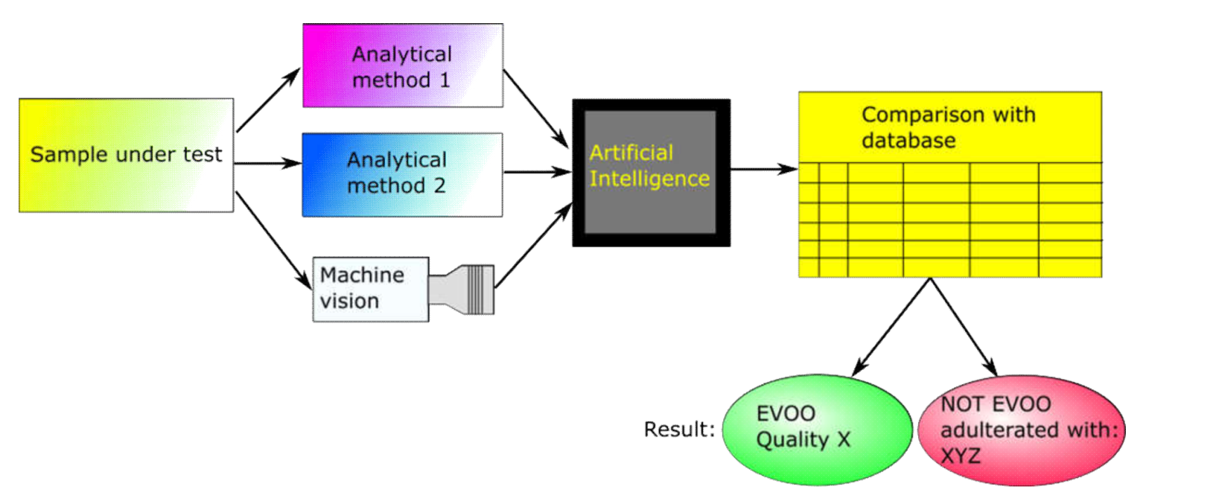

**Fig. 1.** Original π-LAB testing sequence and classification flow-chart for olive oil adulteration detection.

The olive oil sample under test would be exposed to a series of measurements (Analytical method 1 and 2) as well as optical investigation (Machine vision), processed through an algorithm (Artificial Intelligence) and compared to a predefined database with samples of known quality in order to classify the quality of the sample under test. An actual view of the device as it was manufactured is presented in Fig. 2.

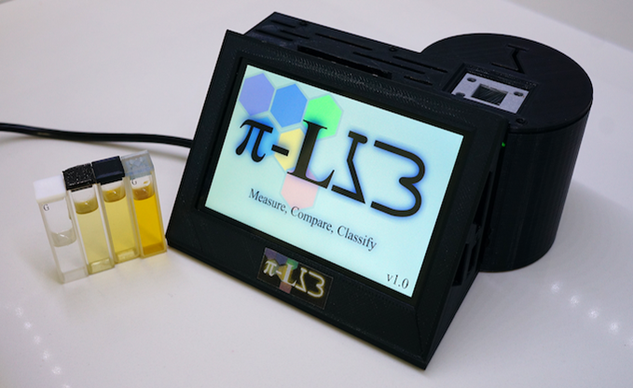

**Fig. 2.** The π-LAB device as it was manufactured.

The testing methods that were chosen to be used in the π-LAB hardware were the absorption spectroscopy in the visible, fluorescence and / or scattered light measurement as well as color mapping and image processing / classification. An exploded view of the device and its constituent sub-components is presented in Fig. 3.

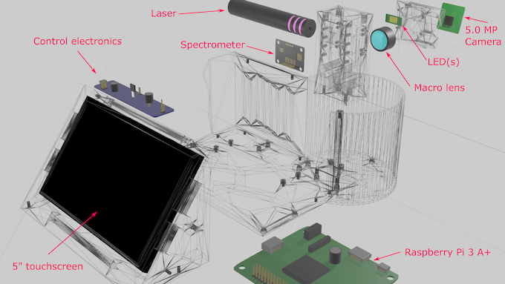

**Fig. 3.** The π-LAB subcomponents in the device (exploded view).

The device is centered around a cuvette housing area where an optical grade glass cuvette of 10 mm optical path on 2 sides and sanded glass on the other two sides is placed. The cuvette has a rectangular cross section. In front of the transparent side of the cuvette reside the Light Emitting Diode(s) which illuminate the sample with broadband visible light and the 5.0 MP camera mounted on a 10x macro lens, responsible for acquiring visible images of the liquid sample inside the cuvette (see Fig. 3). On the opposite side, the optical-filter based spectrometer board resides which analyses the absorbed LED light into 8 optical band components. The laser beam of the setup is directed towards the sanded side of the cuvette in order to scatter the intense laser light and avoid speckle formation. Both scattered laser light images and luminescence information is captured by both the camera and the spectrometer. All systems are powered through a custom-designed printed circuit board which also allows the control of the LEDs and the laser. The controlling, processing and visualization of the data is taken care by an ARM-based single board computer and a graphical user interface (GUI) was developed in Python (TKinter) for ease of use. The graphics are drawn in a 5 inch touchscreen which acts also as a user input device. A snapshot of some GUI elements of the custom developed software is presented in Fig. 4.

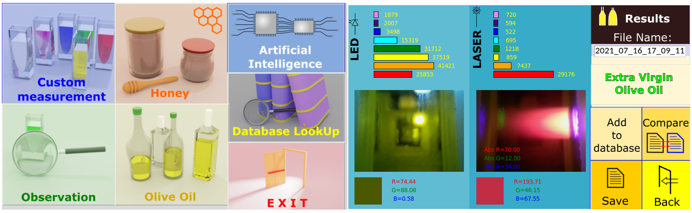

**Fig. 4.** Graphical User Interface elements developed for the π-LAB operation.

In particular the spectrometer used in the device was the AMS 7341, 10 channel spectrometer manufactured by AMS Technologies. This spectrometer is based on a CMOS photodetector array with optical filters lithographically developed on top of it. The spectral bands detectable by this spectrometer are: 415nm, 445nm, 480nm, 515nm, 555nm, 590nm, 630nm and 680nm. Additionally, a wider band at 940nm (with a FWHM of typically 80nm versus the 40nm for the visible wavelengths) is available but was not used in the device. The camera used was the v1.3 5.0Megapixels (MP) camera of the Raspberry Pi platform, namely the Omni vision 5647 Camera Module. The Single Board Computer used was the Raspberry Pi 3 Model A+ which houses a 1.4GHz 64-bit quad-core processor, coupled to 512Mb of RAM and for the operating system and software a high endurance 32Gb SD card was used (Sandisk). Careful consideration had to be placed in the choice of the broadband light source which should cover two basic needs: a high color rendering index (CRI) and repeatable sample-to-sample spectral performance. For these reasons the Cree LED JB2835AWT-W-U40GA0000-N0000001 was chosen as the visible light source at a white light temperature of 4000K (and CRI index of 90) in order to acquire a white light spectrum with satisfactory light emission across the whole visible light band as seen in Fig. 5.

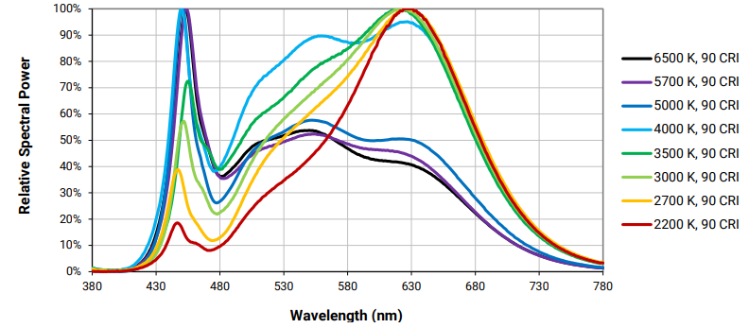

**Fig. 5.** The spectral content of the LED white light source. For π-LAB the 4000K version of the LED was chosen.

The laser source used in this work was the Sony SLD3235VF with a central emission wavelength of 405nm and an output optical power of 40mW. The laser emission is used to excite any luminescence in the samples under investigation and the chosen wavelength covers the detection range of the spectrometer used.

* 1. Operational flow chart and

The device as a whole can perform measurements in the following fashion:

1. Acquire image(s) of liquid sample under LED illumination.

2. Acquire image(s) of the liquid sample under laser illumination (scattered laser light or luminescence detection).

3. Acquire absorption spectrum under LED illumination with an integration time ranging from 10ms up to 500ms and various sensor gains.

4. Acquire scattering and luminescence spectra under 405nm laser illumination, emitting at full power, with variable integration time or sensor gain.

5. Calculate average color value under LED illumination, away from the LED saturation zone.

Using the above measurement p-LAB stores the data in a local database and during the training process samples of known quality are used to designate various qualities of the target liquid. For example, an extra virgin olive oil contains exhibits measurable changes across many values with respect to a virgin olive oil and significant differences are observed with adulterated olive oils even if the adulteration is as low as 1%. The database stores the range of values that constitute a sample classification from another across as many classes as the user desires. For instance, the classes ‘extra virgin, ‘virgin’, ‘pommace’, ‘oxidized’ and ‘adulterated’ were created for olive oil samples.

Once the training phase is complete, two sample processing pathways are possible. In the simplest form, a principal component analysis (PCA) algorithm is used for the classification of the unknown sample which is calculating an n-dimensional vector (n is the number of parameters used for qualification) and finds the closest distance to the existing database samples. If the samples cannot be satisfactorily classified using the PCA method, then a neural network can be trained, typically a Convolutional Neural Network (CNN) which directly acquires as an input the output Figures (after the measurements) of the GUI as shown in the right-hand side of Fig. 4.

1. Conclusions

In the present work a low-cost device is presented capable of performing absorption spectroscopy in the visible combined with luminescence, light scattering and basic image processing capabilities. The device can act as a platform for food screening and its modularity allows adaptability to the specific requirements of the target liquid food. The device has been originally developed for olive oil adulteration detection, which can perform with satisfactory results and has also been used for the quality assessment of coffee drinks. The proposed platform is envisioned in the next iterations to include even more powerful and capable hardware, extend spectroscopic capabilities in the near infrared region (including the required light sources) and add at least one more laser source in order to cover an even broader spectrum for both absorption and fluorescence spectroscopy. As the lithographic advances in electronics allow for cheaper and more capable low-cost semiconductor light sources, detectors, lasers and cameras, platforms such as the one proposed in this work benefit from becoming even stronger and provide even more accurate results paving the way towards a new class of instrumentation that could be defined as the ‘home-analytics’ class.

References

1. Rohman, Abdul, Y. B. Che Man, and Farahwahida Mohd Yusof.: "The use of FTIR spectroscopy and chemometrics for rapid authentication of extra virgin olive oil." Journal of the American Oil Chemists' Society 91, 207-213 (2014).
2. Milanez, Karla Danielle Tavares Melo, et al. "Multivariate modeling for detecting adulteration of extra virgin olive oil with soybean oil using fluorescence and UV–Vis spectroscopies: A preliminary approach." LWT-Food Science and Technology 85, 9-15 (2017).
3. Nanou, E., Bekogianni, M., Stamatoukos, T., Couris, S.: “Detection of Adulteration of Extra Virgin Olive Oil via Laser-Induced Breakdown Spectroscopy and Ultraviolet-Visible-Near-Infrared Absorption Spectroscopy: A Comparative Study.” Foods 14, 321 (2025).
4. Xu, Yi, et al. "Rapid detection of adulteration in extra-virgin olive oil using three-dimensional fluorescence spectra technology with selected multivariate calibrations." International Journal of Food Properties 18.9, 2085-2098 (2015).
5. Lastra-Mejías, Miguel, et al. "Chaotic parameters from fluorescence spectra to resolve fraudulent mixtures of fresh and expired protected designation of origin extra virgin olive oils." Talanta 195, 1-7 (2019).