**Piezoelectric impedance intelligent sensing method and monitoring technology for corrosion of steel structures**

Weijie Li 1, 2, Yanpeng Si 1, 2, Xuefeng Zhao 1, 2

1 State Key Laboratory of Coastal and Offshore Engineering, Dalian University of Technology, Dalian 116024, China;

2 Department of Civil Engineering, Dalian University of Technology, Dalian 116024, China;

**Abstract:** Corrosion induced steel loss is the primary cause for the failure and destruction of steel structures. Traditional methods such as corrosion coupon method and electrochemical methods are difficult to realize online monitoring of corrosion. In this paper, the piezoelectric impedance intelligent sensing method and monitoring technology for the corrosion monitoring of steel structures were proposed. The corrosion sensor was consisted of a piezoelectric patch laminated with a metal plate, and it operates based on the piezoelectric impedance coupling and corrosion-sensitive feature in its resonance. Firstly, based on the linear piezoelectric elasticity theory and the Kirchhoff thin plate assumption, a theoretical model of piezoelectric impedance for the piezoelectric-metal laminated structures was derived. Secondly, finite element simulation and experiments were carried out to validate the corrosion sensing mechanism and investigate its response under accelerated corrosion tests. Thirdly, to achieve high durability, the packaging structure of the sensor was designed with optimized sensor parameters. Lastly, a cloud based wireless impedance monitoring system was developed and its performance was examined in an outdoor corrosion monitoring of a steel structure. The results demonstrated that the resonant frequency of the sensor has good linear relationship with corrosion induced thickness loss.

**Key words:** Steel structures; Corrosion monitoring; Piezoelectric impedance; Peak frequency; Wireless monitoring technology

1. **Introduction**

Steel structures are extensively used in civil engineering, marine engineering, where corrosion issues not only compromise substantial economic losses but also cause structural safety and durability. The steel corrosion is one of the main challenges in steel structures, leading to the thickness loss of structural members and strength reduction of the structures. Statistics[1] indicate that the global annual direct economic losses attributable to metal corrosion range from 700billion to 1 trillion, reaching 2%-4% of the gross domestic product in developed countries. Severe corrosion can structurally damage steel structures, shorten their lifespan, and even lead to catastrophic accidents and environmental pollution[2-4]. Therefore, it is of crucial importance to develop effective corrosion sensing methods and monitoring technologies for steel structures to enhance their safety and reliability during their service life.

In recent years, various corrosion detection and monitoring methods for steel structures have been developed. Ultrasonic methods[5-7] have been employed to assess thickness loss through wave propagation analysis, though their accuracy is affected by temperature variations. Electrochemical approaches[8-10], including polarization resistance and impedance spectroscopy, have been widely investigated but remain limited by modeling assumptions, providing primarily qualitative corrosion probability rather than quantitative measurements. Fiber optic sensing technology[11, 12] have attracted significant attention due to their sensitivity to minor corrosion-induced changes, yet they rely on indirect measurement principles. Acoustic emission techniques[13, 14] have been used to detect stress waves from material degradation, though their effectiveness is compromised by environmental noise and low sensitivity to early-stage corrosion. Recent advances in computer vision[15, 16] have enabled automated corrosion assessment through deep learning. Improved neural network architectures have demonstrated promising classification accuracy, while drone-assisted inspection methods[17, 18] have been explored for remote monitoring. However, these vision-based approaches remain largely limited to surface-level analysis and face challenges in real-time implementation and operational costs. Despite these developments, current methods are constrained by several limitations. These include the inability to provide continuous real-time monitoring, dependence on periodic manual inspections, and lack of comprehensive automated solutions.

The electromechanical impedance (EMI) technique has emerged as a promising structural health monitoring method due to its high sensitivity, cost-effectiveness, noninvasive nature, and real-time monitoring capabilities. This technique has been successfully applied in various fields, including concrete structures[19-21], aerospace structures[22, 23], pre-stressed structures[24-26], bolt loosening detection[27, 28], and medical health monitoring[26, 29]. In the EMI approach, lead zirconate titanate (PZT) patches are bonded to the host structure as coupled sensors and actuators. When an alternating voltage is applied within a specific frequency range, structural damage including corrosion is reflected in the impedance spectrum. Several studies have explored EMI-based corrosion monitoring. Talakokula et al.[30] demonstrated that equivalent parameters extracted from admittance signatures could effectively quantify reinforcement corrosion in concrete. Ai et al.[31] proposed a unified mechanical impedance approach, showing enhanced sensitivity to steel beam corrosion compared to traditional admittance analysis. Zhu et al.[32] introduced Structural Mechanical Impedance (SMI), validating its effectiveness in steel corrosion detection through experimental studies. Other researchers[33-36] have applied EMI techniques for pipe wall thinning assessment, peak frequency shift analysis in steel plates, and chloride-induced corrosion detection in reinforced concrete. Despite these advances, EMI-based corrosion monitoring of steel structures remains limited. Challenges include the difficulty in establishing direct relationships between EMI peak frequencies and structural parameters, as well as the reliance on statistical indicators (e.g., RMSD) for qualitative rather than quantitative assessment.

This paper presents an intelligent corrosion monitoring system for steel structures utilizing EMI technology. A novel circular piezoelectric-metal transducer is developed, comprising a PZT patch bonded to a metal corrosion coupon. A wireless impedance monitoring system (WIMS) is implemented based on the AD5933 impedance converter, integrated with microcontroller, communication, IoT cloud, and power supply modules to form a comprehensive monitoring solution. The paper is organized as follows. First, the sensing mechanism of the circular piezoelectric-metal transducer is elucidated. Harmonic response and finite element analyses are then conducted to verify the sensor's sensitivity. Following sensor packaging for enhanced durability, accelerated corrosion tests are performed to validate monitoring effectiveness. Subsequently, the WIMS is introduced and its sensitivity is experimentally confirmed. The integrated system is deployed on transmission towers for long-term monitoring. Experimental results and discussions are presented, demonstrating the system's field applicability.

1. **Sensing principle for corrosion monitoring**

In the 1990s, the electromechanical impedance (EMI) analysis method was first proposed by Liang et al.[37], who established the classical one-dimensional theoretical model. However, this model was oversimplified and failed to accurately describe the impedance characteristics of two-dimensional or three-dimensional structures. In our previous work[38], a new type of EMI based corrosion sensor was proposed. The proposed corrosion sensor is essentially a circular piezoelectric-metal transducer. As illustrated in Figure 1, the sensor is composed of a piezoelectric patch bonded to a metal corrosion coupon, forming a laminated structure. The piezoelectric patch is polarized along the thickness direction and coated with electrodes on its surfaces. When excited by an alternating voltage, it undergoes extensional vibration, which induces bending vibration in the entire system. For modeling simplification, a circular cross-sectional structure was adopted. Based on Kirchhoff's thin-plate theory, constitutive equations, and dynamic equilibrium equations, an axisymmetric bending vibration impedance model was derived to provide a theoretical basis for corrosion monitoring. Ultimately, the derived expressions for the admittance (Y) and impedance (Z) of the model are given by Equation (1).

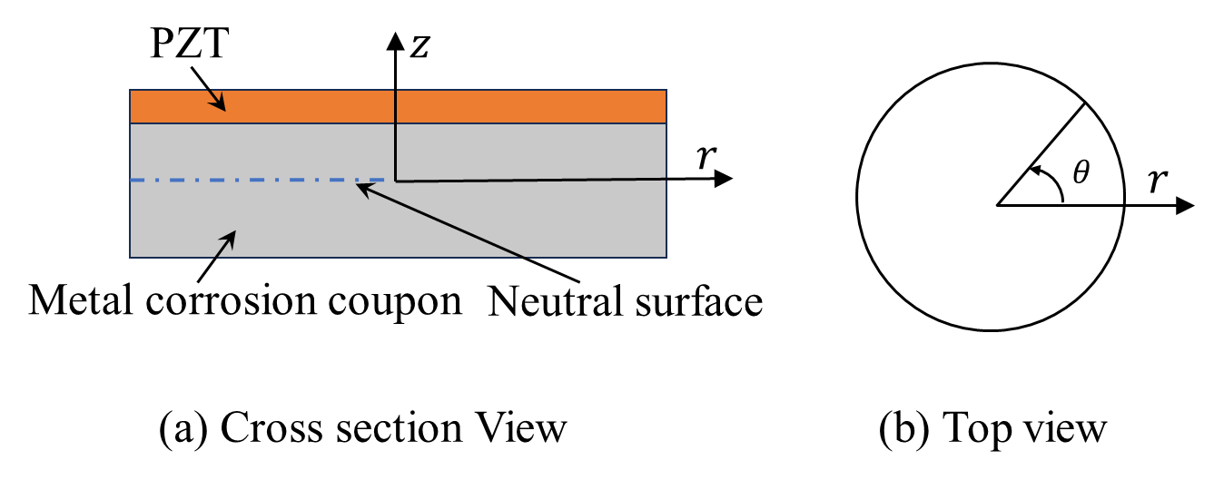

**Figure 1.** Schematic diagram of the corrosion sensor.

|  |  |
| --- | --- |
|  | (1) |

where , ,  and  represent the admittance, impedance, conductance and susceptance ,respectively;

The admittance consists of a real part (conductance, G) and an imaginary part (susceptance, B). In the admittance or conductance spectrum, the frequency corresponding to a local peak represents the peak frequency of the corrosion sensor. When corrosion reduces the thickness of the metal corrosion coupon, the bending stiffness of the corrosion sensor decreases, leading to a shift in the peak frequency. Therefore, by monitoring the peak frequency shift in the admittance spectrum, the corrosion extent can be quantitatively evaluated, enabling real-time thickness loss monitoring.

1. **Experiments**
   1. **Fabrication of** **the corrosion sensor**

The corrosion sensor consists of a circular metal corrosion coupon and a PZT patch with identical cross-sectional dimensions, which is bonded to the coupon's surface using epoxy resin. To investigate the piezoelectric impedance response under varying thickness losses, multiple sensors were fabricated with different metal corrosion coupon thicknesses. Both the PZT patch and metal corrosion coupon have a diameter of 30 mm, while the metal corrosion coupon thicknesses are 1.0 mm, 1.5 mm, 2.0 mm, 2.5 mm, and 3.0 mm, respectively. The thickness of the PZT patch is fixed at 1 mm, as illustrated in Figure 2.

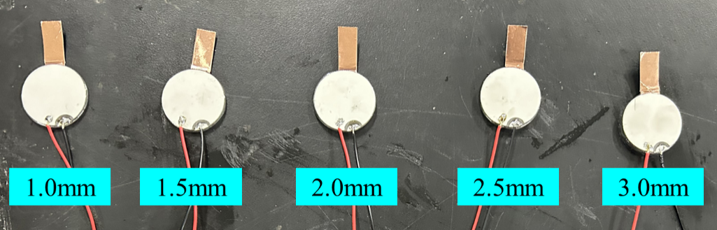

**Figure 2.** Corrosion sensors of different thicknesses.

* 1. **Sensitivity investigation for the corrosion sensor**

The piezoelectric impedance characteristics of the five corrosion sensors with different thicknesses prepared in Section 3.1 were tested using a PV520A impedance analyzer (PV520A, Beijing Bond ERA Electronic Technology Co., Ltd.). As illustrated in Figure 3, the experimental setup was configured as follows. First, each corrosion sensor was placed on a foam cushion to simulate free boundary conditions. The sensor was then connected to the impedance analyzer via conducting wires, while the analyzer was interfaced with a computer system for data acquisition and processing. Prior to formal testing, preliminary frequency sweeping was conducted to determine the optimal test parameters, ultimately establishing a frequency range of 1-200 kHz with a scanning step of 200 Hz, resulting in measurements at 995 frequency points. Based on the measured conductance spectra, the peak frequencies of the first two bending modes were extracted, and the relationship between these peak frequencies and the metal corrosion coupon thickness was fitted.

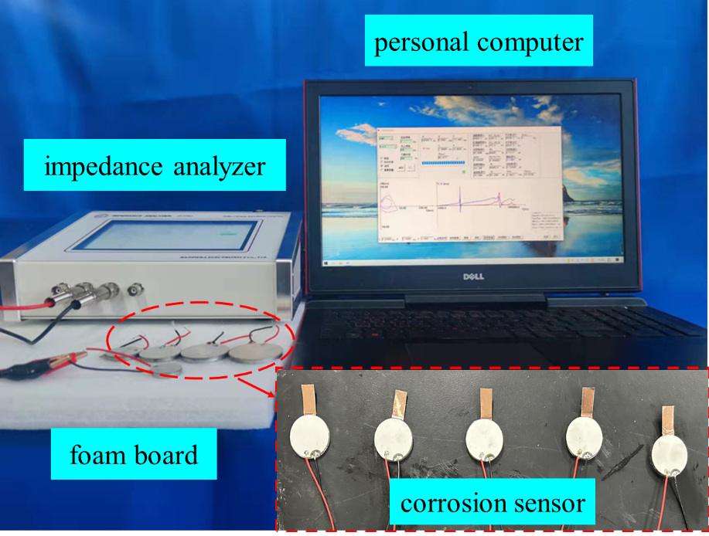

**Figure 3.** Test method for the piezoelectric impedance signal measurement.

* 1. **Sensitivity analysis of the corrosion sensor via finite element simulation**

A three-dimensional finite element model of the corrosion sensor was developed using the ANSYS software. PZT-5H and Q235 steel were employed to define the material properties of the piezoelectric patch and the metal corrosion coupon, respectively, with SOLID5 and SOLID45 elements selected for meshing at a uniform size of 1 mm. Considering structural symmetry, only a quarter-model was established to enhance computational efficiency (Figure 4). For boundary conditions, the voltage degrees of freedom at the top and bottom surfaces of the piezoelectric patch were coupled to their respective master nodes, where the bottom electrode was grounded (0 V) and the top electrode was excited with a 1 V AC signal.

Harmonic response analysis was performed to obtain impedance characteristics for sensors of varying thicknesses. Consistent with the experimental conditions, the frequency range was set from 1 kHz to 200 kHz, with a step size of 200 Hz and a total of 995 steps. The peak frequencies of the first two bending modes were then extracted, and the relationships between these peak frequencies and the metal corrosion coupon thickness were fitted.

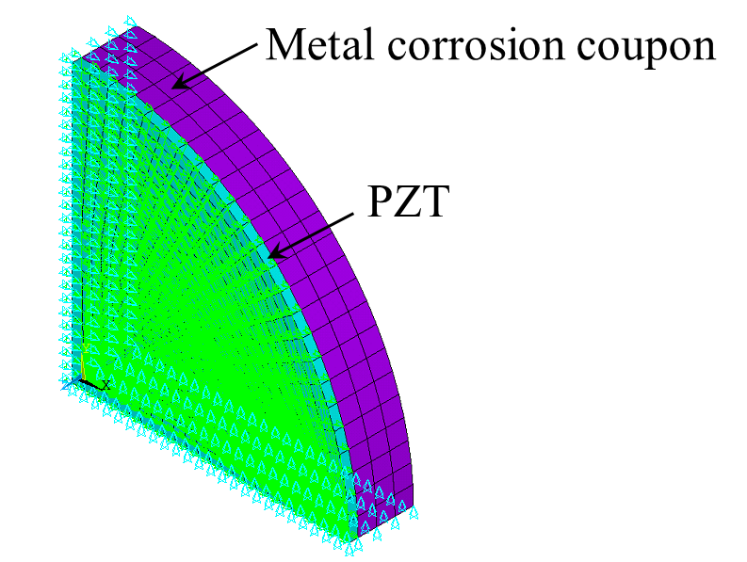

**Figure 4.** Finite element model of the corrosion sensor.

* 1. **Packaging of the corrosion sensor with the host structure**

To minimize interference from external loads and environmental factors, the corrosion sensor was packaged within a protective housing. Previous research[39] indicated superior performance and packaging effectiveness with polydimethylsiloxane (PDMS) compared to silicone rubber, silicone sealant, epoxy resin, and other tested materials. Experimental results demonstrated that PDMS provided the most superior encapsulation performance. The packaging housing was machined from Q235 steel with the following dimensions, with outer diameter of 42 mm, inner diameter of 36 mm, base thickness of 2 mm, and height of 6 mm.

To achieve electrochemical behavior consistency between the corrosion sensor and host structure, a 3mm-thick metal corrosion coupon was electrically connected to the metal housing through copper foil. All connection components were packaged within the PDMS protective layer. During monitoring, the sensor is installed on the host structure surface, where tight contact between the metal housing and host structure forms a complete electrochemical corrosion circuit that includes the metal corrosion coupon, housing, and host structure. This innovative design maintains the free vibration boundary condition of the piezoelectric patch while ensuring the metal corrosion coupon experiences the same electrochemical environment as the host structure. Figure 5 illustrates the structural model and physical prototype of the packaging sensor.

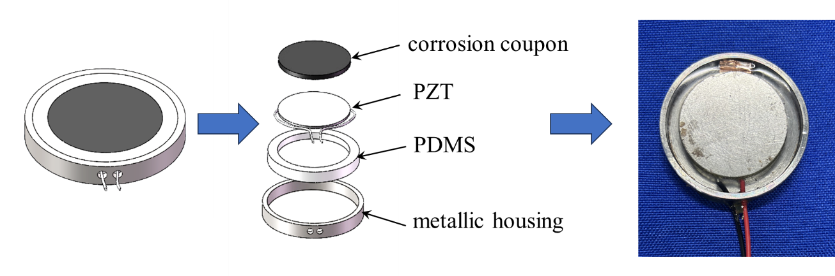

**Figure 5.** The packaging sensor assembly model and corrosion sensor.

* 1. **The corrosion monitoring test of the steel plate**

To validate the monitoring performance of the packaging corrosion sensor under practical conditions, an accelerated corrosion test was designed and conducted on steel plates. A rectangular Q235 steel plate (15×10 cm) served as the host structure, with the packaging sensor firmly attached to its surface using magnetic fixtures. This installation method ensured reliable electrical contact between the metal housing and the steel plate, guaranteeing that the metal corrosion coupon would experience identical electrochemical corrosion conditions as the host plate during the corrosion process.

The test was performed in a standard salt spray chamber under controlled conditions. A 5% NaCl solution was used as the corrosive medium, continuously atomized through a spray system to simulate marine atmospheric conditions. The ambient temperature was maintained constant throughout the experiment. To track corrosion progression, impedance measurements were conducted at 24-hour intervals for five consecutive days. The specimen was first cleaned to remove surface corrosion products, after which the electromechanical impedance characteristics were measured using an impedance analyzer across a frequency range of 20-50 kHz with a 20 Hz step size. The experimental setup and measurement protocol are illustrated in Figure 6. This accelerated corrosion testing protocol provides an effective means to evaluate the sensor's monitoring capability in realistic corrosion environments.

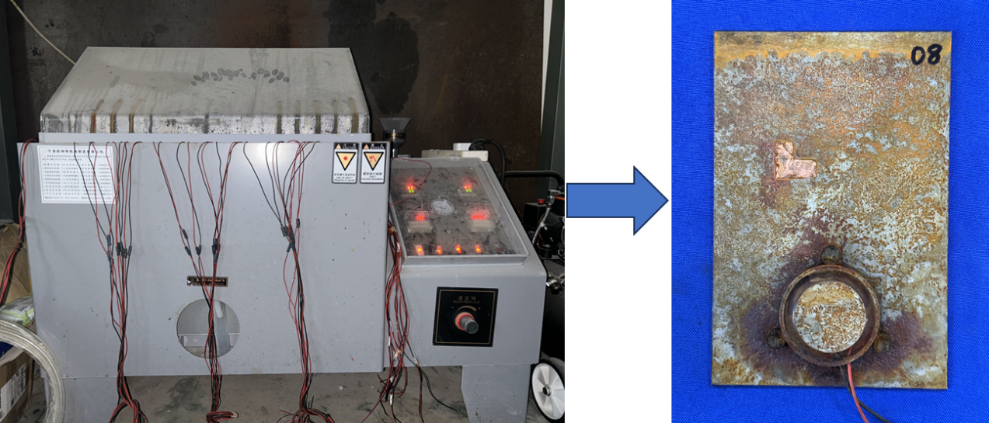

**Figure 6.** Accelerated corrosion test for steel plate corrosion monitoring.

1. **Wireless impedance monitoring** **system and engineering applications**
   1. **Wireless impedance monitoring system and system integration**

To bridge the gap between laboratory research and practical applications in structural corrosion monitoring, addressing critical challenges including long-distance operation, long-term stability, and real-time monitoring, this study innovatively developed a Wireless impedance monitoring system (WIMS) based on the AD5933 impedance chip. The system features a modular design comprising five functional units, as shown in Figure 7.

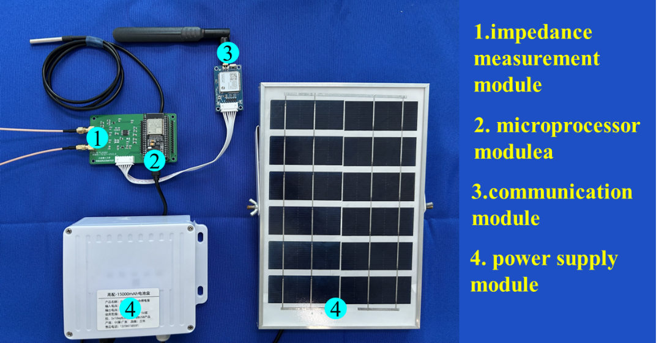

**Figure 7.** Wireless impedance monitoring system prototype.

The core impedance measurement module incorporates Analog Devices' high-precision AD5933 chip, capable of generating frequency-sweep excitation signals from 1 kHz to 100 kHz and performing impedance measurements within a 100 Ω to 10 MΩ range. The integrated Discrete Fourier Transform (DFT) processor enables real-time acquisition and storage of impedance real and imaginary components in registers. For intelligent control, the system employs an ESP32-WROOM-32 development board as the microprocessor, which communicates with the AD5933 via I2C bus to execute measurement control, data processing, and storage tasks. The communication subsystem utilizes a Air724UG 4G module for remote data transmission, interfacing with the main control unit through UART. The power supply system combines solar energy with high-capacity power banks to ensure continuous operation under harsh weather conditions. Monitoring data is transmitted in real-time to a cloud-based IoT platform, where professional algorithms perform analysis to enable intelligent assessment and early warning of structural corrosion conditions. This system provides a reliable technical solution for long-term structural health monitoring.

* 1. **Sensitivity study of the WIMS for the packaging sensors**

To validate the WIMS's performance, five packaged corrosion sensor samples with varying thicknesses were prepared. Each sensor consisted of a 30 mm diameter, 1 mm thick piezoelectric patch coupled with metal corrosion coupons of identical diameter but different thicknesses (1.0, 1.5, 2.0, 2.5, and 3.0 mm), packaging following the method described in Section 3.4. During testing, the WIMS was configured to scan frequencies from 10 kHz to 35 kHz with 50 Hz increments, performing 500 measurement points. By analyzing the obtained conductance spectra, the characteristic frequency of the first bending mode was extracted to establish a quantitative relationship between frequency and metal corrosion coupon thickness, providing data support for practical engineering applications. The five packaged sensors with different thicknesses are shown in Figure 8.

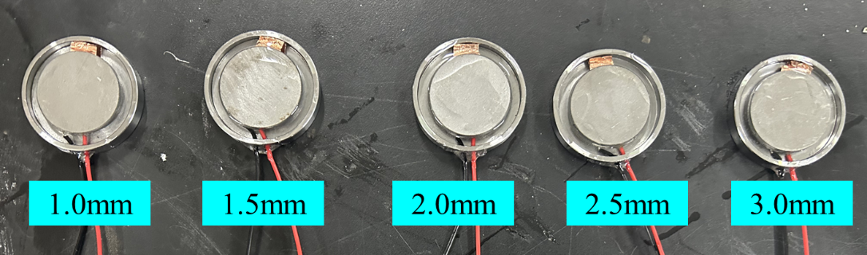

**Figure 8.** The five packaging sensors with different thicknesses.

* 1. **Field application in transmission tower monitoring**

The developed WIMS was successfully deployed for monitoring critical components of a scaled transmission tower model. The field implementation involved installing packaging corrosion sensors within specially designed plastic protective casings, which were securely mounted on the tower's angle steel using magnetic attachments to establish reliable electrical contact between sensor housings and steel structures. During operation, piezoelectric impedance signals were periodically collected and first bending mode peak frequencies were extracted, enabling real-time assessment of angle steel corrosion conditions.

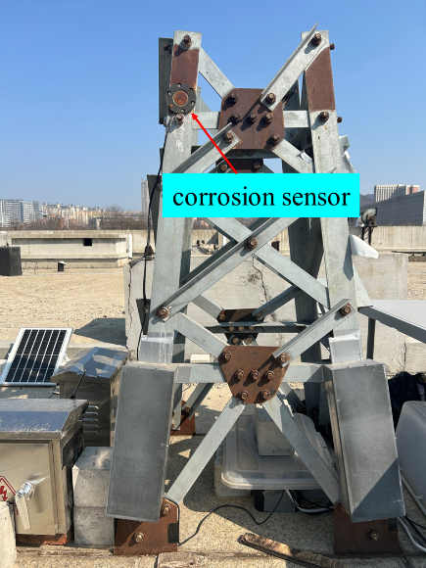

**Figure 9.** Field application diagram.

1. **Results and Discussion**
   1. **Thickness sensitivity analysis of the corrosion sensor**

Table 1 presents a comparative analysis of the first two bending mode peak frequencies obtained from experimental tests and finite element simulations. As illustrated in Figures 10 and 11, both the conductance spectrum test data and peak frequency-thickness fitting curves demonstrate a consistent pattern. As the metal corrosion coupon thickness decreases (indicating increased corrosion severity), the peak frequencies of both the first (Mode 1) and second (Mode 2) bending modes exhibit a systematic downward trend. All test cases achieved excellent fitting goodness (R² > 0.99), confirming a strong linear correlation between corrosion severity and frequency response. The discrepancy between experimental and simulated results remained within an acceptable range of 0-13.4%, demonstrating remarkable consistency and validating the reliability of the testing methodology. Notably, the slope of the fitting curves directly reflects the detection sensitivity of the sensor.

**Table 1.** Comparison of experimental and finite element simulation values.

|  |  |  |  |  |  |  |  |  |
| --- | --- | --- | --- | --- | --- | --- | --- | --- |
| Thickness | first-order peak frequency(kHz) | | | | second-order peak frequency(kHz) | | | |
| Experimental values | Finite element analysis values | Error | Experimental values | | Finite element analysis values | Error |
| 3.0mm | 28.2 | 28.2 | 0.00% | 99.8 | | 103.2 | 3.41% |
| 2.5mm | 24.2 | 24.2 | 0.00% | 90.4 | | 91.8 | 1.55% |
| 2.0mm | 20.2 | 20.0 | 0.99% | 76.0 | | 79.0 | 3.95% |
| 1.5mm | 16.0 | 15.8 | 1.25% | 61.0 | | 64.4 | 5.57% |
| 1.0mm | 13.4 | 11.6 | 13.4% | 51.8 | | 48.6 | 6.18% |



(a) Conductance spectra (b) Peak frequency versus thickness

**Figure 10.** Experimental results of EMI response under different thickness.



(a) Conductance spectra (b) Peak frequency versus thickness

**Figure 11.** Finite element simulations results of EMI response under different thickness.

* 1. **Accelerated corrosion test results for steel plate corrosion monitoring**

Table 2 summarizes the variations in peak frequencies for the first bending modes during the 5-day accelerated corrosion test. Figure 12 clearly shows that the characteristic frequencies in the conductance spectra decrease progressively with increasing corrosion duration, maintaining an excellent linear relationship with corrosion progression. This observed trend perfectly aligns with the thickness-dependent frequency behavior predicted by prior finite element simulations, conclusively demonstrating the sensor's feasibility for quantitative corrosion monitoring in steel structures. The test data reveal a well-defined correspondence between characteristic frequency response and corrosion development, providing a solid foundation for engineering applications.

**Table 2.** The peak frequencies of the first bending modes.

|  |  |
| --- | --- |
| Days of corrosion | first-order resonant frequency(kHz) |
| 1 | 29.5 |
| 2 | 29.4 |
| 3 | 29.3 |
| 4 | 29.2 |
| 5 | 29.0 |



(a) Conductance spectra (b) Peak frequency versus days of corrosion

**Figure 12.** Accelerated corrosion test results of EMI response under different days of corrosion.

* 1. **Sensitivity analysis of packaging sensors using WIMS**

The WIMS was employed to conduct impedance tests on packaging sensors with varying thicknesses, yielding the conductance spectra and frequency-thickness relationship curves presented in Figure 13. The test results confirm that as the metal corrosion coupon thickness decreases (indicating more severe corrosion), the characteristic frequency of the sensor's first bending mode decreases systematically, with linear fitting goodness exceeding R² > 0.99. These findings not only reaffirm the excellent linear response relationship between sensor output signals and corrosion severity, but also validate the reliable performance of the WIMS in practical applications. Throughout the testing process, the system maintained stable operation and accurate data acquisition, demonstrating significant potential for engineering corrosion monitoring applications.



(a) Conductance spectra (b) Peak frequency versus thickness

**Figure 13.** WIMS test results of EMI response under different thickness.

* 1. **Engineering application analysis of WIMS**

The WIMS successfully conducted 100-day continuous corrosion monitoring of transmission tower angle steel, with periodic measurements of piezoelectric impedance signals. As shown in Figure 14, the conductance spectra and temporal variation curves of peak frequencies reveal a decreasing trend in the first bending mode peak frequency with increasing corrosion duration. The sensor demonstrates effective detection capability for corrosion initiation and reliable tracking of steel plate corrosion progression, confirming its practical utility in long-term structural health monitoring.



**Figure 14.** The conductance spectrum and peak frequency variation curve.

1. **Conclusions**

This study proposes an intelligent monitoring system solution based on electromechanical impedance technology (EMI) to address practical needs in engineering structural corrosion monitoring. Through an integrated approach combining theoretical analysis, numerical simulation, and experimental validation, systematic investigations were conducted on the monitoring mechanism, engineering applicability, and wireless monitoring technology of corrosion sensors, yielding several innovative research achievements. The main conclusions are summarized as follows:

(1) An innovative smart corrosion sensor was developed. Both experimental studies and finite element analysis confirmed that the first and second bending mode peak frequencies of the sensor exhibit excellent linear correlation (R² > 0.99) with the metal corrosion coupon thickness, enabling quantitative corrosion monitoring.

(2) Critical technical challenge including sensor packaging protection were successfully addressed for practical engineering applications. Accelerated corrosion test data demonstrated that the characteristic frequency of the sensor varies systematically with corrosion progression (R² > 0.97), verifying its reliability for steel structure corrosion monitoring.

(3) A wireless impedance monitoring system (WIMS) based on IoT technology was successfully developed, achieving remote online monitoring capability through engineered encapsulation design. System tests confirmed its accurate identification of sensor characteristic frequency variations and excellent corrosion monitoring sensitivity.

Through multidisciplinary innovation, this study has established a complete technical system encompassing sensing mechanism, engineering application, and monitoring system. The proposed intelligent monitoring solution offers advantages of quantitative accuracy, sensitive response, and remote transmission capability, providing a novel technical approach for engineering structural corrosion monitoring. Future research will focus on optimizing the system's long-term stability in complex environments and expanding its applications in health monitoring of critical infrastructure.

**Reference**

[1] KANIA H. Corrosion and Anticorrosion of Alloys/Metals: The Important Global Issue [J]. Coatings, 2023, 13(2).

[2] TONG K, BAI X L, FAN Z H, et al. Analysis and investigation of the leakage failure on the shale gas gathering and transmission pipeline [J]. Engineering Failure Analysis, 2022, 140.

[3] CASCINI L, PORTIOLI F, LANDOLFO R. Probabilistic Time Variant Assessment of Thin-Walled Steel Members under Atmospheric Corrosion Attack [J]. Journal of Civil Engineering and Management, 2014, 20(3): 404-14.

[4] LI Y, HU D, XU Y, et al. Study on the mechanical behavior of corroded bridge steel based on the entire process of tensile failure [J]. Materials Research Express, 2025, 12(1).

[5] MAO H Y, FU J C, ZHANG H X, et al. STUDY ON CHARACTERIZING FOR CORROSION DEGREES OF 1045 STEEL WITH NONLINEAR ULTRASONIC COEFFICIENTS [J]. Materials Evaluation, 2023, 81(10): 46-55.

[6] FARIN M, MOULIN E, CHEHAMI L, et al. Monitoring saltwater corrosion of steel using ultrasonic coda wave interferometry with temperature control [J]. Ultrasonics, 2022, 124.

[7] JALALI H, RIZZO P. Highly nonlinear solitary waves for the detection of localized corrosion [J]. Smart Materials and Structures, 2020, 29(8).

[8] XIA D-H, DENG C-M, MACDONALD D, et al. Electrochemical measurements used for assessment of corrosion and protection of metallic materials in the field: A critical review [J]. Journal of Materials Science & Technology, 2022, 112: 151-83.

[9] NAZ M Y, SULAIMAN S A, SHUKRULLAH S, et al. Development of erosion-corrosion mechanisms for the study of steel surface behavior in a sand slurry [J]. Measurement, 2017, 106: 203-10.

[10] ALEXANDER C L, ORAZEM M E. Indirect electrochemical impedance spectroscopy for corrosion detection in external post-tensioned tendons: 1. Proof of concept [J]. Corrosion Science, 2020, 164.

[11] LUO D, LI Y, LIM K-S, et al. Development of Fe-C film coated polymer optical fiber sensor for steel bar corrosion monitoring [J]. Measurement, 2023, 210.

[12] PEREIRA L, SOUSA I, MESQUITA E, et al. FBG-Based Accelerometer for Buried Pipeline Natural Frequency Monitoring and Corrosion Detection [J]. Buildings, 2024, 14(2).

[13] ANGELOPOULOS N, KAPPATOS V. An Experimental Assessment Using Acoustic Emission Sensors to Effectively Detect Surface Deterioration on Steel Plates [J]. Sensors, 2024, 24(19).

[14] MAY Z, ALAM M K, NAYAN N A, et al. Acoustic emission corrosion feature extraction and severity prediction using hybrid wavelet packet transform and linear support vector classifier [J]. Plos One, 2021, 16(12).

[15] CHA Y J, CHOI W, SUH G, et al. Autonomous Structural Visual Inspection Using Region‐Based Deep Learning for Detecting Multiple Damage Types [J]. Computer-Aided Civil and Infrastructure Engineering, 2017, 33(9): 731-47.

[16] HUANG X, DUAN Z, HAO S, et al. A Deep Learning Framework for Corrosion Assessment of Steel Structures Using Inception v3 Model [J]. Buildings, 2025, 15(4).

[17] HAN Q, ZHAO N, XU J. Recognition and location of steel structure surface corrosion based on unmanned aerial vehicle images [J]. Journal of Civil Structural Health Monitoring, 2021, 11(5): 1375-92.

[18] GAO J. Accurate Detection Method of Corrosion State of Steel Structure Bridge in Internet of Things Environment Based on Visual Image Characteristics [J]. Journal of Testing and Evaluation, 2024, 52(3): 1351-62.

[19] LI G, LUO M, HUANG J, et al. Early-age concrete strength monitoring using smart aggregate based on electromechanical impedance and machine learning [J]. Mechanical Systems and Signal Processing, 2023, 186.

[20] PAN H H, HUANG M-W. Piezoelectric cement sensor-based electromechanical impedance technique for the strength monitoring of cement mortar [J]. Construction and Building Materials, 2020, 254.

[21] AI D, DU L, LI H, et al. Corrosion damage identification for reinforced concrete beam using embedded piezoelectric transducer: Numerical simulation [J]. Measurement, 2022, 192.

[22] HOSHYARMANESH H, GHODSI M, KIM M, et al. Temperature Effects on Electromechanical Response of Deposited Piezoelectric Sensors Used in Structural Health Monitoring of Aerospace Structures [J]. Sensors, 2019, 19(12).

[23] HOSHYARMANESH H, ABBASI A. Structural health monitoring of rotary aerospace structures based on electromechanical impedance of integrated piezoelectric transducers [J]. Journal of Intelligent Material Systems and Structures, 2018, 29(9): 1799-817.

[24] PAVELKO I. On the strength of the piezoceramic transducer in the system of structural health monitoring [J]. Journal of Physics: Conference Series, 2024, 2692(1).

[25] KAUR N, GOYAL S, ANAND K, et al. A cost-effective approach for assessment of pre-stressing force in bridges using piezoelectric transducers [J]. Measurement, 2021, 168.

[26] ESMAEEL A, AHMED K I E, FATHEL-BAB A M R. Determination of damping coefficient of soft tissues using piezoelectric transducer [J]. Biomedical Microdevices, 2021, 23(2).

[27] NA W S. Bolt loosening detection using impedance based non-destructive method and probabilistic neural network technique with minimal training data [J]. Engineering Structures, 2021, 226.

[28] WU J, CHEN Y, WANG J, et al. Electromechanical Impedance Instrumented Wearable Piezoelectric Ring-Type Sensor for Bolted Connection Monitoring [J]. IEEE Sensors Journal, 2023, 23(13): 14872-81.

[29] WEI Y G, LIANG Y X, QI K L, et al. Exploring the application of piezoelectric ceramics in bone regeneration [J]. Journal of Biomaterials Applications, 2024, 39(5): 409-20.

[30] TALAKOKULA V, BHALLA S, GUPTA A. Corrosion assessment of reinforced concrete structures based on equivalent structural parameters using electro-mechanical impedance technique [J]. Journal of Intelligent Material Systems and Structures, 2014, 25(4): 484-500.

[31] AI D, ZHU H, LUO H, et al. An effective electromechanical impedance technique for steel structural health monitoring [J]. Construction and Building Materials, 2014, 73: 97-104.

[32] ZHU H, LUO H, AI D, et al. Mechanical impedance-based technique for steel structural corrosion damage detection [J]. Measurement, 2016, 88: 353-9.

[33] NA W S. Possibility of detecting wall thickness loss using a PZT based structural health monitoring method for metal based pipeline facilities [J]. NDT & E International, 2017, 88: 42-50.

[34] LIU Y, FENG X. Monitoring corrosion-induced thickness loss of stainless steel plates using the electromechanical impedance technique [J]. Measurement Science and Technology, 2021, 32(2).

[35] THORIYA A, VORA T, MAKWANA V. Corrosion assessment in rebars of high-strength concrete using electromechanical impedance technique [J]. Materials Today: Proceedings, 2022, 57: 2234-41.

[36] MORWAL T, BANSAL T, AZAM A, et al. Exploring chloride-induced corrosion in reinforced concrete structures through embedded piezo sensor technology: an experimental and numerical study [J]. Smart Materials and Structures, 2024, 33(3).

[37] LIANG C, SUN F P, ROGERS C A. AN IMPEDANCE METHOD FOR DYNAMIC ANALYSIS OF ACTIVE MATERIAL SYSTEMS [J]. Journal of Vibration and Acoustics-Transactions of the Asme, 1994, 116(1): 120-8.

[38] LI W, WANG J, LIU T, et al. Electromechanical impedance instrumented circular piezoelectric-metal transducer for corrosion monitoring: modeling and validation [J]. Smart Materials and Structures, 2020, 29(3).

[39] LU B, LI W, LIU Z, et al. Corrosion monitoring for transmission line based on electromechanical impedance instrumented circular piezoelectric corrosion sensor [J]. Sensors and Actuators A: Physical, 2024, 378.