A versatile semi-analytical micromechanical model for elasticity of cementitious composites

Amit Kumar1 [0000-0003-0977-0741] and Shashank Bishnoi1[0000-0002-2183-2530]

1Department of Civil Engineering, Indian Institute of Technology, Delhi, India

[amit.kumar@civil.iitd.ac.in](mailto:amit.kumar@civil.iitd.ac.in)

**Abstract.** Elastic modulus of cementitious composites is an important parameter in the design and performance of concrete structures. Its precise estimation remains a challenge due to variable composition of cement pastes. Micromechanical models, based on Eshelby theory provide an effective alternative to predict the same for different types of binders and different water-cement ratios. They utilize the intrinsic morphological and constitutive properties of the paste constituents and the physics of their interaction to offer more generic applicability. However, the published literature offers the model application to a specific range of porosities and aspect ratios. Furthermore, comprehensive solution algorithms for such models are hardly encountered. Therefore, the proposed model, prepared in MATLAB, offers a detailed and versatile algorithm to estimate elastic moduli of heterogenous cementitious composites through multiscale micromechanics. The model can be utilized for a wide range of water-binder ratios and binder types and demonstrates excellent agreement with experiments and numerical simulations in existing literature.

**Keywords:** micromechanics, multiscale modelling, homogenization.

* 1. Introduction

Composites have been very popular materials due to their diverse engineering properties. Consequently, it is essential to assess their effective properties, including stiffness and effective permeability. Multiscale mean-field homogenisation approaches, based on Representative Element Volume (RVE) obeying the law of separation of scales [1], are useful for determining these effective properties. They are based on the well-established Eshelby theory [2], which estimates the effective stiffness of a matrix inclusion morphology as given in **equation 1.**

|  |  |  |
| --- | --- | --- |
|  |  | *1* |

where, 𝕃0and𝕃r are the fourth-order stiffness tensor of the matrix and the *rth* inhomogeneity, respectively, and *cr &*𝔸*r* are the volume fractions and fourth-order global strain concentration tensors, respectively. 𝔸*r* relates the strain in the *rth* inclusion to the overall strain applied on the boundary of the composite. It depends on the scenario of interaction between the heterogeneities. If the concentration of heterogeneities in the RVE is less, methods like Mori-Tanaka (MT)[3] are used for homogenization. However, if the concentration increases more than 50% of the volume of RVE, a Self-consistent Scheme (SCS)[4] is required which essentially assumes that each inclusion is interacting with the equivalent material. This results in implicit formulations. Closed-form expressions for in such composites exist for spherical constituents only. However, several composites may contain non-spherical heterogeneities orientated randomly in space. Such systems are complex to solve and have been a topic of research for many years [5], [6] . For instance, analytical approximation employing truncated series expansions as demonstrated by [7] offer closed-form expressions without iterative calculations. Generic expressions for cylindrical crystals and all porosity ranges have been used in [6] based on intelligently choosing 15 combinations of the orientation angles, as suggested in [8]. However, the rationale for selecting those specific combinations has not been adequately elucidated. The absence of thorough representations of theoretical frameworks in the published literature may necessitate their treatment as "black boxes".



This study fills this literature gap by introducing a comprehensive iterative method for calculating self-consistent estimates of binary composites with isotropic distributions of non-spherical inclusions. This may help in easy understanding and tailoring of the SCS estimates of composites with the desired precision.

* 1. Methodology

The equivalent properties of a binary composite using orientational averaging in SCS can be expressed using equation **2**:

|  |  |
| --- | --- |
|  | *2* |

Where, ℙ and are 𝕊 called the Hill polarization tensor and Eshelby tensors for the inclusion respectively. is the fourth order identity matrix. All the remaining symbols have their usual meaning. ℙ and 𝕊 are calculated based on Poisson’s ratio of the effective stiffness of the composite. The angles in the argument refer to the orientation of a particular inclusion in the special coordinate system as illustrated in figure 1.



It is noteworthy that all the equations are written in compact Einstein notation as standard practice in continuum mechanics. The solution of **equation 2** requires an iterative approach as the equivalent stiffness 𝕃 appears on both sides of the equation. The initial value of 𝕃*scs* may be chosen as either Voigt or Reuss bound value. The iterative form of equation 2 is expressed in equation 3.



Practically, depending on the number of values of the angular intervals *dθ,dϕ* and *dψ*, the obtained stiffness tensor 𝕃*scs* for (*i+1*)*th* after exact iteration may not be perfectively isotropic. Thus, it becomes confusing to choose Poisson’s ratio of the effective stiffness for calculation of Hill and Eshelby tensors for the next iteration. A nearest isotropic tensor to this anisotropic tensor can be utilised for this purpose [9], [10], [11], [12]**.**

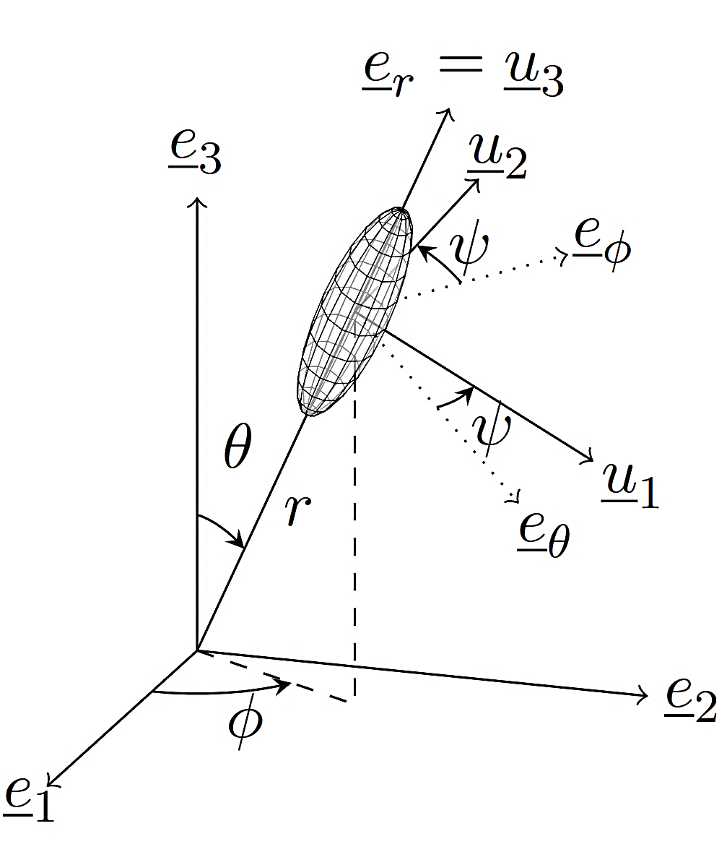

**Fig. 1.** Orientation of a given crystal characterized by the three Euler angles θ,ϕ and ψ ; the angles which the inclusion’s frame (u1, u2, u3) make with the reference frame (e1, e2, e3) [5]



**Figure 1:**

|  |  |
| --- | --- |
|  | *3* |

These methods are based on minimising the distance between the original anisotropic tensor (say 𝔸 and the calculated nearest isotropic tensor (say 𝔹), as shown in equation 4.



|  |  |
| --- | --- |
|  | *4* |
| Where is defined as |  |

A critical calculation in the above system is the evaluation of integrals of equation 3 in each step. A 3-dimensional trapezoidal rule can be employed for this purpose. The entire volume of the integration domain may be divided into small cubical regions called voxels. Values of the functions may be evaluated at the centre of each voxel and then multiplied by the corresponding voxel’s volume. Notably, the value of the function at the centre may be calculated as a weighted average of its values at the 8 corners of the voxels.

The conversion of tensors in spherical coordinate system is simplified using Stroh formalism[13] which can convert the 3x3 sized rotation tensors to 6x6 size thus making conversion of tensors to spherical coordination faster. The equation for spherical coordinates then reduces to equation *5*.

|  |  |  |
| --- | --- | --- |
|  |  | *5* |

Where ***K*** is the 6x6 rotation tensor obtained using Stroh formalism.

The complete flowchart of the process is given in figure 2.

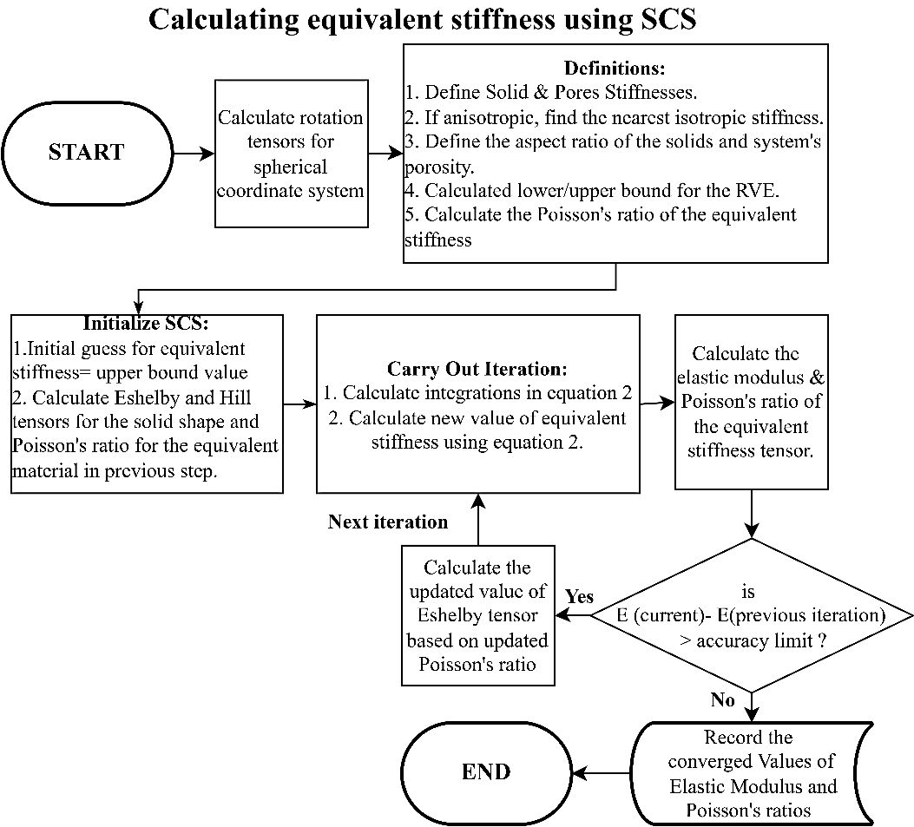

**Fig. 1.** Flowchart of the model

* 1. Application to Cementitious composites

Composites where cement is used as the binder are called cementitious composites and contain multiscale heterogeneities. Concrete is such a composite which contain stone aggregates and mortar as heterogeneities at the macroscale. Further the apparently homogeneous mortar is also heterogeneous at a lower scale of observation where it contains sand particle embedded a matrix of cement paste. Similarly, cement paste is composed of different hydrates and pores which make it heterogeneous at a further lower scale. This hierarchical multi-scale structure is shown in **figure 3**.

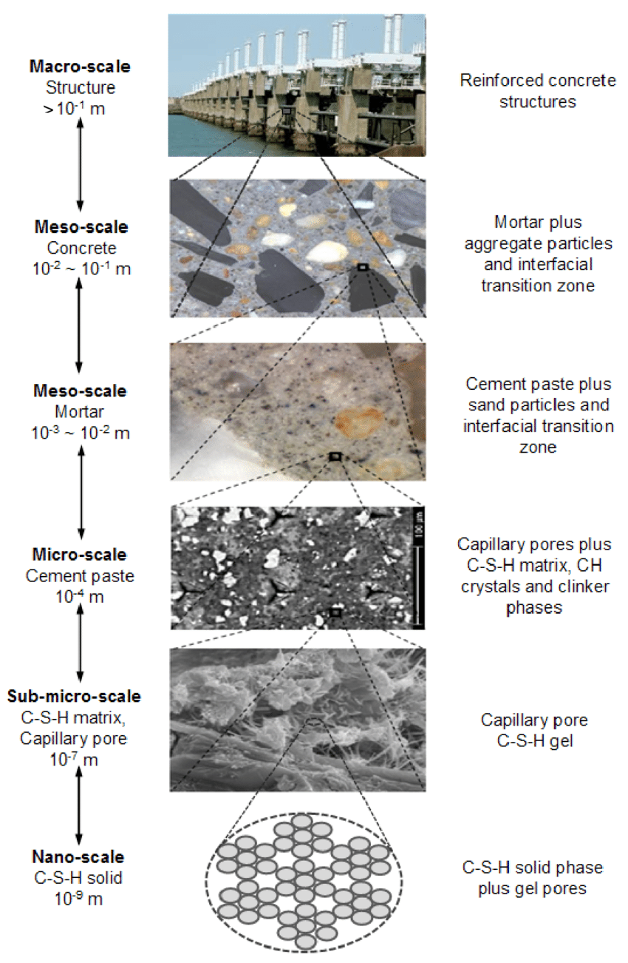

**Fig. 1.** Multiscale heterogeneity in concrete

Homogenisation for the lowest scale i.e. Calcium-Silicate-Hydrate (C-S-H) gel is illustrated in the next subsection. Elastic moduli at different scales shown in the figure may be easily obtained using suitable homogenisation schemes with orientational averaging at each scale.

1. Elastic modulus of C-S-H gels

C-S-H gels are binary composites of C-S-H solids and gel-pores. Although the solids and pores can have different sizes and morphologies, the gel may be idealised as a homogeneous composition of solids and pores of uniform shapes. Their modelling using mean-field homogenisation schemes has the advantage to avoid the influence of the sizes of pores and the solids. This is because the homogenisation approach is based on Eshelby theory which suggests that the overall property of the composite is independent of the sizes of the heterogeneities and is dependent only on the shapes of the heterogeneities and their constituent properties. Since, C-S-H solids have layered flat morphology, they are modelled as oblates and pores are modelled as spheres. Literature suggests two types of C-S-H gels; Low Density (LD) and High Density (HD) CSH gels with gel porosity 37% and 24% respectively[14]. Their microstructures can be modeled with oblates with aspect ratios of 0.033 and 0.24, respectively, for LD and HD C-S-H [7].

* 1. Model Output and Validation

The output of the model is validated against the experimental data of nano-indentation on C-S-H gels, reported in literature and is shown in **figure 4**. The experimental elastic moduli of LD and HD C-S-H gels are obtained by deconvolution of the indentation results. Cleary the model has good correlations with the experimental values[15]. Thus, the model appears to be useful for application of orientational averaging and isotropy approximations to cementitious composites. The stiffness of other layers may be obtained in a similar manner using appropriate homogenization schemes.

|  |  |
| --- | --- |
|  |  |

**Fig. 2.** Model validation for C-S-H gels with oblate-shaped solids

* 1. Conclusions and future directions

The presented model for appears to be efficient and versatile for applying SCS on cementitious composites with isotropically oriented constituents. It suggests that the method of finding the nearest isotropic tensor can be successfully applied to find equivalent isotropic stiffness tensors. It can be an easy and comprehensive solution to polycrystals with spheroidal constituents of a wide range of aspect ratios and volume fractions. It may serve its users to customize the different parameters of calculations easily and quantify their individual effects. However, exploring the detailed reasoning of the correlation between the nearest isotropic tensor and isotropic orientational averaging would be interesting. This may help to find better approximations of the calculated stiffness tensor in each iteration. Further, porous polycrystals with Penny-shaped and cylinder-shaped solids having extreme aspect ratios were not explored in the study. They will be explored in future works in this direction.

References

[1] A. Zaoui, “Continuum Micromechanics: Survey,” *J. Eng. Mech.*, vol. 128, no. 8, pp. 808–816, Aug. 2002, doi: 10.1061/(ASCE)0733-9399(2002)128:8(808).

[2] J. D. Eshelby, “The Determination of the Elastic Field of an Ellipsoidal Inclusion, and Related Problems,” *JSTOR*, 1957, [Online]. Available: https://www.jstor.org/stable/100095

[3] T. Mori and K. Tanaka, “Average stress in matrix and average elastic energy of materials with misfitting inclusions,” *Acta Metallurgica*, vol. 21, no. 5, pp. 571–574, May 1973, doi: 10.1016/0001-6160(73)90064-3.

[4] R. Hill, “A self-consistent mechanics of composite materials,” *Journal of the Mechanics and Physics of Solids*, vol. 13, no. 4, pp. 213–222, Aug. 1965, doi: 10.1016/0022-5096(65)90010-4.

[5] J. Sanahuja, L. Dormieux, S. Meille, C. Hellmich, and A. Fritsch, “Micromechanical Explanation of Elasticity and Strength of Gypsum: From Elongated Anisotropic Crystals to Isotropic Porous Polycrystals,” *J. Eng. Mech.*, vol. 136, no. 2, pp. 239–253, Feb. 2010, doi: 10.1061/(ASCE)EM.1943-7889.0000072.

[6] B. Pichler, C. Hellmich, and J. Eberhardsteiner, “Spherical and acicular representation of hydrates in a micromechanical model for cement paste: prediction of early-age elasticity and strength,” *Acta Mech*, vol. 203, no. 3–4, pp. 137–162, Mar. 2009, doi: 10.1007/s00707-008-0007-9.

[7] J. Sanahuja and L. Dormieux, “Creep of a C-S-H gel: a micromechanical approach,” *An. Acad. Bras. Ciênc.*, vol. 82, no. 1, pp. 25–41, Mar. 2010, doi: 10.1590/S0001-37652010000100004.

[8] A. H. Stroud, “APPROXIMATE CALCULATION OF MULTIPLE INTEGRALS,” *Prentice-Hall, Inc*, 1971.

[9] J. T. Browaeys and S. Chevrot, “Decomposition of the elastic tensor and geophysical applications,” *Geophysical Journal International*, vol. 159, no. 2, pp. 667–678, Nov. 2004, doi: 10.1111/j.1365-246X.2004.02415.x.

[10] F. Cavallini, “The best isotropic approximation of an anisotropic Hooke’s law,” 1999.

[11] E. Fjær, R. M. Holt, and J. S. Rathore, Eds., *Seismic Anisotropy*. Society of Exploration Geophysicists, 1996. doi: 10.1190/1.9781560802693.

[12] D. C. Gazis, I. Tadjbakhsh, and R. A. Toupin, “The elastic tensor of given symmetry nearest to an anisotropic elastic tensor,” *Acta Cryst*, vol. 16, no. 9, pp. 917–922, Sep. 1963, doi: 10.1107/S0365110X63002449.

[13] A. N. Stroh, “Dislocations and Cracks in Anisotropic Elasticity,” *Philosophical Magazine*, vol. 3, no. 30, pp. 625–646, Jun. 1958, doi: 10.1080/14786435808565804.

[14] H. M. Jennings, “A model for the microstructure of calcium silicate hydrate in cement paste,” *Cement and Concrete Research*, vol. 30, no. 1, pp. 101–116, Jan. 2000, doi: 10.1016/S0008-8846(99)00209-4.

[15] G. Constantinides and F.-J. Ulm, “The effect of two types of C-S-H on the elasticity of cement-based materials: Results from nanoindentation and micromechanical modeling,” *Cement and Concrete Research*, vol. 34, no. 1, pp. 67–80, Jan. 2004, doi: 10.1016/S0008-8846(03)00230-8.