**ML-assisted Grid Refinement of Layered Voronoi-cell Lattice Models for Limit Analysis of Concrete Structures**

Qiwei Zhang1, Alessandro Fascetti2, and John Bolander1

1 University of California, Davis, CA 95616, USA

2 University of Pittsburg, Pittsburg, PA, USA  
jebolander@ucdavis.edu

**Abstract.** This research utilizes a layered Voronoi-cell lattice model (L-VCLM), which is based on a two-dimensional discretization of the planar or thin-walled concrete structure. Similar to layered finite element approaches, kinematic constraints are used to model elasticity and the development of material nonlinearity in the wall thickness direction. The discrete nature of the L-VCLM has advantages in simulating localized phenomena, such as cracking or yield line formation. Whereas the L-VCLM is elastically uniform under in-plane loading, it exhibits spurious heterogeneity under flexural loading. However, such errors disappear with grid refinement. This suggests adaptive grid refinement as a means for modeling nonlinear behavior in large systems, which is the main topic of this research. The process of adaptive refinement is first developed for one-way structural elements and then generalized for planar systems. Plastic limit analyses are conducted, as an intermediate step toward fracture analyses. The process begins with coarse-grid simulations of one or more structural members. Grid refinement is assisted through k-means clustering of the yield events within the discrete network(s). Accuracy of the adaptive L-VCLM is assessed through benchmark comparisons with theoretical results.

**Keywords:** Reinforced concrete, discrete model, thin-walled members.

1. Introduction

Planar or thin-walled elements of structural concrete are ubiquitous within the civil infrastructure. Common examples include shear walls and floor slabs in building construction and, more recently, elements produced via additive manufacturing [4]. The analyses of such structural elements for out-of-plane loading is challenging, due to the needs for capturing the distribution of damage in the plane and through the thin wall dimension. Three-dimensional models are apt for this purpose, but are computationally expensive, to the extent that analyses are limited to individual or small assemblages of structural members. Layered finite element models help address concerns with computational expense, but such formulations rely on continuum representations of damage, which are problematic when considering cracking and other forms of displacement discontinuity.

Lattice models are an effective means for simulating the mechanical behavior of concrete materials and structures. They provide discrete representations of cracking, avoiding complications associated with continuum formulations [3]. Within the family of particle-based lattice models, a distinction can be made between

* morphology-based discretization schemes [5] [8], for which the particles provide either a direct or indirect representation of coarse fractions of aggregates within the concrete. In this way, salient features of the fracture process are related to material structure; and
* amorphic discretization schemes [1] [18], which have no association with material structure. The resulting models possess some of the attributes of continuum models, such as elastic uniformity, while providing a discrete representation of discontinuous phenomena, notably cracking.

Voronoi-cell lattice models (VCLM), which form the basis for the research presented herein, utilize amorphic discretization schemes. For the case of thin-walled structural members, computational expense can be reduced by

* forming a layered assembly of lattice elements, which is subject to kinematic constraints to reduce the dimensionality of problem [19]. This layered Voronoi-cell lattice model (L-VCLM) accommodates the various forms of reinforcement used within cement-based composites [19].
* adaptive grid refinement, based on a sequence of L-VCLM analyses. Grid refinement can be facilitated using cluster analysis, a form of unsupervised machine learning, as presented hereafter.

As a first step toward demonstrating the utility of the adaptive L-VCLM, plastic limit analyses are conducted for planar structures subjected to out-of-plane loading. For the basic geometries and boundary conditions considered herein, theoretical yield line patterns and limit loads are available for benchmark comparisons. These analyses provide insights into model behavior that might not be evident during structural concrete analyses, which involve additional complicating factors.

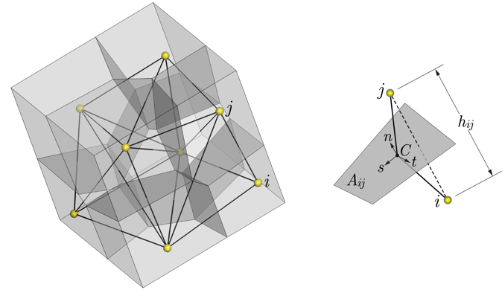

**Fig. 1.** Voronoi-cell discretization of a material volume and rigid-body-spring element *i-j*

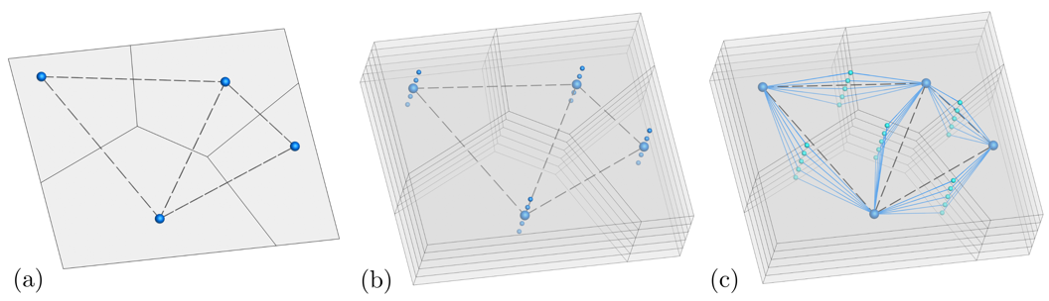

**Fig. 2.** Construction of layered VCLM: a) Voronoi partitioning of central plane; b) extrusion of nodal point set in the thickness direction; and c) modification of nodal connectivity to produce layered elements

1. Model Construction
   1. VCLM Formulation

Voronoi-cell lattice models possess features of classical lattice models used to simulate material breakdown and other physical processes [9]. In particular, two-node elements are used to discretize the material domain, as shown in Fig. 1. According to the rigid-body-spring concept of Kawai [11], each element is composed of a zero-size spring set, which connects to the nodal degrees of freedom via rigid-arm constraints. The spring set is positioned at the area centroid  of the Voronoi facet associated with nodes  and . The stiffness coefficients of the lineal springs are



where  and  are the distance between and facet area associated with nodes  and , respectively;  is Young's modulus of the bulk material; and  defines the stiffness of the tangential springs relative to that of the normal spring. Elastic uniformity of the VCLM is achieved by setting , in conjunction with an iterative scheme for realizing the Poisson effect [1].

An event-based approach is used to simulate material nonlinearity; and breaking rules are formulated in terms of vectorial measures of stress and strain. Other details regarding the VCLM formulation and several of its applications are described elsewhere [13].

* 1. **L-VCLM Configuration**

The central plane of the thin-walled structure is partitioned into Voronoi cells (Fig. 2a). Nodal points are positioned using a process of random sequential addition [17]. For each of the resulting nodes, an additional  nodes are placed in the thickness direction, uniformly spaced above and below the central plane as shown in Fig. 2b. The 3D network of nodes is tessellated, resulting in  identical horizontal layers of elements connecting through the same partitioning of the vertical facets. The connectivities of those horizontal elements are then referenced to the mid-plane nodes, which produces the desired layered elements (Fig. 2c). The extraneous nodes used for the 3D tessellation have to be removed or constrained. This can be viewed as a planar generalization of the fiber or layered discretizations of one-dimensional structural elements [2] [15].

1. Adaptive Grid Refinement

Most adaptive analysis procedures of thin-walled structures are based on elastic stress calculations. Fewer account for nonlinear material behavior [7]. Herein, the adaptive process is guided by the extent of plastic yielding within a set of preliminary models.

For a prescribed number of nominally identical structures and boundary conditions, the procedure is as follows.

1. For each of the  structures:

* The domain is discretized using uniform nodal density, without regard to potential yield lines.
* Lateral load is applied incrementally, leading to a plastic collapse mechanism.
* A spatial map of the yield events, sampled at a prescribed distance from the free surfaces, is produced.

1. A composite map of the yield events is made from the  analysis results.
2. The composite map is subjected to cluster analysis using, for example, the k-means algorithm.
3. For each identified cluster, weighted linear regression analysis is used to determine an associated yield line segment. Slope adjustments are made to ensure the segments intersect at common points.
4. Nodal density is graded according to a Gaussian distribution centered on each respective yield line segment.

The gradation of nodal point density is accomplished using



where  is a prescribed function of position within the planar domain, and  constrains the minimum distance between neighboring generator points. Using Lloyd's algorithm [6], centroidal Voronoi tessellations (CVT) are constructed for the examples that follow. Nodal points associated with support boundary conditions are excluded from the algorithmic updates.

1. **Plastic Limit Analyses**

For fracture analyses, a secant approach has been used to accommodate material softening, in accordance with an energy balance criterion to ensure objective results. The element response tends to therefore have a saw-tooth appearance, which is common to some other event-based modeling strategies. Herein, elastic-plastic behavior is simulated by a controlled stress release, while maintaining initial stiffness. The secant approach becomes problematic for elements undergoing large plastic deformation.

Grid refinement local to yield line(s) is based on yield event maps produced by coarse grid models. To facilitate results interpretation, the maps correspond to the event counts for elements within a single layer of the L-VCLM, rather than within its entire volume. With respect to the choice of layer, preliminary analyses suggest that any layer can be used for this purpose, except for those close to the neutral axis. Herein, the event maps are produced from the elements of layer 3, out of  layers. To demonstrate the procedure, two basic cases are considered: simply supported one-way and two-way slabs, for which the theoretical yield lines and corresponding limit loads are known [12].

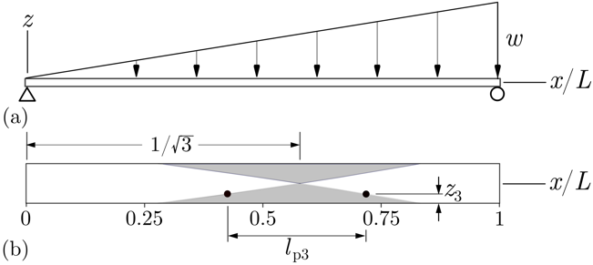

**Fig. 3.** a) Simply supported one-way slab under lateral loading; and b) asymptotic limits of plastic yielding

* 1. One-way Slab Analysis

For the triangular pressure distribution shown in Fig. 3, the maximum moment occurs at . The lateral load associated with plastic collapse is



where  is the plastic moment capacity of the cross-section. The lateral load is incrementally applied to the nodes associated with each respective Voronoi cell. The load value scales with the corresponding cell volume, multiplied by distance from the left support to obtain the triangular load distribution.

Figure 4 shows yield event maps produced from three random realizations of the slab, which has a thickness . The color scale is based on a normalized measure of yield event count



where  is the number of events for a given element and  is the maximum number of events experienced by any element within the set of  models. It can be shown that  correlates well with the magnitude of plastic strain.

Weighted least squares regression analysis of the each event map produces estimates of the yield line location, as shown in Fig. 4. Each yield indicator is weighted by its  value, such that locations with a higher event count act more prominently in position determination.

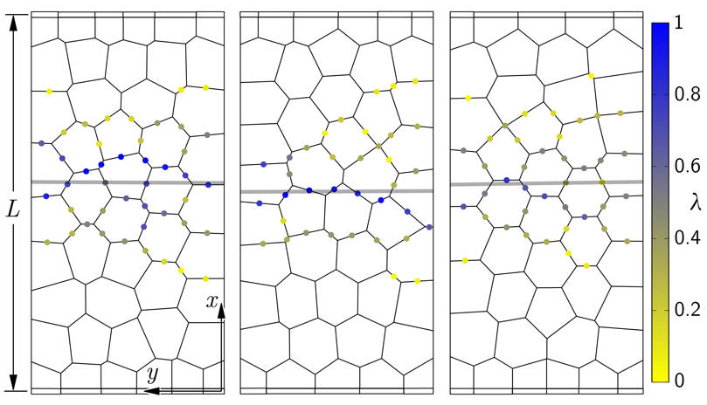

**Fig. 4.** Determination of yield line trajectory based on individual maps of yield events

The yield event sample from any one simulation is subject to variation due to the random geometry of the coarse lattice. By making a composite map from all  data sets, a presumably better estimate of the yield line trajectory can be obtained, as shown in Fig. 5a. Indeed, the segment estimated by regression analysis of the composite map agrees well with the theoretical solution. Based on a Gaussian distribution, nodal density is increased local to this yield line segment, resulting in the L-VCLM shown in Fig. 5b.

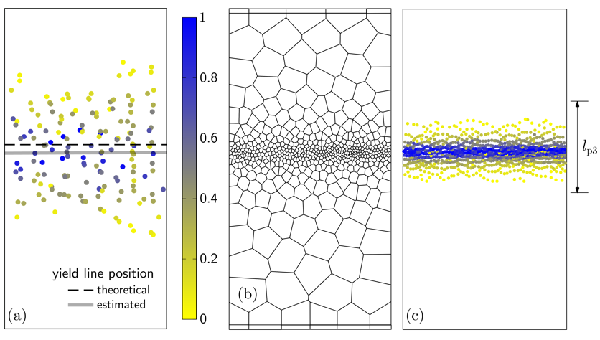

**Fig. 5.** a) Estimated yield line position based on a composite map of four sets of data from element layer 3; b) refined grid using estimated yield line position; and c) associated yield event map compared with theoretical yield zone bounds.

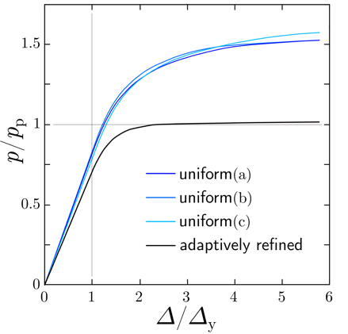

**Fig. 6.** Lateral pressure versus midspan displacement for one-way slab examples

The utility of grid refinement local to the yield line segment is evident when plotting the load versus displacement response of the slab. Figure 6 presents the relation between lateral pressure and midspan displacement for each case considered in Fig. 4, along with the adaptation shown in Fig. 5. The lateral pressure and displacement values have been normalized by the theoretical pressure, associated with the plastic limit, and the midspan displacement at yield initiation, respectively. For the coarse, uniform discretizations of the slab, the plastic limit loads are about 50% greater than the theoretical value. The overstrength is caused by the inability of the coarse grid () to accommodate flexural deformation, where ** = *h/t* is the average element aspect ratio. By refining the grid local to the yield line segment,  is reduced such that the stress field within each layer approaches membrane conditions. The plastic limit load approaches the theoretical value.

* 1. Two-way Slab Analysis

A two-way slab, with plan aspect ratio  and thickness , is simply supported along its edges. With loading into the inelastic range, yield bands form as shown in Fig. 7a. As for the one-way slab example, element yielding is presented in terms of normalized event count, . In contrast to most theoretical derivations of plastic limit load, which assume one-dimensional yield lines, plastic zone formation is a multi-dimensional process in actual structures. As previously described, plastic yielding spreads along the surfaces of the plate as the elastic core of the section allows for increased loading. Nonetheless, the simulated yield bands shown in Fig. 7a exhibit the classical yield line pattern for a rectangular slab with these boundary conditions.

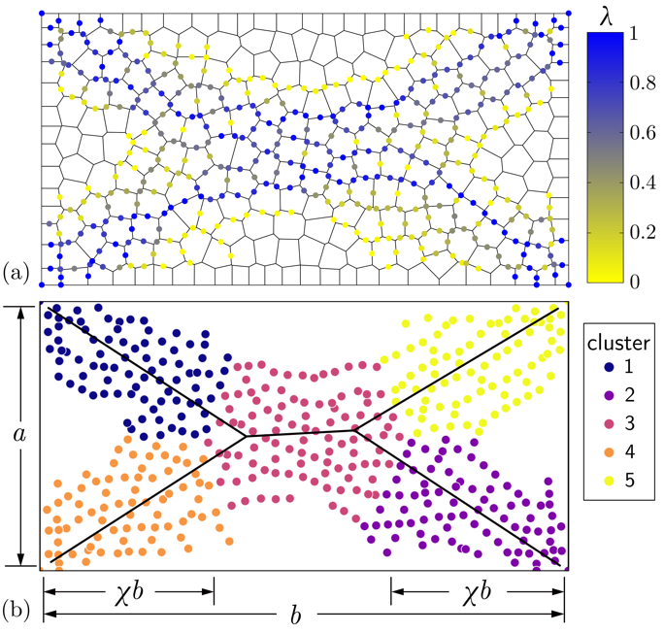

**Fig. 7.** a) Yield event pattern for two-way slab subjected to out-of-plane loading; and b) yield line segments identified through cluster analysis

As noted in Section 3, the process of adaptive refinement involves cluster analyses of the yield events. Figure 7b presents the results obtained from  structural models and a k-means algorithm [14]. In lieu of silhouette score analysis or other procedures to determine an appropriate number of clusters, the number (=5) is based on knowledge of the theoretical solution. Weighted least squares regression is used to estimate the yield line segment associated with each cluster. The regression lines were constrained to pass nearby the slab corners by introducing a heavily weighted point at each corner location. Grid refinement, as shown in Fig. 9a, is based on this estimated set of yield line segments and a map to control nodal point density (presented in Fig. 8 for this case, where  is target density and  increases density). Regions adjacent to these segments were coarsened to reduce computational expense. The corresponding map of yield events is presented in Fig. 9b.

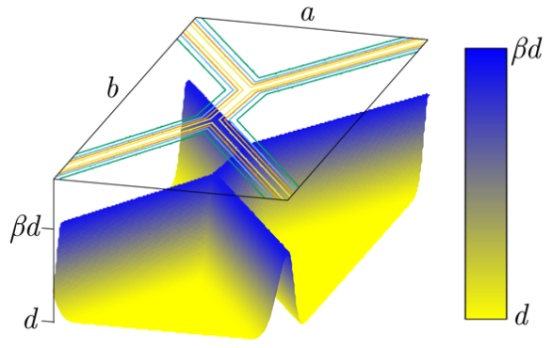

**Fig. 8.** Density map for generating centroidal Voronoi diagram

The horizontal position of intersection of yield lines is given by [12]



For , the value  equals 0.326, which is indicated on Fig. 7b. The simulated position of the intersection points agrees reasonably well with theory. Differences are expected given the volumetric representation of the simulated yield zone in comparison with yield line theory.

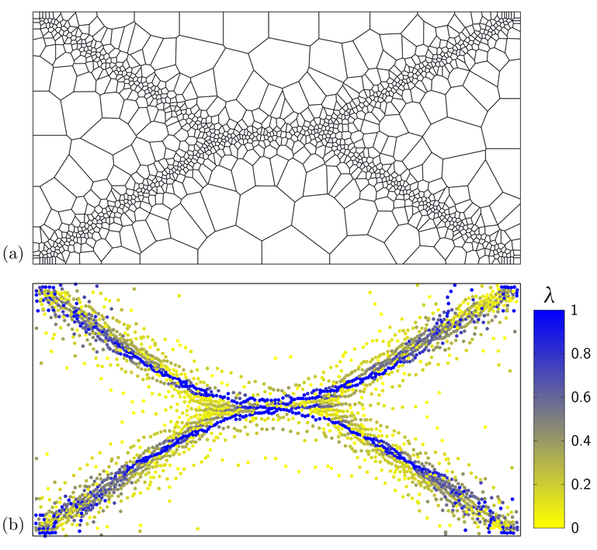

**Fig. 9.** a) Refined grid; and b) associated yield event pattern

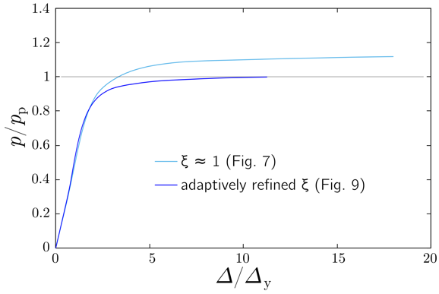

**Fig. 10.** Load versus midspan displacement up to plastic collapse

Figure 10 presents lateral load versus deflection behaviors produced using the uniform and refined grid structures. The pressure value associated with the plastic collapse mechanism is [12]



where  is the plastic moment of the section per unit length in the  plane. For the uniform coarser discretization, the collapse load exceeds the theoretical load by about 5%. Similar to the previous example, the accuracy of the solution improves with grid refinement.

1. Application Domain

The preceding plastic limit analyses demonstrate basic capabilities of the L-VCLM and the potential for adaptive mesh refinement. However, the envisaged application domain is thin-walled elements made of reinforced concrete. As a step in that direction, the elastic deformation of a concrete slab is simulated. The example has been taken from an experimental program in which out-of-plane loading was applied to a slab structure supported by a  array of columns, after removing the central column [16]. Out-of-plane loading was applied using an actuator and a series of distribution elements. For the simulated deformation pattern, shown in Fig. 11a, uniform out-of-plane loading was applied within the column array boundaries. Although the simulation is limited to elastic deformation, it is notable in that all reinforcing bars are explicitly represented within the model. The L-VCLM allows for the discrete representation of short-fiber or bar reinforcement in a computationally efficient way [10]. Figure 11b presents axial stress variation in selected reinforcing bars that run along the bottom face of the slab structure. As expected, tensile stresses appear in the region of column removal; compressive stresses appear in the negative moment regions, near the column supports.

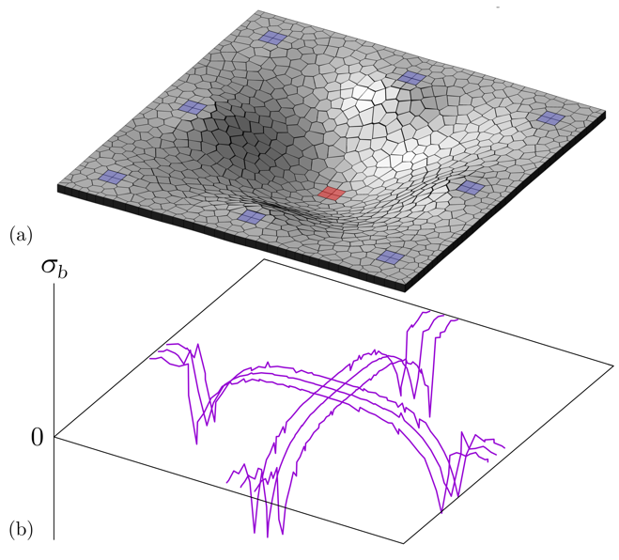

**Fig. 11.** a) Elastic deformation of a RC slab due to column removal; and b) axial stress variation in selected reinforcing bars within the L-VCLM.

1. Conclusions

This research aims to produce computationally efficient models of planar or thin-walled structural elements that are subject to out-of-plane loading. The following remarks and conclusions can be made.

* For thin-walled structures, the concomitant goals of tracking material nonlinearity in-plane and through the wall thickness direction can be accomplished via a layered Voronoi-cell lattice model (L-VCLM). The 3D structure is reduced to a planar model by introducing the plane section constraint through the wall thickness, rendering the L-VCLM vastly superior in terms of computational efficiency.
* As an intermediate step between elastic stress and fracture analyses, plastic limit analyses are an effective means for elucidating model behavior. Both elastic and plastic limit analyses indicate grid size sensitivity for cases of flexural loading. The degrees of freedom associated with the Voronoi cells and the spring components are not compatible with ordinary beam theory. In particular, the spring components in the out-of-plane direction are activated during flexural loading.
* As the element aspect ratio, , is reduced, the individual elements representing each layer approach conditions of membrane action, for which the lattice is elastically uniform. This desirable behavior is observed within the plastic analyses, as well.
* The aforementioned improvements with grid refinement suggest opportunities for adaptive refinement, which is a main component of this research. Herein, a suite of  models are subjected to out-of-plane loading, approaching the plastic limit state. Spatial maps of the yield events are recorded for each model. Cluster analyses, a form of unsupervised learning, are used to identify potential yield lines from a composite map of the yield events. The grid is refined local to the identified yield line segments. It is found that the ensuing analysis, based on the refined grid, is significantly more accurate in terms of localized behavior and the plastic limit load.

With respect to structural concrete, this form of adaptive analysis is complicated by several factors. Material behavior is anisotropic, including softening in tension. Reinforcing elements, such as bars or fibers, are also typically present. Nonetheless, these factors have been incorporated into the L-VCLM framework, albeit without adaptive refinement of the grid. It is anticipated that the ML-assisted scheme for adaptive refinement will be effective, using fracture events in place of the yield events of plastic limit analyses.

References

1. Asahina D, Aoyagi K, Kim K, Birkholzer JT, Bolander JE (2017) Elastically-homogeneous lattice models of damage in geomaterials. Computers and Geotechnics 81: 195 – 206.
2. Bažant Z, Bhat P (1977) Prediction of hysteresis of reinforced concrete members. Journal of the Structural Division, ASCE 103(1): 153–167.
3. Bolander JE, Elíǎs J, Cusatis G, Nagai K (2021) Discrete mechanical mod- els of concrete fracture. Engineering Fracture Mechanics 257: 108030.
4. Chang Z, Xu Y, Chen Y, Gan Y, Schlangen E, Šavija B (2021) A discrete lattice model for assessment of buildability performance of 3D-printed con- crete. Computer-Aided Civil and Infrastructure Engineering 36(5): 638– 655.
5. Cusatis G, Pelessone D, Mencarelli A (2011) Lattice Discrete Particle Model (LDPM) for failure behavior of concrete. I: Theory. Cement & Concrete Composites 33(9): 881–890.
6. Du Q, Faber V, Gunzburger M (1999) Centroidal Voronoi tessellations: applications and algorithms. SIAM Review 41(4): 637–676.
7. Elíǎs J (2016) Adaptive technique for discrete models of fracture. International Journal of Solids and Structures 100–101: 376–387.
8. Fascetti A, Ichimaru S, Bolander JE (2022) Stochastic lattice discrete par- ticle modeling of fracture in pervious concrete. Computer-Aided Civil and Infrastructure Engineering 37(14): 1788–1808.
9. Herrmann HJ, Roux S (1990) Statistical Models for the Fracture of Disordered Media. Elsevier, 353 pages.
10. Kang J, Kim K, Lim YM, Bolander JE (2014) Modeling of fiber-reinforced cement composites: Discrete representation of fiber pullout. International Journal of Solids and Structures 51(10): 1970–1979.
11. Kawai T (1978) New discrete models and their application to seismic response analysis of structures. Nuclear Engineering and Design 48(1): 207–229.
12. Nielsen MP, Hoang LC (2011) Limit Analysis and Concrete Plasticity. CRC Press, 796 pages.
13. Pan Y, Prado A, Porras R, Hafez OM, Bolander JE (2017) Lattice modeling of early-age behavior of structural concrete. Materials 10: 231.
14. Pedregosa F, et al (2011) Scikit-learn: Machine learning in Python. The Journal of Machine Learning Research 12: 2825–2830.
15. Spacone E, Filippou F, Taucer F (1996) Fibre beam-column model for non-linear analysis of R/C frames: Part I. formulation. Earthquake Engineering and Structural Dynamics 25: 711–725.
16. Weng YH, Qian K, Fu F, Fang Q (2020) Numerical investigation on load redistribution capacity of flat slab substructures to resist progressive collapse. Journal of Building Engineering 29: 101109.
17. Widom B (1966) Random sequential addition of hard spheres to a volume. Journal of Chemical Physics 44: 3888–3894.
18. Zhang Q, Elíǎs J, Nagai K, Bolander JE (2024) Discrete modeling of elastic heterogeneous media. Mechanics Research Communications 137: 104277.
19. Zhang Q, Fascetti A, Perez Lara MA, Bolander JE (2025) Discrete mechanical modeling of planar structures subjected to out-of-plane loading. International Journal of Solids and Structures 314: 113321.