**Assessing the Sustainability and Reuse Potential of Prefabricated Hollow Core Slabs: A Feasibility Study**

Abhiram Sivapalakumar, Nirosha D. Adasooriya

University of Stavanger, Stavanger/Norway  
abhiram941@gmail.com

**Abstract.** Sustainability in construction is increasingly critical due to the need to reduce environmental impact while maintaining structural performance. Hollow-Core Slabs (HCSs), as widely used prefabricated components, offer significant potential for sustainable reuse. This study investigates the feasibility of repurposing HCSs instead of demolition, highlighting their role in reducing construction waste and supporting a circular economy. A mixed-method approach integrating literature review, case study analysis, and environmental impact assessment was used to evaluate both theoretical and practical aspects. The research also presents structured guidelines for pre-disassembly evaluation, disassembly procedures, and testing procedures to optimize reuse. Findings confirm that reusing HCSs can meaningfully lower the environmental footprint of construction, promoting more sustainable and resource-efficient building practices.

**Keywords:** Prefabricated Concrete Elements, Hollow- Core Slab Reuse, Design for Disassembly (DfD), Cradle-to-Cradle (CtC)

1. Introduction

### Concrete is the most consumed construction material worldwide after water [1]. It is a major source of CO₂ emissions, accounting for roughly 37% of construction-related outputs [2]. Although prefabrication methods such as Hollow-Core Slabs (HCSs) reduce material waste during production, current end-of-life practices remain largely linear demolition leads to significant resource loss and environmental impact.

### Circular economy principles offer an alternative. Defined by the European Union (EU) as a system that promotes reuse, refurbishment, and recycling, this model aims to extend the lifecycle of materials while minimizing waste [3]. In construction, this involves shifting from a “take-make-waste” approach to one that narrows, slows, and closes re-source loops. Prefabricated HCSs are well-suited for this, yet their reuse remains rare due to unclear regulations, lack of guidelines, and technical barriers.

### While concepts like Design for Disassembly (DfD) and Cradle-to-Cradle (CtC) are gaining attention, they are seldom applied in practice. Most existing research focuses on recycling concrete or improving mix compositions, with little emphasis on reusing structural elements [4-6]. Pilot projects in Norway, such as KA13 and Oslo Storby Legevakt, have demonstrated the environmental benefits of reused HCSs, but also revealed economic and logistical challenges, including increased costs and insufficient documentation [7,8].

1. Methodology

This study employs a mixed-method research design, combining theoretical inquiry, case-based structural assessment, and quantitative environmental analysis to evaluate the feasibility and sustainability of reusing prefabricated HCSs in concrete construction.

* 1. Research Design

The research integrates both qualitative and quantitative methodologies to address the multifaceted nature of circular construction. The qualitative component comprises a systematic literature review guided by the TONE framework (Trustworthiness, Objectivity, Novelty, and Evidence), which ensures critical evaluation of academic publications, industry reports, and relevant standards [9]. A pre-case study from Hong Kong was done to understand the waste reduction methods in the industry.

The quantitative dimension involves a case study-based structural assessment and a comparative life cycle analysis (LCA), focusing on environmental indicators such as Global Warming Potential (GWP) and Water Depletion Potential (WDP). Both Cradle to Grave (CtG) and CtC perspectives were applied to capture the full environmental implications of reuse versus traditional demolition.

* 1. Case Study and Structural Evaluation

The SIS-Velferdsbygg (SVB) building, constructed by Veidekke Prefab, was selected as a representative donor structure. Structural drawings, element documentation, and floor plans were examined to assess the reusability of installed HCSs. Particular attention was given to the analysis of connection types, accessibility, structural independence, and the feasibility of removal without compromising element integrity.

A reuse scenario was developed by digitally repurposing selected HCSs from SVB into a hypothetical recipient structure. Parameters such as load-bearing capacity, fire resistance, sound insulation, and geometrical compatibility were considered in accordance with TEK17 and EN 1992-1-1 standards. Lessons from previously documented pilot projects- such as KA13, OSBL, and laboratory studies in Poland were integrated to inform testing expectations and performance thresholds [7,8,10].

* 1. Analytical Tools and Standards

This study applied a combination of digital tools and technical standards to support the structural evaluation, environmental analysis, and development of reuse guidelines.

### **Software tools**

Table 1 shows the main programs that were used. These tools helped assess both the technical and environmental aspects of HCS reuse and supported the development of clear, step by step processes.

**Table 1-** Software tools used for the study

|  |  |
| --- | --- |
| Software name | Purpose |
| Solibri | Employed for building information modeling (BIM), load path analysis, and disassembly scenario simulation. |
| AutoCAD | Used for detailed planning of reuse layouts, crane positioning, and disassembly logistics. |
| Microsoft Excel | Applied to perform LCA calculations, focusing on environmental metrics sourced from Environmental Product Declarations (EPDs) provided by Veidekke Prefab. |
| Draw.io | Used to construct workflow diagrams and visualize decision-making frameworks for reuse evaluation. |

### **Standards and guidelines**

A focused document review was carried out to support the development of reuse guidelines and ensure consistency with established standards and regulations (Table 2). The review concentrated on technical, regulatory, and environmental documents relevant to the reuse of HCSs, providing a foundation for addressing structural safety, and sustainability requirements.

**Table 2**- Standards and Guidelines used for the study

|  |  |
| --- | --- |
| Name of standard / guideline | Purpose |
| NS 3682 | Norwegian guidelines for the reuse of concrete elements. |
| ISO 20887 | International standards to design for adaptability and disassembly |
| TEK17 | Used to define the functional and safety requirements that reused elements must meet in new construction scenarios. |
| DOK- Regulations on Documentation of Construction Products | Provided a clear framework for how reused elements must be documented in terms of quality, traceability, and compliance with safety standards. |
| EPD (Environmental Product Declaration) | Provided by Veidekke Prefab to calculate GWP, material and water savings for the case study of SVB. |

* 1. **Data Collection and Evaluation Strategy**

Data for this study were collected from both primary and secondary sources. Primary data included structural drawings, floor plans, and EPDs from Veidekke Prefab, which provided lifecycle data for HCSs. This data was essential for assessing both reuse feasibility and environmental performance. Secondary sources consisted of academic literature, national standards, industry reports, and survey findings on reuse practices in Norway. Insights from pilot projects such as KA13 and Oslo Storby Legevakt also informed the practical aspects of reuse. To evaluate environmental impact, a CtG versus CtC analysis was conducted using EPD data. This comparison demonstrated the reduction in carbon emissions and water use achieved through HCS reuse.

The reuse evaluation followed three phases:

1. Pre-disassembly assessment analyzing element accessibility, independence, and connection types.
2. Disassembly planning and execution focusing on logistics, sequencing, and safe removal.
3. Post-disassembly testing checking structural performance, visual quality, and compliance with reuse standards.

This structured approach ensured that both technical and environmental aspects were thoroughly addressed in the development of reuse guidelines.

1. Reuse and Circular Economy

The reuse of prefabricated structural elements, particularly HCSs, plays a critical role in supporting the transition toward a circular economy in the construction industry. As opposed to the linear “take-make-waste” model, the circular economy emphasizes resource efficiency by extending the useful life of materials through reuse, refurbishment, and recycling. According to the EU, circularity involves keeping products and materials in use for as long as possible, thereby reducing waste and resource extraction [3].

In Norway, data from Statistics Norway (SSB) highlights that a significant share of 530473 tonnes of concrete waste arises from the demolition of buildings [11]. This accumulation of construction waste underscores the urgent need to rethink end-of-service-life (EoSL) strategies. Recycling concrete at this stage often leads to downcycling, where material quality and structural properties are diminished [4-6, 12]. By contrast, reuse preserves the original form and performance of the element, enabling a more efficient and sustainable use of resources. As recognized in ISO 20887, reusability refers to the ability of a component to be reused in its original form while maintaining its functional qualities for the same or a different purpose [13].

The CtC model shown in Fig. 1 offers a clear framework for circular construction. Unlike the traditional CtG model shown in Fig. 2, CtC promotes a closed-loop system in which components are intentionally designed for future reuse. Incorporating DfD is essential in this context, allowing elements like HCSs to be safely detached and reused without significant damage or loss of integrity.

Reuse is also prioritized in the waste hierarchy, ranking above recycling as a preferred strategy for waste reduction [14]. It aligns with the International Energy Agency's (IEA) recommendation to focus research efforts not just on recycling but on the recovery and direct reuse of building elements especially those with high embodied carbon such as concrete.

Pilot projects such as KA13 and Oslo Storby Legevakt have demonstrated the technical feasibility and environmental benefits of reusing HCSs. For example, reused slabs from Regjeringsbygg R4 in KA13 resulted in 89% lower CO₂ emissions compared to newly produced equivalents. However, these projects also revealed barriers such as high disassembly costs, design adjustments, and lack of clear regulatory guidance.

When full reuse is not feasible due to damage or outdated specifications, remanufacturing provides an intermediate strategy. This involves restoring or upgrading components through cleaning, reinforcement, or slight redesign so they can meet current safety and performance requirements. While more resource-intensive than direct reuse, remanufacturing still preserves embodied energy and reduces the need for new materials [15,16].

Despite growing interest, regulatory and industry standards continue to focus primarily on new construction, offering limited guidance for the certification, documentation, or performance assessment of reused elements. Broader adoption of reuse practices will require clearer regulatory frameworks, better documentation processes, and technical guidance aligned with real-world construction scenarios.

**Fig. 1**. CtG system limits for reuse

**Et bilde som inneholder tekst, skjermbilde, design

KI-generert innhold kan være feil.**

**Fig. 2**. System limits for traditional approach (CtG), adapted from EPD

1. **Case Study on SIS- Velferdsbygg (SVB)**

This study incorporates a real-world case to evaluate the feasibility of reusing prefabricated HCSs in a new construction context. The considered building, SVB, located at the University of Stavanger and built by Veidekke Prefab, served as the source structure. The focus was placed on the third floor of the building, where a large number of HD265 and HD320 slabs were installed.

The SVB complex consists of four floors and was part of a larger development that also included a sports hall and connecting structures. In total, approximately 4920 m² of HD265 slabs (560 units) and 327 m² of HD320 slabs (48 units) were used in the project, amounting to over 1,898 tonnes of prefabricated concrete. These slabs were designed for a service life of 50 years, with classification parameters including Consequence Class CC2, Reliability Class RC2, Seismic Class II, and Fire Resistance REI90, as per NS-EN 1990:2002+NA:2016 requirements.

* 1. Load Assessment and Structural Role

A critical aspect of evaluating HCS reuse is understanding the previous load conditions they were subjected to. In SVB, these included self-weight, dead loads from superimposed elements, and imposed loads related to occupancy and facade components. Load values were documented based on project data from the responsible structural engineering firm (RIB). The evaluation also included localized line loads from facades and point loads from roof structures, which influenced slab selection for reuse.

The reuse feasibility assessment prioritized slabs with simpler load histories and minimal structural alteration. This was essential to reduce uncertainties in residual capacity and avoid the need for extensive remanufacturing. Preference was given to slabs with clear access and minimal composite topping or structural interdependence, in line with documented best practices from earlier case studies.

* 1. **Structural System and Connections**

The structural framework of SVB featured a combination of precast columns, beams, and load-bearing walls, with stabilization achieved through stairwells and elevator shafts. The HCSs in SVB were integrated using a variety of connection types, including slab-to-wall and slab-to-beam joints. These connection methods were closely studied, as their reversibility and disassembly complexity significantly affect reuse potential.

The project also explored how element identification, logistics for crane placement, and dismantling strategy can influence the practicality of salvaging slabs for reuse. Structural drawings and BIM models (see Fig. 3) were used to trace the specific positioning and conditions of individual slabs selected for the reuse scenario.

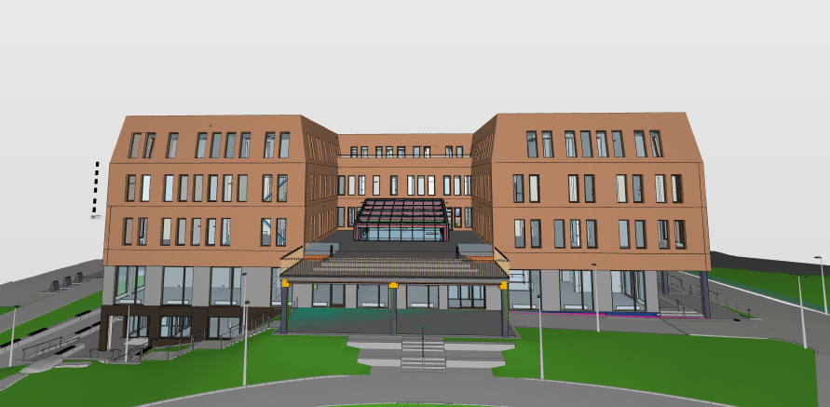

**Fig. 3.** BIM-Model of SiS Velferdsbygg

* 1. Reuse Case Implementation

To evaluate the practical potential of HCS reuse, a detailed reuse case was developed based on structural elements salvaged from the third and second floors of SVB. The goal was to design a new student housing facility using the repurposed slabs, thereby maximizing material efficiency while ensuring compliance with structural and functional standards.

### **Selection Criteria and Planning**

The reuse case prioritized HD265 slabs with a length of 8.4 meters and width of 1.2 meters, originally used in SVB. All reused elements were cut or trimmed to uniform lengths where required. Elements with excessive topping, embedded fixtures, or complex structural integration were excluded due to disassembly challenges and potential damage during extraction. The elements selected were evaluated for compatibility in dimensions, material integrity, and expected structural performance.

### **Floor Plan and Structural Integration**

A proposed floor plan (see Fig. 4 and Fig. 5) of approximately 68.45 m by 18.5 m was created, incorporating 1,098.37 m² of reused HCSs, corresponding to the HCS-IDs documented from SVB. Each slab’s previous load history, position, and condition informed its placement in the new design. The reuse layout included student rooms, each 20 m² in size, as well as shared facilities like bathrooms, a laundry room, and a communal area.

Support for the reused slabs was provided through newly manufactured L-shaped and Inverted Tee Beams, with connection points carefully aligned to existing voids in the HCSs. These allowed reuse of prior anchorage patterns or simple steel rod connections, minimizing the need for drilling or adhesive bonding.

### **Load Adjustments and Compliance**

The reuse structure was classified as a Category A building under NS-EN 1991-1-1, suitable for residential/domestic use. Imposed loads were reduced compared to the original office design of SVB, aligning better with the residual capacity of the slabs. While dead loads from the slabs remained unchanged, additional floor finishing layers and acoustic insulation were factored into the new design, especially given the stricter comfort requirements for residential buildings.

**Sound and Fire Regulations**

Adapting the reused HCSs for student housing required reassessment of sound and fire performance to comply with NS 8175 and TEK17 standards.

For sound insulation, the reused structure must achieve Sound Class C, with a minimum R’w of 45 dB. The original 265 mm HCSs meet this with a measured R’w of 56 dB, but their impact sound level (L’n,w) of 76 dB exceeds acceptable limits. Two floor design options were evaluated. While Option 1 (Fig. 6) is more cost-effective, it does not fully meet impact sound requirements. Option 2 (Fig. 7) offers better performance and is more suitable for regulatory compliance.

In terms of fire resistance, student housing is classified under Risk Class 4, requiring a minimum rating of REI60. The HCSs from SVB were originally rated REI90, exceeding this requirement. No additional fire protection measures are needed for reuse.

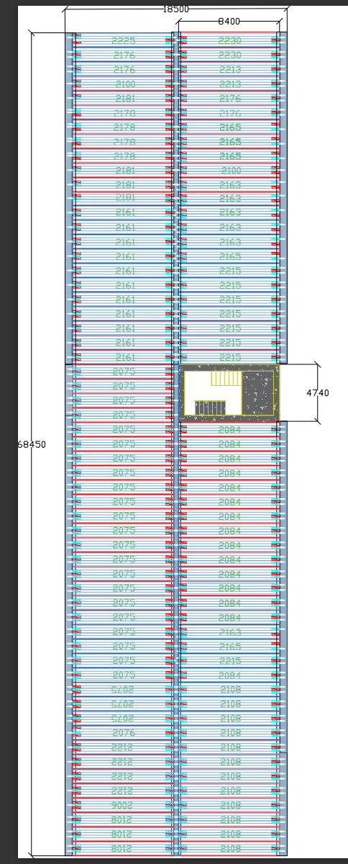

**Fig. 4**. HCS's used for the reuse case

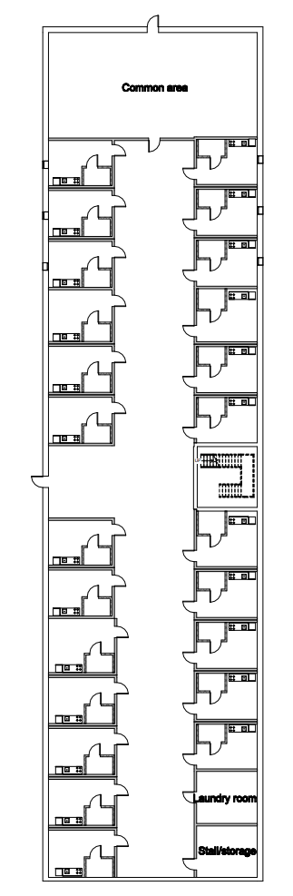

**Fig. 5**. Architectural sketch of floor plan

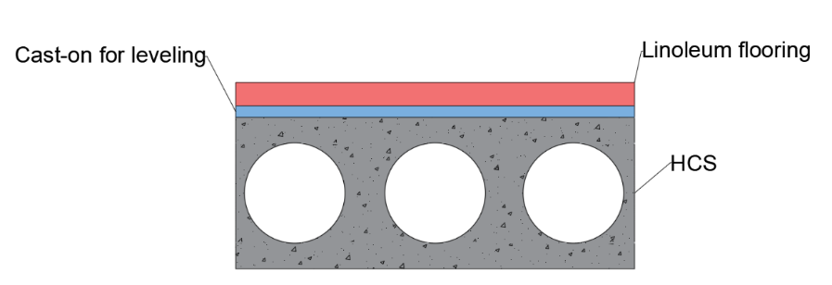

**Fig. 6**. Flooring Option 1

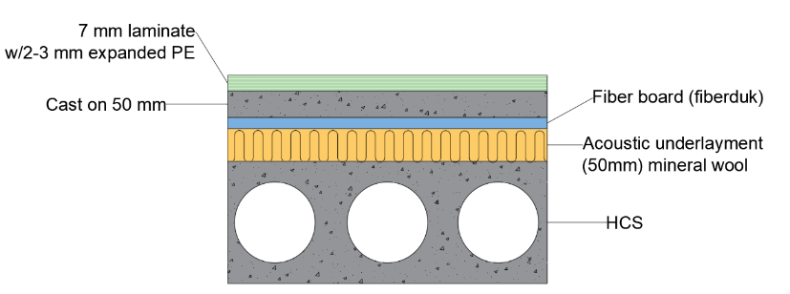

**Fig. 7**. Flooring Option 2

1. **Proposed Framework**

To enable the practical reuse of HCSs in existing buildings, this study introduces a set of tailored steps in a framework that bridge the gaps left by existing standards. While ISO 20887 provides general principles for DfD and NS 3682 offers procedures for post-disassembly testing, neither fully addresses the challenges involved in reusing elements from buildings that were not originally designed for reuse. These guidelines adapt and expand on those standards, specifically for real-world conditions where HCSs must be recovered, evaluated, and reintegrated. The proposed framework consists of pre-disassembly evaluation, disassembly procedure, testing and evaluation and documentary strategy.

* 1. Pre-Disassembly Evaluation

This framework establishes a systematic method for assessing the feasibility of disassembling HCSs before any physical work begins. It evaluates critical factors such as the accessibility of the elements, their independence from other structural components, surface conditions, and the type of connections used. By identifying potential barriers early, this phase ensures that only slabs suitable for reuse proceed to the disassembly and testing stages. This proactive approach reduces time, costs, and unnecessary damage during the process. A summary has been given in Fig. 8.

* 1. Disassembly Procedure

The disassembly framework addresses the lack of practical detail in existing standards by outlining a step-by-step approach for safely dismantling HCSs. It includes guidance on crane positioning, lifting techniques, element sequencing, and handling protocols to preserve the structural integrity of the slabs. This structured procedure ensures that the disassembly process is both safe and efficient, enabling successful extraction even from complex or tightly integrated structures.

* 1. Testing and Evaluation

Once disassembled, HCSs must be evaluated to verify their structural performance, functional suitability, and regulatory compliance. This testing guideline (See Fig. 9) condenses the broader scope of NS 3682 into a focused checklist of essential tests covering load-bearing capacity, visual inspections, cracking, deflection limits, and material degradation. By streamlining the testing process into a more accessible format, it becomes more practical for industry adoption without compromising safety or performance standards.

* 1. Documentation Strategy

A dedicated documentation guideline complements the technical process by specifying the necessary records and traceability measures for reused HCSs. This includes original element data, removal procedures, test results, and reuse conditions. Clear documentation is essential for regulatory approval, lifecycle tracking, and integration into digital systems like material passports or BIM models The flow of information and a standardized method of documentation are important for ensuring effective communication and coordination among various actors across the value chain. While some of the data may primarily serve specific stages of the production or life cycle, the comprehensive collection of details ensures the availability of all necessary documentation for the element. The documentation approach considers both NS 3682 and the material passport discussed by BAMB [17].

**Fig. 9**. Key points for each category of the testing guideline

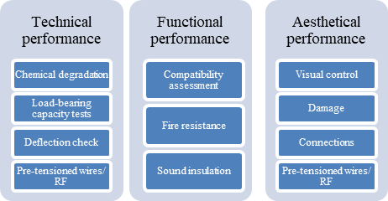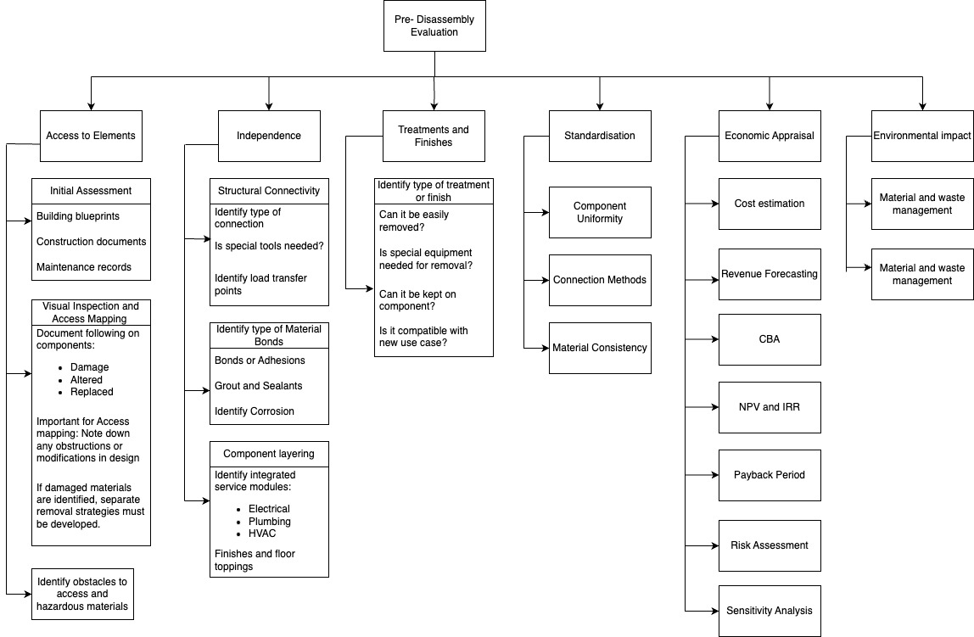

**Fig. 8**. Chart for pre-disassembly evaluation

* 1. **Connection Design in Reuse Applications**

The design and implementation of connections are vital to the success of structural reuse projects, especially with prefabricated HCSs. While disassembly and testing confirm the slabs’ structural capacity, proper connection systems are critical for their reintegration. This section reviews key connection types explored in this study. Reversibility is essential in circular construction; however, as Durmisevic notes, irreversible connections often damage elements during disassembly. In this context, known connection methods were adapted for reused HCSs, with attention to future reusability and structural integrity (see Table 2).

**Table 2.** Connection Design in Reuse Applications

|  |  |  |
| --- | --- | --- |
| Connections possibilities | Adapted connection methods | Advantages and Limitations |
| HCS to Wall – Drilled Bar with Bond Beam | drilling a bar through the slab into a bond beam atop a newly constructed wall. | a practical and relatively quick solution.  it is not reversible and thus limits future reuse. |
| HCS to Wall – L-Profile with Void Anchoring | using the slab’s internal voids for anchoring, with L-shaped steel profiles bolted to the wall | improves design flexibility and allows for easier installation at varying heights  method is more reversible than the drilled bar approach |
| HCS to Inverted Tee Beam | a traditional and time-efficient connection widely used in prefabrication | easy to execute and structurally sound,  not suitable for reuse beyond the second application and lacks compatibility with DfD principles. |
| HCS to L-Shaped Beam | aligning slab voids with pre-installed anchors in a newly cast L-beam. Plastic cups and grout ensure controlled filling of voids, while neoprene bearings prevent damage. | the most reliable options for reuse projects due to its familiarity and efficient execution. However, like the inverted tee beam, it is not designed for reversibility and limits future disassembly |
| Longitudinal Connections between Adjacent Slabs | involves precision cutting into the slab core to create a direct joint for grouting and bar placement, which is effective but irreversible. The second uses external steel plates anchored with mechanical fasteners, offering improved adaptability and partial reversibility | visually appealing and more labor-intensive, the plate solution better aligns with circular design principles and allows for potential future disassembly |

All four guidelines are integrated into a reuse flowchart Fig. 10, which provides a visual overview of the entire process from initial assessment to final testing. This flowchart acts as both a reference tool and an implementation roadmap, ensuring usability across various project contexts and simplifying the reuse of HCSs for contractors, engineers, and developers.

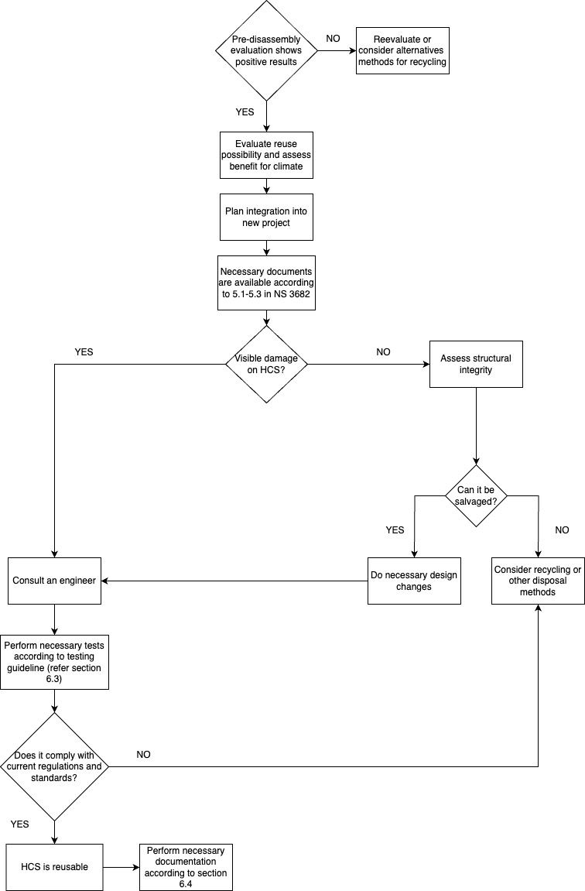

NO

YES

**Fig. 4**- Flowchart summarizing guidelines

1. **Environmental analysis**

The environmental benefits of using and reusing HCSs in the SVB project were assessed through a comparative LCA. This analysis focused on three primary metrics: material savings, GWP reduction, and water usage optimization. The calculations were based on detailed structural data from SVB and life cycle metrics provided in EPDs from Veidekke Prefab. The procedure involved comparing actual data from the implemented HCS system to a theoretical cast-in-situ solid slab alternative, representing conventional construction practice.

* 1. Material Savings

To quantify material savings, the total volume of concrete used in HCSs was compared to that which would have been required for solid cast-in-situ slabs of equivalent structural capacity. The calculation included the number, length, width, and thickness of HCSs used on each floor and assumed solid slab dimensions based on typical Norwegian construction practices. This comparison revealed that the use of HCSs reduced the required concrete volume significantly (43% in average for each floor). The results demonstrate consistent efficiency gains due to the voided cross-section of HCSs, leading to substantial material conservation without compromising structural performance.

* 1. GWP Reduction

To calculate GWP reduction, the difference in concrete mass saved through the use of HCSs was used as input. This mass was then multiplied by the GWP factor from Veidekke’s EPD, which quantifies the CO₂-equivalent emissions per unit of concrete produced (measured in kg CO₂-eq per m³ or per tonne of concrete). The results shown in Table 3 illustrate the climate benefits of using prefabricated HCSs by avoiding the emissions associated with producing, transporting, and casting large volumes of concrete.

* 1. Water Usage Optimization

Water consumption was evaluated by comparing the water input required for the manufacturing and on-site casting of solid slabs to that required for the production of prefabricated HCSs. Water usage data were also drawn from EPDs, with consumption expressed in kg per m³ of concrete.

For each floor, the mass of concrete saved by using HCSs was multiplied by the water use factor from the EPD to calculate the total water saved. The findings showed that HCSs significantly reduced construction-phase water demand. This represents an average reduction of approximately 56,5% in water usage per floor, contributing meaningfully to resource conservation and aligning with sustainability targets in water-stressed regions.

|  |  |  |  |
| --- | --- | --- | --- |
|  | Avg. Amount of material saved compared to solid slab | GWP value of saved mass | Water usage saved by using HCS |
| Floor | Unit : % | Unit: kgCO2-eq | Unit: kg |
| HK | 42,20 % | 37702,67 | 56,31 % |
| H1 | 40,68 % | 47287,80 | 56,44 % |
| H2 | 39,48 % | 25352,74 | 57,00 % |
| H3 | 40,53 % | 38207,15 | 56,39 % |

**Table 3.** Environmental benefit of HCS VS Solid slab

1. Results and Discussion
   1. Structural Feasibility of Reuse

The structural evaluation confirmed that selected HCSs from SVB could be feasibly reused in a newly designed student housing project. Slabs were chosen based on span length, absence of topping, and accessibility for disassembly. These parameters ensured minimal damage during removal and compatibility with the new layout. The new building design incorporated these slabs without exceeding their original loading capacities. The imposed loads in the reuse scenario were lower than in the original office use, which allowed for safe integration without additional reinforcement. Importantly, the existing fire classification of REI90, applied during the SVB construction, exceeded the TEK17 requirement of REI60 for Risk Class 4 buildings, confirming that no additional fire protection measures were necessary.

* 1. Acoustic and Fire Performance

While the airborne sound insulation of the 265 mm HCSs met regulatory requirements, with a measured R’w of 56 dB satisfying NS 8175 Sound Class C, the impact sound insulation (L’n,w) was inadequate for residential use, with values reaching 76 dB. Two floor design options were evaluated to improve performance. Option 1 involved minimal insulation and was more cost-effective but failed to fully meet impact sound thresholds. Option 2 included enhanced insulation layers and achieved full compliance with acoustic regulations. Despite its higher cost, Option 2 proved to be the more robust solution, especially for residential settings where acoustic comfort is a priority. On the fire safety side, no additional interventions were required due to the original REI90 classification of the HCSs, comfortably exceeding the REI60 threshold for student housing.

* 1. Environmental Impact

The environmental analysis revealed substantial benefits from using HCSs instead of cast-in-situ solid slabs. In terms of material savings, concrete volume was reduced by an average of 39.5% to 42.2% per floor. This reduction was achieved through the voided geometry of the HCSs, which maintained load-bearing capacity with less material. Using data from Veidekke Prefab’s EPDs, a CtG assessment showed that the GWP was reduced by 25,353 kg to 47,288 kg CO₂-equivalent per floor, depending on the volume of concrete saved. Similarly, water usage was significantly optimized. Compared to traditional solid slabs, HCSs consumed 43% to 45% less water during manufacturing and installation. These reductions in emissions and water consumption underscore the sustainability potential of integrating HCSs into reuse-focused construction projects.

* 1. **Connection Design in Reuse Applications**

The reuse of HCSs is strongly influenced by the type and adaptability of the connection systems used. While the structural assessment confirmed the viability of the slabs themselves, connecting them in a new configuration posed limitations due to the irreversible nature of most traditional methods.

Wall connections using drilled bars into bond beams were simple but not reusable. In contrast, using L-shaped profiles anchored into slab voids offered better adaptability and partial reversibility, though requiring more complex preparation. Similarly, standard support methods involving inverted tee and L-shaped beams provided structural stability but did not support future disassembly.

For connections between slabs, traditional grouted joints were impractical, leading to the use of externally mounted steel plates with mechanical anchors. This approach was more labor-intensive but better suited to circular design goals.

Overall, the study found that most current connection practices are not optimized for reuse beyond a second application. Advancing the reuse of HCSs will require a shift toward modular, reversible connection systems that enable both structural performance and long-term circularity.

* 1. **Comparison with Existing Research and Projects**

The findings of this study are consistent with the outcomes of previous pilot projects such as KA13 and Oslo Storby Legevakt. In both cases, reused HCSs were successfully implemented but faced notable challenges related to logistics, documentation, and additional testing requirements. Like those projects, this case study confirmed that while structural performance and environmental outcomes are favorable, reuse implementation is hindered by practical and regulatory barriers. The reuse of slabs from SVB also reinforces theoretical models such as CtC and DfD, both of which advocate for preserving material value across building life cycles.

However, unlike new buildings designed with disassembly in mind, SVB was not originally intended for reuse, which complicated removal and highlighted the importance of incorporating DfD principles from the outset in future projects.

1. Conclusion

This research set out to explore the potential for structural reuse in the concrete industry, with a specific focus on prefabricated HCSs. In an era marked by growing environmental concerns and resource scarcity, the construction sector must look beyond traditional linear practices and adopt more circular, low-impact strategies. Reuse, particularly of high-carbon materials like concrete, represents a key opportunity in this transition.

The study aimed to bridge a critical gap in both literature and practice by developing a comprehensive approach to the reuse of HCSs from existing buildings. While international standards such as ISO 20887 and national frameworks like NS 3682 provide a foundation, they fall short in addressing the unique challenges of disassembling and repurposing elements that were not originally designed with reuse in mind. This paper responded to that challenge by proposing a structured framework for assessing reuse potential, planning disassembly, and conducting performance testing supported by a real-world case study and lifecycle-based environmental analysis.

In doing so, the work contributes to the growing body of knowledge promoting sustainable and circular construction. It emphasizes the importance of early-stage planning, regulatory adaptation, and practical tools that enable engineers, designers, and contractors to navigate the complexities of reuse. More broadly, it highlights the urgent need to reframe how materials are valued within the built environment not as disposable, but as long-term assets capable of serving multiple lifecycles.

The reuse of structural elements like HCSs is not just a technical possibility, it is a necessary step toward a more resilient and climate-responsible construction industry. With continued innovation, policy support, and industry commitment, structural reuse can move from niche application to standard practice.

**Acknowledgment**

The authors would like to thank SIS-Velferdsbygg (SVB), located at the University of Stavanger and built by Veidekke Prefab and for their cooperation and insightful contributions. I would like to acknowledge ChatGPT for its assistance with English proofreading.

**References**

1. Nature: Concrete needs to lose its colossal carbon footprint. Nature (2021). <https://doi.org/10.1038/d41586-021-02612-5>

2. United Nations Environment Programme, Yale Center for Ecosystems + Architecture: Building Materials and the Climate: Constructing a New Future. UNEP (2023). https://wedocs.unep.org/20.500.11822/43293

3. European Parliament: Circular economy: definition, importance and benefits. Directorate General for Communication, European Parliament (2023). <https://www.europarl.europa.eu/topics/en/article/20151201STO05603/circular-economy-definition-importance-and-benefits>

4. Norsk Betongforening: Lavkarbonbetong, Publikasjon nr. 37. Norsk Betongforening, Oslo (2020)

5. Kazmi, M.J.M., Wang, Y.F., Sheikh, M.S.: Recycled aggregate concrete: mechanical and durability performance. In: Handbook of Sustainable Concrete and Industrial Waste Management, pp. 211–227. Woodhead Publishing, Elsevier (2022)

6. Liessa, T.: Evaluation of the impact of recycled concrete aggregates on the durability of concrete. UiT (2021). https://munin.uit.no/bitstream/handle/10037/23368/thesis.pdf?sequence=2

7. ENTRA: ENTRA-Rapport om KA13. ENTRA (2021). <https://www.entra.no/om-entra/nyheter-presse/rapport-om-ka13>

8. Reppe, I.S.: NMBU-Ombruk av betongelementer: analyse av marked, barrierer, muligheter og potensiale for klimagassreduksjon ved ombruk av hulldekker fra Regjeringskvartalet. NMBU (2021). <https://nmbu.brage.unit.no/nmbu-xmlui/handle/11250/2787600>

9. Overland, J.-A.: NDLA-TONE – strategi for kildekritikk. NDLA (2018). https://ndla.no/article/4947

10. Ajdukiewicz, D.J.B., Dawczynski, S., et al.: Reuse of RC and PC precast members as contribution to sustainable construction. ResearchGate (2013). <https://www.researchgate.net/publication/287333583>

11. Statistics Norway (SSB): Avfall fra byggeaktivitet. SSB (2023). https://www.ssb.no/natur-og-miljo/avfall/statistikk/avfall-fra-byggeaktivitet

12. Carević, S.M., Carević, V.: Comparative studies of the life cycle analysis between conventional and recycled aggregate concrete. In: ScienceDirect, Elsevier (2018). <https://doi.org/10.1016/B978-0-08-102480-5.00010-5>

13. ISO: ISO 20887:2020(E) - Sustainability in buildings and civil engineering works — Design for disassembly and adaptability — Principles, requirements and guidance. ISO, Geneva (2020)

14. Regjeringen: Avfall som ressurs – avfallspolitikk og sirkulær økonomi. Regjeringen.no (2017). <https://www.regjeringen.no/no/dokumenter/meld.-st.-45-20162017/id2558274/>

15. Marsh, A.P.V., Basart, S.A., Tokede, O.: Circular Economy strategies for concrete: implementation and integration. In: ScienceDirect (2022). <https://doi.org/10.1016/j.jclepro.2022.132486>

16. Velenturf, P.M., et al.: Circular economy and the matter of integrated resources. In: ScienceDirect (2019). <https://doi.org/10.1016/j.scitotenv.2019.06.449>

17. Haupt, M., Lang, W.: Materials passports – best practice. BAMB 2020 (2019). <https://www.bamb2020.eu/wp-content/uploads/2019/02/BAMB_MaterialsPassports_BestPractice.pdf>