Automated Damage Report Generation via Panoptic Segmentation of Ultra-High-Resolution Tunnel Images
Zehao Ye¹[0009-0007-9159-8640],†, Qi Li^{2,†}, Giuseppe Desiderio³, Wenxi Liu², Valentina Villa³, Jelena Ninic^{1,*}
¹ University of Birmingham, Birmingham B15 2TT, UK
² Fuzhou University, Fuzhou, China
³ Politecnico di Torino, Torino, Italy
† Equal contribution
* j.ninic@bham.ac.uk
Abstract. Modern reality capture techniques, such as ultra-high-resolution (UHR) panoramic imaging, can digitally document tunnel surface conditions in detail. However, assessing severe structural damage in aging tunnels still depends on manual inspections—an inefficient and subjective approach. This gap between advanced data collection and practical risk assessment limits effective tunnel maintenance. In this paper, we propose a novel framework that uses UHR panoramic images to automatically detect damage, generate records and risk assessment reports. At its core, a flexible segmentation framework, enhanced by a side network, captures contextual information around each local patch for sufficient receptive field. This method enables direct panoptic segmentation of images over 6k resolution, accurately identifying auxiliary structures and five types of damage. The proposed framework significantly improves the efficiency of planning and monitoring aging tunnel assets.

Keywords: Ultra-High-Resolution Segmentation, Damage Report, Tunnel Monitoring, Defect Detection, Panoptic Segmentation.
- Introduction
Tunnel infrastructure is crucial for connectivity, especially in challenging terrains and urban areas. In the Trans-European Transport Network, Italy has nearly half of the tunnel sections, with 50% in operation for over 30 years and only 19% meeting minimum safety requirements according to (MIT, 2023). Guidelines (MIT, 2023) also promote a preventive approach to infrastructure management, emphasizing risk reduction through proactive maintenance rather than reactive interventions. The importance of continuous monitoring and advanced surveying technologies is also underscored.
Advanced reality capture technologies, such as panoramic imaging and point clouds, have greatly enhanced the efficiency and accuracy of tunnel surface data collection. However, damage detection and risk assessment still rely on manual processes and subjective judgment. Automating these processes is essential for objectively ensuring the safety and reliability of these critical assets (Huang et al., 2021).
Deep learning-based image algorithms show great potential for detecting structural surface damage (Ye et al., 2024), but real-world applications, especially in deteriorated tunnels, face challenges. One of the issues is that tunnel surface conditions are typically stored as UHR panoramic images. Currently, there are two main approaches to UHR segmentation. The first approach uses conventional segmentation algorithms, where images are cropped with high overlap or no overlap and then merged after separate inferences. The former increases computation, while the latter affects accuracy due to the loss of contextual information in the image (Xu et al., 2021). The second employs specialized algorithms for UHR images, which typically rely on a predetermined model that inherently limits their model generality and scalability (Chen et al., 2019; Li et al., 2021). Furthermore, some algorithms require multi-stage parameter tuning with complex training procedures (Cheng et al., 2020; Huynh et al., 2021; Liu et al., 2024). Notably, certain methods utilize down-sampled versions of whole images to capture global information, which strikes a compromise between performance and computational resources at the cost of substantial information loss during compression, rendering it ineffective for real-world super-resolution image processing (Guo et al., 2022; Ji et al., 2023; Qi et al., 2024). In contrast, conventional segmentation models demonstrate superior scalability while only requiring a straightforward training process.
Another major challenge lies in the accurate analysis of severely deteriorated tunnels. Many existing damage identification studies are based on relatively limited and well-annotated datasets, with relatively simple damage types and less complex background environments (Huang et al., 2024; Ye et al., 2024). Some studies have been conducted in real tunnel environments, but they lack a well-constructed, complete end-to-end framework that covers the process from identification to reporting (Xu et al., 2021; Zhou et al., 2022). Consequently, the presence of multiple types of damage and interference from auxiliary structures further complicates the assessment. Additionally, distinguishing individual damage instances is crucial, as damage evaluation typically relies on individual instances as the fundamental unit of analysis. Therefore, to better address the complexities of real-world tunnel conditions, we need to develop a more comprehensive instance-level detection approach.
In this paper, we propose a generalized algorithmic framework that adapts conventional segmentation methods for UHR segmentation of tunnel panoramic images. Our fully automated process performs panoptic segmentation task on tunnel images for the first time, classifying all pixels into five types of damage and auxiliary structures. Panoptic segmentation provides instance-level information, which aligns well with the requirements of risk assessment. Ultimately, the output is a PDF report, making it easy to view and share for guiding focused monitoring efforts.
- Methodology
  - Data collection and dataset creation
In this study, tunnel panoramic images were captured using a vehicle-mounted laser scanner moving at ~5 km/h, shown in Figure 1(a). It can produce 8-bit grayscale .tif images with laser intensity as the color value. Gamma correction was applied to enhance visibility, shown in Figure 1(b). Each 20-meter tunnel segment was divided into 6 sub-images for efficient annotation using a SAM (Segment Anything Model)-based tool (Kirillov et al., 2023; Ji and Zhang, 2023).
As shown in Figure 1(c), five types of damage—seepage, corrosion, damaged joints, spalling, and cracks—were labelled as “things” with connected damage of the same type, even if obscured by auxiliary structures, treated as a single instance. The intact tunnel and auxiliary structures were categorized as “stuff”, including equipment (pipes, lights), repair elements (maintenance steel mesh), signals, and normal tunnel sections. In panoptic segmentation, “stuff” does not have instance identification. These classes were selected because they can be effectively visualized on grayscale laser maps. After merging sub-images, annotations are also merged, and cross-image instances are combined as one. A total of two tunnels were completed, resulting in 50 annotated ~6k resolution images, with 5 used as the test set and the remaining images used for training.
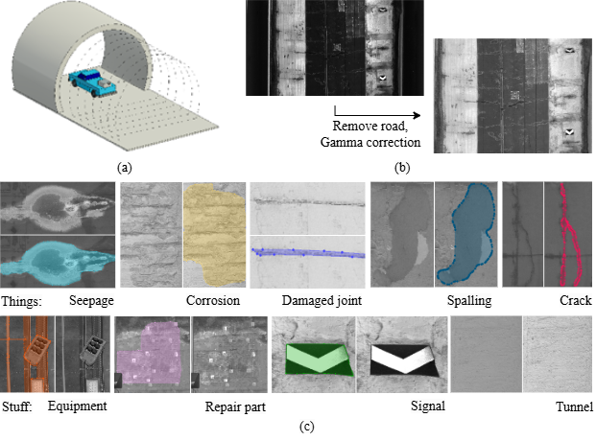
Fig. 1. Data collection: (a) A vehicle-mounted scanner captures tunnel point cloud data. (b) The point cloud is converted into a tunnel panorama, with the road removed and gamma correction applied. (c) Typical annotated “Things” and “Stuff” objects in the dataset.
  - UHR segmentation algorithm framework
The proposed ultra-high-resolution (UHR) image segmentation framework follows three steps, shown in Figure 2. First, the UHR panoramic image $U$ with width $W$ and height $H$ is uniformly divided into $N$ overlapping local patches ($\left\{I_{k}\right\} \left(k=\left[1,…,N\right],I_{k}⊂U\right)$ with width $w$ and height $h$ $(w<W and h<H)$ along the rows and columns. Second, the proposed local panoptic segmentation model computes local prediction results for each local patch. Third, all predicted local results are merged into the final ultra-high-resolution panoptic segmentation map.
.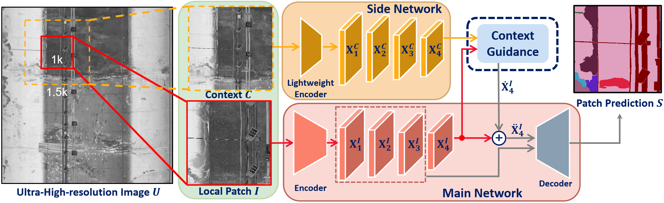
Fig. 2. Proposed UHR segmentation framework.
In contrast to the entire panoramic image, local patches possess a narrower field of view, often omitting crucial contextual information. This limitation hinders a comprehensive semantic understanding of the image content, resulting in misjudgments in segmentation results or the inability to fully present details. Consequently, the first step, the expanded regions centered on the local patches are simultaneously cropped and fed into the segmentation model as contextual information.
As illustrated in Figure 2, given a cropped local patch $I_{k}$, its context $C_{k}$ is not smaller than and covers $I_{k}$, which has the width $w_{c}=λw$ and height $h_{c}=λh$ ($λ>1$). Specifically, when the context is beyond the UHR panoramic image, the area beyond is filled with zeros. To improve the segmentation of local patches, local patch information is associated with corresponding contextual information. The context is first down sampled to align spatially with the local patch for computational efficiency, then both components are simultaneously input into the proposed model. This dual-stream input preserves detailed local features while maintaining context awareness. For the sake of simplicity in description, the target local patch and its context are denoted as $I$ and $C$ , respectively.
The proposed panoptic segmentation model consists of two networks: a ​main network and a ​side network. In the main network, the local patch is processed by a general visual encoder (e.g., Swin Transformer (Liu et al., 2021)) to extract multi-scale features $X_{i}^{I}∈R^{{h_{i}×w}_{i}×c_{i}} (i∈\left\{1,2,3,4\right\})$ for accurate fine-grained representation. Subsequently, these features are fed into a general panoptic segmentation decoder (e.g., Mask2Former (Cheng et al., 2022)) to generate the final panoptic prediction. Meanwhile, the context passes through a lightweight encoder (e.g., EfficientViT (Liu et al., 2023)) to extract multi-scale contextual features $X_{i}^{C}∈R^{{h_{i}×w}_{i}×c_{i}^{'}} (i∈\left\{1,2,3,4\right\})$. This only incurs a slight computational overhead to boost the local features via richer context.
Empirically, among the extracted features, the deepest feature map exhibits the highest semantic richness and is therefore exclusively selected to enhance semantic representations of local patch. Next, the local features $X_{4}^{I}$ and contextual features $X_{4}^{C}$ are passed into the context guidance module. To enable effective information propagation, the context features are first aligned with the local features in channel dimension through a linear projection layer. Both features are then reshaped into a unified ${h_{4}w}_{4}×c_{4}$ format. The multi-head deformable attention mechanism is subsequently employed to guide local features with context by establishing pixel-wise non-local correlations, with the local features serving as queries ($Q$) and the context features acting as both keys ($K$) and values ($V$):
$${\dot{X}}_{4}^{I}=DeformAttn\left(Q, K, V\right)$$
$=DeformAttn\left(Q_{X_{4}^{I}}, K_{X_{4}^{C}},V_{X_{4}^{C}}\right).$ (1)
Through this attention operation, each local region dynamically aggregates the most semantically relevant contextual information. After context guidance, the local features with integrated context are reshaped to dimensions ${h_{4}×w}_{4}×c_{4}$ and combined with the original local features via residual connection:
${\ddot{X}}_{4}^{I}=X_{4}^{I}+γ{\dot{X}}_{4}^{I}$ (2)
where $γ$ is a learnable weight. Finally, the enhanced local features${\ddot{X}}_{4}^{I}$, along with the original multi-scale features $X_{i}^{I} (i∈\left\{1,2,3\right\})$, are fed into the decoder to generate the local panoptic segmentation map $S$.
In the final step, all local prediction results are merged into a unified panoptic segmentation map. First, an empty panoptic map with the same resolution as the original panoramic image is initialized and filled with a no-class label. Then, each local prediction result is sequentially mapped to their corresponding spatial positions in the panoptic map. For overlapping regions, a priority preservation mechanism is implemented: pixels with existing class assignments in the panoptic map remain unmodified to prevent prediction overwriting. Furthermore, to address instance continuity across multiple local patches, an instance merging protocol is applied. When local predictions and the panoptic map share identical class labels for corresponding pixels in the overlapping regions, their instance identifiers are unified. This strategy effectively ensures the uniqueness of cross-region instances while avoiding instance duplication or erroneous segmentation. Through these three steps, a complete UHR panoptic segmentation map is obtained.

  - Evaluation method
In this study, the evaluation of the proposed UHR panoptic segmentation approach is primarily based on three key metrics: Segmentation Quality (SQ), Recognition Quality (RQ) and Panoptic Quality (PQ) (Kirillov et al., 2019). SQ measures the accuracy of the predicted segmentation, regardless of the instance recognition. It is calculated as the ratio of correctly segmented pixels to the total number of predicted and ground truth pixels:
$SQ= \frac{\sum_{i}{|P_{i}∩G_{i}|}}{\sum_{i}{|P_{i}∪G_{i}|}}$ (3)
where, $P_{i}$ is the predicted segmentation and $G_{i}$ is the ground truth segmentation.
RQ evaluates the accuracy of instance recognition, focusing on how well the model can correctly identify individual instances. RQ is computed as the ratio of correctly matched instances to the total number of instances in the ground truth:
$RQ= \frac{\sum_{i}{TP}}{\sum_{i}{(TP+FP+FN)}}$ (4)
where, TP is True Positives, FP is False Positives and FN is False Positives.
PQ is the main metric to assess the overall performance of panoptic segmentation. It combines both segmentation quality and instance recognition, providing a comprehensive measure of the effectiveness of models. PQ is calculated as product of SQ and RQ:
$PQ=SQ×RQ$ (5)
The above calculations are performed per category, followed by a simple average. PQ is the primary comprehensive metric.

  - Damage report generation
To facilitate tunnel damage visualization and reporting, we developed a web-based platform using Gradio (Abid et al., 2019). Our platform streamlines batch image processing, model predictions, and report generation (Figure 3). Users can upload UHR panoramic images, set detection parameters, and automatically process images following our segmentation pipeline (Zone A). The platform provides synchronized displays of original images, and several damage maps (Zone B). Among them, the boundary map (example in Figure 3) displays color-coded bounding boxes based on damage intensity. Damage types are indicated in the legend, while bounding boxes use green, orange, and red to represent low, medium, and high-intensity damage, determined by area size (top 20% in red, bottom 20% in green) (Zone C). Additionally, exportable reports in PDF and COCO-format annotations ensure structured documentation for further analysis (Zone D).
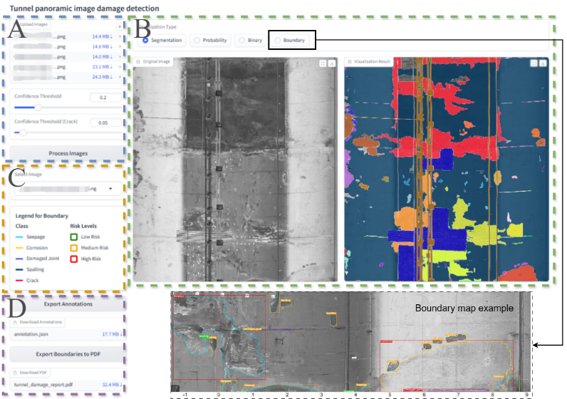
Fig. 3. A web-based platform diagram for displaying tunnel panorama damage detection results.
The damage report is based on a boundary map. A template PDF with legends and blank tables is prepared, and the pypdf (Fenniak et al., 2024) packages are used to embed the map, overlay a coordinate system, and fill in the tables with necessary details.
- Implementation
All experiments were conducted using NVIDIA A100 Tensor Core GPUs, with the software environment consisting of MMCV 2.1, PyTorch 2.0.1, and CUDA 11.7. The code is based on MMDetection (Chen et al., 2019), along with the data augmentation strategies from the Maks2Former official setup. The training batch size is set to 4, with 2 GPUs, each having a batch size of 2. The AdamW optimizer was employed, and the learning rate followed a cosine annealing schedule, starting with a linear warm-up for 250 iterations, then set to 1e-4 and gradually reduced to 1e-7. During training, we introduced mixed-precision training.
For the main network, we used the Swin-L backbone (Liu et al., 2021) and the panoptic segmentation decoder of Mask2Former (Cheng et al., 2022). For the side network, we used the EfficientViT backbone (Liu et al., 2023). The input for training consists of the 6k resolution tunnel UHR panoramic unfolded images. As described in the methodology section, during training, random 1024×1024 local patches and contexts are extracted from the UHR images, which serve as the actual input, similar to typical segmentation algorithms. For the context size, we tested expansions from the local patch by 12.5%, 25%, 50%, 75%, and 100%, corresponding to expansions of 128, 256, 512, 768, and 1024 pixels in all directions. We tested scenario with no context, where Mask2Former is applied for comparison.
During the actual training process, repeatedly reading UHR images and performing local patch and context extraction can significantly reduce training efficiency. Therefore, before training, we performed a preprocessing step to generate all the local patches and contexts of different sizes extracted from the UHR images at once. This also reduced the impact of randomness in the extraction process on the ablation experiments. For each UHR image, we randomly extracted 3600 patches, excluding those without annotations. During training, all extracted patches and corresponding contexts are only learned by the model once. We also compared this with a fixed extraction approach, where the 6k image is split into 6×6 local patches and corresponding contexts are generated, with training conducted 100 epochs to align with the random extraction experiment. We tested different lightweight EfficientViT backbones, including b0, b1, and b2. Additionally, in the context guidance section, we tested the difference between using guidance from the final layer and the last two layers. During the inference stage, we used a 25% overlap to address the instance merging, and take the result of the previous inference for the overlapping part.
- Results and discussion
  - Results and ablation study
The results are shown in Table 1, with the best iteration selected based on PQ on validation set. “128”, “256”, etc. present the expansion of contextual sizes. “b0”, “b1” and “b2” represent the different encoder sizes of EfficientViT used in the side network. “2l” indicates the use of guidance from the last two layers, while the others only from the last layer. “fix” refers to fixed cropping, while “rd” refers to random cropping.
Table 1. Results of proposed framework under different training parameters setting.
Model | PQ | SQ | RQ
No context-fix | 52.40 | 71.07 | 62.75
No context-rd | 53.14 | 73.52 | 62.77
128-b2-rd | 53.68 | 78.30 | 64.42
256-b0-rd | 52.17 | 78.46 | 62.81
256-b1-rd | 53.32 | 80.42 | 63.02
256-b2-rd | 55.99 | 79.58 | 67.14
256-b2-2l-rd | 54.30 | 78.38 | 64.82
256-b2-fix | 53.62 | 79.51 | 63.73
512-b2-rd | 54.10 | 79.38 | 64.51
768-b2-rd | 53.58 | 79.93 | 63.82
1024-b2-rd | 52.49 | 73.06 | 62.67
Table 2. Comparison between best model and no context model (rd) for each defect.
Class | Model | PQ | SQ | RQ
Things | No context-rd | 28.34 | 61.78 | 36.99
 | 256-b2-rd | 33.63 | 72.98 | 44.86
Seepage | No context-rd | 44.47 | 82.45 | 53.94
 | 256-b2-rd | 50.39 | 82.47 | 61.10
Corrosion | No context-rd | 14.21 | 81.72 | 17.39
 | 256-b2-rd | 18.68 | 68.76 | 27.16
Damaged joint | No context-rd | 32.34 | 60.19 | 46.15
 | 256-b2-rd | 42.66 | 60.79 | 70.18
Spalling | No context-rd | 50.66 | 84.54 | 59.93
 | 256-b2-rd | 53.16 | 87.33 | 60.87
Crack | No context-rd | 0 | 0 | 0
 | 256-b2-rd | 3.28 | 65.52 | 5

From the above experiments, we can observe that whether context is included or not, random cropping consistently outperforms fixed cropping. For no context model, introducing random cropping, performance increases from 52.40 to 53.14, an improvement of 0.74, while for 246-b2-fix and 256-b2-rd show a larger gain, improving from 53.62 to 55.99, a difference of 2.37. After adding contextual information, the majority of models showed improvement. Among the different side network backbones, the b2 backbone yielded the best results. When analysing the effect of different context sizes, we found that a context size of 256 was the most effective for our data. Compared to no context model with random cropping, it shows improvements of 2.85 in PQ, 6.06 in SQ and 4.37 in RQ. However, as the context size increased, the performance worsened, with the effect declining by the expending size reached 1024. Larger contexts did not effectively guide the local patch in our dataset. Additionally, using only the context guidance from the last layer produced the best results.
Table 2 compares the best model (256-b2-rd) with the no-context baseline (rd) for each defect category. The results demonstrate that the incorporation of contextual guidance improves the model’s damage recognition performance across all categories, particularly with a notable enhancement in RQ, indicating that proposed method effectively increases prediction accuracy for objects with recognizable qualities.

  - Visualization of analysis results
We visualized the attention distribution of the model when processing the outermost three pixels of a local patch (edge region), shown in Figure 4.
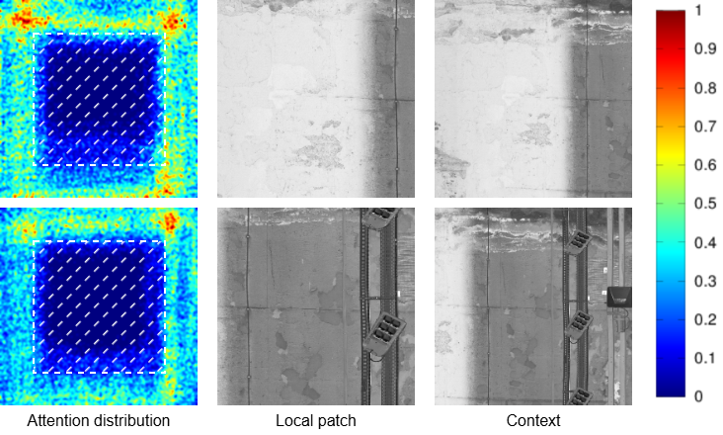
Fig. 4. The visualized normalized attention distribution pattern when processing the outermost three pixels of a local patch, and the area filled with white dashed lines is the local patch.
We found that the model focuses attention mainly on the surrounding context outside the local patch. This shows that when extracting edge features, the model tends to look outward for nearby information to compensate for the lack of information within the patch itself. This attention distribution pattern validates the design rationale of our proposed framework.

  - Damage report generation
We present an example In Figure 5. We can observe that after adding contextual information, the patch predictions improved significantly, greatly alleviating the issues caused by missing context, which previously hindered the patch’s ability to perform accurate analysis. The “no context” results show several missing areas (Figure 5(d) highlight part), leading to discontinuous segmentation of large instances in the UHR image, whereas the inclusion of context greatly mitigated this issue.
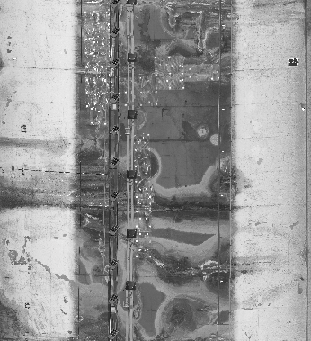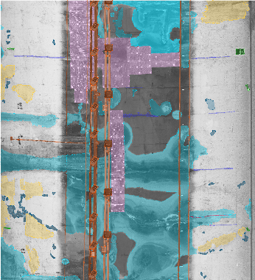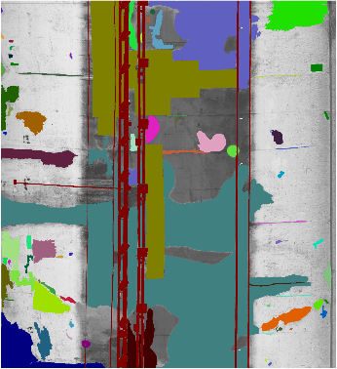
(a) (b) (c)
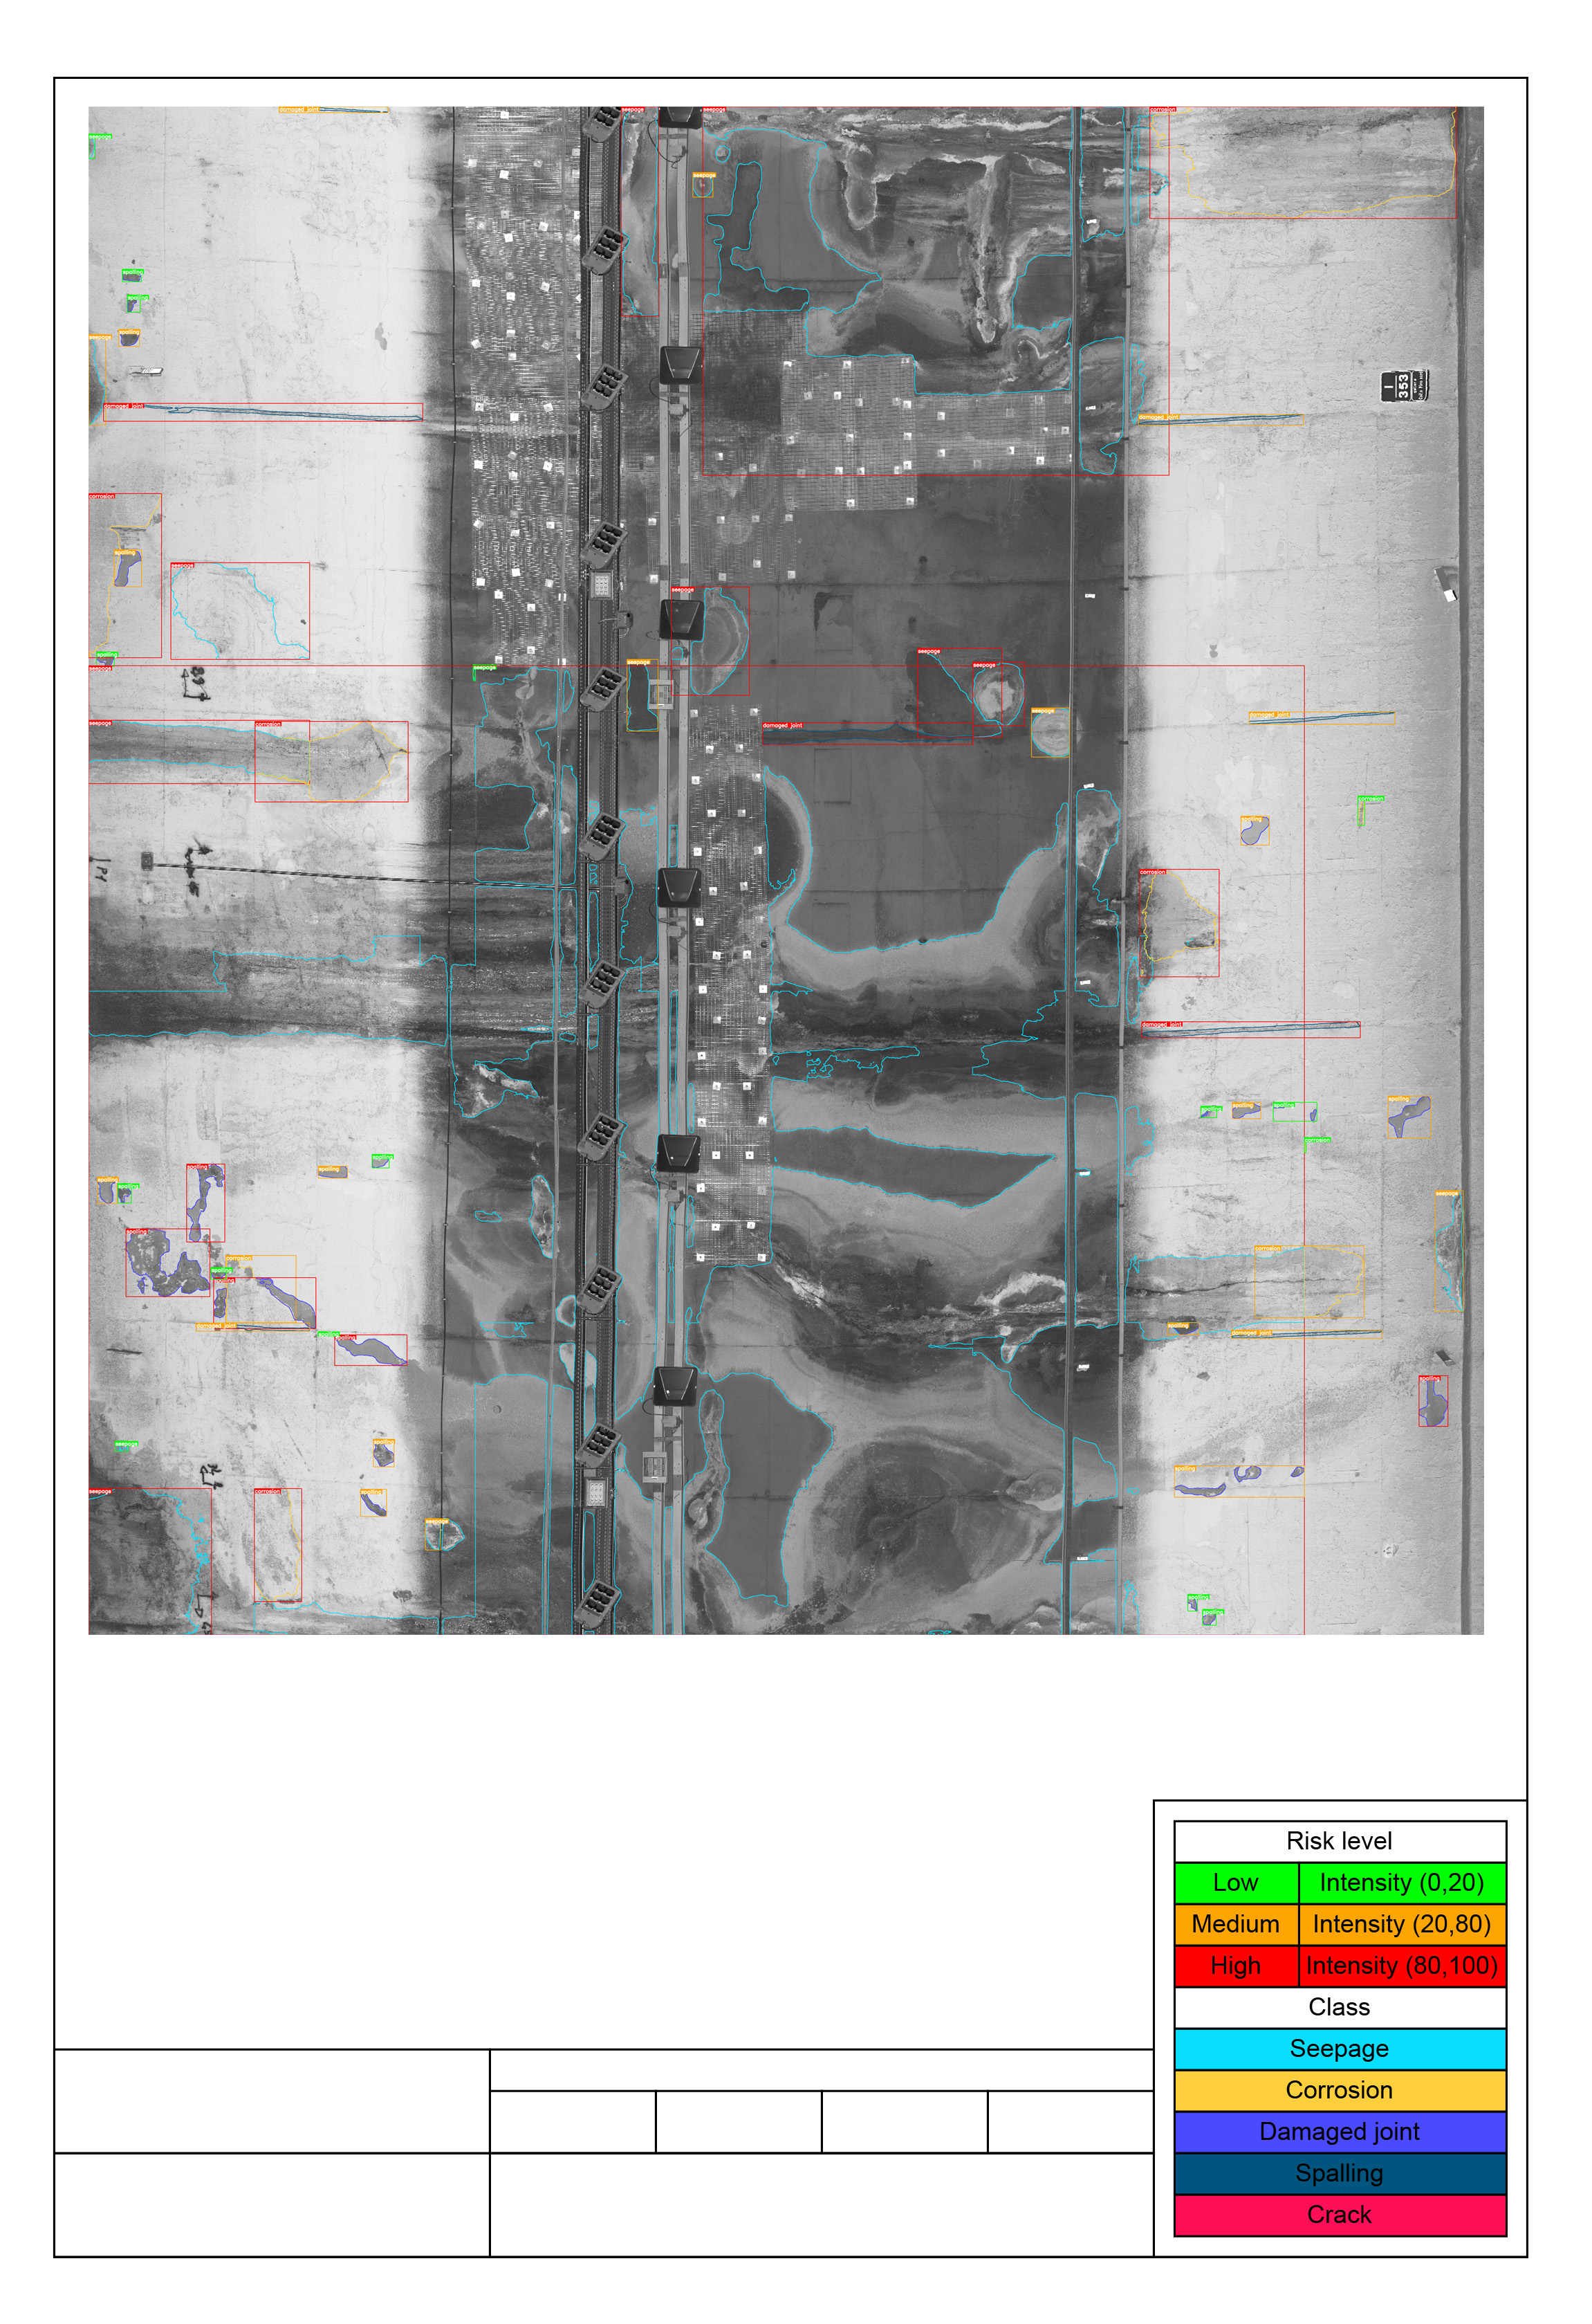
(d) (e) (f)
Fig. 5. The visualized results: (a) Original UHR image; (b) Classification annotation with category colors consistent with Figure 1; (c) Instance annotation; (d) Panoptic segmentation results with no context; (e) Panoptic segmentation results of our proposed method, and (f) Damage report derived from our method.
- Conclusion
In this paper, we propose an innovative framework for UHR image panoptic segmentation, aimed at comprehensive damage detection for tunnel panoramic unfolded images and tunnel damage report generation.
- Based on the general panoptic segmentation algorithm, Mask2Former, we introduced a lightweight side network, EfficientViT, to provide contextual information, significantly improving the panoptic segmentation quality of tunnel UHR images. Compared to models without context guidance, our best model (with 25% outward expansion of context) achieved improvements of 2.85, 6.06, and 4.37 in PQ, SQ, and RQ, respectively.
- From the visualization analysis, partial context information enhances the inference of local patches in UHR images, capturing damaged instances more accurately.
- We have developed an interactive web-based end-to-end platform that can batch process tunnel panoramic unfolded images and generate PDF damage reports and COCO-format digital annotations using our model. This highly automated algorithm framework and platform hold significant implications for tunnel management and monitoring

Acknowledgements
The computations described in this research were performed using the Baskerville Tier 2 HPC service (\url{https://www.baskerville.ac.uk/}). Baskerville was funded by the EPSRC and UKRI through the World Class Labs scheme (EP/T022221/1) and the Digital Research Infrastructure programme (EP/W032244/1) and is operated by Advanced Research Computing at the University of Birmingham. The computations described in this paper were also performed using the University of Birmingham’s BlueBEAR (\url{http://www.birmingham.ac.uk/bear}) HPC service, which provides a High Performance Computing service to the University’s research community. The engineering company TECNE underpinned the research and contributed all necessary data. Their ongoing collaboration has made it possible to engage with practical applications relevant to the field. This publication is part of the project PNRR-NGEU, which has received funding from MUR-DM 118/2023.

References
Abid, A., Abdalla, A., Abid, A., Khan, D., Alfozan, A., & Zou, J., (2019). Gradio: Hassle-free sharing and testing of ml models in the wild. arXiv preprint arXiv:1906.02569.
Cheng, B., Misra, I., Schwing, A. G., Kirillov, A., & Girdhar, R., (2022). Masked-attention mask transformer for universal image segmentation. In Proceedings of the IEEE/CVF conference on computer vision and pattern recognition (pp. 1290-1299).
Cheng, H. K., Chung, J., Tai, Y. W., & Tang, C. K. (2020). Cascadepsp: Toward class-agnostic and very high-resolution segmentation via global and local refinement. In Proceedings of the IEEE/CVF conference on computer vision and pattern recognition (pp. 8890-8899).
Chen, K., Wang, J., Pang, J., Cao, Y., Xiong, Y., Li, X., ... & Lin, D., (2019). MMDetection: Open mmlab detection toolbox and benchmark. arXiv preprint arXiv:1906.07155.
Chen, W., Jiang, Z., Wang, Z., Cui, K., & Qian, X., (2019). Collaborative global-local networks for memory-efficient segmentation of ultra-high resolution images. In Proceedings of the IEEE/CVF conference on computer vision and pattern recognition (pp. 8924-8933).
Fenniak, M., Stamy, M., pubpub-zz, Thoma, M., Peveler, M., exiledkingcc & pypdf Contributors, (2024). The pypdf library. Available at: https://pypi.org/project/pypdf/ [Accessed date].
Guo, S., Liu, L., Gan, Z., Wang, Y., Zhang, W., Wang, C., ... & Xu, K. (2022). Isdnet: Integrating shallow and deep networks for efficient ultra-high resolution segmentation. In Proceedings of the IEEE/CVF conference on computer vision and pattern recognition (pp. 4361-4370).
Huang, H., Cai, Y., Zhang, C., Lu, Y., Hammad, A., & Fan, L., (2024). Crack detection of masonry structure based on thermal and visible image fusion and semantic segmentation. Automation in Construction, 158, 105213.
Huang, M.Q., Ninić, J. and Zhang, Q., (2021). BIM, machine learning and computer vision techniques in underground construction: Current status and future perspectives. Tunnelling and Underground Space Technology, 108, p.103677.
Huynh, C., Tran, A. T., Luu, K., & Hoai, M., (2021). Progressive semantic segmentation. In Proceedings of the IEEE/CVF Conference on Computer Vision and Pattern Recognition (pp. 16755-16764).
Ji, D., Zhao, F., Lu, H., Tao, M., & Ye, J. (2023). Ultra-high resolution segmentation with ultra-rich context: A novel benchmark. In Proceedings of the IEEE/CVF Conference on Computer Vision and Pattern Recognition (pp. 23621-23630).
Ji, S. and Zhang, H. (2023). ISAT with Segment Anything: An Interactive Semi-Automatic Annotation Tool. Available: https://github.com/yatengLG/ISAT_with_segment_anything. Updated on 2023-06-03.
Kirillov, A., He, K., Girshick, R., Rother, C., & Dollár, P., (2019). Panoptic segmentation. In Proceedings of the IEEE/CVF conference on computer vision and pattern recognition (pp. 9404-9413).
Kirillov, A., Mintun, E., Ravi, N., Mao, H., Rolland, C., Gustafson, L., Xiao, T., Whitehead, S., Berg, A.C., Lo, W.Y. and Dollár, P., (2023). Segment anything. In Proceedings of the IEEE/CVF international conference on computer vision (pp. 4015-4026).
Li, Q., Cai, J., Luo, J., Yu, Y., Gu, J., Pan, J., & Liu, W., (2024). Memory-constrained semantic segmentation for ultra-high resolution UAV imagery. IEEE Robotics and Automation Letters, 9(2), 1708-1715.
Li, Q., Yang, W., Liu, W., Yu, Y., & He, S., (2021). From contexts to locality: Ultra-high resolution image segmentation via locality-aware contextual correlation. In Proceedings of the IEEE/CVF International Conference on Computer Vision (pp. 7252-7261).
Liu, W., Li, Q., Lin, X., Yang, W., He, S., & Yu, Y., (2024). Ultra-high Resolution Image Segmentation via Locality-aware Context Fusion and Alternating Local Enhancement. International Journal of Computer Vision, 132(11), 5030-5047.
Liu, X., Peng, H., Zheng, N., Yang, Y., Hu, H., & Yuan, Y. (2023). Efficientvit: Memory efficient vision transformer with cascaded group attention. In Proceedings of the IEEE/CVF conference on computer vision and pattern recognition (pp. 14420-14430).
Liu, Z., Lin, Y., Cao, Y., Hu, H., Wei, Y., Zhang, Z., ... & Guo, B. (2021). Swin transformer: Hierarchical vision transformer using shifted windows. In Proceedings of the IEEE/CVF international conference on computer vision (pp. 10012-10022).
Ministro delle infrastrutture e dei trasporti (MIT) (2023). Relazione concernente lo stato di attuazione degli interventi relativi all’adeguamento delle gallerie stradali della rete transeuropea, [Online], Available: https://www.senato.it/service/PDF/PDFServer/DF/426541.pdf.
Xu, Y., Li, D., Xie, Q., Wu, Q., & Wang, J., (2021). Automatic defect detection and segmentation of tunnel surface using modified Mask R-CNN. Measurement, 178, 109316.
Ye, Z., Lovell, L., Faramarzi, A. and Ninić, J., 2024. Sam-based instance segmentation models for the automation of structural damage detection. Advanced Engineering Informatics, 62, p.102826.
Zhou, Z., Zhang, J., & Gong, C., (2022). Automatic detection method of tunnel lining multi‐defects via an enhanced You Only Look Once network. Computer‐Aided Civil and Infrastructure Engineering, 37(6), 762-780.

