Unsupervised Bridge Anomaly Detection under Environmental Variability Using GAN-Enhanced Adaptive Affinity Propagation

Wen Gao1, Zheng-Han Chen1, Alireza Entezami1, Hassan Sarmadi2, Bahareh Behkamal1

1 Department of Civil and Environmental Engineering, Politecnico di Milano, Milan, Italy

2 Research and Development Director, IPESFP Startup Company, Mashhad, Iran  
wen.gao@polimi.it

**Abstract.** Environmental variability poses a persistent challenge in the structural health monitoring (SHM) of bridges, often masking or mimicking genuine structural anomalies. This study introduces a novel unsupervised anomaly detection framework that robustly adapts to such variability through a fusion of advanced clustering and generative learning. The proposed methodology integrates three key stages: (1) Gaussian Mixture Modeling (GMM) to isolate temperature-affected data, enhanced through Generative Adversarial Networks (GANs) to address data scarcity; (2) Improved Affinity Propagation (IAP) clustering guided by a Fruit Fly Optimization Algorithm (FOA) for automatic hyperparameter tuning and enhanced clustering stability; and (3) a density-based anomaly detection module leveraging Mahalanobis distance metrics to isolate outliers from clustered data. This GAN-FOA-IAP framework is validated using a benchmark bridge, Z24, featuring real modal frequency data. Results show that the method significantly mitigates environmental effects, yielding high detection accuracy, precision, and balanced recall across diverse test scenarios. Comparative analysis against other configurations (e.g., FOA-AP, GAN-FOA-AP) demonstrates the superior adaptability and reliability of the proposed pipeline. The framework does not rely on labeled data, making it highly scalable for real-world SHM systems. By dynamically adapting to environmental influences, it enables timely and accurate anomaly detection, reinforcing its utility for preventive maintenance and safety assurance of bridge structures.

**Keywords:** Structural Health Monitoring, Anomaly Detection, Affinity Propagation, Generative Adversarial Networks, Environmental Variability, Bridge Monitoring

1. Introduction

As critical infrastructure, bridges play a vital role in daily life and economic growth. However, prolonged exposure to environmental factors, operational stress, and natural aging leads to structural degradation, compromising their safety and durability [1–5]. Effective bridge health monitoring is crucial to prevent property loss and ensure public safety. Traditional manual inspection methods are labor-intensive, inefficient, and prone to inaccuracies. Fortunately, with growing government focus and advances in infrastructure, most bridges now employ automated health monitoring systems, enabling real-time data collection and analysis [6, 7]. Bridge monitoring data can be classified into visual data [8] and sensor-based numerical data [9]. While visual inspection enables intuitive surface damage assessment and localization, it cannot detect internal structural deterioration — a critical limitation, as hidden damage often precedes visible failure. Numerical data complements this gap by providing real-time insights into internal structural health, enabling earlier and more comprehensive risk detection [10–12].

Traditional bridge monitoring methods—such as manual inspections and model-based approaches — face challenges in efficiency, cost, and accuracy. These techniques are often labor-intensive and struggle to identify subtle anomalies, particularly when environmental and operational variations obscure structural changes. To overcome these limitations, machine learning, particularly unsupervised learning, has emerged as a promising solution. For instance, the research by Alireza et al. [13] proposed a time series modeling method to improve feature extraction in SHM, demonstrating the effectiveness of unsupervised techniques without the need for labeled data. By analyzing vibration data without requiring labeled datasets, unsupervised methods enable automated and more sensitive anomaly detection [14].

Despite advances in unsupervised learning for structural health monitoring, challenges like noise, environmental variability (e.g., temperature [15], wind), and limited data hinder accurate anomaly detection. Existing methods often struggle to differentiate true structural damage from environmentally induced variations.

In response to this challenge, we put forward a novel unsupervised framework combining Generative Adversarial Networks (GANs) for data augmentation and an Improved Affinity Propagation (IAP) algorithm optimized by the Fruit Fly Optimization Algorithm (FOA) for robust clustering. The GAN-FOA-IAP method adapts to noise and dynamic patterns, while a density-based threshold dynamically identifies anomalies. Tests on bridge data confirm its effectiveness in reducing environmental interference and enhancing detection accuracy.

1. Proposed method
   1. Overview

This chapter outlines the proposed anomaly detection framework, which consists of three key steps:

1. Data Extraction and enhancement: Frost-affected samples are identified using a Gaussian Mixture Model (GMM) and augmented via Generative Adversarial Networks (GANs).
2. Clustering: The augmented and original data are combined and clustered using Improved Affinity Propagation (IAP), optimized by the Fruit Fly Algorithm (FOA).
3. Anomaly Detection: A density-based detector evaluates test samples for corruption.

The workflow is illustrated in Fig. 1.

**Fig.1** Flowchart of the research work in this paper

* 1. Data enhancement

Gaussian Mixture Modeling (GMM) separation of temperature-affected data. To enhance the robustness of the methods in this paper and to make the proposed anomaly detection framework better adapted to the effects of the environment, a Gaussian Mixture Modeling is used in this paper to extract data that is affected by the temperature for the next step of data enhancement. The reason for choosing GMM is that it can be used for unsupervised clustering of data, which is in line with the idea of this paper that expects automation of the algorithm.

Generating Adversarial Networks (GANs). Generative Adversarial Networks (GANs), introduced by Goodfellow et al [16], employ a generator-discriminator framework to produce synthetic data matching real-data distributions. The generator transforms random noise into increasingly realistic samples, while the discriminator evaluates their authenticity through probabilistic classification. This adversarial training mechanism has proven effective for data augmentation.

* 1. The improved affinity propagation algorithm is optimized using the fruit fly optimization algorithm (FOA-IAP)

Improved affinity propagation algorithm (IAP). Affinity Propagation (AP) is an unsupervised graph-based clustering method that automatically determines cluster centers through message passing between data points. Unlike traditional approaches, AP requires no preset cluster number. Instead, it treats all points as potential centers and iteratively refines them by updating two key metrics: responsibility and availability. The algorithm executes through four sequential steps:

(1) Compute the similarity matrix **S** using negative Euclidean distances, then initialize the responsibility (**R**) and availability (**A**) matrices.

(2) Update the attraction matrix **R** according to the following algebraic equation:



The value $r\left(i,k\right)$ reflects the extent to which point *k* is considered an appropriate cluster center for point *i*, and $s\left(i,k\right)$ measures the similarity between the two points.

(3) Update the attribution matrix **A**:





where $a\left(i,k\right)$ denotes the extent to which point *i* chooses point *k* as its clustering center, $r\left(k,k\right)$ denotes the self-attributed degree of attraction of point *k*, and $\sum_{{\text{i}}^{\text{'}}\text{∉}\left\{\text{i,k}\right\}}{\text{max}\left\{\text{0, }{\text{r}}_{\text{t}}\text{(}{\text{i}}^{\text{'}}\text{,}\text{k}\text{)}\right\}}$ denotes the sum of the degrees of attraction that point *k* receives from points other than point *i*. $a\left(k,k\right)$ is interpreted to mean that the degree of self-attribution is the sum of the degrees of attraction that point *k* receives from the sum of positive attractiveness obtained from points other than point *i*.

(4) The fourth step is to update the two matrices according to attenuation coefficients:





After that, repeat steps (2) and (3) until the set maximum number of iterations is reached or the results remain unchanged after several iterations, and jump out of the loop iteration to get the final clustering results.

Although Euclidean distance is widely used, the discriminatory power of Euclidean distance decreases as the dimensionality of the data increases, and Euclidean distance ignores the nonlinear structure of the data and can only measure the linear similarity of the data. Therefore, this paper improves AP clustering and uses Gaussian kernel distance for similarity measurement because Gaussian kernel distance is more suitable for nonlinear differentiable data. Fig. 2 clearly shows the specific structure of the improved affinity propagation clustering (IAP).

Regarding how to obtain the clustering center, for point *i*, the point *m* that makes $a\left(i,k\right)+r(i,k)$ the largest point *m*. If *i*=*m*, then point *i* is the clustering center, and if *i*≠*m*, then point *m* is the clustering center of point *i*.



**Fig. 2** Specific structure of improved affinity propagation clustering

Although the improved affinity propagation clustering does not require the number of clustering centers to be preset, there are two important parameters in the method, namely the preference parameter P and the damping factor $λ$. $λ$ is a parameter that is set to prevent the update from being too large and leading to non-convergence during the updating of the affinity and attribution matrices and is empirically usually set to 0.5. The preference parameter P is the value placed on the diagonal of the similarity matrix S in step (1), and according to the rules for updating the attraction and attribution matrices, it can be seen that a larger $p(k)$ will result in a larger $A\left(k,k^{'}\right)$, which means that the point *k* has a greater possibility of becoming a clustering center. Therefore, the size of the P-value affects the final clustering result, in other words, the larger the P-value, the result tends to make more data points become clustering centers.

The results of the IAP clustering algorithm will be affected because of the P-value; in order to automate the algorithm and get the optimal solution in the value domain, this paper adopts the fruit fly searching algorithm to find the optimal P-value in the range and evaluates the optimal P-value based on the clustering effect indicator silhouette index (2.3).

Fruit fly optimization algorithm (FOA). Fruit Fly Optimization Algorithm (FOA) is an intelligent optimization algorithm based on the bionic principle of fruit fly foraging behavior. Its basic working principle is that the fruit fly determines the location of food according to the smell of food in the air and calls its companions to fly towards the source of food odor. The above operation is performed continuously until the food is found.

In this paper, we utilize this algorithm to automatically find the optimal P-value of the IAP clustering algorithm. The specific steps are as follows:

First, a population with a parameter P-value is randomly initialized, where the P-value of each individual of the population is randomly generated in a given range [*pmin*, *pmax*], and *pmin* and *pmax* are the maximum and minimum values in the similarity matrix after removing the extreme maximums and extreme minimums, respectively.

Evaluation of P-values for current fruit fly population. The P-value of the current fruit fly population is brought into the IAP clustering algorithm, and the optimal P-value in the current fruit fly population is obtained based on the effect of clustering.

Update the flight direction and distance of the fruit fly. Based on the current optimal solution, *pbest* and generate new candidate solutions by introducing random perturbations. P-value is updated as follows:



where *rand(i)* is a random number in the interval [0,1]. Since the range of P-value is to be between [*pmin*, *pmax*]:



Combining the above steps ((6)(7)), we get the update formula of P-value:



The formulation generates a new candidate solution by applying a perturbation on the current optimum P-value. The magnitude of the perturbation depends on the current number of iterations iter and decreases as the number of iterations increases, gradually approximating P-value. Finally, the candidate solutions are restricted to the range of [*pmin*, *pmax*].



**Fig. 3** Automated process for calculating P-value

Unsupervised clustering effect index. While the IAP clustering algorithm reduces dependence on the P-value, its unsupervised nature prevents direct accuracy validation. To address this, we employ the silhouette index—a widely used metric for evaluating cluster cohesion and separation—to assess the quality of each P-value iteration’s results. The silhouette score is calculated as follows:



Here, *a*(*t*) denotes the mean distance between point *t* and all other points within the same cluster, while *b*(*t*) represents the smallest average distance from point *t* to points in any other cluster.

After using the silhouette index as an indicator, the determination of P-value in the IAP algorithm is automated. The detailed procedure is illustrated in Fig. 3.

* 1. Density-based anomaly detector

The third core component is a density-based anomaly detector. Building on similarity-driven clustering, the detector computes anomaly scores using distance metrics from the clustering phase. A statistically derived threshold then identifies anomalies, ensuring robust detection aligned with the feature learning framework [17].

This study's anomaly scoring mechanism builds upon Alireza et al.'s inverse density-distance principle [18, 19]. The fundamental premise recognizes that in clustered data, healthy samples naturally form dense regions with shorter inter-point distances, while anomalies appear as sparse outliers with greater separation. Following training data clustering, this characteristic manifests through distinct spatial patterns: normal data aggregates into tight, high-density clusters whereas anomalies occupy peripheral positions with both lower local density and larger distances from core clusters. These spatial relationships are quantified through our proposed metric:



To effectively discriminate between healthy and damaged data through relative distance analysis, we employ a Mahalanobis distance-based approach to compute local sample density within clustered subsets. Building on the previous stage's *m* health data clusters, each sample's relative density is determined by taking the maximum local density value across all *m* clusters. This density metric serves as the foundation for our anomaly detection algorithm, as formalized in the following equation:





Where $μ_{x}$ and $H_{x}$ denote the mean vector and covariance matrix of **X**.

In this paper, the anomaly score threshold for the test set is defined as 1.1 times the maximum anomaly score observed in the training set, as calculated by the following equation:



1. Application
   1. A concrete box-girder bridge

Z24 bridge is a post-tensioned concrete box girder bridge on the A1 highway in Switzerland, built in 1963 to connect the villages of Koppigen and Utzenstorf. The bridge had a three-span structure (main span of 30 meters and side spans of 14 meters each) and was demolished in 1998 due to expansion needs. Prior to the demolition a long-term structural health monitoring of Z24 bridge was carried out to obtain vibration data. In this section, the effectiveness of the proposed method is verified through the modal characterization of Z24 bridge.

* 1. Data description

This study analyzes the Z24 bridge's modal frequency data across four modes, initially collecting 5,652 samples. After preprocessing to remove incomplete entries, 3,932 valid samples remained, comprising 3,470 healthy and 462 abnormal cases. To reflect real-world conditions—where anomalies are absent during training, we allocated 70% of healthy samples (2,429) for training, while the test set combined the remaining 30% healthy data (1,041) with all abnormal cases (462).

* 1. Data enhancement and model training

After constructing the dataset, the first step is to extract the data from the training set using GMM. In this paper, we set to get two clusters after passing through the GMM and consider the cluster with higher mean as the cluster of data affected by the temperature, and finally we get 584 frequency data affected by the temperature.

The 584 preprocessed samples were augmented using GANs, with two key modifications to improve realism: (1) label smoothing was applied to prevent discriminator overconfidence, and (2) generator loss incorporated mean and covariance constraints to avoid mode collapse and ensure generated data matched the true distribution.

After GANs training, a total of 400 enhanced data were generated to augment the part of the original data that was affected by the environment, a visual comparison of the original and enhanced datasets is provided in Fig. 4.

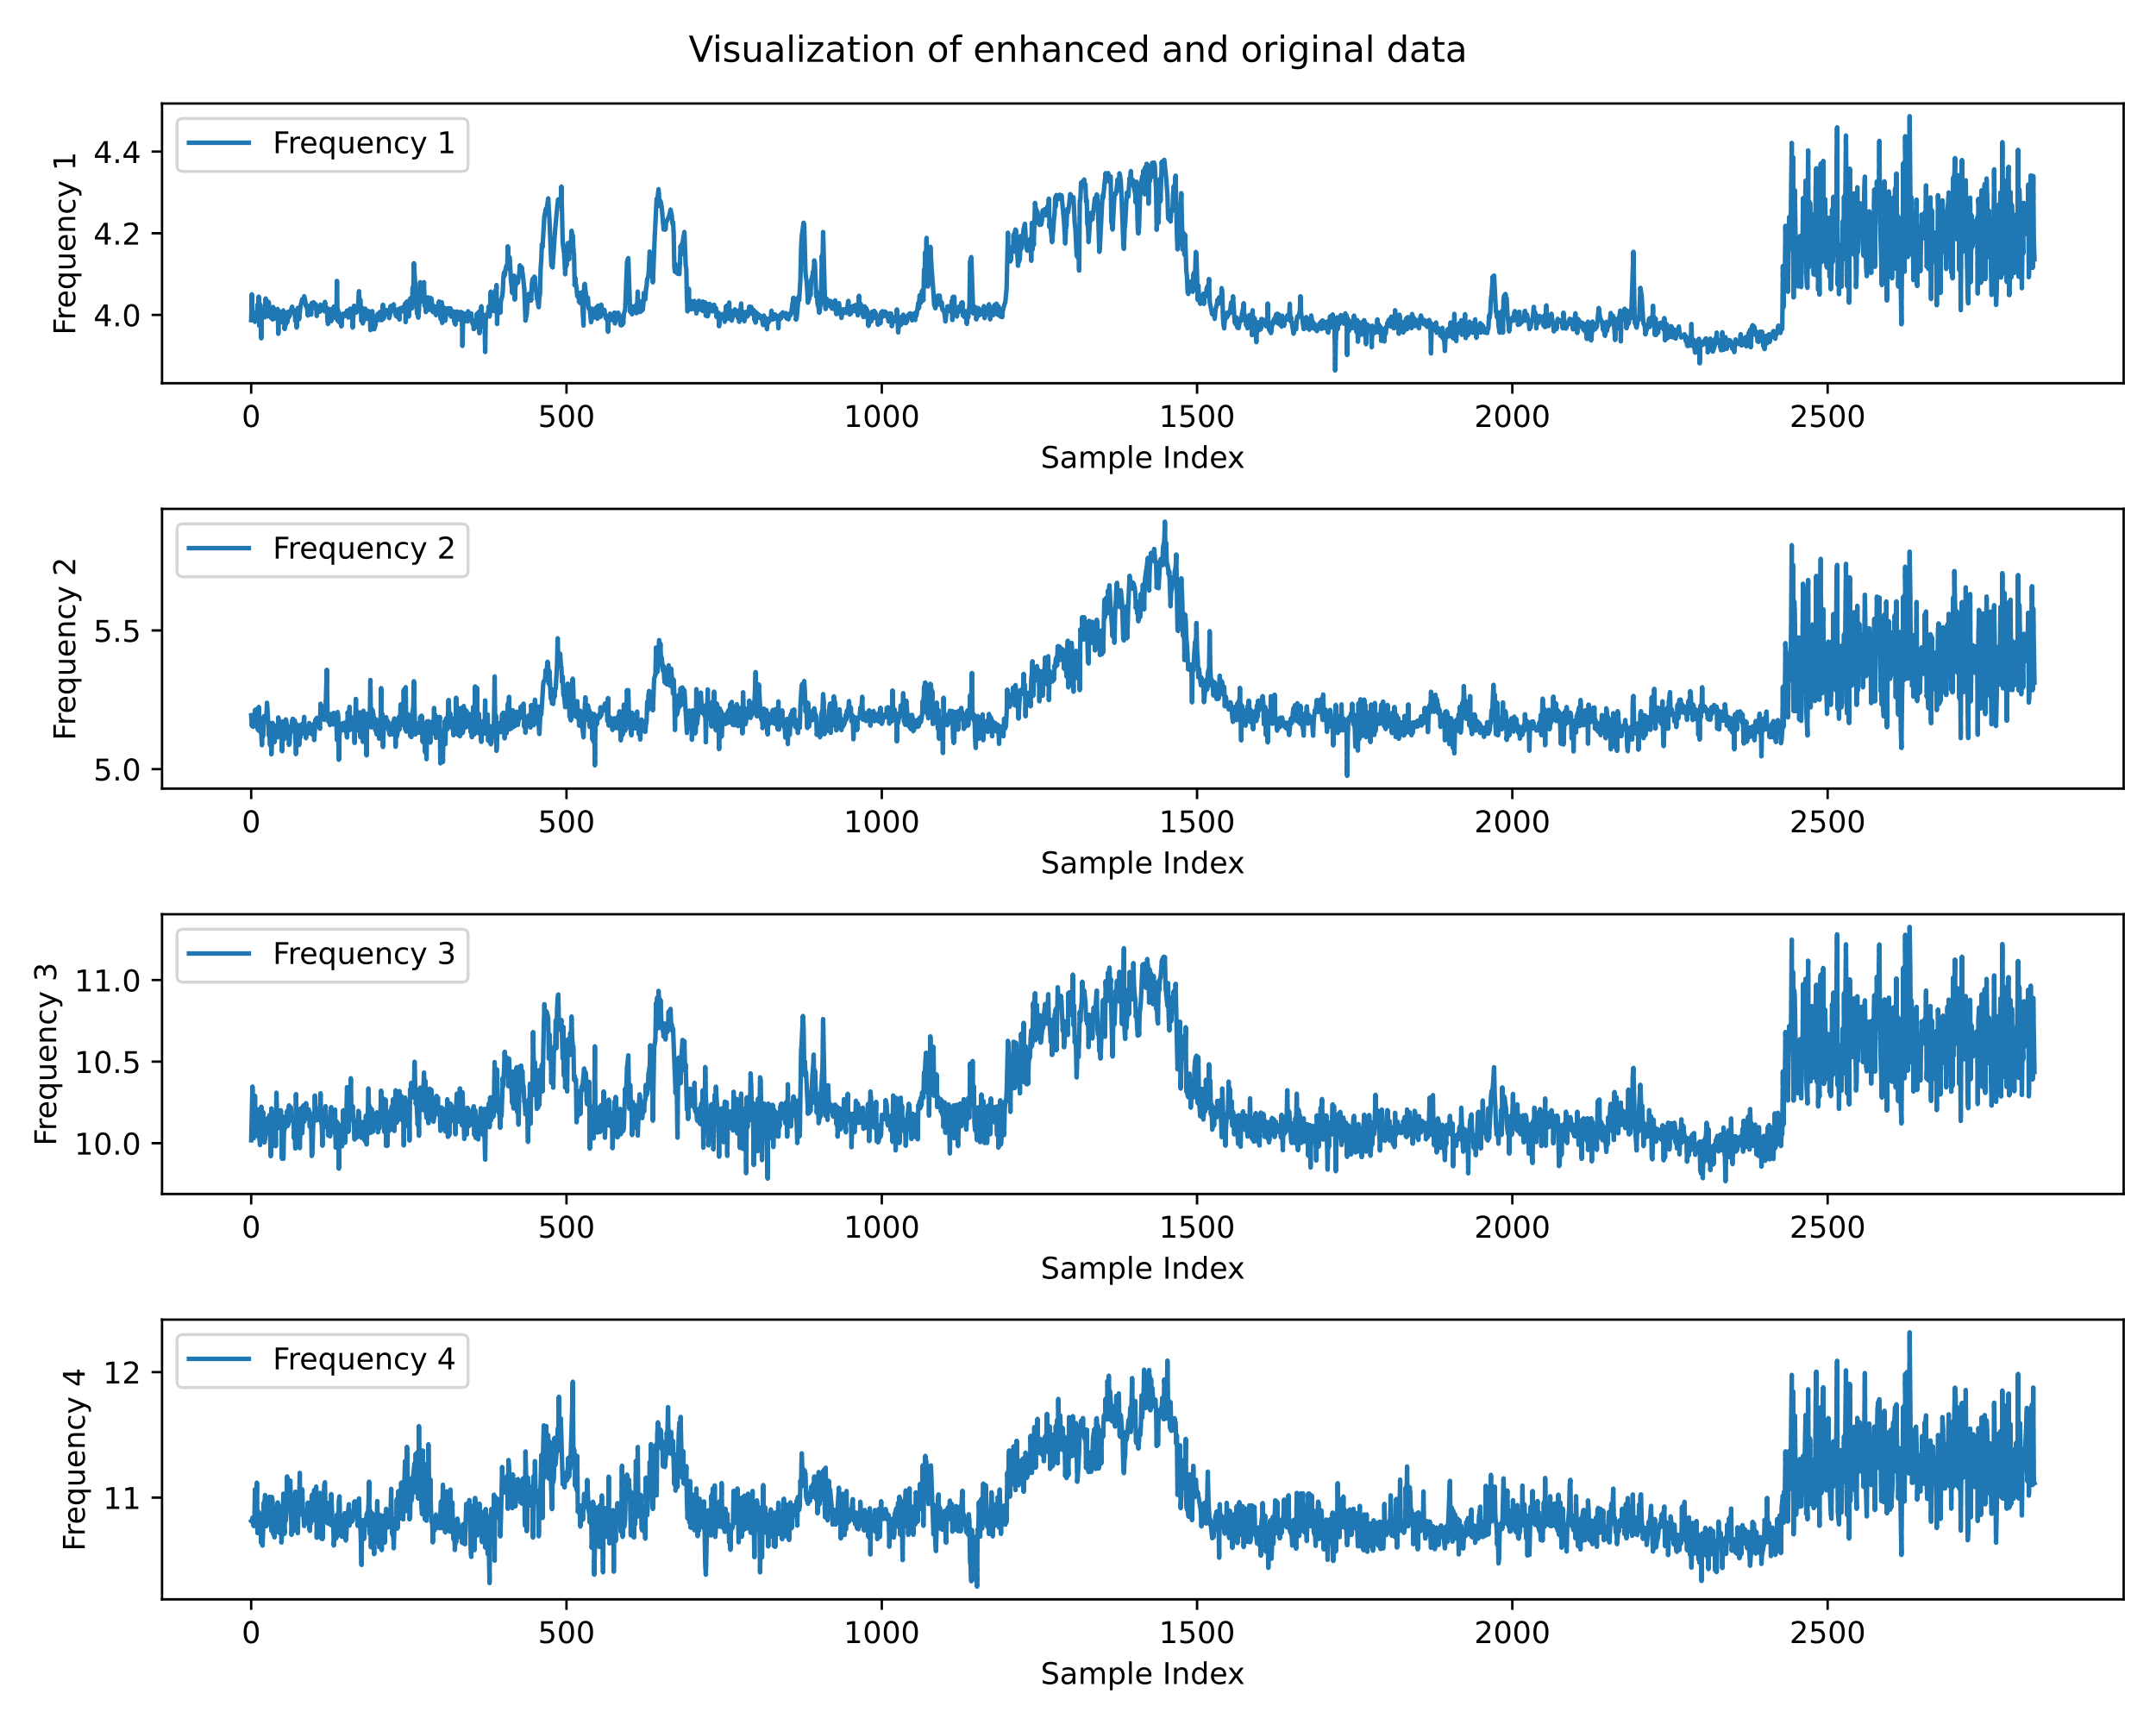

**Fig. 4** Visualization of enhanced and original data of Z24 bridge

1. Results

After clustering, this paper calculated the anomaly scores, and threshold estimates for all the data using the methods mentioned in Chapter 2. The calculated results are shown in Fig. 5. Firstly, it can be seen from the figure that the anomaly score threshold obtained by the anomaly detection framework of this paper is 0.0044, of which only 4 data points are false alarms and 41 data points are leakages. This shows that the framework proposed in this paper performs well on the Z24 bridge.

To visualize the good performance of the proposed method in this paper more, we also conducted 3 sets of comparison tests. They are (1) applying AP clustering optimized by FOA, without incorporating data enhancement through GANs (FOA-AP) (Fig. 6); (2) applying IAP clustering optimized by FOA, without incorporating data enhancement through GANs (FOA-IAP) (Fig. 7); and (3) applying AP clustering optimized by FOA, with incorporating data enhancement through GANs (GAN-FOA-AP) (Fig. 8). The anomaly scores for all three controls were calculated and thresholds estimated in the same way as in this paper.

图表, 散点图

AI 生成的内容可能不正确。

**Fig. 5** Plot of anomaly detection results using GAN-FOA-IAP for Z24 bridge

图表, 散点图

AI 生成的内容可能不正确。

**Fig. 6** Plot of anomaly detection results using FOA-AP for Z24 bridge

图表, 散点图

AI 生成的内容可能不正确。

**Fig. 7** Plot of anomaly detection results using FOA-IAP for Z24 bridge

图表, 散点图

AI 生成的内容可能不正确。

**Fig. 8** Plot of anomaly detection results using GAN-FOA-AP for Z24 bridge

To provide a more intuitive comparison of the performance across methods, this paper summarizes the results of GAN-FOA-IAP and three control groups in a table (Tab. 1), evaluated according to multiple metrics.

**Tab. 1** Performance comparison of GAN-FOA-IAP with other methods at Z24 bridge

|  |  |  |  |  |  |  |  |  |
| --- | --- | --- | --- | --- | --- | --- | --- | --- |
|  | | False alarm | Leakage | Accuracy | Recall | Precision | F1 Score | Balanced Acc |
| GAN-FOA-IAP | **1** | | 43 | **0.9707** | 0.9069 | **0.9976** | **0.9501** | **0.9530** |
| FOA-AP | 3 | | 65 | 0.9548 | 0.8593 | 0.9925 | 0.9211 | 0.9282 |
| FOA-IAP | 7 | | **42** | 0.9674 | **0.9091** | 0.9836 | 0.9449 | 0.9232 |
| GAN-FOA-AP | **1** | | 49 | 0.9667 | 0.8939 | **0.9976** | 0.9429 | 0.9465 |

1. Conclusions

This study validates the proposed unsupervised anomaly detection framework using Z24 bridge data. Key results demonstrate:

1. Data Processing: GAN-based augmentation enhances environmental adaptability
2. Clustering: FOA-IAP clustering with silhouette index reduces parameter sensitivity
3. Detection: Density-based detection achieves 99.76% accuracy and 97.07% precision

Comparative experiments show our method outperforms three baseline approaches, effectively mitigating environmental interference in vibration data while improving monitoring robustness.

References

1. Duran, B., Emory, D., Eftekhar Azam, Y., Linzell, D.G.: A novel CNN architecture for robust structural damage identification via strain measurements and its validation via full-scale experiments. Measurement. 239, 115393 (2025).

2. Fawad, M., Salamak, M., Chen, Q., Uscilowski, M., Koris, K., Jasinski, M., Lazinski, P., Piotrowski, D.: Development of immersive bridge digital twin platform to facilitate bridge damage assessment and asset model updates. Comput. Ind. 164, 104189 (2025).

3. Jayawickrema, U.M.N., Herath, H.M.C.M., Hettiarachchi, N.K., Sooriyaarachchi, H.P., Epaarachchi, J.A.: Fibre-optic sensor and deep learning-based structural health monitoring systems for civil structures: A review. Measurement. 199, 111543 (2022).

4. Xu, Z.-D., Chen, Z.-H., Huang, X.-H., Zhou, C.-Y., Hu, Z.-W., Yang, Q.-H., Gai, P.-P.: Recent Advances in Multi-Dimensional Vibration Mitigation Materials and Devices. Front. Mater. 6, 143 (2019).

5. Entezami, A., Arslan, A.N., De Michele, C., Behkamal, B.: Online Hybrid Learning Methods for Real-Time Structural Health Monitoring Using Remote Sensing and Small Displacement Data. Remote Sens. 14, 3357 (2022).

6. Ko, J.M., Ni, Y.Q.: Technology developments in structural health monitoring of large-scale bridges. Eng. Struct. 27, 1715–1725 (2005).

7. Li, A., Ding, Y., Wang, H., Guo, T.: Analysis and assessment of bridge health monitoring mass data—progress in research/development of “Structural Health Monitoring.” Sci. China Technol. Sci. 55, 2212–2224 (2012).

8. Xu, Y., Brownjohn, J., Kong, D.: A non-contact vision-based system for multipoint displacement monitoring in a cable-stayed footbridge. Struct. Control Health Monit. 25, e2155 (2018).

9. Bao, X., Chen, L.: Recent Progress in Distributed Fiber Optic Sensors. Sensors. 12, 8601–8639 (2012).

10. Ye, X.W., Su, Y.H., Han, J.P.: Structural Health Monitoring of Civil Infrastructure Using Optical Fiber Sensing Technology: A Comprehensive Review. Sci. World J. 2014, 1–11 (2014).

11. Li, H., Ou, J.: The state of the art in structural health monitoring of cable-stayed bridges. J. Civ. Struct. Health Monit. 6, 43–67 (2016). https://doi.org/10.1007/s13349-015-0115-x.

12. Rezaiee-Pajand, M., Entezami, A., Shariatmadar, H.: An iterative order determination method for time-series modeling in structural health monitoring. Adv. Struct. Eng. 21, 300–314 (2018).

13. Entezami, A., Shariatmadar, H., Karamodin, A.: Improving feature extraction via time series modeling for structural health monitoring based on unsupervised learning methods. Sci. Iran. 27, 1001–1018 (2020).

14. Giglioni, V., Venanzi, I., Poggioni, V., Milani, A., Ubertini, F.: Autoencoders for unsupervised real‐time bridge health assessment. Comput.-Aided Civ. Infrastruct. Eng. 38, 959–974 (2023).

15. Behkamal, B., Entezami, A., De Michele, C., Arslan, A.N.: Investigation of Temperature Effects into Long-Span Bridges via Hybrid Sensing and Supervised Regression Models. Remote Sens. 15, 3503 (2023).

16. Goodfellow, I., Pouget-Abadie, J., Mirza, M., Xu, B., Warde-Farley, D., Ozair, S., Courville, A., Bengio, Y.: Generative Adversarial Nets.

17. Pang, G., Shen, C., Cao, L., Hengel, A. van den: Deep Learning for Anomaly Detection: A Review. ACM Comput. Surv. 54, 1–38 (2022).

18. Entezami, A., Sarmadi, H., Behkamal, B.: Short-term damage alarming with limited vibration data in bridge structures: A fully non-parametric machine learning technique. Measurement. 235, 114935 (2024).

19. Entezami, A.: Structural Health Monitoring by Time Series Analysis and Statistical Distance Measures. Springer International Publishing, Cham (2021).