**An Unsupervised Hybrid Clustering Framework for Early Structural Damage Detection under Environmental Variations and Limited Monitoring Data**

Seyed Mojtaba Shapourian1, Ataollah Sadri Rad1, Hassan Sarmadi2, Alireza Entezami1, Bahareh Behkamal1

1 Department of Civil and Environmental Engineering, Politecnico di Milano, Milan, Italy

2 Research and Development Director, IPESFP Startup Company, Mashhad, Iran

ataollah.Sadri@mail.polimi.it

**Abstract.** Structural Health Monitoring (SHM) has become an essential practice for ensuring the safety and serviceability of critical infrastructure. However, early damage detection remains a major challenge due to the scarcity of vibration data and the strong influence of environmental and operational variations (EOVs). To address this, an innovative unsupervised hybrid framework based on Spectral Clustering combined with Density Peaks (SC-DP) is proposed. This method is designed to perform anomaly detection by utilizing only limited modal frequency data, making it particularly suitable for short-term monitoring programs where extensive data collection is impractical. In the proposed framework, spectral clustering is employed in the first phase to partition the training data by identifying its intrinsic structure, without the need for prior knowledge of the number of clusters. Subsequently, the density peaks algorithm is applied in the second phase to recognize damage-related anomalies in the testing data, effectively distinguishing structural changes from environmental effects. The key strengths of the SC-DP method include its reduced dependency on hyperparameter tuning, adaptability to small datasets, and robustness against EOVs. The effectiveness of the proposed approach is validated through two real-world case studies: the Z24 Bridge and the Yonghe Bridge. Comparative analyses demonstrate that the SC-DP framework outperforms conventional methods in detecting early-stage damage while maintaining a low false alarm rate. This research provides a promising tool for practical SHM applications, supporting the development of reliable early-warning systems for large-scale civil structures operating under varying environmental conditions.

**Keywords:** Structural Health Monitoring (SHM); Unsupervised Learning; Spectral Clustering; Density Peaks; Anomaly Detection; Environmental Variability

1. Introduction

Structural health monitoring (SHM) has become an essential field in civil, mechanical, and aerospace engineering, focusing on evaluating and maintaining structural integrity by detecting potential damage. This proactive approach helps keep large-scale infrastructure safe and reliable by providing timely insights to prevent major failures. Most of the constructed facilities were designed by different codes and guidelines and were constructed by various construction techniques, which may be outdated. Some of them were built several years or decades ago, in which case aging and material deterioration are two major factors for their undesirable severability. On the other hand, in reality, any civil structure may encounter unpredictable excitation sources such as earthquake, strong wind, hurricane, typhoon, ﬂood, etc. with different magnitudes, or a sequence or combination of these sources. Under such circumstances, structural damage can emerge leading to adverse changes in the structural performance and serviceability, and dramatically partial and global collapses [1]. SHM aims to evaluate structural health by detecting damage through vibration analysis, a method that has gained significant attention due to its ability to provide real-time monitoring, early identification of issues, and failure prediction. SHM systems enable accurate and immediate detection of damage in large civil infrastructures, ensuring their integrity and safety. To tackle this challenge, vibration-based structural damage detection has been a major focus over the past two decades. This approach involves analysing a structure's dynamic response to identify changes or anomalies that may indicate damage [2]. The data collected through SHM systems provide valuable insights into structural behaviours under varying conditions, allowing engineers to monitor structures effectively and address damage before catastrophic failures occur.

This study aims to create a vibration-based system for monitoring structural health, using machine learning to improve the accuracy of detecting and classifying damage. To do this, vibration data from structures will be collected and analysed to find patterns and signs that indicate possible damage. This study focuses on bridge damage detection on two case studies: the Z24 Bridge in Canton Bern, Switzerland, and the Yonghe Bridge in Tianjin, China. By utilizing an unsupervised machine learning approach, the novel approach, Spectral Clustering combined with Density Peaks (SC-DP), is implemented as a two-step process. First, it mitigates the effects of environmental and operational variations (EOVs) on the data, ensuring more reliable and consistent results. Then, it effectively identifies potential structural damages by accurately detecting anomalies. The findings, supported by various comparisons, demonstrate the efficiency and practicality of this method, validating its ability to enhance short-term monitoring programs by reliably addressing external influences and improving damage detection accuracy. These algorithms can then be applied to real-time data from a structural health monitoring system to detect anomalies and predict possible failures. By continuously monitoring the vibrations of a structure, machine learning algorithms can identify any deviations from normal behaviour and alert engineers to potential issues [3]. This enables the early identification of structural issues, allowing for prompt intervention and maintenance to prevent further deterioration. Additionally, the integration of machine learning algorithms with SHM systems enhances the precision and efficiency of damage detection, providing a proactive approach to maintaining structural integrity.

1. Proposed method

The proposed approach consists of two primary steps: data clustering and anomaly detection, aimed at providing early damage warnings in short-term monitoring of civil structures. As outlined in introduction, the SC-DP framework tackles key challenges, particularly those caused by EOV, by combining feature clustering with anomaly detection.

The process starts with the Spectral Clustering algorithm, which partitions the entire training dataset into clusters. Each cluster, along with both the training and test datasets, is then passed into the Density Pecks function to compute anomaly scores. For each training and test sample, the lowest anomaly score among all clusters is selected as the final output [4]. The anomaly scores from the training data are used to establish a decision threshold through a threshold estimator. If the anomaly score of any test sample exceeds this threshold, an alarm is triggered, indicating potential damage and classifying the structure as damaged. Conversely, if the score remains below the threshold, the structure is classified as undamaged.

For better understanding, **Fig. 1** presents a flowchart illustrating the general process of the proposed Approach. It is important to emphasize that threshold estimation is a crucial component of any unsupervised anomaly detection approach, playing a key role in decision-making. To maintain the non-parametric characteristics of the method, a non-parametric threshold estimator based on a standard confidence interval (SCI) is used.

Spectral clustering excels at identifying clusters by analysing the global structure of data using the eigenvalues of a similarity matrix, effectively capturing non-linear patterns and relationships within the data [5]. This method is particularly useful when clusters have non-convex shapes or are separated by irregular boundaries. By transforming the data into a lower-dimensional space, it identifies groups based on similarities across the entire dataset, making it highly effective for detecting intricate cluster structures.

On the other hand, the Density Peaks algorithm focuses on identifying cluster centers by considering both local density and distance measures [6]. It efficiently detects cluster centers as data points that are not only densely populated but also sufficiently far from other high-density regions. This approach, based on local density peaks, enables effective anomaly detection.

By combining these two approaches, the hybrid method leverages spectral clustering's global perspective with Density Peaks' local density detection. The result is a more adaptive and accurate clustering method that can handle datasets with complex structures, varied densities, and overlapping clusters. This hybrid technique is particularly advantageous in applications where the data has both global patterns and local density variations, leading to more precise and meaningful cluster identification.

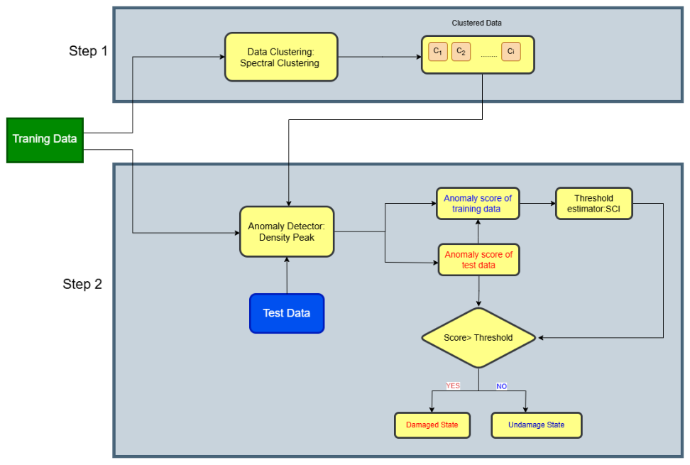

**Fig. 1.** Flowchart of the proposed SC-DP method for early damage Warning.

* 1. Functionality of the Proposed Approach

Spectral clustering is a graph-based algorithm rooted in graph theory, designed to identify clusters of arbitrary shapes within a dataset. This approach transforms the data into a lower-dimensional space where clusters are more distinctly separated. The effectiveness of spectral clustering hinges on the construction of a similarity graph and the use of similarity and Laplacian matrices [4].

The dimensionality reduction is achieved through the eigenvectors of the Laplacian matrix, which represents the similarity graph. This graph models the local neighbourhood relationships among data points as an undirected graph, capturing how closely related samples are within the dataset. The resulting matrix $(\hat{X})$ reflects these neighbourhood connections, enabling the detection of clusters with complex structures.

In this graph representation, the nodes correspond to data samples within the dataset of interest, while the undirected edges indicate connections between these samples. The similarity matrix is used to capture the structure of the similarity graph by measuring the pairwise distances between connected nodes (i.e., data samples) [7]. The Laplacian matrix, in turn, provides an alternative way to represent this similarity graph.

To construct the similarity matrix, the process begins with calculating the pairwise distances among the $t$ feature samples in the dataset $\hat{X}$ .This computation results in a distance matrix $D∈{\text{R}}^{t×t}$. Based on this distance matrix, the similarity matrix is then derived as follows:

()

Here,  represents the element located at the $i^{th}$ row and $j^{th}$ column of the similarity matrix $S∈{\text{R}}^{t×t}$.The term $d_{ij}$ indicates the distance between ${\hat{X}}_{i}$ ​ and ${\hat{X}}_{j}$ ​, found in the $i^{th}$ row and $j^{th}$ column of the distance matrix $D∈{\text{R}}^{t×t}$. The parameter $σ$ refers to the kernel scale, which is set to 1 in this study [4]. After determining the similarity matrix, the Laplacian matrix can then be calculated using one of the following equations:

$L_{u}=D_{g}-S$ (2)

$L_{n}={D_{g}}^{-1}L_{u}$ (3)

$L_{s}={D_{g}}^{-\frac{1}{2}}L_{u}{D_{g}}^{-\frac{1}{2}}$ (4)

Here, $L_{u}$, $L_{n}$, and $L_{s}$ ​ represent the unnormalized, normalized, and symmetric normalized Laplacian matrices, respectively [7]. In all the equations, $D_{g}$ refers to the degree matrix $D_{g}∈{\text{R}}^{t×t}$ derived from the similarity matrix. It is a diagonal matrix obtained by summing the entries in each row of the similarity matrix $S$. In Equation (3), the normalized Laplacian matrix is computed by solving the generalized eigenvalue problem $L_{u}v=λD_{g}v$, where $v$ is a column eigenvector of length $t$, and $λ$ is the corresponding eigenvalue.

Using the Laplacian matrix and considering a specified number of clusters $c$, spectral clustering produces a matrix $V∈{\text{R}}^{t×c}$ that contains $c$ eigenvectors $\{v_{1},...,v_{c}\}$ corresponding to the smallest $c$ eigenvalues of the Laplacian matrix. Each row in the matrix $V$, which is t-dimensional, is then clustered using a partition-based clustering algorithm, such as k-means or k-medoids, where $k=c$. Once the clustering is performed, the outlier-free data samples in $\hat{X}$ are assigned to the same clusters as their corresponding rows in $V$. This means that each sample is labeled with one of the labels $\{1,...,c\}$, thereby dividing the data samples in $\hat{X}$ into $c$ clusters or partitions $\{C_{1},...,C_{c}\}$. Each partition consists of a matrix containing $p$ variables (rows) and $r_{h}$ ​ samples (columns), where $h=1,...,c$. For simplicity, the spectral clustering process can be broken down into three main components: determining the optimal number of clusters, performing matrix computations, and executing the clustering. The input data consists of outlier-free training samples obtained from the initial task of the proposed method, while the output is a set of cluster matrices that group the outlier-free samples according to the identified number of clusters [8]. To determine the optimal number of clusters, this approach utilizes a technique based on the gap statistic. This method compares the total within-cluster variations for different clusters with their expected values under a null reference distribution (i.e., a distribution where no distinct clustering is apparent) [9]. The optimal number of clusters is identified as the point where the compactness of clusters in the original data deviates most significantly from this reference curve. In other words, the best cluster count is chosen as the one that maximizes the gap statistic, which is defined as follows:

$G=E_{n}\left(\log{W_{c}}\right)-\log{W_{c}}$ (5)

Here, $G$ represents the gap statistic value, $E_{n}$ ​ denotes the expected value for a sample size of $n$ derived from the reference distribution, and $W_{c}$ measures the compactness of spectral clustering based on the within-cluster sum of squared errors[10]. Assume that the outlier-free feature samples are grouped into $c$ clusters, denoted as $\{C_{1},...,C_{c}\}$. Let $d_{h}$ ​ be the sum of the pairwise distances for all samples within the $h^{th}$ cluster. Thus, $W_{c}$ ​ can be defined as follows:

$W_{c}=\sum_{h=1}^{c}{\frac{1}{2r_{h}}} d_{h}$ (6)

Here, $r_{h}$ represents the number of samples in the $h^{th}$ cluster. It is important to note that the expected value $E_{n}\left(\log{W_{c}}\right)$ is estimated using Monte Carlo sampling from a reference distribution, while $\log{W_{c}}$ is calculated based on the sample data. To determine the optimal number of clusters, several cluster samples (trials) are evaluated, and their respective gap statistic values are computed [4]. The cluster configuration that satisfies the condition specified in Equation (7) is then selected as the optimal solution.

$G\left(h\right)≥G\left(h+1\right)-SE(h+1)$ (7)

Here, $SE(h+1)$ represents the one-standard-error associated with the natural logarithm of the compactness measure for spectral clustering, calculated with respect to the reference data for each cluster count. After dividing the outlier-free feature samples into $c$ partitions, it is necessary to select one partition that best captures the representative features that are unaffected by variability sources. Essentially, this step acts as a form of dimensionality reduction or feature selection [11]. The primary criterion for selecting the optimal partition is based on the concept of normalized cumulative local density, which aligns with principles from empirical learning theory and will be further detailed in the next section. The chosen partition should be the one that maximizes local density since higher density indicates shorter distances between data points. $.$ In datasets containing outliers, the distances between samples tend to be larger, leading to lower density. Conversely, when the majority of data points in a partition are similar, the distances between them are shorter, resulting in a high-density set.

Density Peaks, on the other hand, identifies cluster centers by finding points that have both a high local density $ρ$ and a large distance from other points with higher density $δ$. The local density for each point $i$ denoted as $ρ_{i}$ is calculated as:

$ρ_{i}=\sum_{j}{x(d_{ij}-d_{c})}$ (8)

where $d_{ij}$ is the distance between points $i$ and $j$, $d_{c}$ is the cutoff distance, and the function $X\left(x\right)$:

$X\left(x\right)=f\left(x\right)=\left\{\begin{aligned}1, &x<0 \\ 0, otherwise\end{aligned}\right.$ (9)

This means that only points within the cutoff distance $d_{c}$ ​ contribute to the density $ρ_{i}$. Alternatively, a smoother measure of density can be used with a Gaussian kernel**:**

$ρ_{i}=\sum_{j}{e^{-{\left(\frac{d_{ij}}{d_{c}}\right)}^{2}}}$ (10)

The minimum distance $δ$, which helps identify points that are isolated from other high-density points. For each point $i$, $δ_{i}$ ​ is defined as the minimum distance to any other point with a higher density:

$δ_{i}=\min_{j:ρ_{j}>ρ_{i}}{d_{ij}.}$ (11)

This means that $δ_{i}$ is the distance from point $i$ to its nearest neighbor that has a higher density than $i$ $\left[7\right]$. For the point with the highest density in the dataset, which has no neighbours with a higher density $δ_{i}$ is set to:

$δ_{i}=\max_{j}{d_{ij}.}$ (12)

The distance to the nearest point with a higher density $δ_{i}$, is then computed for each point, with the point having the highest density assigned the maximum distance within the dataset. Points that exhibit both high $ρ$ and high $δ$ are selected as cluster centers, and the remaining points are assigned to clusters by associating them with their nearest neighbour of higher density. This approach is simple yet effective for detecting Anomaly. By combining the global perspective of spectral clustering with the local cluster center detection capability of Density Peaks, this hybrid approach proves particularly effective for datasets with complex structures or clusters varying in size and density.

* 1. Thresholding

The threshold estimation in anomaly detection is based on the outputs of the learned classiﬁer by the training data. For this purpose, a probabilistic distribution is assumed for the training features to deﬁne the $α^{th}$ percentile as the threshold level. When the distribution of the features is normal or Gaussian, an efﬁcient and practical approach is a statistical interval limit [12, 13]. This approach is based on statistical characteristics of the normal probability distribution. Assume that $D= [d_{1}, ...., d_{ND}]$ is the vector of distance values obtained from the training data based on a statistical distance approach, in which case each distance quantity is representative of the similarity or discrepancy between the features of the undamaged condition(s). On this basis, the threshold τ is deﬁned as the upper bound of the α one-side conﬁdence as follows:

$τ=μ_{D}+Z_{α/2}\frac{σ_{D}}{\sqrt{N_{D}}}$ (13)

where $μ_{D}$ and $σ_{D}$ denote the mean and standard deviation of the vector D. Moreover, $Z_{α/2}$ refers to the conﬁdence coefﬁcient. In the proposed approach, for the estimation of the threshold, a confidence level of $α=5\%$ is considered, which corresponds to a Z-value of 1.96. This value represents the standard deviation multiplier used in a one-sided confidence interval, ensuring that 95% of the normal data points fall within the established boundary, while any point beyond it is considered an anomaly.

1. Application
   1. Simulated short-term assessment of the Z24 box-girder bridge

The Z24 Bridge was a post-tensioned concrete box-girder structure, featuring a central span of 30 meters and two side spans of 14 meters each, as depicted in **Fig. 2**. Located in the canton of Bern, Switzerland, it formed part of the road network connecting Koppigen to Utzenstorf, passing over the A1 highway between Bern and Zurich [10]. The bridge was supported by three columns at each abutment, which were integrated with the main girder, while the piers were firmly anchored into the girder. In 1998, due to the construction of a new railway line near the highway that required a bridge with longer side spans, it was ultimately decided to demolish the Z24 Bridge. Due to the significant influence of temperature fluctuations on structural behavior, detailed monitoring of the thermal state of the bridge was conducted. for the short-term simulation a subset of eigenfrequencies was selected as the vibration data, as shown in **Fig. 3**, This dataset consists of a total of 235 frequency samples, where samples 1 to 198 correspond to the undamaged condition, while samples 199 to 235 represent the damaged condition.

**Fig. 2.** Z24 Concrete Box-Girder Bridge

**Fig. 3.** Short-term eigenfrequencies of the Z24 bridge regarding the first-forth modes (a)-(d).

To evaluate the performance of SC-DP, it is necessary to define the training and test samples. For this purpose, 80% of the undamaged eigenfrequencies from all four modes are used to create a training dataset consisting of 158 samples. The remaining 20% of the undamaged eigenfrequencies are designated as validation or known test points. These points are then combined with all eigenfrequencies from the damaged state, resulting in a test dataset with 77 samples.

The anomaly detection process hinges on analysing deviations from normal structural behaviour. After defining the clusters, the distance from each data point to its corresponding cluster center is calculated[14]. These distances are then used to generate an anomaly score, which helps differentiate between damaged and undamaged conditions. **Fig. 4** illustrates the results of the early damage warning process, where the dashed horizontal lines represent the SCI threshold level. As shown, the anomaly scores for the undamaged state, both in the training and validation phases, remain consistently below this threshold, with no false positives.

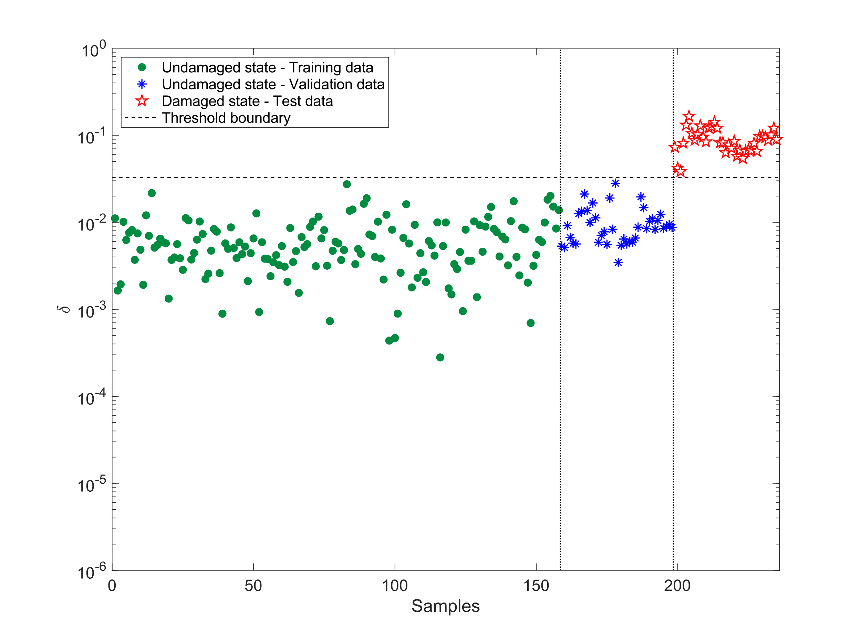

**Fig. 4.** Early damage warning in Z24 bridge by the proposed SC-DP approach.

To demonstrate the success and reliability of the SC-DP approach, it was compared to another widely recognized non-parametric unsupervised learning technique, specifically the Mahalanobis-Squared Distance (MSD) method, which is commonly used in SHM applications [15]. The MSD method calculates the squared distance between data points and the mean of a distribution, helping to identify outliers by considering the covariance structure of the data. While MSD has proven effective in various SHM contexts, the comparison with the SC-DP approach aimed to highlight the advantages of integrating SC-DP. This combination offers a more robust and adaptive approach to anomaly detection by leveraging both the structure of the data and the density of the clusters, providing a more accurate distinction between normal and damaged conditions.

in **Fig. 5**, It is clear that MSD struggled to distinguish between damaged and undamaged states, as the anomaly scores often overlapped. This poor performance was primarily due to environmental variability and the use of the entire training dataset without feature partitioning, which led to a high rate of false negatives. Specifically, MSD exhibited a mis-detection rate of 83.78% along with a false alarm rate of 1.51% [16].

**Fig. 5.** Early damage warning in the Z24 bridge using the MSD method.

* 1. Simulated short-term assessment of the Yonghe bridge

The Yonghe Bridge is a concrete cable-stayed structure that was constructed and completed in 1987. At the time, it was the largest cable-stayed bridge in both China and Asia [17]. The Yonghe Bridge features five spans, covering a total length of 510 meters and a width of 11 meters. Of this width, 9 meters are allocated for vehicle traffic, while two 1-meter sections are designated for pedestrian walkways. The bridge is supported by two abutments and four piers, as shown in **Fig. 6**.

**Fig. 6.** The Yonghe bridge: (a) a real image, (b) the side view and span dimensions.

An Operational Modal Analysis (OMA) technique was utilized to extract the bridge's eigenfrequencies, which served as the primary dynamic features for early damage detection. **Fig. 7** presents the identified eigenfrequencies of the cable-stayed bridge across four stable modes, comprising a total of 216 frequency samples, with 24 measurements collected daily. Instances 1–192 correspond to the undamaged state, while instances 193–216 represent the damaged condition. A noticeable drop in eigenfrequencies on the ninth day clearly reflects the effect of structural damage on the bridge’s stiffness and dynamic behavior. Although tracking changes in modal frequencies may initially appear sufficient for detecting damage, this approach can be misleading due to considerable fluctuations even in the undamaged state. Several frequency drops occur within the undamaged samples (1–192), which could be falsely interpreted as damage. Therefore, without a deeper understanding of the bridge's operational context and structural baseline, relying solely on frequency variation may result in inaccurate assessments.

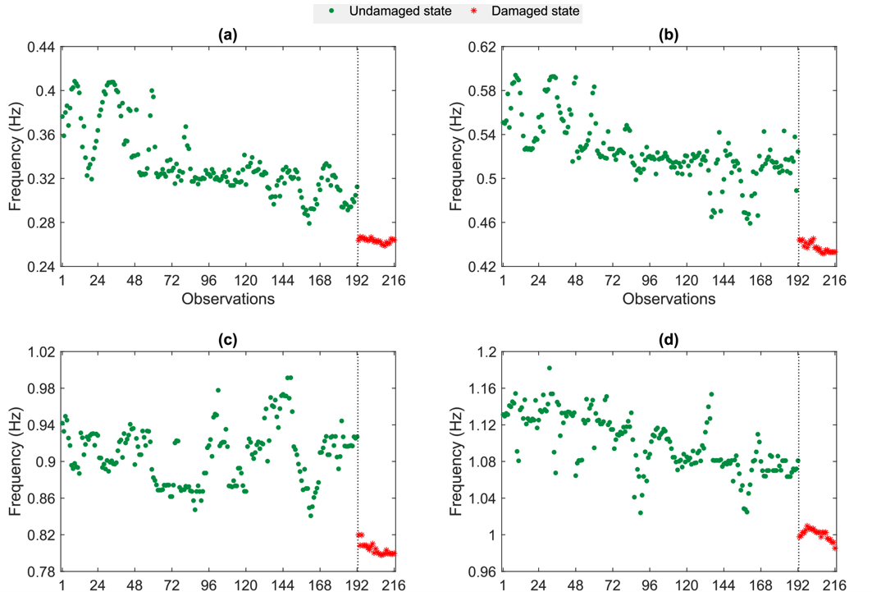

**Fig. 7.** Short-term eigenfrequencies of the Yonghe bridge regarding the first-forth modes (a)-(d).

To assess the performance of the proposed SC-DP method on the Yonghe bridge, the training dataset includes 153 undamaged eigenfrequencies, representing 80% of the total data, while the remaining 20% of undamaged frequencies are used as validation (known test) data. These features are then combined with 24 damaged eigenfrequencies (unknown test data) to form a test matrix containing a total of 63 test features.

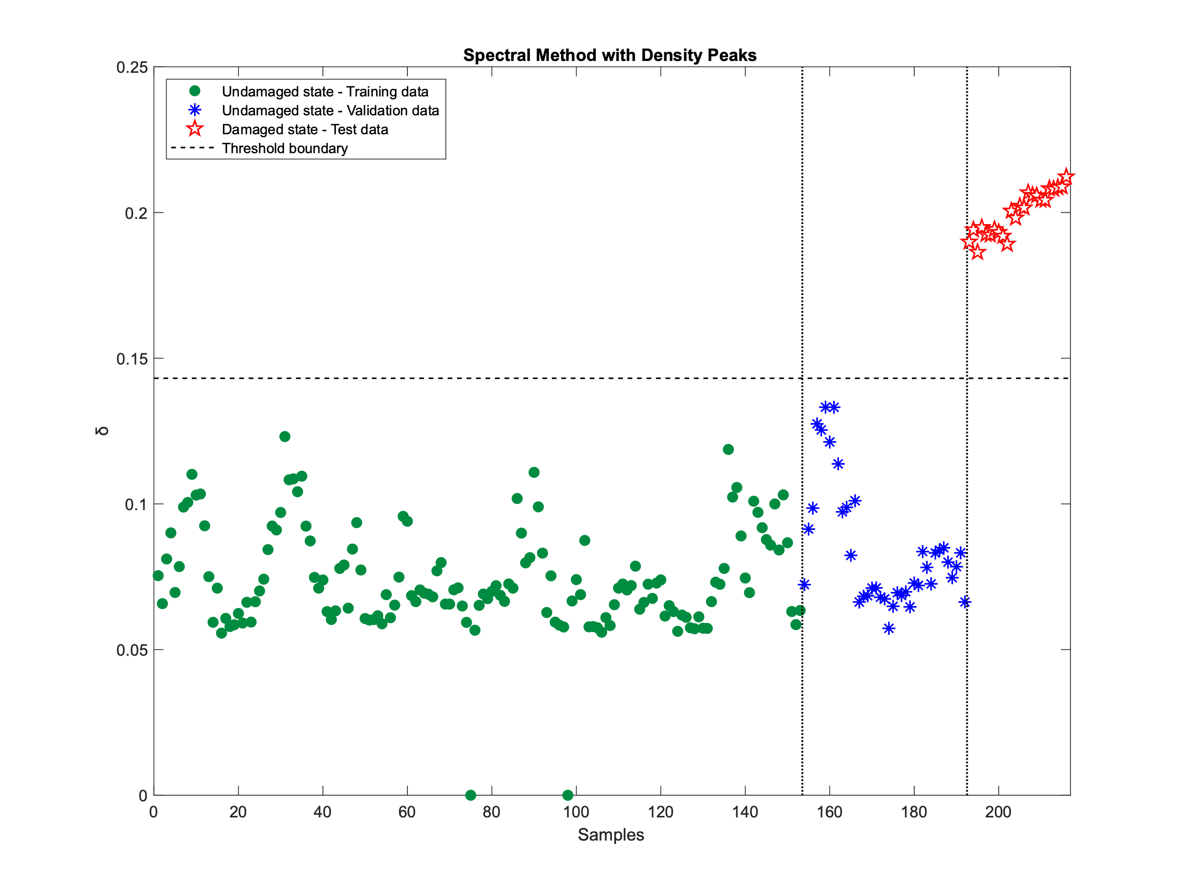

**Fig. 8.** Early damage warning in Yonghe bridge by the proposed SC-DP approach.

**Fig. 8** shows the outcomes of the early damage warning for the Yonghe bridge, all samples representing the undamaged state, including both the training and validation datasets, consistently fall below the threshold line. This clearly demonstrates the robustness of the method. Additionally, the red stars, which indicate the damaged state, are distinctly positioned above the threshold, confirming the method’s success in detecting damage without any overlap with the undamaged samples.

1. Conclusion

The primary objective of this research was to develop an unsupervised, non-parametric approach for damage detection in early warning systems, utilizing short-term vibration data in the field of structural health monitoring (SHM). By implementing the proposed hybrid Spectral Clustering with Density Peaks (SC-DP) approach, this method successfully identified damage conditions while minimizing the impact of environmental factors on the bridge. The approach demonstrates significant potential for more precise detection, thereby enhancing the reliability and effectiveness of early warning systems in SHM.

To evaluate the effectiveness and reliability of the proposed approach, two real-world bridge structures (Z24 and Yonghe) were analysed using limited sets of modal frequencies obtained from short-term monitoring programs. the results demonstrate that the SC-DP approach effectively differentiates between undamaged and damaged states, while also successfully filtering out the effects of environmental and operational variations (EOV) in short-term monitoring scenarios.

The main conclusion drawn from this study is that the proposed approach effectively addresses the challenges of environmental and operational variability, resulting in accurate early damage detection. In the first case study with the Z24 Bridge, the SC-DP method successfully identified damage with zero false alarms (false positives) and no missed detections (false negatives). Similarly, in the second case study involving the Yonghe Bridge, the method delivered reliable results, achieving accurate damage detection without any false positives or false negatives. Contrary to the common belief that EOV is mainly a challenge in long-term SHM programs, this study demonstrated that such variability can also significantly influence the dynamic characteristics, such as modal frequencies, of bridge structures, even in short-term monitoring scenarios.

While the proposed approach has shown reliable and effective performance in damage assessment with limited data, there remain significant challenges and areas for improvement in future research. A key limitation is its dependence on short-term monitoring data, which restricts the ability to capture the full spectrum of environmental and operational variations, especially those influenced by factors like temperature. This challenge becomes even more critical when substantial structural changes occur over extended periods without continuous data collection, making it difficult to effectively monitor civil structures and detect abnormal conditions.

Currently, the method leverages unsupervised learning, which has proven effective for early damage detection. However, to overcome these limitations, integrating advanced deep learning techniques (such as semi-supervised learning, active learning, and unsupervised domain adaptation) could enable more sophisticated and robust anomaly detection, especially in cases with limited data availability. These enhancements would be particularly valuable for monitoring critical bridges, where undetected structural failures could pose severe risks. In such high-stakes situations, implementing real-time monitoring systems could play a crucial role in ensuring infrastructure safety and enabling timely interventions, thus improving the overall resilience of these structures.

References

1. Entezami, A., Behkamal, B., De Michele, C.: Pioneering remote sensing in structural health monitoring. *Long-Term Structural Health Monitoring by Remote Sensing and Advanced Machine Learning*, Springer, Cham: 1–27 (2024).
2. Kim, H. S., Kim, Y. J., Chin, W. J., Yoon, H.: Development of highly efficient construction technologies for super long span bridge. *Engineering* 5(8): 629–636 (2013).
3. Gkoumas, K., Marques Dos Santos, F. L., Van Balen, M., Tsakalidis, A., Ortega Hortelano, A., Grosso, M., Haq, G., Pekár, F.: Research and innovation in bridge maintenance, inspection and monitoring. *Publications Office of the European Union* (2019).
4. Von Luxburg, U., Belkin, M., Bousquet, O.: Consistency of spectral clustering. *The Annals of Statistics* 36(2): 555–586 (2008).
5. Sarmadi, H., Entezami, A., Salar, M., De Michele, C.: Bridge health monitoring in environmental variability by new clustering and threshold estimation methods. *Journal of Civil Structural Health Monitoring* 11(3): (2021).
6. Entezami, A., Sarmadi, H., Behkamal, B.: Short-term damage alarming with limited vibration data in bridge structures: A fully non-parametric machine learning technique. *Measurement* 235: 114935 (2024).
7. Entezami, A., Sarmadi, H., Salar, M., De Michele, C., Arslan, A. N.: A novel data-driven method for structural health monitoring under ambient vibration and high-dimensional features by robust multidimensional scaling. *Structural Health Monitoring* 20(5): 2758–2777 (2021).
8. Entezami, A., Shariatmadar, H.: Structural health monitoring by a new hybrid feature extraction and dynamic time warping methods under ambient vibration and non-stationary signals. *Measurement* 134: 548–568 (2019).
9. Sarmadi, H., Karamodin, A., Entezami, A.: A new iterative model updating technique based on least squares minimal residual method using measured modal data. *Applied Mathematical Modelling* 40(23–24): 10323–10341 (2016).
10. Entezami, A., Sarmadi, H., Behkamal, B., De Michele, C.: On continuous health monitoring of bridges under serious environmental variability by an innovative multi-task unsupervised learning method. *Structure and Infrastructure Engineering* 20(12): 1975–1993 (2024).
11. Entezami, A., Arslan, A. N., De Michele, C., Behkamal, B.: Online hybrid learning methods for real-time structural health monitoring using remote sensing and small displacement data. *Remote Sensing* 14(14): 3357 (2022).
12. Rezaiee-Pajand, M., Entezami, A., Shariatmadar, H.: An iterative order determination method for time-series modeling in structural health monitoring. *Advances in Structural Engineering* 21(2): 300–314 (2018).
13. Entezami, A.: Structural health monitoring by time series analysis and statistical distance measures. *Springer*, Berlin/Heidelberg, Germany (2021).
14. Sarmadi, H., Entezami, A., Magalhães, F.: Unsupervised data normalization for continuous dynamic monitoring by an innovative hybrid feature weighting-selection algorithm and natural nearest neighbor searching. *Structural Health Monitoring* 22(6): 4005–4026 (2023).
15. Worden, K., Farrar, C. R., Manson, G., Park, G.: The fundamental axioms of structural health monitoring. *Proceedings of the Royal Society A: Mathematical, Physical and Engineering Sciences* 463(2082): 1639–1664 (2007).
16. Sarmadi, H., Karamodin, A.: A novel anomaly detection method based on adaptive Mahalanobis-squared distance and one-class KNN rule for structural health monitoring under environmental effects. *Mechanical Systems and Signal Processing* 140: 106495 (2020).
17. Li, H.: Structural assessment of concrete cable-stayed bridge after replacement of closure segment: The service stage. *Practice Periodical on Structural Design and Construction* 25(3): 04020023 (2020).