Structural Integrity of Flange Connection in Onshore Wind Turbine Towers

Elin HerredsvelaStig, Roar Lyse Rødne, Sudath C. Siriwardane and Fredrik Bjørheim

University of Stavanger, 4036 Stavanger, P.O. box 8600, Norway  
[sr.rodne@stud.uis.no](mailto:sr.rodne@stud.uis.no)

**Abstract.** Premature bolt failure on onshore wind turbine towers is a major issue that compromises field operation safety. This article examines the structural integrity of 32CrB4 steel M56 high strength grade 10.9 bolts used for flange connection of wind turbine towers. Mechanical properties, chemical composition and microstructure were comprehensively investigated of three failure bolts a wind turbine in Scandinavia. A range of mechanical testing was employed to determine the mechanical properties such strength and ductility of these bolts. Analysis of the chemical composition conducted with scanning electron microscopy (SEM) and energy dispersive spectroscopy, revealed elemental distributions that could influence material behaviour. Defects and inconsistencies in the material were investigated using optical microscopy, SEM, and electron backscatter diffraction. This showed that while the bolts met their mechanical requirements, evidence of hydrogen embrittlement was observed. These included intergranular cracking near the edges of the fracture surface on all three bolts. Additionally, the variations in size and distribution of gaps indicated material weakness. Despite these findings, the exact causes of bolt failure could not be conclusively identified due to data limitations and the complex interaction of failure mechanisms. This study underscores the need for further research in this area to fully understand all factors affecting the fracture in these bolts. The insights presented can support interesting parties in the wind turbine industry in developing more effective maintenance strategies, ultimately enhancing reliability of wind turbine operation.

**Keywords:** Wind turbine tower, flange connection, high-strength bolt failure, structural integrity, microstructural investigation

1. Introduction

Wind turbines play vital role in meeting the world’s growing demand for renewable energy, providing sustainable alternative to fossil fuels. These structures are design and engineered withstand and resist significant mechanical stresses, including dynamic loads from rotating blades and fluctuating environmental loads such as wind, wave and etc [1]. Bolts used for flange connection of wind turbine tower, which used to join the tower segments, are very important structural component for maintaining the structural integrity and safety of the turbines.

Premature bolt failure remains a persistent issue even though technology has led to an increase in turbine efficiency and its durability [2]. Such failures may result in unplanned downtime, safety hazards and expensive repairs. Common causes of bolt failure include fatigue due to dynamic loading, environment-assisted cracking (i.e. corrosion fatigue, hydrogen embrittlement), improper assembly, and material or manufacturing defects [3,4]. The effects can range from small losses in efficiency due to parts not being properly aligned to serious accidents that harm people and the environment. Although premature failure may be case-dependent, there is a lack of research investigating the causes, effects and potential remedial measures. Despite ongoing occurrences of such failures, the literature does not provide clear or definitive explanations for their root causes, which highlights the need for further study. The first author’s personal connection to a particular wind farm also providing unique motivation to investigate reason behind these failures.

To address mentioned knowledge gaps to some extent, main objective of this paper is to investigate the root causes of flange bolt failure in onshore wind turbines and propose strategies/recommendation for improving durability. The investigation focuses on mechanical strength (tensile strength, impact toughness, and hardness), chemical composition (using scanning electron microscopy with energy dispersive spectroscopy), and microstructural investigation (using SEM and optical microscopy). Special attention is given to identifying defects such as intergranular cracking, voids, inclusions, or compositional anomalies that may indicate hydrogen embrittlement or fatigue damage induced degradations. While the study is exploratory in nature, it provides valuable insights that could help wind turbine manufacturers, operators, and maintenance teams improve bolt designs and develop better preventive maintenance strategies. The paper begins with fractured case study bolts and their material specifications. This is followed by a detailed information about laboratory testing program, including methods and results. Finally, a comprehensive discussion and comparison of the experimental results is provided and hence causes for failure is discussed.

1. Material and Description of Bolts

This investigation focuses on three bolts from a wind turbine in Scandinavia. These bolts, of dimension M56 and strength class 10.9, following UNE-EN-ISO 898-1 [5] and UNE-EN- ISO 898-2 [6] and design, dimensions, and specifications of high- strength hexagon head bolts are defined by DIN 6914 [7]. The bolts have been in service for approximately two years, and were tightened in two stages, with a maximum torque of 1000 Nm. The bolts have been securing tower- tower flange connections within the turbine structure.

All three bolts are from the same batch, made of 32CrB4 steel, known for its tempered martensite structure that offers both strength and durability [8].

Detailed chemical composition, presented in the steel manufacturer's Mill Test Certificate [9], is crucial to reflect on the bolts' performance under operational tension (Table 1).

**Table 1.** Chemical composition of the bolts [9]

|  |  |
| --- | --- |
| Element | % |
| C | 0.330 |
| Mn | 0.820 |
| Si | 0.240 |
| P | 0.010 |
| S | 0.007 |
| Cr | 1.180 |
| Ni | 0.790 |
| Cu | 0.070 |
| Al | 0.027 |
| Ti | 0.0460 |
| B | 0.0032 |
| H | 0.00012 |

1. Methodology
   1. Optical Testing Methodology

Samples from the shanks and heads of the bolts were polished and examined using a SEM (Jeol JSM-IT800), energy-dispersive X-ray spectroscopy (EDS) or electron backscatter diffraction (EBSD), and an optical microscope (Olympus GX53). Figure 16 show the location of specimens in bolt shank.

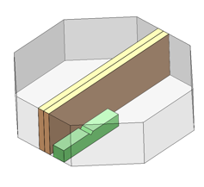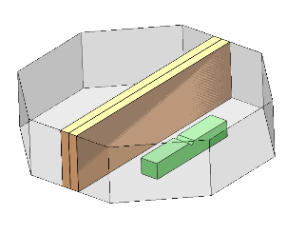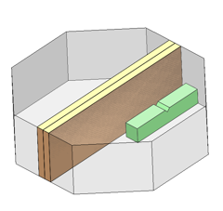

**Fig. 2.** FAH Samples from bolt head.

**Fig. 3.** FBH Samples from bolt head.

**Fig. 4.** FCH Samples from bolt head.

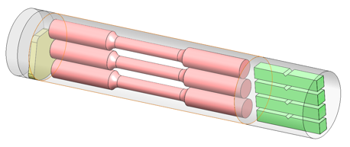

**Fig. 1.** Illustration of samples from bolt shank.

Specimen Preparation for Optical Testing**.** Samples were cut using the Struers Discotom 10 to avoid introducing mechanical stresses. After cutting off a section, the piece was cleaned with ethanol solution, then dried on its own for good measure so no debris or outside impurities remained.

Two cuts from each head were made to microstructure samples, shown in Figure 5,6 and 7.

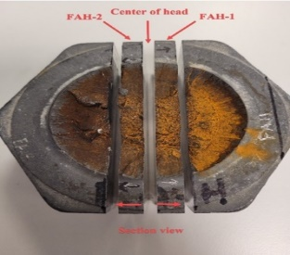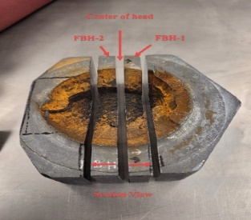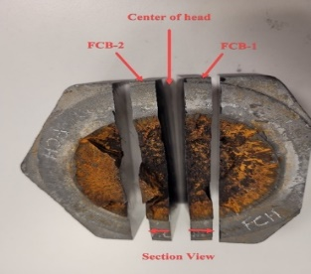

**Fig. 5.** FAH Microstructure samples.

**Fig. 1.** FBH Microstructure samples.

**Fig. 7.** FCH Microstructure samples.

Mounting. Clean samples were hot mounted using the Struers Citopress-30. Bolt heads were mounted in epoxy resin, and bolt shanks in Polyfast resin for its electrical conductivity, suitable for SEM. Mounted samples were grinded and polished with the Struers Tegrapol-35 to achieve smooth, scratch-free surfaces. |

Specimens mounted in a sample holder for consistent treatment. Shank specimens - washed in the ultrasonic cleaner Struers Lavamin between each step. Bolt heads were too large for Lavamin, cleaned with ethanol and blow-dried with air pressure. Tegrapol-35 was thoroughly cleaned between steps to avoid contamination.

**Table 2.** Grinding and polishing of shank samples, Program D.

|  |  |  |  |  |
| --- | --- | --- | --- | --- |
| Material | Duration. Min | Coarseness | Number of cycles | Lubricant |
| Paper | 2 | 80 grit | 1 | Water |
| Paper | 2 | 180 grit | 1 | Water |
| Allegro | 3 | 9 µm | 1 | Diapro 9µm |
| Dac 3 | 3 | 3 µm | 1 | Diapro Dac 3µm |
| Chem | 2 | 0,25 µm | 1 | OP-S |

**Table 3.** Alternative grinding and polishing of shank samples.

|  |  |  |  |  |
| --- | --- | --- | --- | --- |
| Material | Duration. Min | Coarseness | Number of cycles | Lubricant |
| Paper | 2 | 500 grit | 1 | Water |
| Paper | 2 | 1,000 grit | 1 | Water |
| Paper | 2 | 2,000 grit | 1 | Water |
| Mol 3 | 3 | 3 µm | 1 | Diapro Dac 3µm |
| Chem | 2 | 0.25 µm | 1 | OP-S |

****Etching for Optical Microscopy.** Prior to optical microscopy, the parts dipped in 2% Nital solution for 45 seconds. This etching improved the visibility of areas in the micro-structures, enabling one to observe them under a microscope. Etching of specimen from heads revealed residual stress lines inside the heads as shown in Figure 8.

**Fig. 8.** Residual stresses within bolt heads.

**SEM and EDS of fracture surface.** For the examination of fractures by SEM and ideal elements tests (EDS), the fracture surface from the shank were cut, using a Struers Discotom 10. These samples were etched to remove early corrosion that may have occurred during storage. It was used HNO3, nitric acid, for the etching, and ultrasonic ethanol wash for three minutes.

**Electron Backscatter Diffraction.** An additional grinding and polishing procedure were necessary for EBSD examination. The shank specimens were subjected to a refined process to prepare them adequately for high-resolution analysis:

* Mounted in a holder to ensure consistent treatment.
* Washed in the ultrasonic cleaner Struers Lavamin between each step.
* Monitoring ensured that scratch-free surfaces were achieved.
* Tegrapol-35 was cleaned between each step to prevent contamination.
* Resin mounting was removed to fit the specimens into the vacuum chamber of the SEM, as well as to reduce charging.
* The EBSD analysis were performed on a Jeol JSM-IT800 with a UF420 EBSD detector by NORDIF.
* For each scan an area of 300x300 µm and 0.2 µm step size was used.

Due to the similar unit cells of martensite and ferrite the EBSD scan was indexed using a ferritic structure. The three test pieces, FAB, FBB and FCB was put into the SEM and two scans was done. One at the edge of the specimen and the other towards the centre of the specimen. Thereafter we got the following data outputs:

*FAB-Centre, FAB-Edge, FBB-Centre, FBB-Edge, FCB-Centre, FCB-Edge.*   
  
This data information was then used later in the Mtex Parent Austenite Reconstruction.

**Re-examination with Optical Microscope.** Post-EBSD examination, the shank specimens were revisited using the optical microscope to obtain an overview of the pore distribution initially observed. These specimens were hot mounted again in Struers Citopress-30 with Multifast resin and then ground and polished as per the procedures outlined in the Table 4.

**Table 4.** Grinding and polishing before pore testing.

|  |  |  |  |  |
| --- | --- | --- | --- | --- |
| Material | Duration. Min | Coarseness | Number of cycles | Lubricant |
| Paper | 4 | 120 grit | 1 | Water |
| Paper | 4 | 220 grit | 1 | Water |
| Paper | 4 | 320 grit | 1 | Water |
| Paper | 4 | 500 grit | 1 | Water |
| Paper | 4 | 1,000 grit | 1 | Water |
| Paper | 4 | 1,200 grit | 1 | Water |
| Paper | 4 | 2,000 grit | 1 | Water |
| Allegro | 8 | 9 µm | 1 | Diapro 9 µm |
| Mol | 5 | 3 µm | 1 | Diapro Dac 3 µm |
| Nap | 10 | 1 µm | 1 | Diapro 1 µm |
| Chem | 7 | 0.25 µm | 1 | OP-S 0.25 µm |

* 1. Mechanical testing Methodology

**Vickers Hardness test.** The three specimens from the bolt shank used in the optical tests were prepared for Vickers hardness testing. The preparation involved removing the layer of material that had been etched, following the procedure outlined in Table 5 below.

**Table 5.** Polishing for Vickers hardness test.

|  |  |  |  |  |
| --- | --- | --- | --- | --- |
| Material | Duration. Min | Coarseness | Number of cycles | Lubricant |
| Mol 3 | 3 | 3 µm | 1 | Diapro Dac 3 |
| Chem | 2 | 0.25 µm | 1 | OP-S |

The aim of this test was to investigate the material’s hardness properties as a function of the distance from the outer circumference and across the diagonal of the bolt's cross-section.

Test was executed in accordance with NS-EN ISO 6507-1:2018 [10]. Preliminary tests on the specimens were performed, marked in Figure 9, starting at T1 (2 mm from the outer circumference) and progressing with 4 mm distance between further impressions to T10 (38 mm from the starting point).

Bolts A, B preliminary test for HV30 10 seconds. Because of complications, bolt C is subject to the same load. All test was carried out on the Falcon 5000 hardness testing machine. The Falcon 5000 was used to measure Vickers hardness values in a series of bolts in both A, B, and C test at HV10 with 10 s dwell time. On Figure 9 has marked impress (spaced 0.5mm in X and Y) up to impression 76, at 38mm well over the centre of the bolt diameter.

**Fig. 9.** Vickers hardness pattern.

**Charpy V-notch test.** For each bolt, four test specimens from the shank and one specimen from each bolt head were sectioned for Charpy V-Notch (CVN) tests. Figures 1, 2, 3 and 4 shows the original locations of these test specimens in the bolts.

The Charpy V-Notch tests were conducted in accordance with NS-EN ISO 148-1:2016 [11]. The dimensions for the test specimens are provided in Figure 10. Due to an issue with the centre Charpy specimen from bolt A being cut too short, it was decided to take a specimen from an area closer to the outer circumference for better comparability.

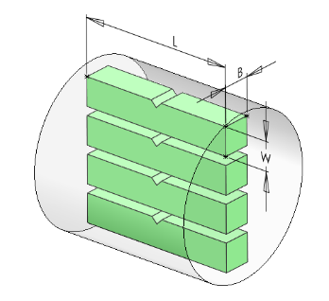

**Fig. 10.** Charpy specimens with dimensions.

The bolts were initially cut using the Struers Discotom 10, an abrasive wet cutting machine with a 2 mm cut-off for each cut. A 55 mm section was cut from each bolt, from which four specimens with a thickness of 10 mm ± 0.06 mm were obtained. Because the specimen areas were too small to be securely mounted, single cutting was employed. The specimens were then adjusted to the desired length and width (l=55 mm ± 0.60 mm, b=10 mm ± 0.11 mm, w=10mm±0,0075mm respectively) using a routing machine, and the V-notch was cut using the Mazak Vertical Smart 430A CNC routing machine.

Tests were conducted on the Zwick/Roell RKP450 machine at room temperature for the shank specimens of appropriate length. The specimens from the bolt heads and shorter shank specimens were tested at -18 degrees Celsius after being cooled in an alcohol bath.

The testing machine was equipped with both digital and analog measurements to record the absorbed energy. Self-centering tongs ensured the proper positioning of the test pieces, and for safety reasons, these were used during testing. After the tests, the absorbed energy was recorded from the digital device, and the fractured surfaces were examined both with the naked eye and using SEM. The fractured samples were stored separately to minimize the risk of damage before SEM examination.

**Tensile test.** The tensile tests were performed according to NS-EN ISO 6892-1:2019 [12]. Three specimens from each bolt were prepared for tensile tests. Specimens were cut from the bolt using the Struers Discotom 10 to achieve the desired thickness, shaped into round specimens on a lathe machine. Center holes were created, and specimens were prepared to be mounted in the Mazak Vertical Smart 430A CNC milling machine to achieve the final dimensions as shown in Figure 11.

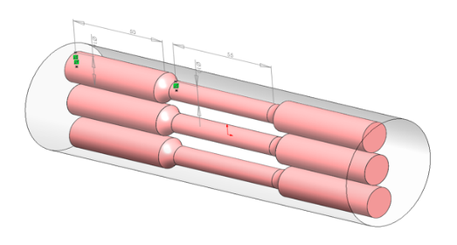

**Fig. 11.** Tensile specimens with dimensions.

* 1. Parent Austenite grain reconstruction by Mtex and EBSD

For this task, it was used a script based on the open-source information at the Mtex homepage [13] and it was used for post processing the EBSD outputs. Hence, the picture were generated for original grainsize and orientation from EBSD scans, reconstructed austenite grains, normal distribution of grain sizes.

1. Result and discussion
   1. Macroscopic Examination and Results

A visual inspection shows that the bolt's fracture surface was very different on the bolts. The central area is rough dimple and textured, indicating ductile fracture, while around its edges there was a remarkable contrast between a shiny smooth surface, typical of brittle fractures [14] as shown in Figures 12-14. This difference practiced between the central part and its periphery must be ascribed to different stress conditions and or microstructural characteristics existing in different parts of bolts [15].

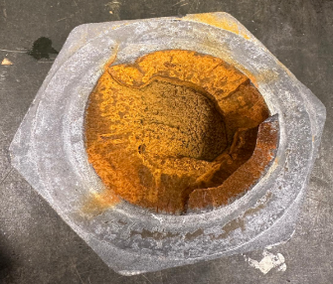

**Fig. 15.** White rust on bolt head.

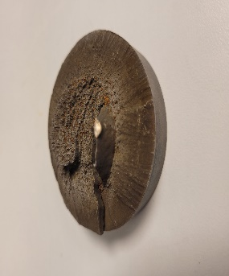

**Fig. 13.** Fracture surface bolt B.

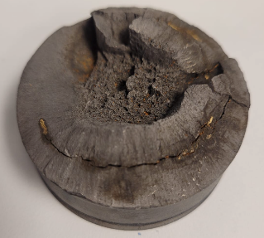

**Fig. 12.** Fracture surface bolt A.

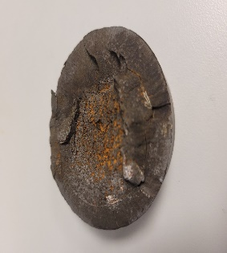

**Fig. 14.** Fracture surface bolt C.

The bolt heads were covered in white rust (see Figure 15), indicating that they had oxidized and undergone corrosion from contact with humidity. Exposure to moisture and plus saline conditions are probably responsible for this case [16].

* 1. Et bilde som inneholder grunn, utendørs, slange, maur

     Automatisk generert beskrivelseObservation of Optical Microscopy

The pictures of the samples taken from with the optical microscope all the microstructure are shown below in Figures 16 to 21.

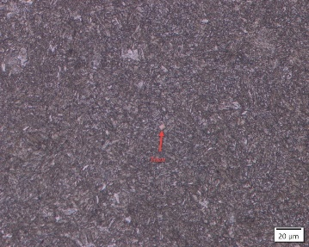

**Fig. 19.** FAB-Shank-26mm from edge, tempered martensite with Titan.

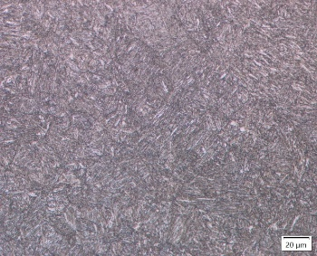

**Fig. 21.** FBB-Shank Edge.

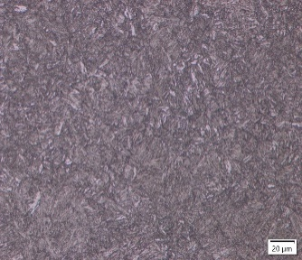

**Fig. 20.** FAB-Shank-Edge, most likely tempered martensite.

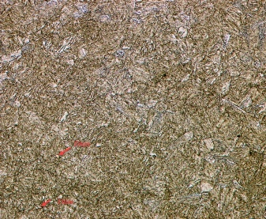

**Fig. 17.** FBH-2 Centre, tempered martensite with Titan.

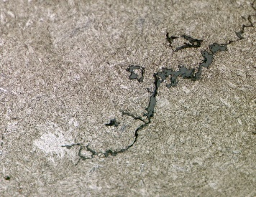

**Fig. 16.** FAH-2 50X possible ductile crack growth.

**Fig. 18.** FCH-1 50X possible ductile crack, zig zag pattern.

As observed from the pictures taken with the optical microscope, all the microstructures seem to be tempered martensite. The evidence could be found for Titanium alloy in Figure 17 and 19. Signs of fractures typical for possible ductile materials, Figures 16 and 18. It has not been easy to extract any more conclusive evidence from the optical microscope observations.

* 1. Optical Pore Test

The pore analysis of specimens FAB, FBB, and FCB gives insight to porosity characteristics and material quality. All measures have been made at the same time to ensure equal parameters.

**Table 6.** Pore analysis FAB.

|  |  |  |  |  |  |  |
| --- | --- | --- | --- | --- | --- | --- |
| FAB | | | | | | |
| Region (mm) | Number of pores | Mean pore size (µm2) | Standard deviation | Min. pore size(µm2) | Max. pore size (µm2) | Area fraction ROI* (%) |
| 0-2 | 1,883 | 5.86 | 45.06 | 1.36 | 1,880.00 | 0.20 |
| 6-8 | 3,375 | 7.67 | 59.33 | 1.36 | 3,372.00 | 0.48 |
| 12-14 | 2,871 | 7.59 | 53.93 | 1.36 | 2,868.00 | 0.42 |
| 24-26 | 3,600 | 7.83 | 60.34 | 1.36 | 3,597.00 | 0.53 |
| 34-36 | 2,181 | 7.96 | 47.05 | 1.36 | 2,178.00 | 0.32 |

**Table 7.** Pore analysis FBB.

|  |  |  |  |  |  |  |
| --- | --- | --- | --- | --- | --- | --- |
| FBB | | | | | | |
| Region (mm) | Number of pores | Mean pore size (µm2) | Standard deviation | Min. pore size(µm2) | Max. pore size (µm2) | Area fraction ROI* (%) |
| 0-2 | 4,236 | 7.28 | 68.10 | 1.36 | 4,233.00 | 0.57 |
| 6-8 | 4,113 | 8.18 | 66.04 | 1.36 | 4,410.00 | 0.63 |
| 12-14 | 3,558 | 9.56 | 69.04 | 1.36 | 3,555.00 | 0.65 |
| 24-26 | 3,983 | 7.40 | 63.75 | 1.36 | 3,980.00 | 0.55 |
| 34-36 | 2,552 | 8.80 | 51.58 | 1.36 | 2,549.00 | 0.43 |

**Table 8.** Pore analysis FCB

|  |  |  |  |  |  |  |
| --- | --- | --- | --- | --- | --- | --- |
| FCB | | | | | | |
| Region (mm) | Number of pores | Mean pore size (µm2) | Standard deviation | Min. pore size(µm2) | Max. pore size (µm2) | Area fraction ROI* (%) |
| 0-2 | 319 | 12.50 | 140.06 | 1.36 | 2,482.62 | 0.07 |
| 6-8 | 2,218 | 7.32 | 47.34 | 1.36 | 2,215.00 | 0.29 |
| 12-14 | 1,122 | 7.32 | 33.95 | 1.36 | 1,119.00 | 0.15 |
| 24-26 | 1,262 | 7.56 | 35.86 | 1.36 | 1,259.00 | 0.18 |
| 34-36 | 1,690 | 8.09 | 41.63 | 1.36 | 1,687.00 | 0.06 |

*ROI: Region of interest

FAB and FBB have pore densities remarkably higher than FCB. The highest is FBB, which ranges from 2552 to 4236 pores, while FCB it ranges from 319 to 1690. FCB shows the largest mean pore sizes, at the 0-2mm region. FAB instead shows the smallest mean pore sizes.

FAB and FBB have a relatively good consistency of porosity between different locations with some variations across areas. FCB shows more variability in porosity, particularly in the 0-2mm region. FCB has the most variable pore sizes. Pore size of FAB and FBB varies in the same range.

* 1. EDS Results and SEM Fracture Surfaces

The chemical composition of the samples were obtained from EDS and mean value and standard deviations are presented in Table 9, 10 & 11 for bolt A, B and C respectively.

**Table 9.** EDS Results bolt A, with K line series.

|  |  |  |  |
| --- | --- | --- | --- |
| Element | Mean value (Wt%) | Standard deviation (Wt% ) | Atomic % |
| Mg | 0.01 | 0.01 | 0.03 |
| Al | 0.07 | 0.01 | 0.14 |
| Si | 0.26 | 0.01 | 0.51 |
| P | 0.03 | 0.01 | 0.06 |
| S | 0.02 | 0.01 | 0.03 |
| Ti | 0.11 | 0.01 | 0.12 |
| Cr | 1.45 | 0.01 | 1.55 |
| Mn | 0.87 | 0.01 | 0.88 |
| Fe | 9719 | 0.03 | 96.68 |
| Total | 100 |  | 100 |

**Table 10.** EDS results bolt B, with K Line series.

|  |  |  |  |
| --- | --- | --- | --- |
| Element | Mean value (Wt%) | Standard deviation (Wt% ) | Atomic % |
| Mg | 0.03 | 0.02 | 0.06 |
| Al | 0.13 | 0.01 | 0.28 |
| Si | 0.35 | 0.01 | 0.68 |
| P | 0.04 | 0.01 | 0.06 |
| S | 0.04 | 0.01 | 0.07 |
| Ti | 0.15 | 0.01 | 0.18 |
| Cr | 1.47 | 0.01 | 1.57 |
| Mn | 0.95 | 0.02 | 0.96 |
| Fe | 96.85 | 0.03 | 96.15 |
| Total | 100 |  | 100 |

**Table 11.** EDS Results bolt C, with K Line series.

|  |  |  |  |
| --- | --- | --- | --- |
| Element | Mean value (Wt%) | Standard deviation (Wt% ) | Atomic % |
| Mg | 0.05 | 0.02 | 0.12 |
| Al | 0.10 | 0.01 | 0.21 |
| Si | 0.33 | 0.01 | 0.66 |
| P | 0.02 | 0.01 | 0.03 |
| S | 0.03 | 0.01 | 0.05 |
| Ti | 0.14 | 0.01 | 0.16 |
| Cr | 1.49 | 0.02 | 1.58 |
| Mn | 0.99 | 0.02 | 1.00 |
| Fe | 96.86 | 0.04 | 96.20 |
| Total | 100 |  | 100 |

**Table 12.** Comparison ofEDS Results with Mill test certificate.

|  |  |  |  |  |  |
| --- | --- | --- | --- | --- | --- |
|  | EDS Result of considered bolts (wt%) | | |  | Mill test certificate (wt%) |
| Element | A | B | C | Mean | Certificate |
| Mg | 0.01 | 0.03 | 0.05 | 0.02 |  |
| Al | 0.07 | 0.13 | 0.10 | 0.10 | 0.27 |
| Si | 0.26 | 0.35 | 0.33 | 0.31 | 0.24 |
| P | 0.03 | 0.04 | 0.02 | 0.04 | 0.010 |
| S | 0.02 | 0.04 | 0.03 | 0.03 | 0.007 |
| Ti | 0.11 | 0.15 | 0.14 | 0.13 | 0.0460 |
| Cr | 1.45 | 1.47 | 1.49 | 1.47 | 1.180 |
| Mn | 0.87 | 0.95 | 0.99 | 0.91 | 0.82 |
| Fe | 97.19 | 96.85 | 96.86 | 97.02 |  |

The EDS scans of the surface fractures all showing minor differences in the chemical composition and well within what be expected. However, when compare the mean values of the elements in the EDS results with the material certificate [9], clear deviations are observed in some alloys. This is most likely due to the 0.1% uncertainty associated with the EDS scan.

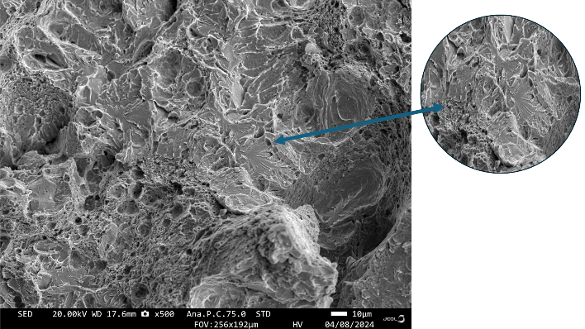

**Fig. 25.** Fracture surface bolt B centre, ductile and brittle surface, shown dimples and cleavage fracture.

Et bilde som inneholder kart, skjermbilde, natur, sort og hvit

KI-generert innhold kan være feil.Et bilde som inneholder skjermbilde, korallrev, natur, sort og hvitEt bilde som inneholder skjermbilde, natur

KI-generert innhold kan være feil.

**Fig. 23.** Fracture surface bolt B near edge, brittle intergranular cracking.

**Fig. 24.** Fracture surface bolt C near edge, intergranular cracking.

**Fig. 22.** Fracture Surface bolt A near edge, intergranular cracking.

The pictures of SEM fracture surfaces above in Fig. 22-25 shows that all three bolts have signs of intergranular cracking near the edges. Through the transition towards the centre of the bolts, they all have possible dimples areas indicating ductile properties. In the centre region they have ductile and brittle properties, with dimple at cleavage/intergranular surfaces. The Bolt A has the intergranular. The Zn layer was measured at bolt C and was found to be within the requirements given in ISO 10684 [17].

Intergranular fracture several situations that can lead to cracking and one is environmental assisted cracking. There has not been any observation of stress corrosion cracking (SCC), and therefore there is a possibility that the intergranular fracture are due to hydrogen embrittlement (HE).

* 1. Parent Austenite Reconstruction by EBSD and Mtex

The original grain size and orientation taken from EBSD for edge and centre of FAB are shown in Figures 26 and 28. The corresponding reconstructed parent austenite grain size and orientations are shown in Figures 27 and 29 respectively.

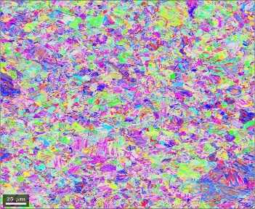

**Fig. 26.** FAB-Edge: Original grain size and orientation from EBSD.

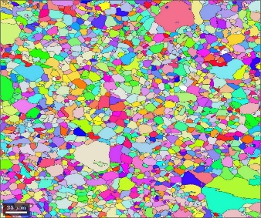

**Fig. 27.** FAB-Edge: Reconstructed Parent Austenite grain size and orientation.

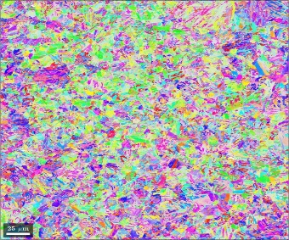

**Fig. 28.** FAB-Centre: Original grain size and orientation from EBSD.

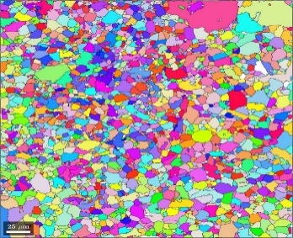

**Fig. 29.** FAB-Centre: Reconstructed parent austenite grain size and orientation.

The mean grain sizes of reconstructed parent austenite are shown in Table 13.

**Table 13.** Mean grain size reconstructed parent austenite.

|  |  |  |  |
| --- | --- | --- | --- |
| Specimen | Mean grain size, mm² | Standard deviation | Grain size indices, iso 643 |
| FAB-Edge | 0.00383 | 0.00686 | 6 |
| FAB-Centre | 0.00389 | 0.00686 | 6 |
| FBB-Edge | 0.00474 | 0.00609 | 5 |
| FBB-Centre | 0.00688 | 0.00993 | 5 |
| FCB-Edge | 0.00373 | 0.00504 | 6 |
| FCB-Centre | 0.00634 | 0.00984 | 5 |

The results of the simulations (Table 13) shows that bolt B and C have smaller grain sizes at edges and A have almost the same at both edge and centre. The standard deviations for the results are quite high and this is due to the similarity of the structures for martensite and ferrite. Ferrite has a structure that is only 2-3% stretched with reference to martensite. The smaller grain size should reflect the tensile properties of the specimens, this due to the Hall-Petch relationship [18]:

$σ_{y}=σ_{0}+\frac{k_{y}}{\sqrt{d}}$ (1)

where $σ_{y}$ is the yield strength, d is average grain diameter, $k_{y}$ and $σ_{0}$ are material constants. All the results are according to NS-EN ISO 643:2020 [19]. Table 13 shows grain size indices 5 or 6.

* 1. Charpy V-notch Results

The Charpy test results are shown in Tables 14 and 15 below.

**Table 14.** Charpy test shank samples.

|  |  |  |  |  |  |  |  |  |
| --- | --- | --- | --- | --- | --- | --- | --- | --- |
|  | Charpy Test shank samples | | | | | | | |
| NR: | FAB-E | Temp | FAB-M | Temp | FBB-M | Temp | FCB-M | Temp |
| 1 | 79.8 | Room | 48.90 | -18 | 98.40 | Room | 78.60 | Room |
| 2 | 80.20 | Room | 57.20 | -18 | 62.90 | Room | 73.80 | Room |
| 3 | 83.30 | Room | 40.40 | -18 | 70.50 | Room | 67.70 | Room |
| 4 | 82.70 | Room | 42.90 | -18 | 77.30 | Room | 103.40 | Room |
| Mean | 81.50 |  | 47.35 |  | 77.28 |  | 80.88 |  |
| Std.dev | 1.52 |  | 6.47 |  | 13.22 |  | 13.57 |  |

**Table 15.** Charpy test bolt heads.

|  |  |  |
| --- | --- | --- |
| Charpy test bolt heads -18C | | |
|  | Manual | Digital |
| F.A.H | 12 | 12.8 |
| F.B.H | 28 | 2866 |
| F.C.H | 24 | 23.1 |

The specimens with maximum value and the one with minimum value from each bolt, were then put into the SEM to analyse the fracture surfaces. The specimen designation was as follows: FAB-M2, FAB-M3, FBB-M1, FBB-M2, FCB-M3 and FCB-M4.

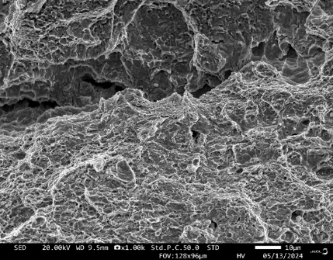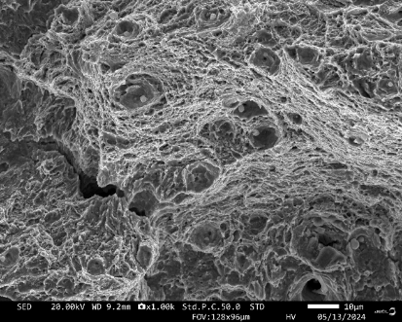

Fig. 32. FAB-M3 near fracture surface, ductile with microvoids.

**Figure. 33.** FAB-M3 near the centre, showing ductile fracture, dimple structure and microvoids.

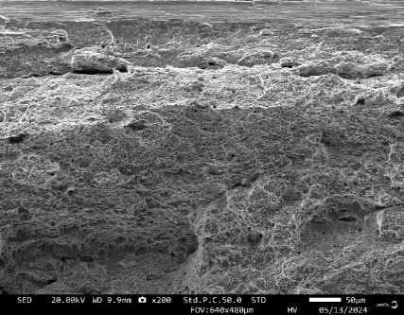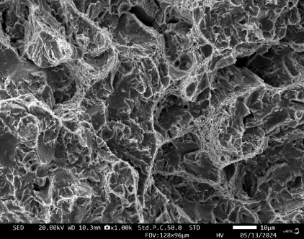

**Fig. 30.** FAB-M2, near fracture surface, ductile, dimples.

**Fig. 31.** FAB-M2, near centre, possible ductile and brittle.

The SEM pictures from the Charpy fracture surfaces (Fig. 30 and 31) showed quite significant differences. At the fracture surfaces of the bolts (FAB, FBB and FCB) they all had intergranular cracks near the edges. This is not in any of the pictures from Charpy specimens.

FAB-M2 has ductile surface with nucleated microvoids near the edge. In the centre area of the fracture there is possible brittle surface. FAB-M3 has ductile surfaces both near the edges and centre. The centre region also has microvoids as sign on ductility.

FBB-M1 has also ductile surface near edge and in the centre. FBB-M2 starts with ductile surface at the edge and transitions to brittle, with cleavage, and ductile dimple surface near the centre.

FCB-M3 also is ductile with nucleated microvoids near the edge. This continues into the centre area. FCB-M4 has ductile near the edge and continues to the centre.

Generally, all the specimens have mostly ductile surfaces. It was expected to see brittle cracks in FAB-M2 since all those samples had been chilled down to -18 and had the lowest values. But FBB-M2 transitions to a ductile and brittle surface in the centre and by that is the sample that is similar to its counterpart at the fracture surface for shank B. It was unfortunate that the internal positions of the specimens were lost since it would have known what specimen came from the edge and centre. Therefor transition temperature of each bolt were not considered.

* 1. Tensile Test

Tensile test results are also tabulated in Table 16.

**Tabel 16.** Tensile test results.

|  |  |  |  |  |  |  |
| --- | --- | --- | --- | --- | --- | --- |
| Specimen | *E-Modulus* | *RP0,2%*[MPa] | *Rm* [MPa] | Breaking Strength [MPa] | *Z* [%] | *A* [%] |
| FAB-M-C | 208 | 1010 | 1080 | 726 | 52.3 | 13.3 |
| FAB-M-E1 | 207 | 1060 | 1130 | 710 | 38.6 | 12.6 |
| FAB-M-E2 | 213 | 1060 | 1120 | 689 | 52.7 | 14.0 |
|  |  |  |  |  |  |  |
| FBB-M-C | 209 | 1020 | 1090 | 707 | 49.1 | 14.4 |
| FBB-M-E1 | 200 | 1070 | 1130 | 701 | 59.2 | 13.8 |
| FBB-M-E2 | 199 | 1050 | 1120 | 703 | 61.6 | 13.3 |
|  |  |  |  |  |  |  |
| FCB-M-C | 206 | 1010 | 1080 | 751 | 41.5 | 13.1 |
| FCB-M-E1 | 278 | 1070 | 1130 | 713 | 61.8 | 13.1 |
| FCB-M-E2 | 205 | 1030 | 1110 | 700 | 60.4 | 14.1 |

*E-Modulus* = Young’s modulus ; *Rp₀.₂ %* = Yield strength at 0.2% offset ; *Rm* = Ultimate tensile strength; *Z* = Reduction in cross-sectional area (%); *A* = Elongation at break (%)

The tensile test results (Table 16) show that the samples taken from the edges of the bolts generally have slightly higher yield strength (*RP0.2*% ) and ultimate tensile strength (*Rm*) compared to those taken from the centre. The test results are consistent across bolt A, B and C.

The breaking strength has slightly higher values in the centre sample in all three bolts. The higher results that can be seen in the specimens from the edges can be explained with the smaller grain size that obtained in the Mtex simulations. These results showed that all bolts smaller mean grain size at the edges. This again can be explained with the bolts being faster cooled down in the outer areas of the bolts than in the centre. All the results recorded are within allowed range of the standard [5].

Additionally, the increase in breaking strength at the centre samples can be explained by all the bolts starting with brittle fracture near the edges and transition to ductile fracture in the centre.

* 1. Vickers Hardness Test

The Vickers hardness test results are plotted against location starting from 0.49 mm on outer edge to 36.75mm passing the bolt centre at 28mm as shown in Figures 32-34 for FAB, FBB and FCB respectively.

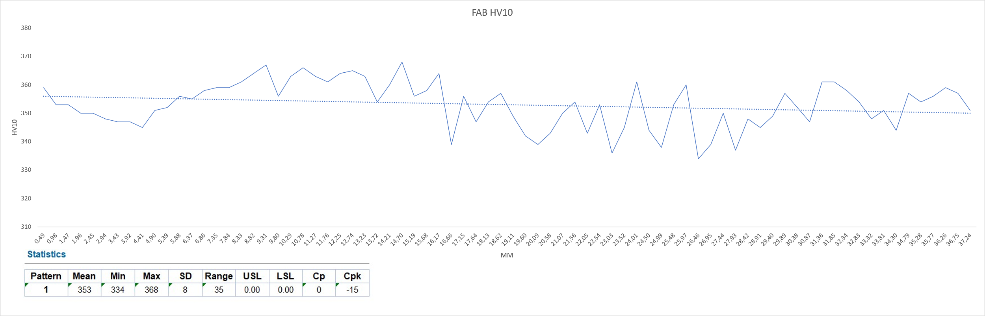

**Fig. 32.** Vickers hardness results FAB.

**Fig. 33.** Vickers hardness results FBB.

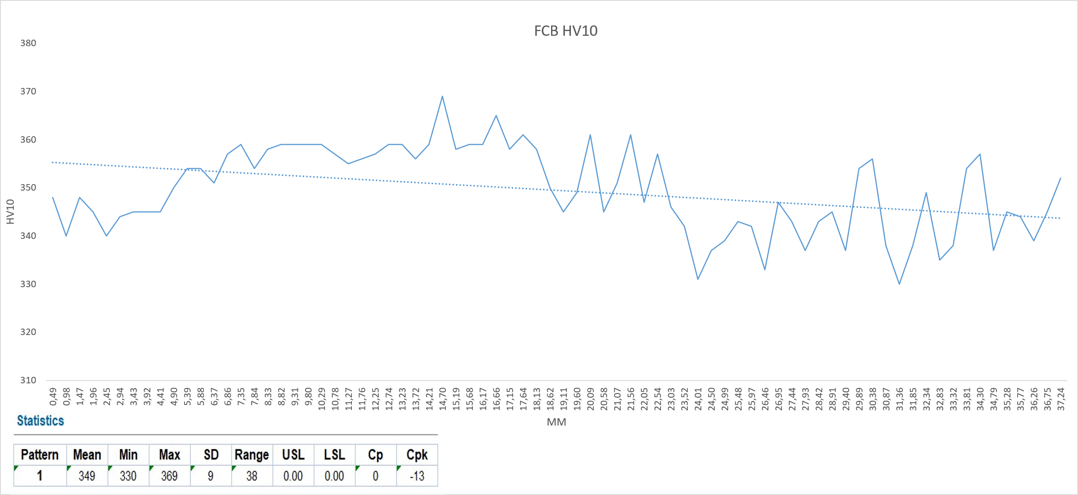

Figures 32–35 present the results of the Vickers hardness test (HV10) for specimens FAB, FBB, and FCB. The measurements start from 0.49 mm at the outer edge and extend to 36.75 mm, passing through the bolt centre at 28 mm. The comparative plot shown in Figure 35 illustrates that FAB has the highest average hardness value, followed by FCB and FBB. The plot highlights differences in hardness levels along the length of the specimens. However, the values tend to stabilize near the middle region.

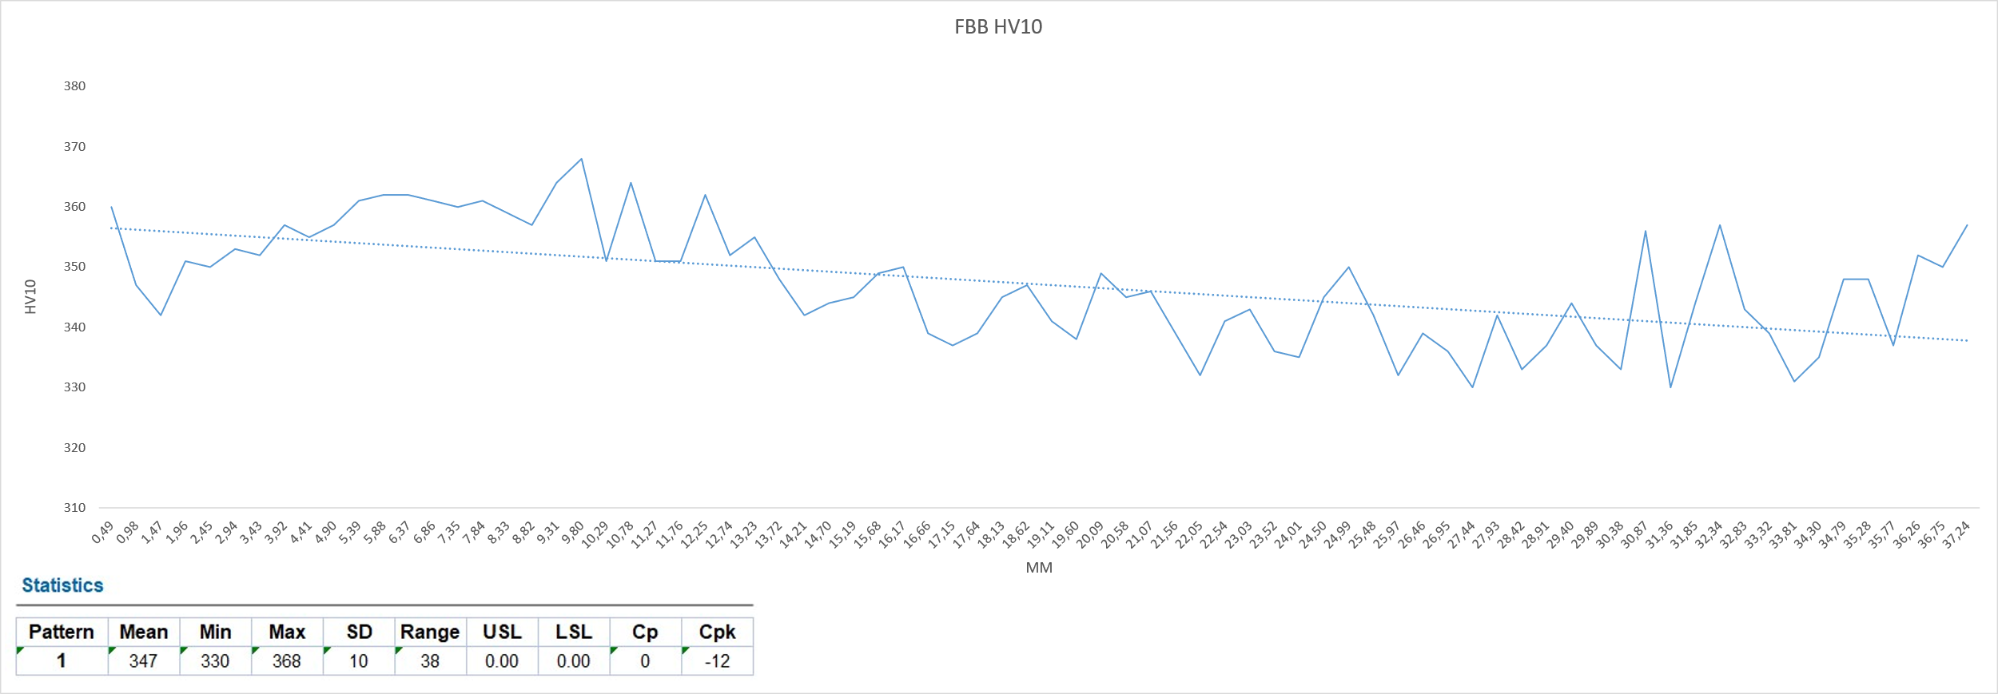

**Fig. 34.** Vickers hardness FCB

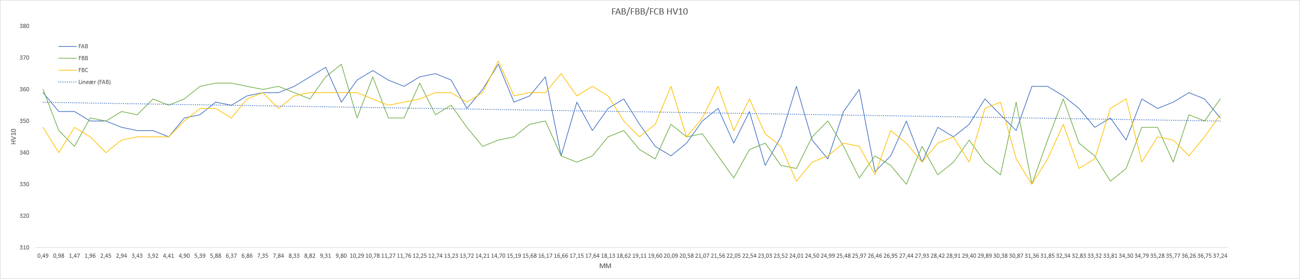

**Fig. 35.** Vickers hardness FAB/FBB/FCB

* 1. Expert consultation

In this investigation of the bolt failures, authors consulted Dr. Angelique Lasseigne, CEO of G2MT Laboratories, LLC, Texas USA, an expert in metallurgical and failure analysis, via mail correspondence and received the following reply;

*“If you notice how the outer circumference of the bolts have a smooth appearance, that is evidence of macroscopic brittle failure. As you move towards the centre of the bolt, the bolt gains ductility and becomes macroscopically ductile. The second features that I notice, are what appears as step marks around the OD circumference of the bolts. These step marks are perpendicular to the OD surface and are called ratchet marks. These ratchet marks were created when more than one crack initiated around the OD circumference of the bolt. The crack features suggest that the initial cracking happened when they performed the first stage of the tightening process and then the crack propagation occurred during their time in service. With all that being said, I think that the bolts were vulnerable to cracking because of the zinc galvanizing process. The galvanizing process is an electrochemical process that generates hydrogen bubbles. These hydrogen bubbles can dissociated into atomic hydrogen and is absorbed into the steel through the iron grain boundaries. The hydrogen weakens the grain boundaries and ultimately causes cracking of the grain boundaries and that is what you see in the electron micrographs that you have. That is intergranular cracking due to the presence of hydrogen absorption. The only other failure mechanism that could cause that same type of failure in steel would be temper embrittlement from the quench and tempering process utilized to make the steel strong. It does not look like temper embrittlement based on the distortion in the centre of the bolt.*

*High strength bolts with quench and tempered martensitic microstructures (which your optical micrographs show tempered martensite) are extremely susceptible to hydrogen cracking during the electroplating process and they actually perform a bake-out heat treatment process to remove the hydrogen. Unfortunately, the hydrogen does not always come out and that’s assuming they performed the heat treatment and performed it appropriately. It only takes 1 ppm of hydrogen to cause cracking in these high strength bolts. I would not recommend galvanizing tempered martensitic bolts because it is too much of a risk.*

*So with all of that being said, those bolts failed due to hydrogen cracking, which was caused by hydrogen absorption during the galvanizing process. The presence of the hydrogen made the bolt more susceptible to fatigue cracking upon torquing and then during service*.”

But whether hydrogen embrittlement is because of a galvanized coating process, whose move passed through out the subject with electroplating or hot dipped galvanizing, used by that producer, is something to be examined further in accordance with relevant studies.

Townsend's [20] study shows that hot-dip galvanizing hydrogen embrittlement retails from the process consists of a reaction between molten Zn and steel to form a series of intermetallic layers which absorb H2, thus increasing the risk of cracking. Also, defects in the zinc coating at the microscopic level makes it easier for hydrogen to come in, with a resulting serious risk for structural failure [20].

Adding an understanding of hot-dip galvanizing results from both G2MT Laboratories and Townsend's research, underlines the importance of strict galvanizing techniques, and careful handling techniques in general, which can reduce hydrogen pickup and improve the strength and durability of structures.

1. Conclusions

The causes of premature failure of M56 high strength bolts (grade 10.9) made from 32CrB4 used for onshore wind turbine towers were investigated in detail in this study. Mechanical testing included Charpy Tests, tensile test and Vickers hardness test. Chemical compositions were analysed by EDS. Microstructural testing’s with optical microscope and SEM-EBSD analysis.

* The bolts generally meet the mechanical requirements. Evidence of intergranular fracture in certain cases is consistent with hydrogen embrittlement. However, none of these findings are enough to set a definite root cause of fracture but might be hydrogen embrittlement. The comparison of results and investigation of the failure behaviour of the bolts led to the following concluding remarks. The tensile tests indicated these bolts met standard-required properties, but lack of comparisons with an unfractured bolt would be helpful.
* Hydrogen embrittlement was not ruled out by the hardness tests.
* From images of the microstructure, it appears almost all tempered martensite with a few possible ductile cracks grows.
* In the SEM images taken, intergranular cracking starts at edge areas and forms a series of strain induced bands which resemble dimples across the centre, so both brittle and ductile responses are evident.
* Fracture surface of bolt B showed more brittle character near its core area than the others.
* The Charpy samples appeared to be ductile fracture surfaces and there was no intergranular cracking, which suggests that over time the bolts had perhaps leaked out the potential hydrogen.

Hence these results indicate a complex interaction of factors leading to failures, which require more study to determine failure/fracture mechanism completely. Additionally, the absence of comparative data from unfractured or alternative bolts limited the scope of analysis. These constraints, while significant, frame the context of the study and underscore the need for continued interdisciplinary research in this domain.

**Acknowledgement**

This paper could not have been completed without the assistance of too many to name. Our thanks go to the team in the workshop and laboratory at the University of Stavanger for their marvellous help. Special thanks go out to Are Molund, Kjell Høgemark, Caroline Einvik and the outstanding laboratory team: Johan A. Thorkaas, Engineer-in-charge; Mats Ingdal, Senior Engineer; and Espen Undheim, Senior Engineer. They have been of value to our research through their help with sample preparation, testing and discussions of results.

We are especially gratefully to the CEO of G2MT’s laboratory in Houston, Texas, Mrs. Angelique Lasseigne, for her knowledge and time dedicated to reviewing our ideas and indicating what course they should take.

**References**

1. N. Jenkins and J. Ekanayake, “Renewable energy engineering,” Cambridge University Press, Cambridge, 2017.
2. R. L. B. A. S. C. Jose Alberto Álvarez, “Failure Analysis of High Strength Galvanized Bolts,” *MDPI,* p. 14, 07 July 2016.
3. DNV, “Study on bolt joingt,” p. 26, 15 01 2019.
4. M. B. Lachowicz and M. M. Lachowicz, "Influence of Corrosion on Fatigue of the Fastening Bolts," MDPI, p. 17, 15 03 2021.
5. N. Standard, “NS-EN ISO 898-1:2013,” 2018.
6. N. Standard, “NS-EN ISO 898-2:2022,” 2022.
7. Deutsdches Institut fur Normung, “High Strenght hexagon head bolts with large widths across flats for structural steel bolting,” October 1989.
8. A. Stepanov, A. Koldaev, N. Arutyunyan and A. Zaitsev, "Evolution of the Structural State and Properties of 32CrB4 Steel," *Metals 2022,* p. 366, 12 2022.
9. M. B. Hernandez, “Mill Test Certificate,” Sidenor Aceros Especiales, Spain, 2021.
10. N. C. C. 4. 1, "NS-EN ISO 6507-1:2023," Norsk Standard, 2023.
11. N. C. C. 4. 1, "NS-EN ISO 148-1:2016, Metallic materials — Charpy pendulum impact test," Norsk Standard, 2016.
12. N. C. C. 4. 1, "NS-EN ISO 6892-1:2019, Metallic materials - Tensile testing," Norsk Standard , 2019.
13. Mtex, "Mtex," [Online]. Available: <https://mtex-toolbox.github.io/>.
14. D. G. R. William D. Callister. JR, Material Science and engineering an introduction, Tenth Edition, 142-171, 181-206, 209-248, Wiley, 2018.
15. P. T.L Anderson, Fracture Mechanics, Fundamentals and Applications, Third Edition, New York: Taylor & Francis Group, 2005.
16. M. B. Lachowicz and M. M. Lachowicz, "Influence of Corrosion on Fatigue of the Fastening Bolts," MDPI, p. 17, 15 03 2021.
17. ISO, “INTERNATIONA LSTANDARD ISO10684, Fasteners —Hot dip galvanized coatings,” ISO, Switzerland, 2004.
18. D. G. R. William D. Callister. JR, Material Science and engineering an introduction, Tenth Edition, 142-171, 181-206, 209-248, Wiley, 2018.
19. N. C. C. 4. 1, "NS-EN ISO 643:2020," Norsk Standard, 2020.
20. H. Townsend, "Effects of zinc coatings on the stress corrosion cracking and hydrogen embrittlement of low-alloy steel," Metallurgical and Materials Transactions A 6(4):877-883, 1975