A statistical comparative analysis of fire resistance of reinforced concrete (RC) and concrete filled steel tubular (CFST) columns using deep learning

Muhammad Noman1, Afaq Ahmed2[0000-0001-9427-4296], Muhammad Salman3, Muhammad Faizan4

1 Civil and Coastal Engineering Department, University of Florida, Gainesville, USA.

2 Civil engineering department, Oslo Metropolitan University, Norway.

3 Civil Engineering Department, UET Taxila, Pakistan.

4 Computer Engineering Department, UET Taxila, Pakistan.

**Abstract.** Fire resistance is a critical aspect which is to be considered to define the structural integrity of columns. This investigation presents the development of predictive neural network (NN) models to predict the fire resistance of reinforced concrete (RC) and concrete filled steel tubular (CFST) columns. Databases of 270 and 223 specimens were prepared for RC and CFST columns, respectively. 12 input parameters were considered for CFST columns, and 8 input parameters were considered for RC columns to train the algorithms. Eight input parameters considered for RC columns modelling are cross-sectional area of columns (mm2), specimen height (mm), compressive strength of concrete (MPa), tensile strength of reinforcement (MPa), longitudinal reinforcement ratio (%), heating rate (°C/min), test load (kN), eccentricity of applied load (mm) and 2 additional parameters were steel plate thickness (mm), and tensile Strength of Steel (MPa) for CFST columns. The models were developed with different neural architectures and most optimum models outperformed all available conventional models with correlation coefficients (R) of 0.92294 for RC columns and 0.99431 for CFST columns. Parametric studies are also done to observe and compare the effectiveness of the most important parameters on fire resistance of RC and CFST columns. The developed models encompass significant advantages for the field of fire engineering. These models can be used to evaluate and compare the performance of RC and CFST columns in the event of fire.

**Keywords:** Fire resistance, CFST columns, RC columns, Machine learning

1. **Introduction:**

In the context of reinforced concrete (RC) and concrete-filled steel tubular (CFST) columns), fire resistance is one of the critical factors regarding structural integrity and safety. During fire events, columns are important for supporting the loads and maintaining the stability of the structure. It is essential to understand and predict the fire resistance levels of structures to design building systems that are safer and to mitigate the risks associated with fire disasters. RF columns are common in construction industry because of their strength, durability and cost effective. Their behavior under extreme temperatures and threats has been studied extensively, resulting in the development of numerous empirical models to predict their behavior. However, these models are sometimes framed within particular bounds, and make some assumptions and simplifications which overlook the very complex relationship among many factors that affect fire resistance [1]. CFST columns are becoming more popular because of their exceptional fire resistance, ability to endure heavy loads, and the merged benefits of concrete and steel. The bond between the concrete core and the steel tube greatly improves their structural efficiency, but makes the prediction of fire resistance more complicated. [2].

The fire resistance of structural elements, particularly columns, remains a complicated issue impacted by a myriad of factors including the material’s fire-protection attributes, cross-section shape, and the fire parameters itself. It is obvious that the fire resistance of reinforced concrete (RC) columns is mainly governed by the mechanical and thermal characteristics of its constituent materials, that is, steel and concrete, the applied load, and the time duration of the fire [1].

Steel concrete filled tubes columns have attracted attention because of their enhanced fire resistance properties relative to ordinary reinforced concrete (RC) columns. The concrete filled steel tube bears the concrete core and therefore, the tube not only enhances the load bearing capacity of the concrete core but also protects against any fracture in case of a fire [2]. Empirical research has demonstrated that CFST columns possess superior fire resistance due to the collaborative interaction between the concrete core and the steel tube. Taking into account the concrete infill’s strength and the axial load’s value, several models have been created aimed at forecasting the fire resistance of CFST columns which incorporate the taper ratio of the steel tube.[3] As principal horizontal elements are the infrastructure’s sustaining pillars, there is a pressing need for prompt diagnosis, evaluation, and strengthening or modification procedures. Fire resistance is typically examined from an engineering perspective, where experimental evaluation is often performed using self-contained and sophisticated numerical models. The models developed here, which may be simplistic in nature, are intended for rapid determination of fire resistance for all the columns under conditions of fire.

Machine learning (ML) algorithms are particularly useful in improving the accuracy of fire resistance predictions because they can analyze large amounts of data and identify complex relationships. Given the nature of algorithms and historical data, ML models can highlight patterns which conventional methods fail to reveal. Studies show the successful application of machine learning in diverse fields of civil engineering such as structural health monitoring, predicting material properties, and estimating the load-bearing capacity [4, 38-46]. Factors such as the geometry, material properties, and fire exposure details can be integrated into machine learning algorithms to yield accurate predictions about a structure's ability to withstand fires. From the literature review, it was found that ML tools like ANNs outperform empirical models in terms of predictive accuracy and generalization capability [4].

Fig. 1 presents the shapes of samples taken for preparing the datasets. For CFST columns, all types of shapes like circular, square, rectangular, and eclipse are considered; meanwhile, for RC columns, only square and rectangular shapes were considered during preparing datasets. No experimental research has examined how column shape affects CFST fire performance. However, circular columns may resist fire longer than square ones, as square corners receive more heat, weakening them faster. [5].

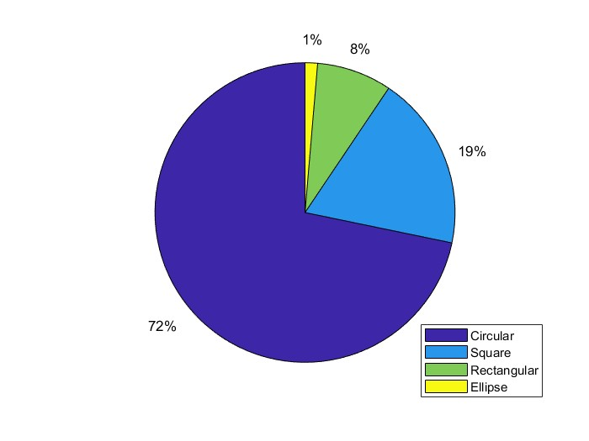

1. **Development of Neural Network Models:**

**Fig. 1** Shapes in the datasets. (a) RC database (b) CFST database

* 1. **Preparation of Datasets:**

To develop the ANN models for predicting the fire resistance of both CFST and RC columns, an extensive investigation is performed through the literature to note down the findings of the experimental investigations done in the past to study the fire resistance of CFST and RC columns. Eight input parameters were considered in the RC columns; 10 input parameters are considered in the CFST columns. The input parameters considered for RC columns are cross-section area of columns (mm2), specimen height (mm), compressive Strength of concrete (MPa), tensile Strength of reinforcement (MPa), longitudinal reinforcement ratio (%), hating rate (°C/min), test load (kN), eccentricity of applied load (mm) and fire resistance (mins) was noted as the target parameters for developing the NN model. To differentiate between slow and fast heating rates, a heating rate parameter was introduced for both CFST and RC columns. The heating rate is the ratio of the temperature of the furnace after 30 minutes of fire per 30 minutes duration.

On the other hand the input parameters considered for CFST columns are cross-section area of columns (mm2), specimen height (mm), compressive Strength of concrete (MPa), steel plate thickness (mm), tensile Strength of Steel (MPa), tensile Strength of reinforcement (MPa), longitudinal reinforcement ratio (%), hating rate (°C/min), test load (kN), eccentricity of applied load (mm) and fire resistance (mins) was noted as the target parameters for developing the NN model.

After thorough investigation, two datasets with a total of 270 samples for RC columns from 11 investigations Refs [1, 6-15] and 223 samples for CFST columns from 21 investigations Refs [16-36] were produced. It is essential to mention that the study focused on the non-protected CFST column. Additionally, double-skin columns or columns incorporating various composites, such as steel fibers, were excluded from the research.

Dividing data into training, validation, and testing sets is essential for effective machine learning. As noted in Ref [36, 38-42], around 70–80% is used for training, 10–20% for validation, and the rest for testing, ensuring balanced model development and assessment. In this investigation, the data is divided automatically by MATLAB [37] into three sets, 70% of the data was kept for training, and the rest is divided into two halves of 15% for validation and testing.

**2.2 Normalization of Data:**

Normalization refers to a preprocessing technique applied to the input data to enhance the convergence and behavior of the model during training [37]. The efficiency of ANNs improves significantly when both input and target data values within the database are normalized. Following this normalization process, all outputs can be de-normalized for comparative analysis after training. The quality of the database directly impacts the performance of the ANN. To enhance the accuracy of the proposed NN model, all variables in the prepared datasets undergo normalization to achieve unitless parameters. Failure to conduct proper normalization and standardization of these variables results in a decrease in the processing and learning rate of the proposed NN model [43-46]. In this research, manual normalization is employed instead of utilizing MATLAB's automated normalization functions. This decision stems from the need to grant users control over the entire ANN operation process rather than relying solely on the code. All the input parameters and target values are normalized between 0.1 and 0.9 by Eq. 1.

$X=\left(\frac{0.8}{∆ }\right)×x+(0.9-\left(\frac{0.9}{ ∆}\right)×)x_{\max{ }})$... (1)

Whereas X shows the normalized parameter and ‘x” is the original value of the parameters. $∆$ shows the deviation among the lowest value and the highest value of the parameter so ,

* 1. **Structure of proposed models:**

The ANN models in the current investigation for RC and CFST columns are developed in MATLAB Toolbox. As there are no specific regulations for selecting a specific type or structure in NN modeling. Although certain guidelines are suggested in the literature, following them and through a hit and trial of different model structures, one can reach the most optimum model, giving the closest predictions. This study has done the same, and numerous models were prepared for RC and CFST columns.

The structure of a neural network greatly affects its performance. Key factors include the choice of activation functions, the number of hidden layers and neurons, and the selected learning and training algorithms.

|  |  |  |  |  |  |  |  |
| --- | --- | --- | --- | --- | --- | --- | --- |
| **RC1-10-10** | 8 | 2 | 10 & 10 | LEARNGDM | TRAINLM | LOGSIG | TANSIG |
| **CFST5-10-10** | 10 | 2 | 10 & 10 | LEARNGDM | TRAINLM | LOGSIG | TANSIG |

**Table 1** Architecture of prepared models for CFST columns

1. **Assessment of prepared NN models:**

To choose the most optimum and accurate models for predicting the fire resistance of RC and CFST columns, all the established models were assessed using various statistical parameters like correlation factor (R), Root mean squared error (RMSE), and mean squared error (MSE). The highest value of the correlation factor and lowest values for MSE and RMSE present the most optimum model. Correlation factor (R), RMSE, and MSE are Quantifiable by Eq. 2, Eq. 3, and Eq. 4, respectively.

|  |  |
| --- | --- |
| $$R = \frac{1}{\left(N-1\right)\sum_{i=1}^{n}{[\frac{\left(Y_{i}-{Y^{'}}_{i} \right)}{S_{y}}\frac{\left(X_{i}-{X^{'}}_{i} \right)}{S_{x}}] }}$$ | … (2) |
| $$RMSE \left(\%\right)= \sqrt{\frac{\sum_{i=1}^{n}{(\frac{Y_{i}-X_{i}}{X_{i}})^{2}}}{N}}$$ | … (3) |
| $$MSE (\%)= \frac{\sum_{i=1}^{n}{(\frac{Y_{i}-X_{i}}{X_{i}})^{2}}}{N}$$ | … (4 |

whereas in above equations, N = Total Number of specimens, Xi = original values, Yi = ANN model predicted values, ${X^{'}}_{i} = \sum_{i=1}^{N}{\frac{X_{I }}{N}}$ and $S_{x}= √\frac{{(X}_{i}-{X^{'}}_{i})^{2}}{N-1}$ and the same for the ${Y^{'}}_{i}$ and Sy. The architecture of the NN models was changed and modified to find the most accurate and best-suited model, giving the closest predicted values having the lowest error. Firstly, the best-performing single hidden layer model was identified. Then, the second hidden layer was added with varying neurons to see if there was any improvement in the overall R-value of the model.

1. **Performance of the final proposed NN models**

It has been established that RC1-10-10 (R =0.92, RMSE=0.35%. MSE=0.12%) and CFST1-10-10 (R =0.99, RMSE = 0.45%, MSE = 0.20%) are the proposed models to predict the fire resistance of RC and CFST columns, respectively. To observe the predicting behaviors of these models more closely, Fig. 11 shows graphical presentations of R values (Training, Validation, Testing, and overall) for RC1-10-10 (R =0.92, RMSE=0.35%. MSE=0.12%).

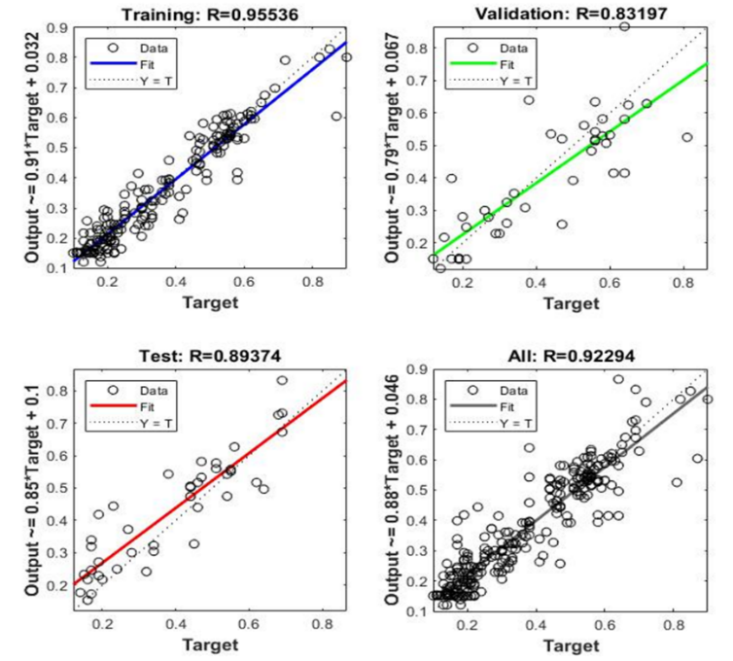

**Fig 2**. R (Training, Validation, Testing & overall) values for RC1-10-10.

Similarly, to check the performance of CFST1-10-10 (R =0.99, RMSE = 0.45%, MSE = 0.20%), the graphs of R values are plotted in Fig. 13. The Training R-value = 0.99, Validation R-value = 0.97, Testing R-value = 0.99, and Overall R value = 0.99 for model CFST1-10-10 are shown. From the data distribution, it can be observed that all the predictions are very close to the mean line.

**Fig 3.** R (Training, Validation, Testing & overall) values for CFST1-10-10.

Fig. 4 compares experimental and predicted fire resistance values for CFST110-10 columns. With R = 0.99, RMSE = 0.45%, and MSE = 0.20%, the model shows high accuracy, closely matching experimental results.

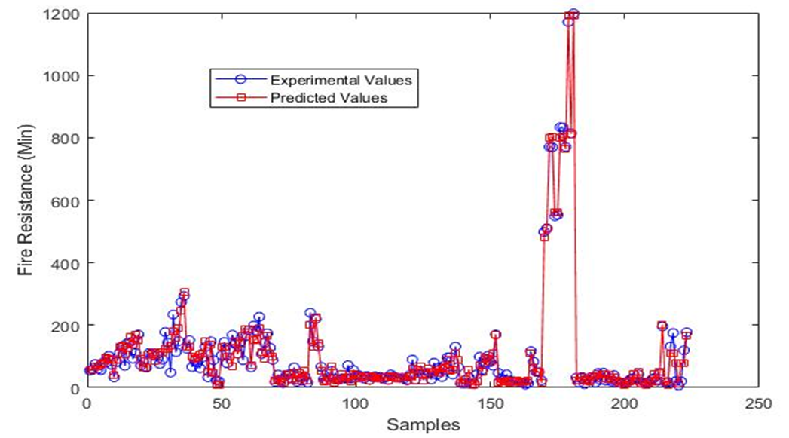

**Fig 4.** Comparison b/w predicted values by CFST1-10-10 and experimental values

1. **CONCLUSION**

The aim of this investigation was to utilize machine learning algorithms to develop neural models for the prediction of fire resistance for both RC and CFST columns and then using the developed models to evaluate and compare the effect of different parameters on the fire resistance of RC and CFST columns. The predictions of prepared models are very close to the original data collected from the literature. There is only a 0.5% difference between the average fire resistance of the collected dataset for RC columns and the predicted dataset by the RC1-10-10. The difference is 1.1% between the average fire resistance of the collected dataset for CFST columns and the predicted dataset by the CFST1-10-10.

**REFERENCES**

1. F. Ali, A. Nadjai, G. Silcock, A. Abu-Tair, Outcomes of a major research on fire resistance of concrete columns, Fire Saf. J. 39 (2004) 433–445. https://doi.org/https://doi.org/10.1016/j.firesaf.2004.02.004.
2. Q.-H. Tan, L.-H. Han, H.-X. Yu, Fire performance of concrete filled steel tubular (CFST) column to RC beam joints, Fire Saf. J. 51 (2012) 68–84. https://doi.org/https://doi.org/10.1016/j.firesaf.2012.03.002.
3. V.K.R. Kodur, M.B. Dwaikat, Performance-based Fire Safety Design of Reinforced Concrete Beams:, J. Fire Prot. Eng. 17 (2007) 293–320. https://api.semanticscholar.org/CorpusID:59362308.
4. B.B. Ekici, U.T. Aksoy, Prediction of building energy consumption by using artificial neural networks, Adv. Eng. Softw. 40 (2009) 356–362. https://doi.org/https://doi.org/10.1016/j.advengsoft.2008.05.003.
5. P. Schaumann, V. Kodur, O. Bahr, Fire behaviour of hollow structural section steel columns filled with high strength concrete, J. Constr. Steel Res. 65 (2009) 1794–1802. https://doi.org/https://doi.org/10.1016/j.jcsr.2009.04.013.
6. T.T. Lie, Fire Resistance of Reinforced Concrete Columns: a Parametric Study, J. Fire Prot. Eng. 1 (1989) 121–129. https://doi.org/10.1177/104239158900100402.
7. H.J. Wu, T.T. Lie, Fire resistance of reinforced concrete columns: experimental studies, National Research Council of Canada, 1992. https://doi.org/10.4224/20375195.
8. V.K.R. Kodur, R.C. McGrath, P. Leroux, J.C. Latour, Experimental studies for evaluating the fire endurance of high-strength concrete columns, National Research Council of Canada, 2005. https://doi.org/10.4224/20378032.
9. V. Kodur, R. McGrath, Fire endurance of high strength concrete columns, Fire Technol. 39 (2003) 73–87. https://doi.org/10.1023/A:1021731327822.
10. T.K. H., Y. Y., Fire Resistance of Reinforced Concrete Columns Subjected to 1-, 2-, and 3-Face Heating, J. Struct. Eng. 130 (2004) 1820–1828. https://doi.org/10.1061/(ASCE)0733-9445(2004)130:11(1820).
11. D. V Reddy, K. Sobhan, L. Liu, J.D. Young, Size effect on fire resistance of structural concrete, Eng. Struct. 99 (2015) 468–478. https://doi.org/https://doi.org/10.1016/j.engstruct.2015.05.015.
12. T. Gernay, Fire resistance and burnout resistance of reinforced concrete columns, Fire Saf. J. 104 (2019) 67–78. https://doi.org/https://doi.org/10.1016/j.firesaf.2019.01.007.
13. A. Benmarce, M. Guenfoud, Experimental behaviour of high-strength concrete columns in fire, Mag. Concr. Res. 57 (2005) 283–287. https://doi.org/10.1680/macr.2005.57.5.283.
14. S.H. Buch, U.K. Sharma, Empirical model for determining fire resistance of Reinforced Concrete columns, Constr. Build. Mater. 225 (2019) 838–852. https://doi.org/https://doi.org/10.1016/j.conbuildmat.2019.07.183.
15. R.N. K., K.V.K. R., Response of High-Strength Concrete Columns under Design Fire Exposure, J. Struct. Eng. 137 (2011) 69–79. https://doi.org/10.1061/(ASCE)ST.1943-541X.0000265.
16. T.T. Lie, M. Chabot, Experimental Studies on the Fire Resistance of Hollow Steel Columns Filled with Plain Concrete, National Research Council of Canada, 1992. https://doi.org/10.4224/20358480.
17. S. Y., O. T., Y. M., T. S., Fire Resistance of Concrete‐Filled, Fire‐Resistant Steel‐Tube Columns, J. Mater. Civ. Eng. 6 (1994) 169–184. https://doi.org/10.1061/(ASCE)0899-1561(1994)6:2(169).
18. L.-H. Han, Y.-F. Yang, L. Xu, An experimental study and calculation on the fire resistance of concrete-filled SHS and RHS columns, J. Constr. Steel Res. 59 (2003) 427–452. https://doi.org/https://doi.org/10.1016/S0143-974X(02)00041-X.
19. L.T. T., Fire Resistance of Circular Steel Columns Filled with Bar‐Reinforced Concrete, J. Struct. Eng. 120 (1994) 1489–1509. https://doi.org/10.1061/(ASCE)0733-9445(1994)120:5(1489).
20. V.K.R. Kodur, T.T. Lie, Experimental studies on the fire resistance of circular hollow steel columns filled with steel-fibre-reinforced concrete, National Research Council of Canada, 1995. https://doi.org/10.4224/20375221.
21. V.K.R. Kodur, Solutions for enhancing the fire endurance of HSS columns filled with high-strength concrete, Eng. J. 43 (2006) 1–7. https://doi.org/10.62913/engj.v43i1.871.
22. M.L. Romero, V. Moliner, A. Espinos, C. Ibañez, A. Hospitaler, Fire behavior of axially loaded slender high strength concrete-filled tubular columns, J. Constr. Steel Res. 67 (2011) 1953–1965. https://doi.org/https://doi.org/10.1016/j.jcsr.2011.06.012.
23. L.-H. Han, F. Chen, F.-Y. Liao, Z. Tao, B. Uy, Fire performance of concrete filled stainless steel tubular columns, Eng. Struct. 56 (2013) 165–181. https://doi.org/https://doi.org/10.1016/j.engstruct.2013.05.005.
24. A. Espinos, M.L. Romero, E. Serra, A. Hospitaler, Circular and square slender concrete-filled tubular columns under large eccentricities and fire, J. Constr. Steel Res. 110 (2015) 90–100. https://doi.org/https://doi.org/10.1016/j.jcsr.2015.03.011.
25. J.P.C. Rodrigues, L. Laim, Fire response of restrained composite columns made with concrete filled hollow sections under different end-support conditions, Eng. Struct. 141 (2017) 83–96. https://doi.org/https://doi.org/10.1016/j.engstruct.2017.02.073.
26. H. Lu, X.-L. Zhao, L.-H. Han, Fire behaviour of high strength self-consolidating concrete filled steel tubular stub columns, J. Constr. Steel Res. 65 (2009) 1995–2010. https://doi.org/https://doi.org/10.1016/j.jcsr.2009.06.013.
27. K.U. Ukanwa, U. Sharma, S.J. Hicks, A. Abu, J.B.P. Lim, G.C. Clifton, Behaviour of continuous concrete filled steel tubular columns loaded concentrically in fire, J. Constr. Steel Res. 136 (2017) 101–109. https://doi.org/https://doi.org/10.1016/j.jcsr.2017.05.011.
28. H. Yang, F. Liu, L. Gardner, Performance of concrete-filled RHS columns exposed to fire on 3 sides, Eng. Struct. 56 (2013) 1986–2004. https://doi.org/https://doi.org/10.1016/j.engstruct.2013.08.019.
29. K. Wang, B. Young, Fire resistance of concrete-filled high strength steel tubular columns, Thin-Walled Struct. 71 (2013) 46–56. https://doi.org/https://doi.org/10.1016/j.tws.2013.05.005.
30. H. Yang, F. Liu, S. Zhang, X. Lv, Experimental investigation of concrete-filled square hollow section columns subjected to non-uniform exposure, Eng. Struct. 48 (2013) 292–312. https://doi.org/https://doi.org/10.1016/j.engstruct.2012.09.011.
31. L. Faqi, W. Yuyin, G. Leroy, V.A. H., Experimental and Numerical Studies of Reinforced Concrete Columns Confined by Circular Steel Tubes Exposed to Fire, J. Struct. Eng. 145 (2019) 4019130. https://doi.org/10.1061/(ASCE)ST.1943-541X.0002416.
32. M. Yu, T. Wang, W. Huang, H. Yuan, J. Ye, Fire resistance of concrete-filled steel tube columns with preload. Part I: Experimental investigation, Compos. Struct. 223 (2019) 1–15. https://doi.org/10.1016/j.compstruct.2019.110994.
33. Z. Tao, M. Ghannam, T.-Y. Song, L.-H. Han, Experimental and numerical investigation of concrete-filled stainless steel columns exposed to fire, J. Constr. Steel Res. 118 (2016) 120–134. https://doi.org/https://doi.org/10.1016/j.jcsr.2015.11.003.
34. V. Moliner, A. Espinos, M.L. Romero, A. Hospitaler, Fire behavior of eccentrically loaded slender high strength concrete-filled tubular columns, J. Constr. Steel Res. 83 (2013) 137–146. https://doi.org/https://doi.org/10.1016/j.jcsr.2013.01.011.
35. T.A.C. Pires, J.P.C. Rodrigues, J.J.R. Silva, Fire resistance of concrete filled circular hollow columns with restrained thermal elongation, J. Constr. Steel Res. 77 (2012) 82–94. https://doi.org/https://doi.org/10.1016/j.jcsr.2012.03.028.
36. H. Lin-Hai, Z. Xiao-Ling, Y. You-Fu, F. Jiu-Bin, Experimental Study and Calculation of Fire Resistance of Concrete-Filled Hollow Steel Columns, J. Struct. Eng. 129 (2003) 346–
37. A. Peña Yañez, The Elements of Statistical Learning Data Mining, Inference, and Prediction, Springer Ser. Stat. 26 (1967) 505–516.
38. Wahab, S., Suleiman, M., Shabbir, F., Mahmoudabadi, N.S., Waqas, S., Herl, N. and Ahmad, A., 2023. Predicting confinement effect of carbon fiber reinforced polymers on strength of concrete using metaheuristics-based artificial neural networks. *arXiv preprint arXiv:2403.13809*.
39. Le-Nguyen, K., Minh, Q.C., Ahmad, A. and Ho, L.S., 2022. Development of deep neural network model to predict the compressive strength of FRCM confined columns. *Frontiers of Structural and Civil Engineering*, *16*(10), pp.1213-1232.
40. Ahmad, A., Lagaros, N.D. and Cotsovos, D.M., 2021. Neural network-based prediction: The case of reinforced concrete members under simple and complex loading. *Applied Sciences*, *11*(11), p.4975.
41. Ahmad, A., Cotsovos, D.M. and Lagaros, N.D., 2016. Assessing the reliability of RC code predictions through the use of artificial neural networks. In *1st international conference on structural safety under fire & blast. Glasgow, UK*.
42. Ahmad, A. and Cotsovos, D.M., 2023. Reliability analysis of models for predicting T-beam response at ultimate limit response. *Proceedings of the Institution of Civil Engineers-Structures and Buildings*, *176*(1), pp.28-50.
43. Ahmad, A., Kotsovou, G., Cotsovos, D.M. and Lagaros, N., 2016, May. Assessing the load carrying capacity of RC members through the use of artificial neural networks. In *11th HSTAM international congress on mechanics, Athens, Greece*.
44. Al-Sayegh, A.T., Mahmoudabadi, N.S., Behbehani, L.J., Saghir, S. and Ahmad, A., 2024. Estimating the axial strain of circular short columns confined with CFRP under centric compressive static load using ANN and GRA techniques. *Heliyon*, *10*(13).
45. Ahmad, A., Arshid, M.U., Mahmood, T., Ahmad, N., Waheed, A. and Safdar, S.S., 2021. Knowledge‐Based Prediction of Load‐Carrying Capacity of RC Flat Slab through Neural Network and FEM. *Mathematical Problems in Engineering*, *2021*(1), p.4528945.
46. Sharib, S., Ahmad, N., Plevris, V. and Ahmad, A., 2021, June. Prediction models for load carrying capacity of rc wall through neural network. In *Proceedings of the 14th ECCOMAS Thematic Conference on Evolutionary and Deterministic Methods for Design, Optimization and Control (EUROGEN 2021)* (pp. 132-142).