Enhancement of Time Series-Based Feature Extraction for Structural Health Monitoring
Ali Ramezani ¹, Soroush Safakhah ¹, Soheila Goli ²
¹Department of Civil Engineering, Semnan Branch, Islamic Azad University, Semnan, Iran
²Department of Civil and Environmental Engineering, Politecnico di Milano, Milan, Italy
ali.ramezani5550@iau.ac.ir
Abstract. Feature extraction plays an important role in vibration-based structural health monitoring (SHM), particularly within the framework of statistical pattern recognition. Among various signal processing techniques, time series analysis using linear time-invariant models has demonstrated strong potential for deriving features that are both reliable and sensitive to structural damage. However, the effectiveness of such models heavily depends on selecting appropriate model orders and ensuring that the resulting residuals are uncorrelated. An under-parameterized model may yield features that are insensitive to damage, leading to inaccurate or missed damage detection. This study proposes an enhanced feature extraction methodology based on autoregressive (AR) modeling of measured acceleration responses, with a focus on optimizing model order selection. The Mahalanobis distance is employed to evaluate and compare the performance of the proposed method against conventional feature extraction techniques. To validate the approach, experimental vibration datasets from a well-known SHM benchmark structure are analyzed. Results confirm that the improved method not only adheres to statistical modeling requirements but also yields features with significantly higher sensitivity to damage than traditional approaches.
Keywords: Structural Health Monitoring, Feature Extraction, Time Series Analysis, Autoregressive.
- Introduction
Damage detection within the realm of structural health monitoring (SHM) becomes an interesting and important issue in civil, mechanical, and aerospace engineering fields in an effort to decrease maintenance costs, improve dynamic behavior or structural systems, and provide appropriate operation [1,2]. Although model-based damage detection techniques have offered classical solutions to detecting, locating, and quantifying damage [3,4], data-based approaches relying upon statistical pattern recognition have gained increasing attention due to their flexibility, reduced dependency on high-fidelity numerical models, and ability to directly utilize measured sensor data [5-8].
In case of using the raw measured vibration responses such as acceleration time histories, data-based SHM methods rely on statistical pattern recognition paradigm. This is generally decomposed into four main parts including operational evaluation, sensing and data acquisition, feature extraction, and feature discrimination for damage detection, localization, and quantification [9]. Feature extraction is a fundamental step in statistical pattern recognition, as it aims to identify meaningful patterns or features from raw vibration responses. Its importance also lies in the fact that if the extracted features are not sensitive to structural damage, even the most robust and rigorous statistical decision-making procedures may yield inaccurate or misleading results in damage detection.
Most data-driven feature extraction methods rely on advanced signal processing techniques. Depending on the characteristics of the vibration responses, various methods have been developed to extract features in the time, frequency, and time–frequency domains [10-12]. When the measured responses exhibit stationary and linear behaviour, time series analysis serves as a reliable and robust tool for feature extraction [13]. This approach involves fitting a time-invariant linear model to the vibration data and extracting its statistical properties, such as model coefficients and residuals, i.e., as key damage-sensitive features [14,15].
In the time series-based feature extraction, selecting an appropriate and sufficient model order is a critical aspect of time series analysis [16,17]. In this context, an incorrect order selection may lead to unreliable time series modelling that fails to accurately represent time domain responses. The model order determines the number of unknown coefficients that must be estimated to predict the system behavior. Akaike Information Criterion (AIC) and Bayesian Information Criterion (BIC) are among the widely used criteria for order selection [18]. However, the suitability of a chosen order also heavily depends on the statistical properties of the model residuals. Specifically, a properly fitted time series model should yield residuals that are uncorrelated and have a zero mean [13,19,20]. If these conditions are not met, time series models should be enhanced. Therefore, it is critical to ensure that the residuals of time series models are uncorrelated.
Building on the above discussion, the primary objective of this article is to enhance the conventional feature extraction technique based on time series modeling. In the first step of the proposed method, a graphical model identification approach is employed to determine a suitable time-invariant model. The core improvement lies in selecting an optimal model order for each sensor vibration response by evaluating the uncorrelatedness of the residuals, rather than relying solely on traditional information criteria. This refinement ensures that the chosen model more accurately captures the underlying structural behavior. Once the optimal model is identified, its coefficients and residuals are extracted and used as key damage-sensitive features. The Mahalanobis distance method is then applied for damage detection and for comparing the performance of the enhanced feature extraction approach against the conventional method. Experimental vibration datasets from a well-established SHM benchmark structure are used to validate the effectiveness and robustness of the proposed technique. The results confirm that the improved method offers superior sensitivity and accuracy compared to the traditional approach.
- AR Modelling
Time series is a sequence of data points that typically consists of successive measurements at a specific time interval. Time series analysis, on the other hand, is a statistical method that attempts to fit a mathematical model to the time series data to extract some statistical features [21]. On the basis of this methodology, there are several time series models such as AutoRegressive (AR), AutoRegressive Moving Average (ARMA), AutoRegressive with eXogenous input (ARX) and AutoRegressive Moving Average with eXogenous input (ARMAX). Among them, the AR representation is the simplest time series analysis that only depends on the output data or the response of the structure. There are some important reasons that make the AR model more applicable to SHM including the sensitivity of its statistical characteristics to damage and structural properties, simplicity, and the only dependence on the structural responses. The basic formulation of an AR model is expressed in the following form:
where y(t) is the measured vibration sample at time t; a_{i} denotes the i^{th} coefficient of the AR model and p is the model order. Moreover, e(t) is the sample of independent residual at time t, which is defined as the difference between the measured response sample and the predicted one by the model.
- An Improved Feature Extraction Method
In the context of SHM, the coefficients and residuals of a time series model are used as the damage-sensitive features [13]. In practice, the coefficients and statistical properties of residuals in the healthy and damaged conditions are ideally different together. The process of feature extraction based on the coefficients of time series models is based on fitting a model to vibration signal and extract both coefficients of the undamaged and damaged structural conditions. In contrast, the feature extraction procedure based on the residuals consists of using a time series model with the coefficients estimated from the undamaged condition to predict the responses of the damaged condition. The fact beyond this approach is that the model used in the baseline condition will no longer correctly predict the response of the damaged structure; therefore, the residual errors regarding this structure will increase. As a result, the increase in the residuals or their statistical properties is an indicator of the damage detection.
The improved feature extraction method is generally to extract these statistical characteristics as the main damage-sensitive features based on fitting an accurate and sufficient model to each vibration response acquired from each sensor. In order to make sure of the model adequacy and accuracy, one needs to determine a robust order. This method lies in the assumption that the measured vibration time-domain responses are linear and stationary. Fig. 1 illustrate the flowchart of the improved feature extraction method. As can be seen, this method consists of five main steps after the data acquisition, which are discussed in details.
Step 1 – Model identification: In the first step, a time series model is identified based on the autocorrelation correlation function (ACF) and partial autocorrelation function (PACF) of the acquired vibration data. The process of identification of time series models is concerned with different factors including the types of data acquisition (input-output or output-only data), the properties of vibration data, and the correlation of data. Under the assumption of the linearity and stationarity of vibration responses, one can select the time-invariant representations such as AR, ARX, ARMA, and ARMAX. In most real cases of SHM for civil engineering structures, the input data or excitation source is unknown (e.g. ambient vibration). For such cases, the response-only time series models AR and ARMA are appropriate choices. Hence, it is attempted to identify one of them by the ACF and PACF. The methodology of model identification by these function originates from Box-Jenkins theory [18]. If the ACF tails off as exponential decay or damped sine wave and the PACF becomes zero after a lag, this implies that time series conforms to the AR model. If both the ACF and PACF tail off as exponential decay or damped sine waves, ARMA is chosen as the most proper time series model.
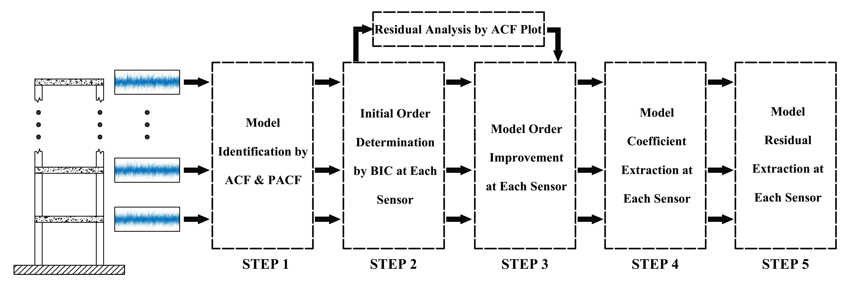
Fig. 1. The flowchart of the proposed feature extraction technique
Step 2 – Initial order determination: In the second step, an initial order is obtained from one of the information criteria. In this article, BIC is applied to determine the initial order at each sensor. For an n-dimensional time series, the BIC equation is expressed as [18]:
where σ_{e}² represents the estimate of the residual variance. To find out an optimum order, one should examine a wide range of orders (e.g. 1-100) and choose a number that has the minimum BIC value.
Step 3 – Model order improvement: Even though the information criterion methods such as AIC or BIC is capable of determining the order of AR model, it is vital to extract uncorrelated residuals from the fitted time series model. Thus, in this step, the initial order of the identified model is improved to determine an improved order at each sensor. The improvement of the initial order is based on the residual analysis through the ACF plot. If the residual sequences of a model are uncorrelated, the samples of ACF should be within the upper and lower confidence intervals.
Step 4 – Model coefficient extraction: When the improved order at each sensor leads to the extraction of uncorrelated residuals, the model coefficients are estimated by one of the computational techniques. Based on the algorithm of coefficient-based feature extraction, the improved order is used for both the undamaged and damaged conditions. The coefficients of these structural states are used as the main damage-sensitive features for damage detection.
Step 5 – Model residual extraction: Using the orders and coefficients obtained from the undamaged condition, one can extract the residual sequences of the model in the damaged state according to the residual-based feature extraction. It is significant to note that the model residuals extracted from the undamaged condition should be uncorrelated.
- Mahalanobis Distance Technique
Mahalanobis distance (MD) is a multivariate statistical distance method that measures the distance between two multivariate datasets [22]. Assume that X and Z refer to the damage-sensitive features of the undamaged conditions (i.e. either the model coefficients or residuals). The discrepancy between these multivariate datasets by the MD method is given by:
where μ_{x} and Σ_{x} are the mean vector and covariance matrix of X. Moreover, z is a column vector of Z so that ncz refers to the number of column in Z.
- An Experimental Benchmark Structure
In order to demonstrate the performance and capability of proposed methods, experimental datasets from a three-story laboratory frame are applied that belongs to the Engineering Institute at Los Alamos National Laboratory [23]. The structure is a three-story laboratory frame whose schematic and sensor locations are shown in Fig 2. A random vibration load is applied by means of an electrodynamic shaker to the base floor along the center line of the frame. The structure is instrumented with four accelerometers mounted at the center line of each floor on the opposite side from the excitation source to measure the acceleration time history response. The shaker and frame are mounted together on an aluminum baseplate and the entire system rests on rigid foam. The sensor signals are sampled at 320 Hz for 25.6 seconds in duration, which are discretized into 8192 data sampled at 3.125 microsecond intervals.
Damage to the structure was simulated as the breathing crack by a bumper mounted on the second floor and a suspended column at the third story. Since the position of the bumper was adjustable, several damage scenarios with different severities were considered into the damaged conditions. On the other hand, diverse undamaged states by incorporating environmental and operational variability (EOV) were defined to simulate realistic conditions. Table 1 presents 17 structural states of the laboratory frame. Based on the first step of the improved feature extraction method, the ACF and PACF plots of the acceleration time histories are used to identify the most appropriate time series model between AR and ARMA, which only depend on the responses of the structure. As a sample, Fig. 3 show their plots for the acceleration response at the sensor 5 in the state 1.
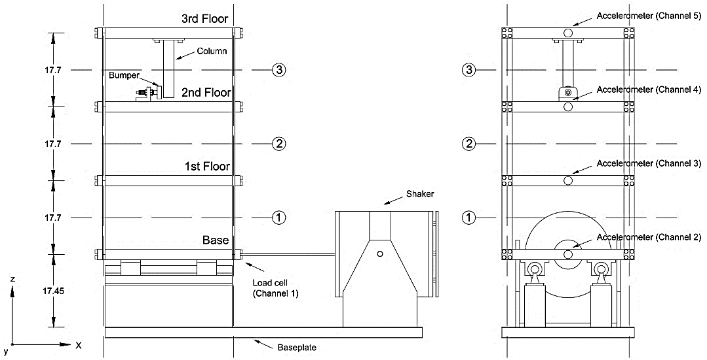
Fig. 2. The three-story laboratory frame
Table 1. The structural state conditions of the laboratory frame
State no. | Condition | Description
1 | Undamaged | Baseline condition without damage and EOV
2-3 | Undamaged | Simulated operational variability by adding a concentrated mass (1.2 kg) on the base and first floors
4-9 | Undamaged | Simulated environmental variability by decreasing structural stiffness at the first, second and third floors
10-14 | Damaged | Nonlinear damage (Gap = 0.20, 0.15, 0.13, 0.10, and 0.05 mm)
15-17 | Damaged | Nonlinear damage (Gap = 0.20, 0.20, and 0.10 mm) with simulated operational variability at the base and first floors
As can be seen, the samples of PACF approximately become zero at lag 30, but the samples of ACF have exponentially decreasing form. Moreover, the damped sine waveforms are observable at the first lags of ACF. Such observations confirm that the time series data conforms to an AR process. In the other words, the AR model is a suitable time series representation for feature extraction. Note that the same conclusion is obtainable for the other vibration responses in the other structural states. Subsequently, the initial and improved AR orders at each sensor are determined by the BIC technique and the improved algorithm in the improved feature extraction method. Table 2 presents the values of initial and improved orders at the sensors 2-5 of the state 1.
Fig. 3. Model identification by the Box-Jenkins methodology: (a) ACF, (b) PACF
Table 2. The initial and optimal AR orders obtained from the baseline condition
Model orders | Sensor no.
Model orders | 2 | 3 | 4 | 5
Initial orders | 36 | 28 | 12 | 16
Optimal orders | 45 | 40 | 31 | 35

Fig. 4. The ACF of the AR residuals: (a) Sensor 3, (b) Sensor 5
Once the improved orders have been determined, the model coefficients are estimated by the Yule-Walker approach. The main criterion for the confidence in the uncorrelatedness of the residuals is to use the residual analysis such as the samples of ACF. In this regard, Fig. 4 shows the ACF’s samples in 25 lags for the analysis of correlation of the residual sequences extracted from the improved orders at the sensors 3 and 5. In these figures, the upper and lower limits (two blue lines) are based on a 95% confidence interval.
Fig. 5. Damage detection in the frame by the well-known MD method: (a) AR coefficients of the improved method, (b) AR coefficients of the conventional method, (c) AR residuals of the improved method, (d) AR residuals of the conventional method
The results of Fig. 4 obviously demonstrate the uncorrelatedness of the residual sequences obtained from the improved orders 40 and 35. This is because most of the ACF’s samples are within the confidence limits in the range of -0.02 to 0.02. In order to compare the performance of the improved and conventional feature extraction methods, Fig. 5 illustrate the results of damage detection by the MD technique. In this figure, the upper plots are obtained from the coefficients of AR models and the lower ones belong to the AR model residuals. On the basis, the damage-sensitive features of the undamaged and damaged conditions come from the 50 test measurements of each state. Furthermore, the norms of AR residuals are used to compute the MD values. In Fig. 5, the dashed lines denote the threshold values based on the 95% confidence interval of MD values of the features associated with the undamaged conditions. To determine these values, it is only necessary to insert the column vector of X into Eq. (3) and compute MD quantities. The 95% confidence interval is based on the mean and standard value of the MD values [22].
As Fig. 5 appears, one can realize the improved feature extraction increase the probability of accurate damage detection without Type I or Type II errors. On the contrary, it can be observed in Fig. 5(b) that the state 9 is detected as the damaged condition, in which case its MD value is larger than the corresponding quantity for the state 10. Moreover, both the states 15 and 16 have the same damage severity. However, the results in Fig. 5(b) indicates that the MD values of these states are different. Approximately, the same conclusion is obtainable from Fig. 5(b).
- Conclusions
In this article, an improved feature extraction method based on time series analysis has been proposed to enhance the conventional technique for some limitations regarding accurate time series modelling. The improved method has focused on the extraction of uncorrelated residuals at each sensor as the main factor of the adequacy and accuracy of time series modelling. The well-known MD technique has been used to compare the improved and conventional feature extraction methods. The experimental results from the laboratory frame have shown that the improved method is able to guarantee the extraction of uncorrelated residuals. Model identification in this method has facilitates the selection the most appropriate time series model. The comparative analysis has also demonstrated that the improved method outperforms the conventional method in terms of damage detection without Type I and Type II errors.

REFERENCES
1. Qarib H., Adeli H. Recent advances in health monitoring of civil structures. Scientia Iranica 21 (6):1733-1742 (2014).
2. Katam R., Pasupuleti V. D. K., Kalapatapu P. A review on structural health monitoring: Past to present. Innovative Infrastructure Solutions 8 (9):248 (2023).
3. Sarmadi H., Entezami A., Ghalehnovi M. On model-based damage detection by an enhanced sensitivity function of modal flexibility and LSMR-Tikhonov method under incomplete noisy modal data. Engineering with Computers 38 (1):111-127 (2022).
4. Daneshvar M. H., Saffarian M., Jahangir H., Sarmadi H. Damage identification of structural systems by modal strain energy and an optimization-based iterative regularization method. Engineering with Computers 39:2067–2087 (2023).
5. Entezami A., Sarmadi H., Behkamal B., Mariani S. Early warning of structural damage via manifold learning-aided data clustering and non-parametric probabilistic anomaly detection. Mechanical Systems and Signal Processing 224:111984 (2025).
6. Entezami A., Sarmadi H. Machine learning-aided prediction of windstorm-induced vibration responses of long-span suspension bridges. Computer-Aided Civil and Infrastructure Engineering 40 (8):1043-1060 (2025).
7. Entezami A., Sarmadi H., Behkamal B. Removal of freezing effects from modal frequencies of civil structures for structural health monitoring. Engineering Structures 319:118722 (2024).
8. Entezami A., Sarmadi H., Behkamal B. Short-term damage alarming with limited vibration data in bridge structures: A fully non-parametric machine learning technique. Measurement 235:114935 (2024).
9. Amezquita-Sanchez J., Adeli H. Feature extraction and classification techniques for health monitoring of structures. Scientia Iranica Transaction A, Civil Engineering 22 (6):1931 (2015).
10. Amezquita-Sanchez J. P., Adeli H. Signal Processing Techniques for Vibration-Based Health Monitoring of Smart Structures. Archives of Computational Methods in Engineering 23 (1):1-15 (2016).
11. Entezami A., Sarmadi H., De Michele C. Probabilistic damage localization by empirical data analysis and symmetric information measure. Measurement 198:111359 (2022).
12. Sarmadi H., Entezami A., Daneshvar Khorram M. Energy-based damage localization under ambient vibration and non-stationary signals by ensemble empirical mode decomposition and Mahalanobis-squared distance. Journal of Vibration and Control 26 (11-12):1012-1027 (2020).
13. Fassois S. D., Sakellariou J. S. Statistical time series methods for structural health monitoring. In: Encyclopedia of Structural Health Monitoring. John Wiley & Sons, Ltd, pp 443-472 (2009).
14. Entezami A., Shariatmadar H., Karamodin A. Improving feature extraction via time series modeling for structural health monitoring based on unsupervised learning methods. Scientia Iranica 27 (3):1001-1018 (2020).
15. Entezami A., Sarmadi H., Salar M., De Michele C., Nadir Arslan A. A novel data-driven method for structural health monitoring under ambient vibration and high dimensional features by robust multidimensional scaling. Structural Health Monitoring 20 (5):2758-2777 (2021).
16. Stull C. J., Hemez F. M., Farrar C. R. On assessing the robustness of structural health monitoring technologies. Structural Health Monitoring 11 (6):712-723 (2012).
17. Entezami A. Structural Health Monitoring by Time Series Analysis and Statistical Distance Measures. Springer International Publishing, Heidelberg, Germany (2021).
18. Box G. E., Jenkins G. M., Reinsel G. C., Ljung G. M. Time Series Analysis: Forecasting and Control. 5th edn. John Wiley & Sons, Hoboken, New Jersey, United States (2015).
19. Entezami A., Shariatmadar H. An unsupervised learning approach by novel damage indices in structural health monitoring for damage localization and quantification. Structural Health Monitoring 17 (2):325-345 (2017).
20. Rezaiee-Pajand M., Entezami A., Shariatmadar H. An iterative order determination method for time-series modeling in structural health monitoring. Advances in Structural Engineering 21 (2):300-314 (2017).
21. Kitagawa G. Introduction to Time Series Modeling. CRC Press, Taylor & Francis Group, Boca Raton, Florida, United States (2010).
22. Sarmadi H., Entezami A., Saeedi Razavi B., Yuen K.-V. Ensemble learning-based structural health monitoring by Mahalanobis distance metrics. Structural Control and Health Monitoring 28 (2):e2663 (2021).
23. Figueiredo E., Park G., Figueiras J., Farrar C., Worden K. Structural health monitoring algorithm comparisons using standard data sets. Los Alamos National Laboratory: LA-14393, (2009).

